**รูปภาพประกอบด้วย ไลน์, พล็อต, ใบเสร็จรับเงิน, ภาพหน้าจอ

คำอธิบายที่สร้างโดยอัตโนมัติFig. S1.** UHPLC chromatogram of the purified-BPC fraction conducted at 214 nm.

*Nuclear magnetic resonance (NMR)*

The 1H-NMR (400 MHz) and 13C-NMR (100 MHz) spectra of the purified-BPC fraction (10 mg dissolved in 0.5 ml of deuterated methanol (CD3OD)) were obtained using a Bruker Advance 300 Ultrashielded instrument, equipped with a 5 mm BBO probe with Z-axis gradient coils and a temperature control unit. Spectra were recorded as part per million (ppm). The resulting spectra (1H-NMR, Fig. S2 and 13C-NMR, Fig. S3) and their chemical shifts (1H-NMR, Table S1and 13C-NMR, Table S2) exhibited similar patterns to those of found in the literature. (Lam et al., 2012)

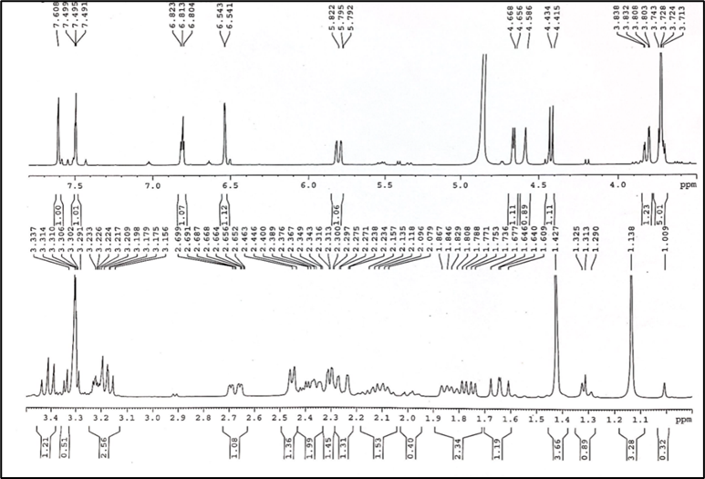

**Fig. S2.** The 1H-NMR spectra of purified-BPC.

**Table S1**

Chemical shifts 1H-NMR spectra and reference data for purified-BPC.

|  |  |  |
| --- | --- | --- |
| H atom | Purified BPC fraction | Reference (Lam et al., 2012) |
| δH  (mult., *J* in Hz) | δH  (mult., *J* in Hz) |
| 1α | 1.80 dd | 1.80 dd |
| 1β | 2.07 m | 2.07 m |
| 2 | 2.34 m | 2.33 m |
|  | 2.38 dt | 2.38 dt |
| 3 | 6.80 t | 6.79 t |
| 6 | 4.65 d | 4.65 d |
| 7α | 1.73 dd | 1.73 dd |
| 7β | 2.65 ddd | 2.65 ddd |
| 8 | 2.275 dd | 2.28 dd |
| 10 | 2.44 d | 2.44 d |
| 11α | 2.22 dd | 2.22 dd |
| 11β | 1.60 dd | 1.60 dd |
| 12 | 5.79 dd | 5.78 dd |
| 14 | 6.54 d | 6.53 d |
| 15 | 7.49 t | 7.48 t |
| 16 | 7.60 s | 7.59 s |
| 19 | 1.42 s | 1.42 s |
| 20 | 1.13 s | 1.13 s |
| OME | 3.72 s | 3.72 s |
| 1’ | 4.41 d | 4.41 d |
| 2’ | 3.61 dd | 3.16 dd |
| 3’ | 3.39 t | 3.39 t |
| 4’ | 3.31 t | 3.32 t |
| 5’ | 3.20 m | 3.20 m |
| 6’ | 3.80 dd | 3.80 dd |
|  | 3.69 dd | 3.69 dd |

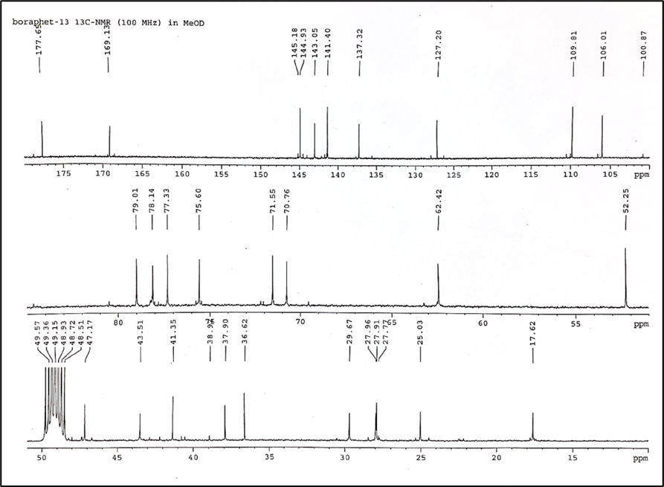

**Fig. S3.** The 13C-NMR spectra of purified-BPC.

**Table S2**

Chemical shifts 13C-NMR spectra and reference data for purified-BPC.

|  |  |  |
| --- | --- | --- |
| Position | Purified BPC fraction | Reference (Lam et al., 2012) |
| δC  (mult., *J* in Hz) | δC  (mult., *J* in Hz) |
| 1 | 17.62, CH2 | 17.5, CH2 |
| 2 | 25.03, CH2 | 24.9, CH2 |
| 3 | 143.0, CH2 | 142.8, CH2 |
| 4 | 137.3, qC | 137.2, qC |
| 5 | 41.3, qC | 41.2, qC |
| 6 | 79.1, CH | 78.8, CH |
| 7 | 29.5, CH2 | 29.5, CH2 |
| 8 | 47.1, CH | 47.0, CH |
| 9 | 36.6, qC | 36.4, qC |
| 10 | 37.9, CH | 37.8, CH |
| 11 | 43.5, CH2 | 43.3, CH2 |
| 12 | 71.5, CH | 71.4, CH |
| 13 | 127.2, CH | 127.0, CH |
| 14 | 109.8, CH | 109.7, CH |
| 15 | 148.8, CH | 148.8, CH |
| 16 | 141.4, CH | 141.2, CH |
| 17 | 177.6, qC | 177.4, qC |
| 18 | 169.1, qC | 168.9, qC |
| 19 | 27.9, CH3 | 27.8, CH3 |
| 20 | 27.9, CH3 | 27.8, CH3 |
| OMe | 52.2, CH3 | 52.1, CH3 |
| 1’ | 106.0, CH | 105.8, CH |
| 2’ | 75.6, CH | 75.4, CH |
| 3’ | 78.1, CH | 78.0, CH |
| 4’ | 70.7, CH | 70.6, CH |
| 5’ | 77.3, CH | 77.1, CH |
| 6’ | 62.4, CH2 | 62.3, CH2 |

*Liquid chromatography mass spectrometry (LC-MS)*

LC-MS was employed to analyze the molecular mass of BPC. The purified-BPC fraction, dissolved in MeOH at concentration 2.0 mg/mL, was filtered through 0.45 µm nylon filter membrane before being injected into a poroshell 120EC-C18 column (3.0 × 150 mm with a particle size of 2.7 uM) (Agilent, USA). Gradient elution of the mobile phase consisting of MeOH:H2O-0.05% trifluoroacetic acid (TFA) was carried out where the MeOH: H2O ratio changed from 10:90 to 80:20 within 60 min. The solvent flow rate was set at 0.5 mL/min and injection volume of 1 µL was used. The signal was then detected via a MS detector on a LC-Q-TOF mass spectrometer (Shimadzu, Japan) in negative electrospray ionization (ESI) mode. Capillary voltage was set at +4.5 kV. Mass spectra were then recorded in the range of 50–1650 m/z. MS/MS experiments were conducted using data dependent acquisition (DDA) mode (auto-MS/MS) in a mass window from m/z 150–1200. Three precursor ions with intensities higher than 400 au were selected per fragmentation cycle among the most intense ions to be fragmented. The collision energy was set at 40 eV. Raw data were converted to m/z XML format using CompassXport software (Bruker, Bremen, Germany) and then processed using MZmine version 2.

The MS spectra of purified BPC with parent ion corresponding to the deprotonated molecular [M-H]- was shown in Fig. S4. Deprotonated molecular ion [M-H]- 535.2225 m/z, presumably was in agreement with the molecular formular C27H37O11. The fragment ions at 581.2246, 535.2225, 681.1151 indicative of the substructure of BPC were also observed in the MS spectra. The theoretical calculation of the molecular formular using Chemdraw program in the negative ion mode resulted in a value of 536.2258 (Error between the theoretical and the experimental masses was 6.165). Therefore, the BPC purified in this study was further used as a standard (BPC-STD) for quantifying the content of BPC in the crude *T. crispa* extracts.

รูปภาพประกอบด้วย ข้อความ, ภาพหน้าจอ, แสดง, ซอฟต์แวร์

คำอธิบายที่สร้างโดยอัตโนมัติ

**Fig. S4.** MS spectra fragmentation pattern of purified-BPC.

**Fig. S5**. UV-absorption spectra of (a) the purified-BPC, (b) crude *T. crispa* extract obtained with 20% EtOH:H2O solvent mixture at 40 ˚C for 60 min and (c) the MGF-free BPC-rich fraction obtained at later times from the sequential extraction conducted under UHPLC at 214 nm.

รูปภาพประกอบด้วย ข้อความ, แผนภาพ, ไลน์, พล็อต

คำอธิบายที่สร้างโดยอัตโนมัติ

**Fig. S6.** UV-absorption spectra of (a) MGF-STD and (b) crude *T. crispa* extract obtained with pure-EtOH at 40 ˚C for 100 min conducted under UHPLC at 280 nm.

**Table S3**

First and second order group contributions of BPC

|  |  |  |  |  |
| --- | --- | --- | --- | --- |
|  | **No.** | **δd** | **δp** | **δh** |
| **First-order group** | | | | |
| CH=CH< | 1 | 0.5372 | -0.9024 | -1.8872 |
| CH2COO | 1 | 0.2913 | 3.6462 | 1.2523 |
| HCOO | 1 | 0 | 1.9308 | 2.1202 |
| OH | 4 | -0.3462 | 1.1404 | 7.1908 |
| CHO (esters) | 1 | 0.8833 | 1.6853 | 0.447 |
| O | 1 | 0.0472 | 3.3432 | 0.0256 |
| **Second-order group** |
| Ring 6 carbons | 2 | -0.3874 | -3.6432 | 0 |
| Ring 5 carbons | 1 | -0.6681 | -2.343 | -0.3071 |
| >C(H or C)-< | 1 | -0.2798 | 0 | -1.1164 |
| Isopropyl acetate | 1 | -0.552 | -0.0652 | 0.3085 |
| Cyclic-OH | 4 | -0.0876 | 0.5914 | 0.5914 |

**Table S4**

First and second order group contributions of MGF

|  |  |  |  |  |
| --- | --- | --- | --- | --- |
|  | **No.** | **δd** | **δp** | **δh** |
| **First-order group** | | | | |
| ACOH | 2 | 0.5288 | 1.101 | 6.958 |
| CH3O | 2 | -0.5828 | 0.1764 | 0.1460 |
| CH< | 1 | 0.6450 | 0.6491 | -0.2018 |
| CH3N | 1 | 0.8769 | 1.2046 | 1.6062 |
| CH3 | 4 | -0.9714 | -1.6448 | -0.7813 |
| ACH | 6 | 0.1105 | -0.5303 | -0.4305 |
| **Second-order group** |
| Ring 6 carbons | 1 | -0.3874 | -3.6432 | 0 |
| Ring 5 carbons | 1 | -0.6681 | -2.3430 | -0.3079 |
| N{H or C}(in cyclic) | 1 | 0.2218 | -2.2018 | -0.0452 |

**Fig. S7**. Effects of extraction temperature on the extractability and selectivity of MGF using A) 20% EtOH:H2O and BPC using B) 90% EtOH:H2O and C) pure-EtOH for 60 min. Data are presented as the mean ± SD (n=3). Different letters and symbols indicate significant differences between samples within the same category at the level of p < 0.05.

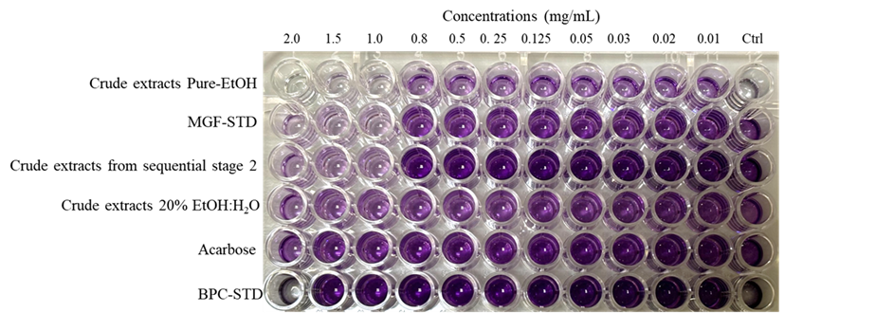

**Fig. S8**. Photographic images of L6 cells after treated with crude *T. crispa* extracts at various extraction conditions, BPC-STD, MGF-STD and acarbose at 24 h using MTT assay. Darker purple color indicates higher cell viability.

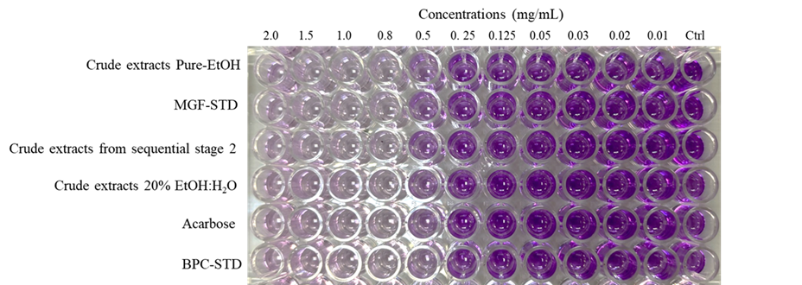

**Fig. S9.** Photographic images of HepG2 cells after treated with crude *T. crispa* extracts at various extraction conditions, BPC-STD, MGF-STD and acarbose at 24 h using MTT assay. Darker purple color indicates higher cell viability.

Reference:

Lam, S. H., Ruan, C. T., Hsieh, P. H., Su, M.J., Lee, S.S., 2012. Hypoglycemic diterpenoids from *Tinospora crispa*. J Nat Prod. 75, 153-159. <https://doi.org/10.1021/np200692v>.