**Supplementary data**

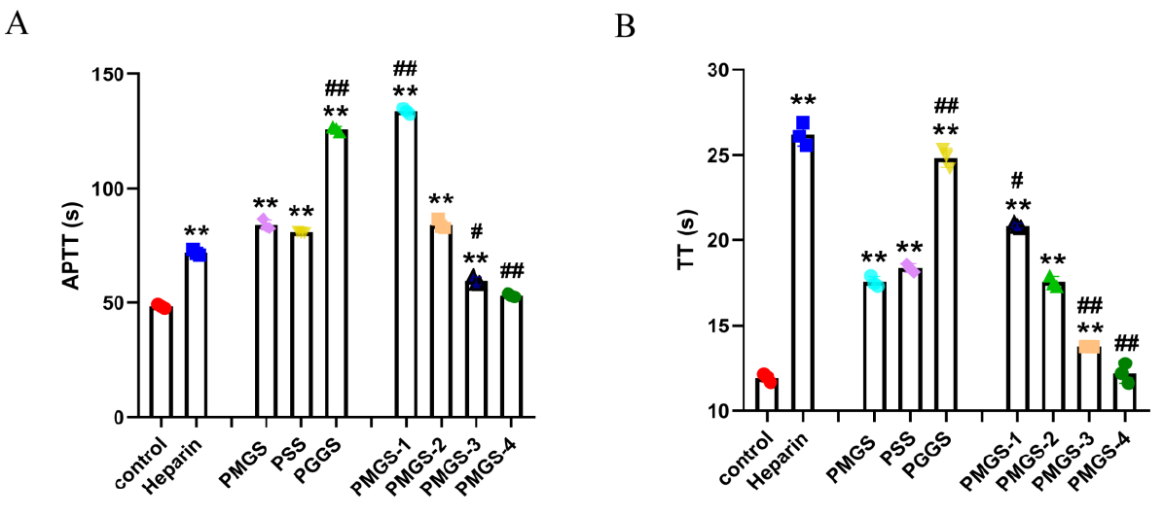

**Figure S1.** Impacts of PSS derivatives on APTT and TT in vitro.

(A) For APTT assay, 50 μL of APTT reagent was mixed with 50 μL of the mixture (1.5 mg/mL sample solution was diluted in sheep plasma at a ratio of 1:59) and incubated at 37 ºC for 180 s. Then, 50 μL of CaCl2 aqueous solution (0.025 M) pre-warmed for 15 min was added. The clotting time was measured by an HP600-4 semiautomatic coagulation analyzer. (B) For TT assay, 50 μL of the mixture mentioned above was incubated at 37 ºC for 180 s. Then, 50 μL of TT reagent pre-warmed for 15 min was added. The clotting time was tested by an HP600-4 semiautomatic coagulation analyzer. Values are shown as the mean ± SEM (n=3). \**p* < 0.05 and \*\**p* < 0.01 vs control group; #*p* < 0.05 and ##*p* < 0.01 vs PMGS (PMGS-2) group. Heparin (3.125 μg/mL) was used as the positive agent.

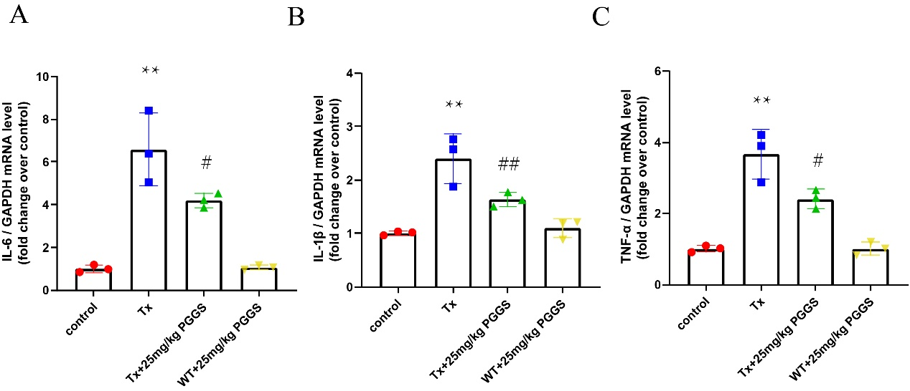

**Figure S2.** The Inhibitory effect of PGGS on TGFβ1-induced inflammation in mice. 25mg/kg PGGS was used as the representative intervention dose for measuring levels of the pro-inflammatory cytokines. (A-C) The mRNA expression of IL-6, IL-1β and TNF-α in atrium tissues of mice in each group determined by qRT-PCR.\**p*＜0.05 and \*\**p*＜0.01 vs control group; #*p*＜0.05 and ##*p*＜0.01 vs TGF-β1 group.