**Identification and functional prediction of novel triterpenoids from *Alismatis Rhizoma* using HPLC-HRMS and *in-silico* analysis**

Tao Gao a,1, Sheng-lin Hu b,1, Rui Yan c, Ling-zhi He c, Nan Fang a, Zhong-hao Zhang a, Zhi-hao Duan a, Zi-zhong Tang a, Yang-er Chen a, Shu Yuan d, Lin Ye e, Xiao-rong Yan b,*, Ming Yuan a,*

a *College of Life Science, Sichuan Agricultural University, Yaan, 625014, China.*

b *Yaan People's Hospital, Yaan, China*

c *Wanzhou Food and Drug Inspection Institute, Wanzhou, 404100, China*

d *College of Resources, Sichuan Agricultural University, Chengdu, 611134, China*

e *College of Animal Science and Technology, Sichuan Agricultural University, Chengdu 611100, China*

*1 These authors contributed equally to this work.*

*Corresponding authors: Ming Yuan and Xiao-rong Yan

E-mail address: [yuanming@sicau.edu.cn](mailto:yuanming@sicau.edu.cn); [2262810416@qq.com](mailto:2262810416@qq.com)

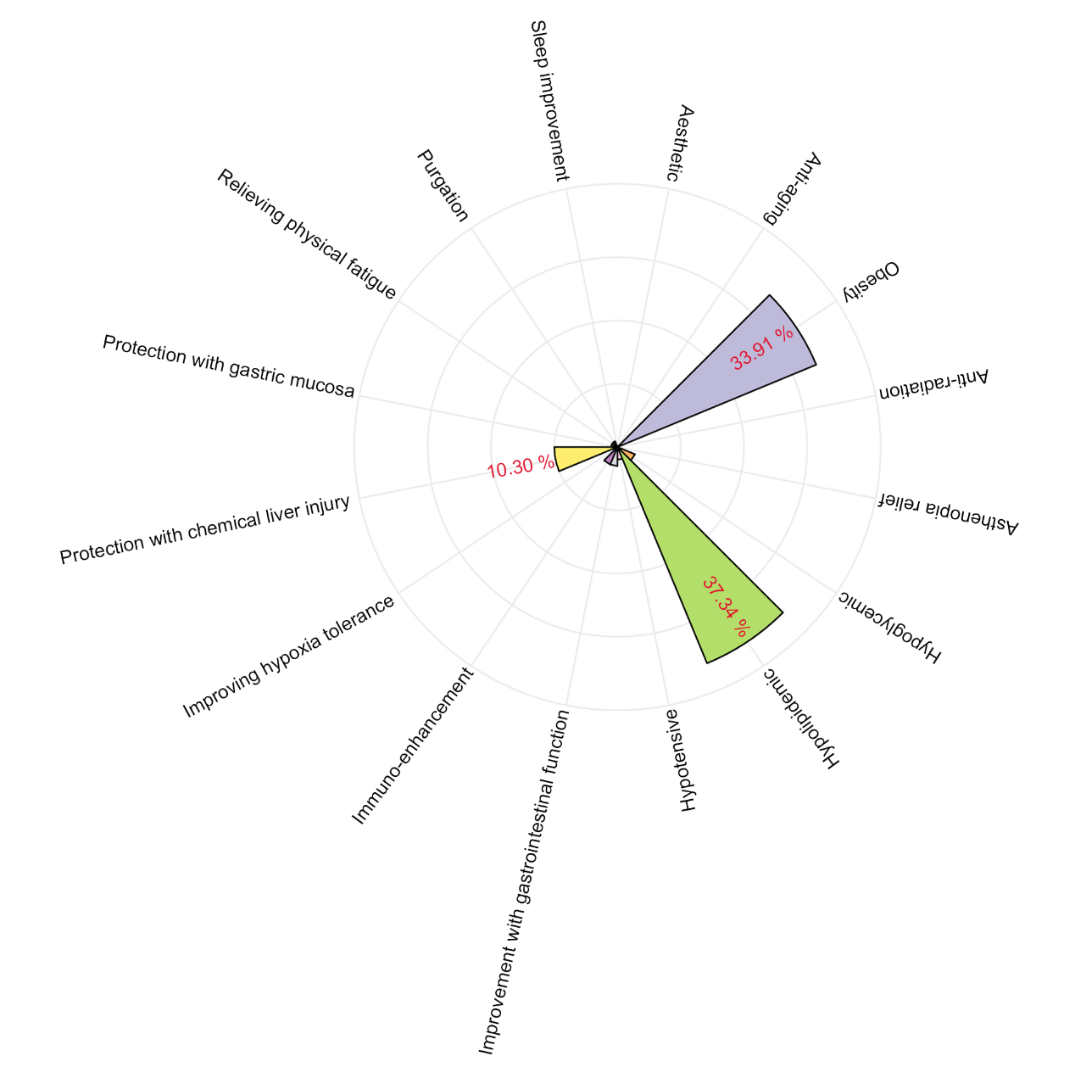

**Fig. S1:** Function of functional food with AR as material. This result was calculated from Table S1.



**Fig. S2** MS/MS spectra of 16 triterpenoids except 16-oxo-alisol A, 16-oxo-11-anhydro-alisol A, Alisol B, and Alisol B 23-acetate.

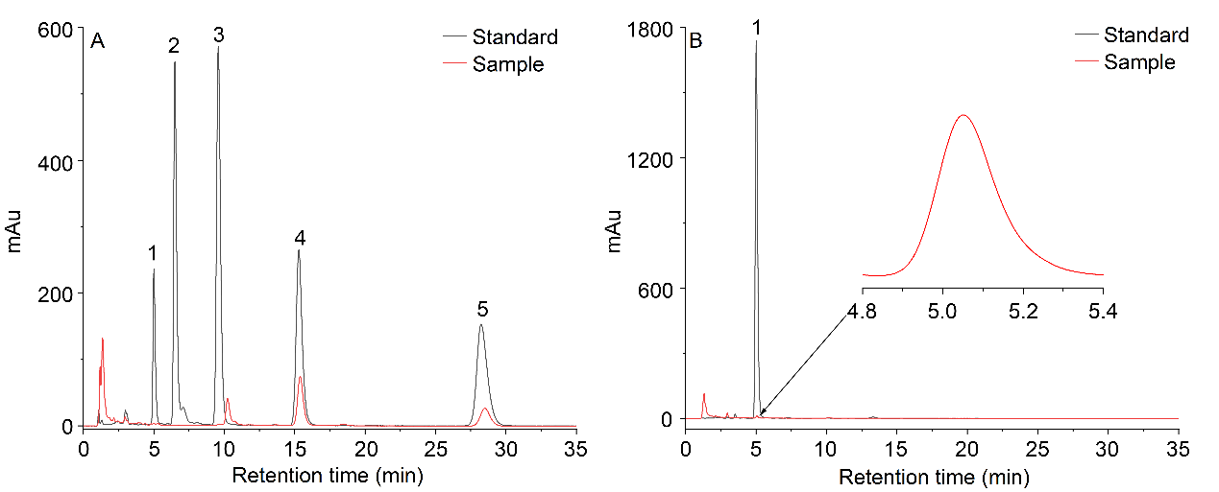

**Fig. S3** HPLC chromatograms at 208 (a) nm and 245 (b) nm of sample and reference substance. Peak 1-5 were alisol C 23-acetate, alisol A, alisol A 24-acetate, alisol B, alisol B 23-acetate. (Method: 0.5 g of sample dried was dissolved in 25mL of 80% acetonitrile and then ultrasonic extracted for 30 min at 50 °C and 240 W. After centrifugation, 1mL of supernatant was collected and passed through a 0.22 um organic membrane for HPLC analysis (1260, Agilent, USA) equipped with an Agilent C-18 column (4.6×150 mm, 5 um). The mobile phase was 80% acetonitrile at a flow rate of 1.0 mL/min, and the injection volume was 10 uL.

**Table S1** The information on functional food with AR as material. Date from Special food information inquiry platform of State Administration for Market Regulation (http://ypzsx.gsxt.gov.cn/specialfood/#/food)

|  |  |  |  |
| --- | --- | --- | --- |
| Product approval number | Function | Product approval number | Function |
| G20130294 | Hypolipidemic | G20130496 | Anti-obesity |
| G20141164 | Hypolipidemic | G20050185 | Anti-obesity |
| G20150689 | Hypolipidemic | G20041047 | Anti-obesity |
| G20150247 | Hypolipidemic | G20060439 | Anti-obesity |
| G20141240 | Hypolipidemic | G20050203 | Anti-obesity |
| G20100653 | Hypolipidemic | G20130063 | Anti-obesity |
| G20080444 | Hypolipidemic | G20040960 | Anti-obesity |
| G20130649 | Hypolipidemic | G20040492 | Anti-obesity |
| G20130178 | Hypolipidemic | G20040271 | Anti-obesity |
| G20150207 | Hypolipidemic | G20050064 | Anti-obesity |
| G20150675 | Hypolipidemic | G20041356 | Anti-obesity |
| G20140455 | Hypolipidemic | G20150208 | Anti-obesity |
| G20120215 | Hypolipidemic | G20141205 | Anti-obesity |
| G20070331 | Hypolipidemic | G20060425 | Anti-obesity |
| G20140629 | Hypolipidemic | G20140503 | Anti-obesity |
| G20060315 | Hypolipidemic | G20110573 | Anti-obesity |
| G20200110 | Hypolipidemic | G20080677 | Anti-obesity |
| G20130866 | Hypolipidemic | G20060470 | Anti-obesity |
| G20070134 | Hypolipidemic | G20060366 | Anti-obesity |
| G20130346 | Hypolipidemic | G20060056 | Anti-obesity |
| G20110193 | Hypolipidemic | G20050386 | Anti-obesity |
| G20060624 | Hypolipidemic | G20050385 | Anti-obesity |
| G20120421 | Hypolipidemic | G20050264 | Anti-obesity |
| G20141105 | Hypolipidemic | G20050242 | Anti-obesity |
| G20150698 | Hypolipidemic | G20050216 | Anti-obesity |
| G20200076 | Hypolipidemic | G20050239 | Anti-obesity |
| G20060077 | Hypolipidemic | G20050006 | Anti-obesity |
| G20060376 | Hypolipidemic | G20041056 | Anti-obesity |
| G20041155 | Hypolipidemic | G20041027 | Anti-obesity |
| G20050624 | Hypolipidemic | G20040857 | Anti-obesity |
| G20190350 | Hypolipidemic | G20040827 | Anti-obesity |
| G20190293 | Hypolipidemic | G20040728 | Anti-obesity |
| G20190248 | Hypolipidemic | G20040521 | Anti-obesity |
| G20150974 | Hypolipidemic | G20040529 | Anti-obesity |
| G20080078 | Hypolipidemic | G20040493 | Anti-obesity |
| G20110785 | Hypolipidemic | G20040310 | Anti-obesity |
| G20090345 | Hypolipidemic | 卫食健字(2003)第0331号 | Anti-obesity |
| G20060656 | Hypolipidemic | 卫食健字(2003)第0265号 | Anti-obesity |
| G20090153 | Hypolipidemic | 卫食健字(2003)第0133号 | Anti-obesity |
| G20100280 | Hypolipidemic | 卫食健字(2003)第0049号 | Anti-obesity |
| G20130263 | Hypolipidemic | 卫食健字(2003)第0055号 | Anti-obesity |
| G20050215 | Hypolipidemic | 卫食健字(2003)第0082号 | Anti-obesity |
| G20041065 | Hypolipidemic | 卫食健字(2002)第0643号 | Anti-obesity |
| G20040382 | Hypolipidemic | 卫食健字(2002)第0590号 | Anti-obesity |
| G20100467 | Hypolipidemic | 卫食健字(2001)第0028号 | Anti-obesity |
| G20060362 | Hypolipidemic | 卫食健字(1999)第0393号 | Anti-obesity |
| G20060783 | Hypolipidemic | 卫食健字(1999)第0440号 | Anti-obesity |
| G20041217 | Hypolipidemic | 卫食健字(1999)第0380号 | Anti-obesity |
| G20130492 | Hypolipidemic | 卫食健字(1999)第083号 | Anti-obesity |
| G20160362 | Hypolipidemic | G20120154 | Protection with chemical liver injury |
| G20160334 | Hypolipidemic | G20060305 | Protection with chemical liver injury |
| G20160200 | Hypolipidemic | G20060825 | Protection with chemical liver injury |
| G20080679 | Hypolipidemic | G20130436 | Protection with chemical liver injury |
| G20141068 | Hypolipidemic | G20130739 | Protection with chemical liver injury |
| G20110652 | Hypolipidemic | G20200538 | Protection with chemical liver injury |
| G20140739 | Hypolipidemic | G20200141 | Protection with chemical liver injury |
| G20140324 | Hypolipidemic | G20200142 | Protection with chemical liver injury |
| G20060393 | Hypolipidemic | G20190313 | Protection with chemical liver injury |
| G20070028 | Hypolipidemic | G20060654 | Protection with chemical liver injury |
| G20120620 | Hypolipidemic | G20110109 | Protection with chemical liver injury |
| G20120456 | Hypolipidemic | G20130263 | Protection with chemical liver injury |
| G20110315 | Hypolipidemic | G20050215 | Protection with chemical liver injury |
| G20090493 | Hypolipidemic | G20060783 | Protection with chemical liver injury |
| G20080686 | Hypolipidemic | G20041000 | Protection with chemical liver injury |
| G20070176 | Hypolipidemic | G20041461 | Protection with chemical liver injury |
| G20050937 | Hypolipidemic | G20090565 | Protection with chemical liver injury |
| G20050823 | Hypolipidemic | G20090493 | Protection with chemical liver injury |
| G20050227 | Hypolipidemic | G20050054 | Protection with chemical liver injury |
| G20050175 | Hypolipidemic | G20040692 | Protection with chemical liver injury |
| G20041187 | Hypolipidemic | G20040660 | Protection with chemical liver injury |
| G20041056 | Hypolipidemic | 卫食健字(2003)第0413号 | Protection with chemical liver injury |
| G20040740 | Hypolipidemic | 卫食健字(2003)第0388号 | Protection with chemical liver injury |
| G20040692 | Hypolipidemic | 卫食健字(2002)第0739号 | Protection with chemical liver injury |
| G20040509 | Hypolipidemic | G20080444 | Hypoglycemic |
| G20040318 | Hypolipidemic | G20050702 | Hypoglycemic |
| G20040050 | Hypolipidemic | G20160334 | Hypoglycemic |
| 卫食健字(2003)第0247号 | Hypolipidemic | G20060393 | Hypoglycemic |
| 卫食健字(2003)第0082号 | Hypolipidemic | G20050535 | Hypoglycemic |
| 卫食健字(2002)第0564号 | Hypolipidemic | G20050227 | Hypoglycemic |
| 卫食健字(2002)第0590号 | Hypolipidemic | G20040740 | Hypoglycemic |
| 卫食健字(2001)第0028号 | Hypolipidemic | G20040050 | Hypoglycemic |
| 卫食健字(2001)第0303号 | Hypolipidemic | G20100444 | Immuno-enhancement |
| 卫食健字(2001)第0235号 | Hypolipidemic | G20110626 | Immuno-enhancement |
| 卫食健字(2001)第0209号 | Hypolipidemic | G20110109 | Immuno-enhancement |
| 卫食健字(2001)第0110号 | Hypolipidemic | G20041000 | Immuno-enhancement |
| 卫食健字(2000)第0260号 | Hypolipidemic | G20050006 | Immuno-enhancement |
| 卫食健字(1998)第401号 | Hypolipidemic | G20041438 | Immuno-enhancement |
| G20090222 | Anti-obesity | G20040345 | Immuno-enhancement |
| G20141041 | Anti-obesity | 卫食健字(2000)第0196号 | Immuno-enhancement |
| G20140676 | Anti-obesity | G20050850 | Hypotensive |
| G20130109 | Anti-obesity | G20090170 | Hypotensive |
| G20100579 | Anti-obesity | G20050823 | Hypotensive |
| G20150173 | Anti-obesity | G20040509 | Hypotensive |
| G20050898 | Anti-obesity | 卫食健字(2000)第0374号 | Hypotensive |
| G20140388 | Anti-obesity | G20050216 | Improvement with gastrointestinal function |
| G20140614 | Anti-obesity | G20040318 | Improvement with gastrointestinal function |
| G20060499 | Anti-obesity | 卫食健字(2002)第0643号 | Improvement with gastrointestinal function |
| G20150998 | Anti-obesity | 卫食健字(2002)第0564号 | Improvement with gastrointestinal function |
| G20140042 | Anti-obesity | G20050216 | Improvement with gastrointestinal function |
| G20130418 | Anti-obesity | G20040318 | Improvement with gastrointestinal function |
| G20130808 | Anti-obesity | 卫食健字(2002)第0643号 | Improvement with gastrointestinal function |
| G20070008 | Anti-obesity | 卫食健字(2002)第0564号 | Improvement with gastrointestinal function |
| G20160083 | Anti-obesity | G20050630 | Relieving physical fatigue |
| G20060755 | Anti-obesity | G20050609 | Relieving physical fatigue |
| G20150176 | Anti-obesity | G20040826 | Relieving physical fatigue |
| G20130926 | Anti-obesity | G20050387 | Protection with gastric mucosa |
| G20150509 | Anti-obesity | G20050054 | Protection with gastric mucosa |
| G20130277 | Anti-obesity | G20060499 | Purgation |
| G20090126 | Anti-obesity | G20130102 | Purgation |
| G20100331 | Anti-obesity | G20060656 | Purgation |
| G20100500 | Anti-obesity | G20040345 | Anti-aging |
| G20130866 | Anti-obesity | 卫食健字(2003)第0133号 | Aesthetic |
| G20100283 | Anti-obesity | G20100444 | Anti-radiation |
| G20140184 | Anti-obesity | G20100054 | Sleep improvement |
| G20120004 | Anti-obesity | G20060318 | Asthenopia relief |
| G20110136 | Anti-obesity | G20060347 | Improving hypoxia tolerance |
| G20060376 | Anti-obesity |  |  |

**Table S2** Topology analysis of PPI network

|  |  |  |  |  |  |  |  |
| --- | --- | --- | --- | --- | --- | --- | --- |
| 25-methoxy-16-oxo-11-anhydroalisol A  (Compound A) | | 25-methoxy-16-oxo-alisol A  (Compound B) | | 25-methoxy-16-oxo-alisol A 23-acetate  (Compound C) | | 25-methoxy-16-oxo-alisol A 24-acetate  (Compound D) | |
| Name | Degree | Name | Degree | Name | Degree | Name | Degree |
| PPARA | 16 | PPARG | 18 | IGF1 | 12 | PPARA | 13 |
| ALB | 13 | PPARA | 16 | EGFR | 12 | RXRA | 13 |
| IGF1 | 12 | RXRA | 14 | PPARA | 12 | EGFR | 11 |
| EGFR | 12 | EGFR | 14 | RXRA | 12 | IGF1 | 10 |
|  |  | REN | 13 | IL2 | 10 |  |  |
|  |  | MMP9 | 10 |  |  |  |  |
|  |  | NR3C1 | 10 |  |  |  |  |