**Supporting material**

**Table S1.** Calculated dihedral angles (α in °) and the bond lengths (d in Å) of single dyes.

|  |  |  |  |  |  |  |
| --- | --- | --- | --- | --- | --- | --- |
| Dye | α1 | α2 | α3 | d1 | d2 | d3 |
| CS-70 | 33.03 | 35.65 | -0.17 | 1.475 | 1.480 | 1.484 |
| CS-72 | 34.45 | -36.28 | 0.15 | 1.475 | 1.480 | 1.485 |

**Table S2.** The polarizability and hyperpolarizabilities.

|  |  |  |  |  |  |  |  |  |  |  |  |  |  |  |  |  |  |  |
| --- | --- | --- | --- | --- | --- | --- | --- | --- | --- | --- | --- | --- | --- | --- | --- | --- | --- | --- |
| Dye | αxx | | αxy | | αyy | | | | αxz | | αyz | | | αzz | | | α | |
| CS-70 | 1021.16 | | 3.86 | | 593.62 | | | | 5.14 | | -41.31 | | | 281.21 | | | 631.99 | |
| CS-72 | 1291.32 | | -37.03 | | 646.19 | | | | 18.17 | | -85.24 | | | 430.64 | | | 789.38 | |
|  | βxxx | βxxy | | βxyy | | βyyy | βxxz | | | βxyz | | βyyz | βxzz | | βyzz | βzzz | | βtot |
| CS-70 | 85434.20 | -2904.02 | | -121.99 | | -236.51 | | 522.68 | | -139.49 | | 14.77 | -284.03 | | -1.15 | 104.82 | | 85086.29 |
| CS-72 | 148333.00 | 2794.85 | | -79.36 | | -118.589 | | -1477.27 | | 4.85 | | -19.89 | -40.39 | | 19.31 | -56.36 | | 148237.77 |

**Table S3.** The bond length of the Ti atom to the O atom (in Å), and adsorption energies (kcal/mol).

|  |  |  |  |
| --- | --- | --- | --- |
| Dye | d1 | d2 | Eads |
| CS-70 | 2.067 | 2.060 | -86.42 |
| CS-72 | 2.070 | 2.059 | -80.01 |

**Table S4.** Absorption spectral data for the S7-S10 states of the co-sensitized system calculated, including excitation energy (E in eV), band wavelength (λ in nm), oscillator strength (f), and main transition modes.

|  |  |  |  |  |  |
| --- | --- | --- | --- | --- | --- |
| Dyes | State | E(eV) | λ(nm) | f | Transition mode |
| CS-70-Chl | 7 | 3.094 | 400.69 | 1.337 | H-1→L+2(0.52) |
| 8 | 3.224 | 384.58 | 0.948 | H-2→L+2(0.58) |
| 9 | 3.466 | 357.73 | 0.024 | H→L+2(0.62) |
| 10 | 3.636 | 340.98 | 0.055 | H-3→L+1(0.37) |
| CS-72-Chl | 7 | 3.057 | 405.60 | 1.372 | H→L+2(0.52) |
| 8 | 3.200 | 387.41 | 0.639 | H-2→L+2(0.56) |
| 9 | 3.428 | 361.66 | 0.180 | H→L+3(0.44) |
| 10 | 3.495 | 354.73 | 0.003 | H→L+3(0.49) |

**Table S5.** The contribution of holes and electrons in intermolecular charge transfer excited states by different parts of the investigated co-sensitized system.

|  |  |  |  |  |  |  |  |  |  |  |  |
| --- | --- | --- | --- | --- | --- | --- | --- | --- | --- | --- | --- |
| Dyes |  | Hole | | | | | Electron | | | | |
|  |  | Chl | D | A΄ | π | A | Chl | D | A΄ | π | A |
| CS-70-Chl | S4 | 98.54% | 0.52% | 0.26% | 0.65% | 0.02% | 4.34% | 7.66% | 75.59% | 10.09% | 2.32% |
| S6 | 98.41% | 0.59% | 0.79% | 0.20% | 0.01% | 11.50% | 7.33% | 69.65% | 9.31% | 2.211% |
| S7 | 97.64% | 0.96% | 0.90% | 0.49% | 0.02% | 87.55% | 0.90% | 9.24% | 1.96% | 0.35% |
|  |  |  |  |  |  |  |  |  |  |  |  |
| CS-72-Chl | S2 | 78.48% | 12.87% | 7.49% | 1.07% | 0.09% | 23.99% | 4.07% | 66.21% | 4.77% | 0.97% |
| S4 | 39.21% | 33.82% | 22.31% | 4.37% | 0.29% | 4.27% | 5.25% | 82.36% | 6.73% | 1.38% |
| S5 | 92.26% | 6.44% | 0.95% | 0.35% | 0.01% | 1.97% | 5.43% | 84.09% | 7.08% | 1.44% |
| S9 | 32.88% | 26.16% | 30.47% | 9.75% | 0.75% | 8.60% | 1.79% | 79.89% | 7.57% | 2.15% |
|  | S10 | 59.44% | 20.97% | 12.65% | 6.46% | 0.47% | 5.74% | 2.62% | 83.88% | 6.07% | 1.70% |

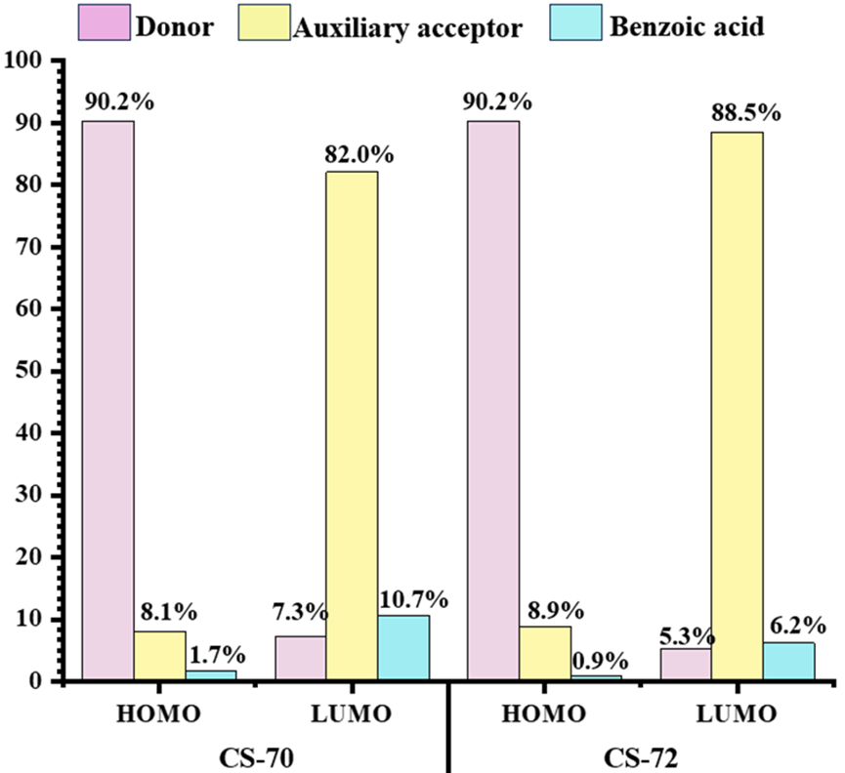

**Figure S1.** Contribution percentage of Mos in CS-70 and CS-72.

**Figure S2.** Simulated fluorescence spectra of dyes CS-70 and CS-72.

|  |  |
| --- | --- |
|  |  |
|  |  |
| a | b |

**Figure S3.** The separated distance of hole centroids (C+) in purple color and electrons centroids (C-) in green color with isocontour value of 0.0002 a.u. and molecular charge difference density (CDD) of electron transition of isolated monomers (a is CS-70 and b is CS-72).

|  |  |
| --- | --- |
| Dyes | ESP |
| CS-70 |  |
| CS-72 |  |

**Figure S4.** The ESP (kcal mol-1) on the VDW surface of the dye.