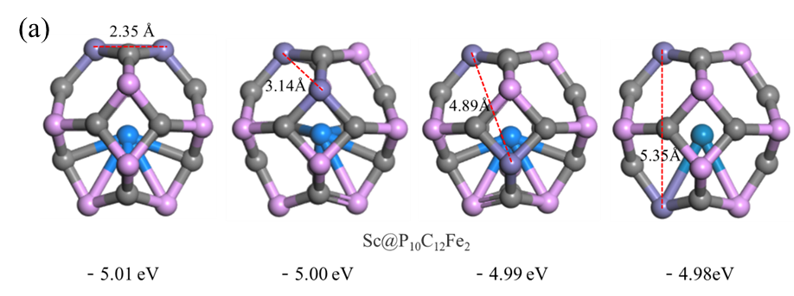

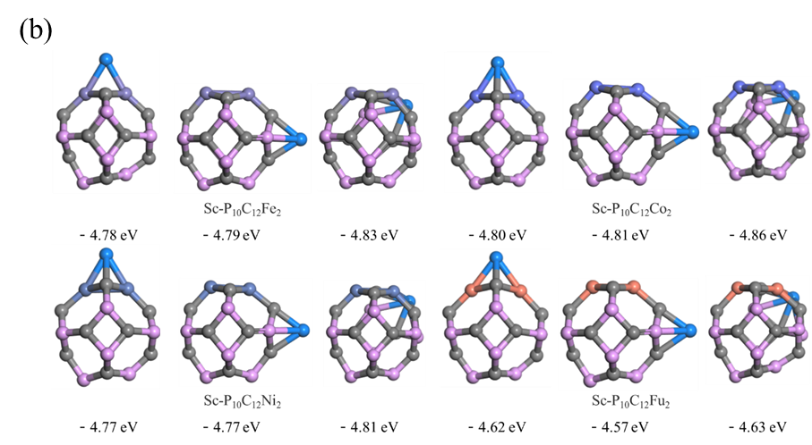

Fig. S1 (a) The optimal configuration of two Fe atoms at different distances of Sc@P10C12Fe2, and (b) the optimal configuration of Sc-P10C12M2

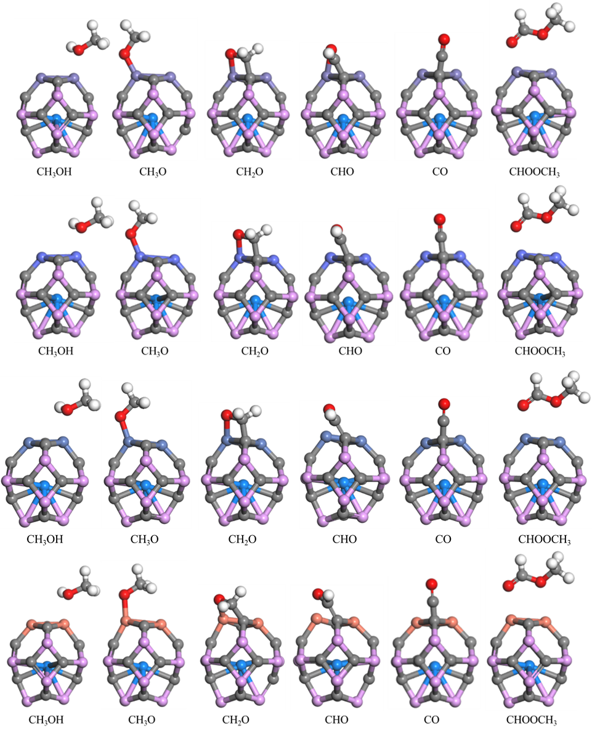

Fig. S2 The stable configurations of CH3OH and related species

on the Sc@P10C12M2 catalysts

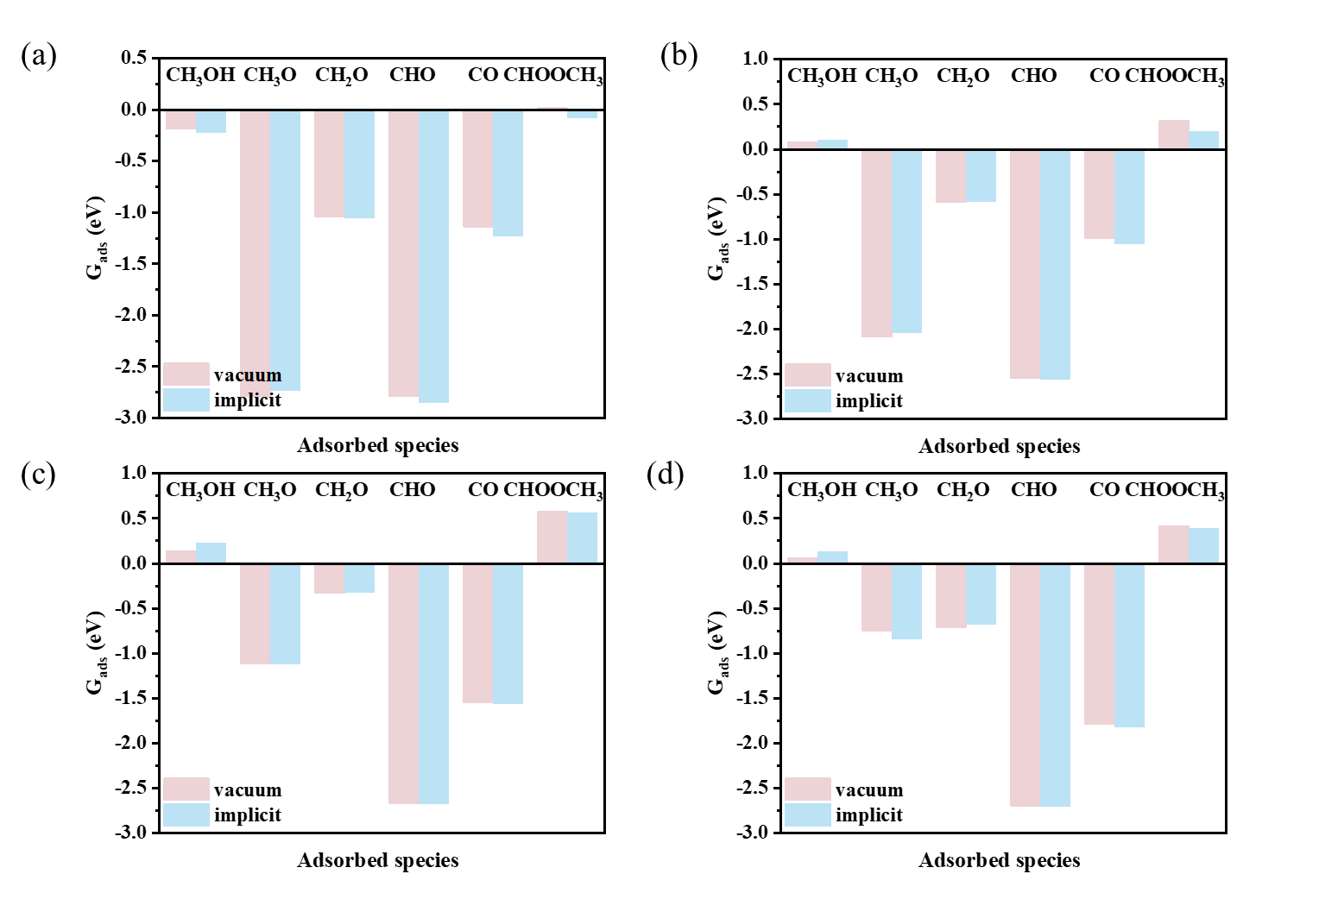

Fig. S3 Adsorption free energies (Gads) of CH3OH and related species in vacuum and water solvent on the (a) Sc@P10C12Fe2, (b) Sc@P10C12Co2, (c) Sc@P10C12Ni2 and

(d) Sc@P10C12Cu2 catalysts

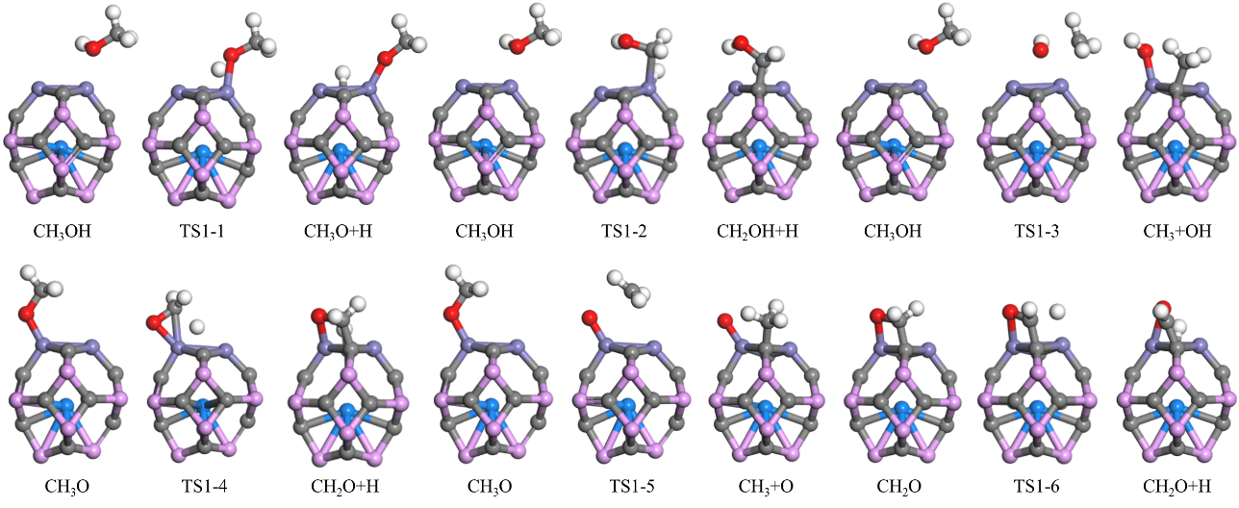

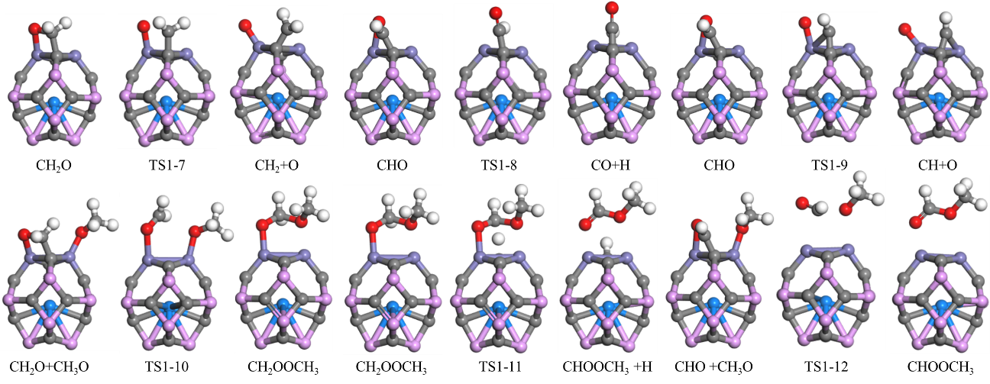

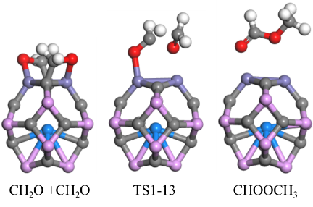

Fig. S4 The configuration of CH3OH and corresponding intermediates involved in the CH3OH to CHOOCH3 reaction on the Sc@P10C12Fe2 surface are shown

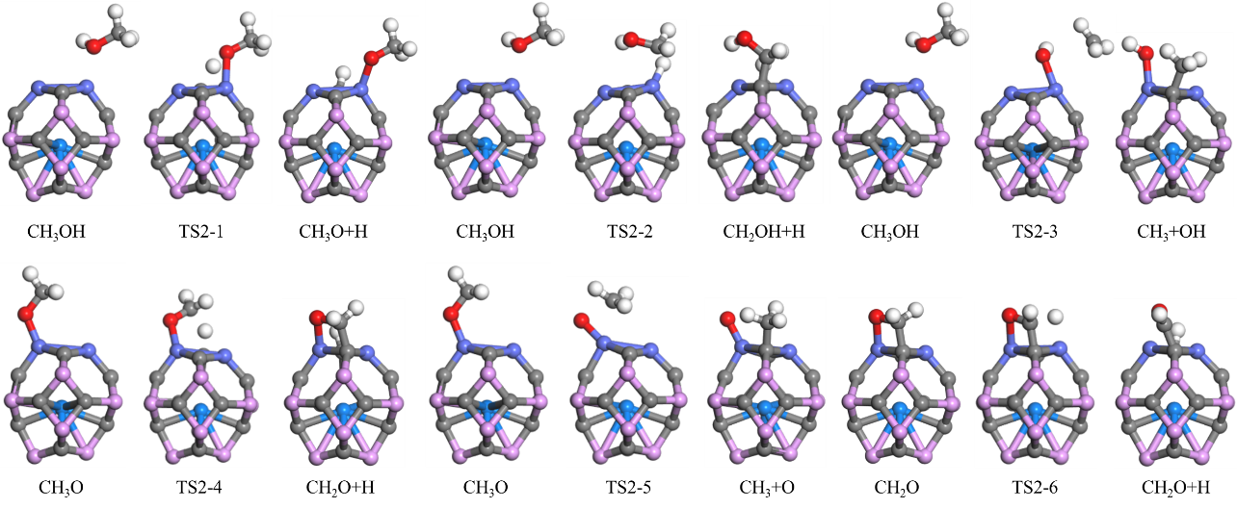

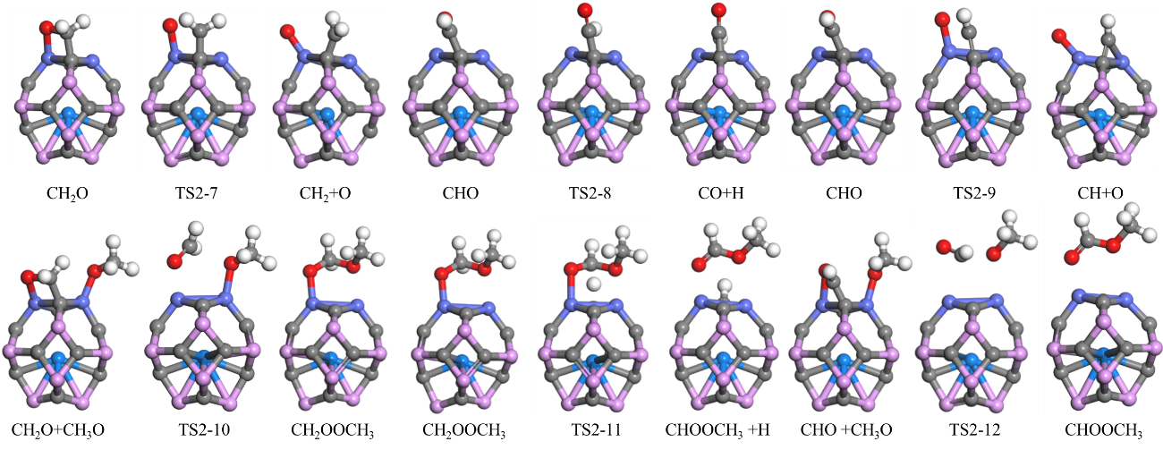

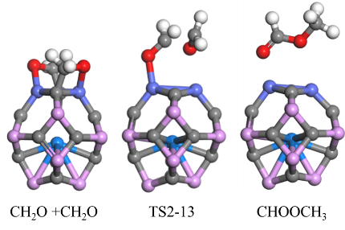

Fig. S5 The configuration of CH3OH and corresponding intermediates involved in the CH3OH to CHOOCH3 reaction on the Sc@P10C12Co2 surface are shown

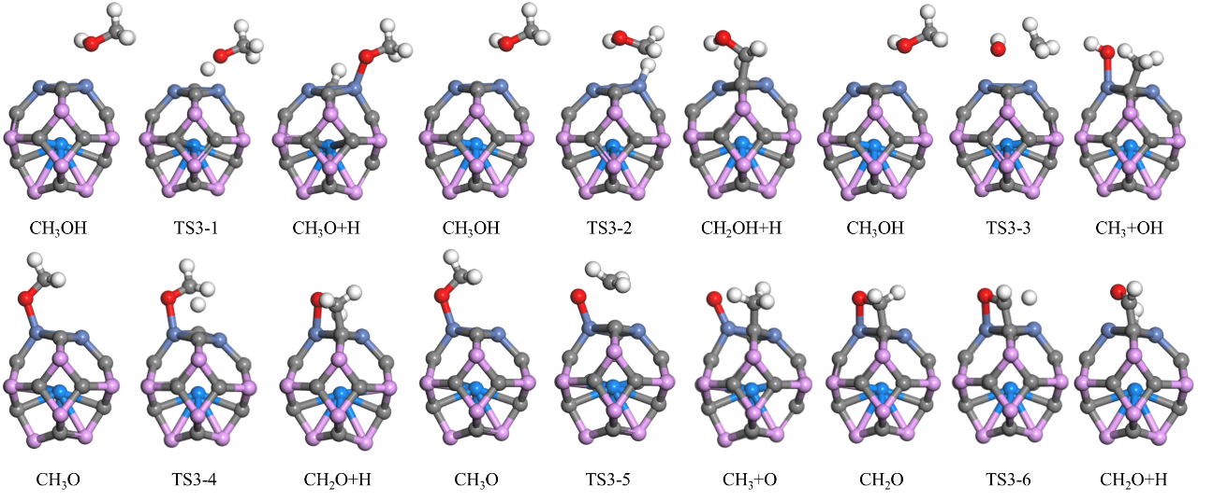

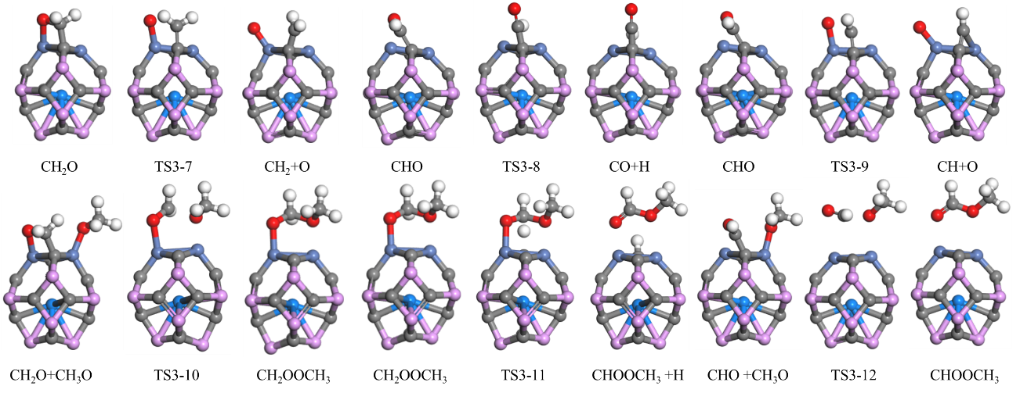

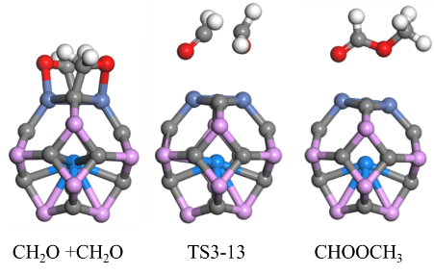

Fig. S6 The configuration of CH3OH and corresponding intermediates involved in the CH3OH to CHOOCH3 reaction on the Sc@P10C12Ni2 surface are shown

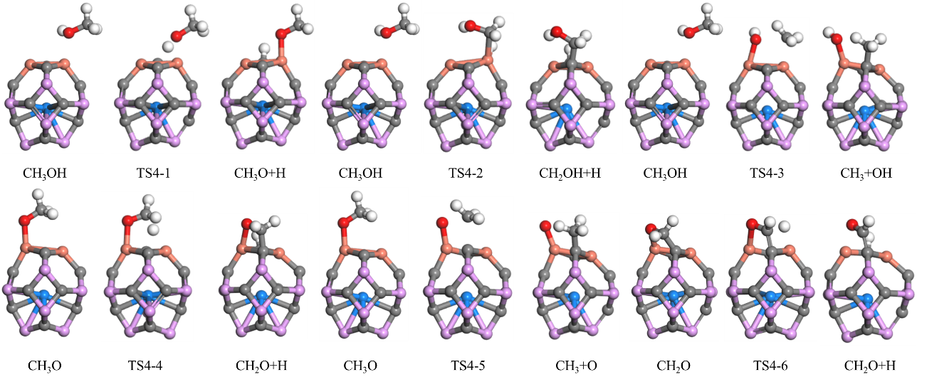

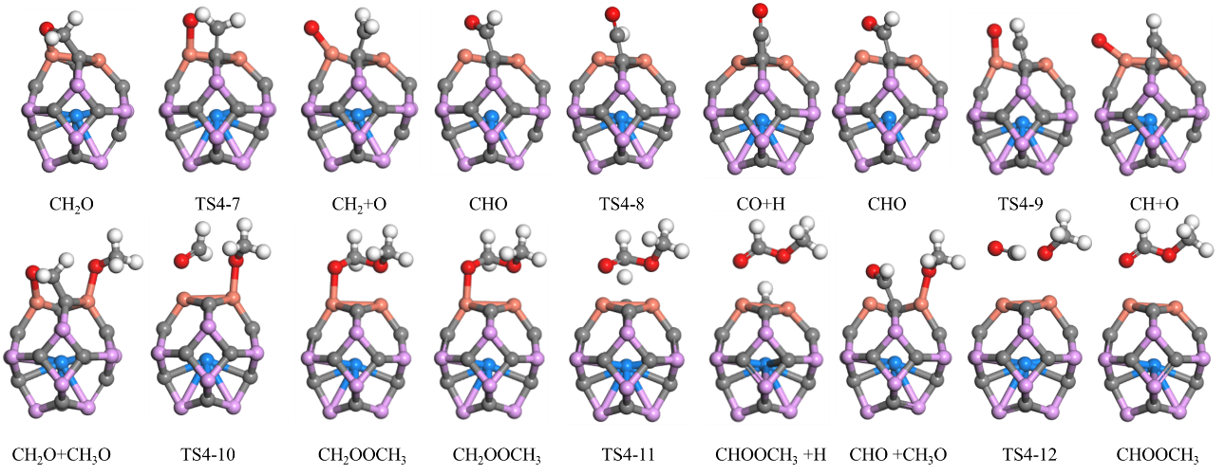

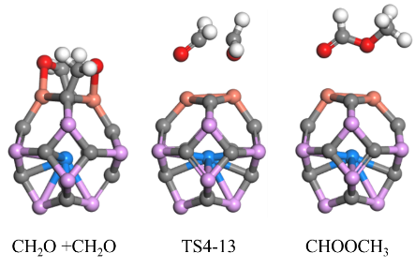

Fig. S7 The configuration of CH3OH and corresponding intermediates involved in the CH3OH to CHOOCH3 reaction on the Sc@P10C12Cu2 surface are shown

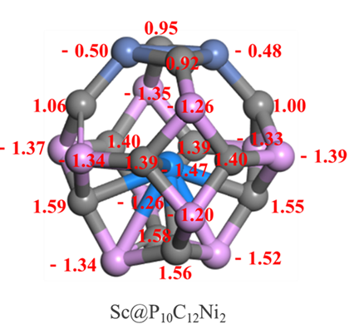

Fig. S8 A detailed electron distribution (e) on the Sc@P10C12Ni2 catalyst