# Wuzi Yanzong Pill alleviates spermatogenesis dysfunction by modulating the gut microbial tryptophan metabolites

**Juan Liua,b, Wuwen Fengb,c,**\***,****Dandan Zhangb, Hao Chengb, Yaochuan Zhoub, Jing Wub, Zixuan Wangd, Zhilei Wanga, Chunyan Fanga, Guangsen Lia, Yaodong Youa, Xujun Yua,**\***, Degui Changa,**\*

a *TCM Regulating Metabolic Diseases Key Laboratory of Sichuan Province, Hospital of Chengdu University of Traditional Chinese Medicine, Chengdu 610032, China*

b *State Key Laboratory of Southwestern Chinese Medicine Resources, School of Pharmacy, Chengdu University of Traditional Chinese Medicine, Chengdu 611137, China*

c *Key Laboratory of the Ministry of Education for Standardization of Chinese Medicine, Chengdu University of Traditional Chinese Medicine, Chengdu 611137, China*

d *Shanghai Key Laboratory of Complex Prescriptions and MOE Key Laboratory for Standardization of Chinese Medicines, Institute of Chinese Materia Medica, Shanghai University of Traditional Chinese Medicine, Shanghai, 201203, China*

*Corresponding authors at: State Key Laboratory of Southwestern Chinese Medicine Resources, School of Pharmacy, Chengdu University of Traditional Chinese Medicine, Chengdu 611137, China; Key Laboratory of the Ministry of Education for Standardization of Chinese Medicine, Chengdu University of Traditional Chinese Medicine, Chengdu 611137, China (W. Feng), TCM Regulating Metabolic Diseases Key Laboratory of Sichuan Province, Hospital of Chengdu University of Traditional Chinese Medicine, Chengdu 610032, China (D. Chang, X. Yu).

E-mail addresses: jiaoxiake-1@foxmail.com (W. Feng), changdegui123@163.com (D. Chang), 20639179@qq.com (X. Yu).

# Supplementary methods

## Chemical components analysis and quality control of WZYZP

The chemical components analysis of WZYZP was established by UPLC-QTOF-MS. The WZYZP (100 mg) was mixed with 500 μL extraction reagent (methanol/water, 4:1, *v*/*v*, containing the internal standards), vortexed, and ultrasound at low temperature for 1 h (45 kHz). After centrifugation, the supernatant was filtered through a 0.22-μm microporous membrane before UPLC-QTOF-MS analysis. Samples were injected onto a UPLC BEH C18 column (Waters, 1.7 μm, 100 mm × 2.1 mm) at a flow rate of 0.5 mL/min. The sample injection volume was 5 μL. The mobile phase was composed of solvent A (water, containing 0.1% formic acid) and solvent B (acetonitrile, containing 0.1% formic acid). The gradient procedure was carried out as follows: 85%−25% A (0−11 min), 25%−2% A (11−12 min), 2% A (12−14 min), 2−85% A (14−14.1 min), 85% A (14.1−16 min). The Q-TOF mass spectrometer was operated with heated electrospray ionization (HESI-II) probe. The positive and negative HESI-II spray voltages were 5.5 kV and 4 kV, respectively, and the heated capillary temperature was 350°C. The full mass scan resolution and MS/MS resolution were 60,000 and 15,000, respectively. The mass range was 100−1,500 *m/z*. The calibration was customized for the analysis to keep the mass tolerance of 5 ppm. Data were collected and processed using Orbitrap Exploris 120 mass spectrometer coupled with Xcalibur software (Xcalibur, Thermo Fisher Scientific).

To ensure the quality of WZYZP for animal studies, high-performance liquid chromatography (HPLC) was used to quantitatively analyze the contents of hyperoside, verbascoside, kaempferol, and schisandrin in WZYZP according to the 2020 edition of Chinese Pharmacopoeia. The reference standards of hyperoside, verbascoside, kaempferol, and schisandrin were accurately weighed and dissolved in 70% methanol with a single reference solution of 0.782, 0.641, 0.303, and 0.490 mg/mL, respectively. Pipette 1 ml of each of the single reference solution into the same 10-ml volumetric flask, and dilute to volume with 70% methanol. The mixed reference standard was filtered through a 0.45-μm nylon filter membrane for the HPLC analysis. For the preparation of the sample solution, WZYZP was finely ground. About 2 g of powder was weighed and transferred to a conical flask with a cover. Then 30 mL of 70% methanol was added and the conical flask was weighed. The solution was ultrasonicated for 1 h (40 kHz). After being cooled to room temperature, 70% methanol was added to compensate for the lost weight. The mixed solution was filtered through a 0.45-μm nylon filter membrane for the HPLC analysis. Samples were injected onto an Eclipse XDB-C18 column (Agilent, 5 μm, 250 mm × 4.6 mm) at 30 °C with a flow rate of 1.0 mL/min. The mobile phase was composed of solvent A (acetonitrile) and solvent B (water, containing 0.05% phosphoric acid). The gradient procedure was carried out as follows: 10% A (0−7 min), 10%−14% A (7−15 min), 14−20% A (15−25 min), 20−45% A (25−35 min), 45−65% A (35−45 min), 65% A (45−60 min), 65−85% A (60−65 min), 85−10% A (65−70 min). The detection wavelength was kept at 254 nm and the injection volume was 10 μL.

|  |  |  |
| --- | --- | --- |
| Gene | Forward primer (5′-3′) | Reverse primer (5′-3′) |
| *Ahr* | AGCCGGTGCAGAAAACAGTAA | AGGCGGTCTAACTCTGTGTTC |
| *Cyp1a1* | GACCCTTACAAGTATTTGGTCGT | GGTATCCAGAGCCAGTAACCT |
| *Cyp1b1* | CACCAGCCTTAGTGCAGACAG | GAGGACCACGGTTTCCGTTG |
| *Plzf* | AAACGGTTCCTGGACAGTTTGCGAC | CCAGTATGGGTCTGTCTGTGTGTCTCC |
| *Dmc1* | GGAGCAACTATGACCTTTCAG | TATTCTTGTTGTGGAAGCGT |
| *Sycp3* | GGATAATTGAAGATGTTGGAGGTG | CCTCTTGGCAAGAAGAGCT |
| *Stra8* | GATGGGAATCCCAACAGCT | GTTTAGGAATACACTGTCATTCTCG |
| *Gapdh* | TCTCCCTCACAATTTCCATCCCAG | GGGTGCAGCGAACTTTATTGATGG |

# Supplementary tables

**Table S1.** The primer sequences used for real-time PCR analysis in our work.

**Table S2.** Identification of compounds of Wuzi Yanzong Pill by UPLC-QTOF-MS

|  |  |  |  |  |  |  |  |
| --- | --- | --- | --- | --- | --- | --- | --- |
| **No.** | **Compound** | **Molecular** | **Formula** | **RT**  **(min)** | **m/z** | **Ionic**  **mode** | **ppm** |
| 1 | Apigenin | Flavonoids | C15H10O5 | 4.15 | 269.046 | - | 0.16 |
| 2 | Kaempferol | Flavonoids | C15H10O6 | 3.43 | 285.040 | - | 0.27 |
| 3 | Quercetin | Flavonoids | C15H10O7 | 1.58 | 303.050 | + | 1.59 |
| 4 | Naringenin | Flavonoids | C15H12O5 | 4.12 | 273.076 | + | 0.09 |
| 5 | Trans-ferulic acid | Phenols | C10H10O4 | 0.82 | 195.065 | + | 1.48 |
| 6 | p-Cymene |  | C10H14 | 9.69 | 135.117 | + | 3.48 |
| 7 | Isoscopoletin | Phenylpropanoids | C10H8O4 | 1.24 | 193.049 | + | 0.46 |
| 8 | Scopoletin | Phenylpropanoids | C10H8O4 | 1.74 | 193.049 | + | 1.30 |
| 9 | Ellagic Acid | Phenylpropanoids | C14H6O8 | 1.77 | 300.999 | - | 0.59 |
| 10 | Daidzein | Flavonoids | C15H10O4 | 6.08 | 253.050 | - | 1.74 |
| 11 | Naringenin chalcone | Flavonoids | C15H12O5 | 4.31 | 271.062 | - | 2.16 |
| 12 | Phloretin | Flavonoids | C15H14O5 | 2.74 | 275.092 | + | 2.36 |
| 13 | *β*-Bourbonene | Terpenoids | C15H24 | 10.54 | 205.195 | + | 1.04 |
| 14 | Isorhamnetin | Flavonoids | C16H12O7 | 4.50 | 315.051 | - | 0.81 |
| 15 | Ethyl myristate | Aliphatic acyl | C16H32O2 | 12.48 | 255.233 | - | 0.81 |
| 16 | Linolenic acid | Aliphatic acyl | C18H30O2 | 9.47 | 277.217 | - | 0.98 |
| 17 | Linoleic acid | Aliphatic acyl | C18H32O2 | 11.45 | 279.233 | - | 0.96 |
| 18 | Stearic acid | Fatty acids | C18H36O2 | 12.63 | 283.264 | - | 0.47 |
| 19 | Sugiol | Terpenoids | C20H28O2 | 5.36 | 301.215 | + | 3.16 |
| 20 | Linolenic acid ethyl ester |  | C20H34O2 | 11.96 | 307.263 | + | 0.18 |
| 21 | Luteolin-4'-O-glucoside | Flavonoids | C21H20O11 | 2.15 | 449.107 | + | 0.39 |
| 22 | Quercetin-3-O-galactoside | Flavonoids | C21H20O12 | 1.96 | 463.088 | - | 0.31 |
| 23 | Phloridzin | Flavonoids | C21H24O10 | 2.75 | 435.130 | - | 0.16 |
| 24 | Quercetin 3-(6''-acetylglucoside) | Flavonoids | C23H22O13 | 1.93 | 505.100 | - | 1.14 |
| 25 | Schisandrin B | Phenylpropanoids | C23H28O6 | 6.07 | 401.195 | + | 0.27 |
| 26 | Schizandrin A | Phenylpropanoids | C24H32O6 | 10.22 | 417.226 | + | 0.61 |
| 27 | Schizandrin | Phenylpropanoids | C24H32O7 | 6.69 | 433.221 | + | 0.65 |
| 28 | 1,3-Dicaffeoylquinic acid | Phenylpropanoids | C25H24O12 | 2.45 | 517.134 | + | 0.63 |
| 29 | Biorobin | Flavonoids | C27H30O15 | 1.98 | 595.166 | + | 2.36 |
| 30 | Kaempferol-7-O-neohesperidoside | Flavonoids | C27H30O15 | 3.56 | 593.131 | - | 0.32 |
| 31 | Rutin | Flavonoids | C27H30O16 | 1.47 | 611.159 | + | 0.49 |
| 32 | Gomisin D | Phenylpropanoids | C28H34O10 | 7.06 | 531.222 | + | 2.16 |
| 33 | Verbascoside | Phenylpropanoids | C29H36O15 | 2.19 | 642.237 | + | 1.00 |
| 34 | Oleanolic acid | Aliphatic acyl | C30H48O3 | 11.89 | 455.354 | - | 3.13 |
| 35 | Corosolic acid | Terpenoids | C30H48O4 | 9.70 | 473.361 | + | 1.62 |
| 36 | Valine | Alkaloid | C5H11NO2 | 6.40 | 118.086 | + | 0.02 |
| 37 | Betaine | Alkaloid | C5H11NO2 | 10.10 | 118.086 | + | 2.31 |
| 38 | Choline chloride |  | C5H14NO | 0.87 | 104.107 | + | 0.49 |
| 39 | 5-Oxo-d-proline | Amino acid derivatives | C5H7NO3 | 0.82 | 128.035 | - | 2.65 |
| 40 | L-isoleucine | Amino acid derivatives | C6H13NO2 | 1.21 | 130.087 | - | 3.18 |
| 41 | Nicotinic acid | Alkaloid | C6H5NO2 | 0.56 | 124.039 | + | 0.54 |
| 42 | 5-Hydroxymethylfurfural |  | C6H6O3 | 0.72 | 127.039 | + | 2.84 |
| 43 | Citric acid | Phenols | C6H8O7 | 0.70 | 191.020 | - | 0.06 |
| 44 | 4-Hydroxybenzoic acid | Phenols | C7H6O3 | 2.66 | 137.025 | - | 2.72 |
| 45 | Gallic acid | Phenols | C7H6O5 | 0.80 | 171.029 | + | 1.92 |
| 46 | Methyl nicotinate | Alkaloid | C7H7NO2 | 0.61 | 138.055 | + | 2.89 |
| 47 | 4-Butyl-gamma-butyrolactone |  | C8H14O2 | 3.50 | 143.107 | + | 2.84 |
| 48 | Methyl vanillate | Phenols | C9H10O4 | 12.29 | 182.985 | + | 0.11 |
| 49 | Phenylalanine | Amino acid derivatives | C9H11NO2 | 0.99 | 166.086 | + | 0.95 |
| 50 | (E/Z)-cinnamic acid | Phenylpropanoids | C9H8O2 | 2.06 | 147.045 | - | 2.19 |
| 51 | p-Coumaric acid | Phenylpropanoids | C9H8O3 | 1.43 | 163.040 | - | 0.43 |
| 52 | Caffeic acid | Phenylpropanoids | C9H8O4 | 1.91 | 181.049 | + | 0.01 |

**Table S3.** Different metabolites induced by Model and WZYZP in the feces.

|  |  |  |  |  |  |  |  |
| --- | --- | --- | --- | --- | --- | --- | --- |
| **No.** | **Metabolite** | ***t*R_m/z** | **Formula** | **ESI mode** | **HMDB ID** | **Model /Control**# | **WZYZP/** **Model** # |
| 1 | Glycyl-L-leucine | 3.18_187.1082m/z | C8H16N2O3 | − | HMDB0000759 | 0.72** | 1.22* |
| 2 | 2-Ethylhydracrylic acid | 3.43_117.0560m/z | C5H10O3 | − | HMDB0000396 | 0.71** | 1.36** |
| 3 | 2-Ethyl-2-hydroxybutyric acid | 4.28_131.0715m/z | C6H12O3 | − | HMDB0001975 | 0.78** | 1.28** |
| 4 | N-Acetyl-D-phenylalanine | 4.34_206.0811m/z | C11H13NO3 | − | HMDB0000512 | 0.48*** | 2.13*** |
| 5 | Deoxycholic acid | 7.82_391.2860m/z | C24H40O4 | − | HMDB0000626 | 1.05*** | 0.97** |
| 6 | L-Tryptophan | 3.26_203.0823m/z | C11H12N2O2 | − | HMDB0000929 | 0.85*** | 1.09* |
| 7 | Glycyl-L-phenylalanine | 3.25_221.0926m/z | C11H14N2O3 | − | HMDB0028848 | 0.54*** | 1.49* |
| 8 | Ursodeoxycholic acid | 7.80_357.2782m/z | C24H40O4 | − | HMDB0000946 | 1.05*** | 0.97** |
| 9 | Indoleacrylic acid | 3.28_205.0963m/z | C11H9NO2 | + | HMDB0000734 | 0.88*** | 1.07** |
| 10 | L-Pyridosine | 3.26_237.1227m/z | C12H18N2O4 | + | HMDB0029443 | 0.87* | 1.13* |
| 11 | Goshuyic acid | 7.81_189.1626m/z | C14H24O2 | + | HMDB0000560 | 1.23*** | 0.91** |
| 12 | Oxindole | 4.27_134.0594m/z | C8H7NO | + | HMDB0061918 | 1.19* | 0.81* |
| 13 | (S,Z)-Lyratol acetate | 7.81_195.1370m/z | C12H18O2 | + | HMDB0031840 | 1.20*** | 0.92** |
| 14 | 2-Phenylpropyl butyrate | 7.81_207.1369m/z | C13H18O2 | + | HMDB0034469 | 1.52*** | 0.80* |
| 15 | N2-(3-Hydroxysuccinoyl)arginine | 5.33_354.1365m/z | C10H18N4O6 | + | HMDB0032765 | 0.51* | 1.70* |
| 16 | 3,4-Dimethyl-5-pentyl-2-furanpropanoic acid | 4.38_221.1526m/z | C14H22O3 | + | HMDB0112083 | 1.23* | 0.71* |
| 17 | Isoleucylproline | 3.20_229.1538m/z | C11H20N2O3 | + | HMDB0011174 | 0.87*** | 1.09* |
| 18 | Tyrosyl-Aspartate | 3.15_279.1000m/z | C13H16N2O6 | + | HMDB0029101 | 0.71** | 1.21* |
| 19 | Uracil | 1.26_113.0346m/z | C4H4N2O2 | + | HMDB0000300 | 1.07** | 0.94** |
| 20 | Asparaginyl-Phenylalanine | 1.09_622.2547m/z | C13H17N3O4 | + | HMDB0028738 | 0.20*** | 2.48** |
| 21 | Cytosine | 0.76_112.0505m/z | C4H5N3O | + | HMDB0000630 | 0.69** | 1.30* |
| 22 | 5-Aminopentanoic acid | 0.77_118.0863m/z | C5H11NO2 | + | HMDB0003355 | 0.91*** | 1.10*** |

WZYZP, Wuzi Yanzong Pill.

Electrospray ionization (ESI) mode: “−” represents negative ion mode and “+” represents positive ion mode.

HMDB ID represents Human Metabolome Database ID consisting of a 4-letter prefix (HMDB) and a 5-number suffix.

#Fold change equals the fold difference in concentration observed between two groups.

\**P* < 0.05, \*\**P* < 0.01, and \*\*\**P* < 0.001 in rows indicated there were significant differences compared to respective groups based on two-tailed student’s *t*-test.

# Supplementary figures

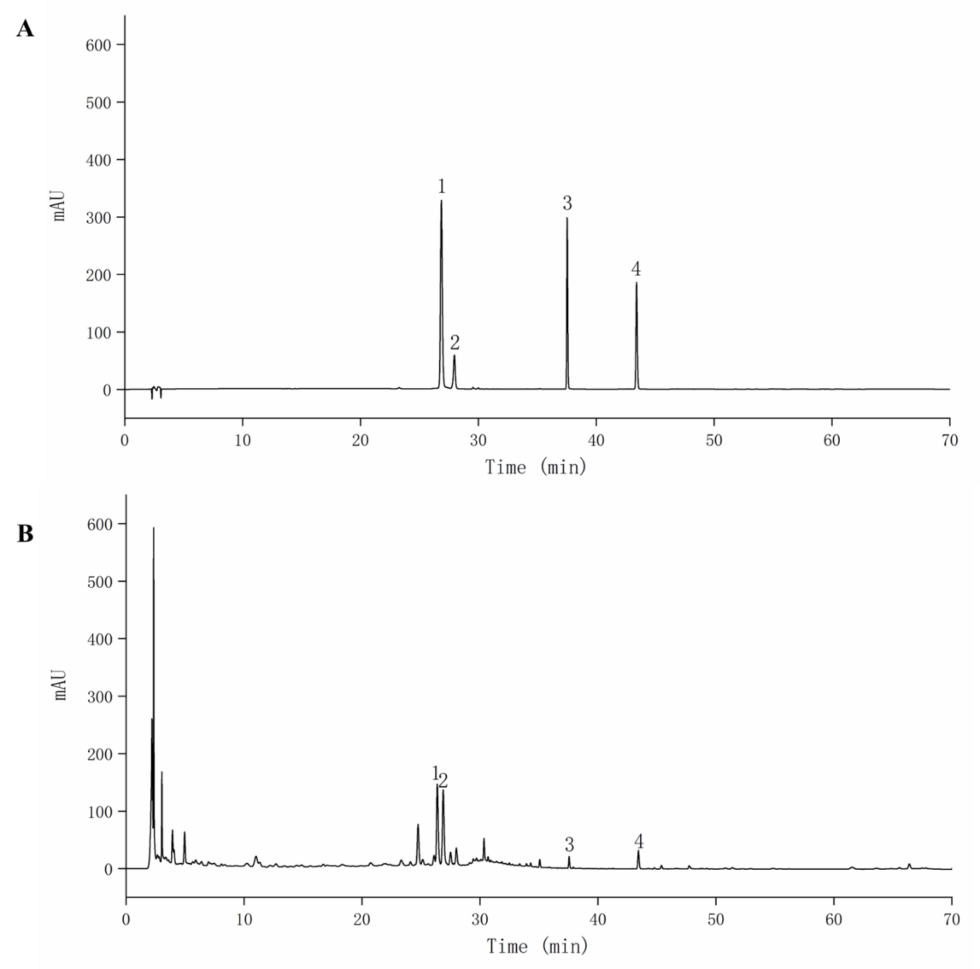

Fig. S1. The multicomponent quantification for quality control of WZYZP by HPLC. (A) HPLC chromatograms of mixed reference solution. 1, hyperoside; 2, verbascoside; 3, kaempferol; 4, schisandrin. (B) HPLC chromatograms of WZYZP solution.

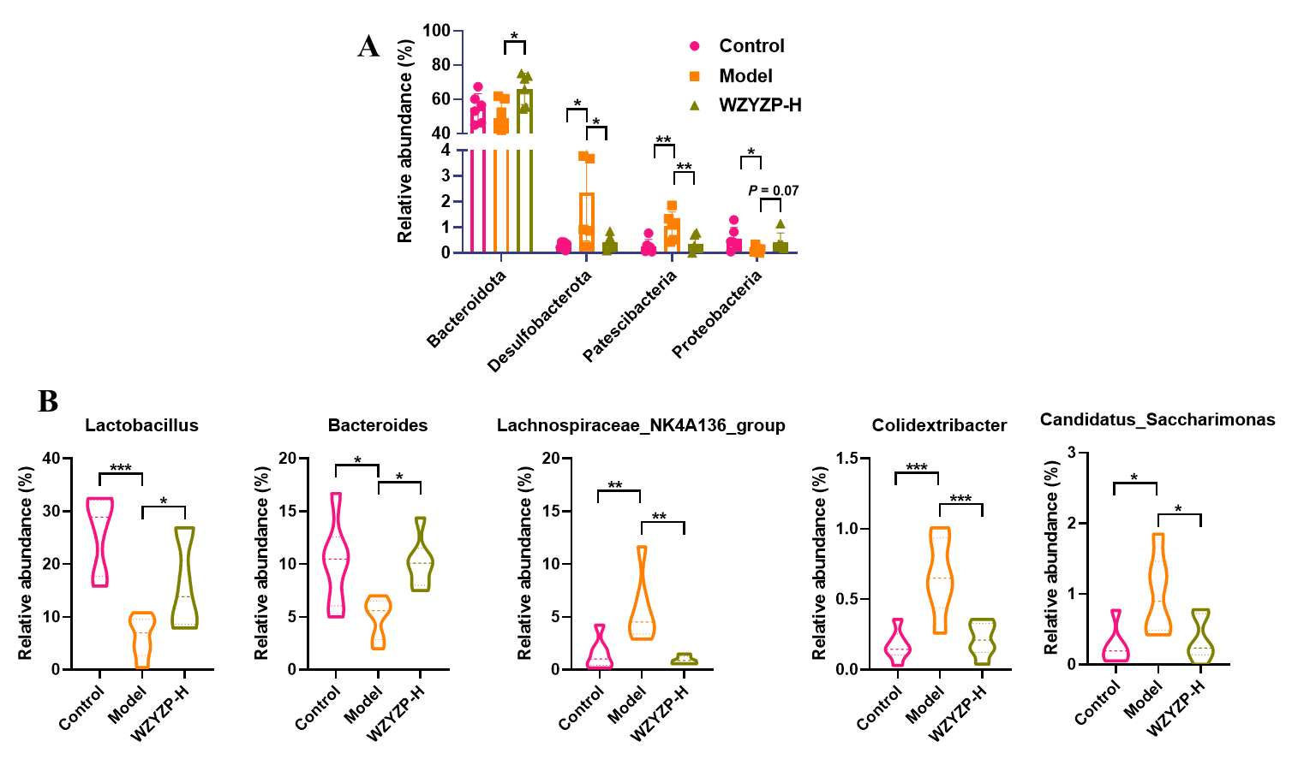

Fig. S2. The effects of WZYZP on gut microbiota. (A) The relative abundance of gut microbiota at phylum level. (B) The relative abundance of gut microbiota at genus level.

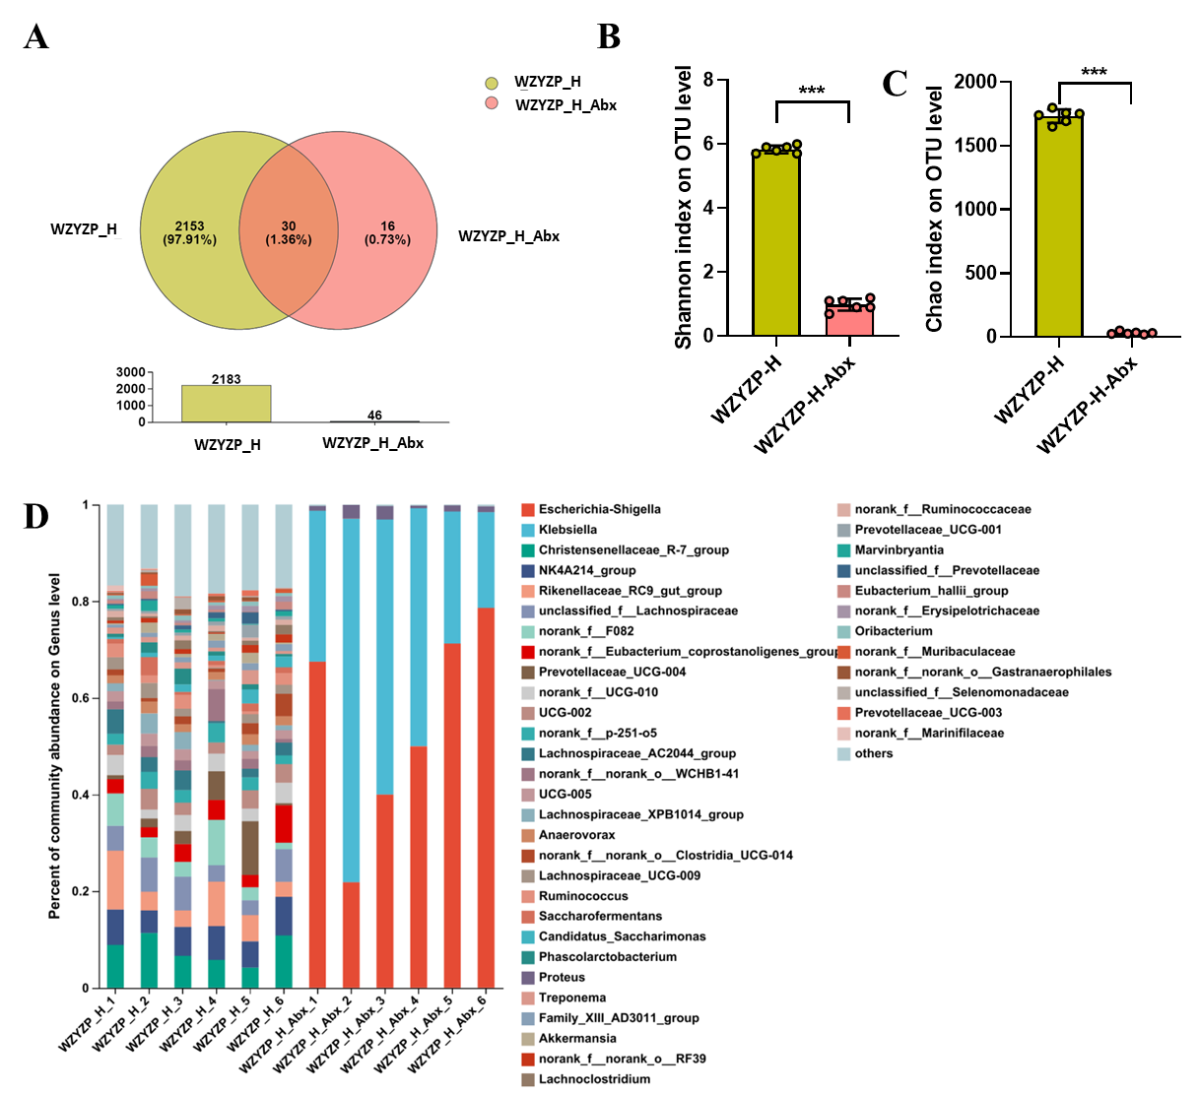

Fig. S3. Antibiotics (Abx) depleted most gut microbiota. (A) Venn diagrams of the number of OUT. (B–C) Microbial alpha diversity expressed as (B) Shannon index and (C) Chao index. (D) The percent of bacteria abundance at the genus level. Data are shown as mean ± SD. \*\*\**P* < 0.001.

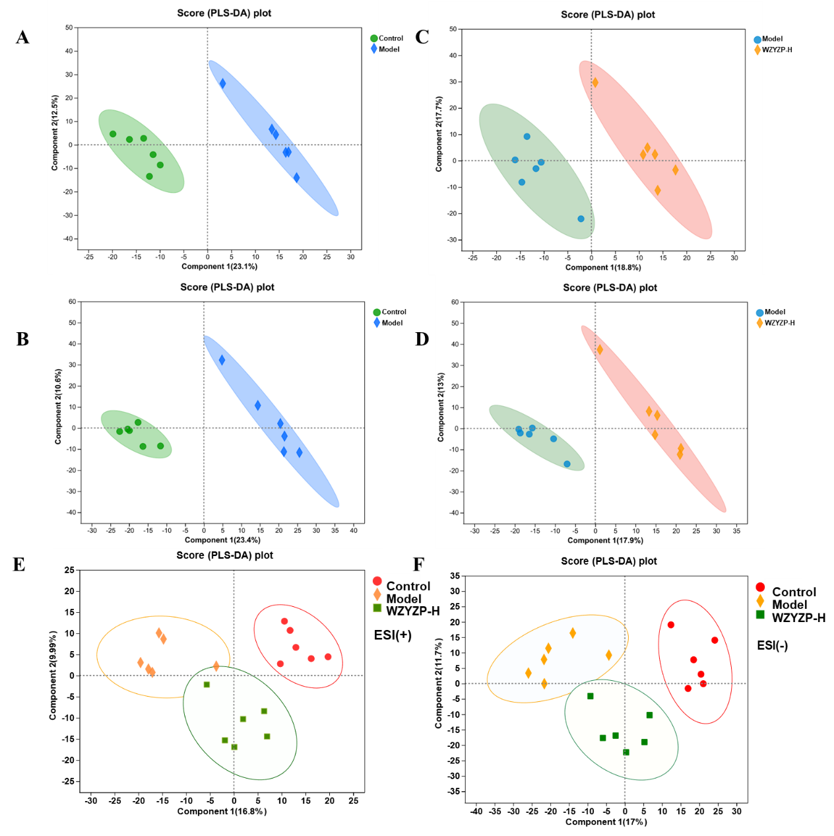

Fig. S4. The effects of WZYZP on the profile of fecal metabolites. The partial least squares discriminant analysis (PLS-DA) scores plots discriminating fecal metabolites: (A) positive ion mode and (B) negative ion mode in control mice and model mice; (C) positive ion mode and (D) negative ion mode in model mice and WZYZP-H mice; (E) positive ion mode and (F) negative ion mode among control mice, model mice, and WZYZP-H mice.