**Supporting Information**

Design highly effective B or N doped mesoporous carbon fibers catalysts for I₃⁻/I⁻ redox couple regeneration in carbon-based dye-sensitized solar cells

Jie Lian, Wenyu Gong, Jianing Guo, Mingxing Wu*

Hebei Key Laboratory of Inorganic Nanomaterials, Hebei Technology Innovation Center for Energy Conversion Materials and Devices, College of Chemistry and Material Science, Hebei Normal University, No. 20 Rd. East of 2nd Ring South, Yuhua District, Shijiazhuang, Hebei, China 050024, E-mail: mingxing.wu@hebtu.edu.cn

*Synthesis*

To prepare the precursor solution, 0.5 g of polyacrylonitrile (PAN) was dissolved in 4.5 mL of N, N-dimethylformamide (DMF) with stirring at room temperature for 3 hours until the solution became colorless. The electrospinning procedure was executed at 18 kV with injection rate of 0.6 mL h-1. The distance between the Al foil collector and the metal needle was maintained at 15 cm. The resultant PAN fiber precursor underwent pre-oxidation at 230°C for 2 h, followed by carbonization at 800°C for 2 h to produce pure Cf. PCf was synthesized using a similar electrospinning method, with the addition of a predetermined quantity of pore-forming agent, SiO2 aerogel (300 μL), to the PAN solution (5 mL). The SiO2 was subsequently etched away using a KOH solution (2 M) for 72 hours to obtain PCf. The boron-doped (BPCf) was obtained by placing the PCf in an autoclave with a boric acid solution (2 M) at 250°C for 24 hours. Nitrogen-doped PCf (NPCf) was synthesized by incorporating SiO2 aerogel (300 μL) as the pore-forming agent and acetamide (0.2 g) as the nitrogen source into the PAN solution (5 mL).

*Device fabrication*

A mesoporous TiO₂ layer, 12 μm thick, was prepared using an 18NR-T TiO₂ paste absorbed with N719 dye to serve as the photoanode. The iodide redox electrolyte consisted of an acetonitrile solution with I₂ (0.03 M), 4-tert-butylpyridine (0.5 M)1-butyl-3-methylimidazolium iodide (0.6 M), LiI (0.06 M), and guanidinium thiocyanate (0.1 M). To prepare the counter electrode, 100 mg of the catalyst (Cf, PCf, BPCf, or NPCf) was dispersed in isopropanol (5 mL) using ultrasonication for 15 min. The resultant suspension was deposited onto FTO glass by spray coating method and then sintered in an N₂ atmosphere at 450 °C for 20 min to form the counter electrode. The DSCs were assembled by enclosing the iodide redox electrolyte using a photoanode and a counter electrode, with an active area of 0.16 cm². For EIS and Tafel polarization curve measurements, symmetrical cells were constructed using two identical counter electrodes sandwiching the iodide redox electrolyte.

*Characterization*

The crystallinity of the synthesized carbon fibers was analyzed using an X-ray diffractometer (D8 ADVANCE, Bruker). Surface and internal morphologies were examined with transmission electron microscopy (TEM, H-7650, HITACHI) and scanning electron microscopy (SEM, S-4800, HITACHI), respectively. The elemental composition and chemical state of the Cf samples were assessed by X-ray photoelectron spectroscopy (XPS, ESCALAB250, Thermo VG) and laser confocal Raman spectroscopy (XploRA PLUS). The pore size distribution and surface area were checked via the N₂ adsorption-desorption method, employing a surface area analyzer (NOVA4000e, Quantachrome). CV measurements were conducted at a three-electrode system with scan rate of 10 mV s-1 on an electrochemical analyzer (CHI660, Chenhua), with the Cf electrode serving as working electrode, Pt foil as auxiliary electrode, and Ag/AgCl as reference electrode. The electrolyte consisted of acetonitrile with LiClO₄ (0.1 M), I₂ (1 mM), and LiI (10 mM). Photocurrent density-voltage (J-V) characteristics of the DSCs were recorded under simulated AM 1.5 solar illumination (PEC-L15, Peccell, Yokohama) using digital source meter (Keithley 2601, Cleveland). Tafel polarization curves and EIS measurements were conducted using symmetrical cells at an electrochemical workstation (PGSTAT302N, AUTOLAB). In EIS, the amplitude of the AC signal was 10 mV over a frequency range from 1 MHz to100 mHz. Tafel polarization curves were performed with a scan rate of 10 mV s-1.

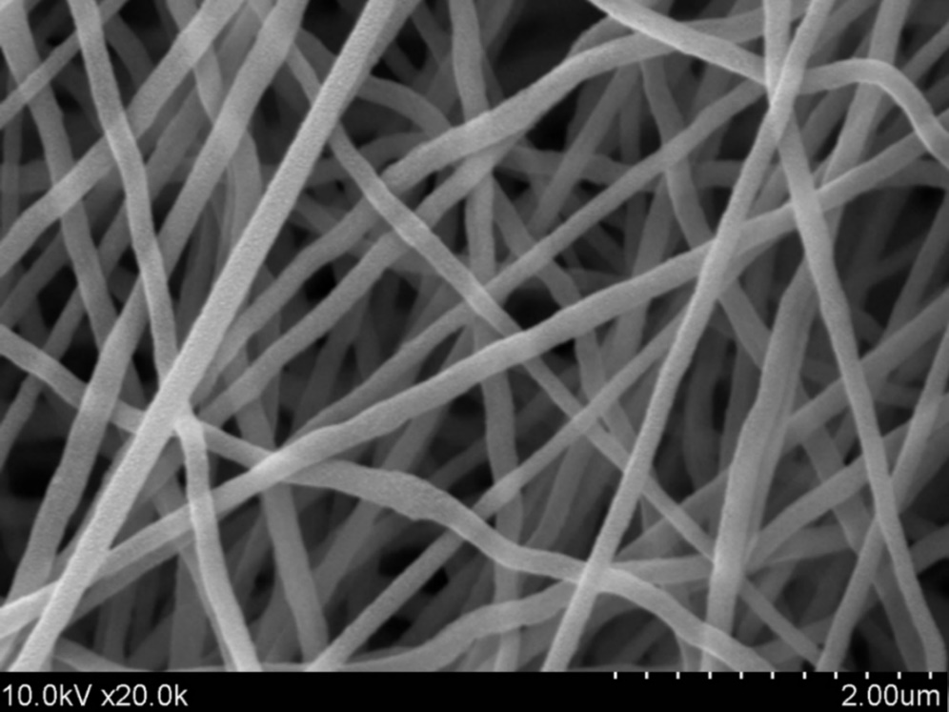

**Fig. S1** SEM image of the carbon fiber (Cf) precursor, polyacrylonitrile (PAN) fiber

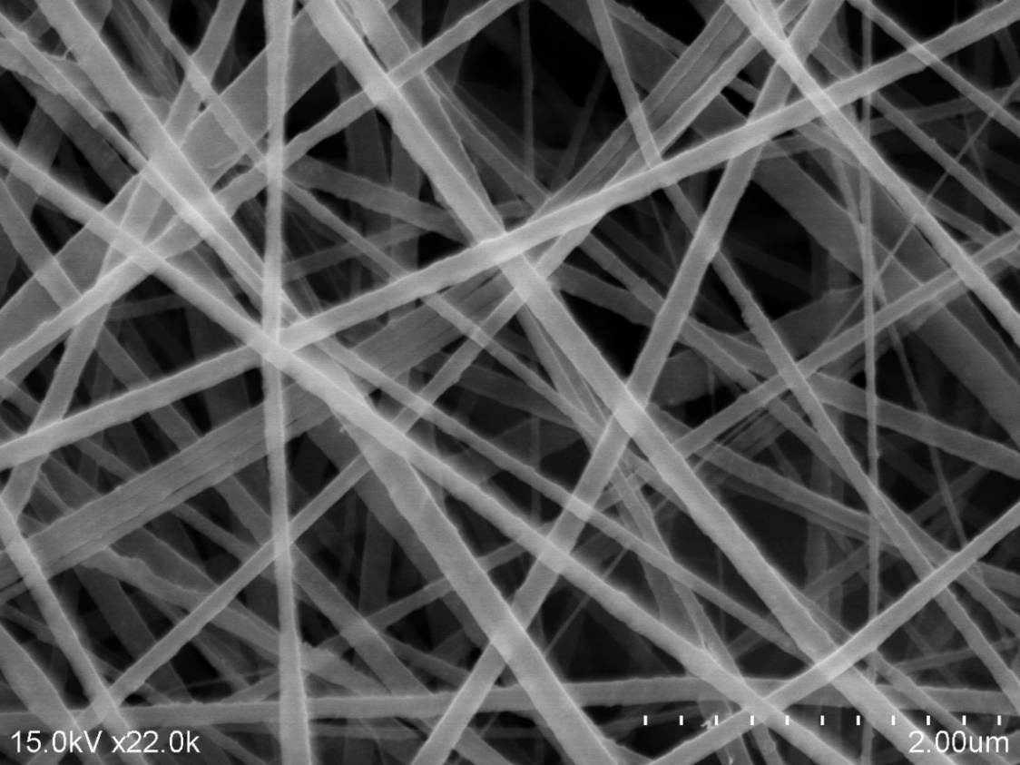

**Fig. S2** SEM image of the mesoporous carbon fiber (PCf) precursor, polyacrylonitrile (PAN) fiber containing pore-making agent of SiO2 aerogel

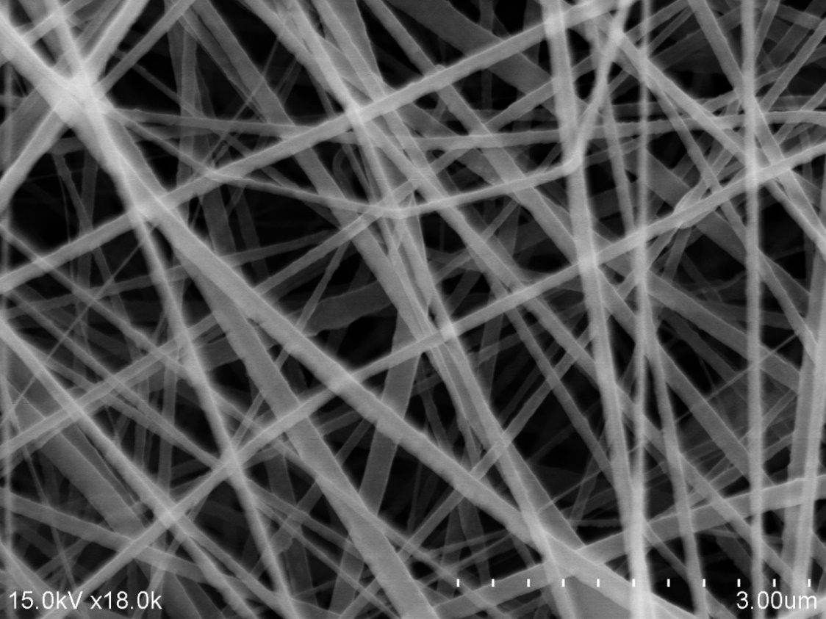

**Fig. S3** SEM image of the boron doped mesoporous carbon fiber (BPCf) precursor, polyacrylonitrile (PAN) fiber containing pore-making agent of SiO2 aerogel

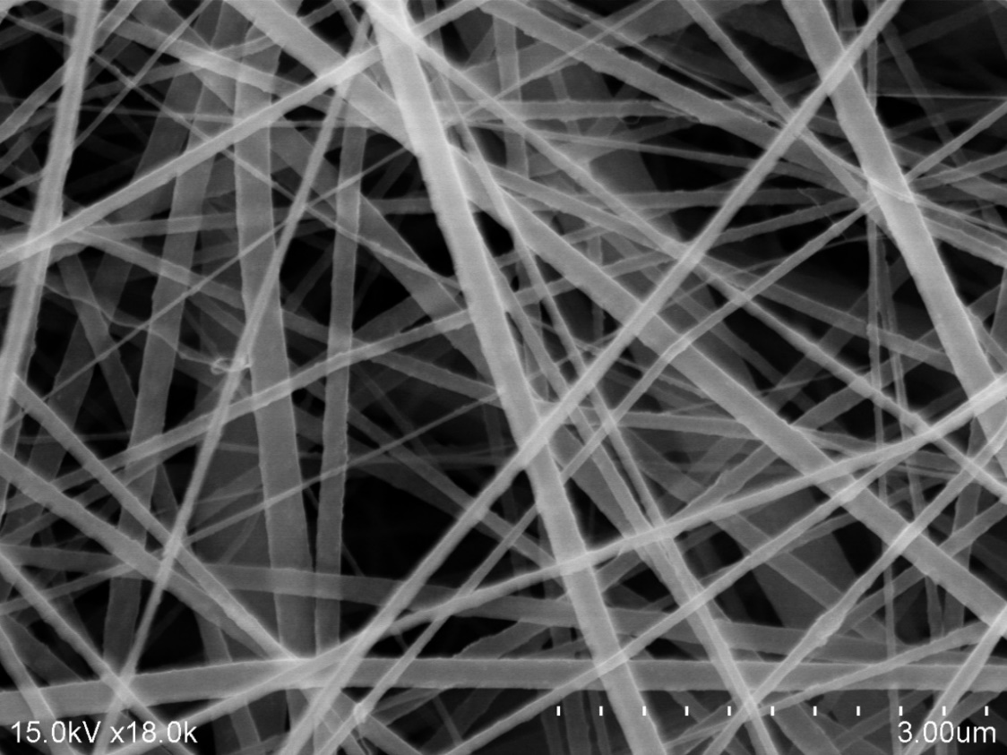

**Fig. S4** SEM image of the nitrogen doped mesoporous carbon fiber (NPCf) precursor, polyacrylonitrile (PAN) fiber containing pore-making agent of SiO2 aerogel and nitrogen source of acetamide



**Fig. S5** XRD patterns of the synthesized carbon fibers



**Fig. S6** Panoramic XPS spectrum for the synthesized boron doped carbon fiber (BPCf)



**Fig. S7** Panoramic XPS spectrum for the synthesized nitrogen doped carbon fiber

(NPCf)



**Fig. S8** The PCE values with error bars of DSCs using different Cf counter electrodes



**Fig. S9** Equivalent circuit diagram used in EIS measurements.



**Fig. S10** Photocurrent density-voltage (J−V) curves of the DSCs using Pt counter electrode.