**Supporting Information**

**Fast** **Fabrication of High-Yield WS2 Nanoscrolls via Ultrasound Sonication**

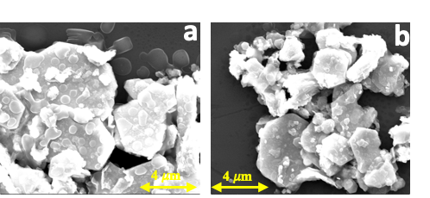

**Figure S1.** SEM images of bulk WS2 **in water** processed under optimized conditions (20 KHz, 2h, 5 mg/mL)

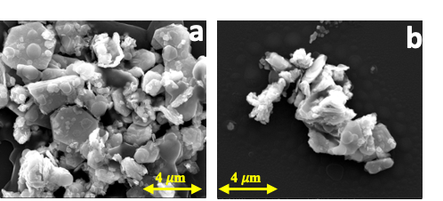

**Figure S2.** SEM images of bulk WS2 **in Ethanol/water (1:1)** processed under optimized conditions (20 KHz, 2h, 5 mg/mL)

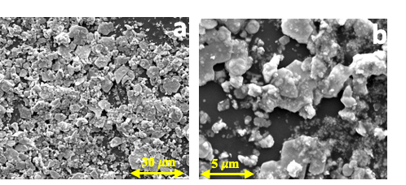

**Figure S3.** SEM images of bulk WS2 **in NMP** processed under optimized conditions (20 KHz, 2h, 5 mg/mL)

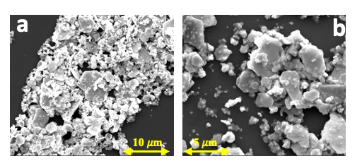

**Figure S4.** SEM images of bulk WS2 **in DMF** in different concentrations processed under optimized conditions with (20 KHz, 2h) at a) 3 mg/mL and b) 10 mg/mL.

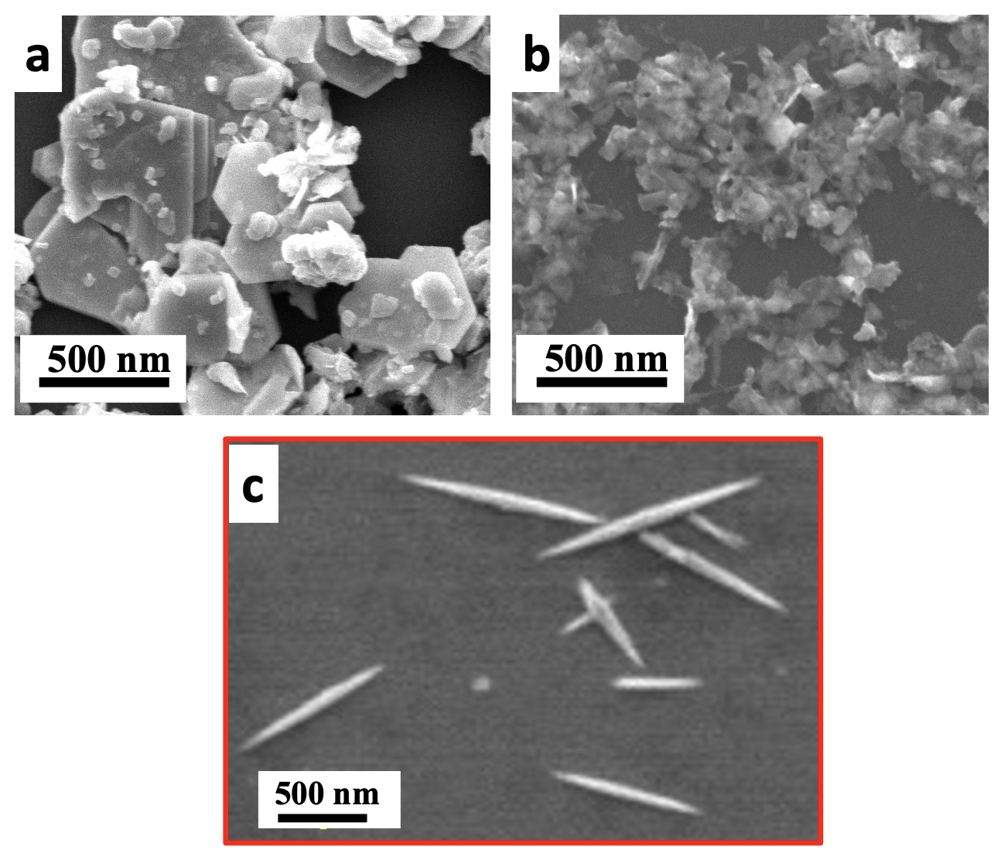

**Figure S5.** SEM images of bulk WS2 **in DMF** processed for different time reaction under optimized conditions with (20 KHz, 5 mg/mL) at a) 30 min, b) 1h and c) 2h (optimum reaction time).

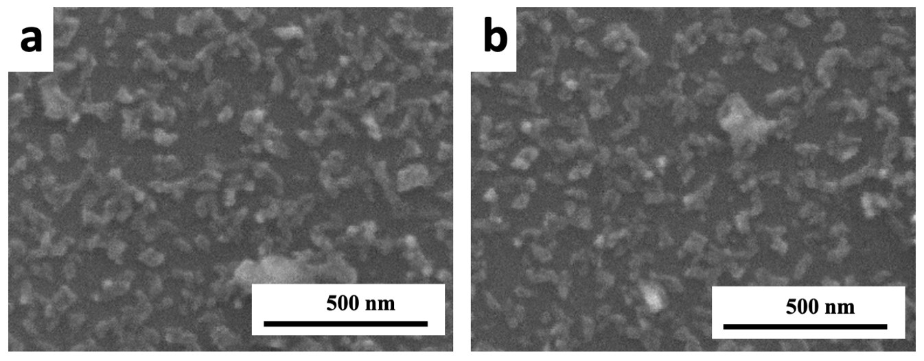

**Figure S6.** (a-b) SEM images of bulk WS2 in DMF processed under optimized conditions with (2h, 5 mg/mL) at high frequency **40 KHz**.