**Valorisation of coal gasification slag and fly ash to mesoporous activated carbon @zeolite socony mobil-5 composite for preconcentration of pharmaceuticals and their removal**

Xoliswa Cingoa,b, c, Azile Nqombolod, Anele Mpupab,e, Luthando Nyabaa, b, Odwa Mapazic, Philiswa Nosizo Nomngongoa, b, *

a Department of Chemical Sciences, University of Johannesburg, Doornfontein Campus, P.O. Box 17011, Doornfontein 2028, South Africa

b Department of Science and Innovation-National Research Foundation South African Research Chair Initiation (DSI-NRF SARChI) in Nanotechnology for Water, University of Johannesburg, Doornfontein 2028, South Africa.

c Analytical Chemistry Division, Mintek, 200 Malibongwe Drive, Randburg 2194, South Africa

d Department of Chemistry, University of Fort Hare, Alice 5700, South Africa

e Agricultural Research Council-Vegetable, Industrial and Medicinal Plants (ARC-VIMP), Roodeplaat, Pretoria 0001, South Africa

* Corresponding author. Department of Chemical Sciences, University of Johannesburg, Doornfontein Campus, P.O. Box 17011, Doornfontein, 2028, South Africa. E-mail address: pnnomngongo@uj.ac.za (P.N. Nomngongo).

Supplementary data



**Fig. S1:** Recovery of residual carbon



**Fig. S2:** N2 adsorption/desorption isotherm plotsfor CFA, CGS, ZSM-5, MAC and MAC@ZSM-5 composite



**Fig. S3**: Selection of suitable elution solvent for preconcentration of aspirin (ASP), ibuprofen (IBP), and paracetamol (PCT) Experimental conditions: sample volume, 5 mL eluent volume: 1000 µL, extraction time 30 min, mass of adsorbent 50 mg, elution time 5 min, sample pH 6.5

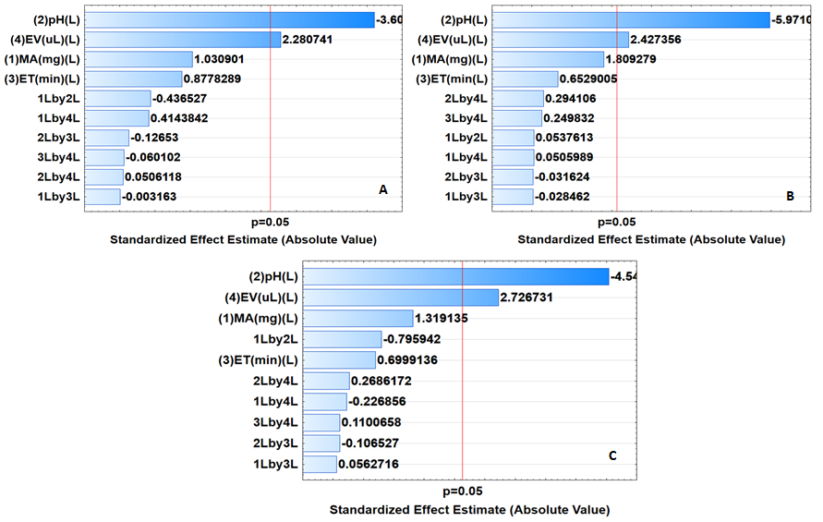

**Fig. S4**: Pareto charts of standardized effects for the extraction and preconcentration of (A)-ASP, -(B) PCT, and (C) IBP. (1L) MA: Mass of adsorbent, (2 L) pH: sample pH, (3 L) ET: extraction and (4 L) EV: eluent volume, 1L by 2L: MA-pH interaction, 1L by 3L: MA-ET interaction, 2L by 3L: pH -ET interaction, 1L by 4 L: MA-EV interaction, 2L by 4L: pH-EV interaction.

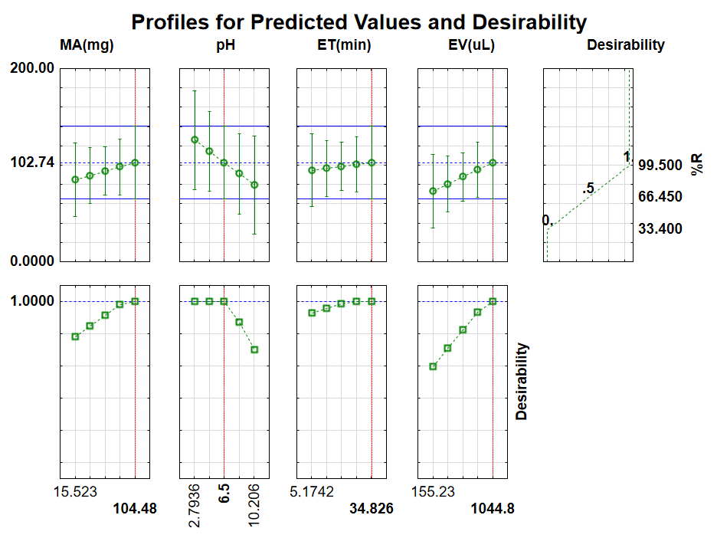

**Fig. S5**: Profiles for predicted values and desirability

**Fig. S6**: Experimental adsorption isotherms of ASP (A), IBP (B), and PCT (C).

**A**

ASP

PCT

IBP

**B**

**Fig.S7**. Typical Chromatogram for specificity (A) standard (10 µg/L) and (B) river water sample



**Fig. S8:** Intraparticle diffusion model graph of PCT (A), IBP (B) and ASP (C)



**Fig. S9**: Regeneration of MAC@ZSM-5 using an initial concentration of (40 µg/L) (n=3) at pH 6.5, sorbent mass 104.48 mg, extraction time 20 min and desorption volume of 1044.8 µL.



Fig. S10 XRD patterns of the spent adsorbent in comparison to the adsorbent before adsoption.

Table S1: Flotation procedure

|  |  |  |  |  |
| --- | --- | --- | --- | --- |
| Test 1 | MIBC (1%) |  |  |  |
| Operation | (g/t) | (mL) | Condit time  (min) | Float time  (min) |
| Conditioning-1 | 200 | 4 | 1 |  |
| Float RC-1 |  |  |  | 5 |
| Conditioning-2 | 50 | 1 | 1 |  |
| Float RC-2 |  |  |  | 5 |
| Conditioning -3 | 50 | 1 | 1 |  |
| Float RC-3 |  |  |  | 5 |
| Total | 300 | 6 |  | 15 |
| Test 2 |  |  |  |  |
| Operation | MIBC (1%)  (g/t) (ml) | Diesel (100%)  (g/t) (µL) | Cond time  (min) | Float time  (min) |
| No of reagents |  |  |  |  |
| Conditioning-1 | 100 2 | 50 11 | 1 |  |
| Float RC-1 |  |  |  | 5 |
| Conditioning -2 | 50 1 | 50 11 | 1 |  |
| Float RC-2 |  |  |  | 5 |
| Conditioning-3 | 50 1 | 50 11 | 1 |  |
| Float RC-3 |  |  |  | 5 |
| Total | 200 4 | 150 |  | 15 |
| Test 3 | MIBC (1%)  (g/t) (ml) | Diesel (100%)  (g/t) (µL) | Condit time  (min) | Float time  (min) |
| Operation |  |  |  |  |
| No of reagents |  |  |  |  |
| Conditioning-1 | 100 2 | 100 22 | 1 |  |
| Float-RC-1 |  |  |  | 5 |
| Conditioning-2 | 50 1 | 100 22 | 1 |  |
| Float RC-2 |  |  |  | 5 |
| Conditioning-3 | 50 1 | 100 22 | 1 |  |
| Float-RC-3 |  |  |  | 5 |
| Total | 200 4 | 300 |  | 15 |
| Test 4 | MIBC (1%)  (g/t) (ml) | Paraffin (100%)  (g/t) (µL) | Condit time  (min) | Float time  (min) |
| Operation |  |  |  |  |
| No of reagents |  |  |  |  |
| Conditioning-1 | 100 2 | 50 11 | 1 |  |
| Float-RC-1 |  |  |  | 5 |
| Conditioning-2 | 50 1 | 50 11 | 1 |  |
| Float-RC-2 |  |  |  | 5 |
| Conditioning-3 | 50 1 | 50 11 | 1 |  |
| Float-RC-3 |  |  |  | 5 |
| Total | 200 4 | 150 |  | 15 |
|  |  |  |  |  |

Table S2: Determination of CFA and CGS composition using XRF analysis

|  |  |  |
| --- | --- | --- |
| Minerals | Coal fly ash composition (%) | Coal gasification slag composition (%) |
| SiO2 | 59.9 | 64.1 |
| Al2O3 | 32.2 | 29.2 |
| Fe2O3 | 4.45 | 4.98 |
| CaO | 6.07 | 6.53 |
| MgO | 1.49 | 0.971 |
| P2O5 | 0.345 | 0.531 |
| SO3 | 0.515 | 0.854 |
| LOI | 8.8 | 31.4 |

Table S3: Proximate and ultimate analysis of CGS and CFA

|  |  |  |
| --- | --- | --- |
|  | Coal fly ash | Coal gasification slag |
|  | Weight (%) | Weight (%) |
| Moisture | 4.68 | 2.39 |
| Ash | 18.9 | 33.5 |
| Volatiles | 23.5 | 21.9 |
| Fixed carbon | 52.9 | 42.2 |
| C | 8.8 | 31.4 |
| N | 0.69 | 0.36 |
| O | 6.12 | 8.71 |
| S | 0.98 | 0.31 |

Table S4: Central composite design matrix and respective analytical response

|  |  |  |  |  |  |  |  |
| --- | --- | --- | --- | --- | --- | --- | --- |
| **Standard run** | **MA(mg)** | **pH** | **ET(min** | **EV(uL)** | **ASP** | **IBP** | **PCT** |
| 1 | 30 | 4 | 10 | 300 | 83.8±2.1 | 82.9±2.2 | 81.6±2.4 |
| 2 | 30 | 4 | 10 | 900 | 88.2±2.3 | 88.7±1.9 | 86.5±2.3 |
| 3 | 30 | 4 | 30 | 300 | 87.9±1.9 | 81.4±2.1 | 79.6±1.9 |
| 4 | 30 | 4 | 30 | 900 | 94.1±1.8 | 90.1±1.5 | 91.9±1.7 |
| 5 | 30 | 9 | 10 | 300 | 62.5±1.5 | 38.3±2.2 | 5.1±2.6 |
| 6 | 30 | 9 | 10 | 900 | 69.8±2.3 | 43.9±2.2 | 69.7±1.9 |
| 7 | 30 | 9 | 30 | 300 | 66.6±2.5 | 35.6±3.1 | 55.8±1.6 |
| 8 | 30 | 9 | 30 | 900 | 68.6±2.1 | 52.6±2.7 | 70.9±2.3 |
| 9 | 90 | 4 | 10 | 300 | 85.1±1.4 | 87.8±1.3 | 88.3±1.7 |
| 10 | 90 | 4 | 10 | 900 | 96.6±1.5 | 98.1±q.7 | 97.5±1.3 |
| 11 | 90 | 4 | 30 | 300 | 89.6±1.4 | 93.7±1.6 | 92.9±1.8 |
| 12 | 90 | 4 | 30 | 900 | 98.9±1.7 | 98.3±1.6 | 99.4±2.0 |
| 13 | 90 | 9 | 10 | 300 | 56.7±2.3 | 48.1±2.8 | 56.4±2.4 |
| 14 | 90 | 9 | 10 | 900 | 68.4±2.2 | 57.2±2.5 | 65.1±2.4 |
| 15 | 90 | 9 | 30 | 300 | 58.7±1.9 | 43.5±2.3 | 56.9±2.4 |
| 16 | 90 | 9 | 30 | 900 | 72.3±3.1 | 59.8±3.2 | 66.6±2.8 |
| 17 | 16 | 7 | 20 | 600 | 53.1±1.6 | 61.3±1.9 | 63.7±1.6 |
| 18 | 104 | 7 | 20 | 600 | 99.5±1.4 | 99.2±1.3 | 98.9±1.5 |
| 19 | 60 | 2.79 | 20 | 600 | 82.2±2.1 | 91.6±2.0 | 89.7±1.8 |
| 20 | 60 | 10 | 20 | 600 | 43.9±2.5 | 34.7±2.3 | 43.4±2.6 |
| 21 | 60 | 7 | 5.2 | 600 | 73.9±1.8 | 73.6±1.5 | 77.4±1.4 |
| 22 | 60 | 7 | 35 | 600 | 98.9±1.8 | 98.3±1.6 | 98.2±1.4 |
| 23 | 60 | 7 | 20 | 155 | 33.4±2.5 | 35.1±2.6 | 36.9±2.4 |
| 24 | 60 | 7 | 20 | 1045 | 98.7±1.9 | 99.8±1.6 | 99.6±1.5 |
| 25 (C) | 60 | 7 | 20 | 600 | 97.5±2.3 | 98.4±1.8 | 98.6±1.7 |
| 26 (C) | 60 | 7 | 20 | 600 | 97.9±1.9 | 97.9±1.6 | 99.1±1.6 |