**Supplemental Materials**

**Investigating** **the preparation process of excellent Cu3VSe4 absorption layer prepared by** **amine-thiol system**

Yanqing Liua,c, Yanchun Yanga,b,c*, Junting Rena,c, Guonan Cuia,c, Xin Zhaoa,c, Rui Wanga,c, Lulu Baia,c, and Chengjun Zhub*

aSchool of Physics and Electronic Information, Inner Mongolia Key Laboratory for Physics and Chemistry of Functional Materials, Inner Mongolia Normal University, 81 Zhaowuda Road, Huhhot, Inner Mongolia, 010022, China

bSchool of Physical Science and Technology, Inner Mongolia University, 2352 West University Road, Huhhot, Inner Mongolia, 010021, China

cInner Mongolia Autonomous Region Engineering Research Center for Rare Earth Functions and New Energy Storage Materials, Inner Mongolia Normal University, 81 Zhaowuda Road, Huhhot, Inner Mongolia, 010022, China

*Corresponding authors

E-mail: [20170020@imnu.edu.c](mailto:20170020@imnu.educ)n (Y. Yang); cjzhu@imu.edu.cn (C. Zhu)



Figure S1. XRD pattern of as-deposited Cu3VSe4 thin films.

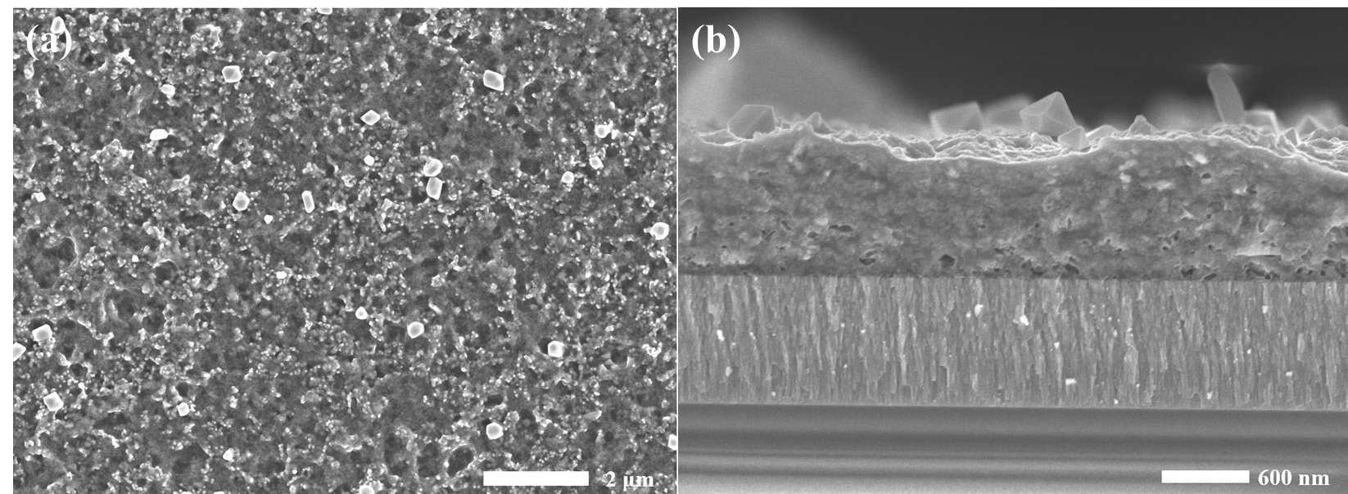

Figure S2. (a) Surface and (b) cross-sectional images of as-deposited Cu3VSe4 thin films.

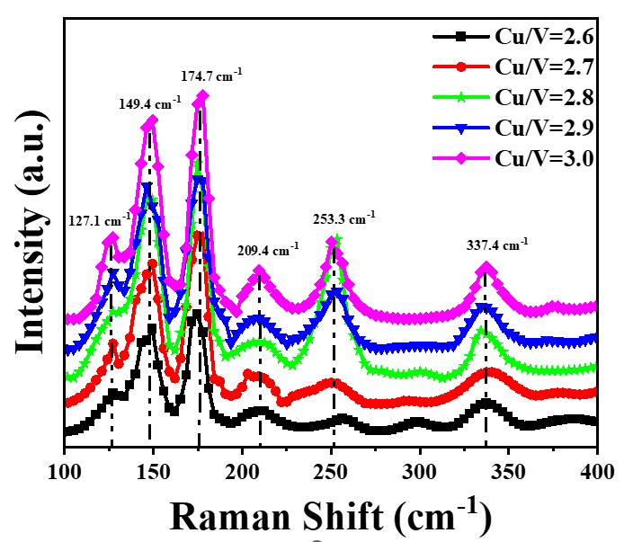Figure S3. Raman spectra of the selenized Cu3VSe4 films with the various Cu/V ratios.



Figure S4. Top view and cross-sectional SEM images of the selenized Cu3VSe4 films with the various Cu/V ratios. (a, a-1) 2.7, (b, b-1) 2.75, (c, c-1) 2.8, (d, d-1) 2.85.

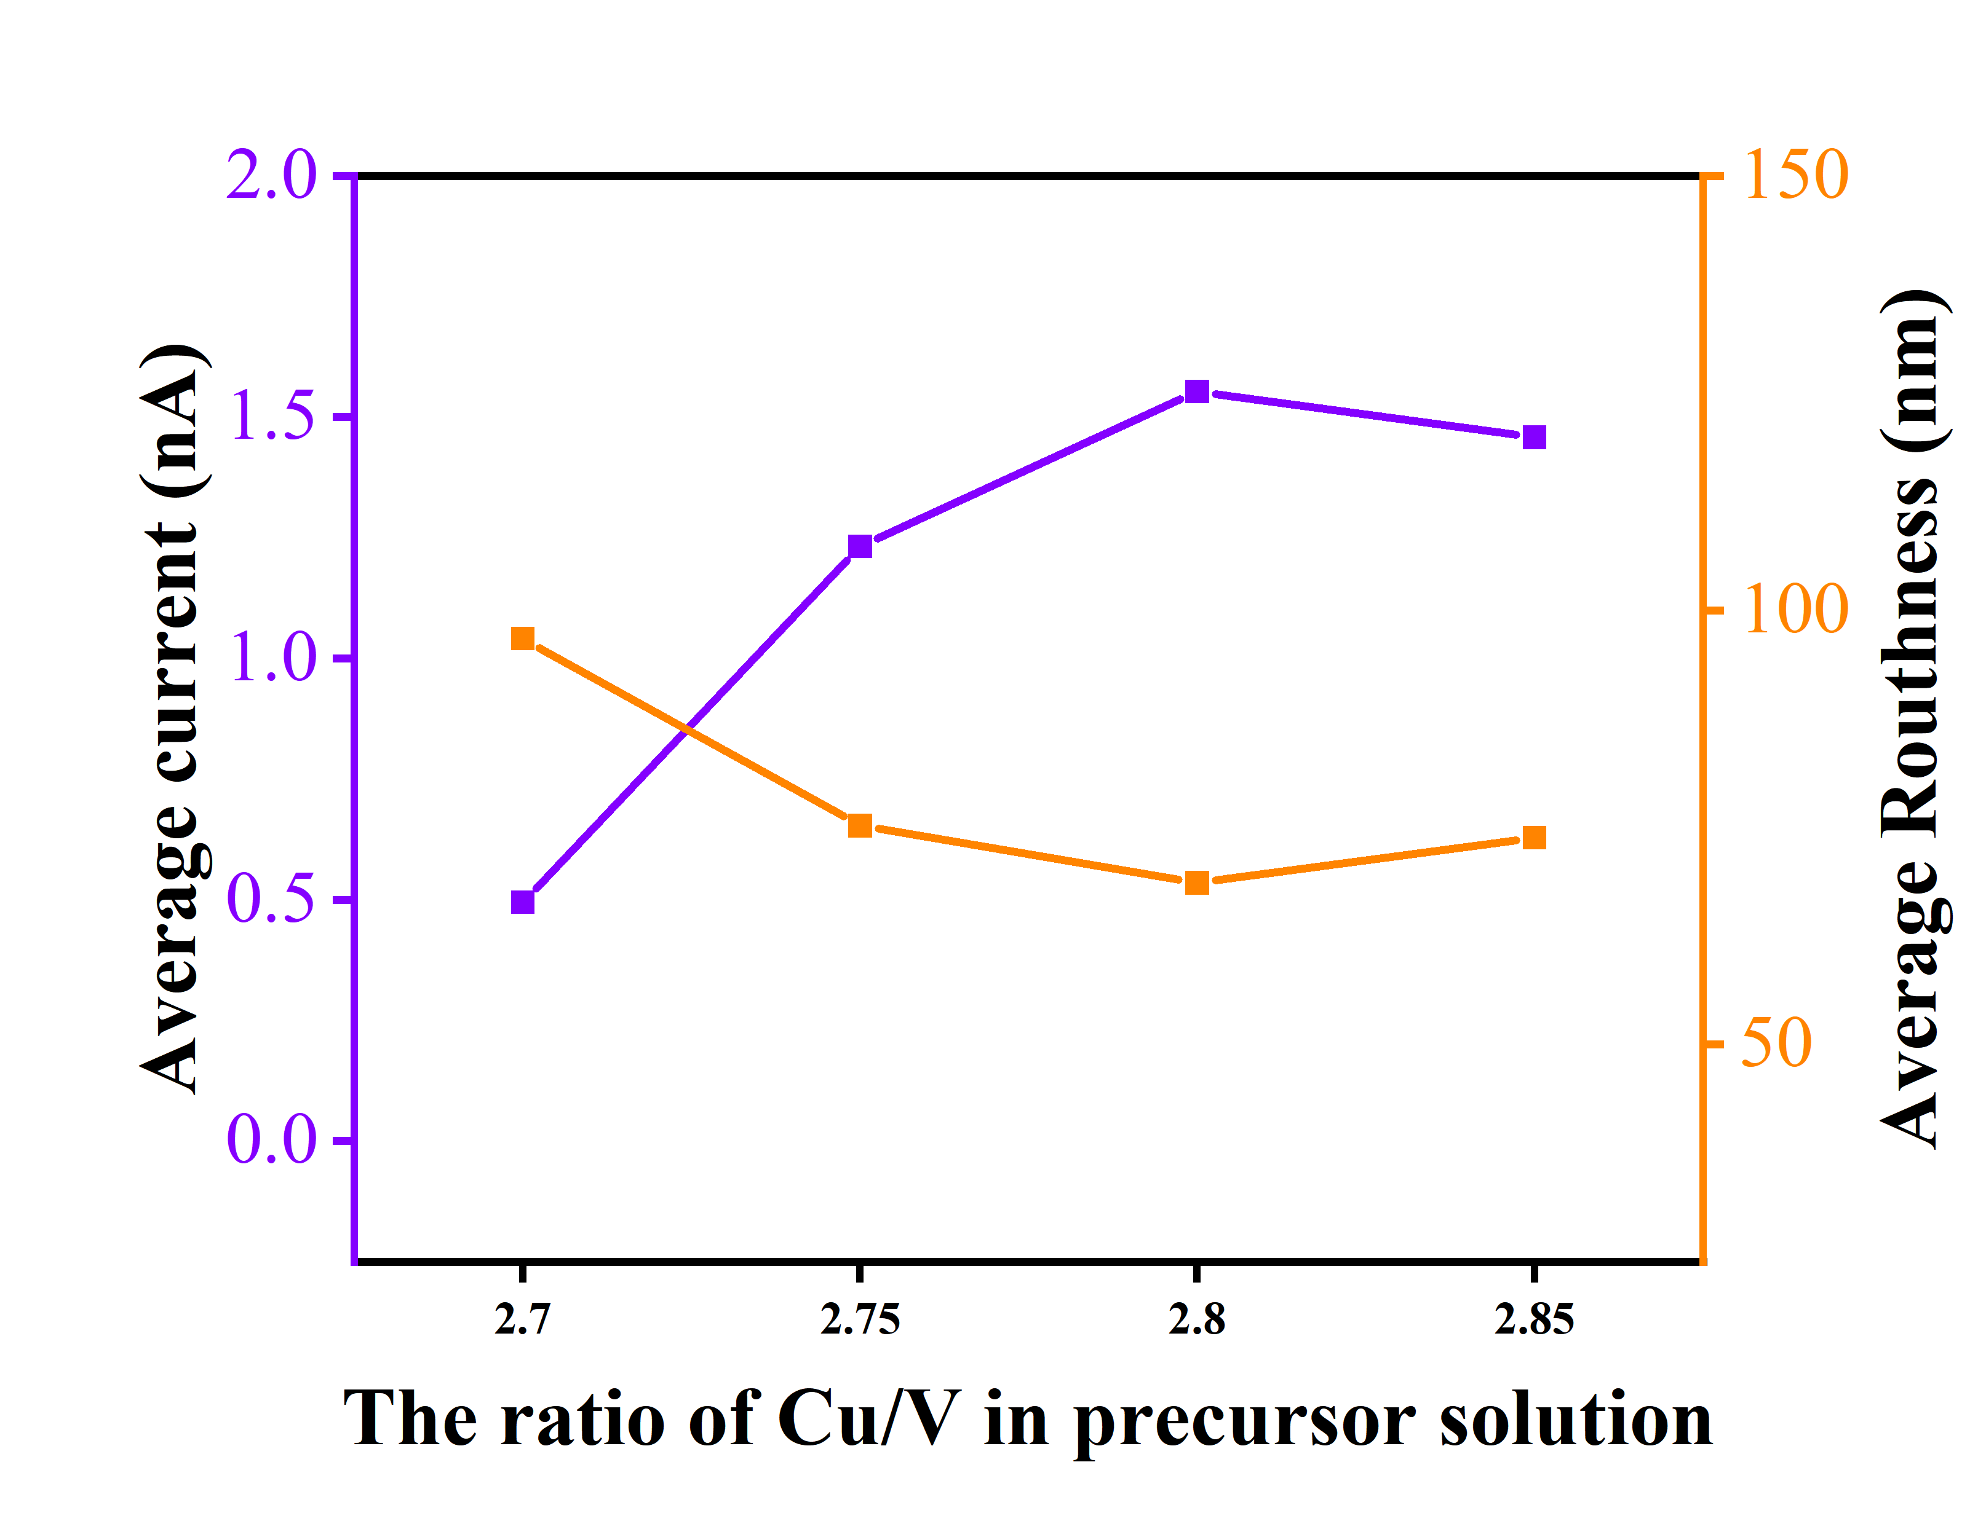

Figure S5. The average surface current and roughness of the selenized Cu3VSe4 films with the various Cu/V ratios.

Table S1 Half-high width of Cu2.8VSe4 films with the different temperatures of HT process.

|  |  |  |  |  |
| --- | --- | --- | --- | --- |
| two-step selenization process | 400-10-550-30 | 400-10-560-30 | 400-10-570-30 | 400-10-580-30 |
| half-high width | 0.15214 | 0.17599 | 0.11813 | 0.13112 |

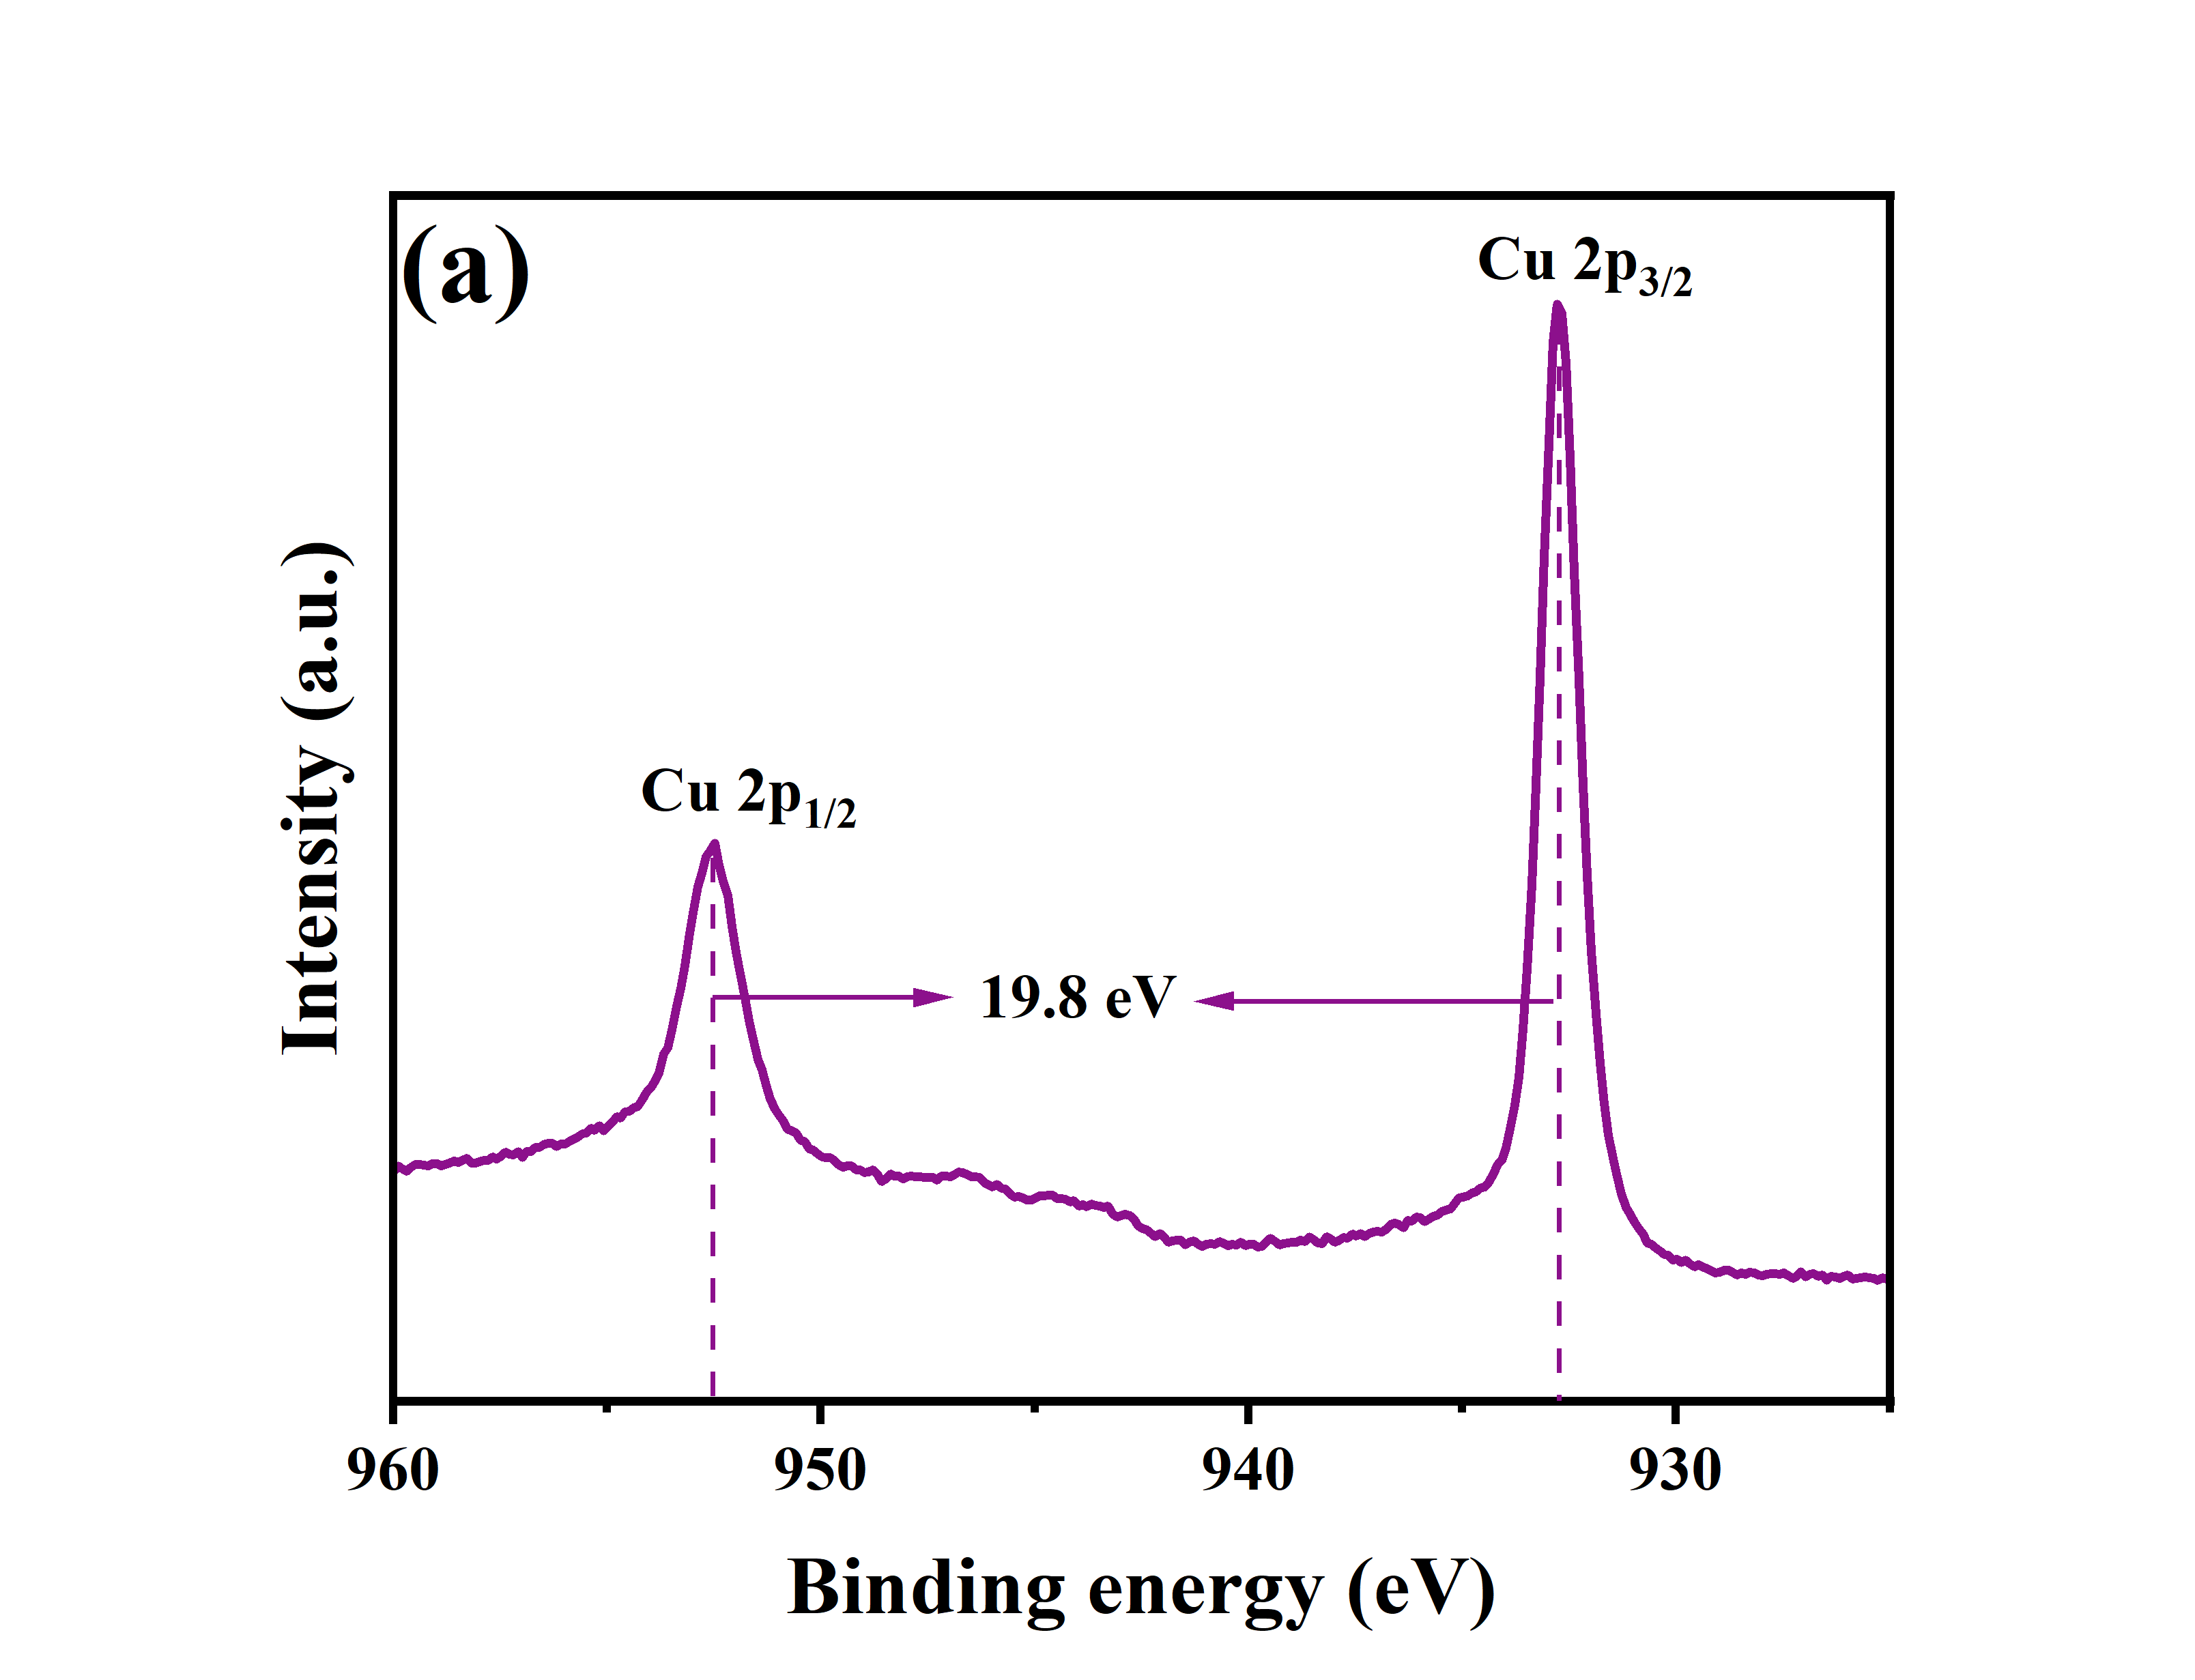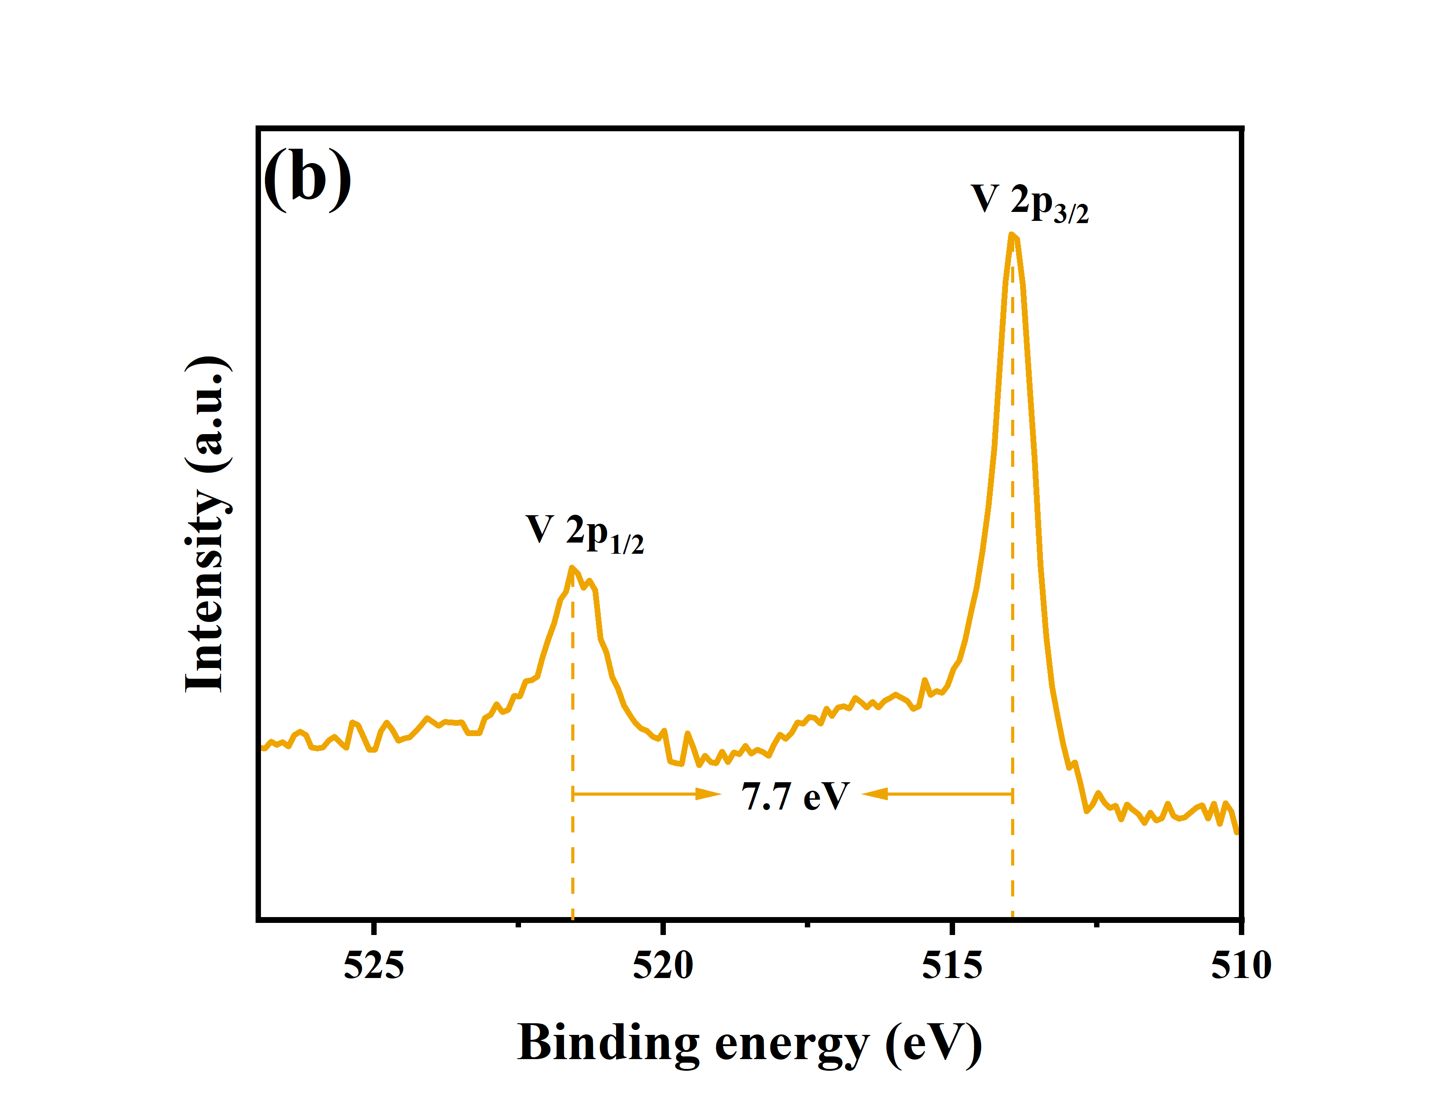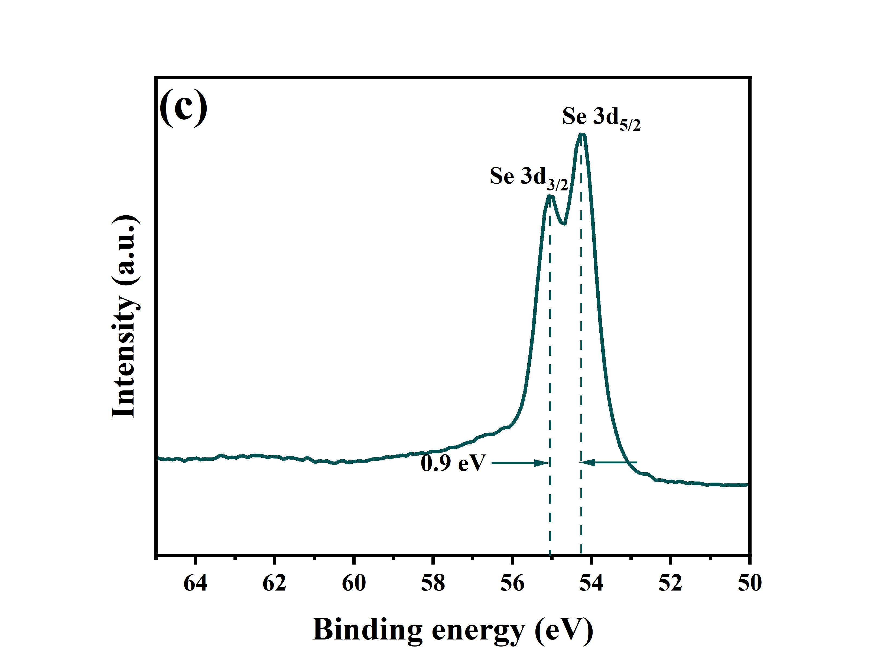

Figure S6. XPS spectra of the best sample. (a) Cu, (b) V, (c) Se.