LED-driven photodeposition of Pt nanoparticles on TiO₂: combined effects of titania crystallinity and adopted wavelength on photoactivity
Adam Kubiak^{a*}, Maria Vittoria Dozzi^{b}, Marco Montalbano^{b}, Michał Cegłowskiª
ªAdam Mickiewicz University, Poznan, Faculty of Chemistry, Uniwersytetu Poznanskiego 8, PL-61614 Poznan, Poland
^{b}Dipartimento di Chimica, Università degli Studi di Milano, via C. Golgi 19, I-20133 Milano, Italy
*Corresponding author: adam.kubiak@amu.edu.pl; Tel.: +48 61 829 18 48

Synthesis of amorphous TiO₂
The synthesis of amorphous TiO₂ was carried out using the sol-gel method. Initially, a reactor equipped with a T25 Basic high-speed stirrer (IKA Werke GmbH, Staufen im Breisgau, Germany) was filled with a mixture of TTIP in IPA. The mixture was stirred at 1000 rpm. Subsequently, a hydrolysis promoter, consisting of ammonia and deionized water in a 1:3 volume ratio, was added at a constant rate of 1 cm³/min. The colloidal suspension was then mixed for 1 hour, after which the resulting alcogel was dried at 120 °C for 24 hours. To remove impurities, the white precipitate was washed several times with deionized water. Finally, the powder was dried at 80 °C for 3 hours.

Wavelength ranges for UVA, UVB, and UVC
In this study, we analyzed the impact of different wavelength ranges on the photodeposition of platinum nanoparticles on TiO₂. The ultraviolet (UV) radiation wavelength ranges are as follows:
- UVA (Ultraviolet A): 320–400 nm
- UVB (Ultraviolet B): 280–320 nm
- UVC (Ultraviolet C): 100–280 nm
Monochromatic LED light with maximum emission at 280 nm, 315 nm, 365 nm, 450 nm, 550 nm, and 650 nm was used for photodeposition. These ranges cover UVC (280 nm), UVB (315 nm), UVA (365 nm), and visible light (450 nm, 550 nm, 650 nm).

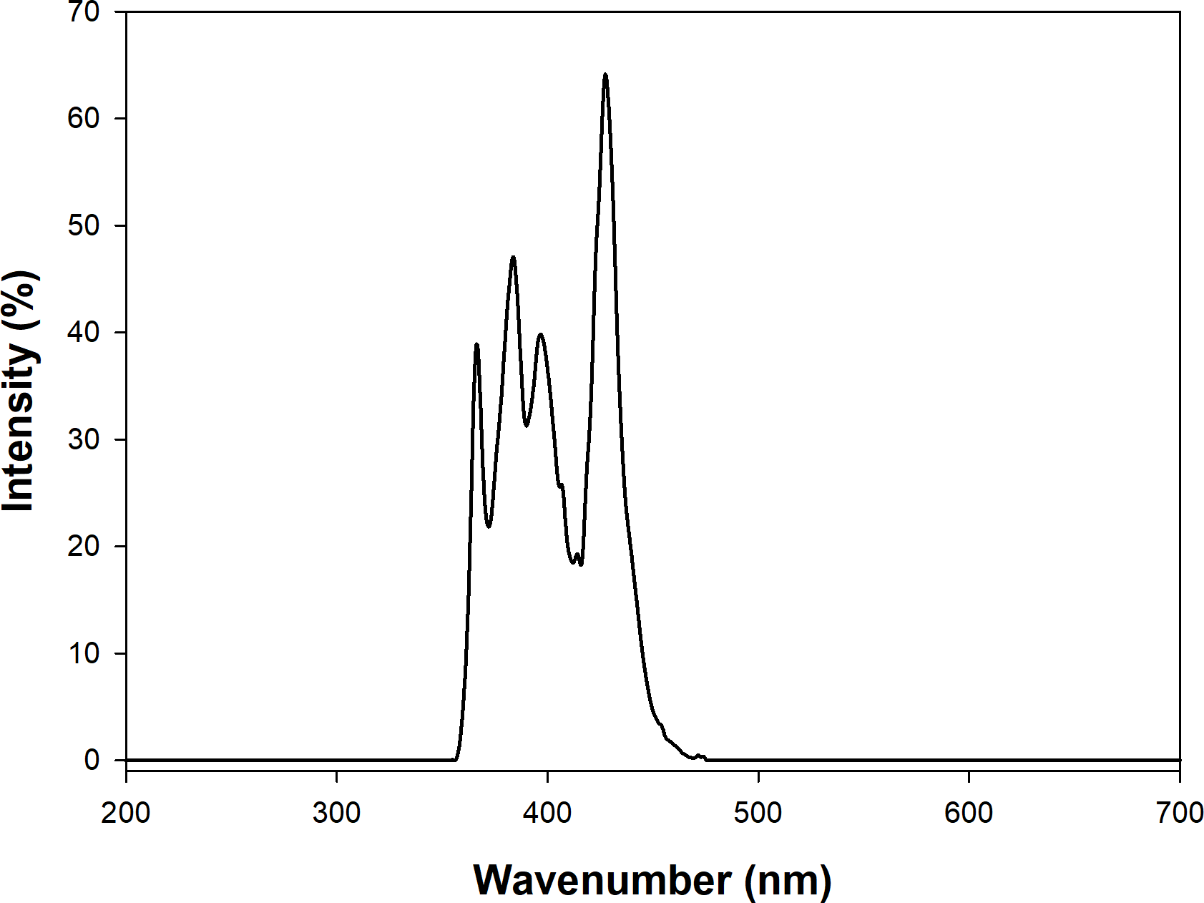
Fig. S1. Emission spectrum of the tailor-made LED light source employed for the Naproxen photo-oxidation tests.
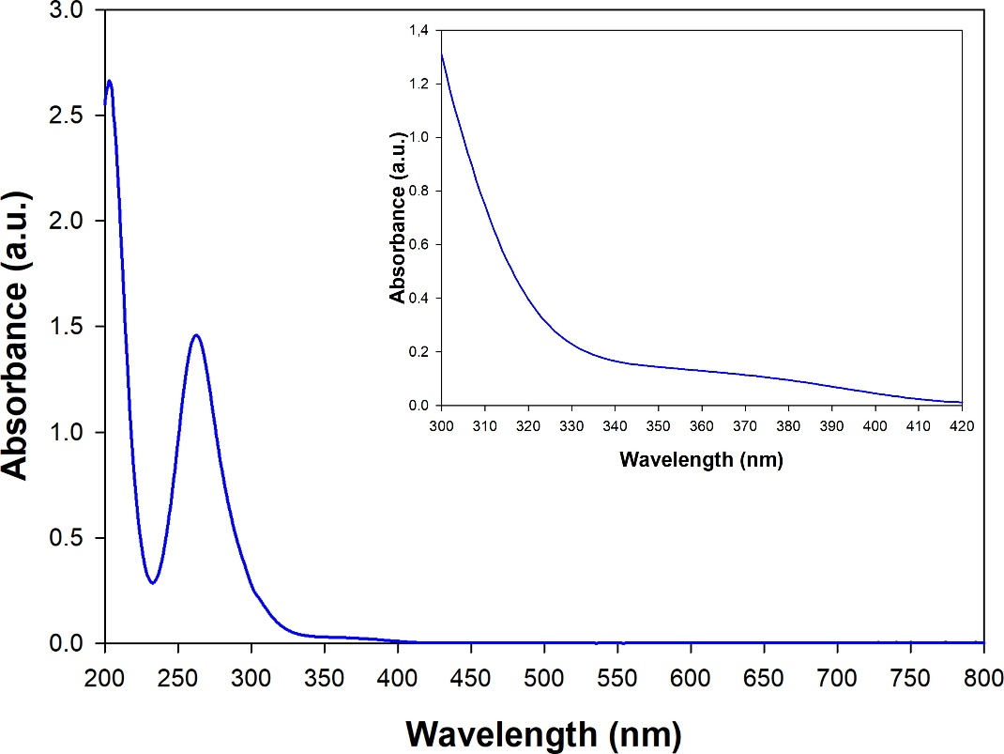
Figure S2. Absorption spectrum of platinum precursors at a concentration of 1 g/L in 50% methanol. The inset shows the 300-420 nm spectrum of the precursor at a concentration of 100 g/L in 50% methanol to better visualize the edge of the precursor absorption band.

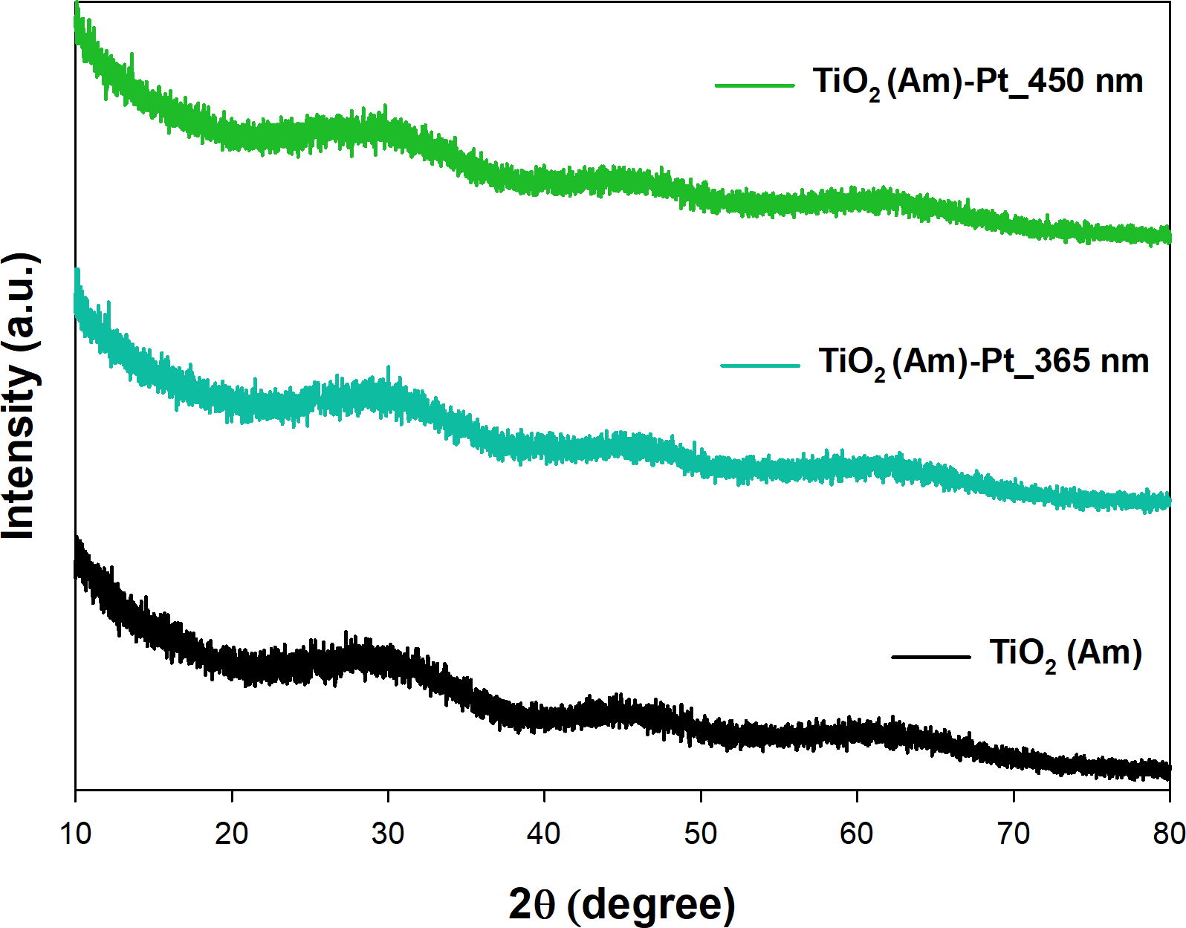
Fig. S3. XRD patterns of TiO₂(Am)-Pt_Xnm series samples.
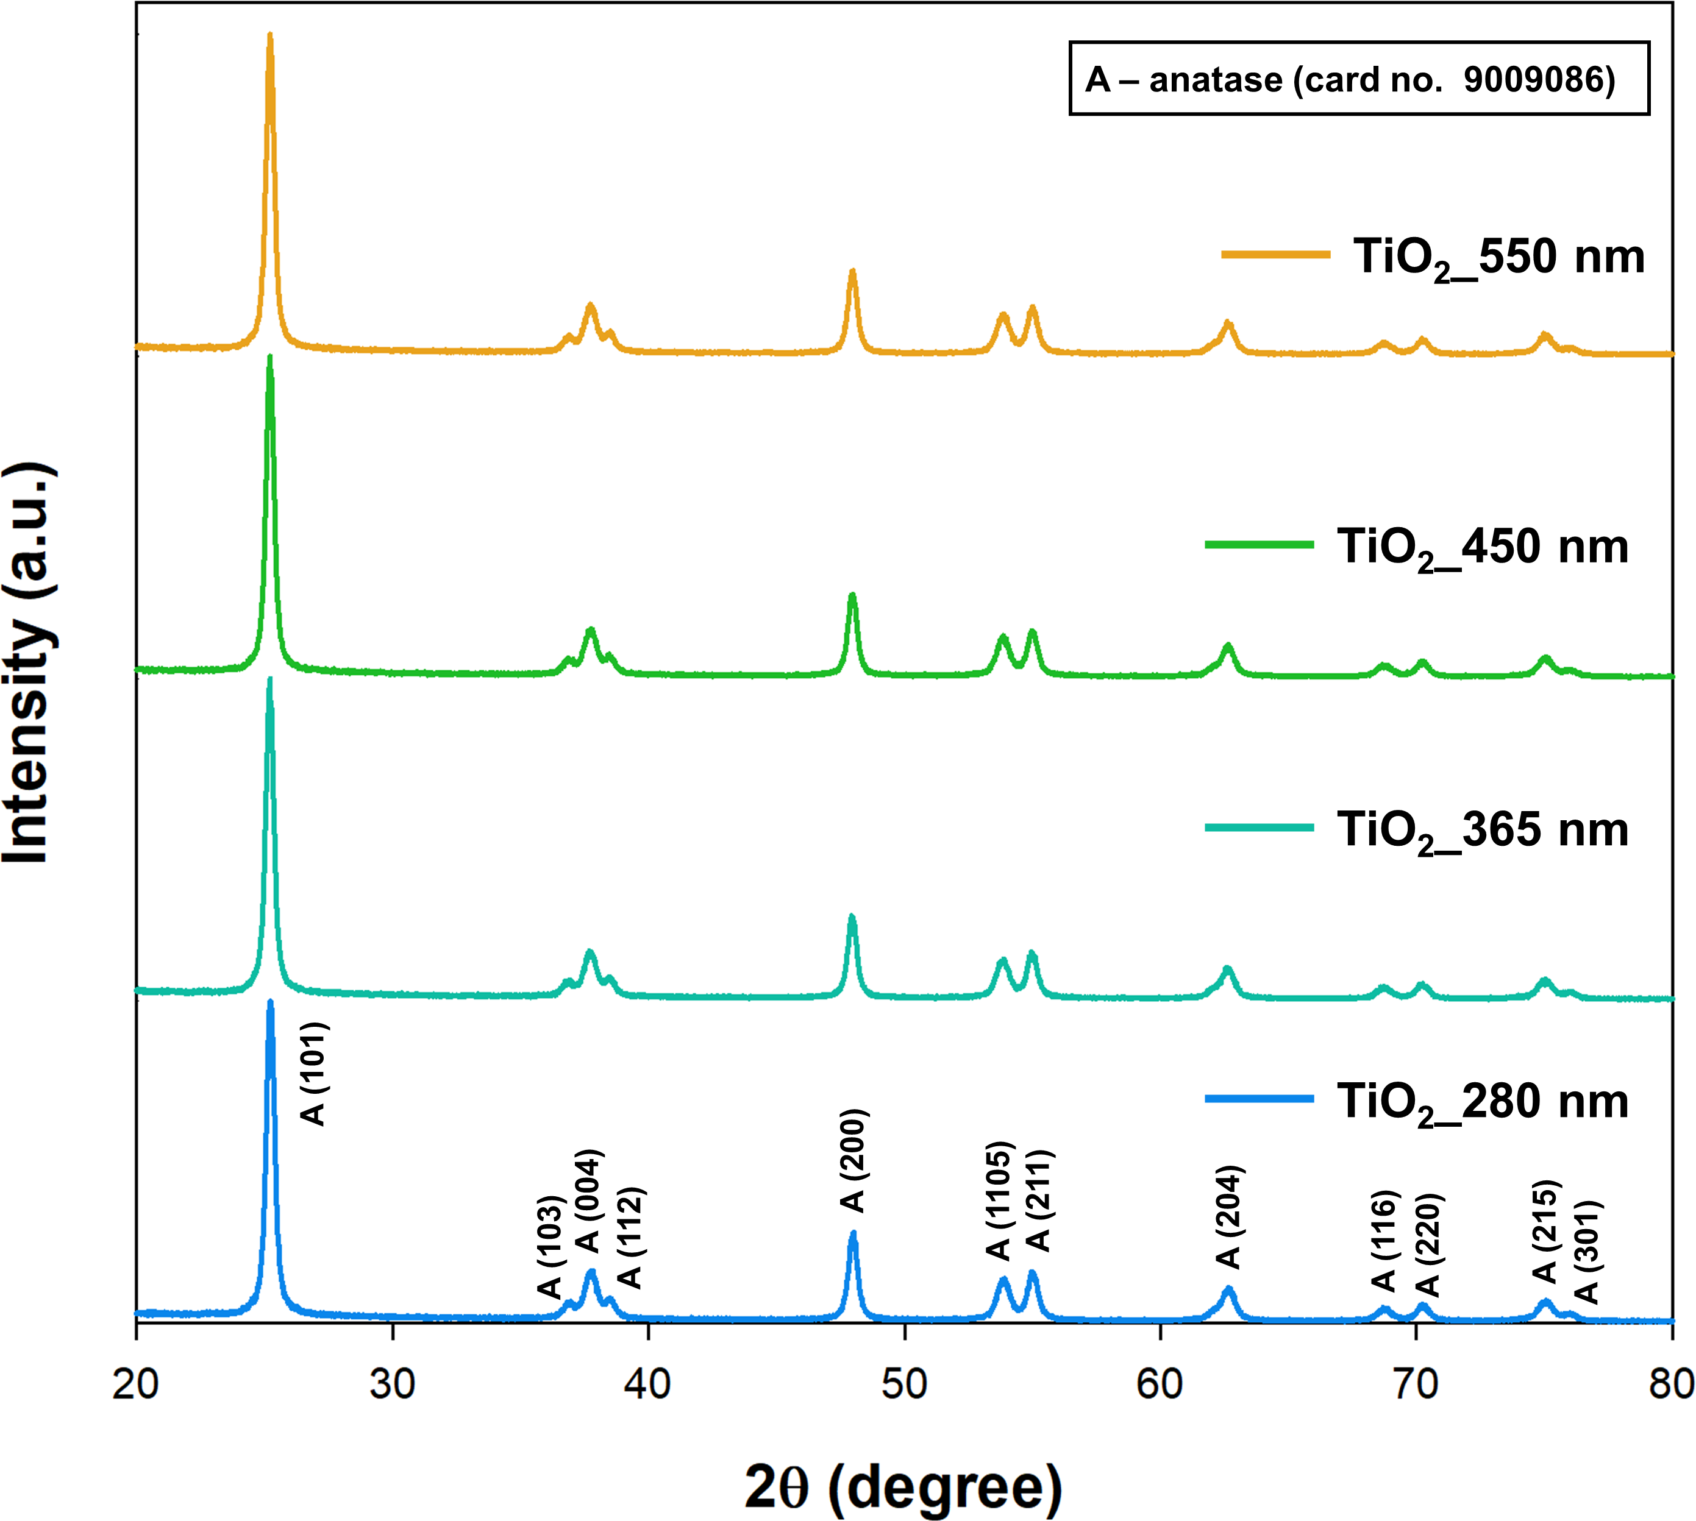
Fig. S4. XRD patterns of reference TiO₂_X nm series samples.
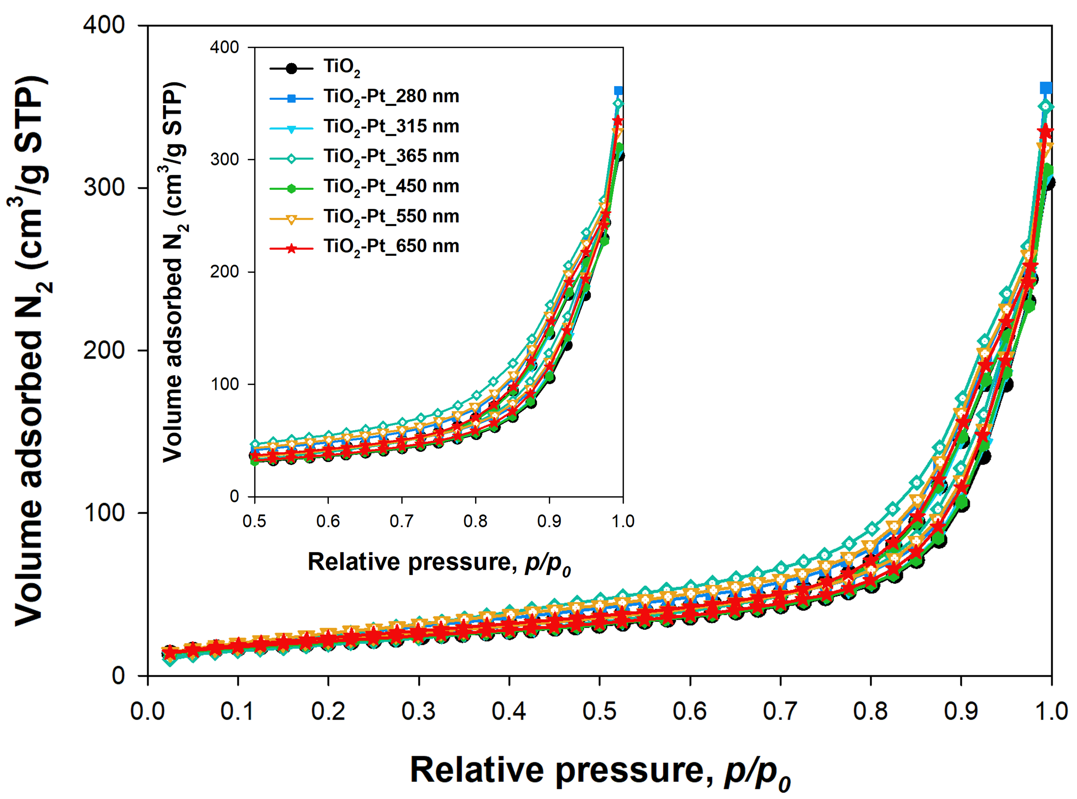
Fig. S5. N₂ adsorption/desorption isotherms of synthesized TiO₂-Pt materials.
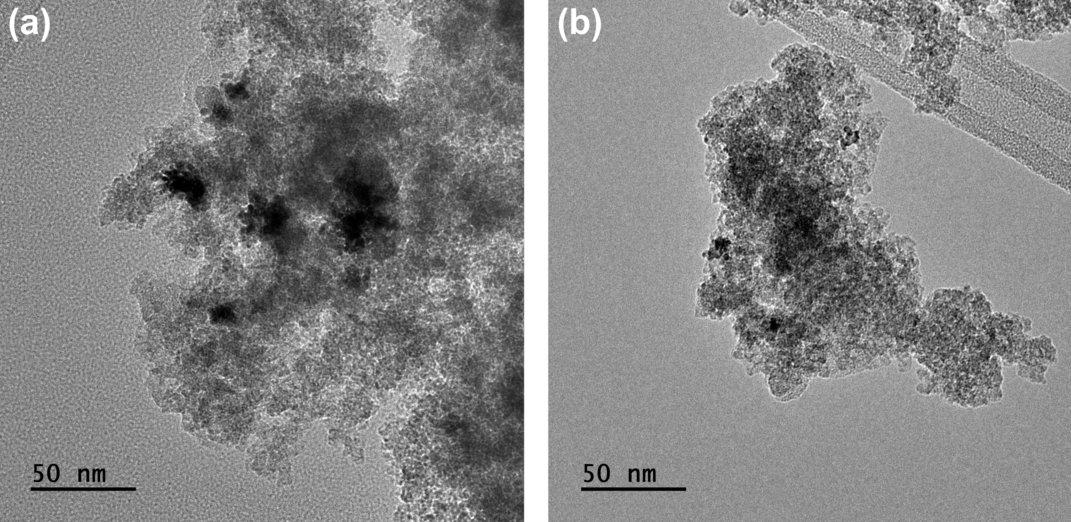
Fig. S6. TEM images of TiO₂(Am)-Pt materials synthesized by irradiating with (a) 365 or (b) 450 nm LED wavelength.

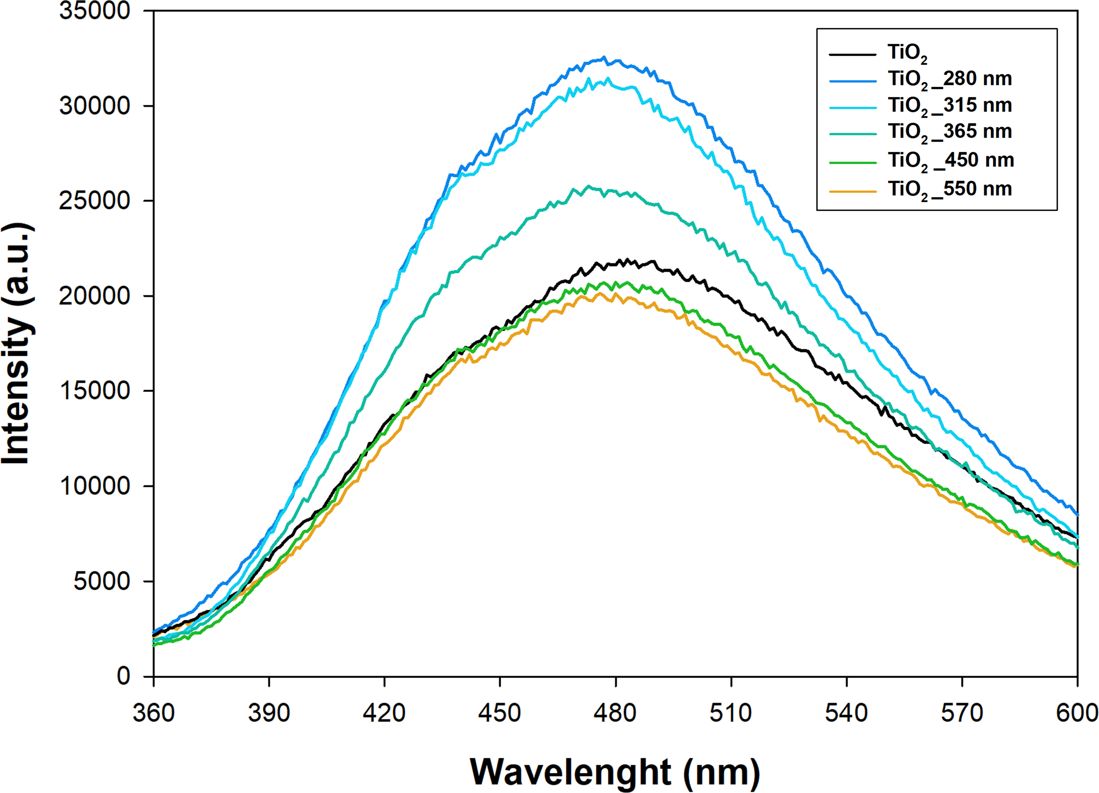
Fig. S7. PL spectra of reference TiO₂_X nm series samples irradiated with different LED wavelengths.

Table S1. Specific surface area (SSA), mean pore volume (V_{p}) and size (S_{p}) of TiO₂-Pt_Xnm series samples.
Sample | SSA surface area
 | SSA (m²/g) | V_{p}  (cm³/g) | S_{p}  (nm)
anatase | 74 | 0.467 | 15.4
TiO₂-Pt_280 nm | 80 | 0.560 | 18.6
TiO₂-Pt_315 nm | 77 | 0.480 | 16.2
TiO₂-Pt_365 nm | 78 | 0.549 | 16.8
TiO₂-Pt_450 nm | 77 | 0.480 | 16.4
TiO₂-Pt_550 nm | 82 | 0.501 | 18.8
TiO₂-Pt_650 nm | 73 | 0.460 | 15.6

Table S2. The mass spectra of the generated ions during the photooxidation of NPX using TiO₂-Pt photocatalysts
NPX | positive mode
 | negative mode
TiO₂-Pt_280 nm  (20 min) | positive mode
 | negative mode
TiO₂-Pt_280 nm  (60 min) | positive mode
 | negative mode
TiO₂-Pt_450 nm  (20 min) | positive mode
 | negative mode
TiO₂-Pt_450 nm  (60 min) | positive mode
 | negative mode

