Supplementary Tables

Table 1. Primer Sequences of QRT-PCR

|  |  |  |
| --- | --- | --- |
| Protein-ID | Forward primer | Reverse primer |
| NtLTP4 | AGGCATCAGTGGCATCAACTTCAG | GCACCGTGGAGCAGTCAATGG |
| Q70G33 | CACTGATGGTAGGTCTAGGCTTTGC | TTGCCATAGGTGTGCCTGTGAAC |
| A1XEL3 | GGAAGAAACCCGAAGAGTTCAGACC | GCTCCTCCTACCAACGCCAAAC |
| A0A1S3ZTJ1 | CAGAGCGGTTCAAGAGCAGGTTC | AGGCGACCAGCAGATCCATACC |
| A0A1S3ZDR0 | CTGCTTGTCCTAATGCTGTCTCCTG | TTGCGGTTCTTGCGTCTCTTCTG |
| A0A1S4A886 | TTTCGGTTCTTGCGTCTCTTCTG | ACTTACTGCCCGAGACTCTGTTG |
| A0A1S4A3W2 | CGTTACTGCCCGAGACTCTGGTTG | TTGGAGGAGGAATGCTACTGTTG |
| A0A1S3Y048 | CCATTGCTGCTAGGGACTCTGTTG | GACTGAGGACGACTGTGGTGTTG |
| Q50LG5 | AAGACCTCACCACCCAACAACAAC | CAACAGAATCACGAGCAGCAATAGC |
| Q9XIV9 | GGGACAACAATTTGGCACCACTTG | TCACAATCGAATCGGCAGATCCAC |
| β-actin | AGGGTTTGCTGGAGATGATG | CGGGTTAAGAGGTGCTTCAG |

Supplementary Figures

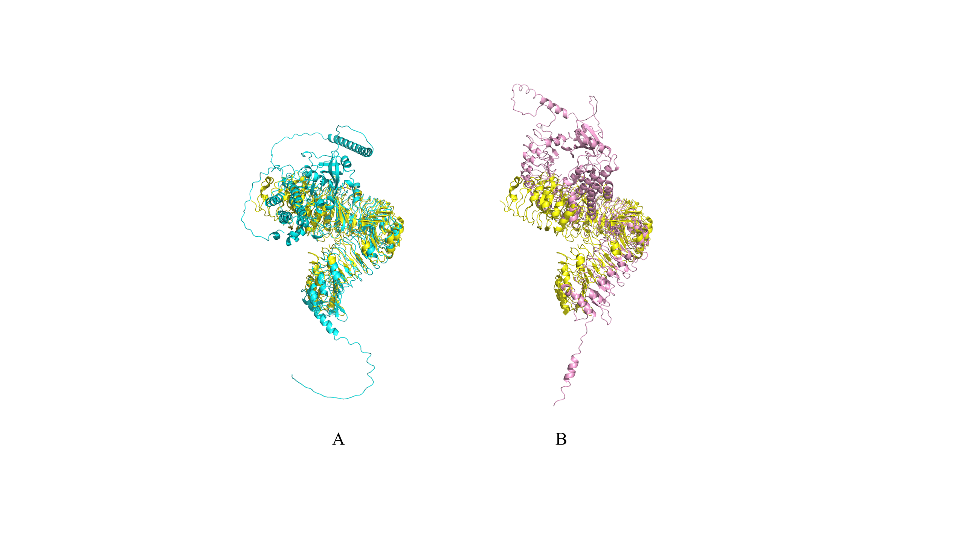

Figure 1. Structure comparison of SR160 (A) and SYR1 (B) with BRI1