**Electronic Supporting Information**

*Of*

**Palladium Nanocubes-Mediated Fenton Catalysis Combined with Chloride Ion-Amplified Electro-Driven Catalysis for Dye Degradation**

Jingming Zhaia#, Heying Lia#, Shegan Gaoa*, Hongbo Sunb, Chuntao Zhaob, Dongmei Yub, Xiantao Linc, Shaowen Chengc, Jinghua Lia, b, c*

a The 1st Affiliated Hospital, School of Medical Technology and Engineering, Henan University of Science and Technology, Luoyang 471000, China

b Qinghai Provincial Key Laboratory of Geology and Environment of Salt Lakes, Qinghai Institute of Salt Lakes, Chinese Academy of Sciences, Xining, 810008, China

c Key Laboratory of Hainan Trauma and Disaster Rescue, The First Affiliated Hospital of Hainan Medical University, College of Emergency and Trauma, Hainan Medical University, Haikou 571199, China

# These authors contributed equally to this work.

* Corresponding author: Dr. Jinghua Li

College of Medical Technology and Engineering, Henan University of Science and Technology, Luoyang 471000, China

Tel: +86-379-64162571

E-mail: anubiss1860@163.com

***List of Contents***

**Figure S1. The SEM image of Pd nanocubes-----------------------------------------------------------S3**

**Figure S2.** Digital photo of color changes in different groups of solutions---------------------------S4

**Figure S3.** The standard concentration-absorbance curve of MB**--------------------------------------**S5

**Figure S4.** Double Salt Bridge System--------------------------------------------------------------------S6

**Figure S5.** Digital photo of the double salt bridge system----------------------------------------------S7

**Figure S6.** Photographs before and after electro-driven catalytic degradation of MB at different concentrations of Pd cubes-----------------------------------------------------------------------------------S8

**Figure S7.** Photographs before and after degradation of MB under different catalytic groups-----------------------------------------------------------------------------------------------------------S9

**Table S1.** Degradation efficiency between different Pd-based synergistic catalytic systems-----S10

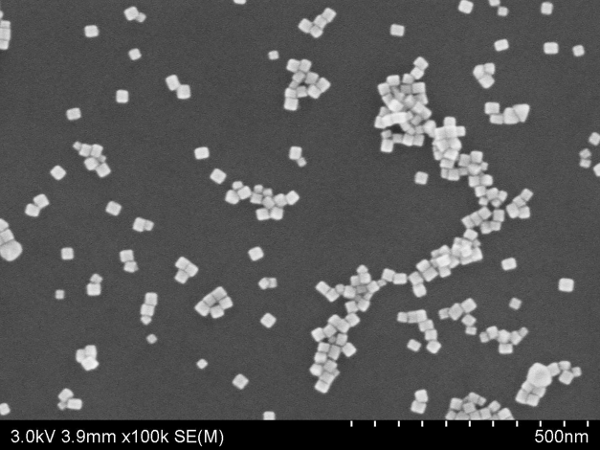

Figure S1. The SEM image of Pd nanocubes.

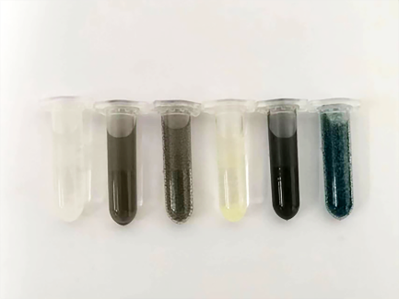

**A**

**B**

**C**

**D**

**E**

**F**

Figure S2. Digital photo of color changes in different groups of solutions (A: TMB, B: Pd cubes, C: Pd cubes + H2O2, D: TMB + H2O2, E: TMB + Pd cubes, F: TMB + Pd cubes + H2O2).

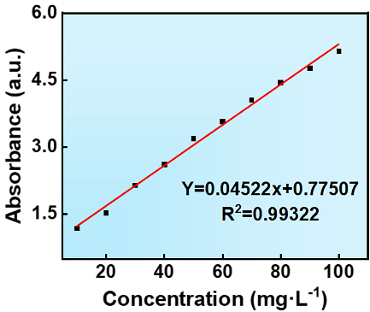

Figure S3. The standard concentration-absorbance curve of MB.

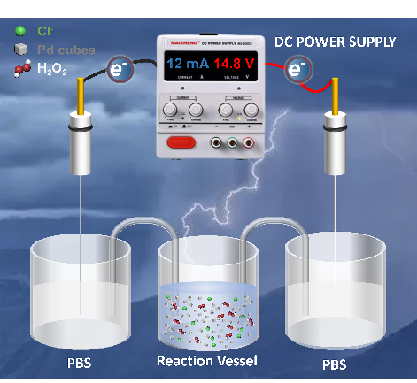

Figure S4. Double Salt Bridge System.

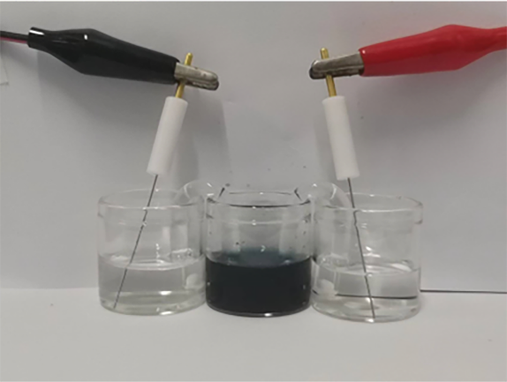

Figure S5. Digital photo of the double salt bridge system.

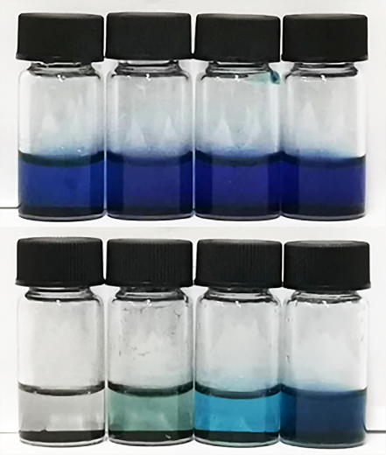

**D**

**B**

**C**

**Before: A**

**D**

**C**

**B**

**After: A**

Figure S6. Photographs before and after electro-driven catalytic degradation of MB at different concentrations of Pd cubes (A: 1000 μg mL-1, B: 500 μg mL-1, C: 250 μg mL-1, D: 125 μg mL-1).

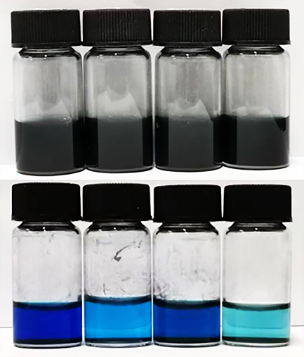

**Before: A**

**B**

**C**

**D**

**After: A**

**B**

**C**

**D**

Figure S7. Photographs before and after degradation of MB under different catalytic groups (A: Control, B: Pd cubes + E, C: Pd cubes + H2O2, D: Pd cubes + H2O2 + E).

Table S1. Degradation efficiency between different Pd-based synergistic catalytic systems.

|  |  |  |  |  |  |  |
| --- | --- | --- | --- | --- | --- | --- |
| Catalyst | MB  (mg L-1) | H2O2  (%) | Catalyst dosage  (g L-1) | Efficiency  (%) | Catalytic systems | Reference |
| Pd cubes | 100 | 2.5 | 1 | ＞99 | electro-driven and Fenton catalysis | This work |
| PdCuAu NAs | 50 | 6 | 2 | 97 | photothermal synergistic Fenton catalysis | [48] |
| PdPtCu NVFs | 50 | 6 | 2 | 99 | photothermal enhanced Fenton catalysis | [49] |
| Pd octahedra | 50 | 3 | 0.125 | 94.8 | photo-Fenton Catalytsis | Later work |