Design, synthesis, and biological evaluation of (E)-3-(3-methoxy-4-substituted phenyl)-acrylic acid derivatives: Role of compound S17 in regulating lipid accumulation via AMPK activation
Mingdong Li ^{a, 1}, Jiahao Liu ^{a, 1}, Yingying Liu ^{a, 1}, Aoxuan Zhang ^{a, 1}, Chaoyu Sun ª, Kang Li ª, Yizhao Liu ª, Shutong Dai ª, Mingyuan Ma ª, Xinru Li ª, Qipan Fan ª, Huanwen Chen ª, Yanfei Xie ^{b, *}, Yuqing Qian ^{a, *}, Siyu Zhou ^{a, *}

ª School of Pharmacy, Jiangxi University of Chinese Medicine, Nanchang, 330006, PR China
^{b} Center for Translational Medicine, Jiangxi University of Chinese Medicine, Nanchang, Jiangxi, China.

¹ These authors contribute equally to this work.
* Corresponding authors.
E-mail addresses: 20070945@jxutcm.edu.cn (Yanfei Xie), qianyuqing@jxutcm.edu.cn (Yuqing Qian), and zhousiyu@jxutcm.edu.cn (Siyu Zhou).

Figure S1 | S3
Figure S2 | S4
Figure S3 | S5
General procedure for the synthesis of compounds 2a-2i, 4a-4c, 5a-5u | S6-S13
¹H NMR and ¹³C NMR spectra of synthetic compounds. | S14-S34
HPLC spectra of synthetic compounds | S35-S45

Figure S1.
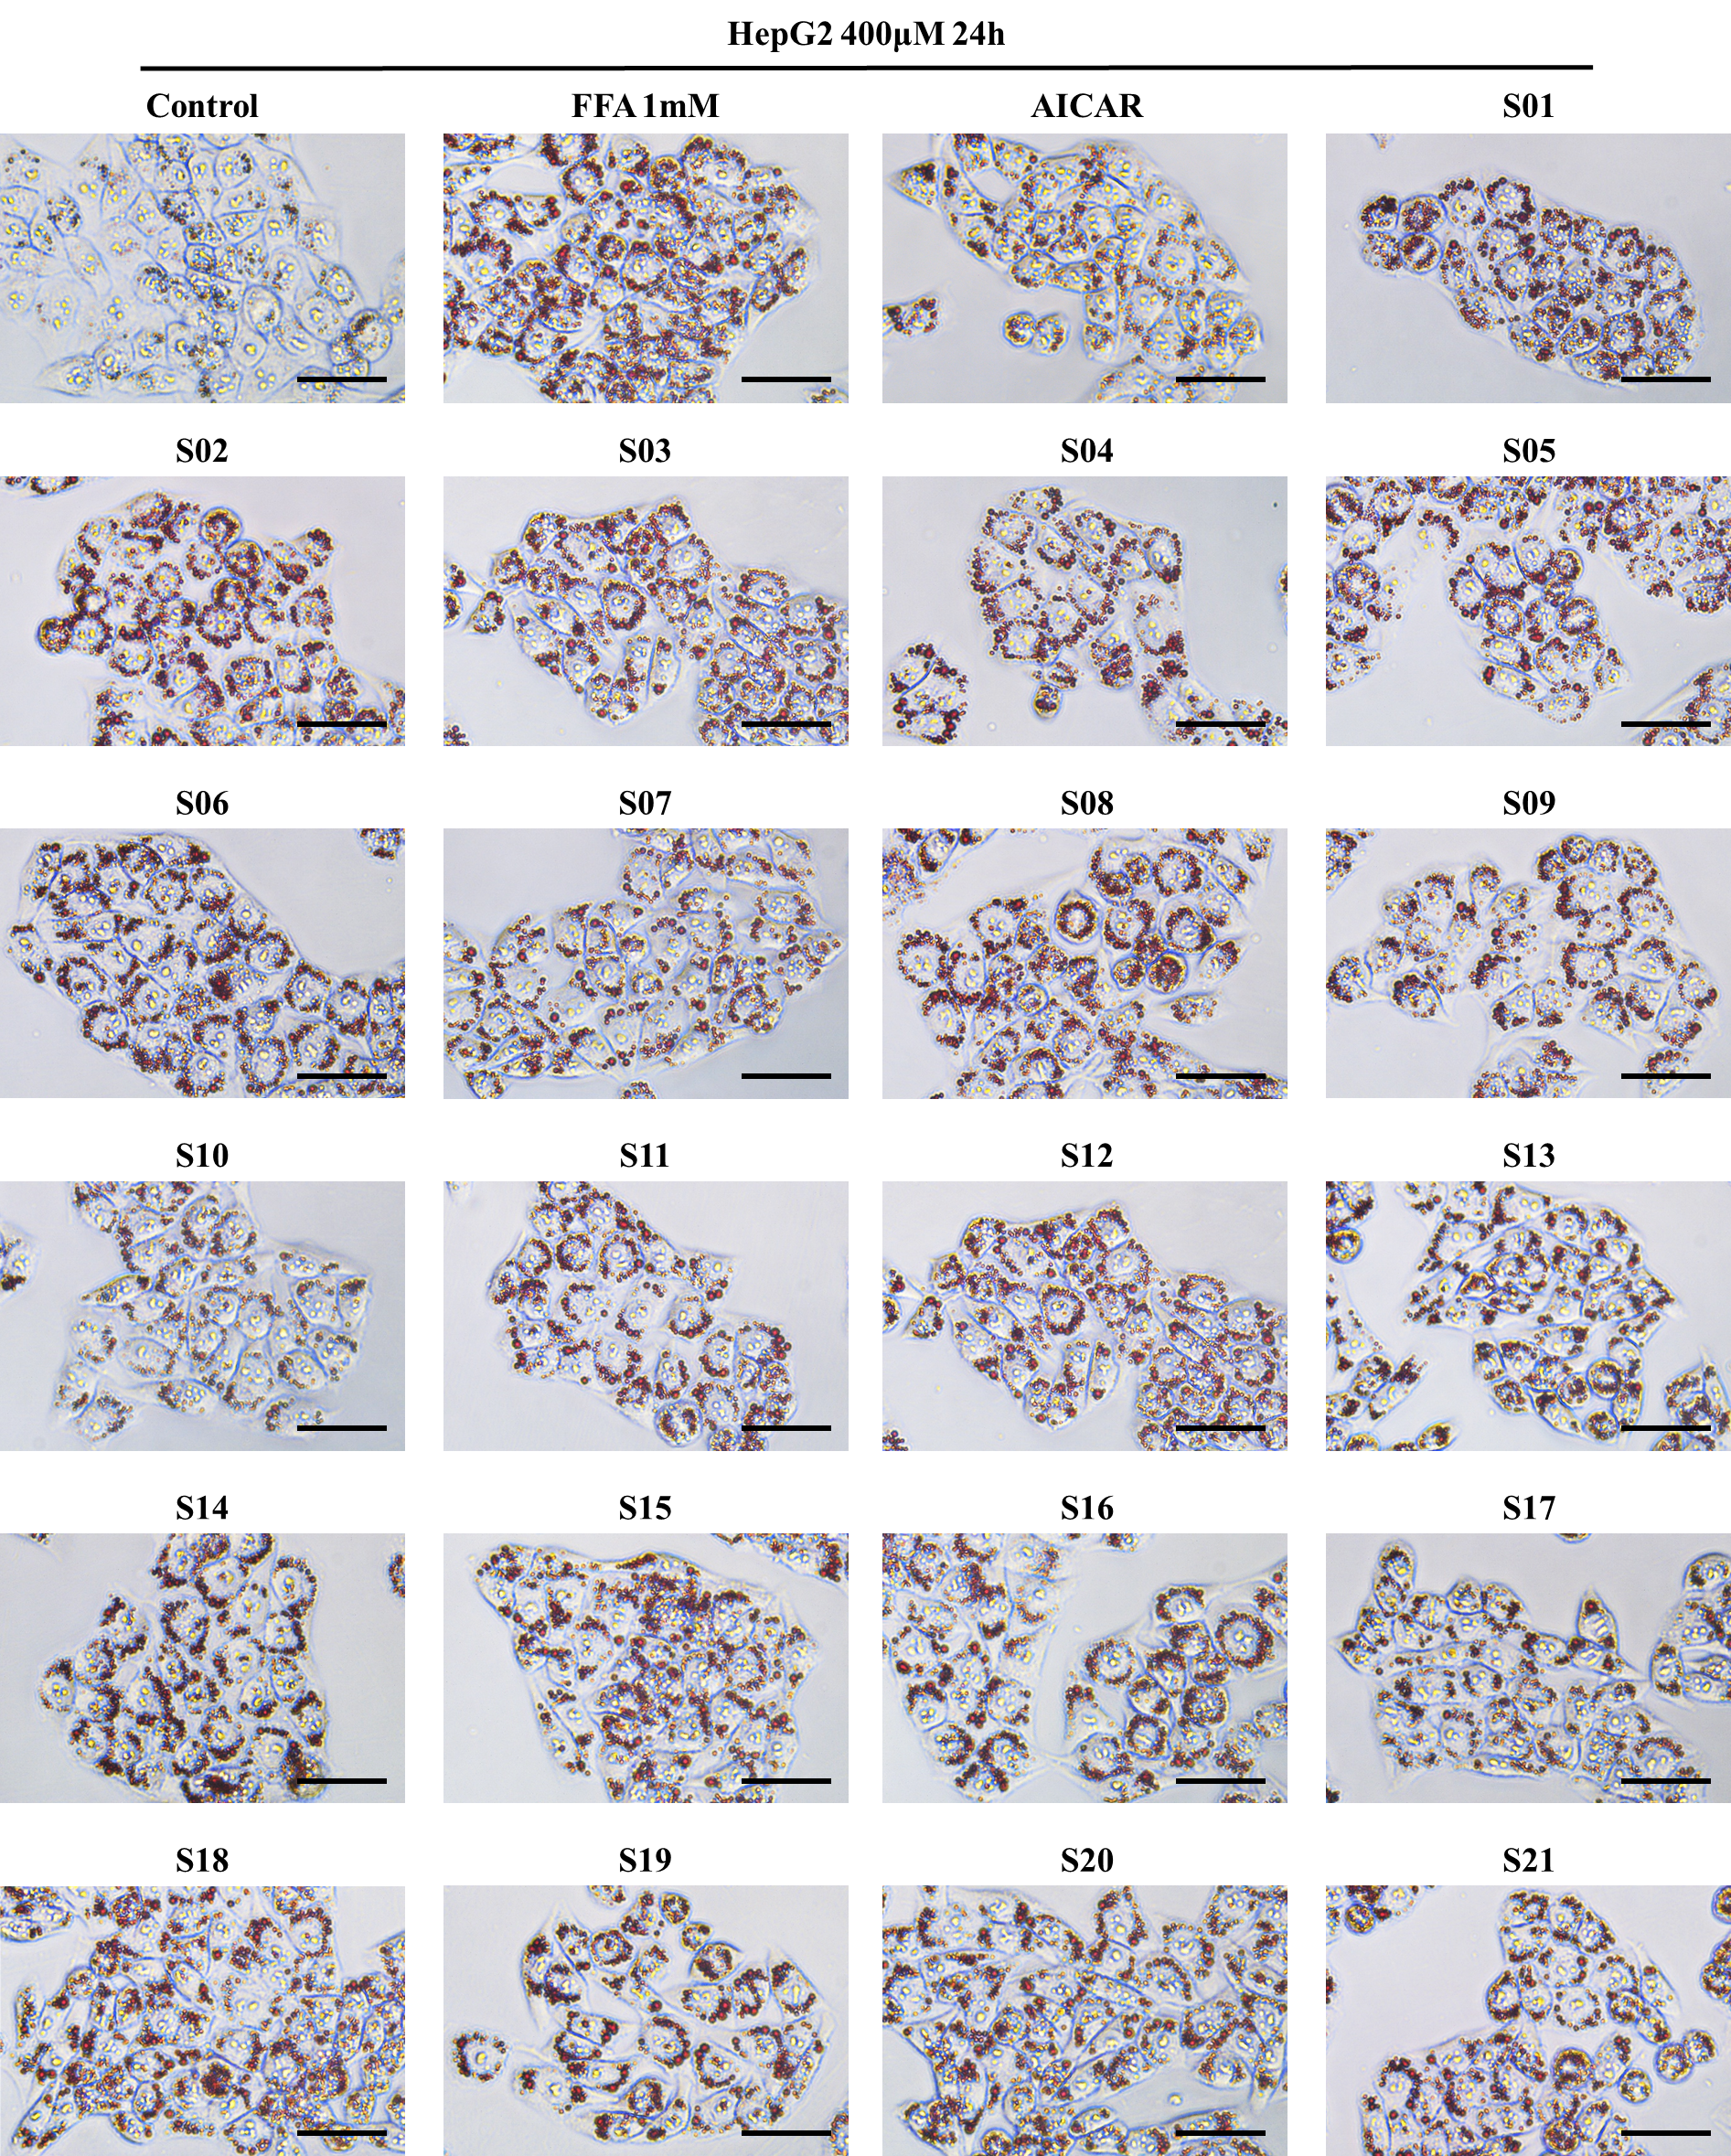
Fig. S1. Influence of compounds S01-S21 on lipid accumulation in FFA-challenged HepG2 cells. Detection of lipid droplet accumulation via fluorescence absorption. The model group received 1 mM FFA (OA: PA = 2:1) and DEME for 24 h. The control group and various sample groups were subjected to treatment with 1 mM FFA (OA: PA = 2:1), DEME, and 500 μM of AICAR or the respective target compounds. Extent of lipid droplet accumulation in response to the target compounds in the absence or presence of FFA (1 mM) for 24 h (scale bar 50 μm, 40×).

Figure S2.
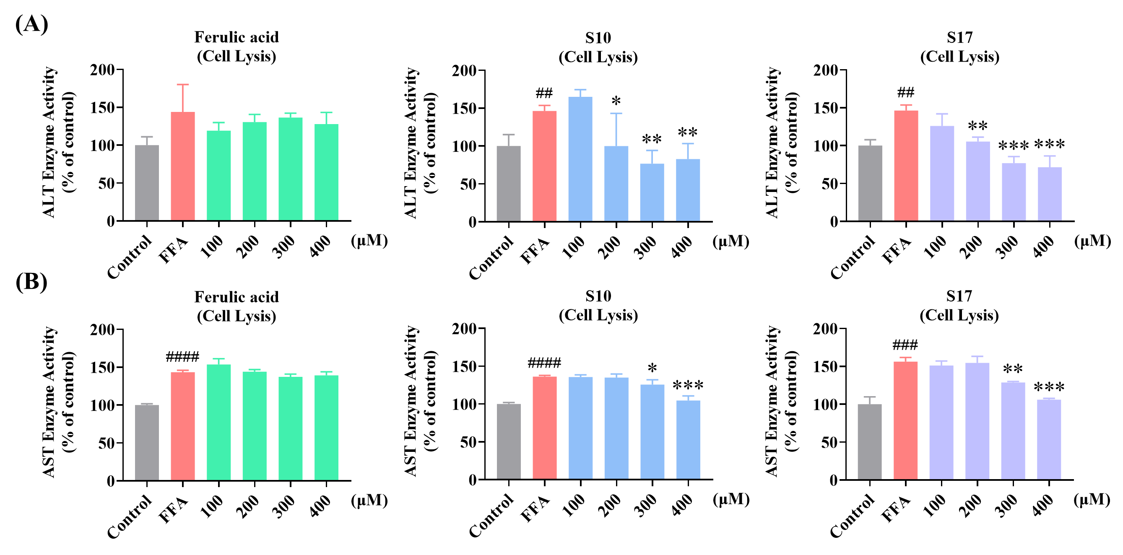
Fig. S2. Impact of S10 and S17 on FFA-Induced ALT and AST activity in HepG2 cells. (A) Measurement of ALT activity in cell lysis via fluorescence absorption following treatment with designated concentrations of S10 or S17 in the absence or presence of 1 mM FFA for 24 h, with FA serving as a control. (B) Measurement of AST activity in cell lysis via fluorescence absorption following treatment with designated concentrations of S10 or S17 in the absence or presence of 1 mM FFA for 24 h, with FA serving as a control. The data, derived from three independent experiments, are presented as mean ± SD. #### P < 0.0001 versus the control group. * P < 0.05, ** P < 0.01, *** P < 0.001 versus the FFA (1 mM) group.

Figure S3.
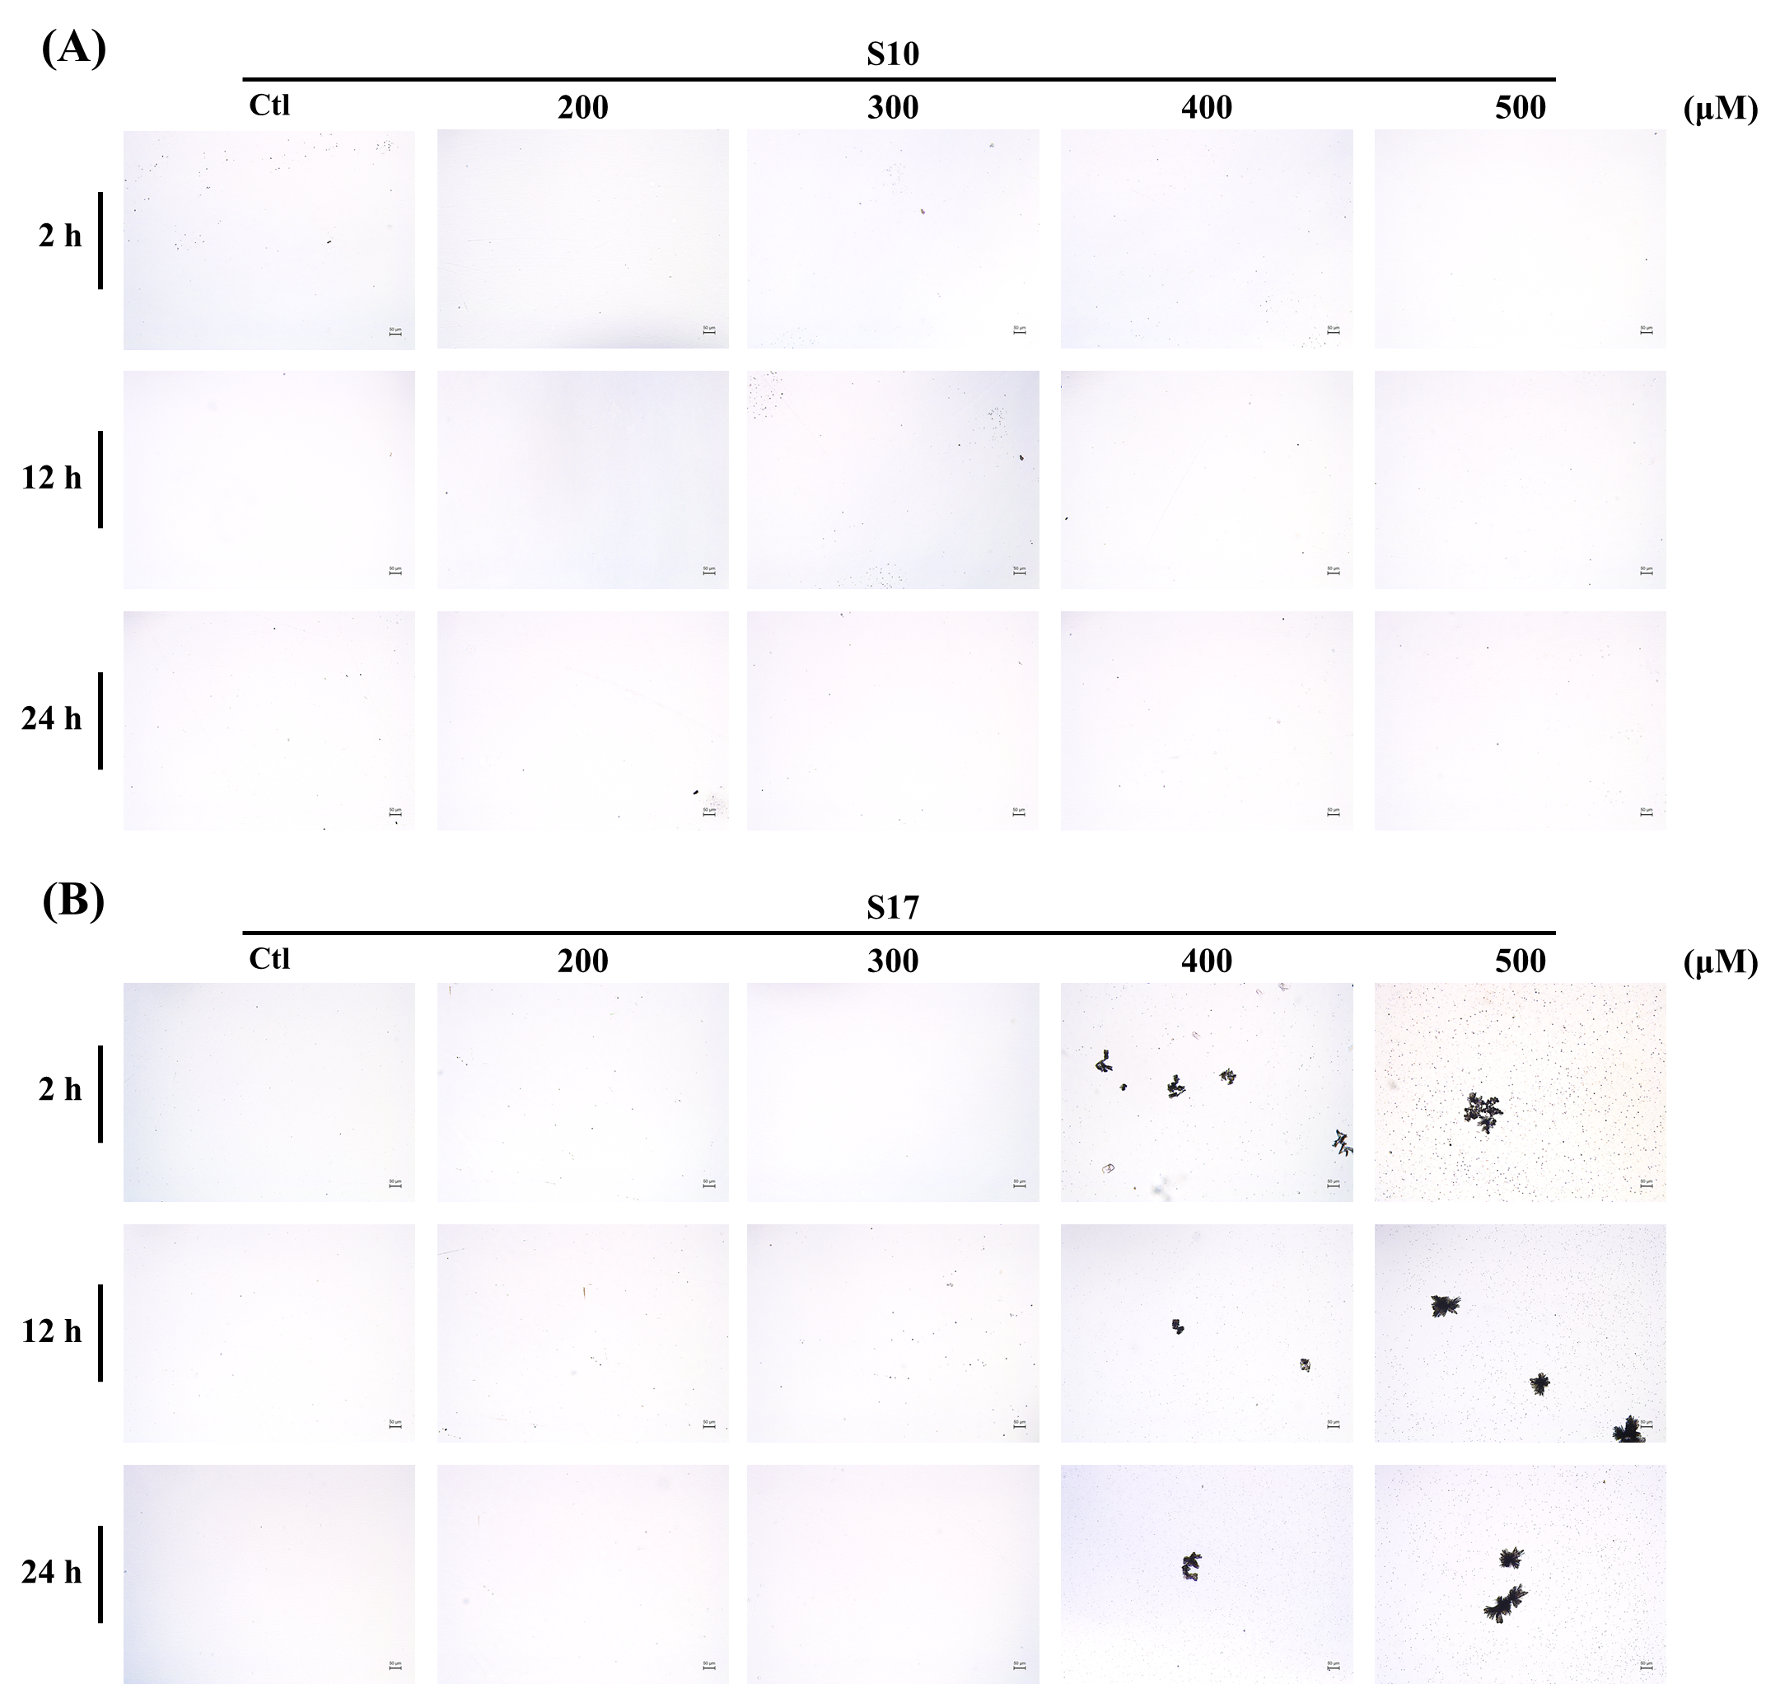
Fig. S3. The water solubility of S10 and S17 in PBS. (A, B) Indicated concentrations of S10 or S17 (200, 300, 400, and 500 μM) dissolved in 1 mL PBS. After 2 h, 12 h, and 24 h, the solution observed and imaged using an optical microscope with a digital camera at 10× magnification (scale bar 50 μm, 10×).

General procedure for the synthesis of compounds 2a-2i, 4a-4c, 5a-5u
2.1.1.1. 2-methyl-2-(p-tolyloxy) propanoic acid (2a). Yield: 53%, white solid; ¹H NMR (600 MHz, CDCl₃) δ 7.07 (d, J = 8.1 Hz, 2H), 6.85 (d, J = 8.4 Hz, 2H), 2.30 (s, 3H), 1.59 (s, 6H); ¹³C NMR (150 MHz, CDCl₃) δ 179.2, 152.3, 132.9, 129.9, 120.8, 79.6, 25.2, 20.8; HRMS (ESI) m/z calculated for C₁₁H₁₃O₃ [M - H]⁻: 193.0870; found: 193.0872.
2.1.1.2. 2-(4-methoxyphenoxy)-2-methylpropanoic acid (2b). Yield: 49%, white solid; ¹H NMR (600 MHz, CDCl₃) δ 6.95 – 6.89 (m, 2H), 6.83 – 6.79 (m, 2H), 3.77 (s, 3H), 1.55 (s, 6H); ¹³C NMR (150 MHz, CDCl₃) δ 178.6, 156.0, 147.9, 122.9, 114.4, 80.2, 55.7, 25.1; HRMS (ESI) m/z calculated for C₁₁H₁₃O₄ [M - H]⁻: 209.0819; found: 209.0811.
2.1.1.3. 2-(4-ethoxyphenoxy)-2-methylpropanoic acid (2c). Yield: 51%, white solid; ¹H NMR (600 MHz, CDCl₃) δ 6.94 – 6.88 (m, 2H), 6.83 – 6.76 (m, 2H), 3.98 (q, J = 7.0 Hz, 2H), 1.54 (s, 6H), 1.39 (t, J = 7.0 Hz, 3H); ¹³C NMR (150 MHz, CDCl₃) δ 178.6, 155.4, 147.7, 123.0, 115.0, 80.3, 63.9, 25.0, 15.0; HRMS (ESI) m/z calculated for C₁₂H₁₅O₄ [M - H]⁻: 223.0976; found: 223.0976.
2.1.1.4. 2-(2-bromophenoxy)-2-methylpropanoic acid (2d). Yield: 46%, white solid; ¹H NMR (600 MHz, CDCl₃) δ 7.58 (dd, J = 8.0, 1.6 Hz, 1H), 7.28 – 7.22 (m, 1H), 7.06 (dd, J = 8.2, 1.4 Hz, 1H), 6.98 (td, J = 7.7, 1.4 Hz, 1H), 1.66 (s, 6H); ¹³C NMR (150 MHz, CDCl₃) δ 176.9, 151.5, 133.8, 128.5, 125.1, 121.4, 117.3, 82.1, 25.0; HRMS (ESI) m/z calculated for C₁₀H₁₀BrO₃ [M - H]⁻: 256.9819; found: 256.9832.
2.1.1.5. 2-(3,5-dimethoxyphenoxy)-2-methylpropanoic acid (2e). Yield: 57%, white solid; ¹H NMR (600 MHz, CDCl₃) δ 6.18 (t, J = 2.2 Hz, 1H), 6.10 (d, J = 2.2 Hz, 2H), 3.74 (s, 6H), 1.63 (s, 6H); ¹³C NMR (150 MHz, CDCl₃) δ 178.7, 161.3, 156.5, 98.8, 95.3, 79.6, 55.5, 25.3; HRMS (ESI) m/z calculated for C₁₂H₁₅O₅ [M - H]⁻: 239.0925; found: 239.0925.
2.1.1.6. 2-(3,5-dichlorophenoxy)-2-methylpropanoic acid (2f). Yield: 51%, white solid; ¹H NMR (600 MHz, CDCl₃) δ 7.05 (t, J = 1.8 Hz, 1H), 6.82 (d, J = 1.8 Hz, 2H), 1.64 (s, 6H); ¹³C NMR (150 MHz, CDCl₃) δ 178.9, 156.2, 135.2, 123.3, 118.8, 80.1, 25.3; HRMS (ESI) m/z calculated for C₁₀H₉Cl₂O₃ [M - H]⁻: 246.9934; found: 246.9946.
2.1.1.7. 2-(4-chloro-3-methylphenoxy)-2-methylpropanoic acid (2g). Yield: 50%, white solid; ¹H NMR (600 MHz, CDCl₃) δ 7.22 (dd, J = 8.7, 1.9 Hz, 1H), 6.83 (d, J = 2.9 Hz, 1H), 6.71 (dd, J = 8.7, 2.9 Hz, 1H), 2.32 (s, 3H), 1.59 (s, 6H); ¹³C NMR (150 MHz, CDCl₃) δ 178.6, 153.2, 137.3, 129.6 (2C), 128.7, 123.3, 119.1, 79.8, 25.2 (2C), 20.4; HRMS (ESI) m/z calculated for C₁₁H₁₂ClO₃ [M - H]⁻: 227.0480; found: 227.0474.
2.1.1.8. 2-(4-fluorophenoxy)-2-methylpropanoic acid (2h). Yield: 56%, white solid; ¹H NMR (600 MHz, CDCl₃) δ 7.03 – 6.86 (m, 4H), 1.58 (s, 6H); ¹³C NMR (150 MHz, CDCl₃) δ 178.9, 159.8 (d, J = 241.0 Hz, 1C), 150.5, 122.7 (d, J = 11.4 Hz, 2C), 116.0 (d, J = 22.6 Hz, 2C), 80.1, 25.2; HRMS (ESI) m/z calculated for C₁₀H₁₀FO₃ [M - H]⁻: 197.0620; found: 197.0628.
2.1.1.9. 2-([1,1'-biphenyl]-4-yloxy)-2-methylpropanoic acid (2i). Yield: 45%, white solid; ¹H NMR (600 MHz, CDCl₃) δ 7.56 – 7.53 (m, 2H), 7.53 – 7.50 (m, 2H), 7.42 (dd, J = 8.5, 7.0 Hz, 2H), 7.35 – 7.31 (m, 1H), 7.06 – 6.99 (m, 2H), 1.65 (s, 6H); ¹³C NMR (150 MHz, CDCl₃) δ 177.2, 153.8, 140.5, 136.6, 128.9, 128.2, 127.2, 127.0, 121.0, 80.0, 25.2; HRMS (ESI) m/z calculated for C₁₆H₁₅O₃ [M - H]⁻: 255.1027; found: 255.1005.
2.1.2.1. 4-(2-hydroxyethoxy)-3-methoxybenzaldehyde (4a). Yield: 65%, yellow solid; ¹H NMR (600 MHz, CDCl₃) δ 9.83 (s, 1H), 7.42 (dd, J = 8.1, 1.8 Hz, 1H), 7.39 (d, J = 1.8 Hz, 1H), 6.98 (d, J = 8.1 Hz, 1H), 4.19 (t, J = 4.5 Hz, 2H), 4.02 (q, J = 4.3 Hz, 2H), 3.90 (s, 3H), 2.95 (d, J = 6.0 Hz, 1H); ¹³C NMR (150 MHz, CDCl₃) δ 191.0, 153.8, 150.0, 130.6, 126.8, 112.2, 109.4, 70.8, 61.1, 56.1; HRMS (ESI) m/z calculated for C₁₀H₁₃O₄ [M + H]⁺: 197.0808; found: 197.0800.
2.1.2.2. 4-(3-hydroxypropoxy)-3-methoxybenzaldehyde (4b). Yield: 61%, yellow solid; ¹H NMR (600 MHz, CDCl₃) δ 9.85 (s, 1H), 7.44 (dd, J = 8.1, 1.9 Hz, 1H), 7.40 (d, J = 1.9 Hz, 1H), 6.99 (d, J = 8.1 Hz, 1H), 4.28 (t, J = 6.0 Hz, 2H), 3.91 (s, 3H), 3.88 (q, J = 5.8 Hz, 2H), 2.15 – 2.10 (m, 2H); ¹³C NMR (150 MHz, CDCl₃) δ 191.1, 153.8, 149.9, 130.4, 126.9, 111.5, 109.2, 67.9, 61.0, 56.1, 31.7; HRMS (ESI) m/z calculated for C₁₁H₁₅O₄ [M + H]⁺: 211.0965; found: 211.0964.
2.1.2.3. 4-(4-hydroxybutoxy)-3-methoxybenzaldehyde (4c). Yield: 56%, yellow solid; ¹H NMR (600 MHz, CDCl₃) δ 9.78 (s, 1H), 7.39 (dd, J = 8.2, 1.9 Hz, 1H), 7.35 (d, J = 1.9 Hz, 1H), 6.92 (d, J = 8.2 Hz, 1H), 4.09 (t, J = 6.3 Hz, 2H), 3.87 (s, 3H), 3.68 (t, J = 6.2 Hz, 2H), 1.99 – 1.90 (m, 2H), 1.73 (dq, J = 8.3, 6.4 Hz, 2H).; ¹³C NMR (150 MHz, CDCl₃) δ 191.1, 153.9, 149.7, 129.9, 126.9, 111.4, 109.2, 68.9, 62.2, 56.0, 29.4, 25.6; HRMS (ESI) m/z calculated for C₁₄H₁₇O₄ [M + H]⁺: 249.1121; found: 249.1115
2.1.3.1. 2-(4-formyl-2-methoxyphenoxy)ethyl 2-methyl-2-(p-tolyloxy)propanoate (5a). Yield: 82%, yellow oil; ¹H NMR (600 MHz, CDCl₃) δ 9.83 (s, 1H), 7.39 (dd, J = 10.7, 2.2 Hz, 2H), 6.91 (d, J = 8.1 Hz, 3H), 6.77 – 6.71 (m, 2H), 4.58 (t, J = 5.1 Hz, 2H), 4.27 (t, J = 5.0 Hz, 2H), 3.86 (s, 3H), 2.19 (s, 3H), 1.56 (s, 6H); ¹³C NMR (150 MHz, CDCl₃) δ 191.0, 174.3, 153.3, 152.9, 150.0, 131.8, 130.5, 129.6, 126.6, 119.4, 112.1, 109.4, 79.2, 66.6, 63.1, 56.0, 25.4, 20.6; HRMS (ESI) m/z calculated for C₂₁H₂₅O₅ [M + H]⁺: 373.1646; found: 373.1635.
2.1.3.2. 2-(4-formyl-2-methoxyphenoxy)ethyl 2-(4-methoxyphenoxy)-2-methylpropanoate (5b). Yield: 78%, yellow oil; ¹H NMR (600 MHz, CDCl₃) δ 9.82 (s, 1H), 7.40 – 7.31 (m, 2H), 6.93 – 6.88 (m, 1H), 6.80 (dt, J = 9.3, 2.2 Hz, 2H), 6.61 (dt, J = 9.5, 2.4 Hz, 2H), 4.54 (d, J = 4.9 Hz, 2H), 4.26 (d, J = 4.9 Hz, 2H), 3.82 (s, 3H), 3.62 (s, 3H), 1.49 (s, 6H); ¹³C NMR (150 MHz, CDCl₃) δ 190.9, 174.1, 155.1, 153.2, 149.8, 148.6, 130.4, 126.5, 121.7, 114.0, 112.0, 109.3, 79.7, 66.5, 63.0, 55.8, 55.3, 25.2; HRMS (ESI) m/z calculated for C₂₁H₂₅O₇ [M + H]⁺: 389.1595; found: 389.1587.
2.1.3.3. 2-(4-formyl-2-methoxyphenoxy)ethyl 2-(4-ethoxyphenoxy)-2-methylpropanoate (5c). Yield: 80%, yellow oil; ¹H NMR (600 MHz, CDCl₃) δ 9.80 (s, 1H), 7.41 – 7.32 (m, 2H), 6.95 – 6.88 (m, 1H), 6.84 – 6.76 (m, 2H), 6.65 – 6.56 (m, 2H), 4.63 – 4.52 (m, 2H), 4.27 (t, J = 4.9 Hz, 2H), 3.83 (dd, J = 5.6, 3.0 Hz, 5H), 1.50 (s, 6H), 1.30 (td, J = 7.1, 2.5 Hz, 3H).; ¹³C NMR (150 MHz, CDCl₃) δ 190.9, 174.2, 154.6, 153.3, 149.9, 148.5, 130.5, 126.5, 121.7, 114.6, 112.0, 109.3, 79.7, 66.6, 63.5, 63.0, 55.9, 25.3, 14.9; HRMS (ESI) m/z calculated for C₂₂H₂₇O₇ [M + H]⁺: 403.1751; found: 403.1738.
2.1.3.4. 2-(4-formyl-2-methoxyphenoxy)ethyl 2-(2-bromophenoxy)-2-methylpropanoate (5d). Yield: 73%, yellow oil; ¹H NMR (600 MHz, CDCl₃) δ 9.85 (s, 1H), 7.50 (dd, J = 7.9, 1.6 Hz, 1H), 7.44 – 7.38 (m, 2H), 7.01 (td, J = 7.8, 7.4, 1.6 Hz, 1H), 6.95 (d, J = 8.1 Hz, 1H), 6.87 (dd, J = 8.3, 1.4 Hz, 1H), 6.81 (td, J = 7.7, 1.4 Hz, 1H), 4.62 (t, J = 4.9 Hz, 2H), 4.32 (t, J = 4.9 Hz, 2H), 3.88 (s, 3H), 1.63 (s, 6H); ¹³C NMR (150 MHz, CDCl₃) δ 191.0, 174.1, 153.4, 152.6, 150.2, 133.6, 130.9, 128.0, 126.6, 123.8, 119.6, 116.4, 112.5, 109.8, 80.9, 66.8, 63.4, 56.1, 25.3; HRMS (ESI) m/z calculated for C₂₀H₂₂BrO₆ [M + H]⁺: 437.0594; found: 437.0590.
2.1.3.5. 2-(4-formyl-2-methoxyphenoxy)ethyl 2-(3,5-dimethoxyphenoxy)-2-methylpropanoate (5e). Yield: 85%, yellow oil; ¹H NMR (600 MHz, CDCl₃) δ 9.80 (s, 1H), 7.48 – 7.28 (m, 2H), 6.89 (d, J = 8.1 Hz, 1H), 5.97 (dd, J = 19.1, 2.3 Hz, 3H), 4.55 (t, J = 5.0 Hz, 2H), 4.24 (t, J = 5.0 Hz, 2H), 3.83 (s, 3H), 3.63 (s, 6H), 1.58 (s, 6H); ¹³C NMR (150 MHz, CDCl₃) δ 191.0, 161.0, 157.1, 153.3, 149.9, 130.5, 126.5, 112.1, 109.4, 97.1, 93.9, 79.0, 66.4, 63.1, 55.9, 55.2, 25.3; HRMS (ESI) m/z calculated for C₂₂H₂₇O₈ [M + H]⁺: 419.1700; found: 419.1687.
2.1.3.6. 2-(4-formyl-2-methoxyphenoxy)ethyl 2-(3,5-dichlorophenoxy)-2-methylpropanoate (5f). Yield: 77%, yellow oil; ¹H NMR (600 MHz, CDCl₃) δ 9.83 (s, 1H), 7.46 – 7.31 (m, 2H), 6.91 (dd, J = 8.1, 1.6 Hz, 1H), 6.84 (d, J = 1.9 Hz, 1H), 6.69 (t, J = 1.7 Hz, 2H), 4.64 – 4.50 (m, 2H), 4.31 – 4.21 (m, 2H), 3.86 (s, 3H), 1.60 (s, 6H); ¹³C NMR (150 MHz, CDCl₃) δ 191.1, 173.4, 156.5, 153.2, 150.0, 135.0, 130.6, 126.6, 122.3, 117.5, 112.1, 109.4, 80.0, 66.5, 63.4, 56.0, 25.3; HRMS (ESI) m/z calculated for C₂₀H₂₁Cl₂O₆ [M + H]⁺: 427.0710; found: 427.0696.
2.1.3.7. 3-(4-formyl-2-methoxyphenoxy)propyl 2-methyl-2-(p-tolyloxy)propanoate (5g). Yield: 76%, yellow oil; ¹H NMR (600 MHz, CDCl₃) δ 9.84 (s, 1H), 7.38 (d, J = 10.0 Hz, 2H), 6.95 (d, J = 8.0 Hz, 2H), 6.79 – 6.62 (m, 3H), 4.38 (t, J = 6.0 Hz, 2H), 3.91 (t, J = 5.0 Hz, 5H), 2.19 (s, 5H), 1.59 (s, 6H); ¹³C NMR (150 MHz, CDCl₃) δ 191.0, 174.5, 153.6, 153.1, 149.7, 131.3, 130.0, 129.7, 126.7, 118.3, 111.3, 109.0, 78.8, 65.1, 61.9, 55.9, 28.1, 25.3, 20.5; HRMS (ESI) m/z calculated for C₂₂H₂₇O₆ [M + H]⁺: 387.1802; found: 387.1789.
2.1.3.8. 3-(4-formyl-2-methoxyphenoxy)propyl 2-(4-methoxyphenoxy)-2-methylpropanoate (5h). Yield: 82%, yellow oil; ¹H NMR (600 MHz, CDCl₃) δ 9.84 (s, 1H), 7.39 (d, J = 7.0 Hz, 2H), 6.80 (d, J = 8.7 Hz, 1H), 6.79 – 6.76 (m, 2H), 6.72 – 6.68 (m, 2H), 4.38 (t, J = 6.1 Hz, 2H), 4.01 (t, J = 6.3 Hz, 2H), 3.90 (s, 3H), 3.69 (s, 3H), 2.21 (p, J = 6.2 Hz, 2H), 1.54 (s, 6H); ¹³C NMR (150 MHz, CDCl₃) δ 191.0, 174.4, 155.1, 153.8, 149.9, 149.1, 130.3, 126.8, 120.9, 114.3, 111.7, 109.4, 79.6, 65.4, 62.0, 56.1, 55.6, 28.4, 25.4; HRMS (ESI) m/z calculated for C₂₂H₂₇O₇ [M + H]⁺: 403.1751; found: 403.1752.
2.1.3.9. 3-(4-formyl-2-methoxyphenoxy)propyl 2-(4-ethoxyphenoxy)-2-methylpropanoate (5i). Yield: 70%, yellow oil; ¹H NMR (600 MHz, CDCl₃) δ 9.85 (s, 1H), 7.40 (d, J = 5.1 Hz, 2H), 6.78 (dd, J = 17.2, 8.5 Hz, 3H), 6.73 – 6.66 (m, 2H), 4.39 (t, J = 6.0 Hz, 2H), 4.00 (t, J = 6.3 Hz, 2H), 3.92 (s, 3H), 3.88 (q, J = 7.0 Hz, 2H), 2.23 (p, J = 6.1 Hz, 2H), 1.55 (s, 6H), 1.36 (t, J = 7.0 Hz, 3H); ¹³C NMR (150 MHz, CDCl₃) δ 191.0, 174.4, 154.3, 153.6, 149.7, 148.8, 130.1, 126.8, 120.6, 114.7, 111.4, 109.0, 79.4, 65.2, 63.6, 61.9, 56.0, 28.2, 25.3, 14.9; HRMS (ESI) m/z calculated for C₂₃H₂₉O₇ [M + H]⁺: 417.1908; found: 417.1898.
2.1.3.10. 3-(4-formyl-2-methoxyphenoxy)propyl 2-(2-bromophenoxy)-2-methylpropanoate (5j). Yield: 71%, yellow oil; ¹H NMR (600 MHz, CDCl₃) δ 9.84 (s, 1H), 7.49 (dd, J = 7.8, 1.8 Hz, 1H), 7.43 – 7.37 (m, 2H), 7.02 (t, J = 7.7 Hz, 1H), 6.84 – 6.69 (m, 3H), 4.38 (td, J = 6.1, 1.6 Hz, 2H), 4.01 – 3.95 (m, 2H), 3.90 (s, 3H), 2.23 – 2.15 (m, 2H), 1.63 (s, 6H); ¹³C NMR (150 MHz, CDCl₃) δ 191.2, 174.1, 153.7, 152.5, 149.8, 133.7, 130.2, 128.0, 126.9, 123.4, 118.2, 115.5, 111.5, 109.1, 80.6, 65.1, 62.1, 56.1, 28.2, 25.3; HRMS (ESI) m/z calculated for C₂₁H₂₄BrO₆ [M + H]⁺: 451.0751; found: 451.0751.
2.1.3.11. 3-(4-formyl-2-methoxyphenoxy)propyl 2-(3,5-dimethoxyphenoxy)-2-methylpropanoate (5k). Yield: 78%, yellow oil; ¹H NMR (600 MHz, CDCl₃) δ 9.85 (s, 1H), 7.40 (d, J = 8.2 Hz, 2H), 6.73 (d, J = 7.8 Hz, 1H), 6.05 – 5.90 (m, 3H), 4.38 (t, J = 6.0 Hz, 2H), 3.91 (s, 3H), 3.87 (t, J = 6.4 Hz, 2H), 3.67 (s, 6H), 2.19 (p, J = 6.2 Hz, 2H), 1.63 (s, 6H); ¹³C NMR (150 MHz, CDCl₃) δ 191.1, 174.2, 161.2, 157.3, 153.7, 149.6, 130.0, 126.9, 111.3, 109.0, 96.2, 93.8, 78.9, 65.1, 62.0, 56.0, 55.3, 28.2, 25.5; HRMS (ESI) m/z calculated for C₂₃H₂₉O₈ [M + H]⁺: 433.1857; found: 433.1844.
2.1.3.12. 3-(4-formyl-2-methoxyphenoxy)propyl 2-(4-chloro-3-methylphenoxy)-2-methylpropanoate (5l). Yield: 83%, yellow oil; ¹H NMR (600 MHz, CDCl₃) δ 9.85 (s, 1H), 7.43 – 7.36 (m, 2H), 7.08 (d, J = 8.5 Hz, 1H), 6.75 – 6.67 (m, 2H), 6.54 (dd, J = 9.0, 2.9 Hz, 1H), 4.38 (t, J = 6.0 Hz, 2H), 3.99 – 3.85 (m, 5H), 2.28 – 2.13 (m, 5H), 1.60 (s, 6H); ¹³C NMR (150 MHz, CDCl₃) δ 191.0, 174.1, 153.9, 153.5, 149.6, 137.0, 136.9, 130.1, 129.3, 127.0, 126.9, 120.9, 116.5, 111.2, 109.0, 79.0, 64.9, 62.0, 55.9, 28.1, 25.3, 20.2; HRMS (ESI) m/z calculated for C₂₂H₂₆ClO₆ [M + H]⁺: 421.1412; found: 421.1405.
2.1.3.13. 3-(4-formyl-2-methoxyphenoxy)propyl 2-(3,5-dichlorophenoxy)-2-methylpropanoate (5m). Yield: 77%, yellow oil; ¹H NMR (600 MHz, CDCl₃) δ 9.85 (s, 1H), 7.43 – 7.37 (m, 2H), 6.84 (dt, J = 2.3, 1.1 Hz, 1H), 6.76 (d, J = 8.0 Hz, 1H), 6.68 (d, J = 1.7 Hz, 2H), 4.39 (t, J = 6.0 Hz, 2H), 3.93 (t, J = 6.1 Hz, 2H), 3.89 (s, 3H), 2.18 (p, J = 6.1 Hz, 2H), 1.60 (s, 6H).; ¹³C NMR (150 MHz, CDCl₃) δ 191.0, 173.4, 156.8, 153.7, 149.9, 135.2, 130.3, 126.8, 122.2, 117.0, 111.5, 109.3, 80.0, 65.1, 62.4, 56.1, 28.3, 25.4; HRMS (ESI) m/z calculated for C₂₁H₂₃Cl₂O₆ [M + H]⁺: 441.0866; found: 441.0851.
2.1.3.14. 4-(4-formyl-2-methoxyphenoxy)butyl 2-(4-methoxyphenoxy)-2-methylpropanoate (5n). Yield: 73%, yellow oil; ¹H NMR (600 MHz, CDCl₃) δ 9.84 (s, 1H), 7.45 – 7.38 (m, 2H), 6.92 (d, J = 8.0 Hz, 1H), 6.87 – 6.81 (m, 2H), 6.78 – 6.72 (m, 2H), 4.26 (t, J = 5.9 Hz, 2H), 4.07 (t, J = 5.9 Hz, 2H), 3.91 (s, 3H), 3.74 (s, 3H), 1.88 (h, J = 6.3 Hz, 4H), 1.54 (s, 6H); ¹³C NMR (150 MHz, CDCl₃) δ 191.0, 174.5, 155.3, 154.0, 150.0, 149.1, 130.2, 126.9, 121.5, 114.3, 111.6, 109.4, 79.8, 68.5, 65.0, 56.1, 55.7, 25.7, 25.5, 25.4; HRMS (ESI) m/z calculated for C₂₃H₂₉O₇ [M + H]⁺: 417.1908; found: 417.1900.
2.1.3.15. 4-(4-formyl-2-methoxyphenoxy)butyl 2-(4-ethoxyphenoxy)-2-methylpropanoate (5o). Yield: 75%, yellow oil; ¹H NMR (400 MHz, CDCl₃) δ 9.84 (s, 1H), 7.41 (d, J = 7.8 Hz, 2H), 6.92 (d, J = 7.9 Hz, 1H), 6.84 – 6.78 (m, 2H), 6.77 – 6.72 (m, 2H), 4.28 – 4.23 (m, 2H), 4.11 – 4.04 (m, 2H), 3.97 – 3.92 (m, 2H), 3.91 (s, 3H), 1.87 (p, J = 2.8 Hz, 4H), 1.53 (s, 6H), 1.36 (t, J = 7.0 Hz, 3H); ¹³C NMR (100 MHz, CDCl₃) δ 191.1, 174.5, 154.7, 154.0, 150.0, 148.9, 130.2, 126.9, 121.5, 114.9, 111.6, 109.4, 79.8, 68.5, 65.0, 63.9, 56.1, 25.7, 25.5, 25.4, 15.0; HRMS (ESI) m/z calculated for C₂₄H₃₁O₇ [M + H]⁺: 431.2064; found: 431.055.
2.1.3.16. 4-(4-formyl-2-methoxyphenoxy)butyl 2-(4-fluorophenoxy)-2-methylpropanoate (5p). Yield: 67%, yellow oil; ¹H NMR (400 MHz, CDCl₃) δ 9.84 (s, 1H), 7.48 – 7.33 (m, 2H), 6.91 (td, J = 8.0, 2.0 Hz, 3H), 6.87 – 6.76 (m, 2H), 4.30 – 4.19 (m, 2H), 4.14 – 4.00 (m, 2H), 3.91 (s, 3H), 1.86 (dt, J = 4.9, 1.8 Hz, 4H), 1.56 (s, 6H); ¹³C NMR (100 MHz, CDCl₃) δ 190.9, 174.1, 159.5 (d, J = 239.3 Hz, 1C), 153.9, 151.3 (d, J = 2.5 Hz, 1C), 149.9, 130.1, 126.7, 121.1 (d, J = 8.1 Hz, 2C), 115.7 (d, J = 22.9 Hz, 2C), 111.4, 109.3, 79.7, 68.3, 65.0, 56.0, 25.5, 25.3, 25.2; HRMS (ESI) m/z calculated for C₂₂H₂₆FO₆ [M + H]⁺: 405.1708; found: 405.1703.
2.1.3.17. 4-(4-formyl-2-methoxyphenoxy)butyl 2-(2-bromophenoxy)-2-methylpropanoate (5q). Yield: 81%, yellow oil; ¹H NMR (400 MHz, CDCl₃) δ 9.84 (s, 1H), 7.57 – 7.49 (m, 1H), 7.46 – 7.37 (m, 2H), 7.19 – 7.09 (m, 1H), 6.92 (d, J = 8.0 Hz, 1H), 6.90 – 6.81 (m, 2H), 4.27 (td, J = 6.0, 5.0, 2.6 Hz, 2H), 4.10 – 4.02 (m, 2H), 3.91 (s, 3H), 1.86 (dp, J = 5.2, 1.7 Hz, 4H), 1.64 (s, 6H); ¹³C NMR (100 MHz, CDCl₃) δ 191.1, 174.2, 154.0, 152.7, 150.0, 133.7, 130.2, 128.1, 126.9, 123.6, 119.1, 116.1, 111.6, 109.4, 80.9, 68.5, 65.3, 56.1, 53.6, 25.7, 25.4, 25.3; HRMS (ESI) m/z calculated for C₂₂H₂₆BrO₆ [M + H]⁺: 465.0907; found: 465.0890.
2.1.3.18. 4-(4-formyl-2-methoxyphenoxy)butyl 2-([1,1'-biphenyl]-4-yloxy)-2-methylpropanoate (5r). Yield: 75%, yellow oil; ¹H NMR (400 MHz, CDCl₃) δ 9.82 (s, 1H), 7.53 – 7.49 (m, 2H), 7.49 – 7.44 (m, 2H), 7.42 – 7.36 (m, 3H), 7.34 (dd, J = 8.1, 1.9 Hz, 1H), 7.32 – 7.27 (m, 1H), 6.94 – 6.87 (m, 2H), 6.82 (d, J = 8.1 Hz, 1H), 4.27 (t, J = 5.9 Hz, 2H), 4.10 – 3.95 (m, 2H), 3.88 (s, 3H), 1.90 – 1.75 (m, 4H), 1.65 (s, 6H); ¹³C NMR (100 MHz, CDCl₃) δ 191.0, 174.4, 155.2, 154.0, 149.9, 140.6, 135.0, 130.1, 128.9, 127.9, 127.0, 126.9, 126.8, 118.9, 111.5, 109.4, 79.3, 68.4, 65.1, 56.1, 25.6 (2C), 25.3; HRMS (ESI) m/z calculated for C₂₈H₃₁O₆ [M + H]⁺: 463.2115; found: 463.2101.
2.1.3.19. 4-(4-formyl-2-methoxyphenoxy)butyl 2-(3,5-dimethoxyphenoxy)-2-methylpropanoate (5s). Yield: 72%, yellow oil; ¹H NMR (600 MHz, CDCl₃) δ 9.84 (s, 1H), 7.46 – 7.38 (m, 2H), 6.91 (d, J = 8.1 Hz, 1H), 6.09 (t, J = 2.1 Hz, 1H), 6.00 (d, J = 2.1 Hz, 2H), 4.25 (q, J = 3.3 Hz, 2H), 4.03 (q, J = 4.5, 3.2 Hz, 2H), 3.91 (s, 3H), 3.71 (s, 6H), 1.84 (p, J = 3.2 Hz, 4H), 1.61 (s, 6H).; ¹³C NMR (150 MHz, CDCl₃) δ 191.0, 174.4, 161.3, 157.4, 154.1, 150.0, 130.2, 126.9, 111.6, 109.4, 97.3, 94.3, 79.3, 68.4, 65.1, 56.1, 55.4, 25.6, 25.3; HRMS (ESI) m/z calculated for C₂₄H₃₁O₈ [M + H]⁺: 447.2013; found: 447.2003.
2.1.3.20. 4-(4-formyl-2-methoxyphenoxy)butyl 2-(4-chloro-3-methylphenoxy)-2-methylpropanoate (5t). Yield: 72%, yellow oil; ¹H NMR (400 MHz, CDCl₃) δ 9.84 (s, 1H), 7.46 – 7.36 (m, 2H), 7.15 (d, J = 8.7 Hz, 1H), 6.91 (d, J = 8.0 Hz, 1H), 6.75 – 6.70 (m, 1H), 6.59 (dd, J = 8.7, 2.9 Hz, 1H), 4.25 (td, J = 6.0, 5.0, 2.7 Hz, 2H), 4.08 – 3.99 (m, 2H), 3.91 (s, 3H), 2.28 (s, 3H), 1.83 (p, J = 3.0 Hz, 4H), 1.58 (s, 6H); ¹³C NMR (100 MHz, CDCl₃) δ 190.9, 174.1, 154.0, 153.9, 149.8, 136.9, 130.1, 129.3, 127.4, 126.7, 121.7, 117.4, 111.4, 109.3, 79.4, 68.3, 65.0, 56.0, 25.5, 25.4, 25.2, 20.2; HRMS (ESI) m/z calculated for C₂₃H₂₈ClO₆ [M + H]⁺: 435.1569; found: 435.1565.
2.1.3.21. 4-(4-formyl-2-methoxyphenoxy)butyl 2-(3,5-dichlorophenoxy)-2-methylpropanoate (5u). Yield: 73%, yellow oil; ¹H NMR (600 MHz, CDCl₃) δ 9.85 (s, 1H), 7.44 – 7.38 (m, 2H), 6.96 (d, J = 1.8 Hz, 1H), 6.92 (d, J = 8.1 Hz, 1H), 6.73 (d, J = 1.7 Hz, 2H), 4.30 – 4.25 (m, 2H), 4.09 – 4.04 (m, 2H), 3.91 (s, 3H), 1.84 (p, J = 2.6 Hz, 4H), 1.61 (s, 6H).; ¹³C NMR (150 MHz, CDCl₃) δ 191.1, 173.5, 156.8, 154.0, 150.0, 135.2, 130.2, 126.9, 122.4, 117.6, 111.6, 109.4, 80.2, 68.3, 65.4, 56.1, 25.6, 25.5, 25.3; HRMS (ESI) m/z calculated for C₂₂H₂₅Cl₂O₆ [M + H]⁺: 455.1023; found: 455.1010.

¹H-NMR and ¹³C-NMR spectra of synthetic compounds
¹H NMR spectrum of compound S01
¹³C NMR spectrum of compound S01
¹H NMR spectrum of compound S02
¹³C NMR spectrum of compound S02
¹H NMR spectrum of compound S03
¹³C NMR spectrum of compound S03
¹H NMR spectrum of compound S04
¹³C NMR spectrum of compound S04
¹H NMR spectrum of compound S05
¹³C NMR spectrum of compound S05
¹H NMR spectrum of compound S06
¹³C NMR spectrum of compound S06
¹H NMR spectrum of compound S07
¹³C NMR spectrum of compound S07
¹H NMR spectrum of compound S08
¹³C NMR spectrum of compound S08
¹H NMR spectrum of compound S09
¹³C NMR spectrum of compound S09
¹H NMR spectrum of compound S10
¹³C NMR spectrum of compound S10

¹H NMR spectrum of compound S11
¹³C NMR spectrum of compound S11
¹H NMR spectrum of compound S12
¹³C NMR spectrum of compound S12
¹H NMR spectrum of compound S13
¹³C NMR spectrum of compound S13
¹H NMR spectrum of compound S14
¹³C NMR spectrum of compound S14
¹H NMR spectrum of compound S15
¹³C NMR spectrum of compound S15
¹H NMR spectrum of compound S16
¹³C NMR spectrum of compound S16
¹H NMR spectrum of compound S17
¹³C NMR spectrum of compound S17

¹H NMR spectrum of compound S18
¹³C NMR spectrum of compound S18
¹H NMR spectrum of compound S19
¹³C NMR spectrum of compound S19
¹H NMR spectrum of compound S20
¹³C NMR spectrum of compound S20
¹H NMR spectrum of compound S21
¹³C NMR spectrum of compound S21

HPLC spectra of synthetic compounds
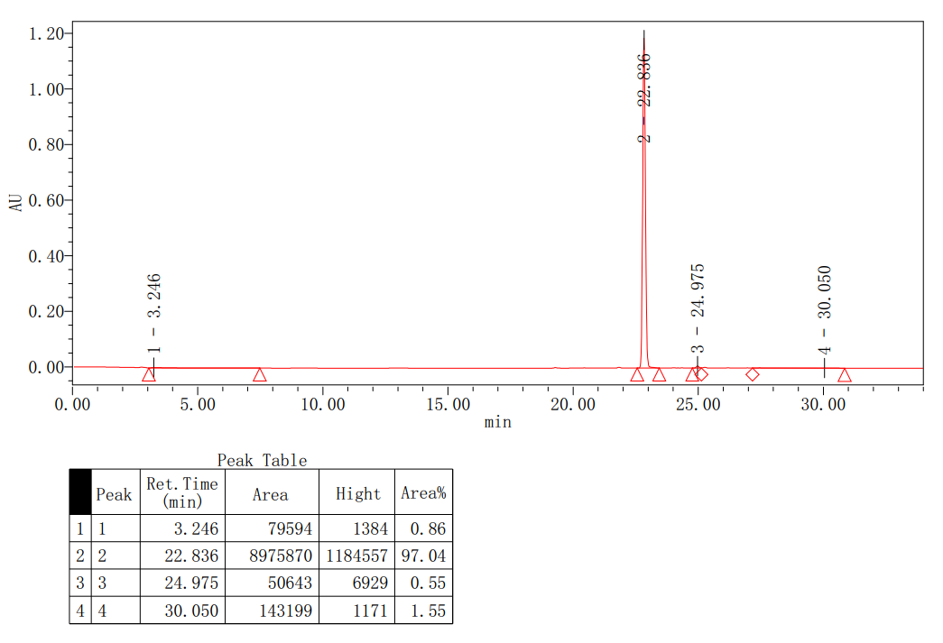
HPLC spectrum of compound S01
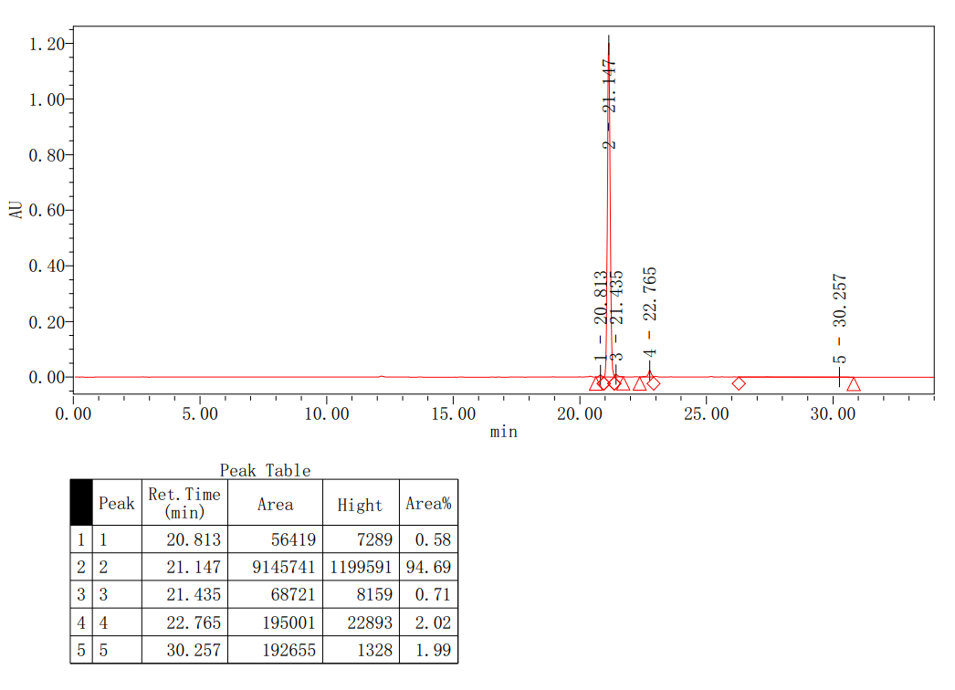
HPLC spectrum of compound S02
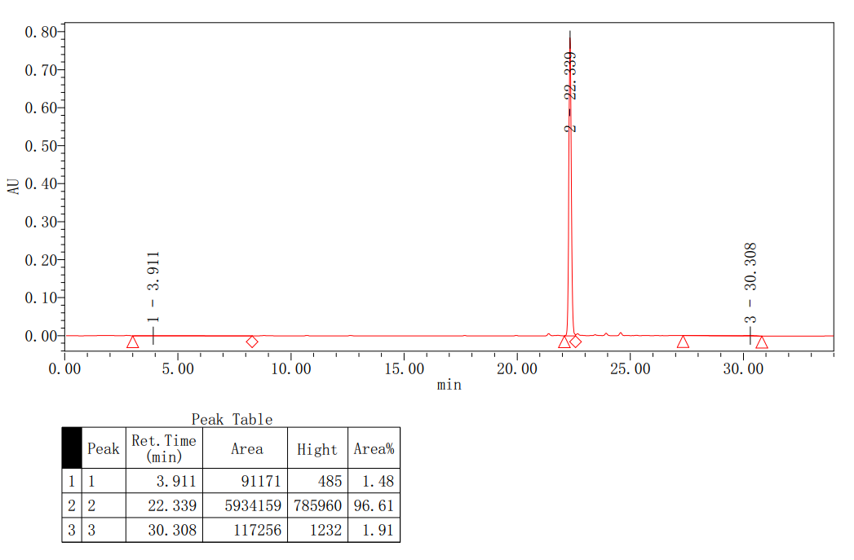
HPLC spectrum of compound S03
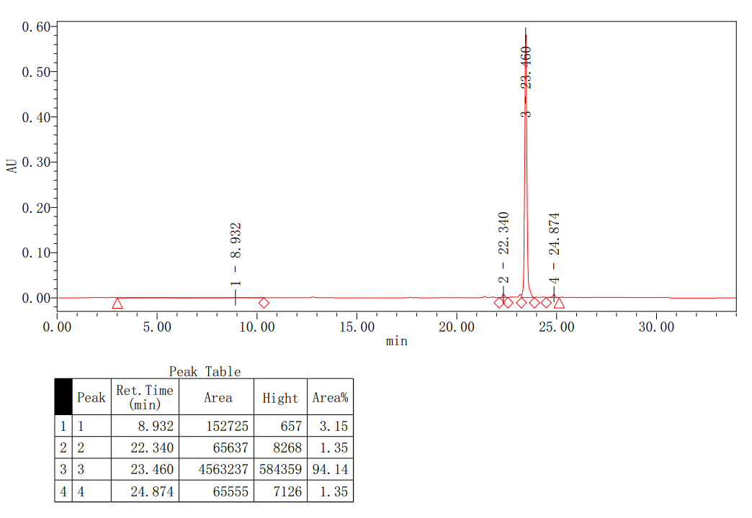
HPLC spectrum of compound S04
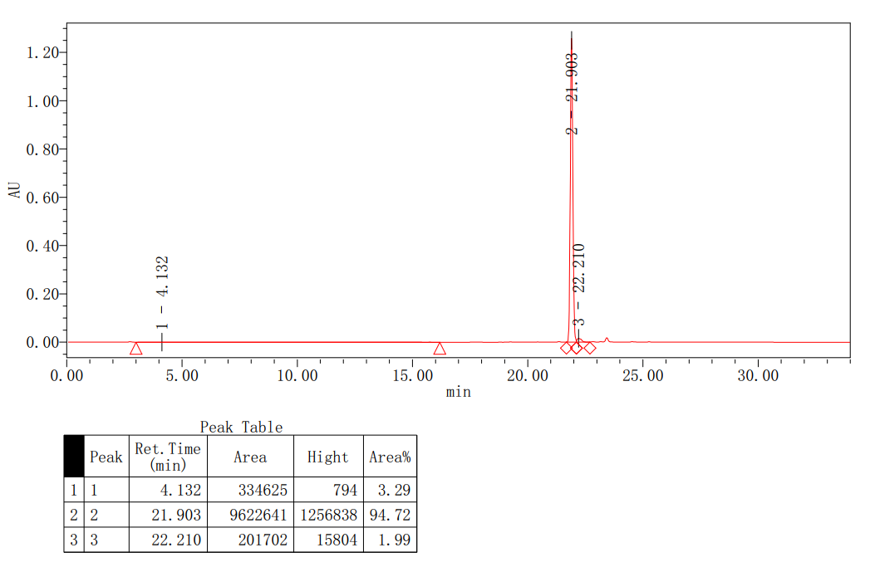
HPLC spectrum of compound S05
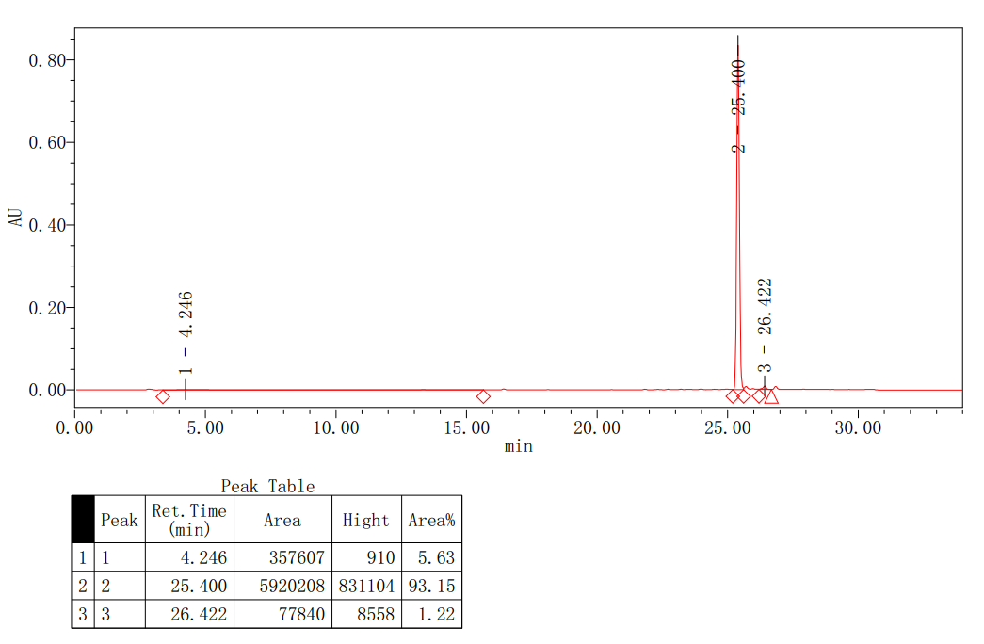
HPLC spectrum of compound S06
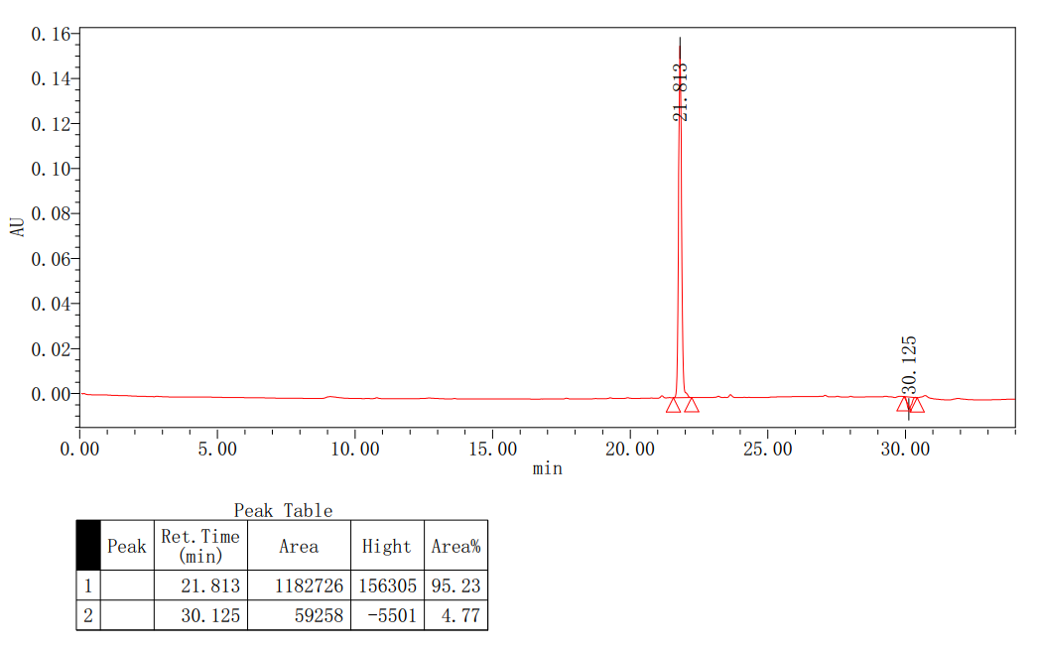
HPLC spectrum of compound S07
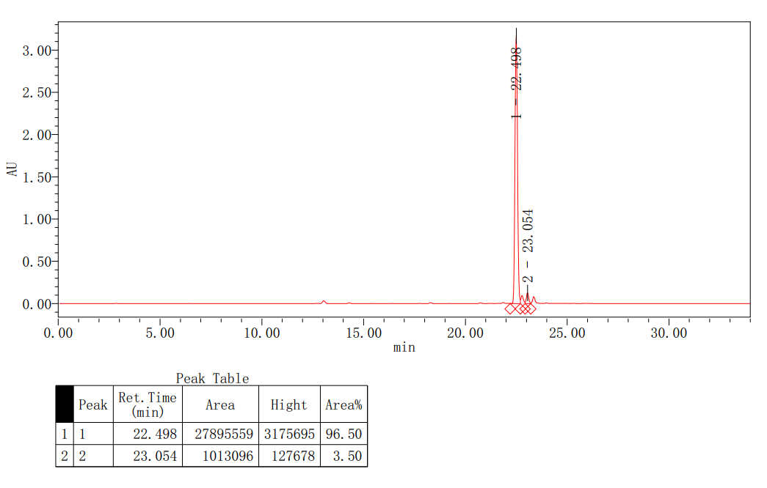
HPLC spectrum of compound S08

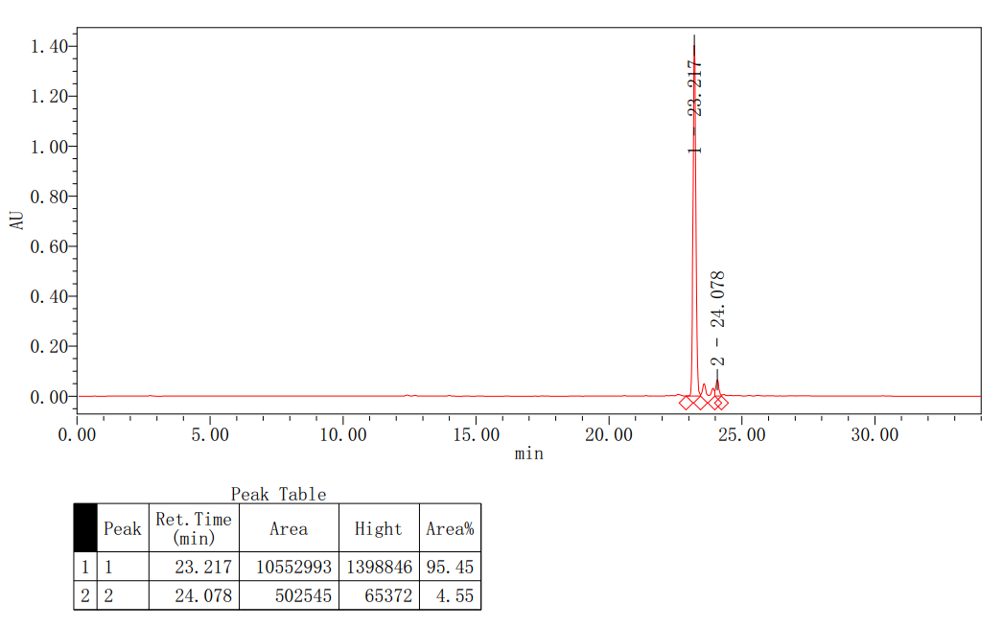
HPLC spectrum of compound S09
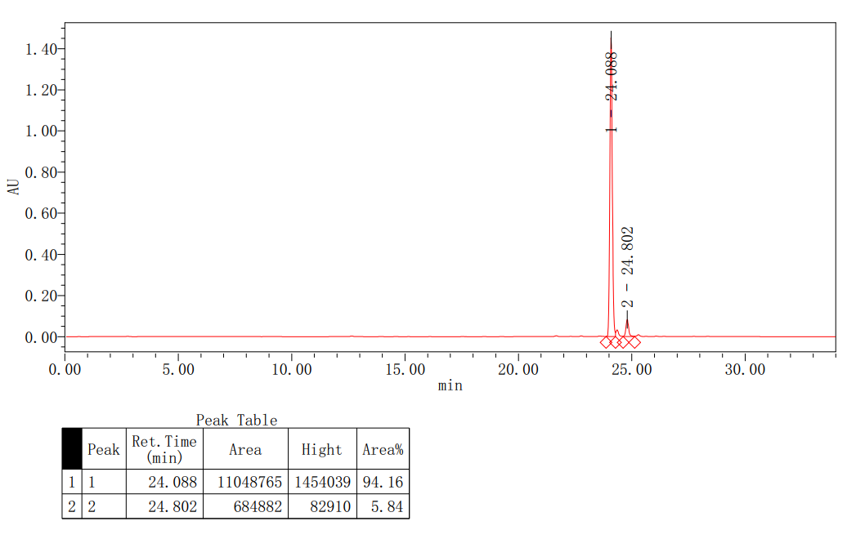
HPLC spectrum of compound S10
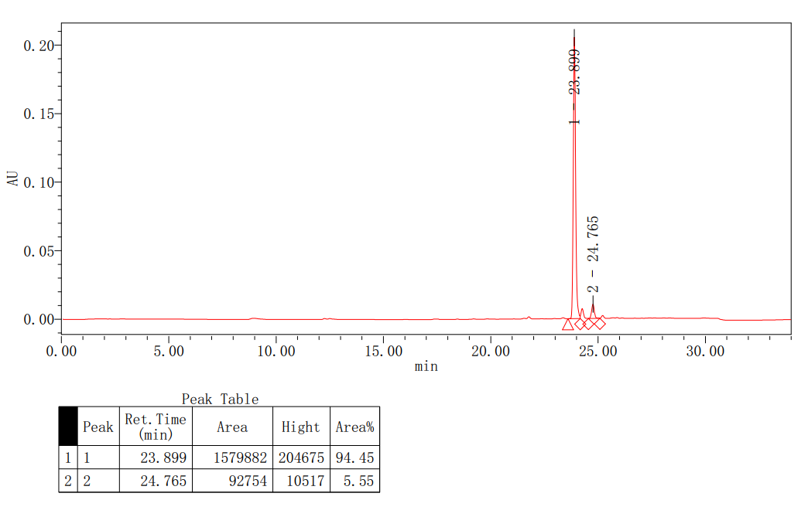
HPLC spectrum of compound S11
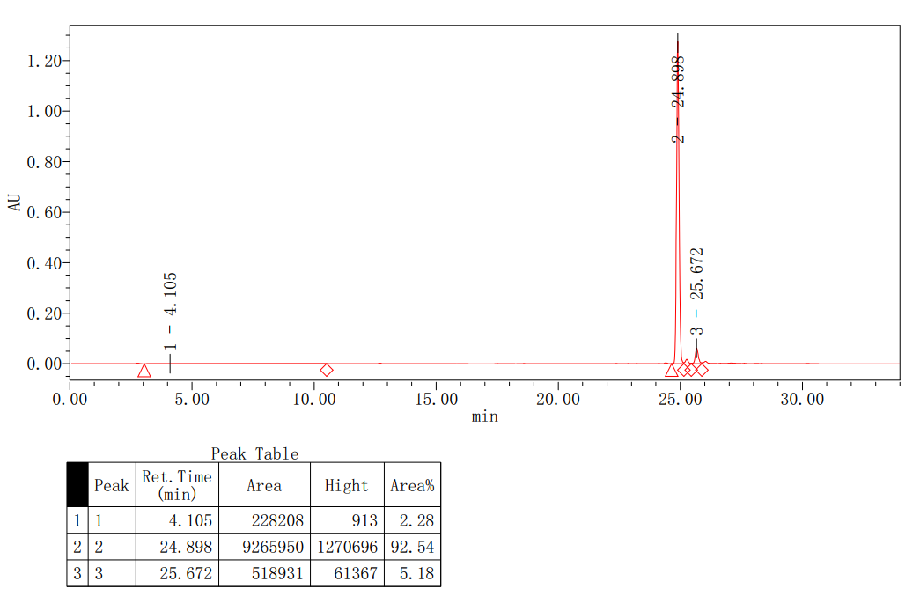
HPLC spectrum of compound S12
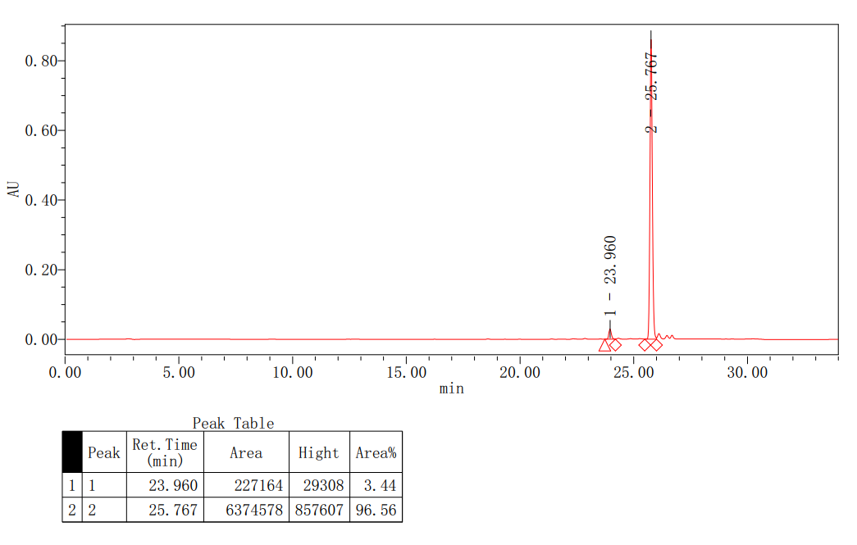
HPLC spectrum of compound S13
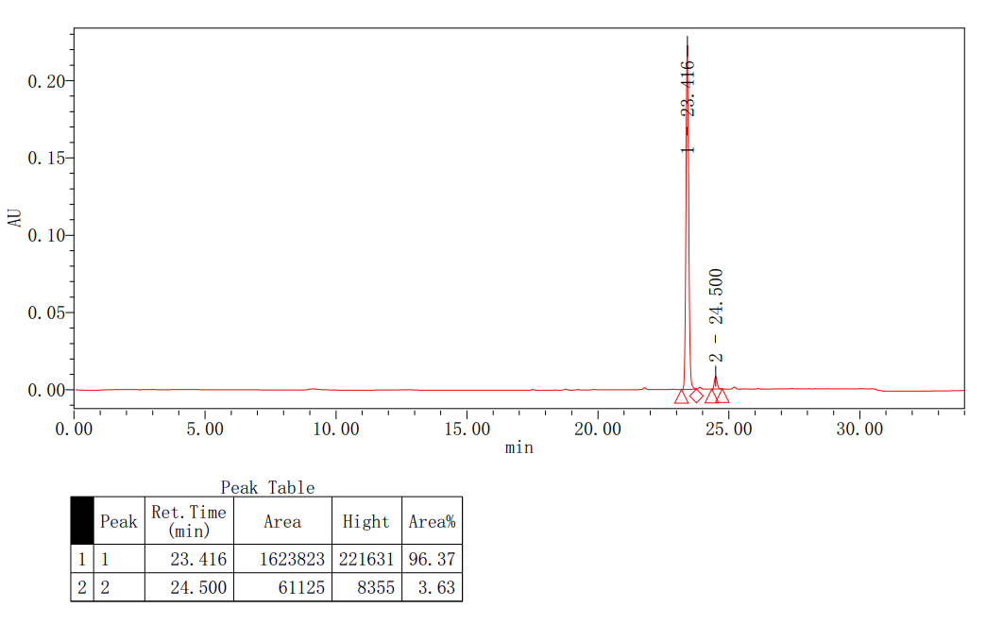
HPLC spectrum of compound S14
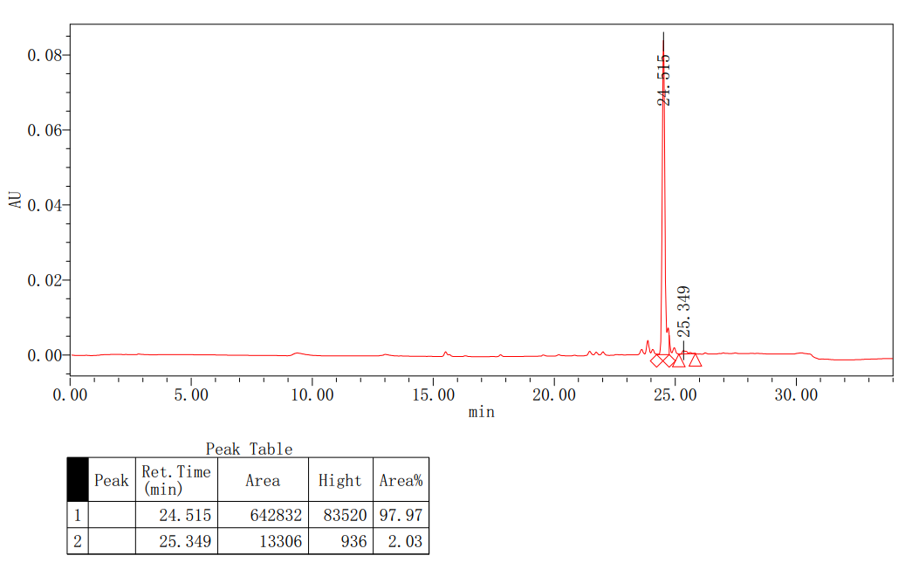
HPLC spectrum of compound S15
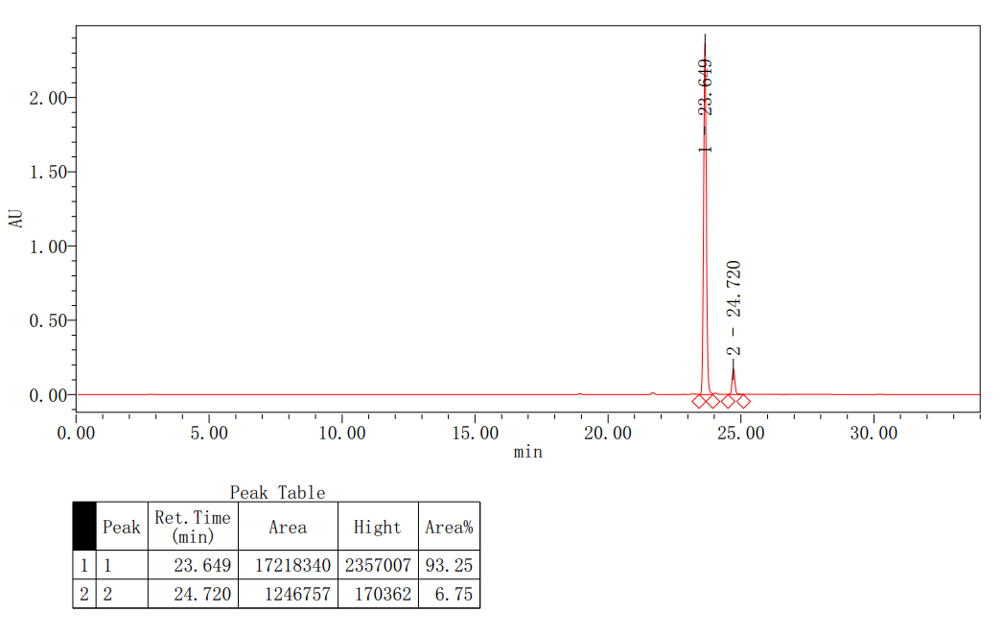
HPLC spectrum of compound S16
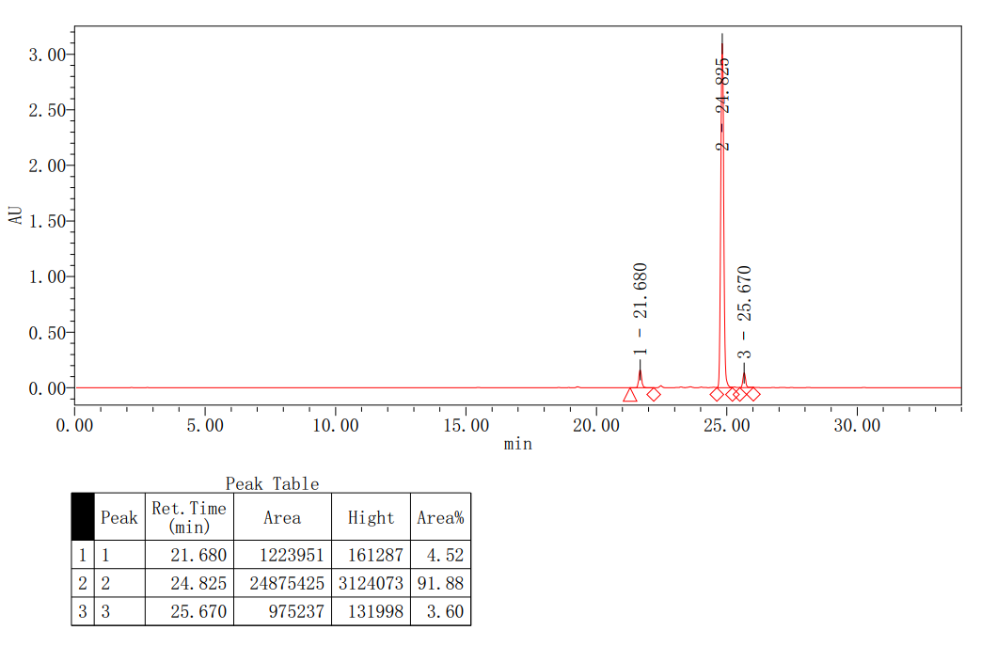
HPLC spectrum of compound S17
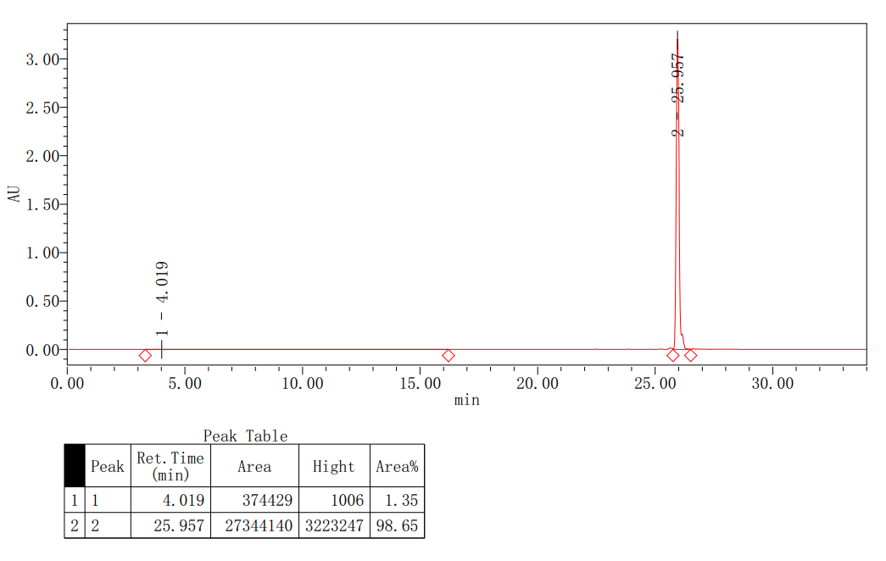
HPLC spectrum of compound S18
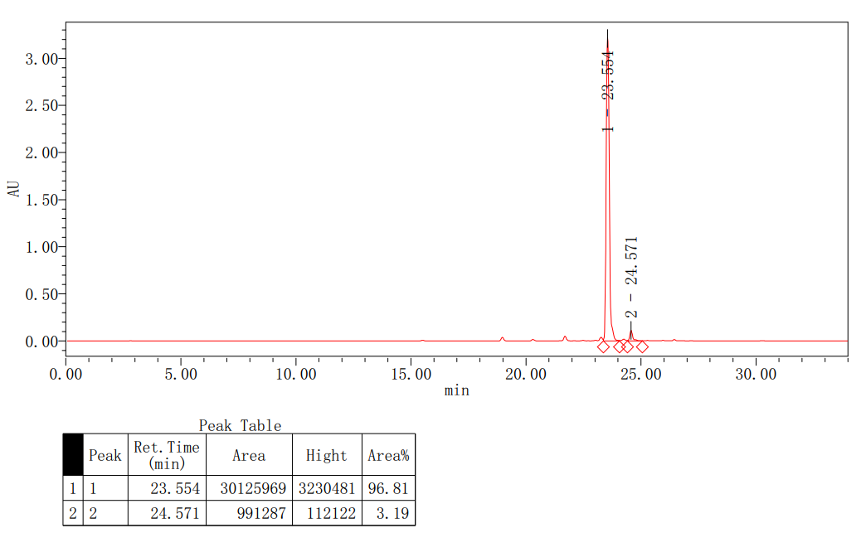
HPLC spectrum of compound S19
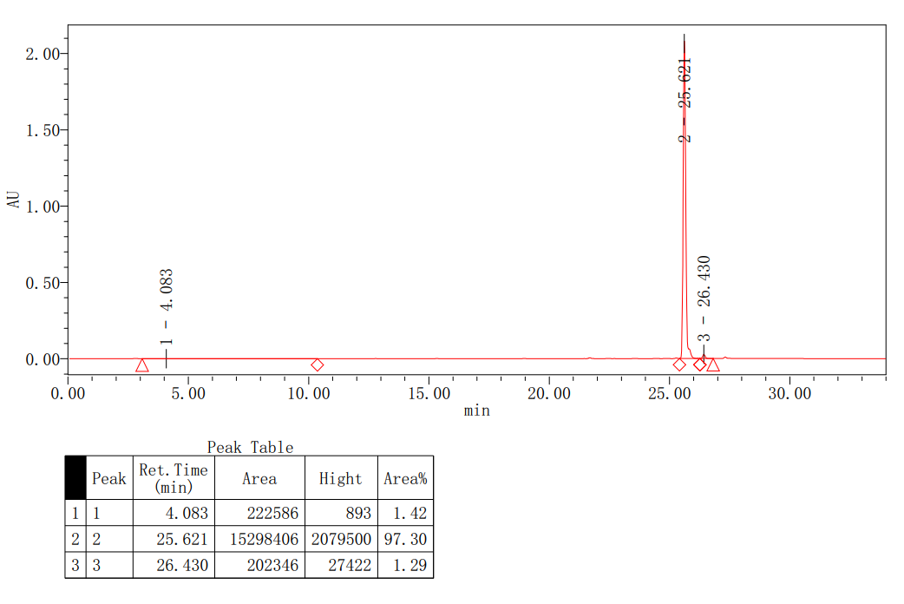
HPLC spectrum of compound S20
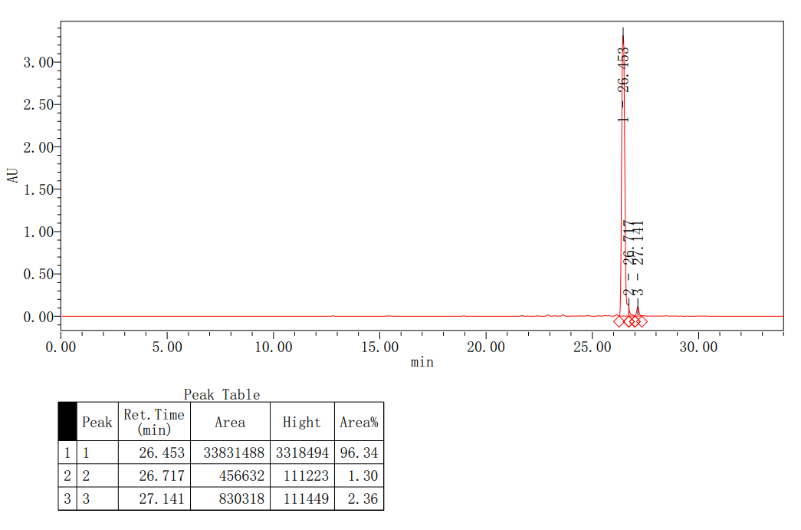
HPLC spectrum of compound S21

