**Design, synthesis, and evaluation of novel 3-(piperazin-1-yl)propan-2-ol-modified carbazole derivatives targeting the bacterial membrane**

Si-Yue Ma†, Ying-Guo Ding†, Xin-Xin Tuo, Guo-Qing Wang, Hong-Wu Liu, Jiao Meng, Tai-Hong Zhang, Li-Wei Liu, Pu-Ying Qi, Xiang Zhou*, Song Yang*

National Key Laboratory of Green Pesticide, Key Laboratory of Green Pesticide and Agricultural Bioengineering, Ministry of Education, Center for R&D of Fine Chemicals of Guizhou University, Guiyang, 550025, China.

†The two authors contributed equally to this work.

* Corresponding author.

E-mail: jhzx.msm@gmail.com or [syang@gzu.edu.cn](mailto:syang@gzu.edu.cn) (S. Yang);

xiangzhou@gzu.edu.cn or zhoux1534@163.com (X. Zhou)

Contents

1. Compound **B16** interacts with the DNA of *Xoo*. 3

2. The Phytotoxicity test on rice plant. 4

3. The metabolism property of compound **B16**. 5

4. The metabolism property of compound **B16**. 6

5. Characterization data of target compounds 7

5.1 Characterization data of other intermediates and target compounds 7

5.2. 1H NMR, 13C NMR, and HRMS spectra for the target compounds 24

1. Compound B16 interacts with the DNA of *Xoo*.

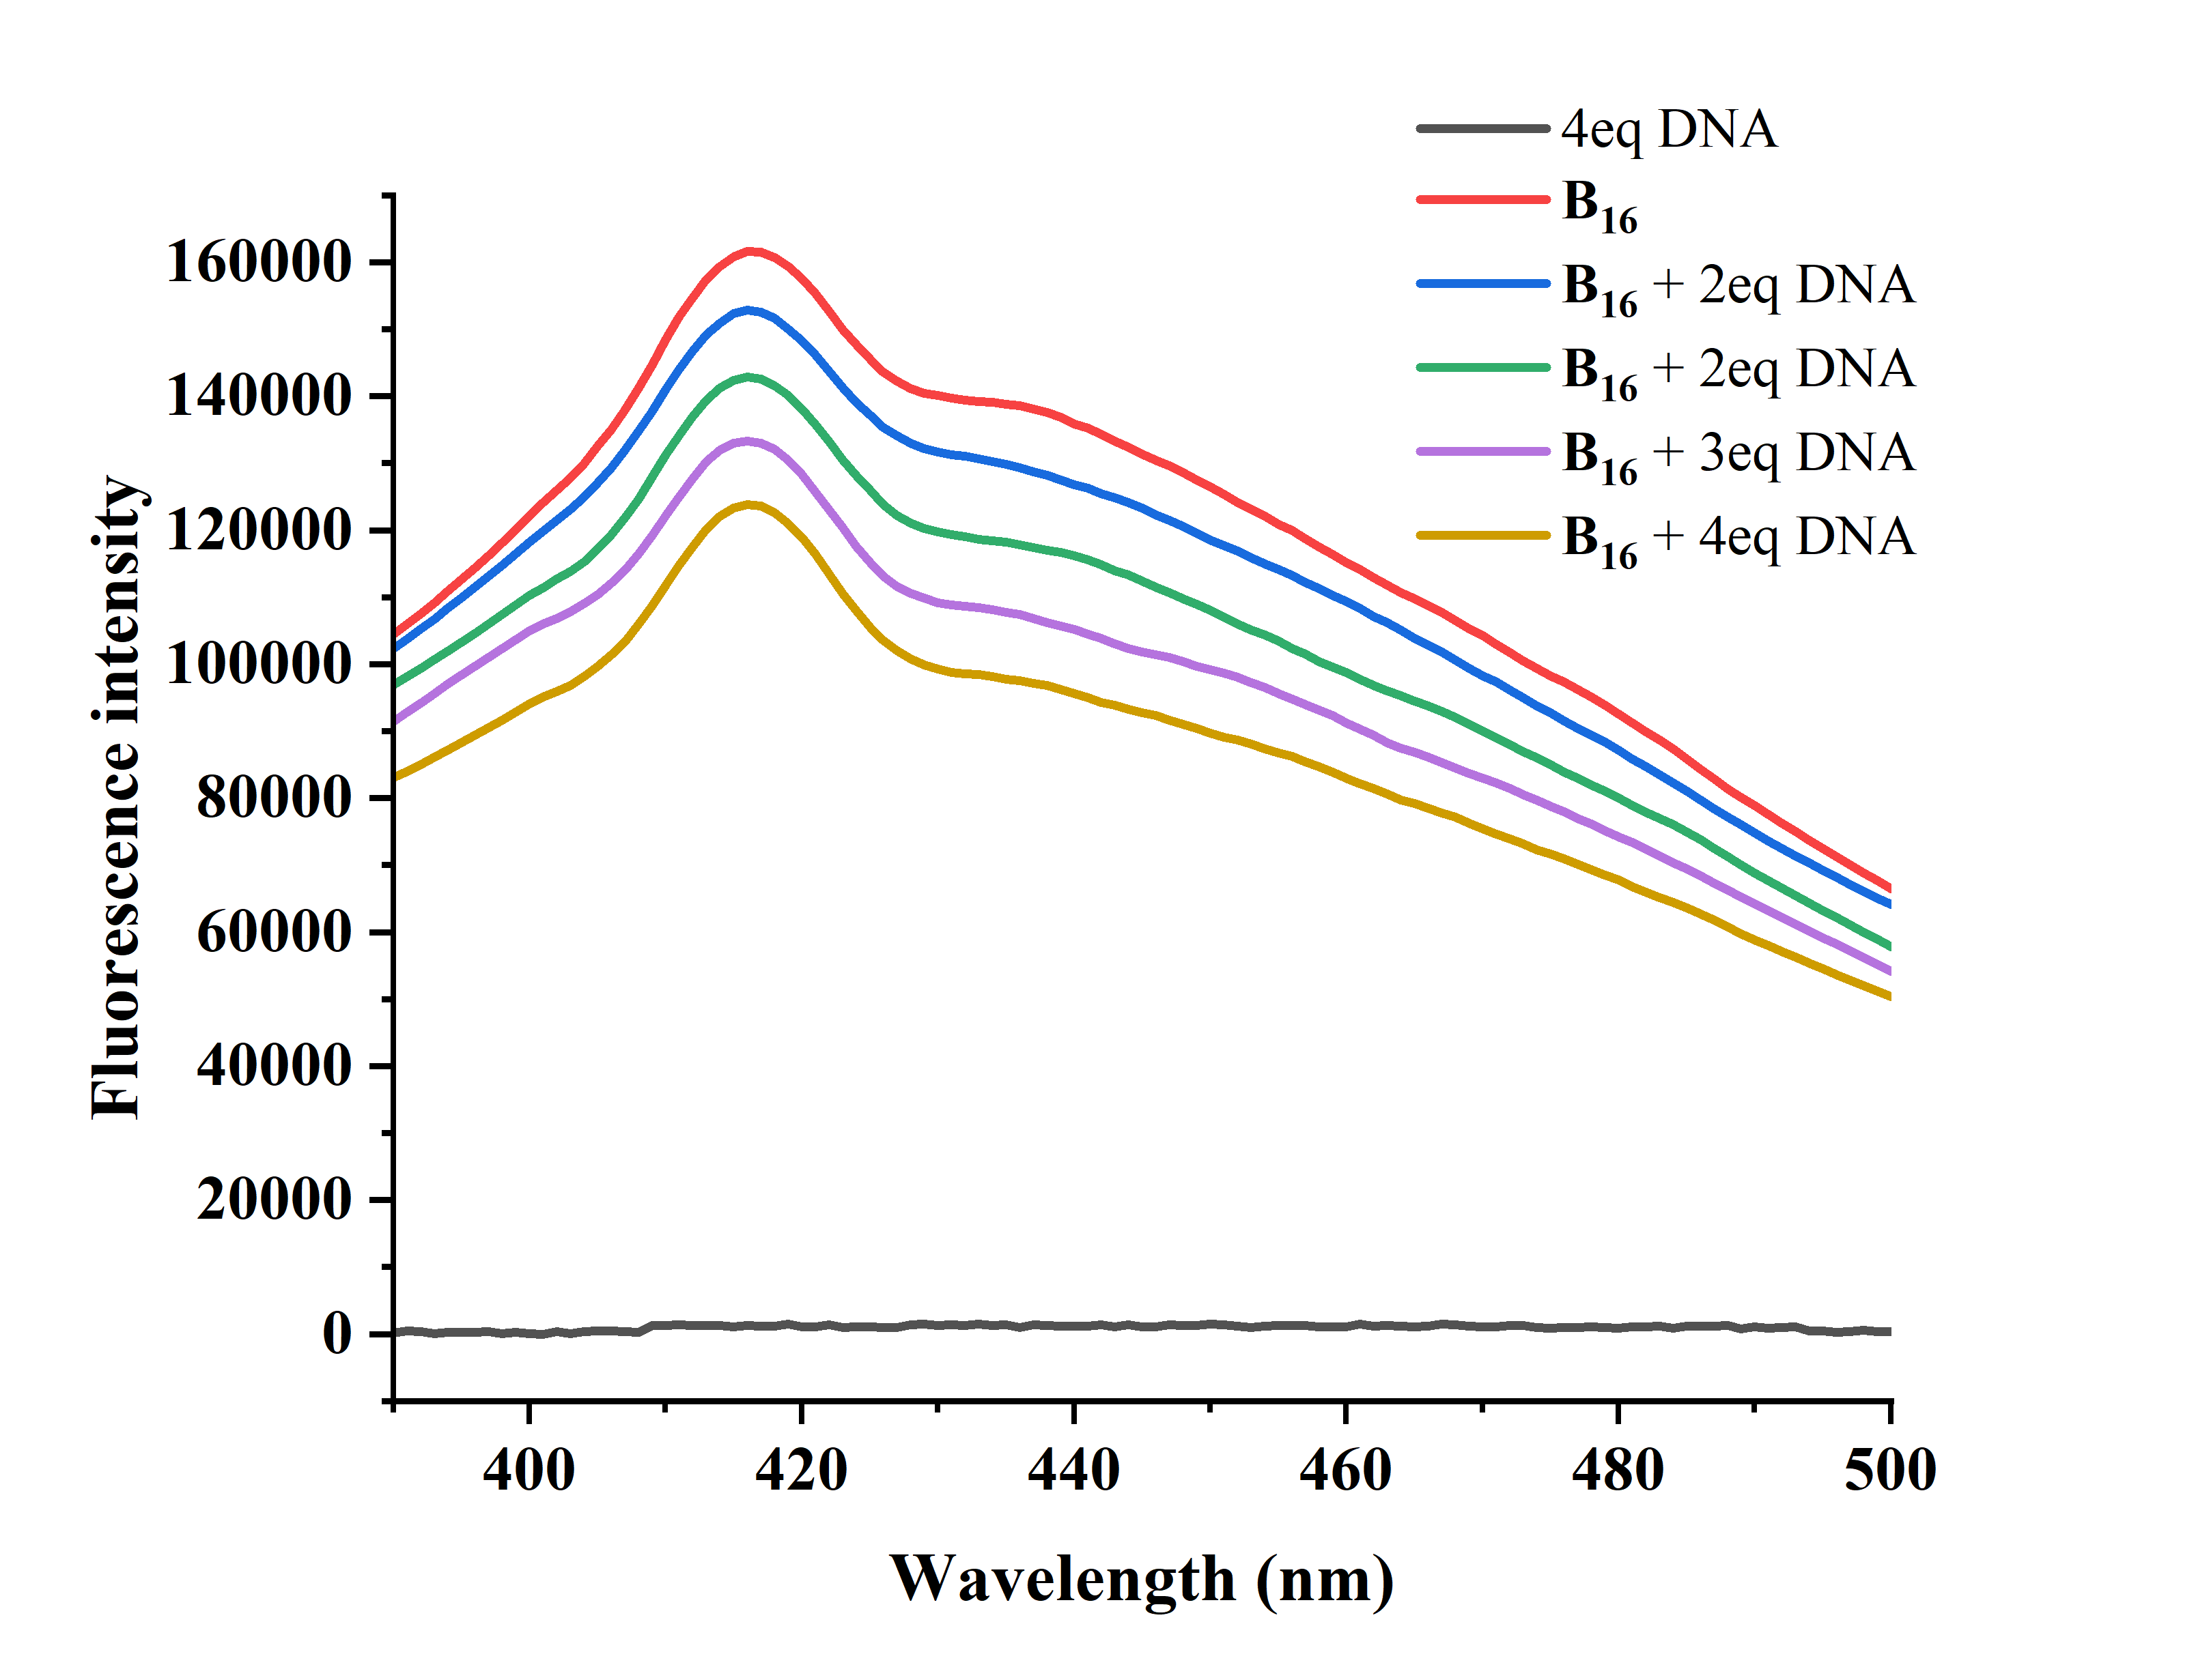

**Figure S1.** Fluorescence spectra for concentration dependent fluorescent intensity of compound **B16** with different dosages of DNA..

1. The Phytotoxicity test on rice plant.

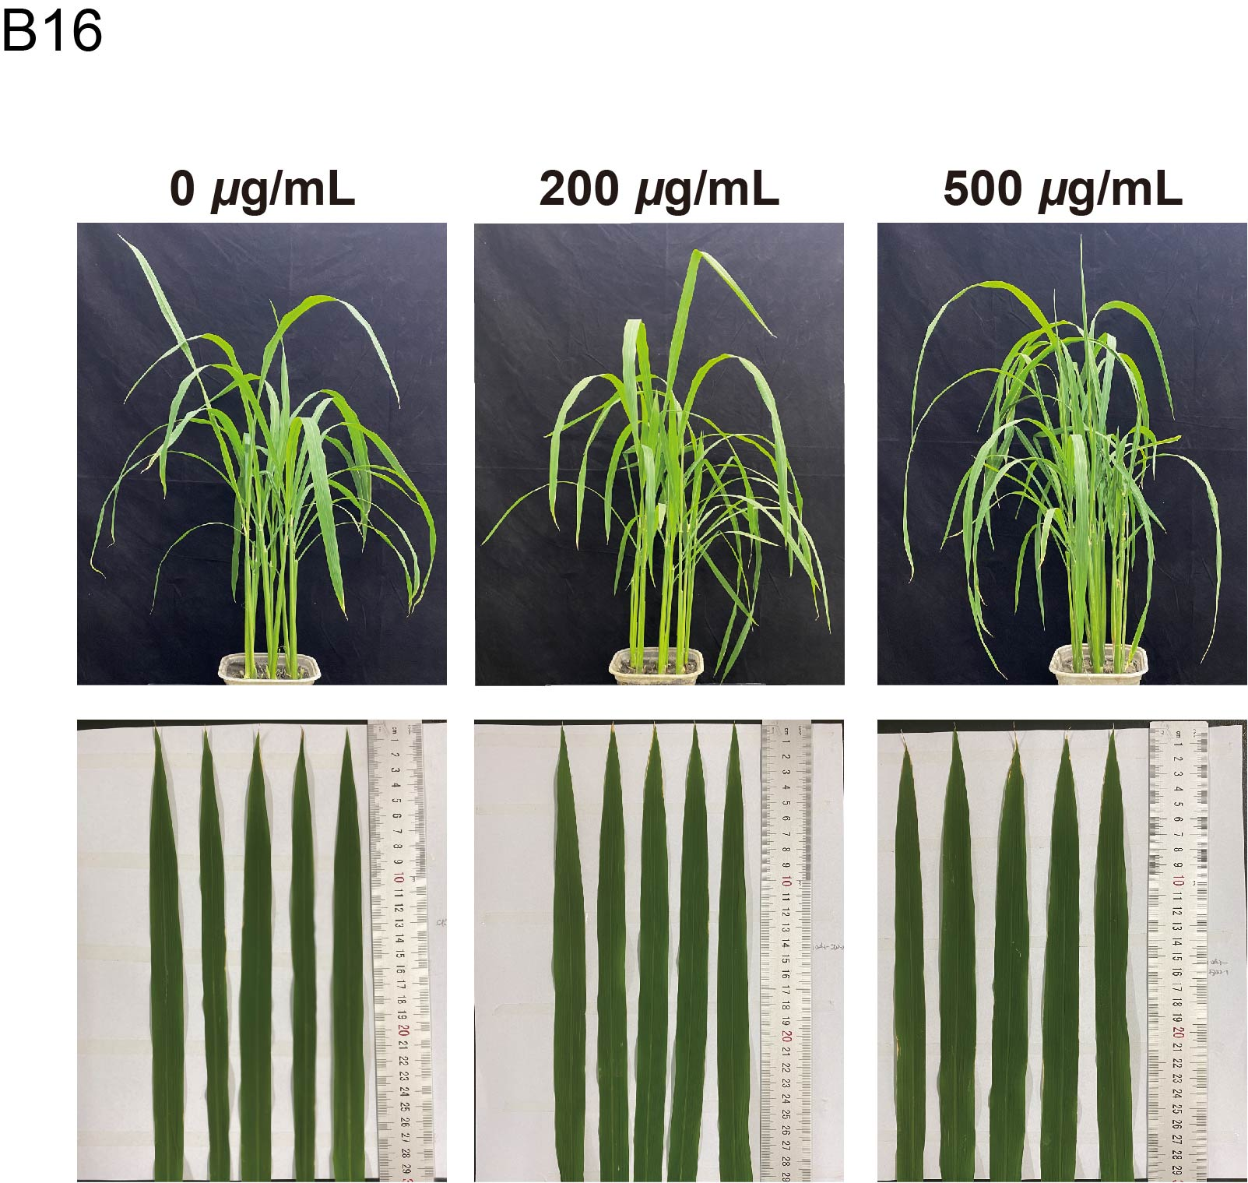

**Figure S2.** Phytotoxicity test of **B16** on rice plants after treatment for 7 d at the concentration of 200 and 500 μg/mL, respectively.

2. The metabolism property of compound B16.

**Table S1** The metabolism property of compound **B16** through the online prediction tool ADMETlab 2.0.

|  |  |  |
| --- | --- | --- |
| Metabolism Property | Value | Decision |
| Metabolism |  |  |
| CYP1A2 inhibitor | 0.682 |  |
| CYP1A2-substrate | 0.123 |  |
| CYP2C19-inhibitor | 0.478 |  |
| CYP2C19-substrate | 0.921 |  |
| CYP2C9-inhibitor | 0.024 |  |
| CYP2C9-substrate | 0.108 |  |
| CYP2D6-inhibitor | 0.985 |  |
| CYP2D6-substrate | 0.921 |  |
| CYP3A4-inhibitor | 0.175 |  |
| CYP3A4-substrate | 0.919 |  |

3. The metabolism property of compound B16.

**Table S2** ADMET and drug-like properties of compound **B16** *via* the online prediction tool ADMETlab 2.0.

|  |  |  |  |
| --- | --- | --- | --- |
| **Property** | | **Value** | **Decision** |
| Absorption | Caco-2 Permeability | -5.629 | Medium |
| Madin–Darby canine kidney cells (MDCK) (Pgp) permeability | 0.000015 | Excellent |
| Human intestinal absorption (HIA) | 0.288 | Excellent |
| Distribution | Plasma protein binding(PPB) | 94.71 | Bad |
| Volume distribution (VD) | 1.282 | Excellent |
| Excretion |  |  |
| Clearance | 10.65 | Excellent |
| The half-life (T1/2) | 0.023 |  |
| Toxicity | Rat oral acute toxicity | 0.927 | Bad |
| Skin sensitization | 0.311 | Medium |
| Eye corrosion | 0.003 | Excellent |
| Eye irritation | 0.006 | Excellent |
| Respiratory toxicity | 0.601 | Medium |
| Drug-likeness | Lipinski rule | Accepted | Excellent |
| Golden triangle | Accepted | Excellent |

4. Characterization data of target compounds

4.1 Characterization data of other intermediates and target compounds

**1-(4-(3-(9*H*-carbazol-9-yl)-2-hydroxypropyl)piperazin-1-yl)-3-(propylamino)propan-2-ol (B1)**

A yellow oil, yield 53.7%; 1H NMR (400 MHz, DMSO-*d*6, ppm) δ 8.13 (d, *J* = 7.6 Hz, 2H, carbazol-H), 7.62 (d, *J* = 8.2 Hz, 2H, carbazol-H), 7.45 – 7.40 (m, 2H, carbazol-H), 7.21 – 7.16 (m, 2H, carbazol-H), 4.93 (s, 1H, OH), 4.47 (dd, *J* = 14.8, 3.9 Hz, 1H, carbazol-CH2), 4.27 (dd, *J* = 14.8, 6.8 Hz, 1H, carbazol-CH2), 4.05 (s, 1H, CH2-CH-CH2), 3.68 (dt, *J* = 10.6, 5.3 Hz, 1H, OH), 2.58 (dd, *J* = 11.7, 4.2 Hz, 1H, CH2-CH-CH2), 2.49 – 2.35 (m, 10H, piperazine-H + piperazin-CH2-2H), 2.33 (d, *J* = 5.7 Hz, 1H, CH2-piperazine-H ), 2.28 (d, *J* = 5.9 Hz, 2H, CH-CH2-CH3), 1.47 – 1.36 (m, 2H, CH2-CH2-CH3), 0.86 (t, *J* = 7.4 Hz, 3H, CH2-CH3); 13C NMR (101 MHz, DMSO-*d*6, ppm) δ 141.18, 125.89, 122.51, 120.47, 119.05, 110.30, 67.70, 66.94, 63.47, 62.44, 54.82, 54.13, 54.05, 51.68, 48.09, 22.94, 12.21; HRMS (ESI): m/z calcd for C25H37O2N4: 425.2911; found: 425.2903; HRMS (ESI) [M+H]+ calcd for C25H37O2N4: 425.2911; found: 425.2903**.**

**1-(4-(3-(9*H*-carbazol-9-yl)-2-hydroxypropyl)piperazin-1-yl)-3-(2-methylpiperidin-1-yl)propan-2-ol (B2)**

A yellow oil, yield 64.0%; 1H NMR (400 MHz, DMSO-*d*6, ppm) δ 8.12 (d, *J* = 7.7 Hz, 2H, carbazol-H), 7.63 (d, *J* = 8.3 Hz, 2H, carbazol-H), 7.45 – 7.40 (m, 2H, carbazol-H), 7.17 (dd, *J* = 11.0, 3.8 Hz, 2H, carbazol-H), 4.96 (s, 1H, OH), 4.46 (dd, *J* = 14.7, 4.0 Hz, 1H, carbazol-CH2), 4.28 (dd, *J* = 14.7, 6.8 Hz, 1H, carbazol-CH2), 4.06 (s, 1H, CH2-CH-CH2), 3.80 (d, *J* = 4.1 Hz, 1H, CH2-CH-CH2), 2.96 (s, 2H, CH-CH2-piperazine-2H), 2.80 – 2.60 (m, 2H, piperazin-CH2-2H), 2.41 (dd, *J* = 18.3, 11.5 Hz, 8H, piperazine-H), 2.35 – 2.28 (m, 3H, piperidine-H + piperazin-CH2-CH), 2.27 – 2.20 (m, 1H, piperazin-CH2-CH), 1.59 (d, *J* = 8.4 Hz, 2H, piperidine-H), 1.53 (s, 2H, piperidine-H), 1.29 (d, *J* = 5.9 Hz, 2H, piperidine-H), 1.05 (d, *J* = 6.0 Hz, 3H, 2-methylpiperidin-H); 13C NMR (101 MHz, DMSO-*d*6, ppm) δ 141.17, 125.90, 122.52, 120.47, 119.06, 110.31, 67.67, 63.18, 63.06, 62.39, 58.41, 56.74, 54.07, 54.00, 53.93, 52.64, 48.07, 33.47, 25.23, 23.04; HRMS (ESI) [M+H]+calcd for C28H41O2N4: 465.3224; found: 465.3217.

**1-(4-(3-(9*H*-carbazol-9-yl)-2-hydroxypropyl)piperazin-1-yl)-3-(3-methylpiperidin-1-yl)propan-2-ol (B3)**

A yellow oil, yield 56.6%; 1H NMR (400 MHz, DMSO-*d*6, ppm) δ 8.12 (d, *J* = 7.6 Hz, 2H, carbazol-H), 7.62 (d, *J* = 8.3 Hz, 2H, carbazol-H), 7.45 – 7.39 (m, 2H, carbazol-H), 7.17 (dd, *J* = 11.0, 3.9 Hz, 2H, carbazol-H), 4.93 (d, *J* = 4.7 Hz, 1H, OH), 4.46 (dd, *J* = 14.8, 3.9 Hz, 1H, carbazol-CH2), 4.31 – 4.23 (m, 1H, carbazol-CH2), 4.15 (s, 1H, OH), 4.05 (s, 1H, carbazol-CH2), 3.78 – 3.71 (m, 1H, CH2-CH-CH2), 2.77 (d, *J* = 9.3 Hz, 1H, piperazin-CH2-2H), 2.48 – 2.34 (m, 8H, piperazine-H), 2.32 – 2.23 (m, 3H, piperidine-H + piperazin-CH2-CH), 2.22 – 2.15 (m, 2H, piperidine-CH2), 1.94 – 1.82 (m, 1H, piperidine-H), 1.65 – 1.52 (m, 4H, piperidine-H), 1.49 – 1.38 (m, 1H, piperidine-H), 0.81 (d, *J* = 6.1 Hz, 4H, 2-methylpiperidin-H + piperidine-H);

13C NMR (101 MHz, DMSO-*d*6, ppm) δ 141.18, 125.89, 122.51, 120.47, 119.05, 110.30, 67.69, 63.84, 63.45, 62.87, 62.44, 54.87, 54.33, 54.12, 53.99, 48.09, 32.99, 31.10, 31.06, 25.53, 20.03; HRMS (ESI) [M+H]+calcd for C28H41O2N4: 465.3224; found: 465.3217.

**1-(4-(3-(9*H*-carbazol-9-yl)-2-hydroxypropyl)piperazin-1-yl)-3-(4-methylpiperidin-1-yl)propan-2-ol (B4)**

A yellow oil, yield 30.0%; 1H NMR (500 MHz, DMSO-*d*6, ppm) δ 8.12 (d, *J* = 7.7 Hz, 2H, carbazol-H), 7.62 (d, *J* = 8.3 Hz, 2H, carbazol-H), 7.43 (td, *J* = 7.1, 3.6 Hz, 2H, carbazol-H), 7.20 – 7.15 (m, 2H, carbazol-H), 4.92 (s, 1H, OH), 4.47 (dd, *J* = 14.8, 3.9 Hz, 1H, carbazol-CH2), 4.27 (dd, *J* = 14.8, 6.9 Hz, 1H, carbazol-CH2), 4.05 (s, 1H, CH2-CH-CH2), 3.78 – 3.71 (m, 1H, CH2-CH-CH2), 2.82 (d, *J* = 2.6 Hz, CH-CH2-(4-methylpiperidin)-H), 2.49 – 2.33 (m, 8H, piperazine-H), 2.30 (ddd, *J* = 13.6, 8.9, 3.2 Hz, 3H, piperidine-H), 2.20 (dt, *J* = 12.7, 7.5 Hz, 2H, ), 2.01 – 1.87 (m, 2H, piperidine-3-H), 1.54 (d, *J* = 11.3 Hz, 2H, CH-CH2-piperidine), 1.35 – 1.24 (m, ), 1.17 – 1.06 (m, 2H, piperidine-H), 0.87 (d, *J* = 6.5 Hz, 3H, 4-methylpiperidin-H); 13C NMR (126 MHz, DMSO-*d*6, ppm) δ 141.24, 125.94, 122.58, 120.53, 119.10, 110.37, 67.76, 65.71, 63.75, 63.51, 62.50, 54.83, 54.30, 54.20, 54.06, 48.16, 34.56, 30.76, 22.40; HRMS (ESI) [M+H]+ calcd for C28H41O2N4: 465.3224; found: 465.3216.

**1-(4-(3-(9*H*-carbazol-9-yl)-2-hydroxypropyl)piperazin-1-yl)-3-(4-ethylpiperazin-1-yl)propan-2-ol (B5)**

A yellow oil, yield 28.0%; 1H NMR (400 MHz, DMSO-*d*6, ppm) δ 8.13 (d, *J* = 7.6 Hz, 2H, carbazol-H), 7.62 (d, *J* = 8.3 Hz, 2H, carbazol-H), 7.45 – 7.40 (m, 2H, carbazol-H), 7.17 (dd, *J* = 11.0, 3.9 Hz, 2H, carbazol-H), 4.91 (s, 1H, OH), 4.47 (dd, *J* = 14.8, 3.9 Hz, 1H, carbazol-CH2), 4.27 (dd, *J* = 14.8, 6.8 Hz, 1H), 4.16 (s, 1H, OH), 4.05 (s, 1H, CH2-CH-CH2), 3.78 – 3.70 (m, 1H, CH2-CH-CH2), 2.47 – 2.36 (m, 12H, piperazine-H + piperazine-CH2-CH-2H + CH-CH2-piperazine-2H), 2.34 – 2.16 (m, 11H, piperazine-H + piperazine-CH2-CH3), 0.97 (t, *J* = 7.1 Hz, 3H, CH2-CH3);

13C NMR (101 MHz, DMSO-*d*6, ppm) δ 141.18, 125.89, 122.52, 120.47, 119.05, 110.31, 67.70, 65.71, 63.37, 62.44, 55.38, 54.12, 53.99, 53.88, 52.92, 52.11, 48.10, 12.45; HRMS (ESI) [M+H]+ calcd for C28H42O2N5: 480.3333; found: 480.3325.

**1-(4-(3-(9*H*-carbazol-9-yl)-2-hydroxypropyl)piperazin-1-yl)-3-(4-isopropylpiperazin-1-yl)propan-2-ol (B6)**.

A yellow oil, yield 74.3%; 1H NMR (400 MHz, DMSO-*d*6, ppm) δ 8.24 (t, *J* = 6.2 Hz, 1H, N-H), 8.13 (d, *J* = 7.7 Hz, 2H, carbazol-H), 7.62 (d, *J* = 8.3 Hz, 2H, carbazol-H), 7.46 – 7.39 (m, 2H, carbazol-H), 7.31 – 7.26 (m, 2H, benzyl-H), 7.18 (t, *J* = 7.2 Hz, 2H, carbazol-H), 7.12 (t, *J* = 8.9 Hz, 2H, benzyl-H), 4.96 (s, 1H, OH), 4.46 (dd, *J* = 14.8, 4.1 Hz, 1H, carbazol-CH2), 4.30 (d, *J* = 6.8 Hz, 1H, NH-CH2), 4.27 (d, *J* = 6.2 Hz, 2H, carbazol-CH2), 4.07 (s, 1H, CH2-CH-CH2), 2.97 (s, 2H, piperazine-CH2-amide), 2.51 (d, *J* = 1.7 Hz, 2H, CH-CH2-piperazine), 2.49 – 2.31 (m, 8H, piperazine-H); 13C NMR (101 MHz, DMSO-*d*6, ppm) δ 169.84, 141.16, 136.44, 129.68, 129.60, 125.91, 122.52, 120.48, 119.07, 115.51, 115.30, 110.30, 67.62, 62.32, 61.73, 53.78, 53.44, 48.04, 41.62; 19F NMR (377 MHz, DMSO) δ -73.43, -116.28; HRMS (ESI) [M+H]+ calcd for C28H32O2N4F: 475.2504; found: 475.2491.

**1-(4-(3-(4-(3-(9*H*-carbazol-9-yl)-2-hydroxypropyl)piperazin-1-yl)-2-hydroxypropyl)piperazin-1-yl)ethan-1-one (B7)**

A yellow oil, yield 45.0%;  1H NMR (500 MHz, DMSO-*d*6, ppm) δ 8.13 (d, *J* = 7.6 Hz, 2H, carbazol-H), 7.62 (d, *J* = 8.3 Hz, 2H, carbazol-H), 7.45 – 7.39 (m, 2H, carbazol-H), 7.18 (t, *J* = 7.4 Hz, 2H, carbazol-H), 4.92 (d, *J* = 4.3 Hz, 1H, OH), 4.47 (dd, *J* = 14.8, 3.9 Hz, 1H, carbazol-CH2), 4.27 (dd, *J* = 14.8, 6.8 Hz, 2H, carbazol-CH2 + CH-CH2-piperazine), 4.06 (s, 1H, CH2-CH-CH2), 3.77 (s, 1H, CH2-CH-CH2), 3.48 – 3.39 (m, CH-CH2-piperazine + piperazine-CH2 + piperazine-H), 2.42 (dd, *J* = 13.3, 8.4 Hz, 8H, piperazine-H), 2.37 – 2.29 (m, 7H, piperazine-H + 2-hydroxypropyl-H), 2.26 – 2.21 (m, 2H, piperazine-H), 1.97 (s, 3H, ethan-1-one-CH3); 13C NMR (126 MHz, DMSO-*d*6, ppm) δ 168.59, 141.24, 125.95, 122.58, 120.53, 119.11, 110.36, 67.75, 65.89, 63.35, 63.25, 62.49, 54.16, 54.03, 53.69, 48.15, 46.25, 41.43, 21.70; HRMS (ESI) [M+H]+calcd for C28H40O3N5: 494.3126; found: 494.3130.

**1-(4-(3-(9*H*-carbazol-9-yl)-2-hydroxypropyl)piperazin-1-yl)-3-morpholinopropan-2-ol (B8)**

A yellow oil, yield 38.7%; 1H NMR (400 MHz, DMSO-*d*6, ppm) δ 8.13 (d, *J* = 7.6 Hz, 2H, carbazol-H), 7.62 (d, *J* = 8.3 Hz, 2H, carbazol-H), 7.46 – 7.39 (m, 2H, carbazol-H), 7.17 (dd, *J* = 11.0, 3.9 Hz, 2H, carbazol-H), 4.95 (s, 1H, OH), 4.46 (dd, *J* = 14.7, 3.8 Hz, 1H, carbazol-CH2), 4.27 (dd, *J* = 14.7, 6.8 Hz, 2H, carbazol-CH2 + CH-CH2-piperazine), 4.05 (s, 1H, CH2-CH-CH2), 3.77 (s, 1H, CH2-CH-CH2), 3.57 – 3.53 (m, 4H, morpholin-H), 2.41 (t, *J* = 19.0 Hz, 10H, piperazine-H + morpholin-H), 2.31 (dd, *J* = 12.7, 4.4 Hz, 3H, 2-hydroxypropyl-H), 2.27 – 2.17 (m, 2H, 2-hydroxypropyl-H); 13C NMR (101 MHz, DMSO-*d*6, ppm) δ 141.15, 125.91, 122.49, 120.50, 119.06, 110.30, 67.65, 66.69, 63.80, 63.28, 54.45, 54.02, 53.92, 48.05; HRMS (ESI) [M+H]+calcd for C26H37O3N4: 453.2860; found: 453.2848.

**1-(4-(3-(9*H*-carbazol-9-yl)-2-hydroxypropyl)piperazin-1-yl)-3-((4-methoxybenzyl)amino)propan-2-ol (B9)**

A yellow oil, yield 55.6%; 1H NMR (400 MHz, DMSO-*d*6, ppm) δ 8.13 (d, *J* = 7.7 Hz, 2H, carbazol-H), 7.62 (d, *J* = 8.2 Hz, 2H, 2H, carbazol-H), 7.46 – 7.40 (m, 2H, 2H, carbazol-H), 7.29 (d, *J* = 8.5 Hz, 2H, benzyl-H), 7.18 (t, *J* = 7.4 Hz, 2H, carbazol-H), 6.89 (d, *J* = 8.6 Hz, 2H, benzyl-H), 4.95 (s, 1H, OH), 4.46 (dd, *J* = 14.8, 3.9 Hz, 1H, carbazol-CH2), 4.27 (dd, *J* = 14.7, 6.8 Hz, 1H, carbazol-CH2), 4.05 (d, *J* = 4.9 Hz, 1H, CH2-CH-CH2), 3.79 – 3.73 (m, 2H, CH2-CH-CH2), 3.73 (s, 1H, OCH3), 3.62 (d, *J* = 63.1 Hz, 3H, NH-CH2), 2.65 (dd, *J* = 11.9, 3.9 Hz, 1H), 2.48 – 2.34 (m, 8H, piperazin-H), 2.33 – 2.28 (m, 2H, piperazine-CH2-CH); 13C NMR (101 MHz, DMSO-*d*6, ppm) δ 158.89, 141.18, 130.20, 125.89, 122.51, 120.48, 119.05, 114.08, 110.31, 67.69, 66.31, 63.18, 62.40, 55.50, 54.04, 53.97, 53.30, 52.15, 48.08; HRMS (ESI) [M+H]+calcd for C30H39O3N4: 503.3017; found: 503.3009.

**1-(4-(3-(9*H*-carbazol-9-yl)-2-hydroxypropyl)piperazin-1-yl)-3-((4-methylbenzyl)amino)propan-2-ol (B10)**

A yellow oil, yield 54.0%; 1H NMR (400 MHz, DMSO-*d*6, ppm) δ 8.13 (d, *J* = 7.6 Hz, 2H, carbazol-H), 7.63 (d, *J* = 8.2 Hz, 2H, carbazol-H), 7.43 (t, *J* = 7.1 Hz, 2H, carbazol-H), 7.35 (d, J = 7.9 Hz, 2H, benzyl-H) 7.18 (t, *J* = 7.1 Hz, 4H, carbazol-2H + benzyl-2H), 4.99 (s, 2H, 2-OH), 4.46 (dd, *J* = 14.7, 4.1 Hz, 1H, carbazol-CH2), 4.28 (dd, *J* = 14.7, 6.7 Hz, 1H, carbazol-CH2), 4.13 – 4.02 (m, 1H, CH2-CH-CH2), 3.94 (d, *J* = 3.3 Hz, 2H, NH-CH2), 3.91 (d, *J* = 7.5 Hz, 1H, CH2-CH-CH2), 3.17 (s, 1H, NH-CH), 2.84 (dd, *J* = 12.2, 3.6 Hz, 1H, piperazine-CH2-CH), 2.62 (dd, *J* = 12.2, 7.9 Hz, 1H, piperazine-CH2-CH), 2.41 – 2.31 (m, 10H, piperazine-8H + CH-CH2-NH), 2.30 (s, 1H, CH-CH2-NH), 2.29 (s, 3H, benzyl-CH3); 13C NMR (126 MHz, DMSO-*d*6, ppm) δ 141.21, 136.50, 129.29, 128.80, 125.96, 125.19, 122.54, 120.56, 119.11, 110.36, 67.72, 66.57, 63.31, 62.47, 54.05, 48.11, 22.55, 21.82, 21.25; HRMS (ESI) [M+H]+calcd for C29H37O2N4: 487.3068; found: 487.3058.

**1-(4-(3-(9*H*-carbazol-9-yl)-2-hydroxypropyl)piperazin-1-yl)-3-(benzylamino)propan-2-ol (B11)**

A yellow oil, yield 54.8%; 1H NMR (400 MHz, DMSO-*d*6, ppm) δ 8.13 (d, *J* = 7.7 Hz, 2H, carbazol-H), 7.63 (d, *J* = 8.2 Hz, 2H, carbazol-H), 7.42 (dd, *J* = 11.3, 4.1 Hz, 2H, carbazol-H), 7.34 – 7.27 (m, 4H, benzyl-H), 7.24 – 7.21 (m, 1H, benzyl-H), 7.18 (t, *J* = 7.5 Hz, 2H, carbazol-H), 4.93 (s, 1H, OH), 4.47 (dd, *J* = 14.8, 3.9 Hz, 1H, carbazol-CH2), 4.27 (dd, *J* = 14.8, 6.8 Hz, 1H, carbazol-CH2), 4.05 (s, 1H, CH2-CH-CH2), 3.74 (d, *J* = 4.0 Hz, 1H, CH2-CH-CH2), 3.70 (d, *J* = 3.9 Hz, 1H, CH2-CH-CH2), 2.57 (dd, *J* = 11.7, 4.3 Hz, 1H, piperazine-CH2-CH), 2.46 – 2.35 (m, 8H, piperazine-8), 2.29 (ddd, *J* = 19.0, 11.2, 6.2 Hz, 4H, piperazine-CH2); 13C NMR (101 MHz, DMSO-*d*6, ppm) δ 141.19, 128.57, 128.39, 127.00, 125.89, 122.52, 120.48, 119.05, 110.31, 67.69, 67.17, 63.41, 62.46, 54.25, 54.12, 54.05, 53.49, 48.10; HRMS (ESI) [M+H]+ calcd for C29H37O2N4: 473.2911; found: 473.2903.

**1-(4-(3-(9*H*-carbazol-9-yl)-2-hydroxypropyl)piperazin-1-yl)-3-((2-fluorobenzyl)amino)propan-2-ol (B12)**

A yellow oil, yield 47.9%; 1H NMR (400 MHz, DMSO-*d*6, ppm) δ 8.13 (d, *J* = 7.6 Hz, 2H, carbazol-H), 7.62 (d, *J* = 8.2 Hz, 2H, carbazol-H), 7.47 – 7.40 (m, 2H, carbazol-H), 7.27 (tdd, *J* = 7.4, 5.5, 1.8 Hz, 1H, benzyl-H), 7.20 – 7.16 (m, 1H, carbazol-H), 7.16 – 7.10 (m, 1H, benzyl-H), 4.94 (d, *J* = 5.0 Hz, 1H, OH), 4.46 (dd, *J* = 14.8, 3.8 Hz, 2H, carbazol-CH2), 4.27 (dd, *J* = 14.8, 6.8 Hz, 1H, carbazol-CH2), 4.04 (d, *J* = 4.5 Hz, 1H, CH2-CH-CH2), 3.74 (s, 1H, NH-CH2), 3.70 (s, 1H, CH2-CH-CH2), 2.56 (dd, *J* = 11.6, 4.3 Hz, 1H, CH-CH2-NH), 2.40 (ddd, *J* = 19.6, 12.0, 6.9 Hz, 8H, piperazine-H), 2.28 (ddd, *J* = 18.4, 12.5, 6.1 Hz, 4H, CH-CH2-piperazine + piperazine-CH2-CH); 13C NMR (101 MHz, DMSO-*d*6, ppm) δ 160.96 (d, 1*J* C-F = 243.5 Hz) , 141.18, 130.75 (d, 3*J*C-F = 5.0 Hz), 128.97 (d, 3*J*C-F = 8.1 Hz), 128.04 (d, 2*J*C-F = 15.0 Hz), 125.89, 124.64 (d, 4*J* C-F = 3.1 Hz), 122.51, 120.47, 119.05, 115.39 (d, 2*J*C-F= 21.8 Hz), 110.30, 67.68, 67.22, 63.37, 62.45, 55.37, 54.26, 54.10, 54.04, 48.09, 46.59; 19F NMR (377 MHz, DMSO-*d*6, ppm) δ -119.51; HRMS (ESI) [M+H]+calcd for C29H36O2N4F: 491.2817; found: 491.2807.

**1-(4-(3-(9*H*-carbazol-9-yl)-2-hydroxypropyl)piperazin-1-yl)-3-((3-fluorobenzyl)amino)propan-2-ol (B13)**

A yellow oil, yield 73.5%; 1H NMR (400 MHz, DMSO-*d*6, ppm) δ 8.13 (d, *J* = 7.6 Hz, 2H, carbazol-H), 7.63 (d, *J* = 8.2 Hz, 2H, carbazol-H), 7.47 (s, 1H, carbazol-H), 7.45 – 7.40 (m, 1H, carbazol-H), 7.27 (ddd, *J* = 7.4, 6.5, 1.7 Hz, 1H, benzyl-H), 7.18 (dd, *J* = 7.8, 4.1 Hz, 2H, carbazol-H), 7.14 (dd, *J* = 14.8, 6.7 Hz, 2H, benzyl-H), 4.92 (s, 1H, OH), 4.47 (dd, *J* = 14.7, 3.9 Hz, 1H, carbazol-CH2), 4.27 (dd, *J* = 14.8, 6.8 Hz, 1H, carbazol-CH2), 4.08 – 4.01 (m, 1H, CH2-CH-CH2), 3.74 (s, 2H, NH-CH2), 3.70 (d, *J* = 4.3 Hz, 1H, CH2-CH-CH2), 2.57 (dd, *J* = 11.6, 4.3 Hz, 1H, piperazine-CH2-CH), 2.41 (ddd, *J* = 19.5, 12.1, 6.9 Hz, 8H, piperazine-H), 2.34 – 2.24 (m, 4H, CH-CH2-piperazine + piperazine-CH2-CH); 13C NMR (101 MHz, DMSO-*d*6, ppm) δ 160.96 (d, 1*J*C-F = 243.4 Hz), 159.75, 141.19, 130.75 (d, 3*J*C-F = 4.9 Hz), 128.96 (d, 3*J*C-F = 8.3 Hz), 128.07 (d, 2*J*C-F = 14.9 Hz), 125.89, 124.64 (d, 4*J*C-F = 3.2 Hz), 122.52, 120.47, 119.05, 115.40 (d, 2*J*C-F = 21.8 Hz), 110.31, 67.69, 67.25, 67.23, 63.38, 62.46, 54.28, 54.12, 54.05, 48.09, 46.62, 46.60; 19F NMR (377 MHz, DMSO-*d*6, ppm) δ -119.51; HRMS (ESI) [M+H]+ calcd for C29H36O2N4F: 491.2817; found: 491.2808.

**1-(4-(3-(9*H*-carbazol-9-yl)-2-hydroxypropyl)piperazin-1-yl)-3-((4-fluorobenzyl)amino)propan-2-ol (B14)**

A yellow oil, yield 28.9%; 1H NMR (500 MHz, DMSO-*d*6, ppm) δ 8.13 (d, *J* = 7.7 Hz, 2H, carbazol-H), 7.62 (d, *J* = 8.2 Hz, 2H, carbazol-H), 7.43 (t, *J* = 7.6 Hz, 2H, carbazol-H), 7.35 (dd, *J* = 8.0, 6.0 Hz, 2H, benzyl-H), 7.18 (t, *J* = 7.4 Hz, 2H, carbazol-H), 7.12 (t, *J* = 8.8 Hz, 2H, benzyl-H), 4.96 (s, 1H, OH), 4.47 (dd, *J* = 14.8, 3.7 Hz, 2H, carbazol-CH2), 4.27 (dd, *J* = 14.8, 6.8 Hz, carbazol-CH2), 4.04 (s, 1H, OH), 3.71 (s, 1H, NH-CH2), 3.66 (t, *J* = 9.2 Hz, 2H, CH2-CH-CH2), 2.54 (dd, *J* = 11.6, 4.2 Hz, piperazine-CH2-CH), 2.48 – 2.34 (m, 8H, piperazine-H), 2.28 (ddd, *J* = 19.4, 12.5, 6.2 Hz, CH-CH2-piperazine + piperazine-CH2-CH); HRMS (ESI) [M+H]+ calcd for C29H36O2N4F: 491.2817; found: 491.2808.

**1-(4-(3-(9*H*-carbazol-9-yl)-2-hydroxypropyl)piperazin-1-yl)-3-((2-chlorobenzyl)amino)propan-2-ol (B15)**

A yellow oil, yield 78.7%; 1H NMR (400 MHz, DMSO-*d*6, ppm) δ 8.13 (d, *J* = 7.6 Hz, 2H, carbazol-H), 7.62 (d, *J* = 8.2 Hz, 2H, carbazol-H), 7.51 (dd, *J* = 7.5, 1.6 Hz, 1H, benzyl-H), 7.46 – 7.38 (m, 2H, carbazol-H), 7.34 – 7.23 (m, 1H, benzyl-H), 7.18 (t, *J* = 7.2 Hz, 2H, carbazol-H), 4.92 (s, 1H, OH), 4.47 (dd, *J* = 14.7, 3.9 Hz, 1H, carbazol-CH2), 4.27 (dd, *J* = 14.7, 6.8 Hz, 1H, carbazol-CH2), 4.05 (s, 1H, CH2-CH-CH2), 3.79 (d, *J* = 3.9 Hz, 2H, NH-CH2), 3.73 (dd, *J* = 11.1, 6.0 Hz, 1H, CH-CH2-NH), 2.59 (dd, *J* = 11.6, 4.4 Hz, 1H, CH-CH2-NH), 2.49 – 2.36 (m, 8H, piperazine-H), 2.35 – 2.25 (m, 4H, CH2-piperazine + piperazine-CH2); 13C NMR (101 MHz, DMSO-*d*6, ppm) δ 141.18, 138.56, 133.07, 130.34, 129.50, 128.72, 127.46, 125.89, 122.52, 120.47, 119.05, 110.31, 67.70, 67.32, 63.34, 62.46, 54.29, 54.12, 54.06, 50.80, 48.09; HRMS (ESI) [M+H]+ calcd for C29H36O2N4Cl: 507.2521; found: 507.2513.

**1-(4-(3-(9*H*-carbazol-9-yl)-2-hydroxypropyl)piperazin-1-yl)-3-((3-chlorobenzyl)amino)propan-2-ol (B16)**

A yellow oil, yield 54.7%; 1H NMR (400 MHz, DMSO-*d*6, ppm) δ 8.13 (d, *J* = 7.6 Hz, 2H, carbazol-H), 7.62 (d, *J* = 8.2 Hz, 2H, carbazol-H), 7.43 (dd, *J* = 11.3, 4.1 Hz, 2H, carbazol-H), 7.39 (s, 1H, benzyl-H), 7.31 (d, *J* = 7.4 Hz, 1H, benzyl-H), 7.28 – 7.24 (m, 2H, benzyl-H), 7.18 (t, *J* = 7.2 Hz, 2H, carbazol-H), 4.93 (s, 1H, OH), 4.46 (dd, *J* = 14.7, 3.9 Hz, 1H, carbazol-CH2), 4.27 (dd, *J* = 14.8, 6.8 Hz, 1H, carbazol-CH2), 4.05 (s, 1H, CH2-CH-CH2), 3.73 (d, *J* = 8.5 Hz, 1H, CH2-CH-CH2), 3.70 (d, *J* = 3.2 Hz, 2H, NH-CH2), 2.53 (dd, *J* = 11.8, 4.4 Hz, 1H, CH-CH2-NH), 2.45 – 2.35 (m, 9H, piperazine-8H + CH-CH2-NH), 2.33 – 2.22 (m, 4H, piperazine-CH2-CH-2H + piperazine-CH2-CH-2H); 13C NMR (101 MHz, DMSO-*d*6, ppm) δ 144.26, 141.18, 133.36, 130.38, 128.04, 126.99, 126.87, 125.89, 122.52, 120.47, 119.05, 110.30, 67.68, 67.25, 63.32, 62.44, 54.08, 54.04, 52.74, 48.09; HRMS (ESI) [M+H]+calcd for C29H36O2N4Cl: 507.2521; found: 507.2513.

**1-(4-(3-(9*H*-carbazol-9-yl)-2-hydroxypropyl)piperazin-1-yl)-3-((4-chlorobenzyl)amino)propan-2-ol (B17)**

A yellow oil, yield 74.6%; 1H NMR (400 MHz, DMSO-*d*6, ppm) δ 8.13 (d, *J* = 7.6 Hz, 2H, carbazol-H), 7.62 (d, *J* = 8.2 Hz, 2H, carbazol-H), 7.45 – 7.40 (m, 1H, carbazol-H), 7.34 (s, 4H, benzyl-H), 7.17 (dd, *J* = 11.0, 3.9 Hz, 2H, carbazol-H), 4.47 (dd, *J* = 14.8, 3.9 Hz, 1H, carbazol-CH2), 4.27 (dd, *J* = 14.8, 6.8 Hz, 1H, carbazol-CH2), 4.05 (dd, *J* = 10.9, 5.3 Hz, 1H, CH2-CH-CH2), 3.72 (d, *J* = 2.1 Hz, 1H, CH2-CH-CH2), 3.67 (dd, *J* = 12.0, 4.9 Hz, 4H, NH-CH2 + CH-CH2-piperazine), 2.56 – 2.51 (m, 1H, CH-CH2-NH), 2.45 – 2.35 (m, 8H, piperazine-H), 2.33 – 2.22 (m, 4H, piperazine-CH2-CH-2H + piperazine-CH2-CH-2H); 13C NMR (101 MHz, DMSO-*d*6, ppm) δ 141.18, 140.60, 130.16, 129.34, 128.47, 128.41, 125.89, 122.51, 120.48, 119.05, 110.31, 67.70, 67.26, 63.36, 62.45, 54.13, 54.05, 52.66, 48.10, 45.29; HRMS (ESI) [M+H]+calcd for C29H36O2N4Cl: 507.2521; found: 507.2511.

**1-(4-(3-(9*H*-carbazol-9-yl)-2-hydroxypropyl)piperazin-1-yl)-3-((2,4-dichlorobenzyl)amino)propan-2-ol (B18)**

A yellow oil, yield 44.6%; 1H NMR (400 MHz, DMSO-*d*6, ppm) δ 8.12 (d, *J* = 7.6 Hz, 2H, carbazol-H), 7.62 (d, *J* = 8.2 Hz, 2H, carbazol-H), 7.56 – 7.53 (m, 1H), 7.42 (t, *J* = 6.7 Hz, 2H, carbazol-H), 7.40 – 7.37 (m, 1H), 7.17 (dd, *J* = 11.0, 3.9 Hz, 2H, carbazol-H), 4.94 (d, *J* = 4.5 Hz, 1H), 4.50 (s, 1H), 4.47 (dd, *J* = 14.8, 3.9 Hz, 1H), 4.27 (dd, *J* = 14.8, 6.8 Hz, 1H), 4.05 (s, 1H), 3.76 (s, 1H), 3.72 (d, *J* = 4.7 Hz, 1H), 2.57 (dd, *J* = 11.6, 4.3 Hz, 1H), 2.45 – 2.35 (m, 3H), 2.34 – 2.24 (m, 2H); 13C NMR (101 MHz, DMSO-*d*6, ppmz) δ 141.18, 137.85, 133.91, 132.22, 131.56, 128.89, 127.58, 125.89, 122.52, 120.47, 119.05, 110.30, 67.70, 67.33, 67.30, 63.26, 62.45, 54.12, 54.05, 50.18, 48.09; HRMS (ESI) [M+H]+ calcd for C29H36O2N4Cl2: 541.2132; found: 541.2118.

**1-(4-(3-(9*H*-carbazol-9-yl)-2-hydroxypropyl)piperazin-1-yl)-3-((furan-2-ylmethyl)amino)propan-2-ol (B19)**

A yellow oil, yield 53.7%; 1H NMR (400 MHz, DMSO-*d*6, ppm) δ 8.13 (d, *J* = 7.6 Hz, 2H, carbazol-H), 7.62 (d, *J* = 8.2 Hz, 2H, carbazol-H), 7.54 (dd, *J* = 1.7, 0.7 Hz, 1H, furan-H), 7.43 (t, *J* = 7.2 Hz, 2H, carbazol-H), 7.18 (t, *J* = 7.4 Hz, 2H, carbazol-H), 6.37 (dd, *J* = 3.1, 1.9 Hz, 1H, furan-H), 6.22 (d, *J* = 2.7 Hz, 1H, furan-H), 4.92 (d, *J* = 4.3 Hz, 1H, OH), 4.47 (dd, *J* = 14.8, 3.9 Hz, 1H, carbazol-CH2), 4.27 (dd, *J* = 14.8, 6.8 Hz, 1H, carbazol-CH2), 4.05 (s, 1H, CH2-CH-CH2), 3.67 (s, 3H, NH-CH2-funan + CH-CH2-NH), 2.57 (dd, *J* = 11.7, 4.3 Hz, 1H, piperazine-CH2-CH), 2.40 (ddd, *J* = 16.4, 12.1, 7.0 Hz, 8H, piperazine-H), 2.35 – 2.29 (m, 1H, CH2-piperazine), 2.26 (dd, *J* = 7.6, 4.9 Hz, 2H, piperazine-CH2); 13C NMR (101 MHz, DMSO-*d*6, ppm) δ 154.98, 142.19, 141.19, 125.90, 122.52, 120.48, 119.05, 110.70, 110.31, 106.98, 67.70, 67.19, 63.40, 62.45, 54.18, 54.12, 54.04, 48.10, 46.15; HRMS (ESI) [M+H]+calcd for C27H35O3N4: 463.2704; found: 463.2695.

**1-(4-(3-(9*H*-carbazol-9-yl)-2-hydroxypropyl)piperazin-1-yl)-3-((thiophen-2-ylmethyl)amino)propan-2-ol (B20)**

A yellow oil, yield 48.5%; 1H NMR (400 MHz, DMSO-*d*6, ppm) δ 8.13 (d, *J* = 7.6 Hz, 2H, carbazol-H), 7.62 (d, *J* = 8.2 Hz, 2H, carbazol-H), 7.43 (t, *J* = 7.1 Hz, 2H, carbazol-H), 7.37 – 7.34 (m, 1H, thiophene-H), 7.18 (t, *J* = 7.1 Hz, 2H, carbazol-H), 6.94 (d, *J* = 3.6 Hz, 1H, thiophene-H), 4.92 (d, *J* = 4.9 Hz, 1H, OH), 4.47 (dd, *J* = 14.8, 3.8 Hz, 1H, carbazol-CH2), 4.27 (dd, *J* = 14.8, 6.8 Hz, 1H, carbazol-CH2), 4.03 (dd, *J* = 14.2, 7.1 Hz, 1H, CH2-CH-CH2), 3.71 (s, 1H, CH2-CH-CH2), 2.60 (dd, *J* = 11.7, 4.3 Hz, 1H, CH-CH2-piperazine), 2.45 (dd, *J* = 11.7, 7.0 Hz, 2H, piperazine-4H), 2.38 (dd, *J* = 12.6, 6.9 Hz, 4H, piperazine-H), 2.32 (d, *J* = 5.7 Hz, 1H, piperazine-CH2-CH), 2.29 (d, *J* = 4.8 Hz, 2H, piperazine-CH2-CH), 2.27 – 2.22 (m, 1H, CH-CH2-piperazine); HRMS (ESI) [M+H]+ calcd for C27H35O2N4S: 479.2475; found: 479.2464.**1-(4-(3-(9*H*-carbazol-9-yl)-2-hydroxypropyl)piperazin-1-yl)-3-(4-methoxyphenoxy)propan-2-ol** (**C1**)

A yellow oil, yield 70.4%; 1H NMR (500 MHz, DMSO-*d*6, ppm) δ 8.13 (d, *J* = 7.7 Hz, 2H, carbazol-H), 7.63 (d, *J* = 8.3 Hz, 2H, carbazol-H), 7.43 (ddd, *J* = 8.2, 7.3, 1.1 Hz, 2H, carbazol-H), 7.21 – 7.16 (m, 2H, carbazol-H), 6.89 – 6.82 (m, 4H, phenyl-H), 4.95 (d, *J* = 5.1 Hz, 1H, OH), 4.83 (d, *J* = 4.5 Hz, CH-CH2-O), 4.47 (dd, *J* = 14.8, 3.9 Hz, 1H, carbazol-CH2), 4.27 (dd, *J* = 14.8, 6.9 Hz, 2H, NH-CH2), 4.05 (dd, *J* = 9.9, 5.1 Hz, CH2-CH-CH2), 3.92 (dd, *J* = 10.1, 4.8 Hz, CH2-CH-CH2), 3.88 (d, *J* = 3.9 Hz, CH2-CH-CH2), 3.80 – 3.76 (m), 3.68 (s, 3H, phenyl-OCH3), 2.47 – 2.35 (m, 8H, piperazine-H), 2.35 – 2.26 (m, 2H, piperazineH-CH2);  13C NMR (126 MHz, DMSO-*d*6, ppm) δ 153.76, 153.27, 141.22, 125.97, 122.55, 120.55, 119.11, 115.87, 115.06, 110.37, 72.10, 67.74, 67.05, 62.47, 61.67, 55.83, 54.20, 54.15, 48.13; HRMS (ESI) [M+H]+ calcd for C29H36O4N3: 490.2700; found: 490.2687.

**1-(4-(3-(9*H*-carbazol-9-yl)-2-hydroxypropyl)piperazin-1-yl)-3-(2-fluorophenoxy)propan-2-ol (C2)**

A yellow oil, yield 89.0%; 1H NMR (500 MHz, DMSO-*d*6, ppm) δ 8.13 (d, *J* = 7.7 Hz, 2H, carbazol-H), 7.63 (d, *J* = 8.3 Hz, 2H, carbazol-H), 7.45 – 7.40 (m, 2H, carbazol-H), 7.20 – 7.16 (m, 4H, carbazol-H + benzyl-H), 7.11 (d, *J* = 7.6 Hz, 1H,benzyl-H), 6.93 (dtd, *J* = 7.9, 4.6, 3.2 Hz, 1H, benzyl-H), 4.95 (s, 1H, OH), 4.47 (dd, *J* = 14.8, 3.9 Hz, 1H, carbazol-CH2), 4.28 (dd, *J* = 14.8, 6.9 Hz, 1H, carbazol-CH2), 4.04 (dd, *J* = 9.3, 3.1 Hz, 2H, CH2-CH-CH2), 3.97 – 3.87 (m, CH-CH2-O), 2.51 (s, 1H, piperazine-H), 2.48 – 2.21 (m, 9H, 1H, piperazine-H + CH-CH2- piperazine-H); 13C NMR (126 MHz, DMSO-*d*6, ppm) δ 1δ 152.29 (d, 1*J*C-F = 243.3 Hz), 147.22 (d, 3*J*C-F = 10.3 Hz, ), 125.97, 125.31 (d, 4*J*C-F = 3.8 Hz), 122.56, 121.93 (d, 2*J*C-F= 6.8 Hz), 121.44 (d, 2*J*C-F = 6.7 Hz), 120.55, 119.12, 116.66, 116.49 (d, 2*J*C-F = 17.9 Hz)., 115.69, 115.62, 110.37, 72.56, 70.54, 67.71, 66.89, 62.41, 61.45, 54.08, 50.12, 48.12, 44.25; 19F NMR (471 MHz, DMSO-*d*6, ppm) δ -134.79; HRMS (ESI) [M+H]+ calcd for C28H33O3N3F: 478.2500; found: 478.2485.

**1-(4-(3-(9*H*-carbazol-9-yl)-2-hydroxypropyl)piperazin-1-yl)-3-(3-chlorophenoxy)propan-2-ol (C3)**

A yellow oil, yield 72.5%; 1H NMR (500 MHz, DMSO-*d*6, ppm) δ 8.13 (d, *J* = 7.7 Hz, 2H, carbazol-H), 7.63 (d, *J* = 8.3 Hz, 2H, carbazol-H), 7.45 – 7.40 (m, 1H, phenyl-H), 7.29 (t, *J* = 8.2 Hz, phenyl-H), 7.20 – 7.16 (m, 2H, carbazol-H), 7.02 (t, *J* = 2.2 Hz, phenyl-H), 6.98 (dd, *J* = 7.9, 1.2 Hz, phenyl-H), 6.94 – 6.90 (m, 1H, phenyl-H), 4.92 (dd, *J* = 22.1, 4.9 Hz, 1H, OH), 4.47 (dd, *J* = 14.8, 3.9 Hz, 1H, carbazol-CH2), 4.27 (dd, *J* = 14.8, 6.9 Hz, 1H, carbazol-CH2), 4.10 – 4.03 (m, 1H, CH-CH2-O), 4.00 (dd, *J* = 9.7, 3.3 Hz, CH2-CH-CH2), 3.93 (dd, *J* = 9.5, 4.7 Hz, CH-CH2-O), 3.88 (dd, *J* = 9.7, 6.1 Hz, piperazine-CH2-CH), 2.51 (s, 1H, CH-CH2-piperazine), 2.46 – 2.36 (m, 8H, piperazine-H), 2.35 – 2.28 (m, 2H, CH-CH2-piperazine + piperazin -CH2-CH); 13C NMR (126 MHz, DMSO-*d*6, ppm) δ 160.28, 141.23, 134.22, 131.38, 125.96, 122.56, 120.94, 120.55, 119.11, 115.02, 114.25, 110.37, 72.00, 67.75, 66.88, 62.48, 61.47, 54.19, 54.14, 48.14; HRMS (ESI) [M+H]+ calcd for C28H33O3N3Cl: 494.2205; found: 494.2193.

**1-(4-(3-(9*H*-carbazol-9-yl)-2-hydroxypropyl)piperazin-1-yl)-3-(4-chlorophenoxy)propan-2-ol (C4)**

A yellow oil, yield 44.2%; 1H NMR (500 MHz, DMSO-*d*6, ppm) δ 8.13 (d, *J* = 7.6 Hz, carbazol-H), 7.62 (d, *J* = 8.3 Hz, carbazol-H), 7.44 – 7.40 (m, 2H, carbazol-H), 7.34 – 7.30 (m, 2H, phenyl-H), 7.20 – 7.16 (m, 2H, carbazol-H), 7.00 – 6.97 (m, 2H, phenyl-H) ), 4.91 (dd, *J* = 27.1, 4.9 Hz, 1H,OH), 4.47 (dd, *J* = 14.8, 3.9 Hz, 1H, carbazol-CH2), 4.33 (dd, *J* = 11.4, 2.6 Hz, H, carbazol-CH2), 4.30 – 4.24 (m, H, NH-CH2), 4.07 – 4.03 (m, 1H, CH2-CH-CH2), 3.98 – 3.94 (m, 1H, CH-CH2-O), 3.81 (dd, *J* = 11.4, 6.6 Hz, piperazine-CH2-CH), 2.84 (dd, *J* = 5.0, 4.3 Hz, CH-CH2-piperazine), 2.71 – 2.69 (m, 1H, CH-CH2- piperazine), 2.57 – 2.52 (m, 1H, piperazin -CH2-CH)), 2.49 – 2.26 (m, piperazine –H + piperazin-CH2-CH); 13C NMR (126 MHz, DMSO-*d*6, ppm) δ 158.16, 157.61, 141.22, 129.81, 129.74, 125.96, 122.55, 120.55, 119.11, 116.81, 71.96, 69.79, 67.74, 66.91, 62.47, 61.53, 54.14, 50.13, 44.25; HRMS (ESI) [M+H]+ calcd for C28H33O3N3Cl: 494.2205; found: 494.2191.

**1-(4-(3-(9*H*-carbazol-9-yl)-2-hydroxypropyl)piperazin-1-yl)-3-(2-bromophenoxy)propan-2-ol (C5)**

A yellow oil, yield 48.5%; 1H NMR (500 MHz, DMSO-*d*6, ppm) δ 8.13 (d, *J* = 7.6 Hz, carbazol-H), 7.63 (d, *J* = 8.3 Hz, carbazol-H), 7.56 (ddd, *J* = 7.8, 1.4, 0.9 Hz, 1H, phenyl-H), 7.43 (ddd, *J* = 8.3, 7.2, 1.1 Hz, carbazol-H), 7.32 (ddd, *J* = 8.3, 7.5, 1.6 Hz, phenyl-H), 7.20 – 7.16 (m, 2H, carbazol-H), 7.12 (dd, *J* = 8.3, 1.3 Hz, 1H, phenyl-H), 6.88 (td, *J* = 7.6, 1.3 Hz, 1H, phenyl-H), 4.97 – 4.84 (m, 1H, OH), 4.47 (dd, *J* = 14.8, 3.9 Hz, 1H, carbazol-CH2), 4.27 (dd, *J* = 14.8, 6.9 Hz, 1H, carbazol-CH2), 4.07 – 4.04 (m, 1H, CH2-CH-CH2), 4.03 – 4.00 (m, 1H, CH-CH2-O), 3.97 (q, *J* = 4.6 Hz, CH-CH2-O), 3.40 (s, 1H, OH), 2.54 (dd, *J* = 12.5, 3.4 Hz, 2H, CH-CH2-piperazine), 2.48 – 2.27 (m, 9H, piperazin-H + piperazin-CH2-CH); 13C NMR (126 MHz, DMSO-*d*6, ppm) δ 155.46, 141.23, 133.47, 129.50, 125.96, 122.56, 122.47, 120.54, 119.11, 114.40, 111.64, 110.37, 72.25, 67.74, 66.91, 62.46, 61.49, 55.46, 54.17, 48.14; HRMS (ESI) [M+H]+calcd for C28H33O3N3Br: 538.1700; found: 538.1688.

**1-(4-(3-(9*H*-carbazol-9-yl)-2-hydroxypropyl)piperazin-1-yl)-3-(3-bromophenoxy)propan-2-ol (C6)**

A yellow oil, yield 30.0%; 1H NMR (500 MHz, DMSO-*d*6, ppm) δ 8.13 (d, *J* = 7.7 Hz, carbazol-H), 7.62 (d, *J* = 8.2 Hz, carbazol-H), 7.45 – 7.41 (m, 2H, carbazol-H), 7.23 (t, *J* = 8.1 Hz, 1H, phenyl-H), 7.18 (dd, *J* = 11.0, 3.8 Hz, 2H, carbazol-H), 7.16 – 7.14 (m, 1H, phenyl-H), 7.12 – 7.09 (m, 1H, phenyl-H), 6.96 (dd, *J* = 8.0, 2.1 Hz, phenyl-H ), 4.92 (dd, *J* = 22.9, 4.9 Hz, 1H, OH ), 4.47 (dd, *J* = 14.8, 3.9 Hz, 1H, carbazol-CH2), 4.27 (dd, *J* = 14.8, 6.9 Hz, 1H, carbazol-CH2), 4.05 (dd, *J* = 10.1, 5.1 Hz, CH2-CH-CH2), 4.02 – 3.98 (m, 1H, CH-CH2-O), 3.95 – 3.90 (m, 1H, CH2-CH-CH2), 3.87 (dd, *J* = 9.7, 6.1 Hz, CH-CH2-O), 3.41 (s, piperazine-CH2-CH), 2.52 (d, *J* = 11.4 Hz, CH-CH2- piperazine), 2.48 – 2.29 (m, 8H, piperazine-8H); 13C NMR (126 MHz, DMSO-*d*6, ppm) δ 145.47, 141.19, 127.11, 125.99, 125.12, 124.99, 122.53, 120.56, 119.14, 110.35, 67.70, 67.10, 63.46, 62.45, 54.10, 54.04, 48.28, 48.07; HRMS (ESI) [M+H]+ calcd for C28H33O3N4Br: 538.1700; found: 538.1688.

**3-(4-(3-(9*H*-carbazol-9-yl)-2-hydroxypropyl)piperazin-1-yl)-*N*-(4-chlorobenzyl)propanamide (C7)**

A yellow oil, yield 55.6%; 1H NMR (500 MHz, DMSO-*d*6, ppm) δ 8.13 (d, *J* = 7.7 Hz, 2H, carbazol-H), 7.62 (d, *J* = 8.3 Hz, 2H, carbazol-H), 7.45 – 7.41 (m, 4H, carbazol-H + phenyl-H), 7.20 – 7.16 (m, 2H, carbazol-H), 6.93 – 6.89 (m, 2H, phenyl-H), 4.94 (d, *J* = 5.1 Hz, 1H, OH), 4.89 (d, *J* = 4.6 Hz, 2H, CH-CH2-O), 4.47 (dd, *J* = 14.8, 3.9 Hz, 1H, carbazol-CH2), 4.27 (dd, *J* = 14.8, 6.8 Hz, 1H, carbazol-CH2), 4.08 – 4.02 (m, 1H, CH2-CH-CH2), 3.97 (d, *J* = 3.6 Hz, 1H, OH), 3.83 (dd, *J* = 9.3, 5.7 Hz, ), 2.49 – 2.35 (m, 8H, piperazine-H), 2.35 – 2.27 (m, piperazine-CH2-CH); 13C NMR (126 MHz, DMSO-*d*6, ppm) δ 158.60, 141.23, 132.63, 125.96, 122.56, 120.55, 119.11, 117.35, 112.32, 110.37, 71.91, 67.74, 66.90, 62.47, 61.52, 54.19, 54.14, 48.14; HRMS (ESI) [M+H]+ calcd for C28H32O3N3Br: 537.1622; found: 537.1589.

4.2. 1H NMR, 13C NMR, and HRMS spectra for the target compounds

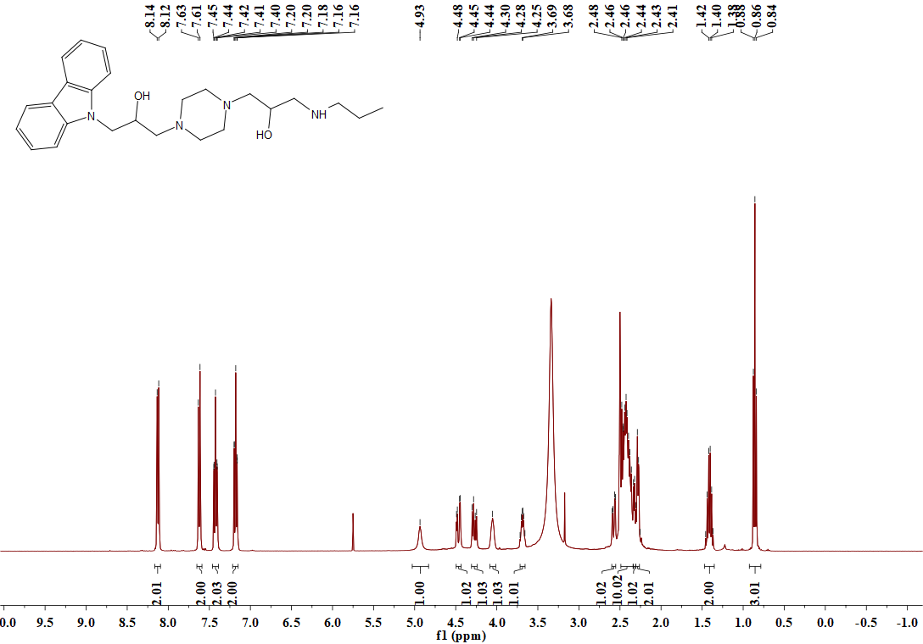

**Figure S3.** 1H NMR spectrum (DMSO-*d*6, 400 MHz) of **B1**

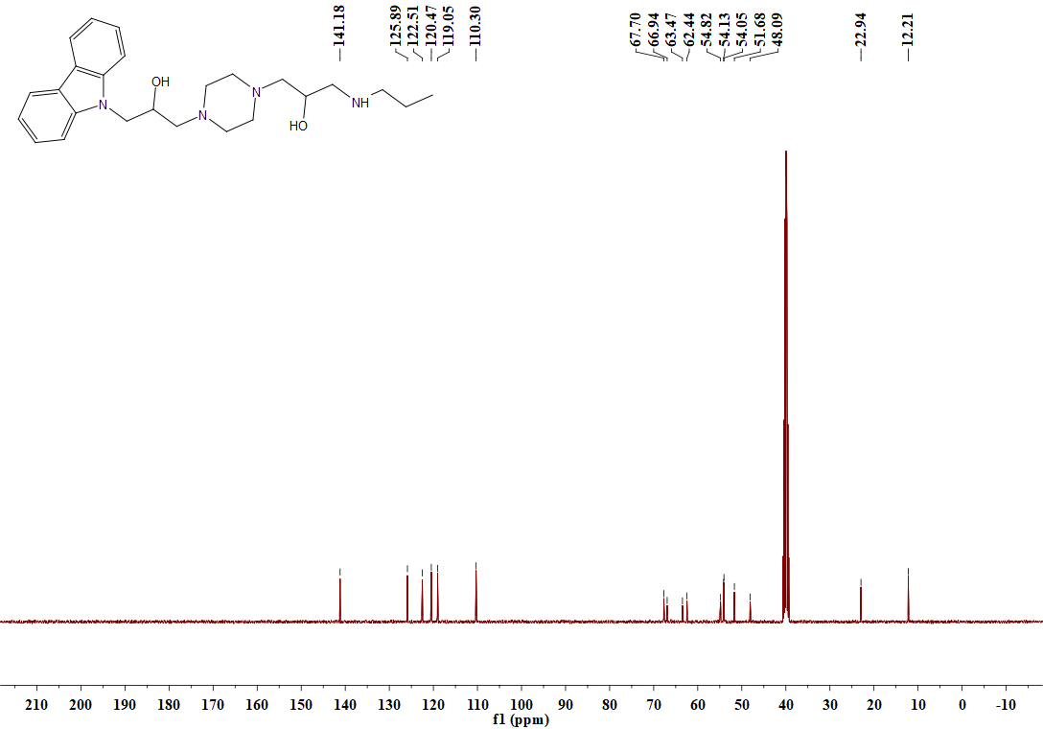

**Figure S4.** 13C NMR spectrum (DMSO-*d*6, 101 MHz) of **B1**



Figure S5. HRMS spectrum of target compound B1

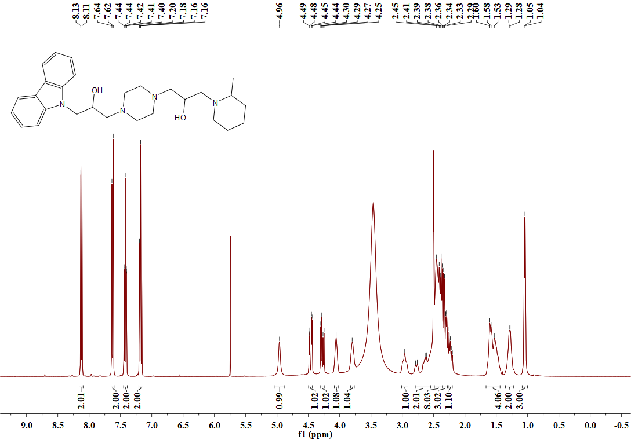

**Figure S6.** 1H NMR spectrum (DMSO-*d*6, 400 MHz) of **B2**

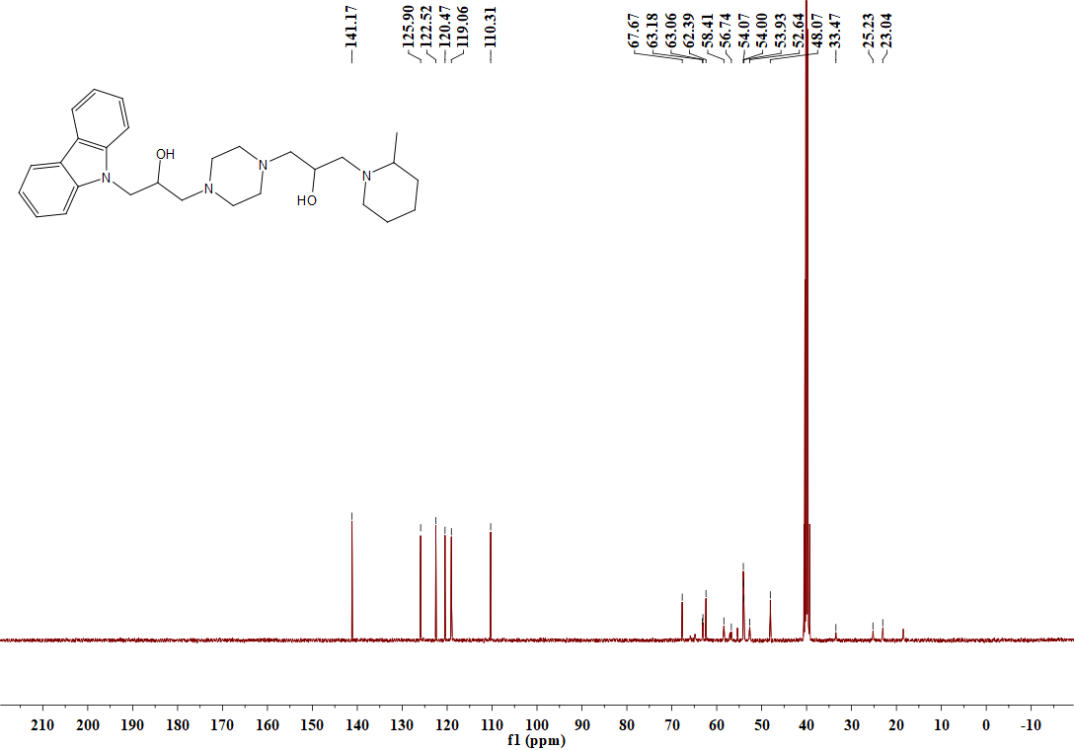

**Figure S7.** 13C NMR spectrum (DMSO-*d*6, 101 MHz) of **B2**



Figure S8. HRMS spectrum of target compound B2.

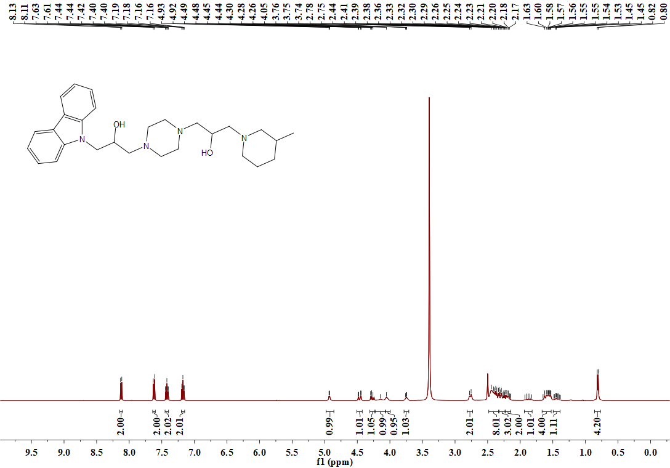

**Figure S9.** 1H NMR spectrum (DMSO-*d*6, 400 MHz) of **B3**

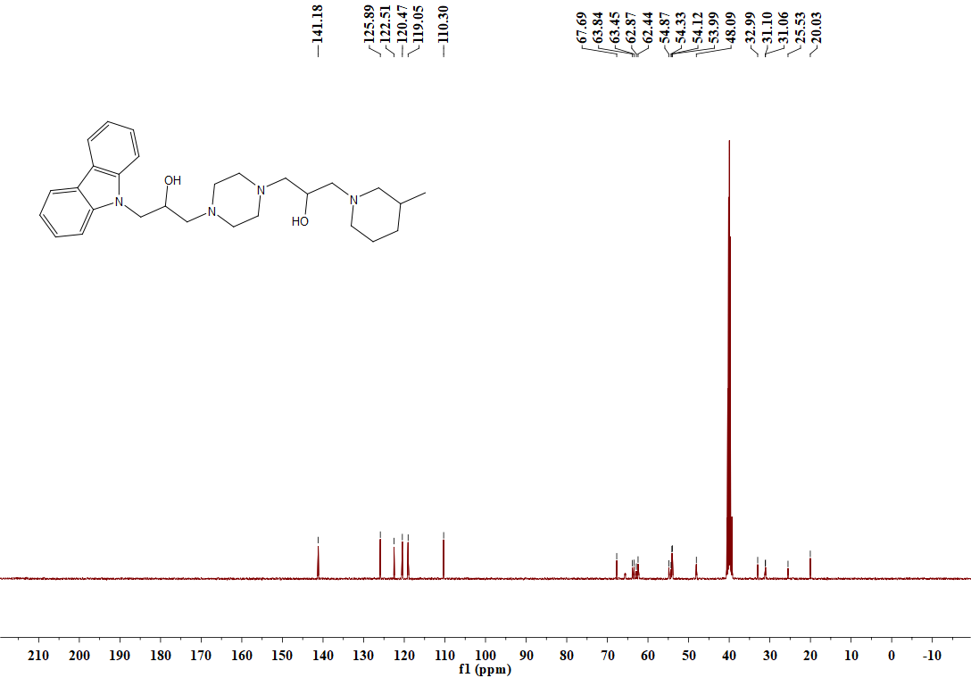

**Figure S10.** 13C NMR spectrum (DMSO-*d*6, 101 MHz) of **B3**



Figure S11. HRMS spectrum of target compound B3

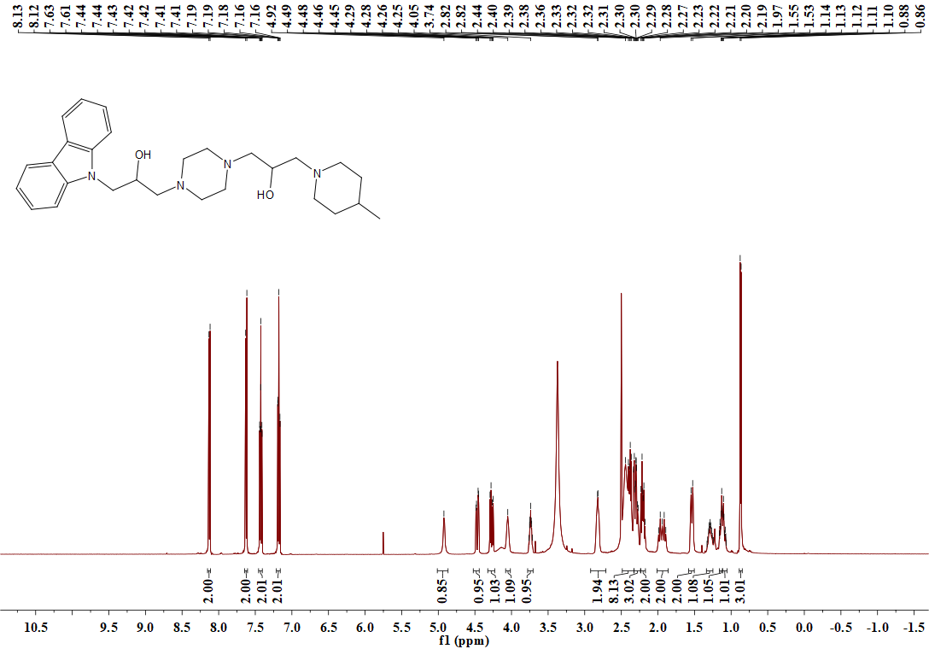

**Figure S12.** 1H NMR spectrum (DMSO-*d*6, 400 MHz) of **B4**

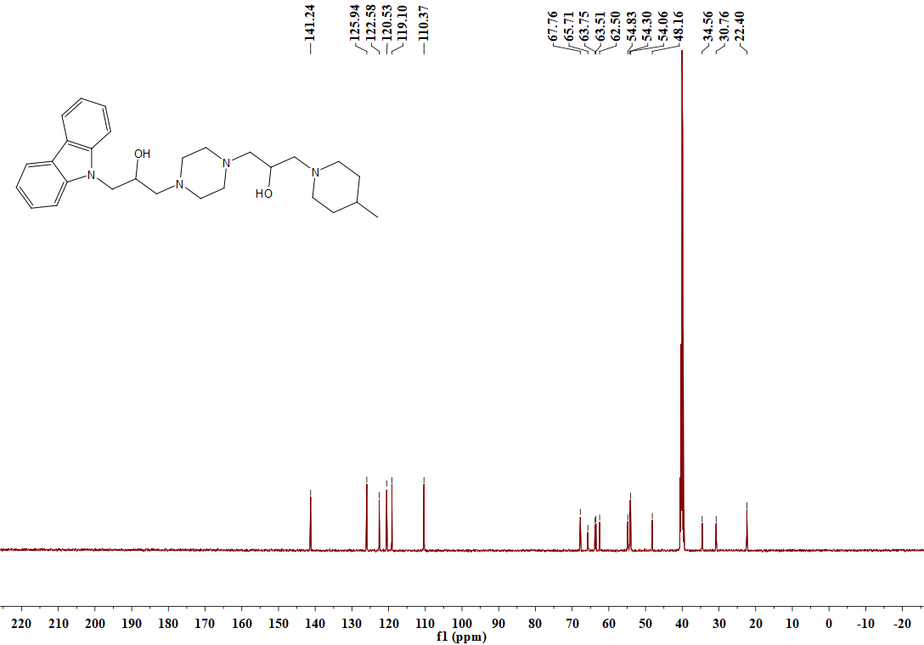

**Figure S13.** 13C NMR spectrum (DMSO-*d*6, 101 MHz) of **B4**



Figure S14. HRMS spectrum of target compound B4

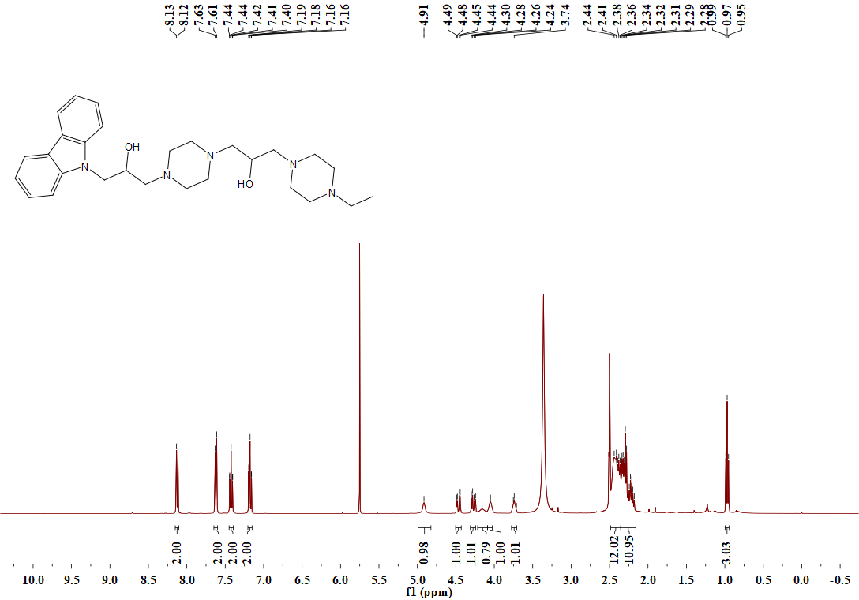

**Figure S15.** 1H NMR spectrum (DMSO-*d*6, 400 MHz) of **B5**

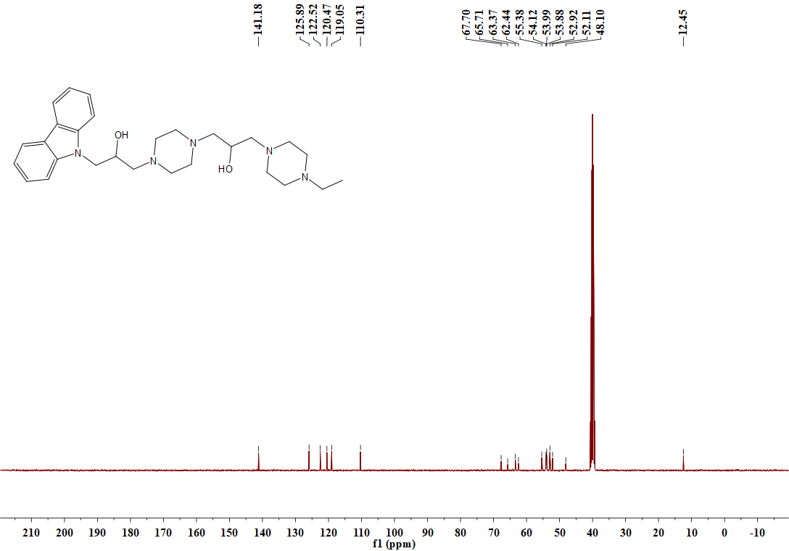

**Figure S16.** 13C NMR spectrum (DMSO-*d*6, 101 MHz) of **B5**



Figure S17. HRMS spectrum of target compound B5

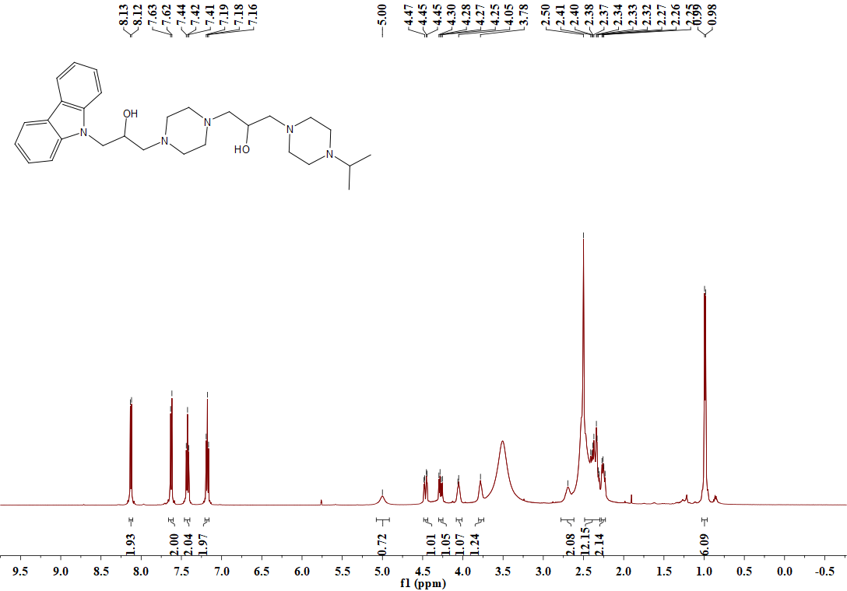

**Figure S18.** 1H NMR spectrum (DMSO-*d*6, 400 MHz) of **B6**

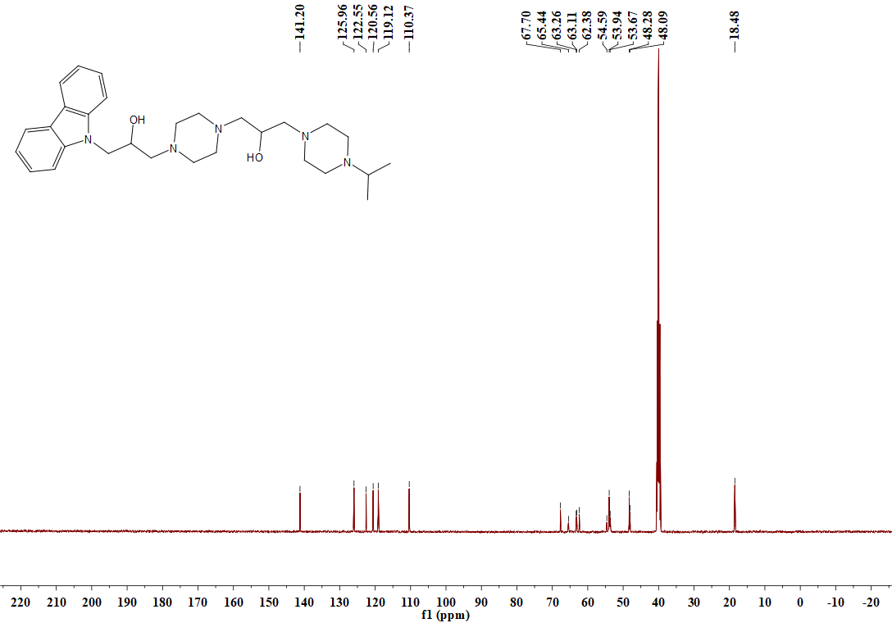

**Figure S19.** 13C NMR spectrum (DMSO-*d*6, 101 MHz) of **B6**



Figure S20. HRMS spectrum of target compound B6

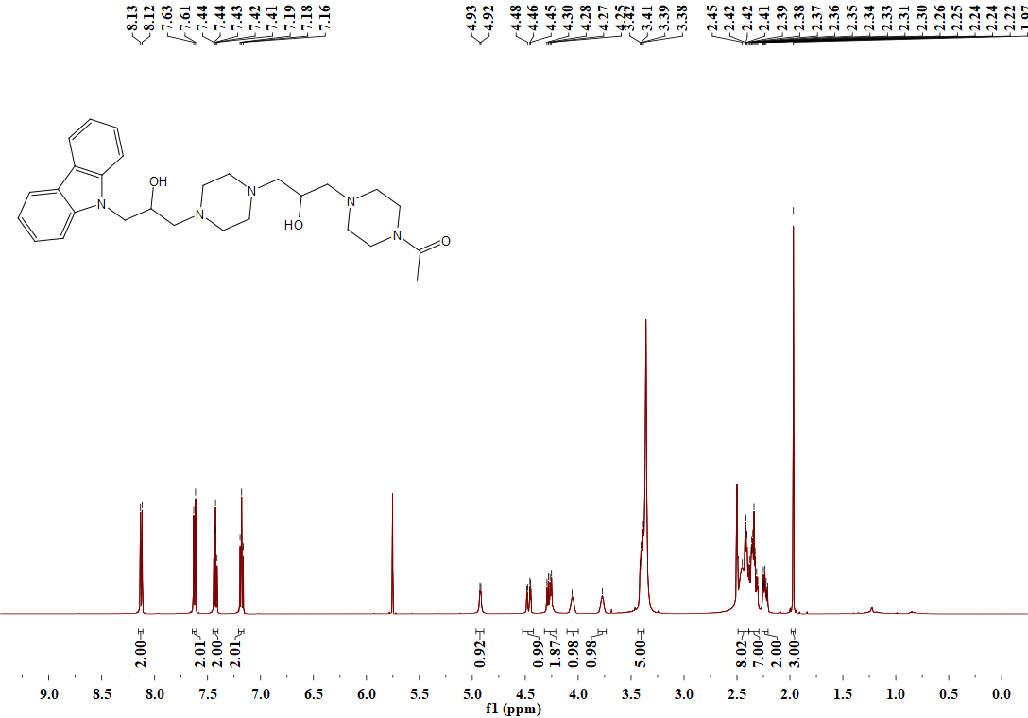

**Figure S21.** 1H NMR spectrum (DMSO-*d*6, 400 MHz) of **B7**

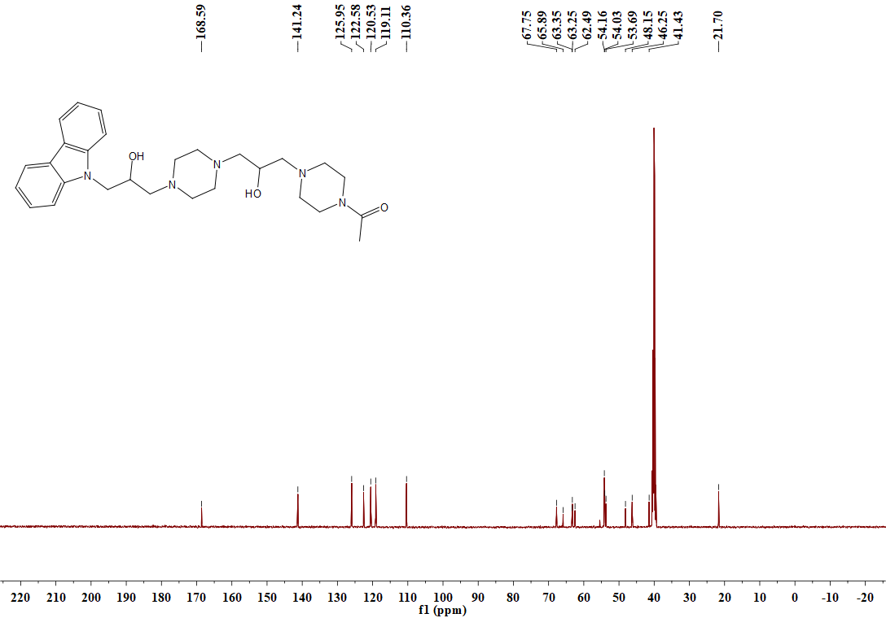

**Figure S22.** 13C NMR spectrum (DMSO-*d*6, 101 MHz) of **B7**



Figure S23. HRMS spectrum of target compound B7

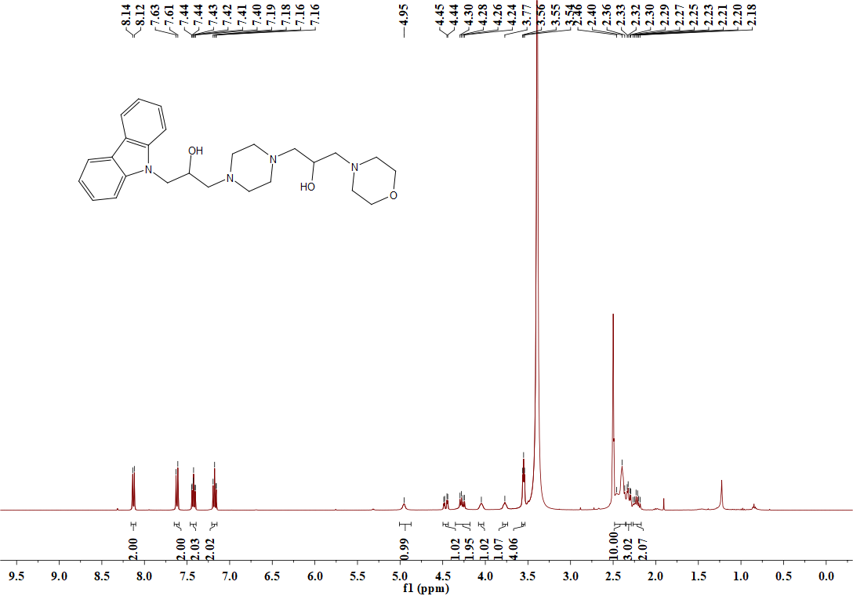

**Figure S24.** 1H NMR spectrum (DMSO-*d*6, 400 MHz) of **B8**

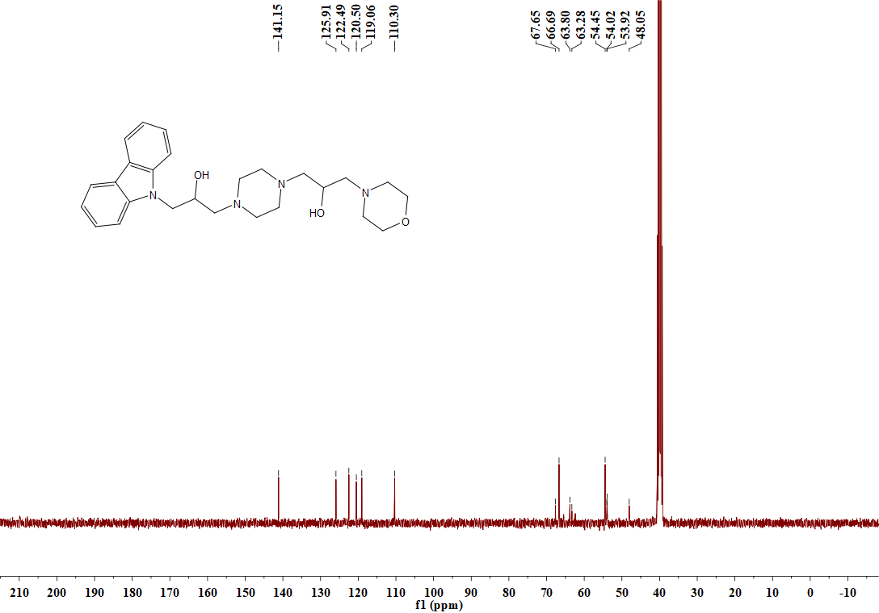

**Figure S25.** 13C NMR spectrum (DMSO-*d*6, 101 MHz) of **B8**



Figure S26. HRMS spectrum of target compound B8

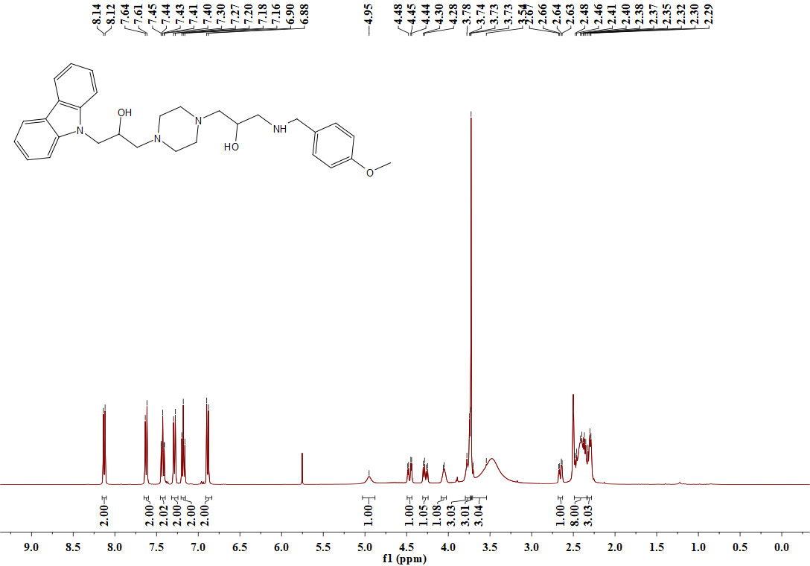

**Figure S27.** 1H NMR spectrum (DMSO-*d*6, 400 MHz) of **B9**

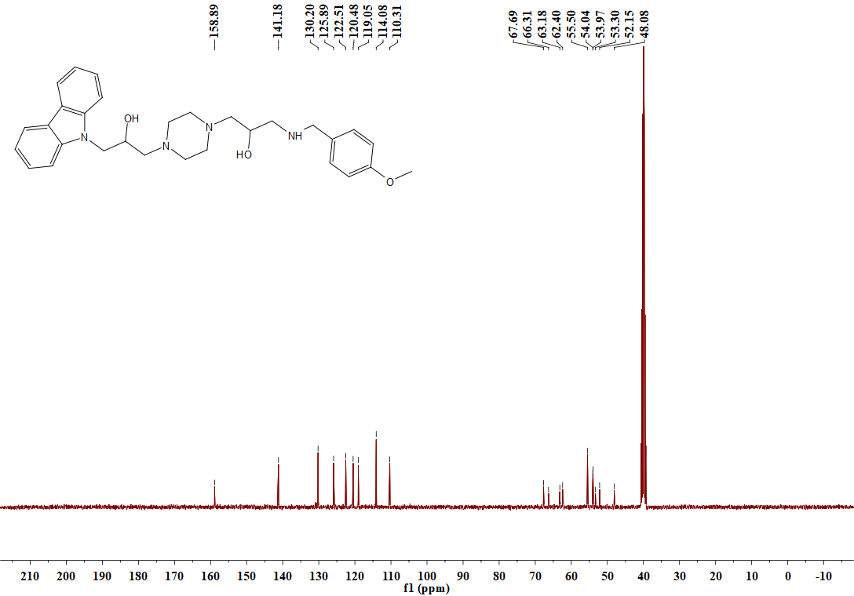

**Figure S28.** 13C NMR spectrum (DMSO-*d*6, 101 MHz) of **B9**



Figure S29. HRMS spectrum of target compound B9

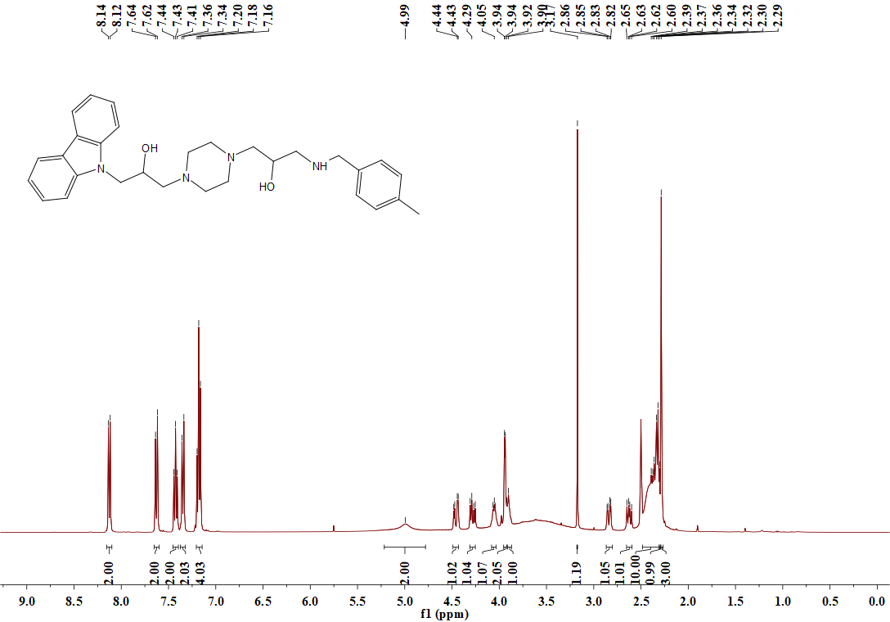

**Figure S30.** 1H NMR spectrum (DMSO-*d*6, 400 MHz) of **B10**

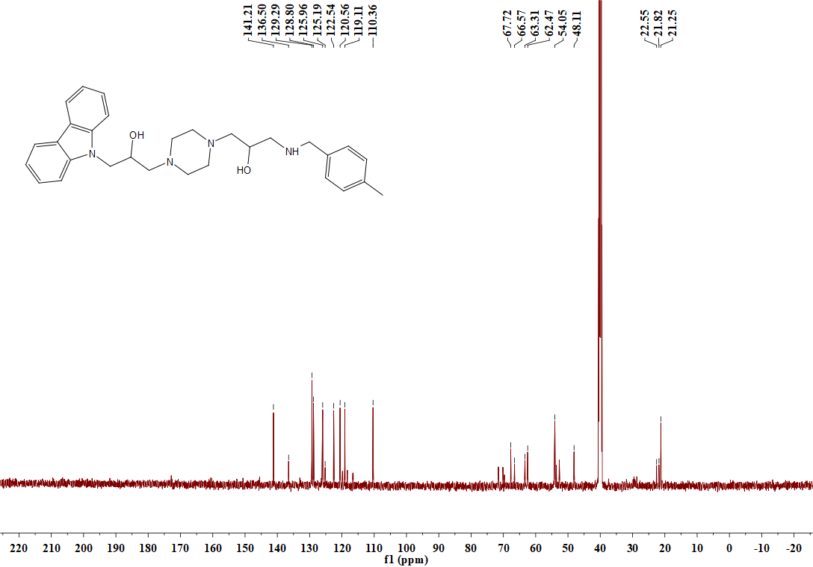

**Figure S31.** 13C NMR spectrum (DMSO-*d*6, 101 MHz) of **B10**



Figure S32. HRMS spectrum of target compound B10

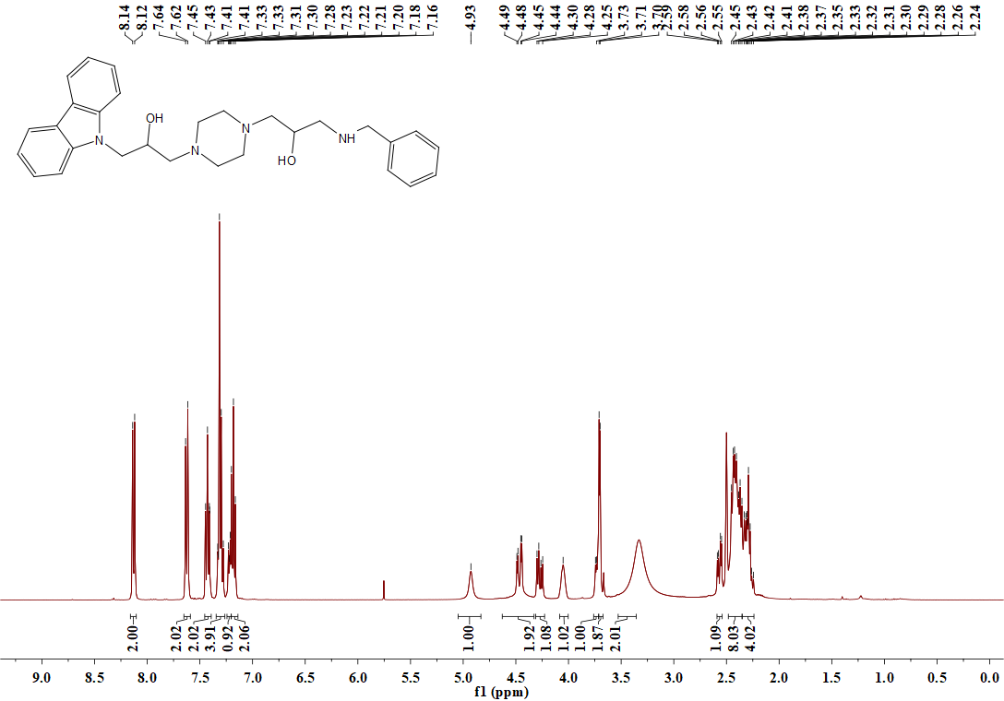

**Figure S33.** 1H NMR spectrum (DMSO-*d*6, 400 MHz) of **B11**

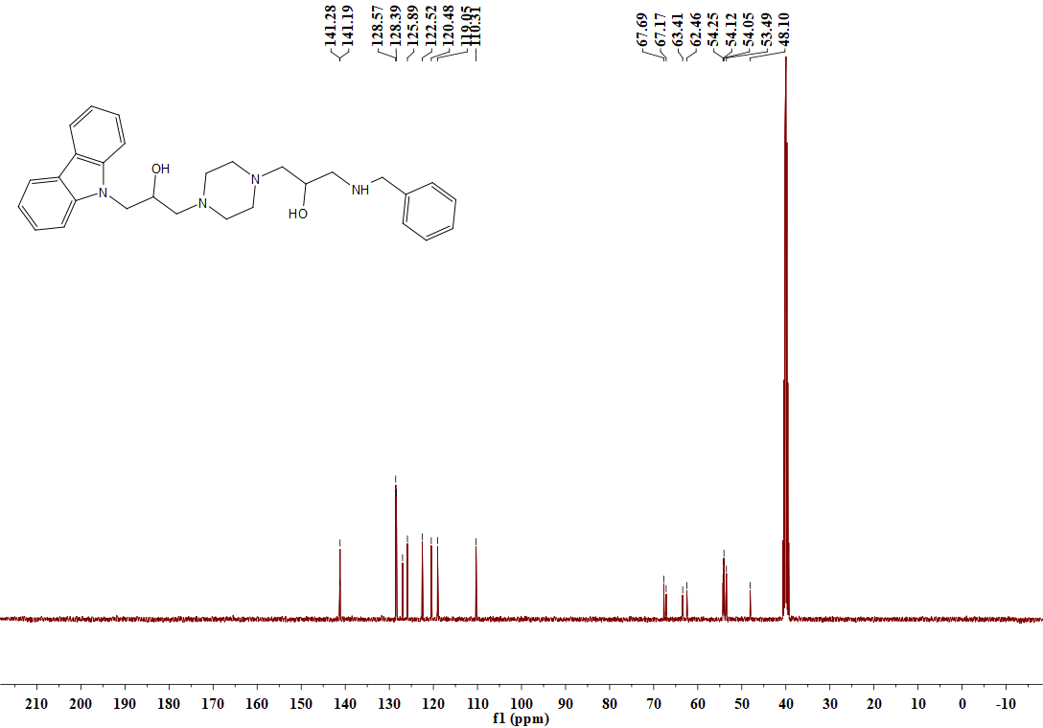

**Figure S34.** 13C NMR spectrum (DMSO-*d*6, 101 MHz) of **B11**



Figure S35. HRMS spectrum of target compound **B**11

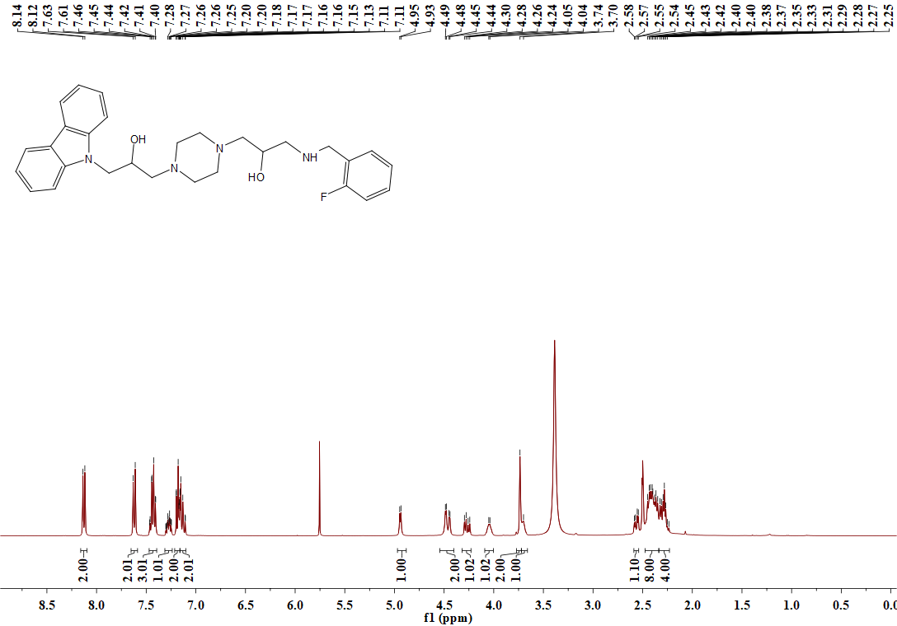

**Figure S36.** 1H NMR spectrum (DMSO-*d*6, 400 MHz) of **B12**

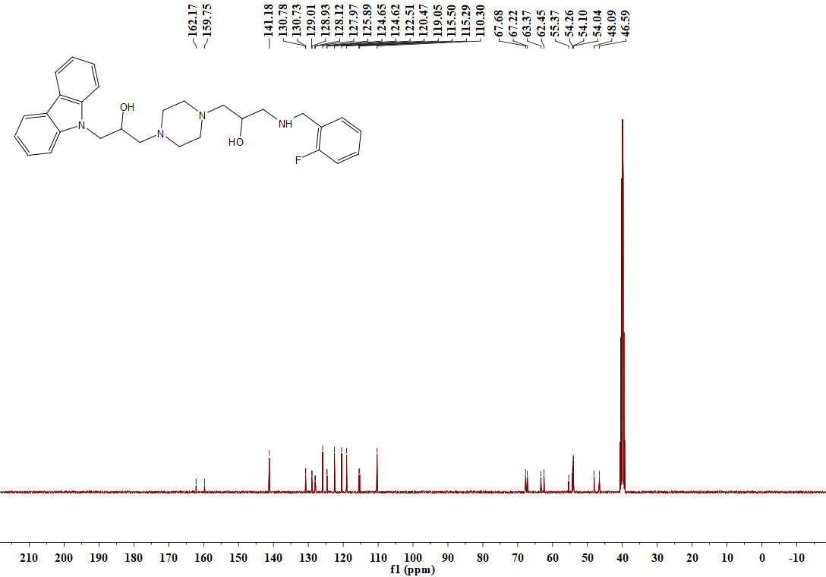

**Figure S37.** 13C NMR spectrum (DMSO-*d*6, 101 MHz) of **B12**

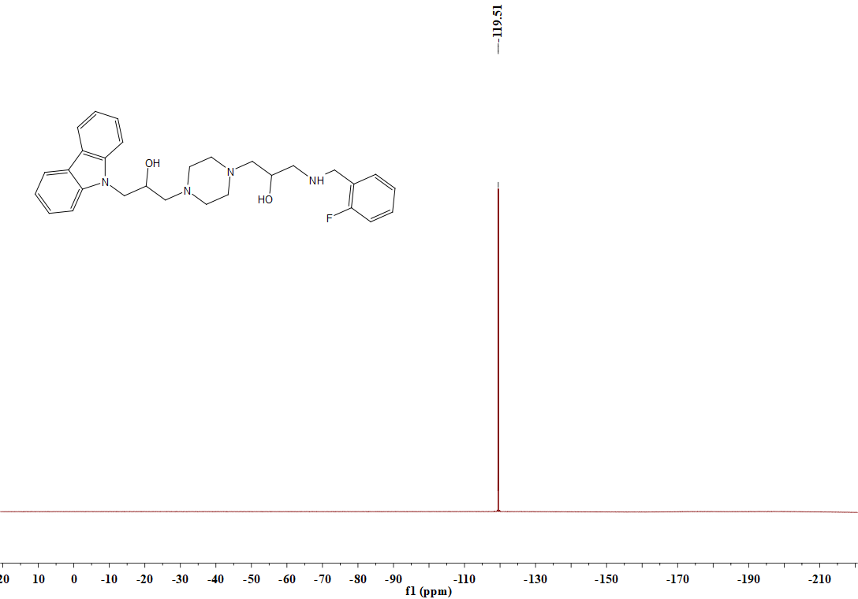

**Figure S38.** 19F NMR spectrum (DMSO-*d*6, 377 MHz) of **B12**



Figure S39. HRMS spectrum of target compound B12

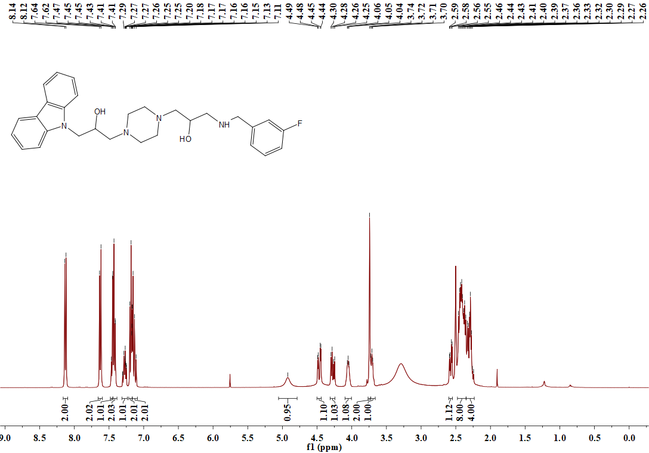

**Figure S40.** 1H NMR spectrum (DMSO-*d*6, 400 MHz) of **B**13

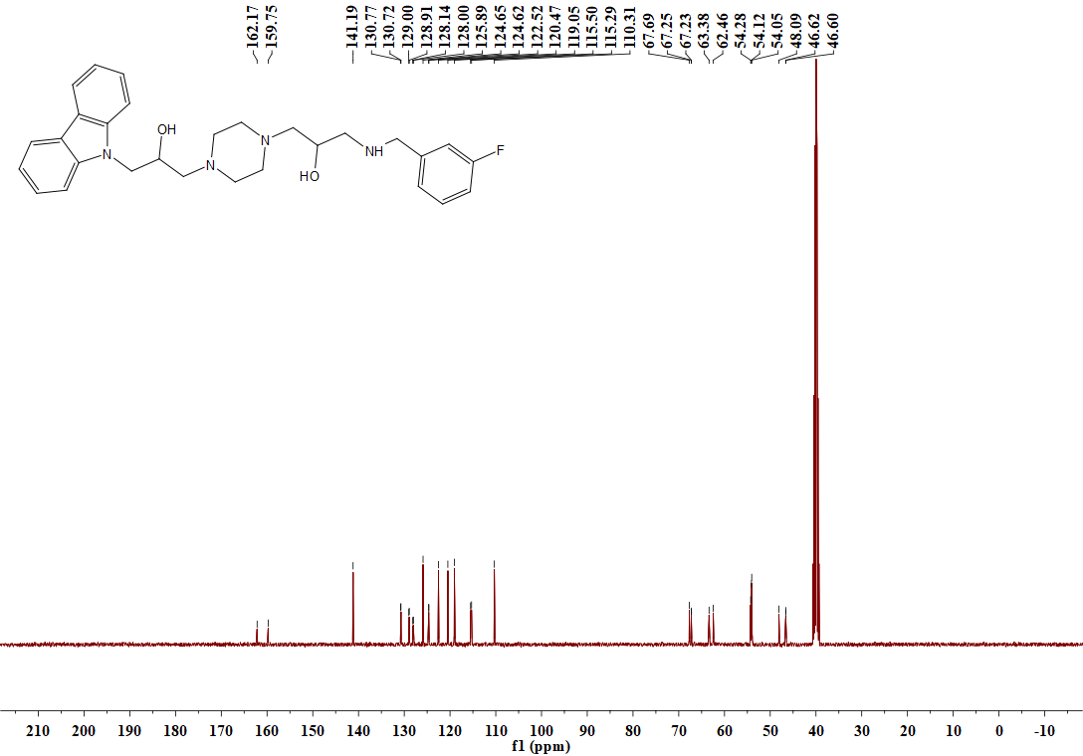

**Figure S41.** 13C NMR spectrum (DMSO-*d*6, 101 MHz) of **B**13

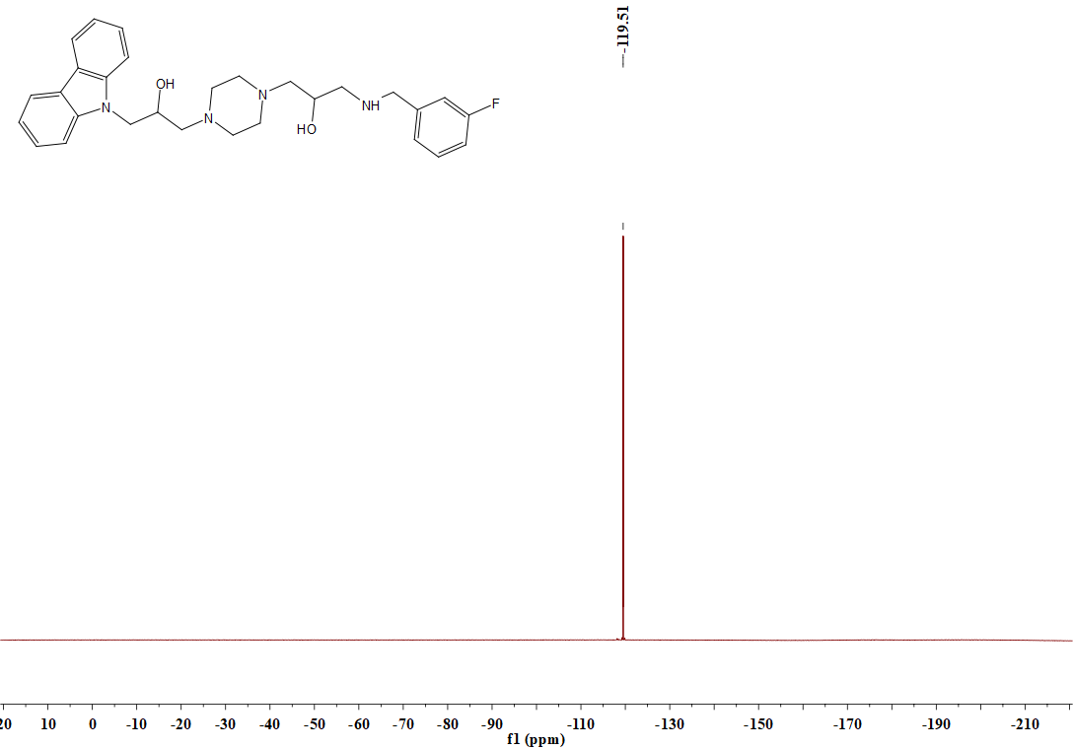

**Figure S42.** 19F NMR spectrum (DMSO-*d*6, 377 MHz) of **B13**



Figure S43. HRMS spectrum of target compound B13

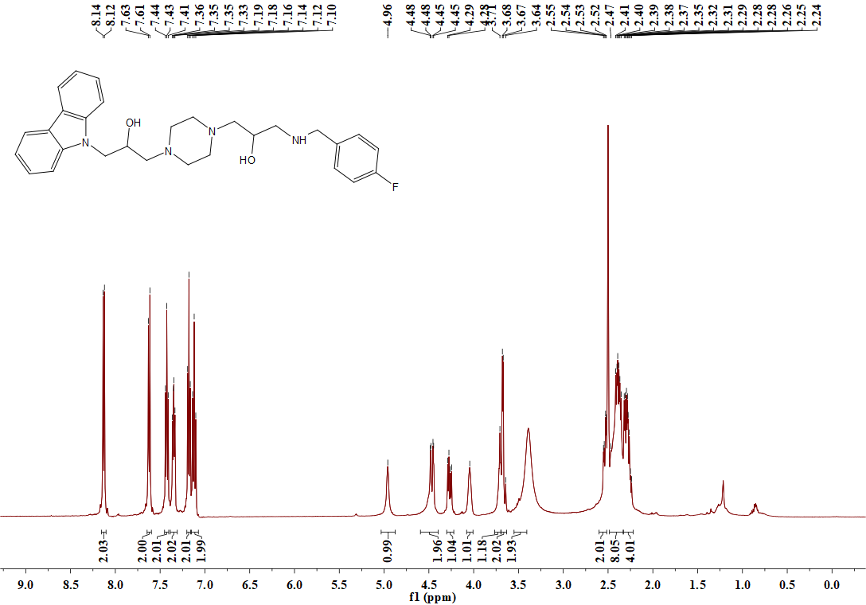

**Figure S44.** 1H NMR spectrum (DMSO-*d*6, 400 MHz) of **B14**



Figure S45. HRMS spectrum of target compound B14

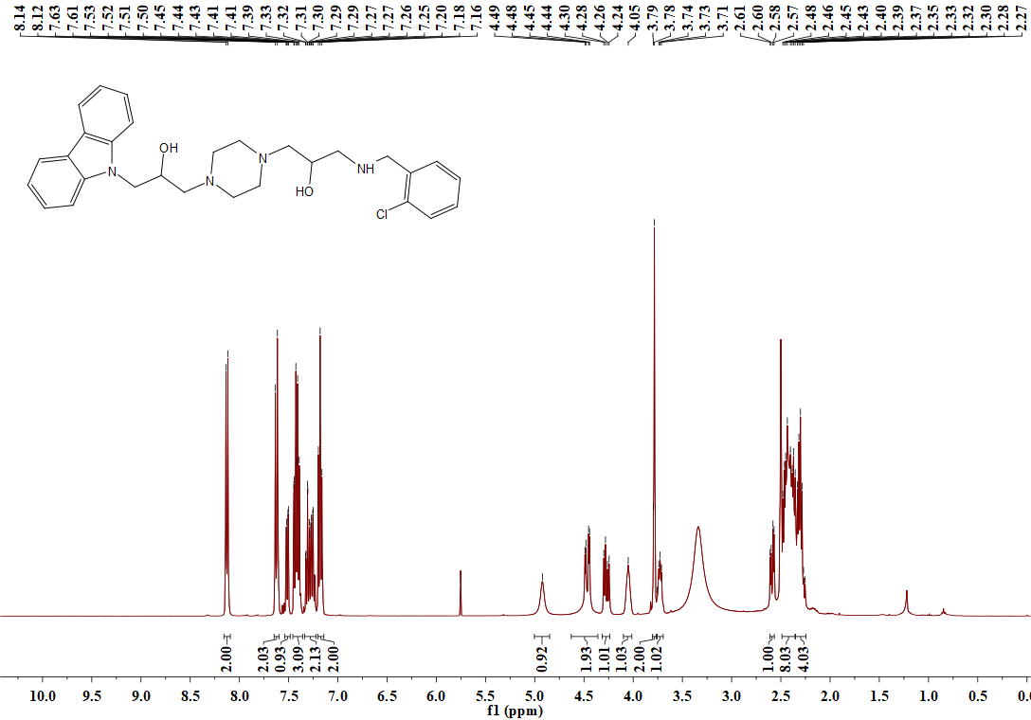

**Figure S46.** 1H NMR spectrum (DMSO-*d*6, 400 MHz) of **B15**

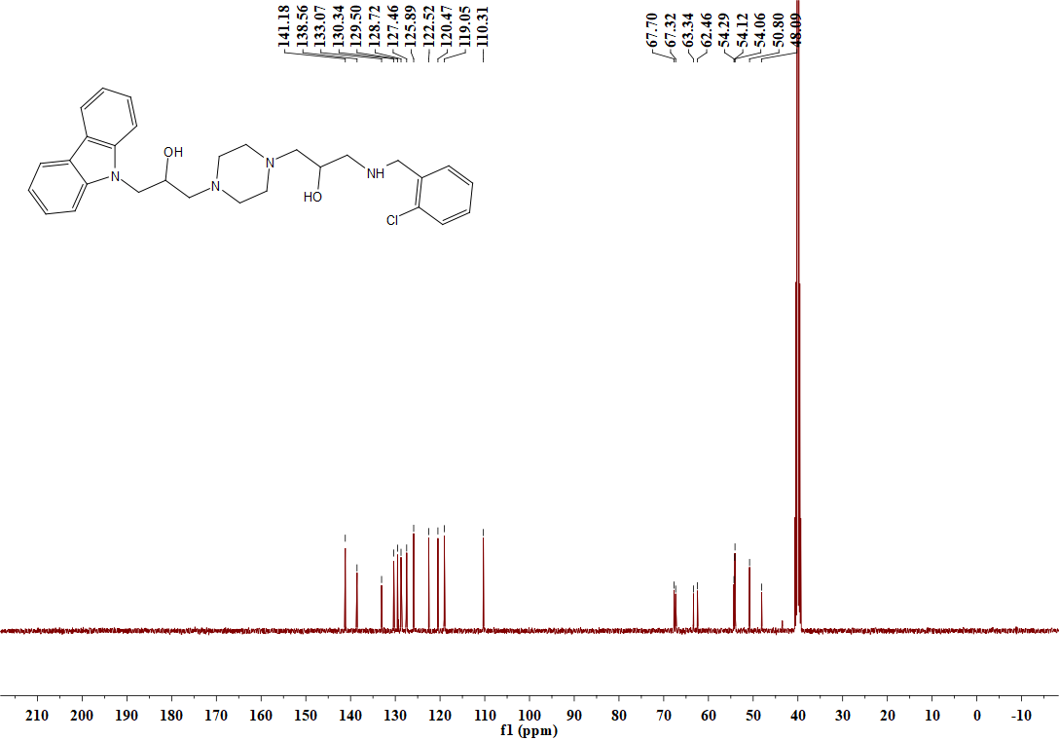

**Figure S47.** 13C NMR spectrum (DMSO-*d*6, 101 MHz) of **B15**



Figure S48. HRMS spectrum of target compound B15

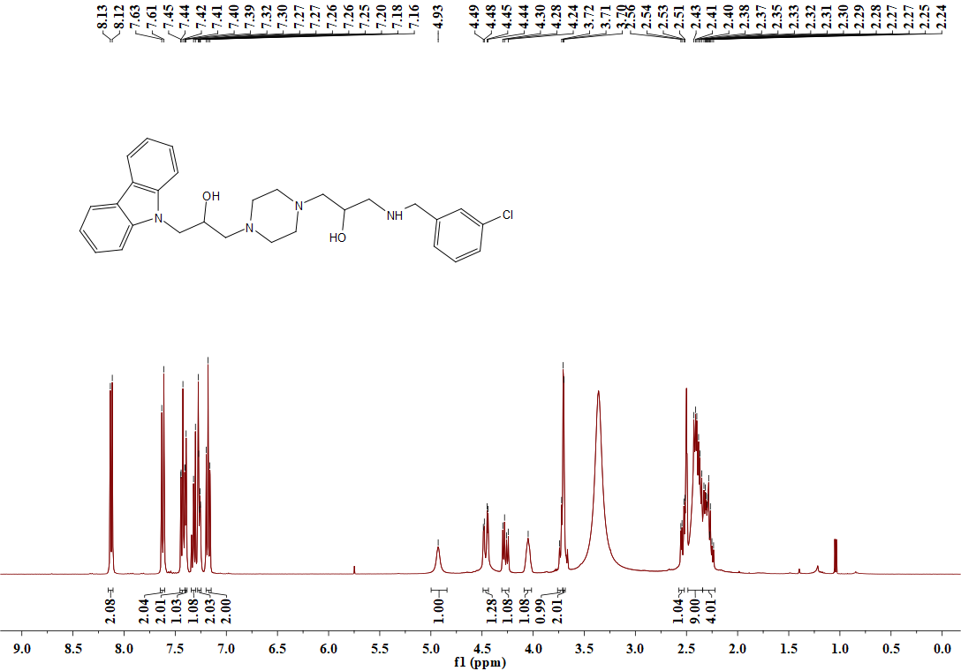

**Figure S49.** 1H NMR spectrum (DMSO-*d*6, 400 MHz) of **B16**

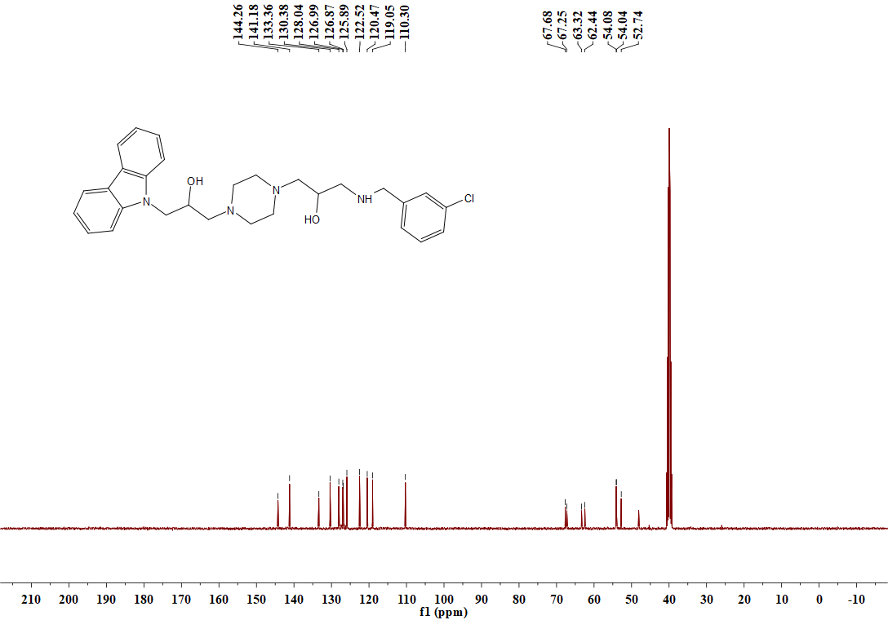

**Figure S50.** 13C NMR spectrum (DMSO-*d*6, 101 MHz) of **B16**



Figure S51. HRMS spectrum of target compound B16

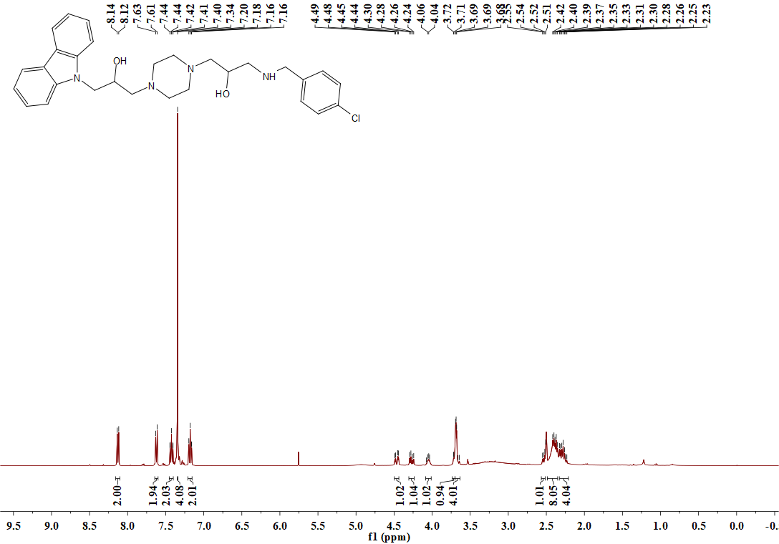

**Figure S52.** 1H NMR spectrum (DMSO-*d*6, 400 MHz) of **B17**

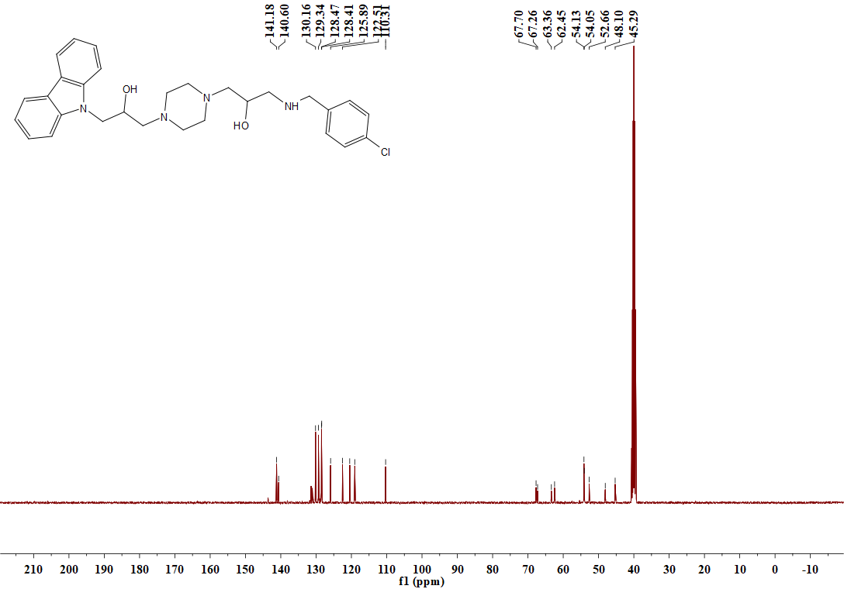

**Figure S53.** 13C NMR spectrum (DMSO-*d*6, 101 MHz) of **B17**



Figure S54. HRMS spectrum of target compound B1**7**

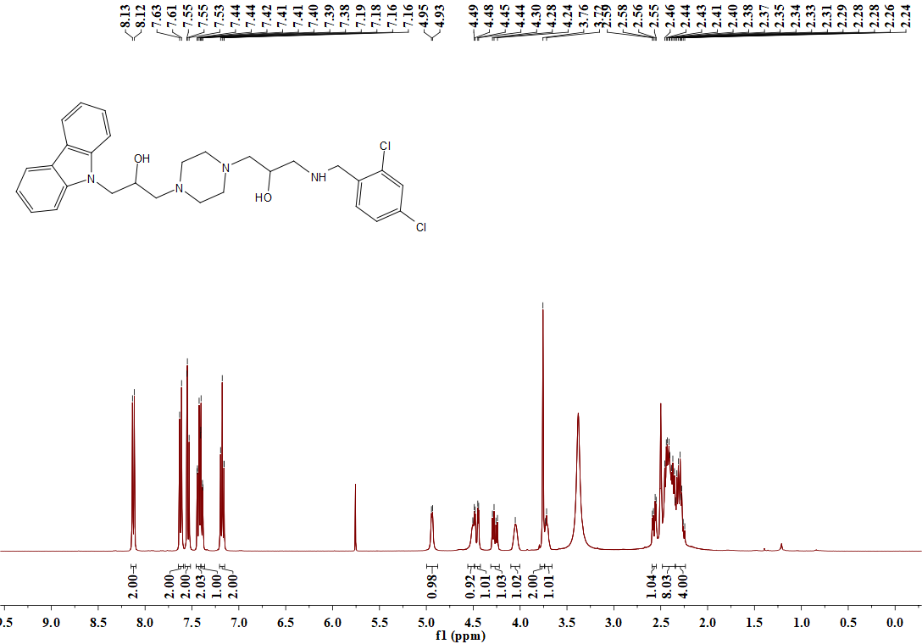

**Figure S55.** 1H NMR spectrum (DMSO-*d*6, 400 MHz) of **B18**

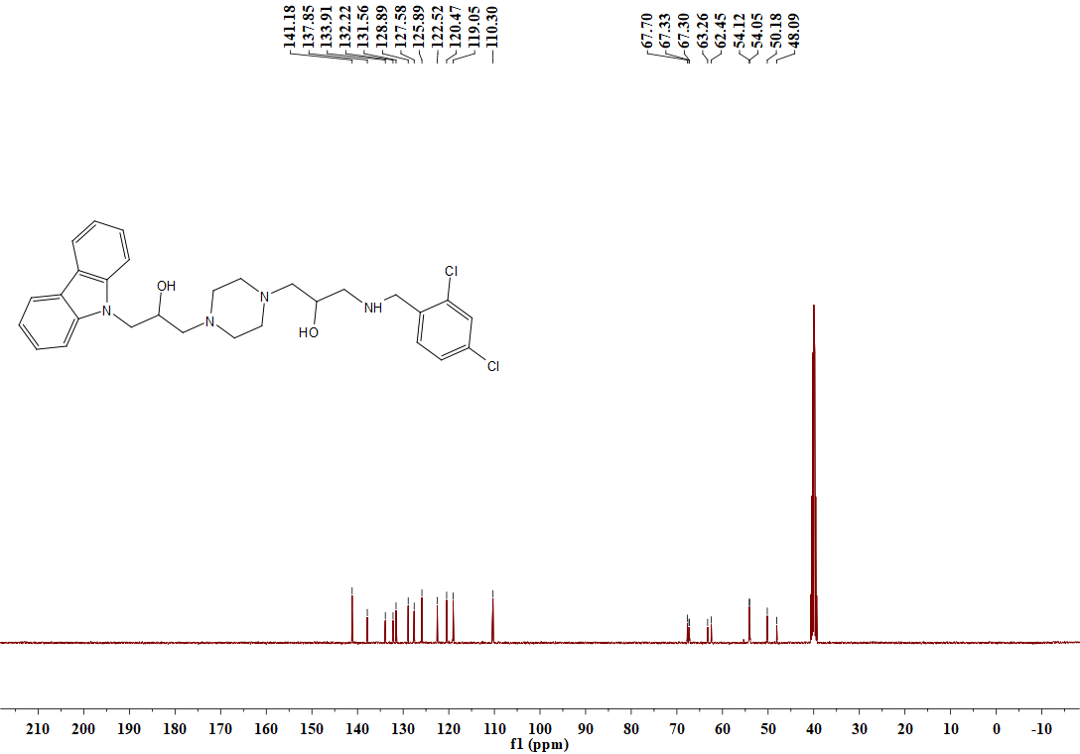

**Figure S56.** 13C NMR spectrum (DMSO-*d*6, 101 MHz) of **B18**



Figure S57. HRMS spectrum of target compound B18

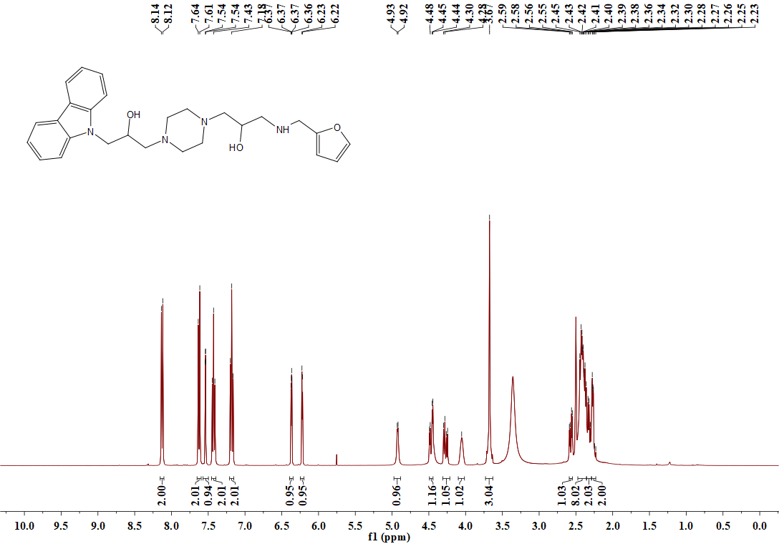

**Figure S58.** 1H NMR spectrum (DMSO-*d*6, 400 MHz) of **B19**

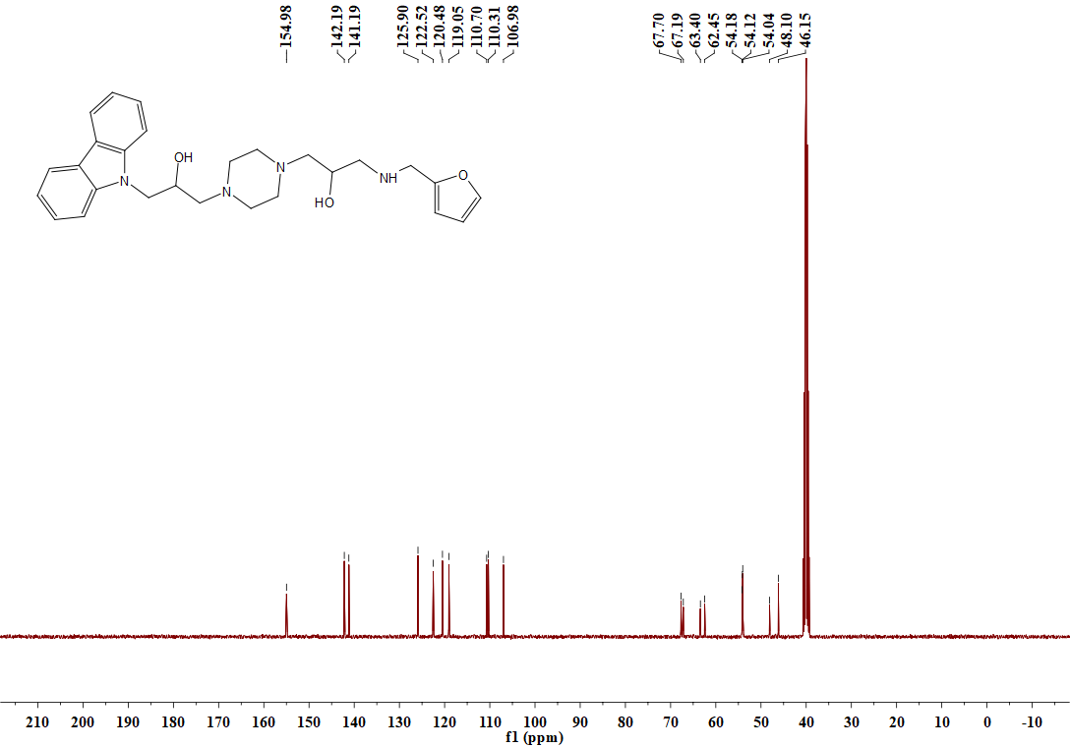

**Figure S59.** 13C NMR spectrum (DMSO-*d*6, 101 MHz) of **B19**



Figure S60. HRMS spectrum of target compound B19

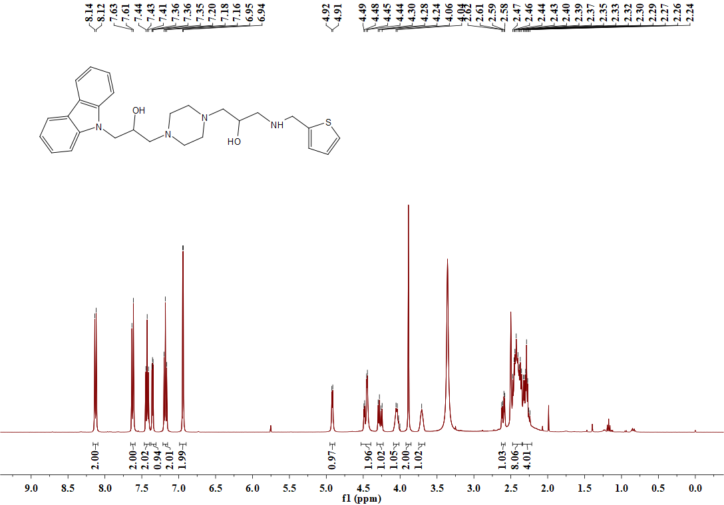

**Figure S61.** 1H NMR spectrum (DMSO-*d*6, 400 MHz) of **B20**

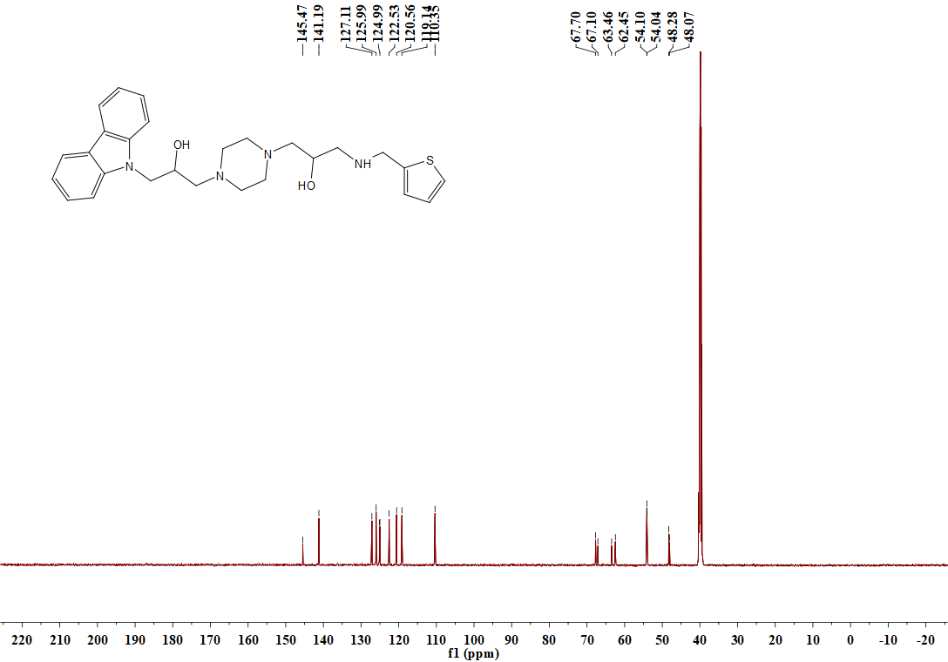

**Figure S62.** 13C NMR spectrum (DMSO-*d*6, 101 MHz) of **B20**



Figure S63. HRMS spectrum of target compound B20

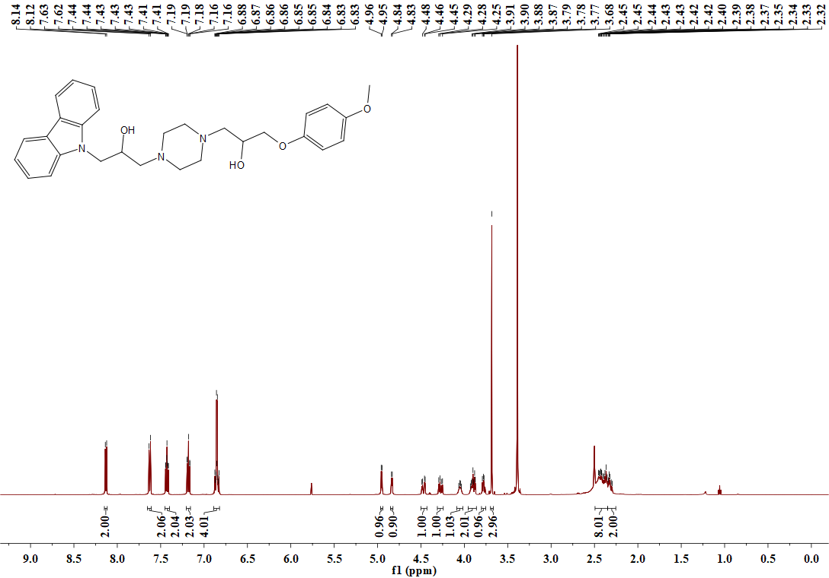

**Figure S64.** 1H NMR spectrum (DMSO-*d*6, 400 MHz) of **C1**

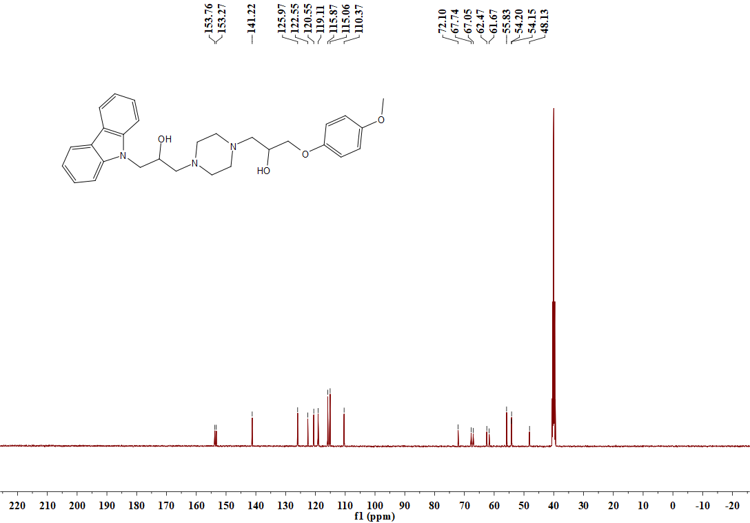

**Figure S65.** 13C NMR spectrum (DMSO-*d*6, 101 MHz) of **C1**



Figure S66. HRMS spectrum of target compound C1

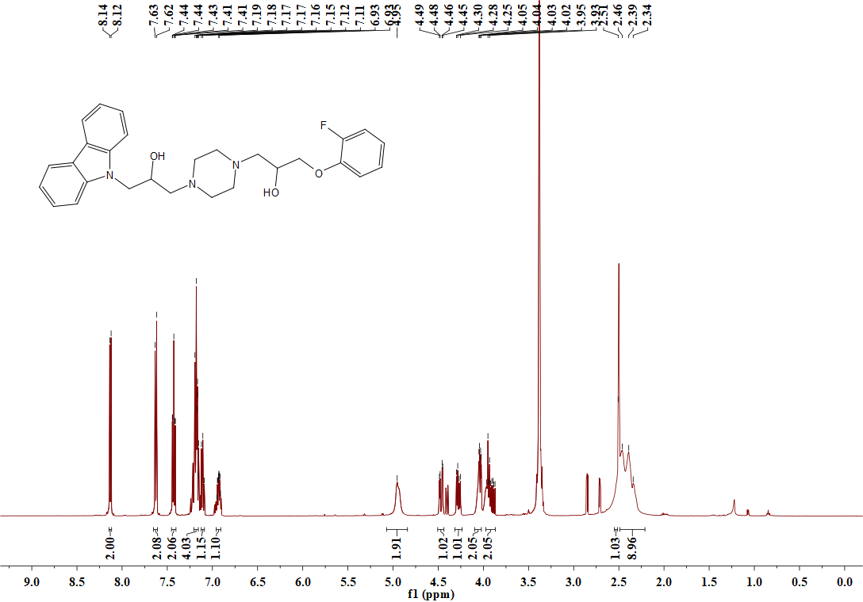

**Figure S67.** 1H NMR spectrum (DMSO-*d*6, 400 MHz) of **C2**

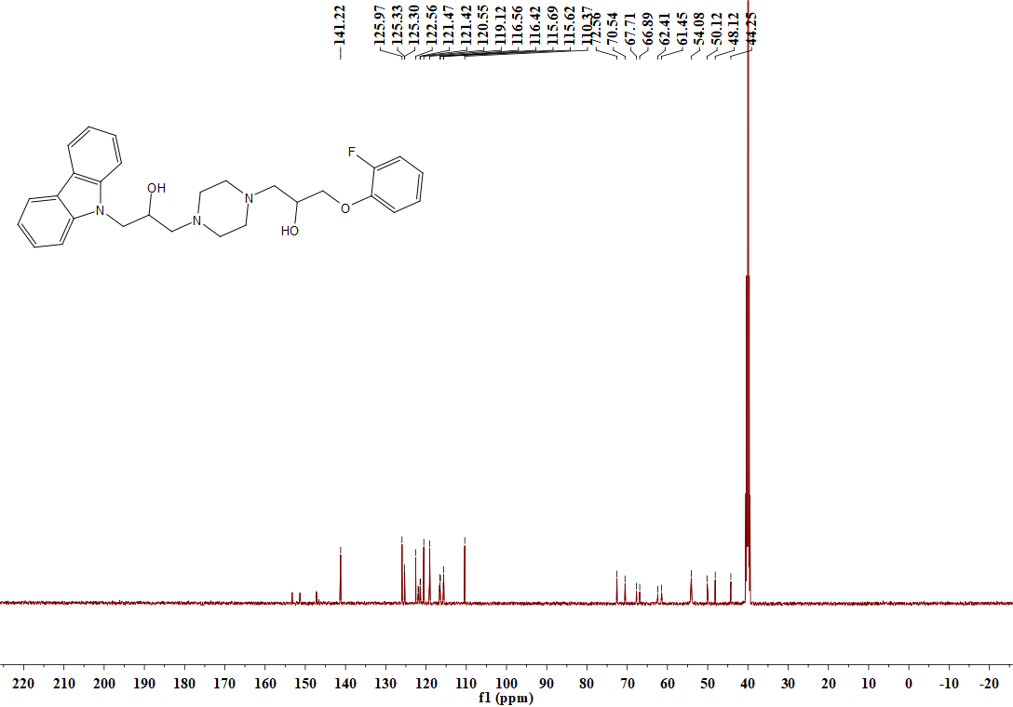

**Figure S68.** 13C NMR spectrum (DMSO-*d*6, 101 MHz) of **C2**



Figure S69. HRMS spectrum of target compound C2

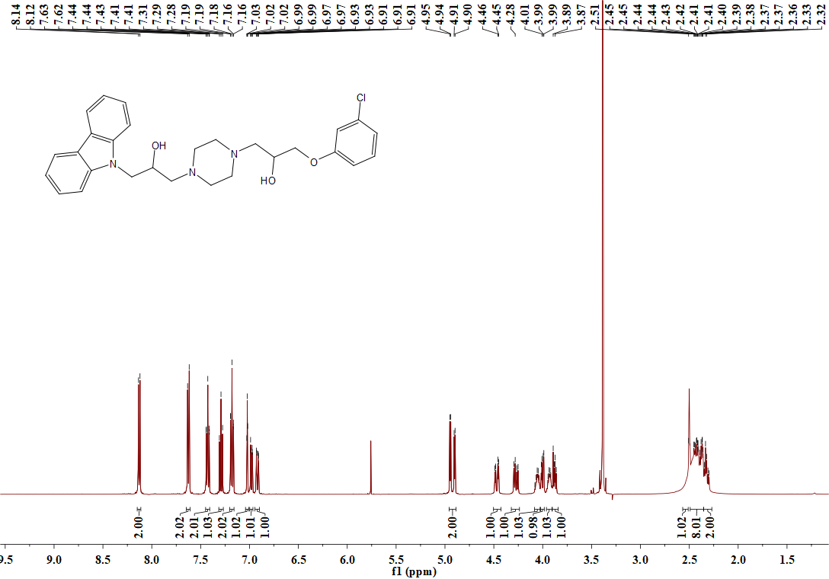

**Figure S70.** 1H NMR spectrum (DMSO-*d*6, 400 MHz) of **C3**

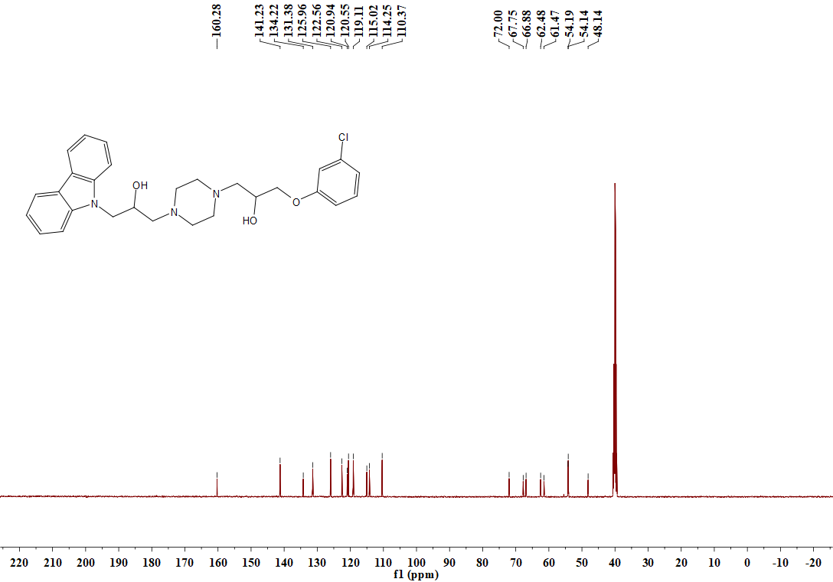

**Figure S71.** 13C NMR spectrum (DMSO-*d*6, 101 MHz) of **C3**



Figure S72. HRMS spectrum of target compound C3

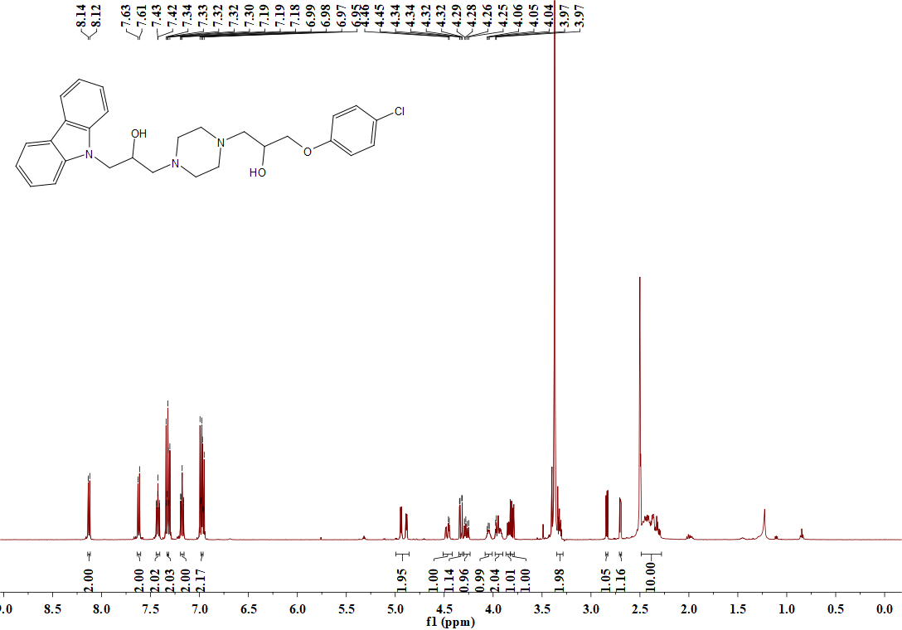

**Figure S73.** 1H NMR spectrum (DMSO-*d*6, 400 MHz) ofC4

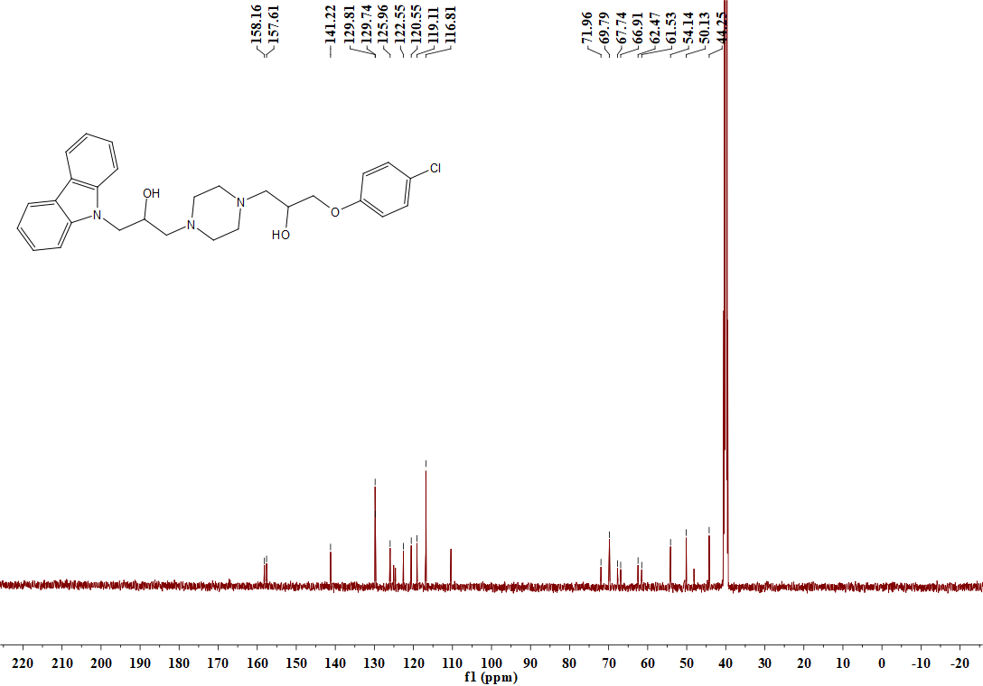

**Figure S74.** 13C NMR spectrum (DMSO-*d*6, 101 MHz) of **C4**



Figure S75. HRMS spectrum of target compound C4

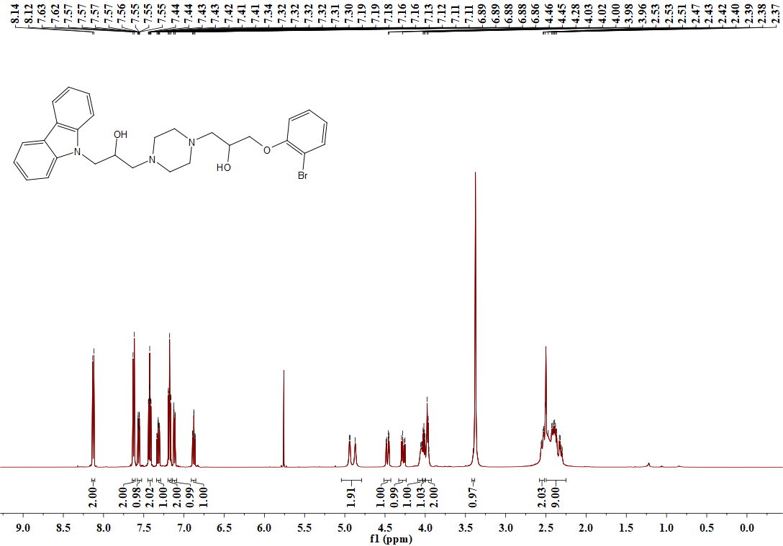

**Figure S76.** 1H NMR spectrum (DMSO-*d*6, 400 MHz) of **C5**

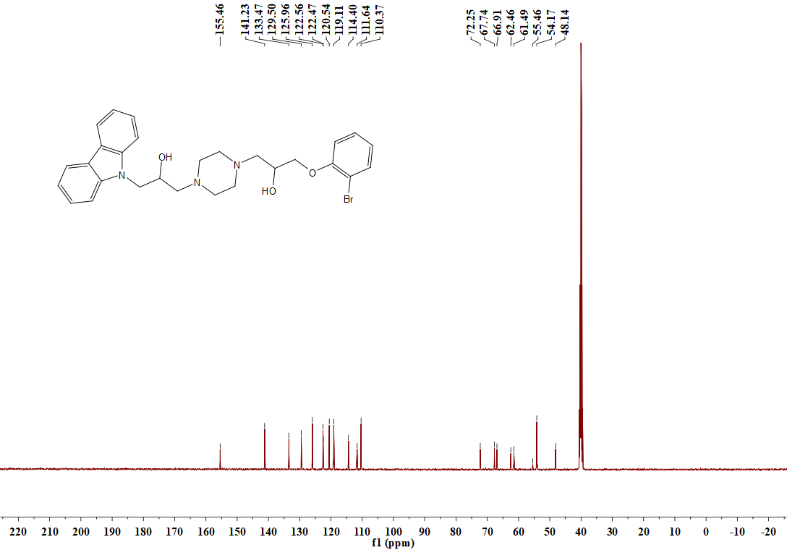

**Figure S77.** 13C NMR spectrum (DMSO-*d*6, 101 MHz) of **C5**



Figure S78. HRMS spectrum of target compound C5

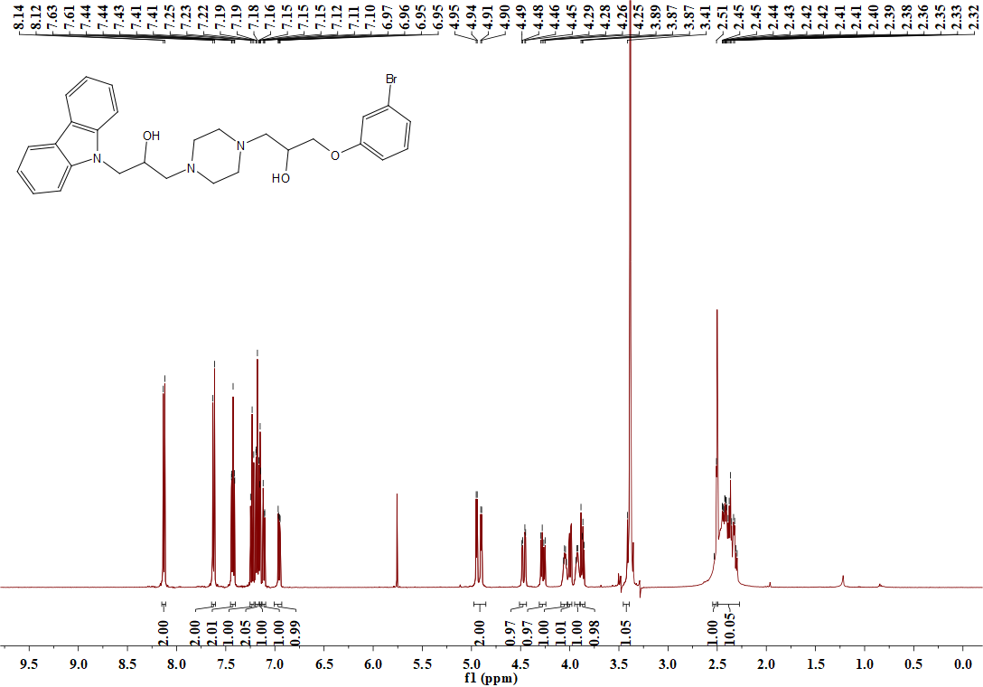

**Figure S79.** 1H NMR spectrum (DMSO-*d*6, 400 MHz) of **C6**

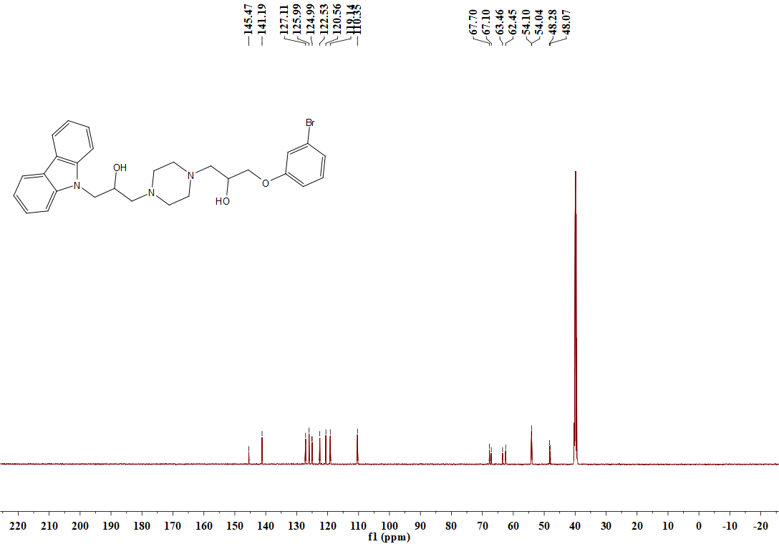

**Figure S80.** 13C NMR spectrum (DMSO-*d*6, 101 MHz) of **C6**



Figure S81. HRMS spectrum of target compound C6

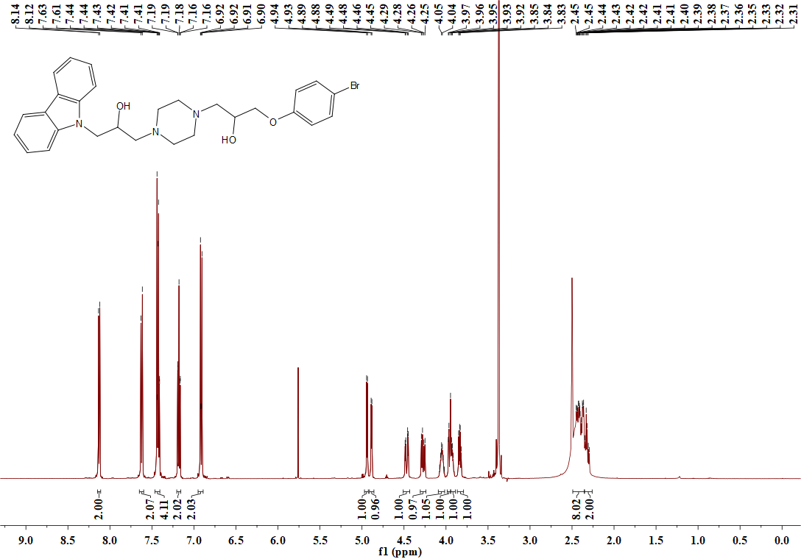

**Figure S82.** 1H NMR spectrum (DMSO-*d*6, 400 MHz) of **C7**

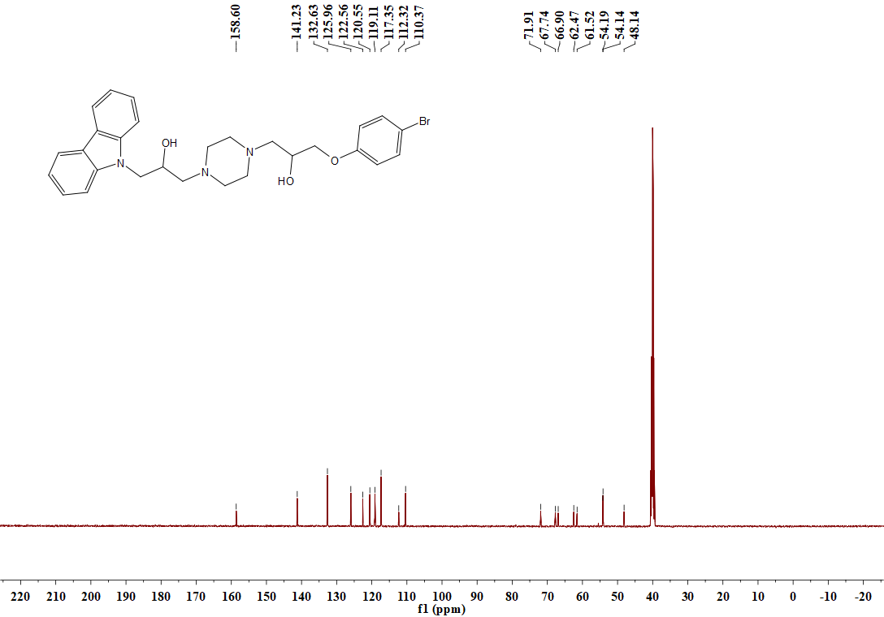

**Figure S83.** 13C NMR spectrum (DMSO-*d*6, 101 MHz) of **C7**



Figure S84. HRMS spectrum of target compound C7