***Enhancing Hydrogen Peroxide Activation in Heterogeneous Fenton Reaction by Codoping Hydrochar with Iron and Copper: Characterization, and Process Optimization***

Abderrazzak Adachi1, Faiçal El Ouadrhiri1*, Fatima Moussaoui1, Soukaina El Bourachdi1, Abdelmajid Faris2, Khalil Azzaoui1,3, Belkheir Hammouti3, Amal Lahkimi1*

1Laboratory of Engineering, Electrochemistry, Modelling and Environment, Faculty of Sciences Dhar El Mahraz, Sidi Mohamed Ben Abdelah University, Fez, Morocco.

2Laboratory of Molecular Chemistry, Department of Chemistry, Faculty of Sciences Semlalia, Cadi Ayyad University, P.O. Box 2390, 40001 Marrakech, Morocco.

3Euro Mediterranean University of Fez, Fez, Morocco.

*\*Corresponding author Email:* [*faical.elouadrhiri@usmba.ac.ma*](mailto:faical.elouadrhiri@usmba.ac.ma)*,*

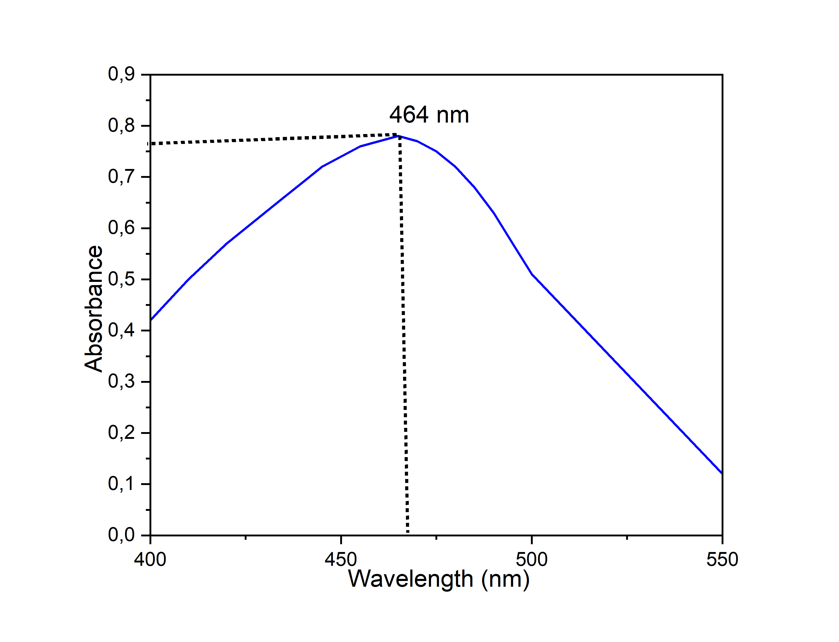

a

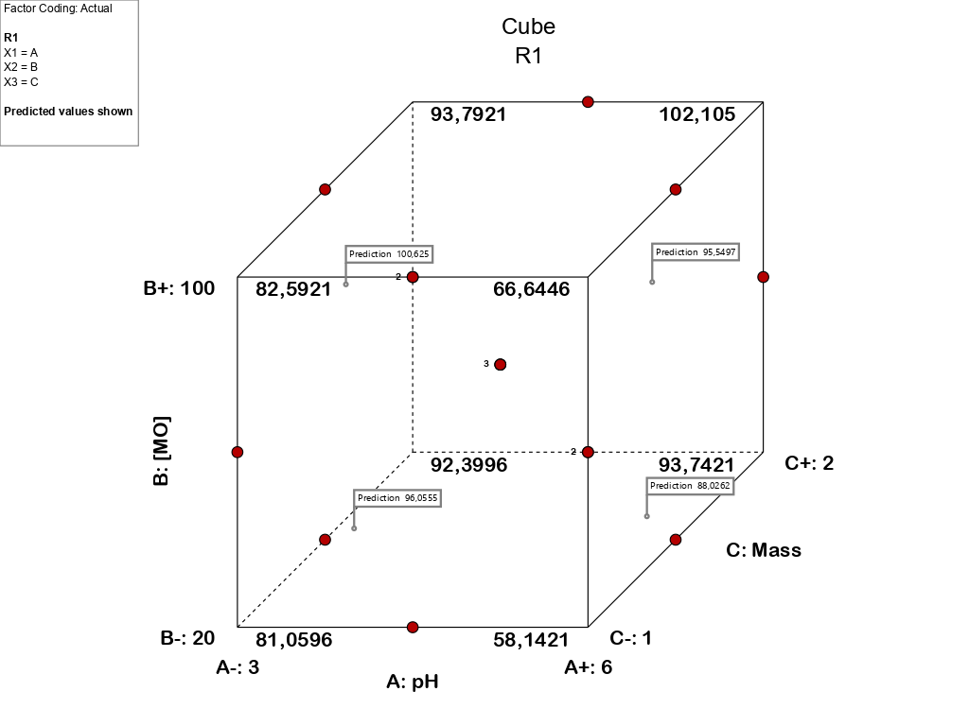**Fig 1S. (a) spectrum of methyl orange MO, (b) calibration curve of methyl orange at 464nm wavelength.**

**Figure 2S: Geometrical location of the experimental points of the BBD design for k=3 factors.**

**Table 1S: experimental matrix of the BBD design.**

|  |  |  |  |  |  |
| --- | --- | --- | --- | --- | --- |
|  | Variables | | | Response 1 |  |
| Run | **A:pH** | **B:[MO]**  **(mg/l)** | **C:Mass**  **(g/l)** | **Degradation (%)** | |
| **Experimental** | **predicted** |
| 1 | 3 | 100 | 1,5 | 97,43 | 98,25 |
| 2 | 6 | 100 | 1,5 | 96,64 | 94,43 |
| 3 | 4,5 | 60 | 1,5 | 93,78 | 93,79 |
| 4 | 3 | 60 | 1 | 88,47 | 85,17 |
| 5 | 4,5 | 60 | 1,5 | 90,51 | 93,79 |
| 6 | 6 | 20 | 1,5 | 88,28 | 87,46 |
| 7 | 3 | 60 | 2 | 97,64 | 97,91 |
| 8 | 4,5 | 60 | 1,5 | 97,08 | 93,79 |
| 9 | 3 | 20 | 1,5 | 96,04 | 98,25 |
| 10 | 4,5 | 100 | 1 | 69,99 | 72,47 |
| 11 | 6 | 60 | 2 | 99,44 | 102,74 |
| 12 | 4,5 | 20 | 1 | 64,76 | 65,85 |
| 13 | 6 | 60 | 1 | 66,01 | 65,74 |
| 14 | 4,5 | 100 | 2 | 95,28 | 94,19 |
| 15 | 4,5 | 20 | 2 | 96,33 | 93,85 |

**Table 2S: ANOVA analysis for the quadratic Degradation (%) model**

|  |  |  |  |  |  |  |
| --- | --- | --- | --- | --- | --- | --- |
| Source | Sum of Squares | df | Mean Square | F-value | p-value |  |
| Model | 1965,58 | 9 | 218,40 | 31,98 | 0,0007 | significant |
| A-pH | 106,65 | 1 | 106,65 | 15,62 | 0,0108 |  |
| B-[MO] | 48,96 | 1 | 48,96 | 7,17 | 0,0440 |  |
| C-Mass | 1095,12 | 1 | 1095,12 | 160,35 | < 0.0001 |  |
| AB | 12,15 | 1 | 12,15 | 1,78 | 0,2399 |  |
| AC | 147,14 | 1 | 147,14 | 21,54 | 0,0056 |  |
| BC | 0,0049 | 1 | 0,0049 | 0,0007 | 0,9797 |  |
| A² | 52,05 | 1 | 52,05 | 7,62 | 0,0398 |  |
| B² | 61,48 | 1 | 61,48 | 9,00 | 0,0301 |  |
| C² | 429,71 | 1 | 429,71 | 62,92 | 0,0005 |  |
| Residual | 34,15 | 5 | 6,83 |  |  |  |
| Lack of Fit | 27,16 | 3 | 9,05 | 2,59 | 0,2906 | not significant |
| Pure Error | 6,99 | 2 | 3,49 |  |  |  |
| Cor Total | 1999,73 | 14 |  |  |  |  |

|  |  |  |  |  |
| --- | --- | --- | --- | --- |
| Std. Dev. | 2,61 |  | R² | 0,9829 |
| Mean | 89,00 |  | **Adjusted R²** | 0,9522 |
| C.V. % | 2,94 |  | **Predicted R²** | 0,7748 |
|  |  |  | **Adeq Precision** | 16,9454 |

**Table 4: Optimization constraints using the desirability function**

|  |  |  |  |  |  |
| --- | --- | --- | --- | --- | --- |
| **Name** | **Goal** | **Lower Limit** | **Upper Limit** | **Importance** | **Graphe** |
| **A : pH** | maximize | 3 | 6 | 3 |  |
| **B : [MO]** | maximize | 20 | 100 | 4 |  |
| **C : Mass** | minimize | 1 | 2 | 1 |  |
| **R1** | maximize | 64,76 | 99,44 | 5 |  |

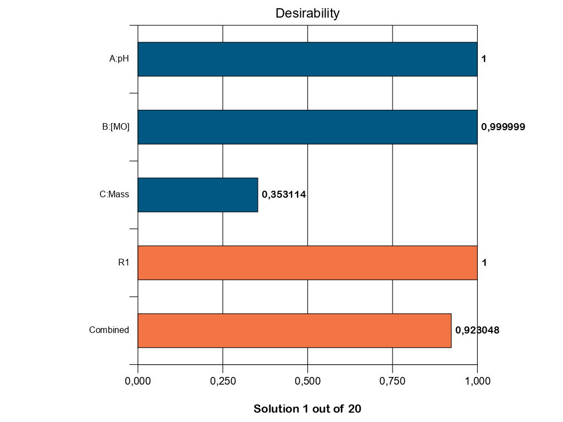

**Figure 3S : Optimization desirability function**