***Original western blots***

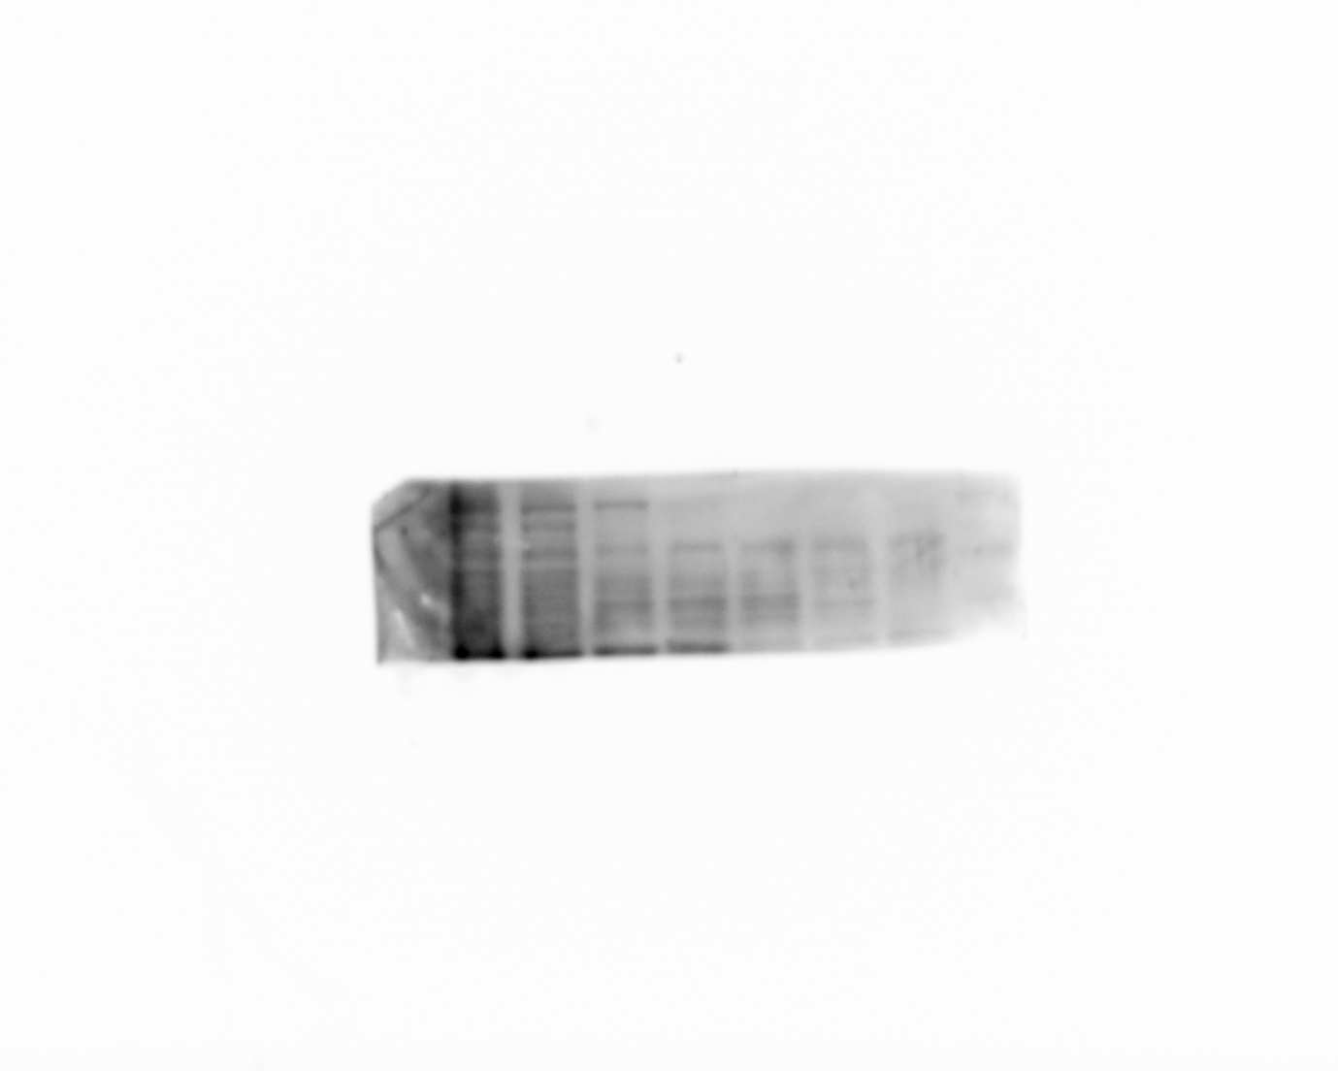

TGFβR2

CAL-27/compound 1

45 50 55 60 65 70 75 ℃

64KDa

45 50 55 60 65 70 75 ℃

CAL-27/PBS

64KDa

TGFβR2

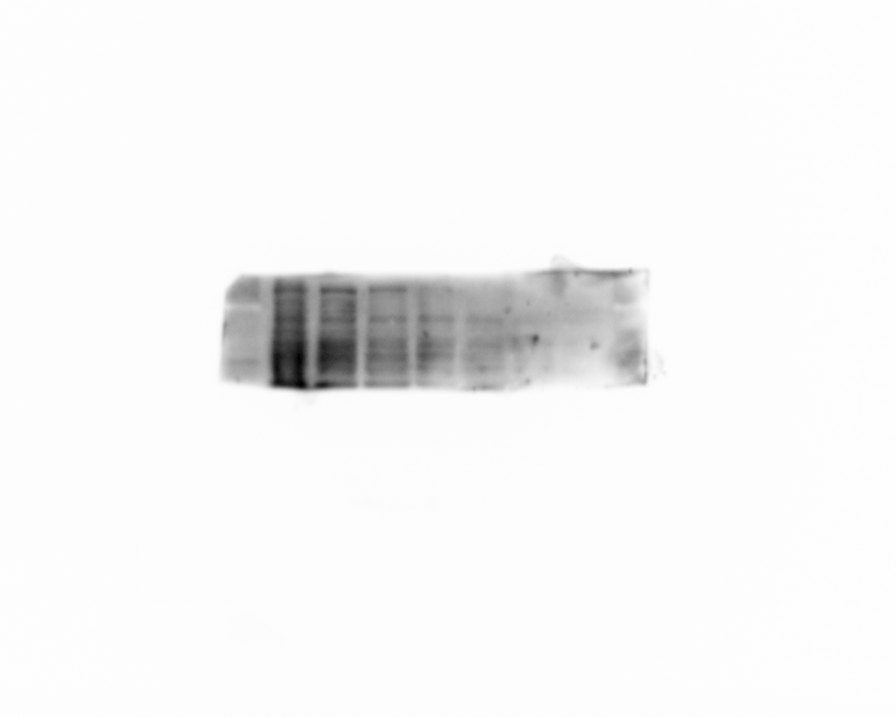

Supplementary Figure 1. The entire original gel of TGFβR2 in Figure 3B.

Compound1

0 15 30 μM

CAL-27

58KDa

Smad2

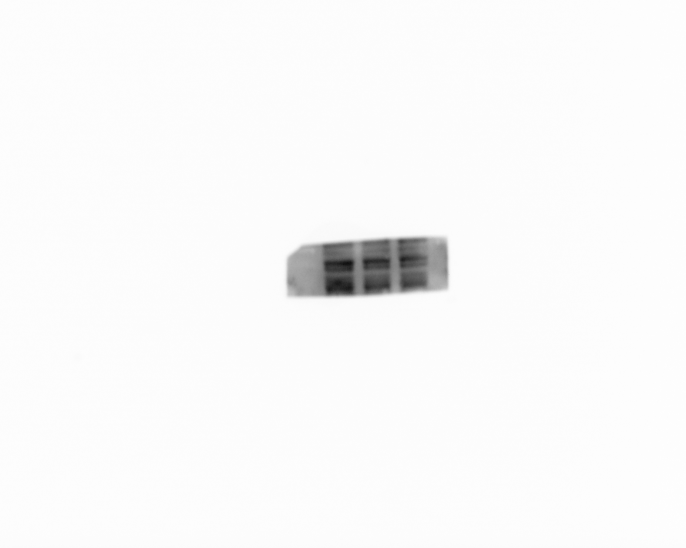

Supplementary Figure 2. The entire original gel of Smad2 in Figure 3C.

Compound 1

0 15 30 μM

CAL-27

58KDa

p-Smad2

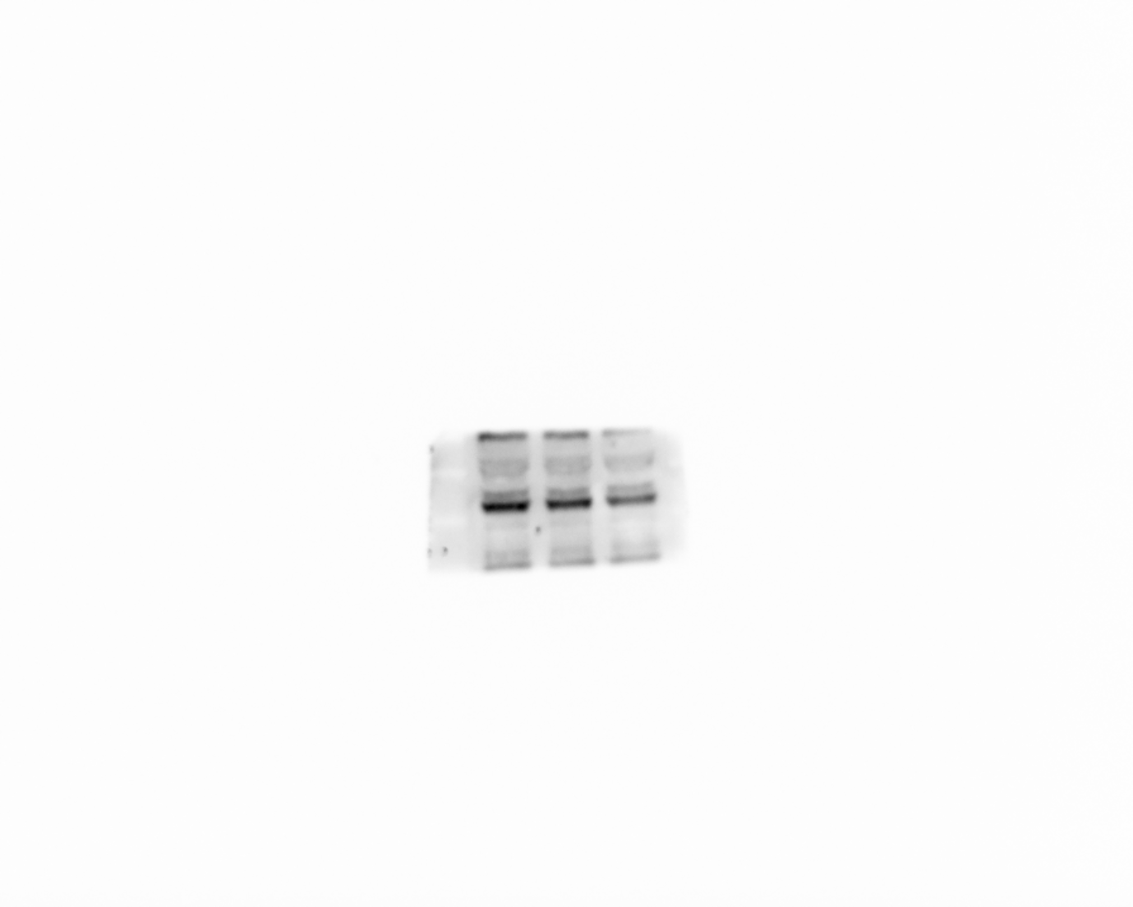

Supplementary Figure 3. The entire original gel of p-Smad2 in Figure 3C.

Smad3

55KDa

CAL-27

Compound 1

0 15 30 μM

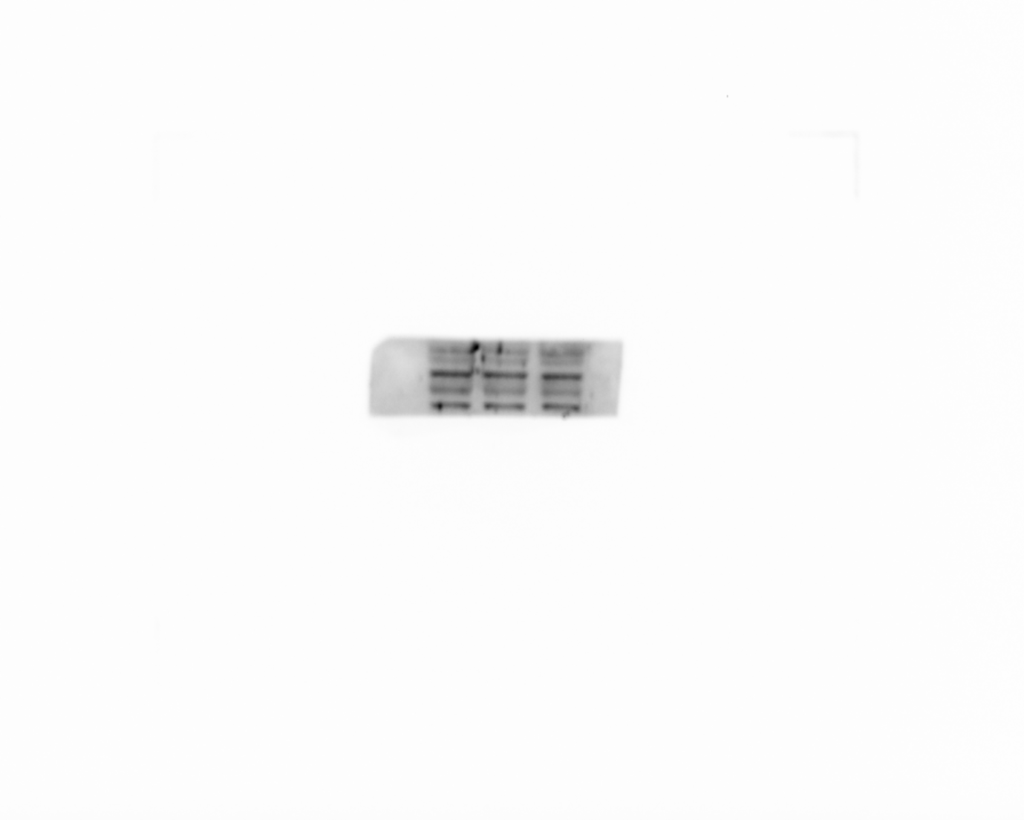

Supplementary Figure 4. The entire original gel of Smad3 in Figure 3C.

55KDa

p-Smad3

CAL-27

Compound 1

0 15 30 μM

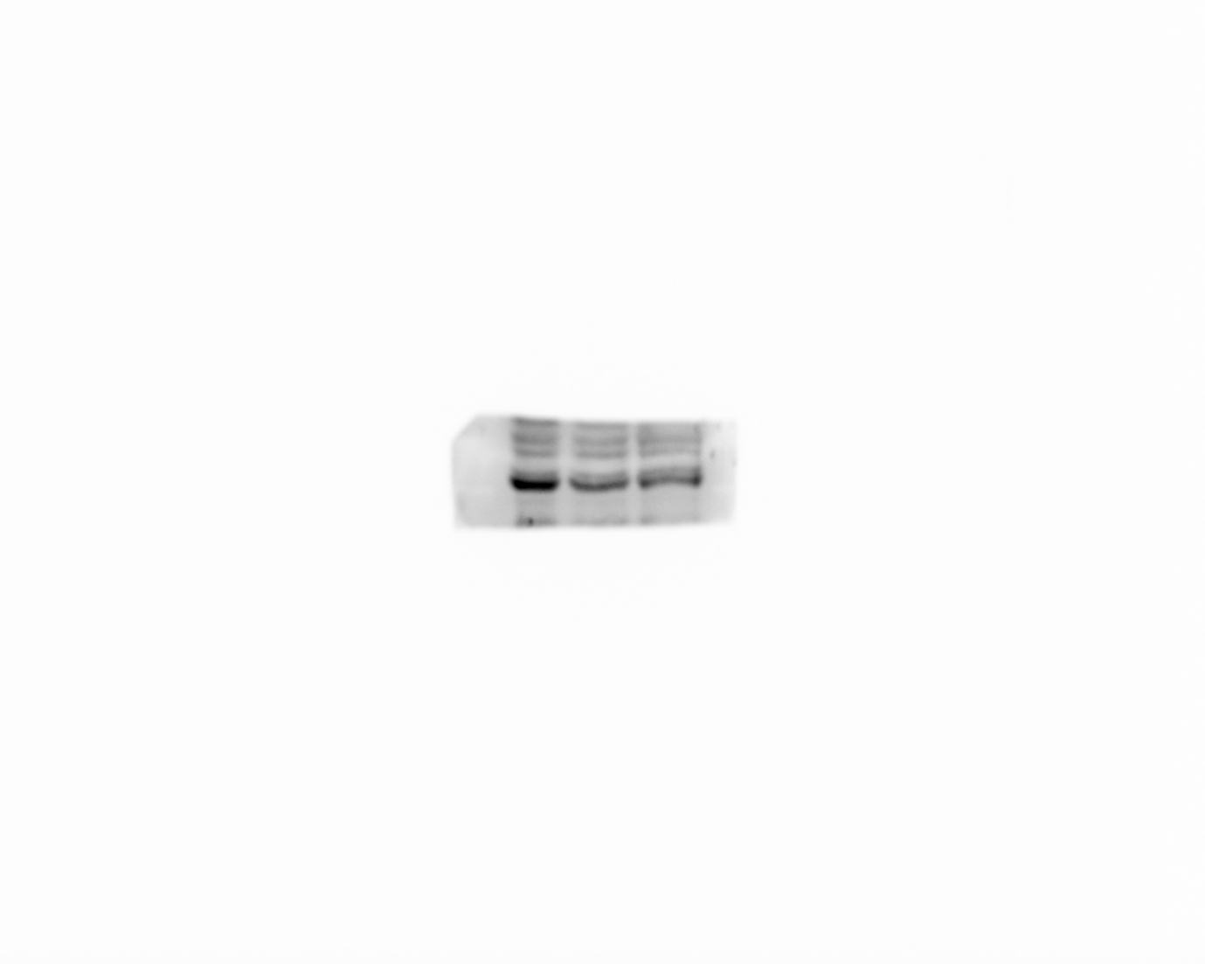

Supplementary Figure 5. The entire original gel of p-Smad3 in Figure 3C.

0 15 30 μM

AKT

60KDa

CAL-27

Compound 1

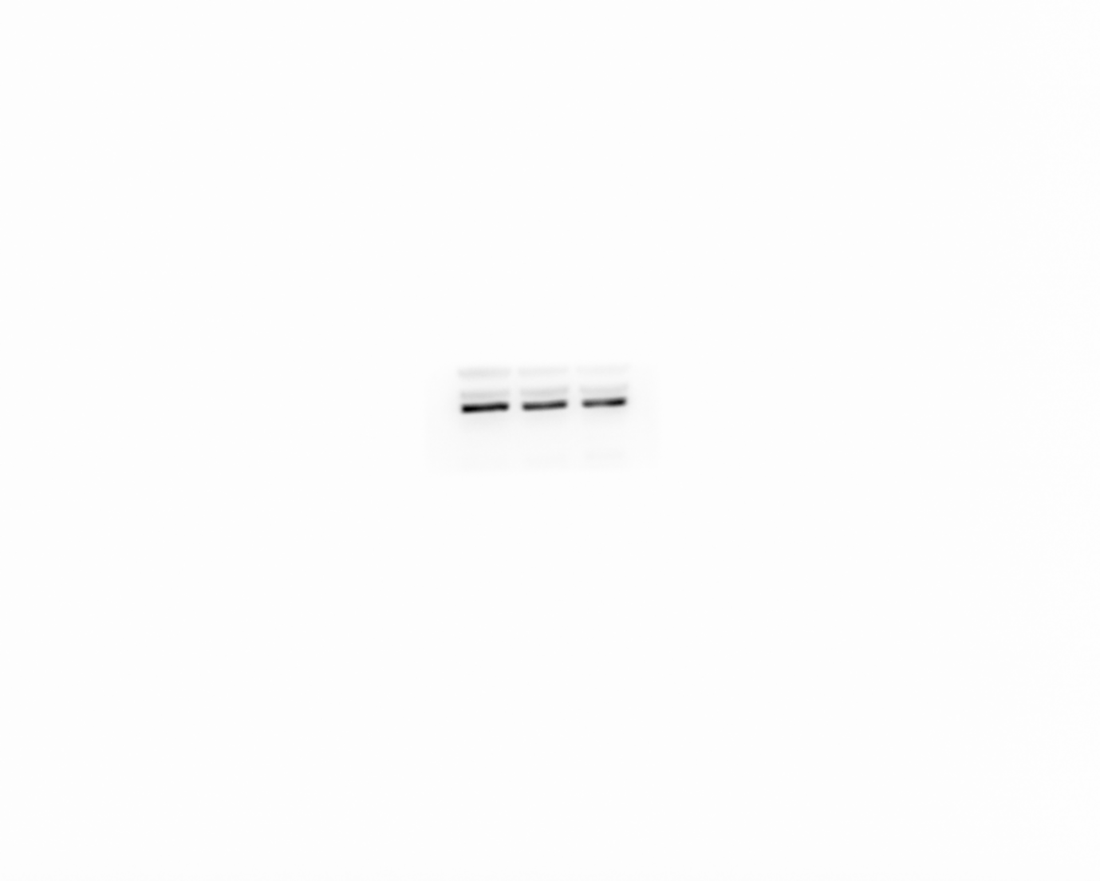

Supplementary Figure 6. The entire original gel of AKT in Figure 3D.

0 15 30 μM

CAL-27

60KDa

p-AKT

Compound 1

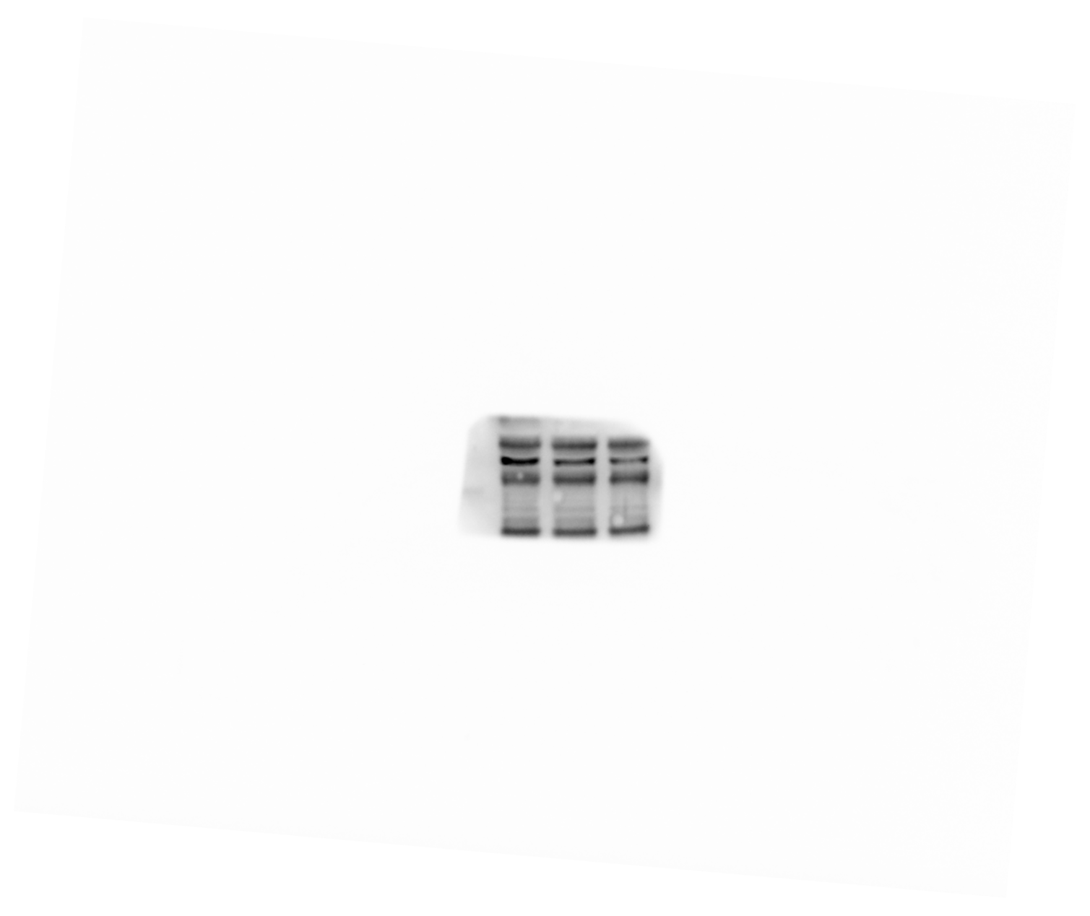

Supplementary Figure 7. The entire original gel of P-AKT in Figure 3D.

Compound 1

0 15 30 μM

CAL-27

85KDa

PI3K

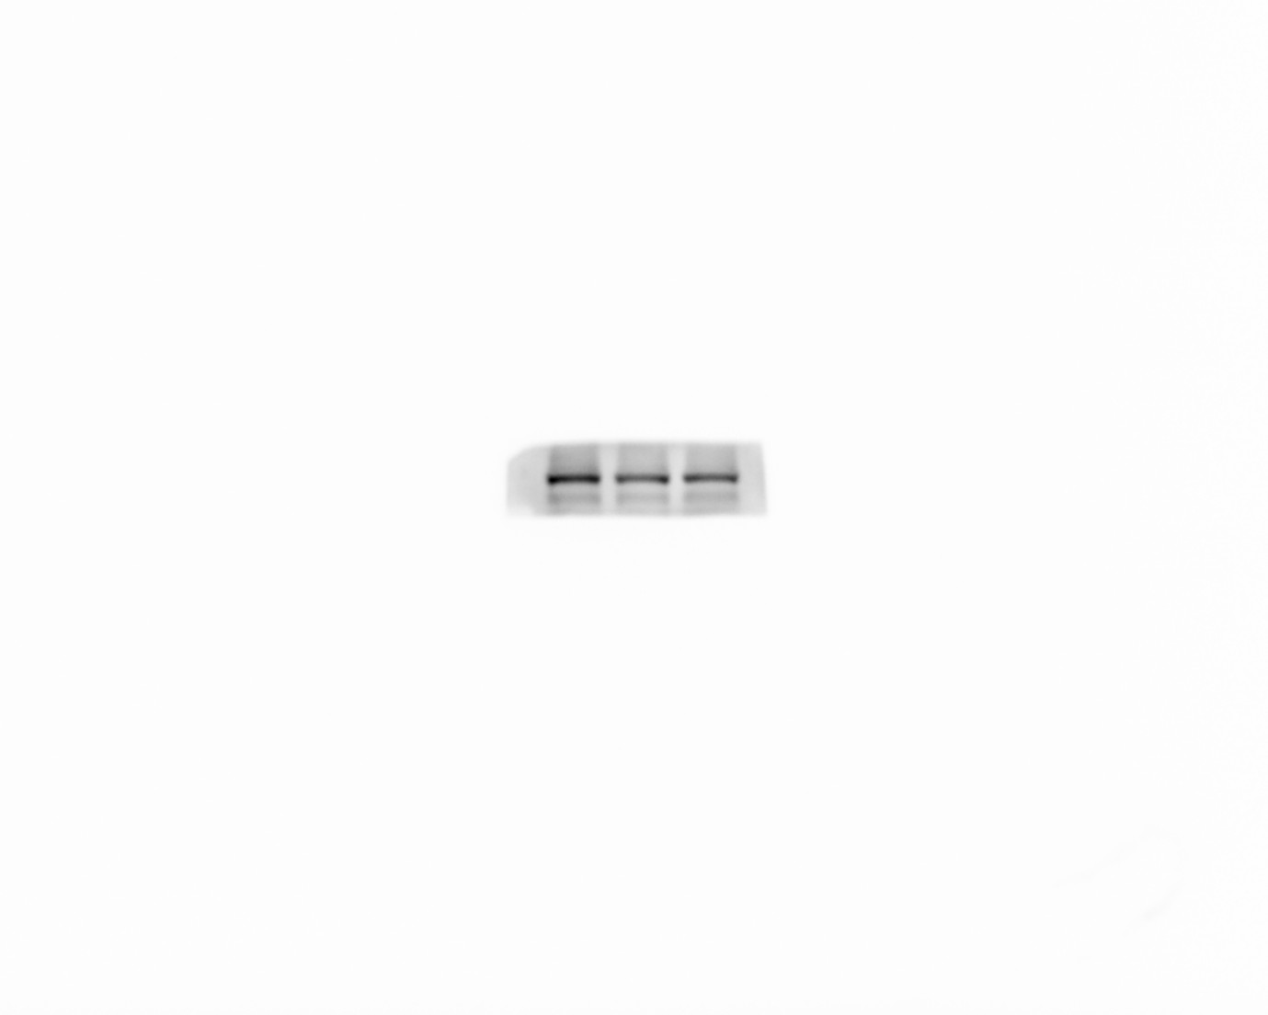

Supplementary Figure 8. The entire original gel of PI3K in Figure 3D.

Compound 1

0 15 30 μM

85KDa

p-PI3K

CAL-27

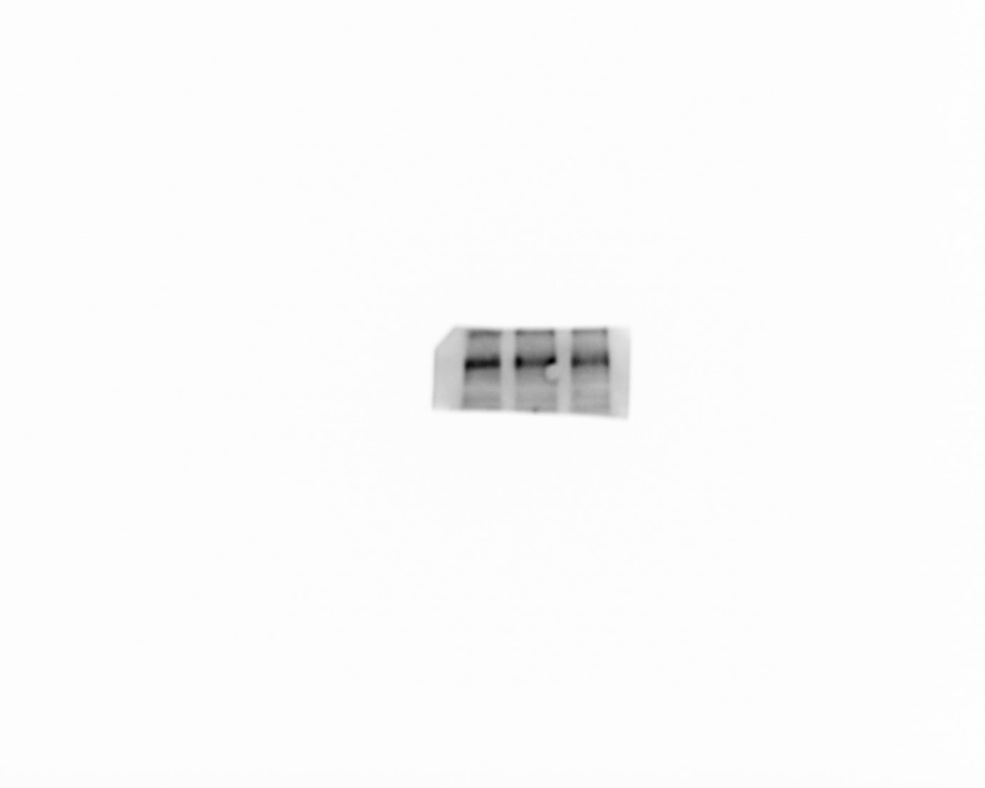

Supplementary Figure 9. The entire original gel of p-PI3K in Figure 3D.

36KDa

gapdh

0 15 30 μM

Compound 1

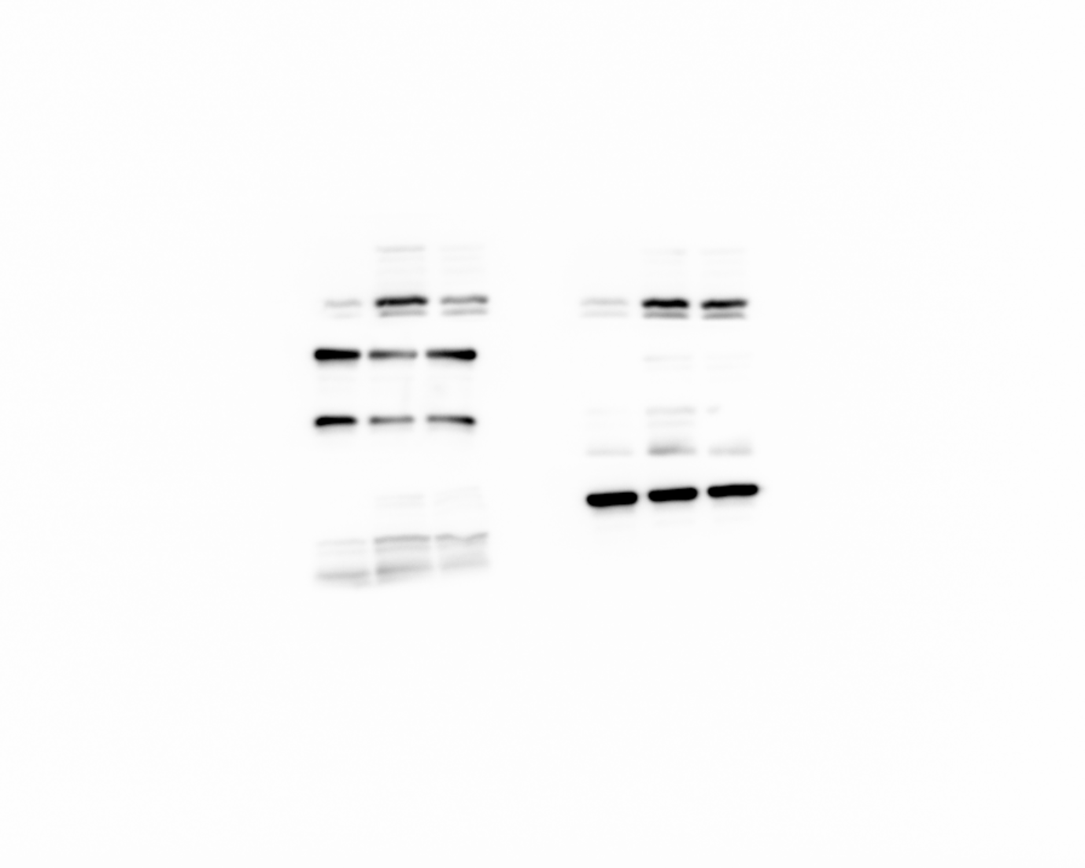

Supplementary Figure 10. The entire original gel of gapdh in Figure 3C-D.

21KDa

Compound 1

0 10 20 0 15 30 μM

CAL-27

Twist1

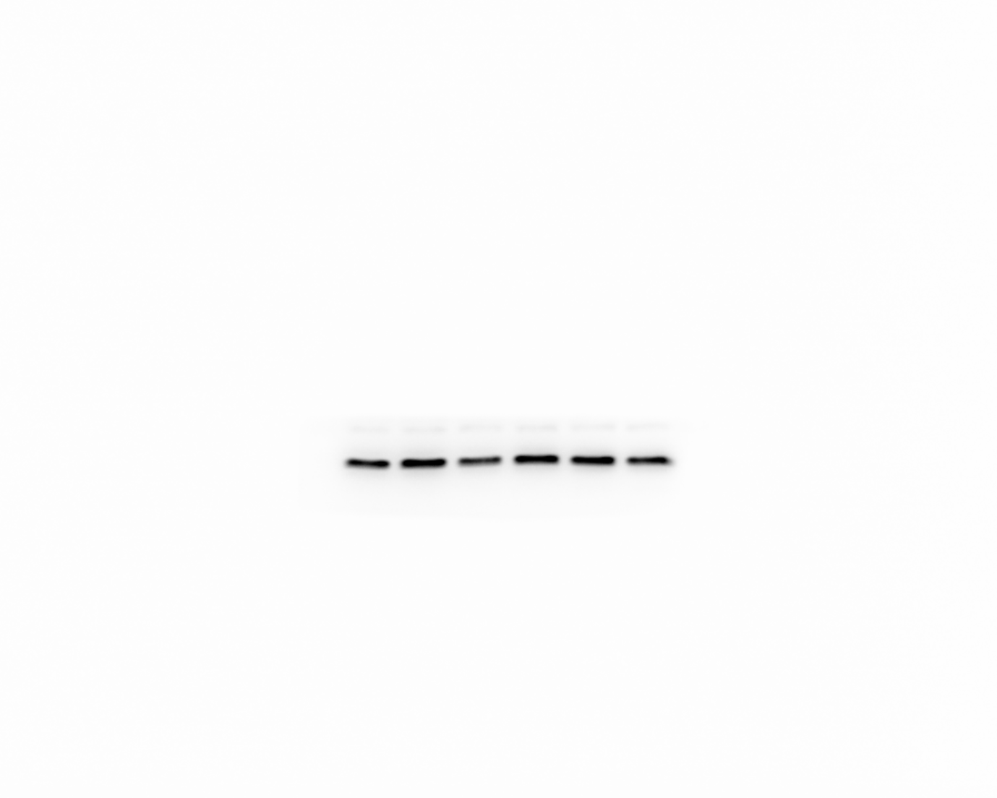

Supplementary Figure 11. The entire original gel of Twist1 in Figure 3E.

Compound 1

0 15 30 45 60 μM

CAL-27

Vimentin

54KDa

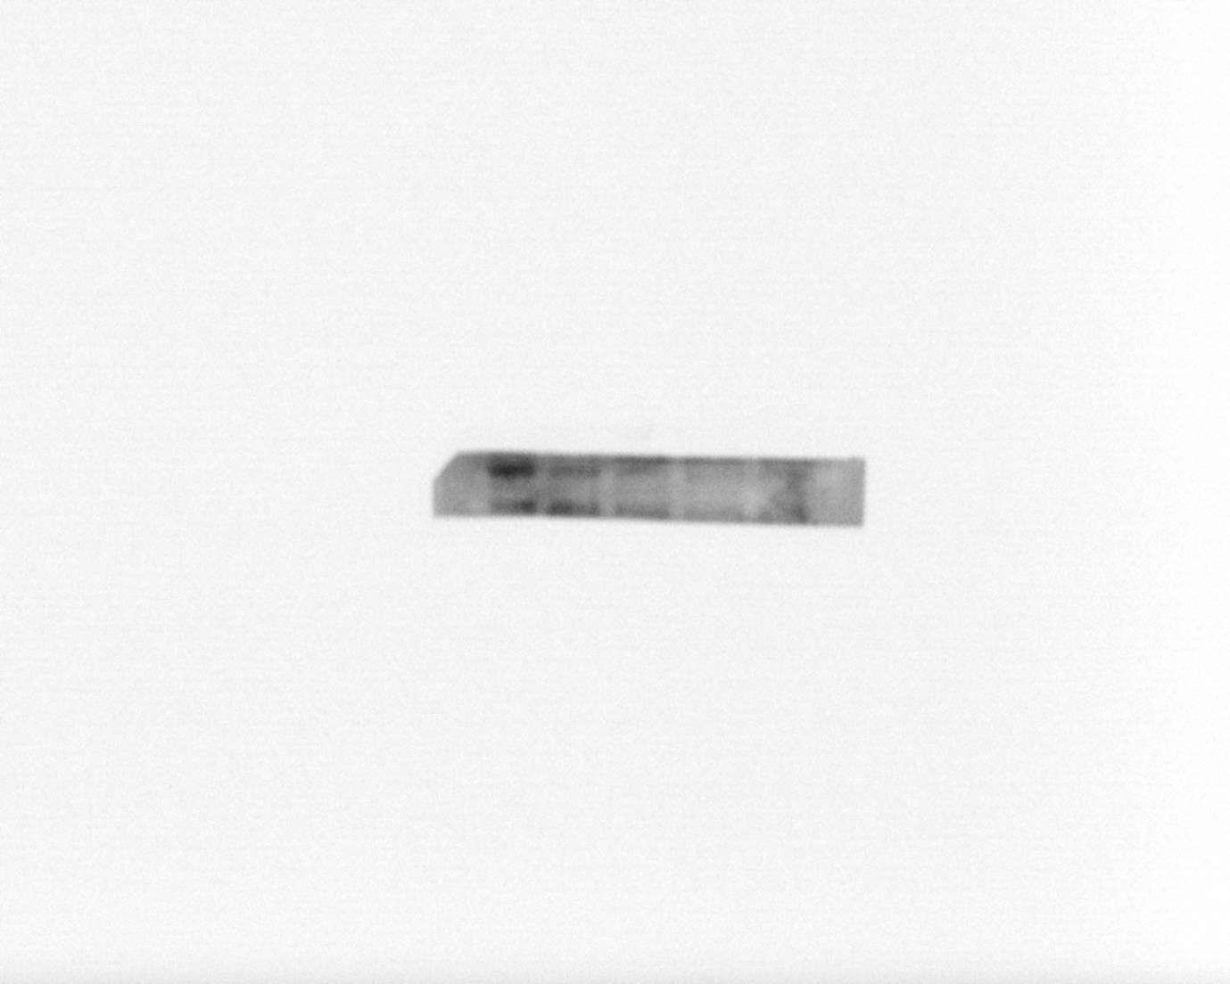

Supplementary Figure 12. The entire original gel of Vimentin in Figure 3E.

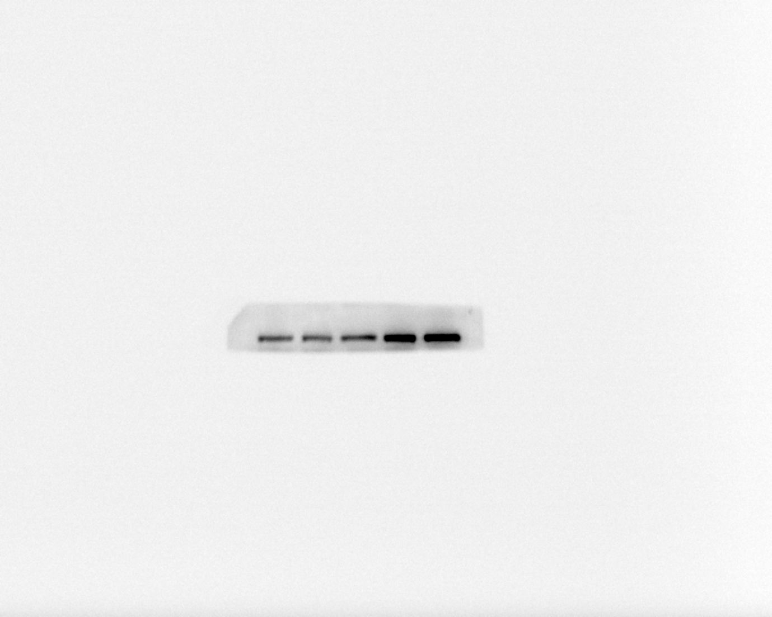

CAL-27

Compound 1

0 15 30 45 60 μM

120KDa

E-cadherin

Supplementary Figure 13. The entire original gel of E-cadherin in Figure 3E.

99KDa

Compound 1

0 10 20 0 15 30 μM

CAL-27

N-cadherin

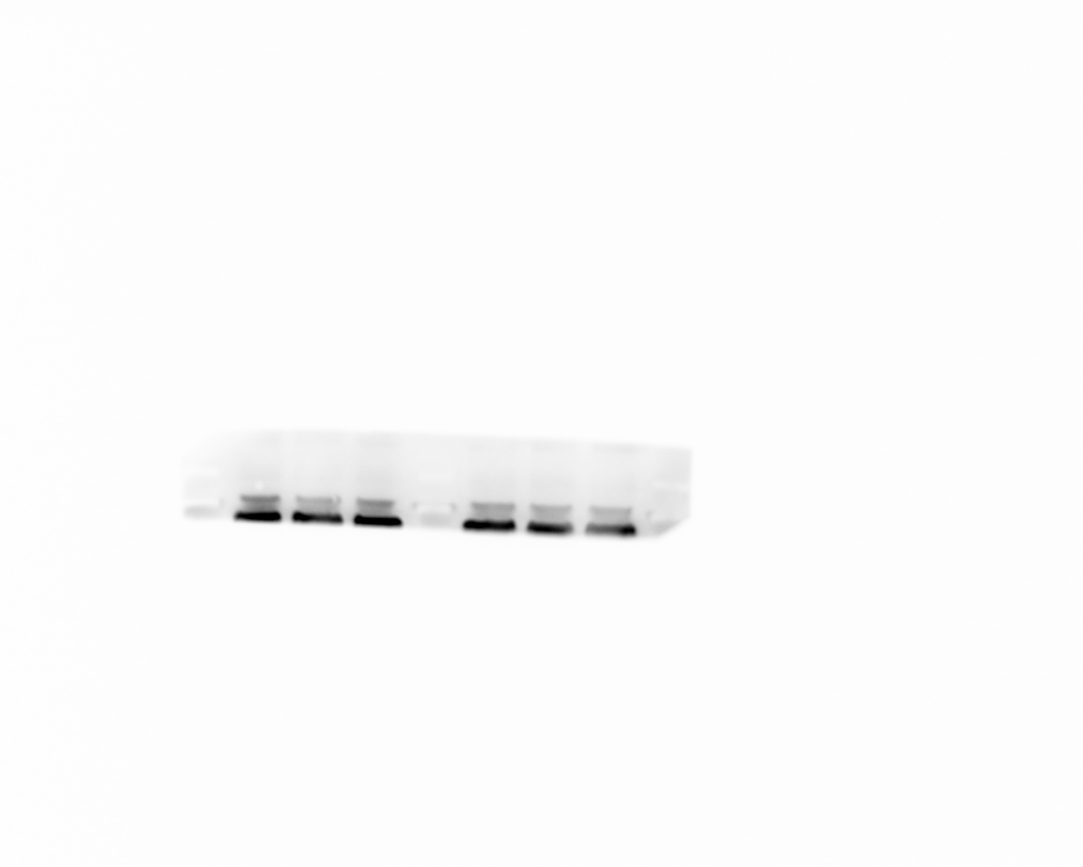

Supplementary Figure 14. The entire original gel of N-cadherin in Figure 3E.

Compound 1

0 10 20 0 15 30 μM

36KDa

gapdh

CAL-27

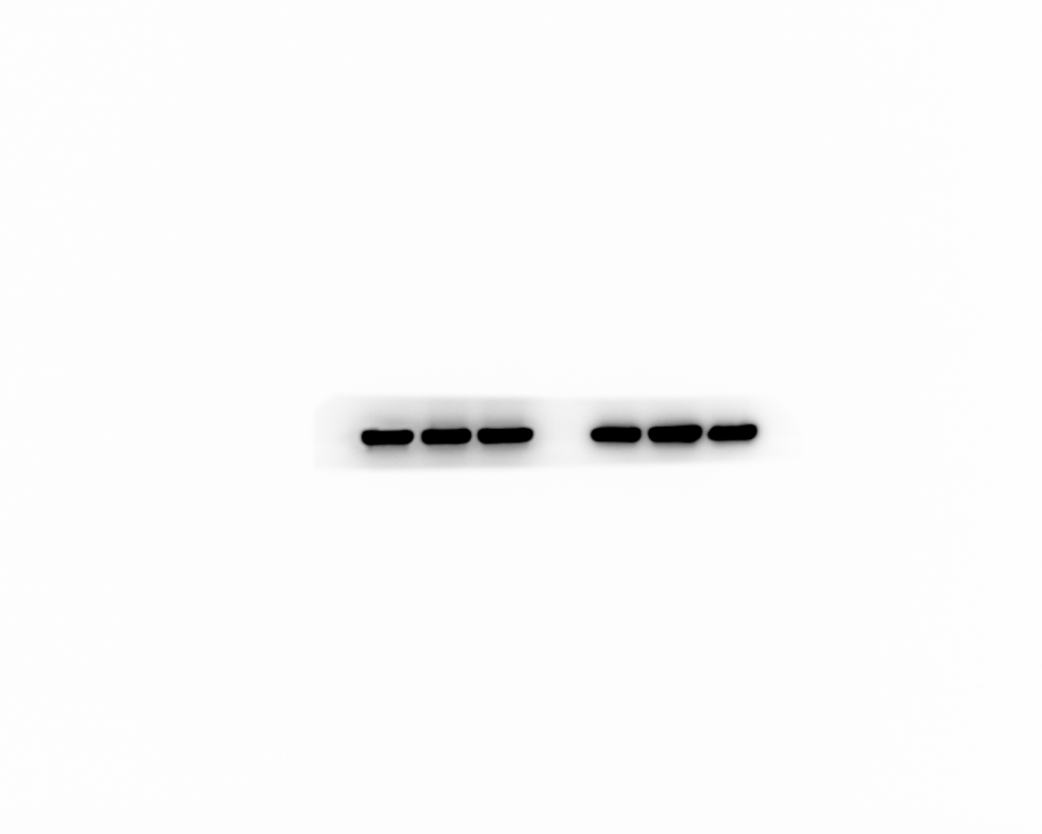

Supplementary Figure 15. The entire original gel of gapdh in Figure 3E.