**Supporting Information for**

**Novel Thiazole-derived Schiff-Bases as Efficient Corrosion Inhibitors for Mild Steel in Acidic Media: Synthesis, Electrochemical and Computational Insights**

Nizar El Guesmi a,b*, Basim H. Asghar a*, Mohamed I. Awad a,c, Abdulrahman N. Al Harbi a, Mohammed A. Kassem a,d, and Mohamed R. Shaaban a,c

a Department of Chemistry, Faculty of Science, Umm Al-Qura University, Makkah, Saudi Arabia

b Department of Chemistry, Faculty of Science, Monastir University, Monastir, Tunisia

*c Department of Chemistry, Faculty of Science, Cairo University, Giza, Egypt*

d Department of Chemistry, Faculty of Science, Benha University, Benha, Egypt

*Correspondence Author.

Nizar El Guesmi and Basim H. Asghar

E-mail address: naguesmi@uqu.edu.sa, bhasghar@uqu.edu.sa; Tel./Fax: +966 551516795, + 966 555511003.

**1. Theoretical calculations**

Quantum chemical calculations were performed on several derivatives to gain a better insight of their electronic, thermodynamic and kinetic properties. The relevant points on the ground potential energy surface were located at the B3LYP/6-31G(d,p) level of theory. This functional has proved to give satisfactory results in predicting electronic and spectroscopic properties of various types of compounds (Jacquemin et al., 2009). All the calculations were performed with Gaussian09 package of programs.

# Jacquemin, D., Wathelet, V., Perpete, E., Adamo, C., 2009. Extensive TD-DFT Benchmark: Singlet-Excited States of Organic Molecules. J Chem Theory Comput. 5, 2420-2435.

M. J. Frisch, G. W. Trucks, H. B. Schlegel, G. E. Scuseria, M. A. Robb, J. R. Cheeseman, G. Scalmani, V. Barone, B. Mennucci, G. A. Petersson, H. Nakatsuji, M. Caricato, X. Li, H. P. Hratchian, A. F. Izmaylov, J. Bloino, G. Zheng, J. L. Sonnenberg, M. Hada, M. Ehara, K. Toyota, R. Fukuda, J. Hasegawa, M. Ishida, T. Nakajima, Y. Honda, O. Kitao, H. Nakai, T. Vreven, J. A. Montgomery, Jr., J. E. Peralta, F. Ogliaro, M. Bearpark, J. J. Heyd, E. Brothers, K. N. Kudin, V. N. Staroverov, R. Kobayashi, J. Normand, K. Raghavachari, A. Rendell, J. C. Burant, S. S. Iyengar, J. Tomasi, M. Cossi, N. Rega, J. M. Millam, M. Klene, J. E. Knox, J. B. Cross, V. Bakken, C. Adamo, J. Jaramillo, R. Gomperts, R. E. Stratmann, O. Yazyev, A. J. Austin, R. Cammi, C. Pomelli, J. W. Ochterski, R. L. Martin, K. Morokuma, V. G. Zakrzewski, G. A. Voth, P. Salvador, J. J. Dannenberg, S. Dapprich, A. D. Daniels, Ö. Farkas, J. B. Foresman, J. V. Ortiz, J. Cioslowski, and D. J. Fox, Gaussian 09, Revision D.01, Gaussian, Inc., Wallingford CT, 2009.

**Coordinates of the optimized geometries**

C:\Users\EHD\Desktop\ABDERRAHMEN HARBI THESIS\calculations SB\N3\SB3.tif

Optimized geometry of **3a**

E(RB3LYP) = -1044.0254 a.u.

Standard orientation:

---------------------------------------------------------------------

Center Atomic Atomic Coordinates (Angstroms)

Number Number Type X Y Z

---------------------------------------------------------------------

1 6 0 -3.471909 -1.407026 0.000928

2 6 0 -4.034742 -0.113845 0.000027

3 6 0 -3.228907 1.022679 -0.000680

4 6 0 -1.835045 0.895760 -0.000515

5 6 0 -1.244111 -0.406171 0.000409

6 6 0 -2.099209 -1.531857 0.001114

7 6 0 0.179621 -0.576966 0.000678

8 7 0 0.992753 0.437990 0.000206

9 6 0 2.359552 0.309596 0.000284

10 8 0 -1.097686 2.008267 -0.001278

11 8 0 -5.390370 -0.039985 -0.000115

12 7 0 3.152386 1.348093 0.001676

13 6 0 4.470296 0.972419 0.001475

14 6 0 4.723789 -0.368420 -0.000180

15 16 0 3.233899 -1.258496 -0.001665

16 1 0 -4.129027 -2.268454 0.001463

17 1 0 -3.656172 2.021268 -0.001385

18 1 0 -1.650565 -2.521940 0.001826

19 1 0 0.552655 -1.609343 0.001493

20 1 0 -5.662210 0.888002 -0.000739

21 1 0 5.677466 -0.876541 -0.000722

22 1 0 -0.136723 1.736528 -0.001140

23 1 0 5.234658 1.740563 0.002578

---------------------------------------------------------------------

C:\Users\EHD\Desktop\ABDERRAHMEN HARBI THESIS\calculations SB\N1\SB1.tif

Optimized geometry of **3b**

E(RB3LYP) = -1275.0930 a.u.

Standard orientation:

---------------------------------------------------------------------

Center Atomic Atomic Coordinates (Angstroms)

Number Number Type X Y Z

---------------------------------------------------------------------

1 6 0 5.579408 0.759065 0.003204

2 6 0 5.774996 -0.637688 -0.000116

3 6 0 4.693832 -1.516600 -0.002568

4 6 0 3.385237 -1.020498 -0.001782

5 6 0 3.164898 0.392359 0.001496

6 6 0 4.290551 1.247602 0.003944

7 6 0 1.839394 0.938502 0.002240

8 7 0 0.783608 0.178636 -0.000126

9 6 0 -0.497849 0.672270 -0.000102

10 8 0 2.376250 -1.894232 -0.004166

11 8 0 7.061000 -1.072002 -0.000754

12 7 0 -1.539183 -0.109556 -0.000064

13 6 0 -2.727928 0.590896 -0.000276

14 6 0 -2.585968 1.957686 -0.000510

15 16 0 -0.916774 2.415624 -0.001438

16 6 0 -4.000020 -0.159908 0.000072

17 6 0 -5.244783 0.491292 -0.002901

18 6 0 -6.430102 -0.238895 -0.002294

19 6 0 -6.397331 -1.635262 0.001241

20 6 0 -5.166267 -2.292257 0.004103

21 6 0 -3.978249 -1.564044 0.003521

22 1 0 6.443299 1.412906 0.005068

23 1 0 4.837609 -2.593135 -0.005104

24 1 0 4.123971 2.321742 0.006461

25 1 0 1.756654 2.033079 0.004802

26 1 0 7.074738 -2.038892 -0.003044

27 1 0 -3.353432 2.717311 -0.000453

28 1 0 -5.293694 1.575996 -0.005914

29 1 0 -7.382176 0.283928 -0.004677

30 1 0 -7.322716 -2.203614 0.001685

31 1 0 -5.128697 -3.377838 0.006806

32 1 0 -3.019065 -2.068654 0.005706

33 1 0 1.523995 -1.373613 -0.003271

---------------------------------------------------------------------

C:\Users\EHD\Desktop\ABDERRAHMEN HARBI THESIS\calculations SB\N2\SB2.tif

Optimized geometry of **3c**

E(RB3LYP) = -1314.4119 a.u.

Standard orientation:

---------------------------------------------------------------------

Center Atomic Atomic Coordinates (Angstroms)

Number Number Type X Y Z

---------------------------------------------------------------------

1 6 0 -5.735540 0.798526 0.094590

2 6 0 -5.976166 -0.590541 0.067367

3 6 0 -4.923998 -1.503070 0.029240

4 6 0 -3.600129 -1.049048 0.016569

5 6 0 -3.334252 0.355244 0.042759

6 6 0 -4.431288 1.245367 0.082507

7 6 0 -1.990976 0.858957 0.029888

8 7 0 -0.960750 0.066272 -0.007800

9 6 0 0.335360 0.519666 -0.038515

10 8 0 -2.619755 -1.954659 -0.019058

11 8 0 -7.275841 -0.984262 0.080500

12 7 0 1.352334 -0.290217 0.021041

13 6 0 2.562101 0.374746 -0.010017

14 6 0 2.485518 1.748049 -0.128408

15 16 0 0.807482 2.238985 -0.166190

16 6 0 3.795345 -0.441689 0.042988

17 6 0 4.970848 0.008948 0.665602

18 6 0 6.115858 -0.787818 0.687868

19 6 0 6.104659 -2.051809 0.098437

20 6 0 4.934012 -2.519687 -0.503645

21 6 0 3.790374 -1.726390 -0.527996

22 1 0 -6.577721 1.479523 0.124306

23 1 0 -5.102287 -2.574312 0.009081

24 1 0 -4.229963 2.313388 0.103049

25 1 0 -1.872055 1.949907 0.057128

26 1 0 -7.319355 -1.950018 0.060114

27 1 0 4.983344 0.970925 1.166387

28 1 0 7.013281 -0.423393 1.179593

29 1 0 6.996047 -2.671972 0.117545

30 1 0 4.911972 -3.507489 -0.955023

31 1 0 2.876157 -2.089928 -0.984123

32 1 0 -1.751300 -1.461546 -0.019228

33 6 0 3.567421 2.775037 -0.283016

34 1 0 3.827737 3.249588 0.671409

35 1 0 4.472370 2.312768 -0.684105

36 1 0 3.260845 3.570860 -0.968629

---------------------------------------------------------------------

|  |  |  |  |
| --- | --- | --- | --- |
|  | **(3a)** | **(3b)** | **(3c)** |
| **LUMO+1** | C:\Users\EHD\Desktop\ABDERRAHMEN HARBI THESIS\calculations SB\N3\LUMO+1 N3.tif | C:\Users\EHD\Desktop\ABDERRAHMEN HARBI THESIS\calculations SB\N1\LUMO+1 N1.tif | C:\Users\EHD\Desktop\ABDERRAHMEN HARBI THESIS\calculations SB\N2\LUMO+1 N2.tif |
| **-0.1197 eV** | **-0.7638 eV** | **-0.5967 eV** |
| **LUMO** | C:\Users\EHD\Desktop\ABDERRAHMEN HARBI THESIS\calculations SB\N3\LUMO N3.tif | C:\Users\EHD\Desktop\ABDERRAHMEN HARBI THESIS\calculations SB\N1\LUMO N1.tif | C:\Users\EHD\Desktop\ABDERRAHMEN HARBI THESIS\calculations SB\N2\LUMO N2.tif |
| **-2.1241 eV** | **-2.1543 eV** | **-2.0465 eV** |
| **HOMO** | C:\Users\EHD\Desktop\ABDERRAHMEN HARBI THESIS\calculations SB\N3\HOMO N3.tif | C:\Users\EHD\Desktop\ABDERRAHMEN HARBI THESIS\calculations SB\N1\HOMO N1.tif | C:\Users\EHD\Desktop\ABDERRAHMEN HARBI THESIS\calculations SB\N2\HOMO N2.tif |
| **-5.7568 eV** | **-5.5704 eV** | **-5.5005 eV** |
| **HOMO-1** | C:\Users\EHD\Desktop\ABDERRAHMEN HARBI THESIS\calculations SB\N3\HOMO-1 N3.tif | C:\Users\EHD\Desktop\ABDERRAHMEN HARBI THESIS\calculations SB\N1\HOMO-1 N1.tif | C:\Users\EHD\Desktop\ABDERRAHMEN HARBI THESIS\calculations SB\N2\HOMO-1 N2.tif |
| **-6.5413 eV** | **-6.2812 eV** | **-6.2648 eV** |

**2. Spectral data of compounds 3a-3c**

***4-((thiazol-2-ylimino)methyl)benzene-1,3-diol (3a)***

**IR Spectrum**

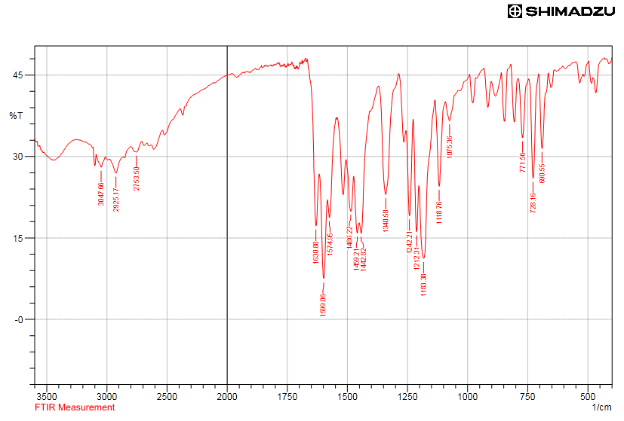

**1H NMR Spectrum**

***4-(((4-phenylthiazol-2-yl)imino)methyl)benzene-1,3-diol (3b)***

**IR Spectrum**

**1H NMR Spectrum**

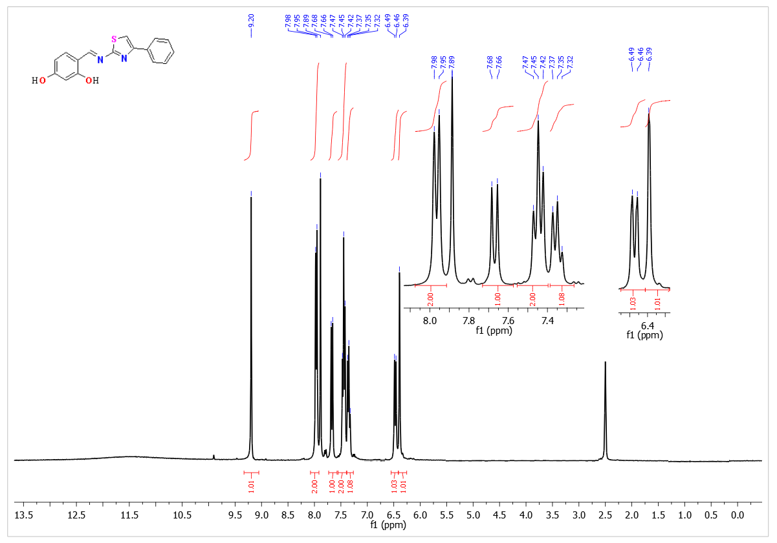

***4-(((5-methyl-4-phenylthiazol-2-yl)imino)methyl)benzene-1,3-diol (3c)***

**IR Spectrum**

**1H NMR Spectrum**

