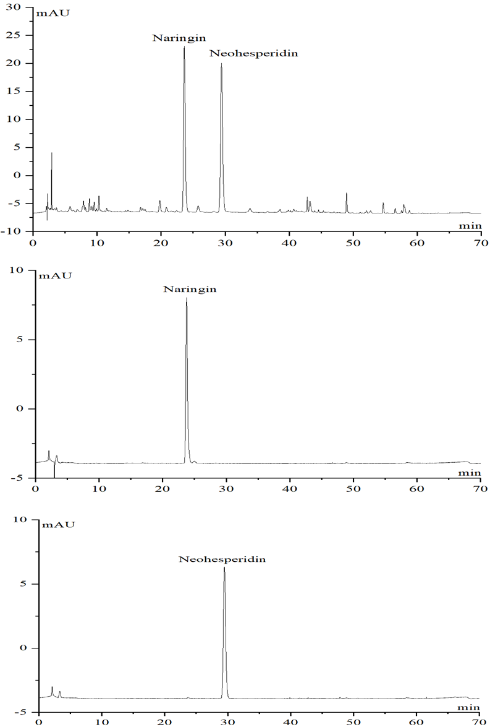
Fig. S1 HPLC chromatograms of naringin and neohesperidin reference and samples.

Fig. S2 The effect of pH of Ch-Lea on the extraction yield.

Fig. S3 SEM micrographs of Fructus aurantii powder after ultrasonic treatment with methanol (A) and ethanol (B).

Table S1 The effect of the molar ratio of Ch-Lea for extraction content.
Molar ratio of Ch-Lea | 1:1 | 1:2 | 1:3 | 1:4 | 1:5
Content (mg/g) | 115.63±4.03 | 122.88±3.21 | 121.12±0.05 | 121.12±4.65 | 115.24±0.36

Table S2 The effect of the water content in NADES/water solution for extraction content.
Water content in NADES (%) | 0 | 10 | 20 | 30 | 40 | 50 | 60 | 70
Content (mg/g) | 122.88±  3.21 | 122.90±1.47 | 124.74±0.70 | 126.91±0.84 | 122.85±2.92 | 124.25±4.58 | 118.32±2.72 | 115.66±3.11

Table S3 The effect of the solid/liquid for extraction content.
Solid/liq-uid (g/g) | 1:20 | 1:30 | 1:40 | 1:60 | 1:80 | 1:100
Content (mg/g) | 116.32±  2.82 | 122.07±  4.80 | 120.59±  3.14 | 122.23±  0.64 | 123.81±  1.91 | 123.34±  1.72

Table S4 The effect of the extraction time for extraction content.
Time | 1 min | 5 min | 15 min | 30 min | 40 min | 60 min
Content (mg/g) | 115.14±  3.82 | 117.86±  0.44 | 122.49±  2.33 | 121.22±  1.82 | 122.22±  2.55 | 121.75±  1.28

Table S5 The effect of the extraction temperature for extraction content.
Temperature (℃) | 20 | 30 | 40 | 50 | 60 | 70
Content (mg/g) | 123.12±  0.96 | 123.59±  1.91 | 123.50±  1.08 | 124.42±  5.19 | 121.98±  0.39 | 120.98±  1.39

Table S6 The effect of the extract power for extraction content.
Extract power | 60W | 120W | 180W | 240W | 300W
Content (mg/g) | 123.28±  1.02 | 122.41±  1.03 | 123.48±  2.37 | 122.12±  2.86 | 124.99±  4.13

