**Supplementary Data**

**Synthesis of N, N-Bis([1,1'-Biphenyl]-4-ylmethyl)-4-Morpholinoaniline Derivatives via SMC Reaction: Assessing Their Anti-Seizure Potential through Electroencephalogram Evaluation and Molecular Docking Studies**

Jawaria Hafeez1, Azka Sabir2, Nasir Rasool1*, Usama Hafeez1, Farhan Siddique3, Muhammad Bilal4, Aqsa Kanwal1, Gulraiz Ahmad1, Faleh Alqahtani5, Imran Imran2, Muhammad Imran6

1Department of Chemistry, Government College University Faisalabad, 38000, Pakistan; [jawariahafeezb8@gmail.com](mailto:jawariahafeezb8@gmail.com%20(J) (J. Hafeez), [nasirrasool@gcuf.edu.pk](mailto:nasirrasool@gcuf.edu.pk) (N. Rasool), [usamahafeez0987@gmail.com](mailto:usamahafeez0987@gmail.com) (U. Hafeez), [aqsa6373@gmail.com](mailto:aqsa6373@gmail.com) (A. Kanwal), [gulchemist35@gmail.com](mailto:gulchemist35@gmail.com) (G. Ahmad)

2Department of Pharmacology, Faculty of Pharmacy, Bahauddin Zakariya University, 60800, Multan, Pakistan. [azkasabir105@gmail.com](mailto:azkasabir105@gmail.com) (A. Sabir), [imran.ch@bzu.edu.pk](mailto:imran.ch@bzu.edu.pk) (I. Imran)

3Department of Pharmaceutical Chemistry, Faculty of Pharmacy, Bahauddin Zakariya University, 60800, Multan, Pakistan. [drfarhansiddique@bzu.edu.pk](mailto:drfarhansiddique@bzu.edu.pk) (F. Siddique)

4School of Chemistry and Chemical Engineering, Shandong University, Jinan 250100, China [muhammadbilalgcuf@gmail.com](mailto:muhammadbilalgcuf@gmail.com) (M. Bilal)

5 Department of Pharmacology and Toxicology, College of Pharmacy, King Saud University, Riyadh 11451, Saudi Arabia.

6Chemistry Department, Faculty of Science, King Khalid University, P.O. Box 9004, Abha 61413, Saudi Arabia [imranchemist@gmail.com](mailto:imranchemist@gmail.com) (M. Imran)

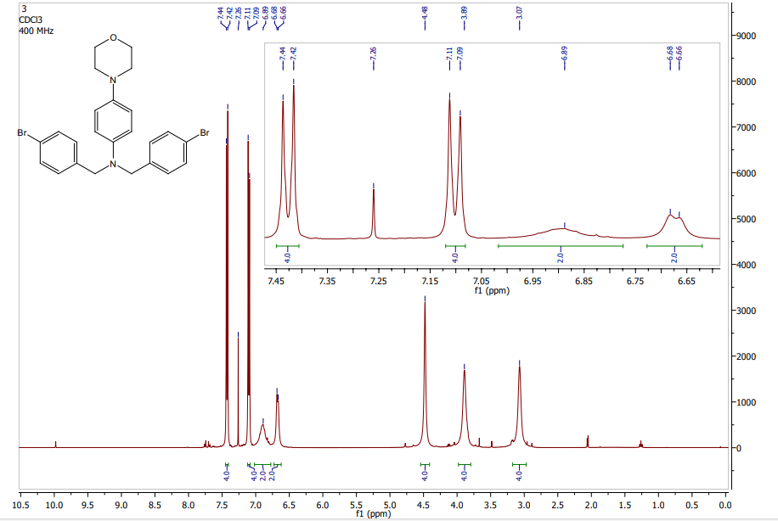

**Figure S1:** 1H NMR spectrum of compound **3**

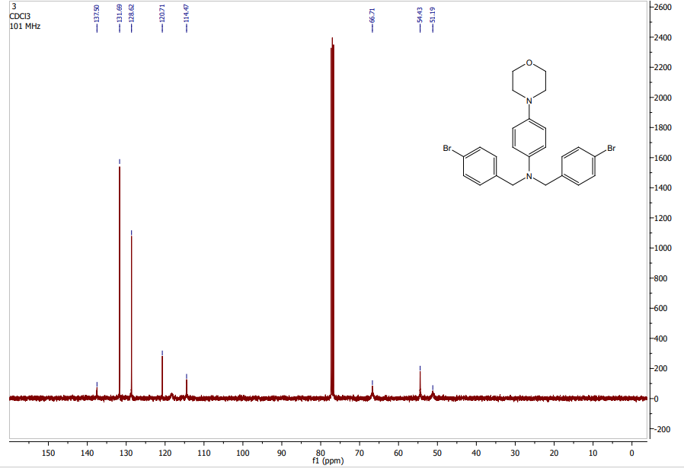

**Figure S2:**  13C NMR spectrum of compound **3**

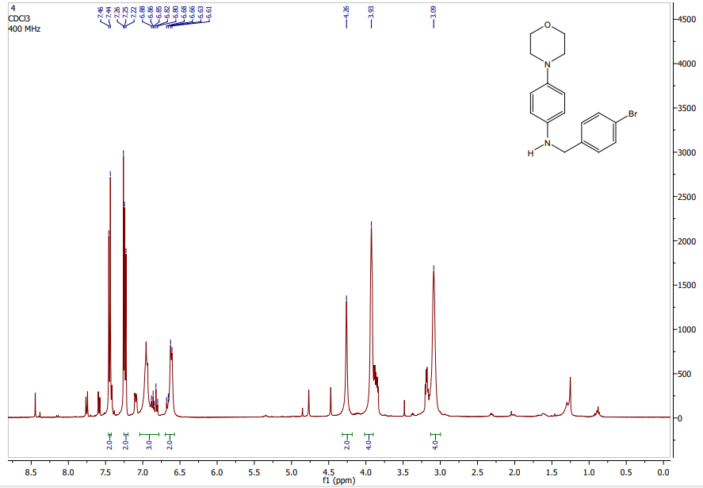

**Figure S3:** 1H NMR spectrum of compound **4**

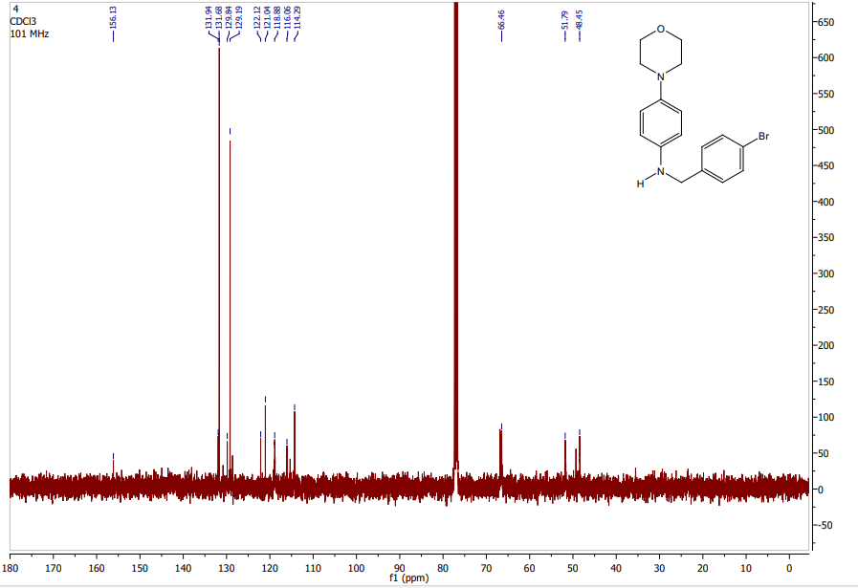

**Figure S4:**  13C NMR spectrum of compound **4**

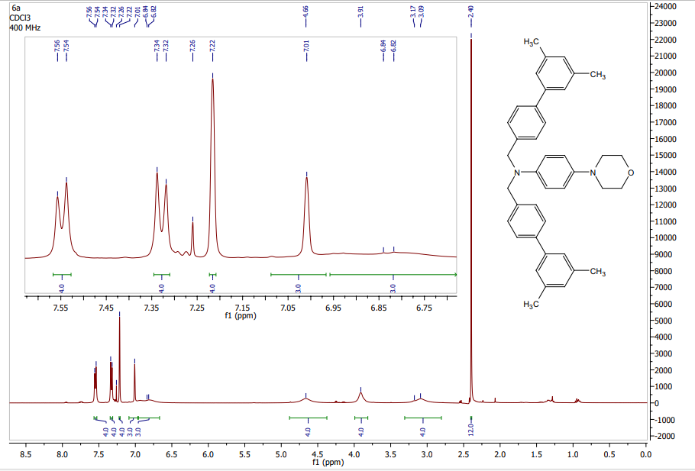

**Figure S5:** 1H NMR spectrum of compound **6a**

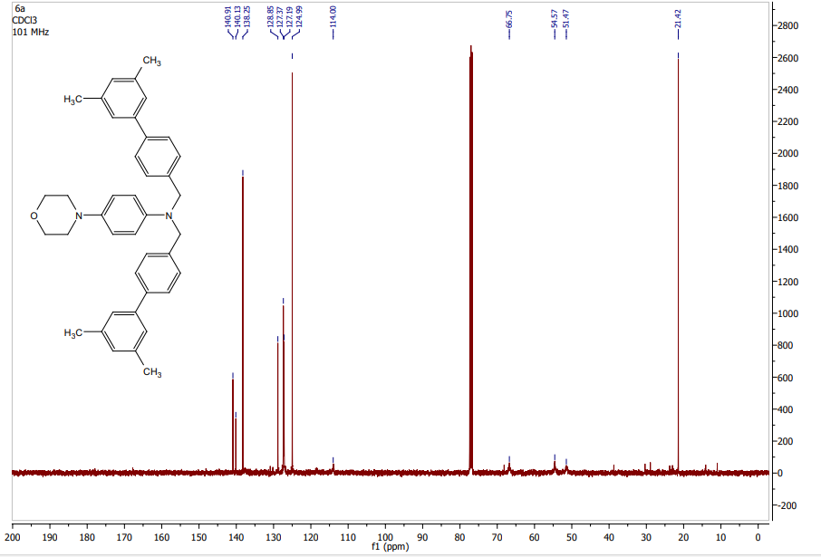

**Figure S6:**  13C NMR spectrum of compound **6a**

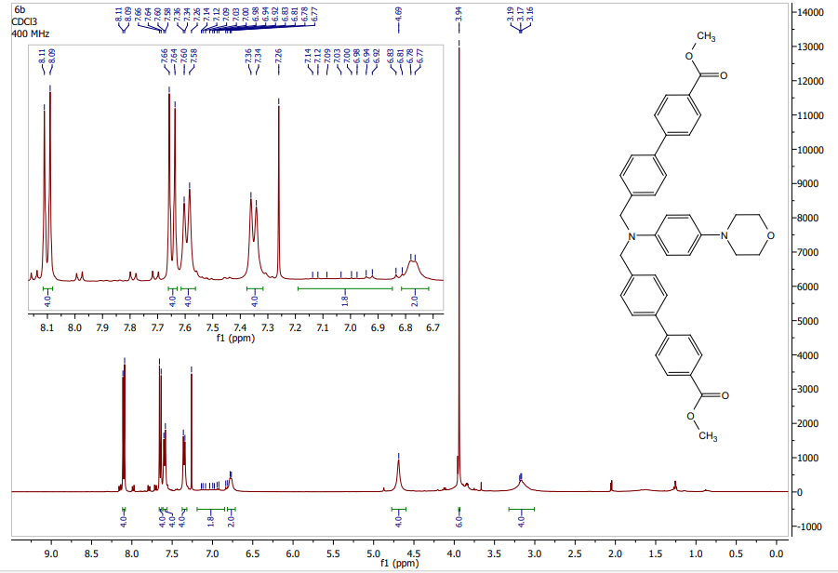

**Figure S7:** 1H NMR spectrum of compound **6b**

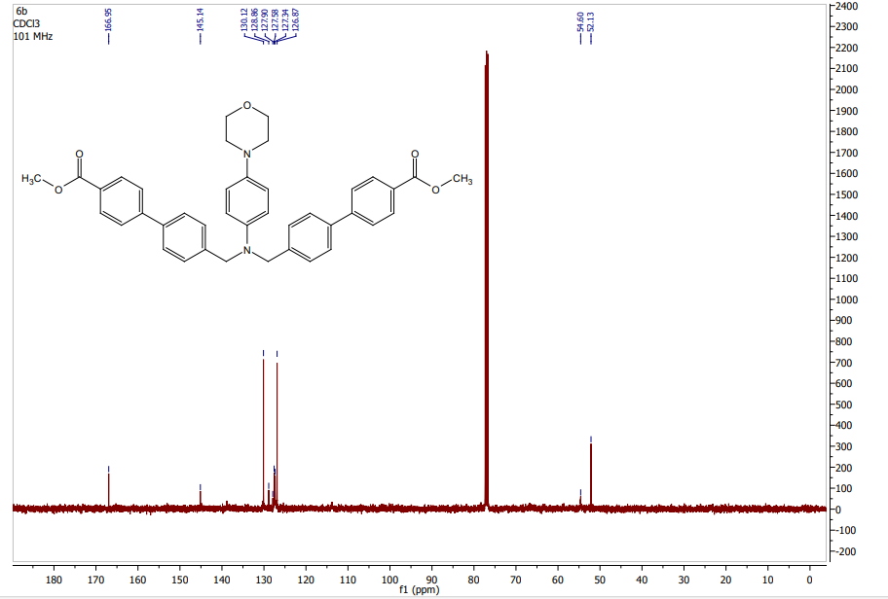

**Figure S8:**  13C NMR spectrum of compound **6b**

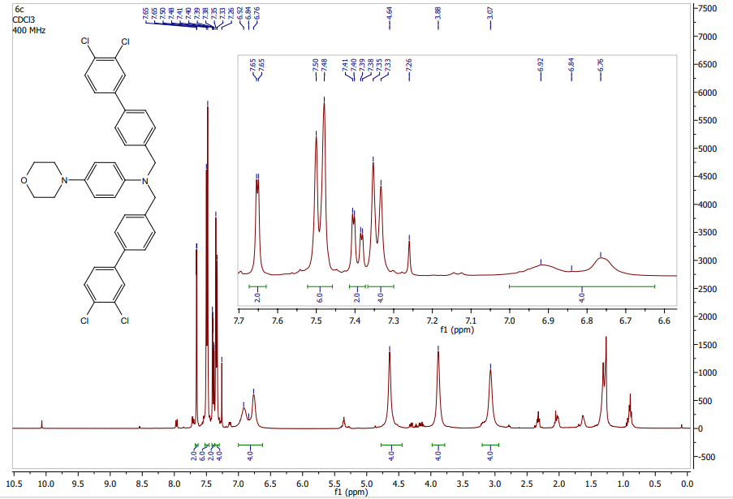

**Figure S9:** 1H NMR spectrum of compound **6c**

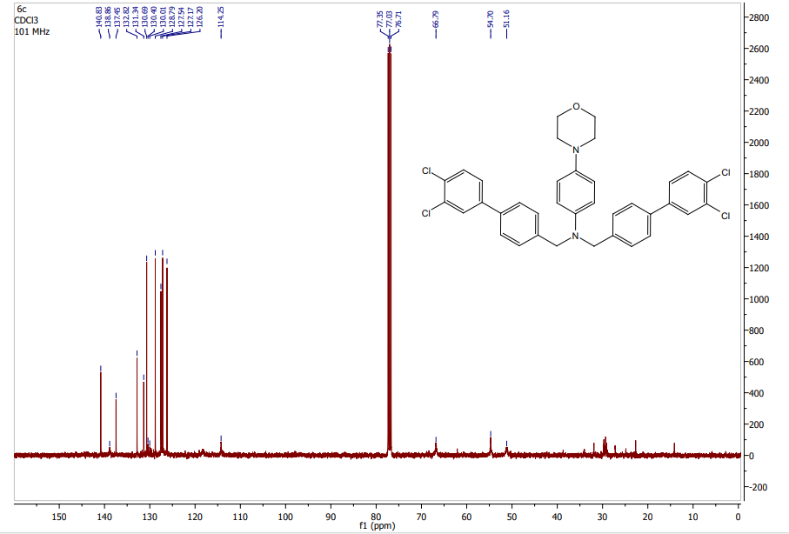

**Figure S10:**  13C NMR spectrum of compound **6c**

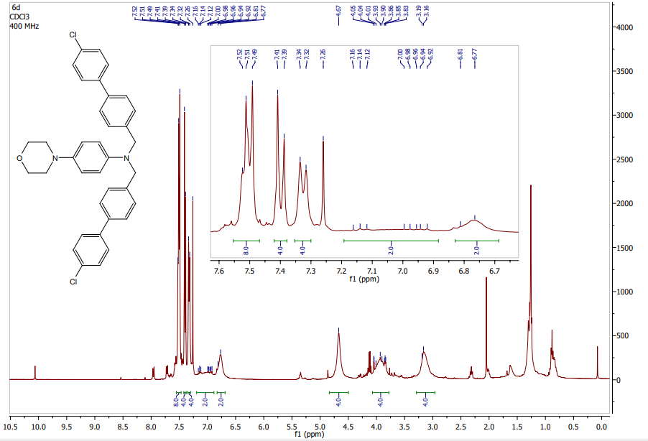

**Figure S11:** 1H NMR spectrum of compound **6d**

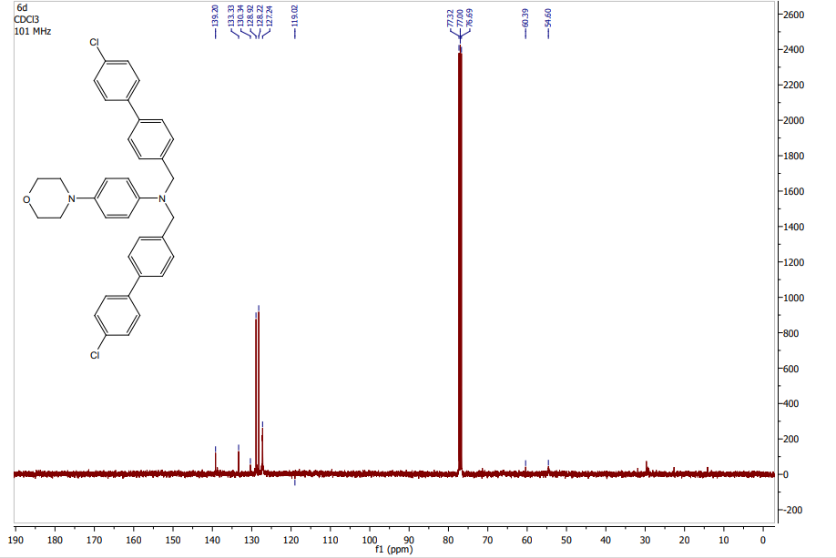

**Figure S12:** 13C NMR spectrum of compound **6d**

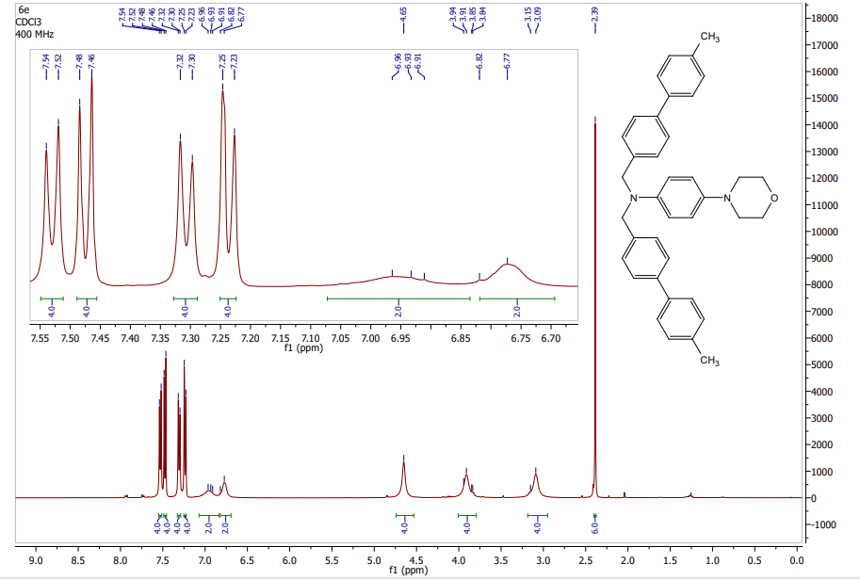

**Figure S13:** 1H NMR spectrum of compound **6e**

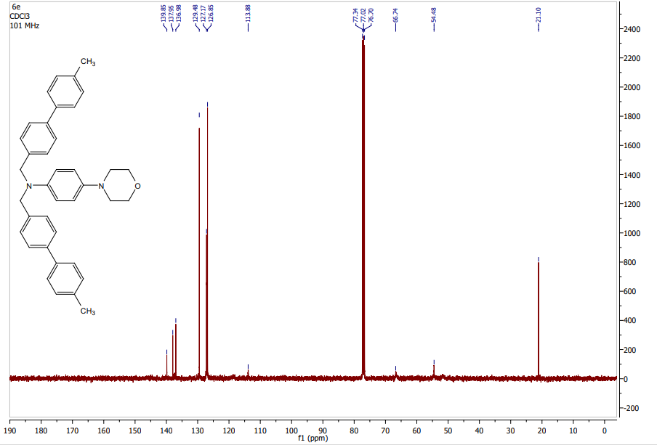

**Figure S14:** 13C NMR spectrum of compound **6e**

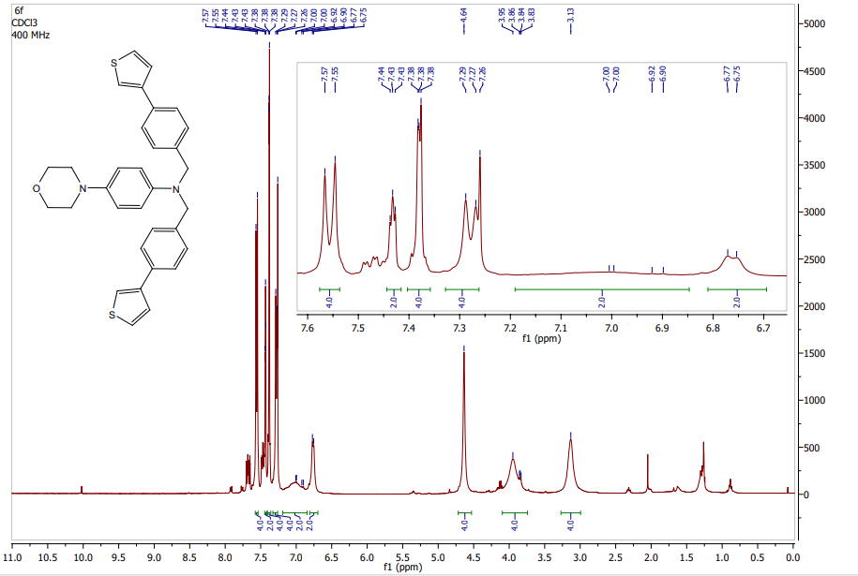

**Figure S15:** 1H NMR spectrum of compound **6f**

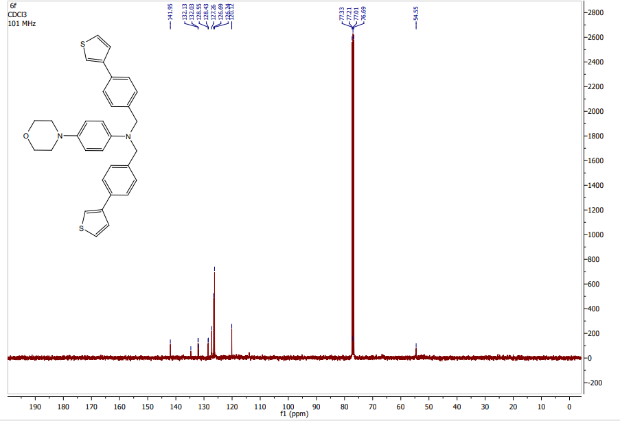

**Figure S16:** 13C NMR spectrum of compound **6f**

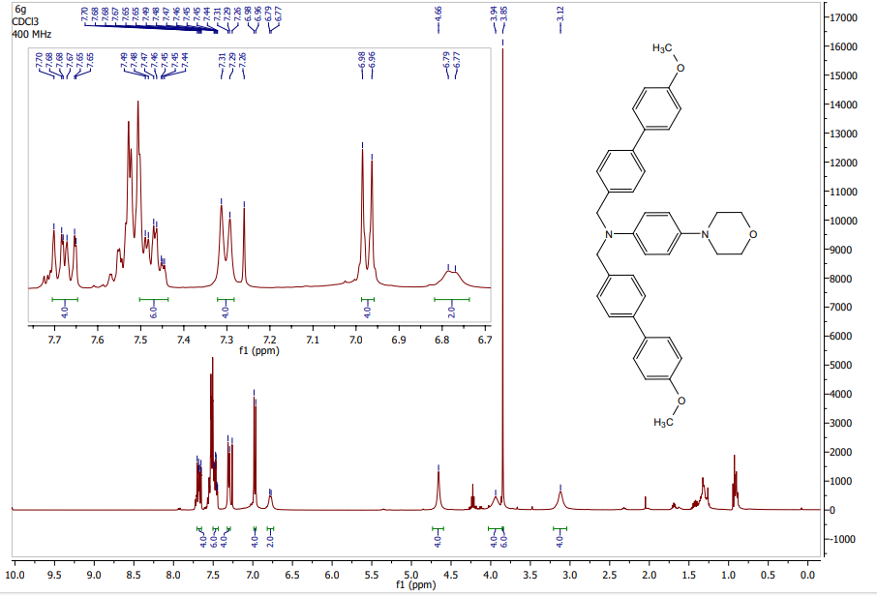

**Figure S17:** 1H NMR spectrum of compound **6g**

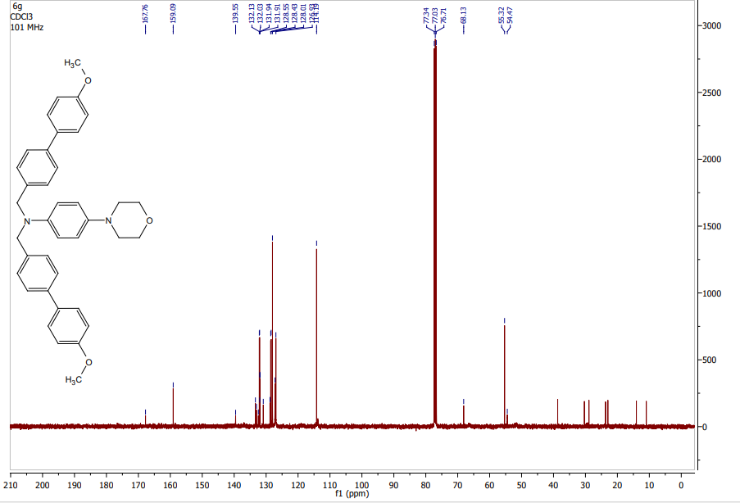

**Figure S18:** 13C NMR spectrum of compound **6g**

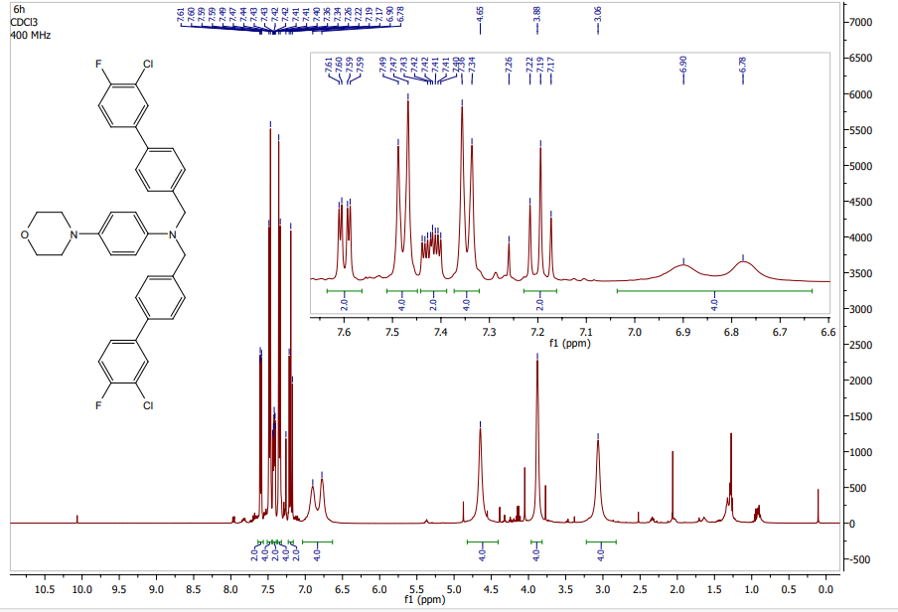

**Figure S19:** 1H NMR spectrum of compound **6h**

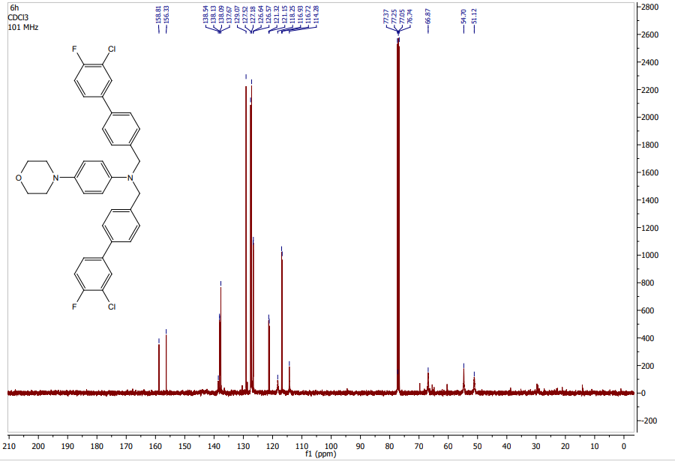

**Figure S20:** 13C NMR spectrum of compound **6h**

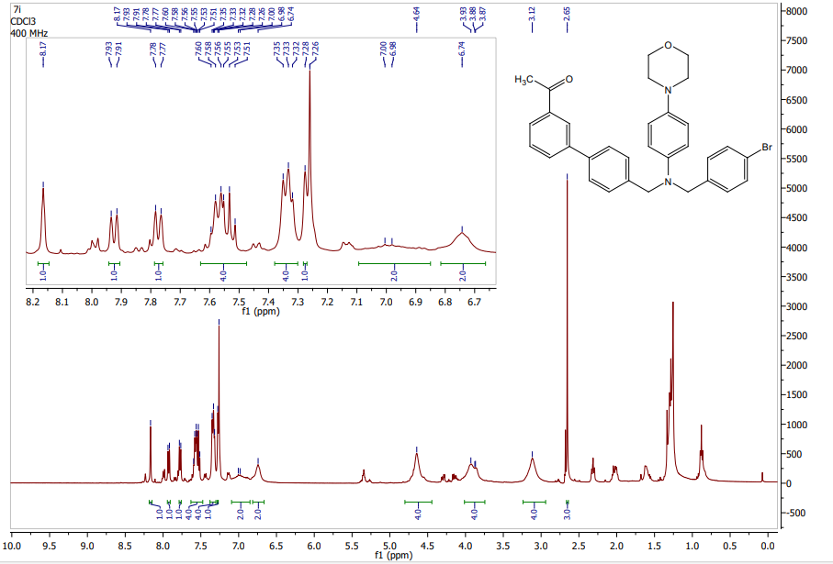

**Figure S21:** 1H NMR spectrum of compound **7i**

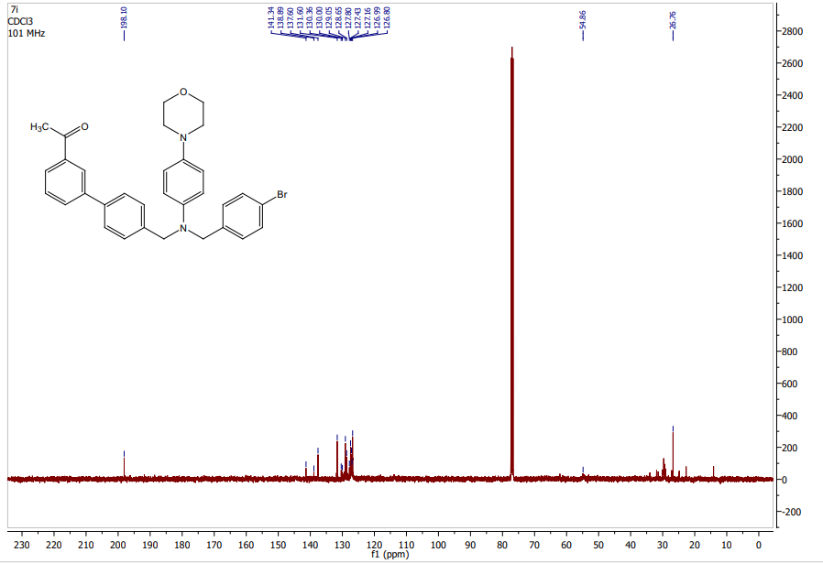

**Figure S22:** 13C NMR spectrum of compound **7i**