**Supplementary Information**

Table SM1: Analysis of variance (ANOVA) for furfural yield

|  |  |  |  |  |  |  |
| --- | --- | --- | --- | --- | --- | --- |
| Source | Sum of squares | df | Mean square | F-value | p-value  Prob>F | % contribution |
| Model | 2397.20 | 6 | 399.53 | 31.99 | 0.0306 significant |  |
| T | 795.75 | 2 | 397.87 | 31.85 | 0.0304 | 33.2% |
| C | 1521.21 | 2 | 760.61 | 60.90 | 0.0162 | 63.46% |
| S | 80.25 | 2 | 40.12 | 3.21 | 0.2374 | 3.34% |
| Residual | 24.98 | 2 | 12.49 |  |  |  |
| Cor. total | 2422.18 | 8 |  |  |  |  |
| R2 | 0.9897 |  |  |  |  |  |
| Adj.R2 | 0.9587 |  |  |  |  |  |
| Pred-R2 | 0.7912 |  |  |  |  |  |
| Adeq. precision | 17.07 |  |  |  |  |  |

Table SM2: Response data of average S/N ratios for furfural synthesis conditions

|  |  |  |  |  |
| --- | --- | --- | --- | --- |
| Level | T (oC) | C (wt.%) | t (h) | S (mL/g) |
| 1 | 33.71 | 31.89 | 33.63 | 34.91 |
| 2 | 36.15 | 33.66 | 34.41 | 33.04 |
| 3 | 32.51 | 36.83 | 34.46 | 34.43 |
| Range | 3.64 | 4.94 | 0.83 | 1.87 |
| Rank | 2nd | 1st | 4th | 3rd |

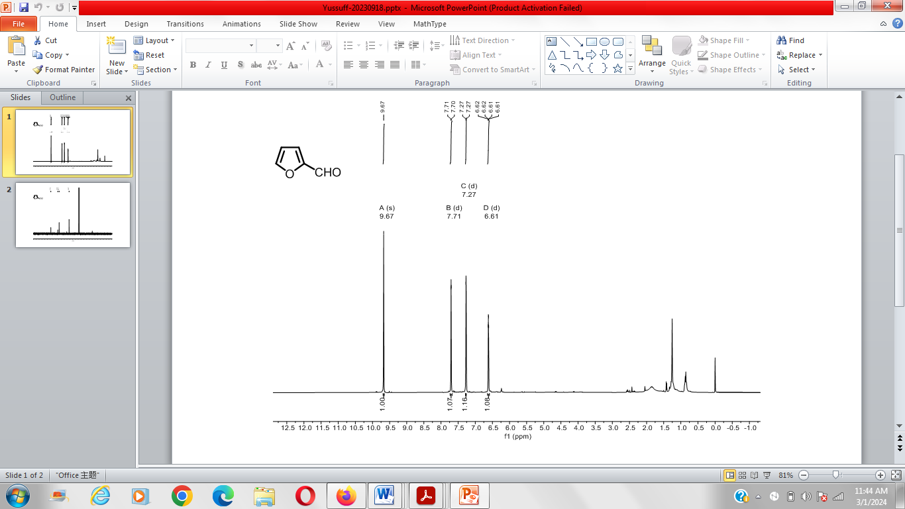

(a)

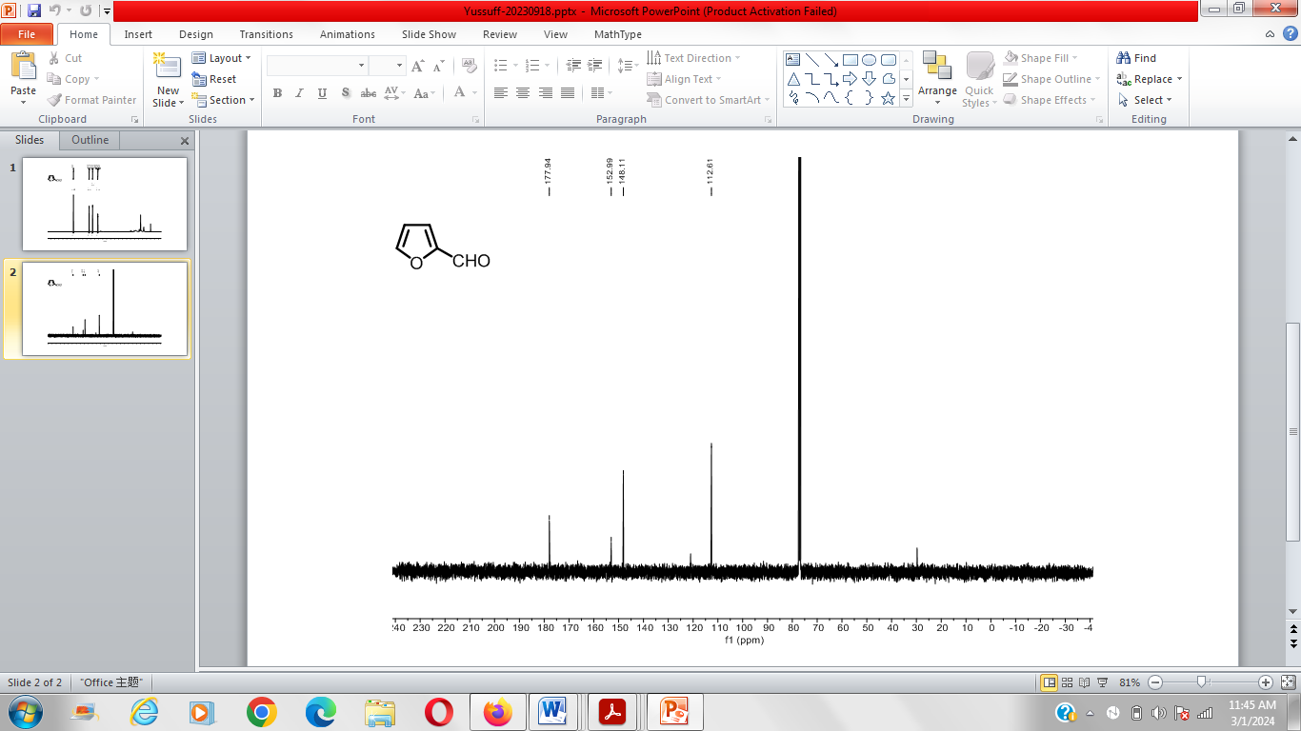

(b)

Fig. SM1: (a) 1H NMR and (b) 13C NMR spectra of furfural sample prepared under optimum conditions