Supplementary material
Spike Lavender Essential Oil attenuates Hyperuricemia and induced renal injury by modulating the TLR4/NF-κB/NLRP3 signalling pathway
Peijie Zhou^{a†}, Biao Zhang^{b†}, Xuan Wang ^{a†}, Jiawei Duanª, Jinkai Liª, Jie Wangª, Ning Xiaª, Shihao Zhangª, Jinghui Wangª, Dongyan Guoª, Chongbo Zhaoª, Huanxian Shiª, Jiangxue Chengª, Yundong Xieª, Jing Sun^{a*}, Xiaofei Zhang^{a*}
ª Key Laboratory of Basic and New Drug Research of Traditional Chinese Medicine, Shaanxi University of Chinese Medicine, Xianyang 712046, Shaanxi, China
^{b} Department of Pharmaceutics, Shenyang Pharmaceutical University, Shenyang 110016, China
* Corresponding author: Jing Sun, Email: ph.175@163.com
Xiaofei Zhang, Email: 2051028@sntcm.edu.cn
† These authors have contributed equally to this work and share first authorship.

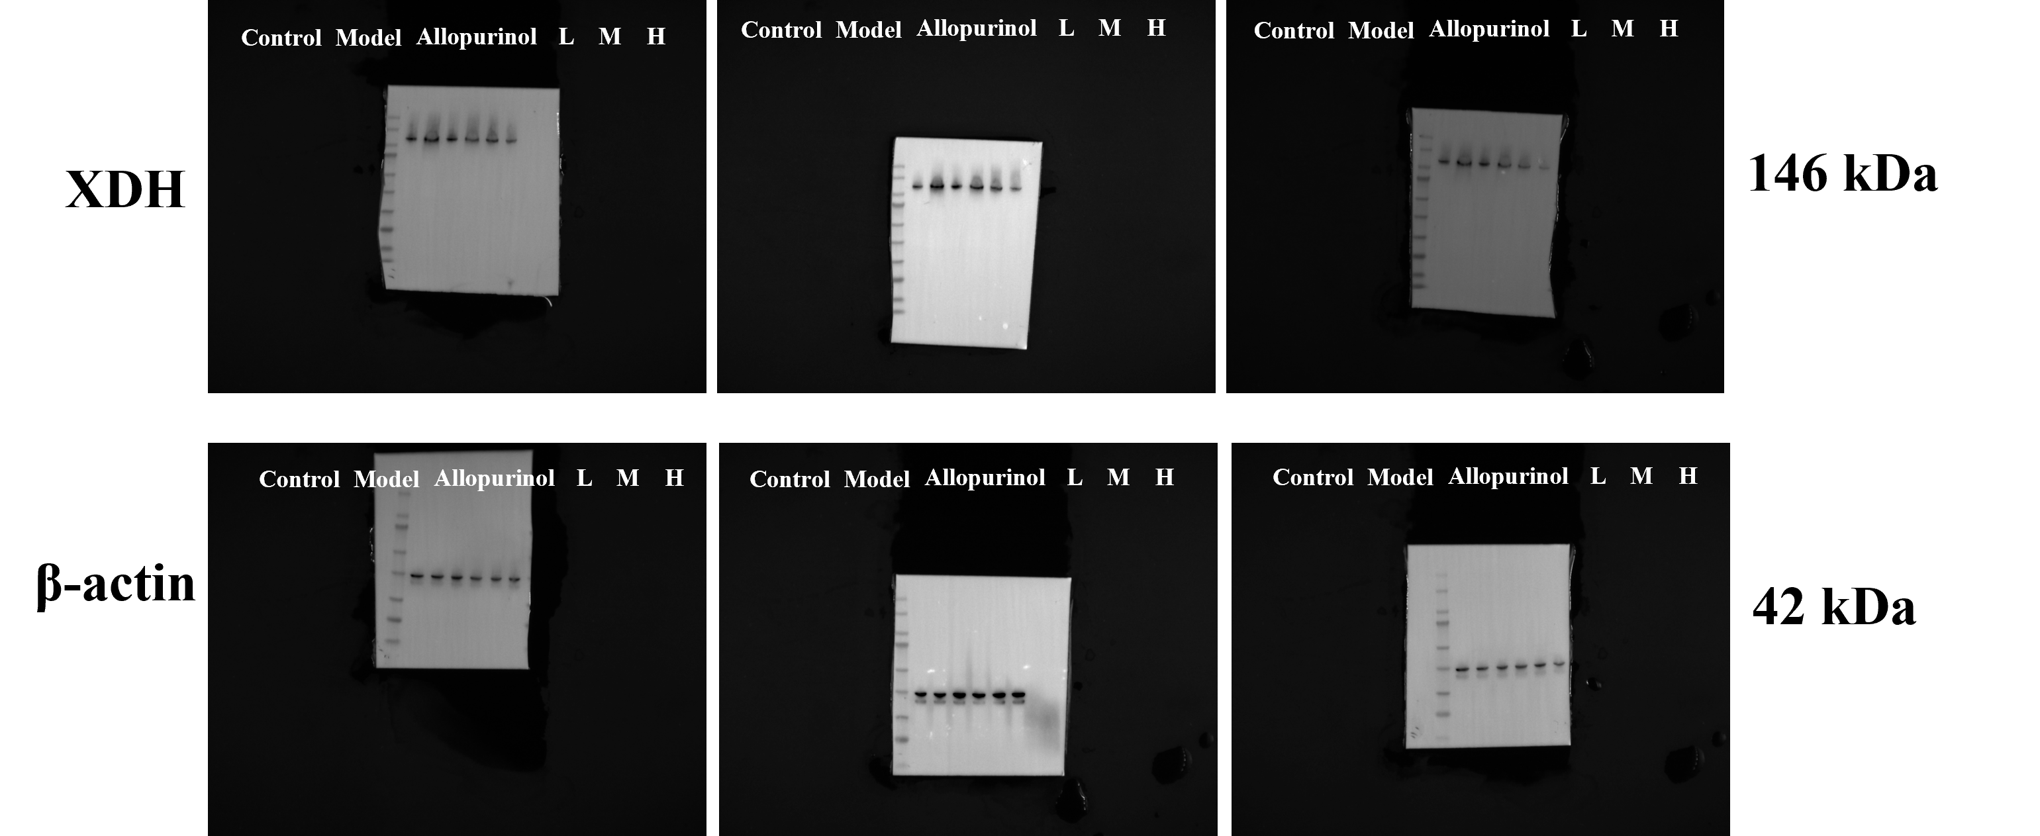
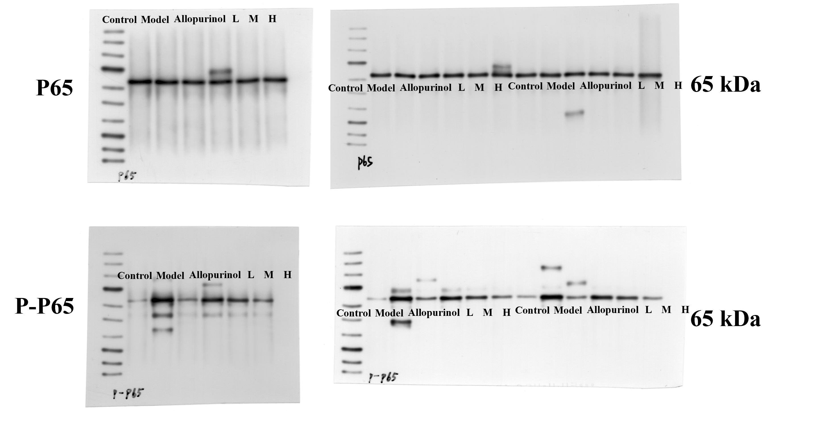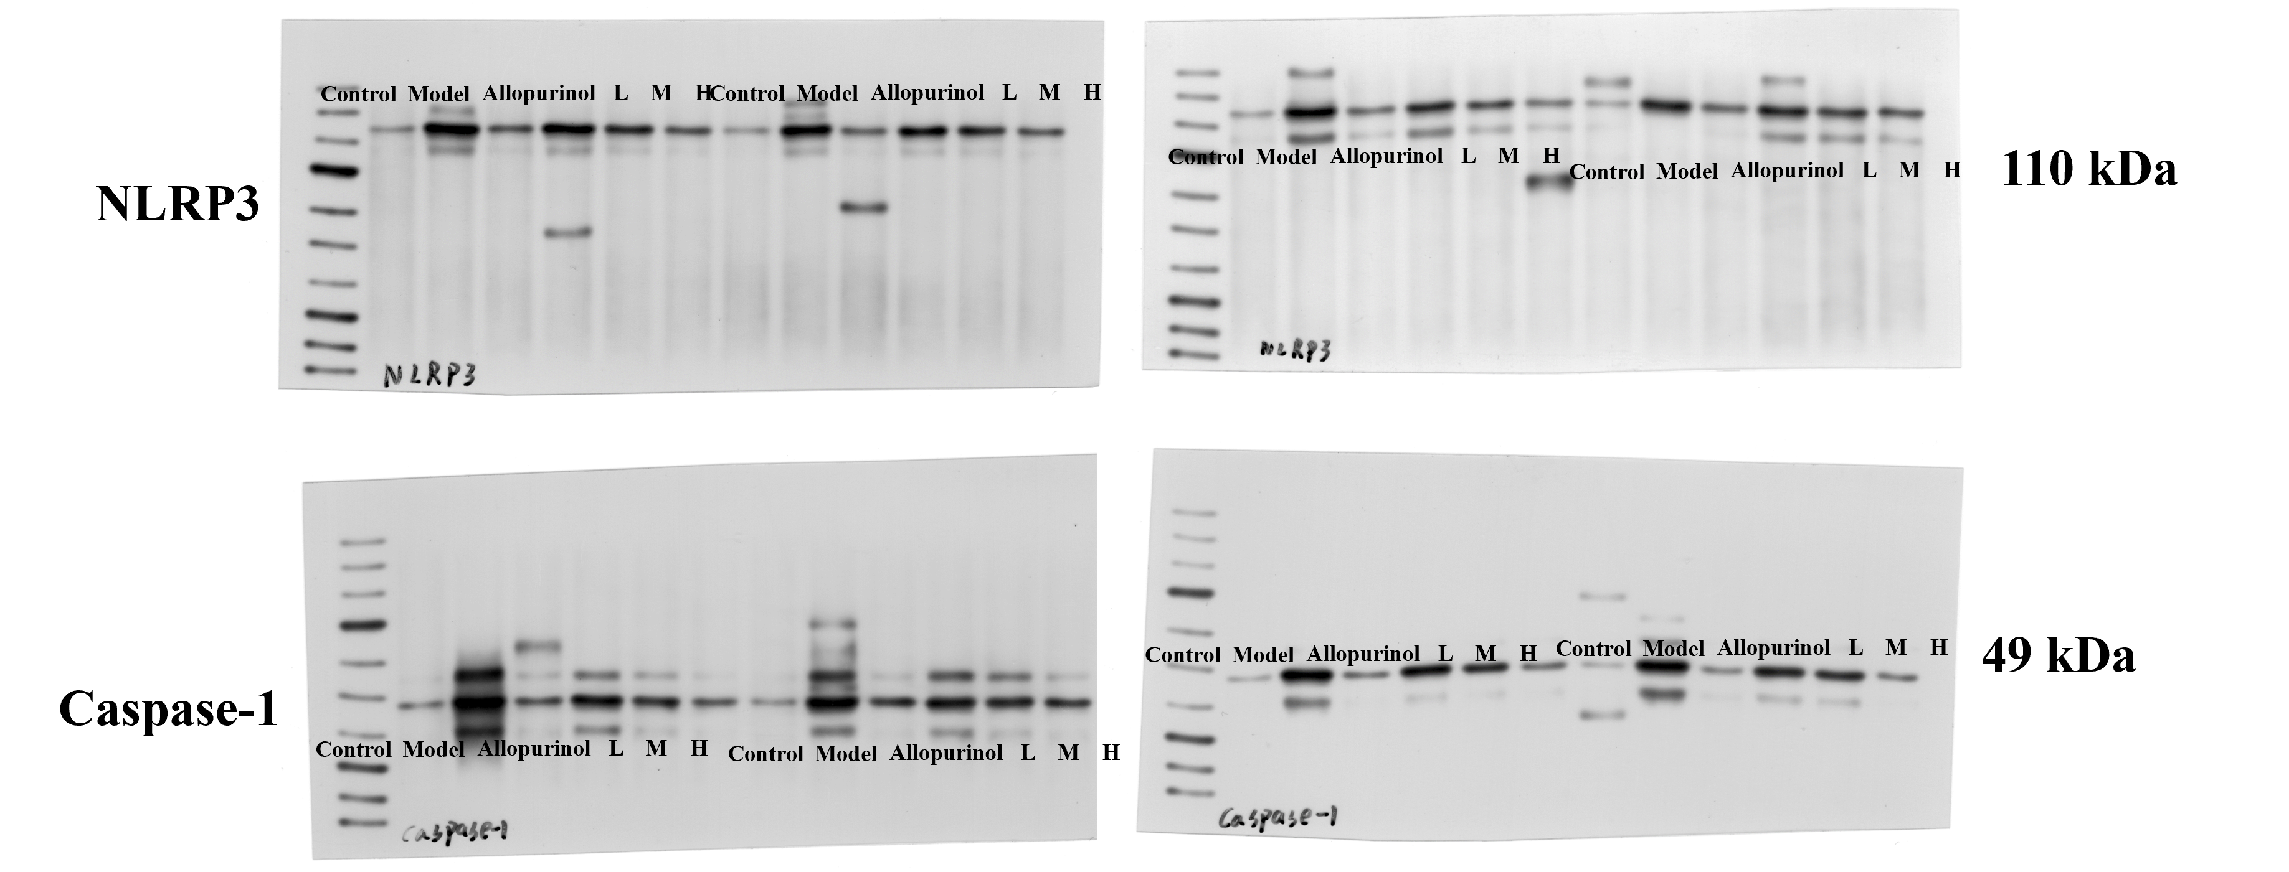
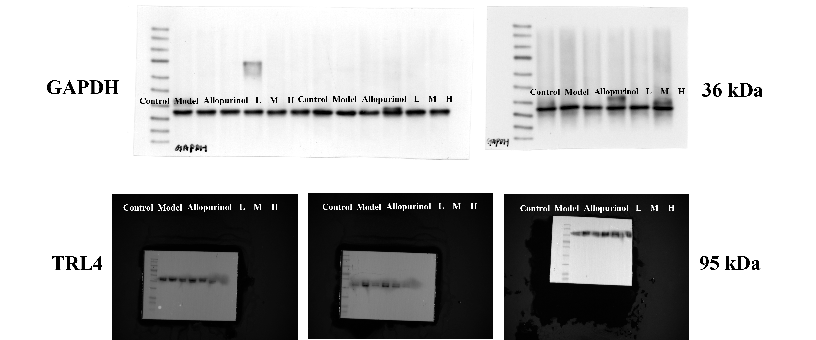
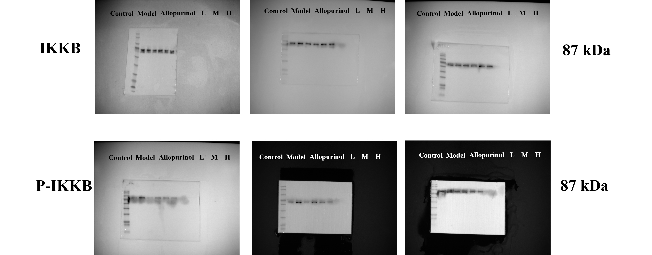
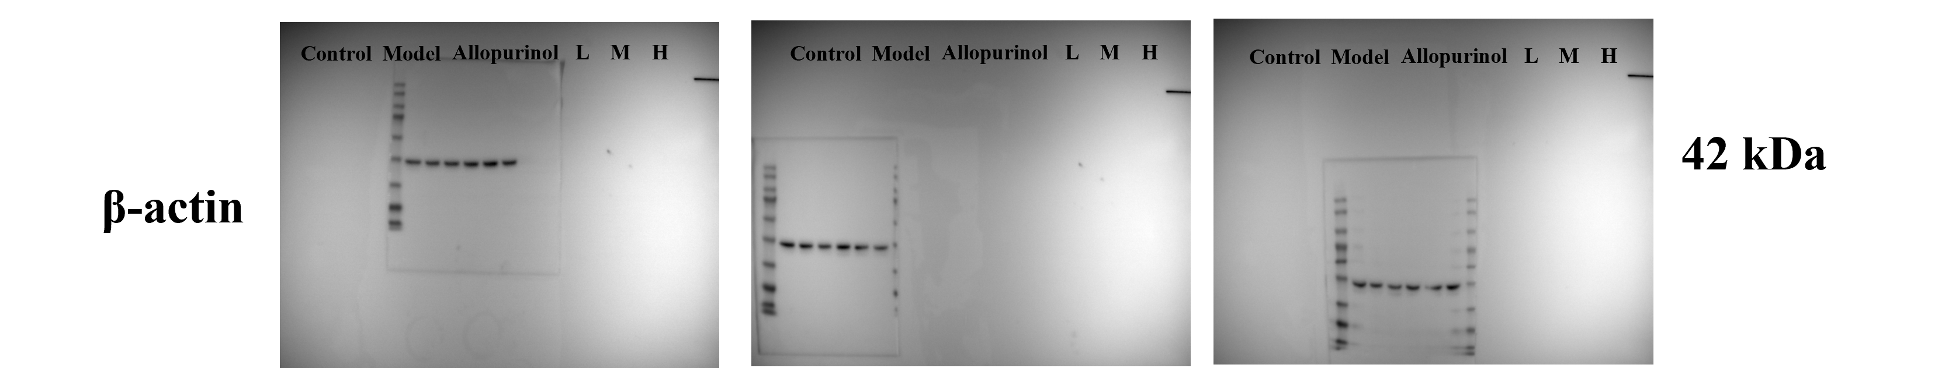
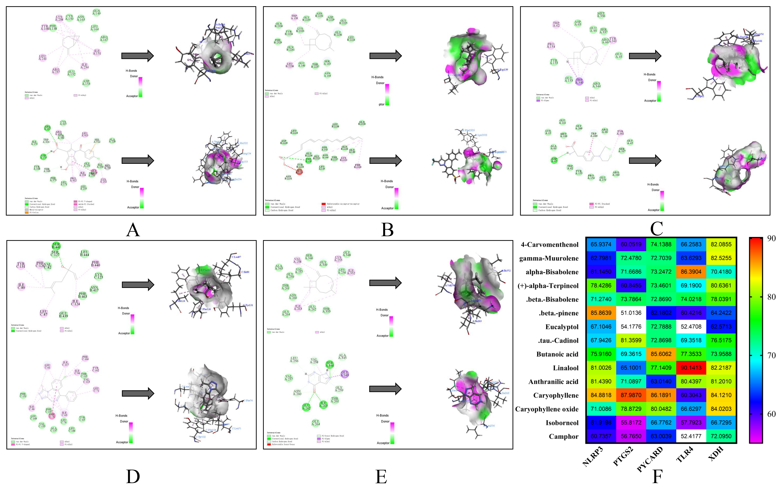
Fig S1. Sub-docking results. A. Docking results of β-pinene and NLRP3 (top), positive drug indomethacin and NLRP3 (bottom) B. Docking results of caryophyllen and PTGS2 (top), positive drug celecoxib (bottom) C. Docking results of caryophyllen and ASC (top), positive drug melphalan (bottom) D. Docking results of linalool and TLR4 (top), positive drug alprazolam and TLR4 (bottom) E. Docking results of caryophyllen and XOD (top), positive drug allopurinol and XOD (bottom). I. Heatmap of the binding scores of the active ingredients in SLEO to the key targets.

Methods
Greedy algorithms for finding a minimal set of bioactive components in SLEO
Input: Small molecule-target relationship list
Output: Minimum small molecule set covering all targets
m = number of all small molecules
Targets = targets of all small molecules
while targetNeeded != NULL do:
bestSmallMolecule = NULL
targetCovered = NULL
for i = 1, 2, 3, …, m do：
Covered = The target set of the i-th small molecule ∩ targetNeeded
if targetCovered contains targetNeeded do:
the i-th small molecule = bestSmallMolecule
targetCovered = Covered
End
targetNeeded = targetNeeded ∪ targetCovered
Small molecule collection covering all targets = Small molecule collection covering all targets ∪ bestSmallMolecule
End

Table S1. Greedy algorithm raw data table
molecules_total | targets_all_molecules | molecules_total | targets_all_molecules
Bicyclo[3.1.1]heptane, 6,6-dimethyl-2-methylene-, (1S)- | PPARA | Coumarin | ESR1
Bicyclo[3.1.1]heptane, 6,6-dimethyl-2-methylene-, (1S)- | SHBG | Coumarin | HSP90AA1
Bicyclo[3.1.1]heptane, 6,6-dimethyl-2-methylene-, (1S)- | ESR1 | Coumarin | PTGS2
Bicyclo[3.1.1]heptane, 6,6-dimethyl-2-methylene-, (1S)- | CYP2C19 | Coumarin | KDR
Bicyclo[3.1.1]heptane, 6,6-dimethyl-2-methylene-, (1S)- | AR | Coumarin | TYMS
Eucalyptol | ESR1 | Coumarin | AKR1B1
Eucalyptol | AR | Coumarin | ADH1B
Eucalyptol | HMGCR | Coumarin | ACE
Eucalyptol | NLRP3 | Coumarin | CYP11B2
Eucalyptol | PPM1B | Coumarin | CYP17A1
Eucalyptol | ADRA2A | Coumarin | MAOA
Eucalyptol | HSP90AA1 | Coumarin | GSR
Linalool | AR | Coumarin | LYN
Linalool | NR3C2 | Coumarin | IGF1R
Linalool | SLC6A3 | Coumarin | NQO1
Linalool | DRD2 | Coumarin | XDH
Linalool | JAK2 | Coumarin | NFKB1
Linalool | PTGS2 | Coumarin | RBP4
Linalool | PARP1 | .beta.-Bisabolene | AR
Linalool | KDR | .beta.-Bisabolene | ADRA2A
Linalool | MAPK8 | .beta.-Bisabolene | NR3C2
Linalool | TYMS | .beta.-Bisabolene | SLC6A3
Linalool | MAPK1 | .beta.-Bisabolene | CYP17A1
Linalool | AKR1B1 | .beta.-Bisabolene | MAOA
Linalool | P2RX7 | .beta.-Bisabolene | ABCG2
Linalool | PYGL | .beta.-Bisabolene | HNF4A
1,7,7-trimethylbicyclo[2.2.1]heptan-2-one | PPARA | .beta.-Bisabolene | PLAT
1,7,7-trimethylbicyclo[2.2.1]heptan-2-one | SHBG | .beta.-Bisabolene | PLIN1
1,7,7-trimethylbicyclo[2.2.1]heptan-2-one | AR | .beta.-Bisabolene | DRD5
1,7,7-trimethylbicyclo[2.2.1]heptan-2-one | SLC6A3 | .beta.-Bisabolene | RELA
1,7,7-trimethylbicyclo[2.2.1]heptan-2-one | DRD2 | .beta.-Bisabolene | NOS3
1,7,7-trimethylbicyclo[2.2.1]heptan-2-one | PARP1 | .beta.-Bisabolene | DNMT1
1,7,7-trimethylbicyclo[2.2.1]heptan-2-one | TYMS | .beta.-Bisabolene | TLR9
1,7,7-trimethylbicyclo[2.2.1]heptan-2-one | P2RX7 | .beta.-Bisabolene | CYP2D6
1,7,7-trimethylbicyclo[2.2.1]heptan-2-one | G6PD | .beta.-Bisabolene | RXRA
1,7,7-trimethylbicyclo[2.2.1]heptan-2-one | ADH1B | .beta.-Bisabolene | ABCG2
1,7,7-trimethylbicyclo[2.2.1]heptan-2-one | FABP2 | .gamma.-Muurolene | PPARA
1,7,7-trimethylbicyclo[2.2.1]heptan-2-one | GLI2 | .gamma.-Muurolene | SHBG
1,7,7-trimethylbicyclo[2.2.1]heptan-2-one | GLI1 | .gamma.-Muurolene | ESR1
1,7,7-trimethylbicyclo[2.2.1]heptan-2-one | CYP11B2 | .gamma.-Muurolene | CYP2C19
1,7,7-trimethylbicyclo[2.2.1]heptan-2-one | SLC22A6 | .gamma.-Muurolene | HMGCR
endo-Borneol | PPARA | .gamma.-Muurolene | NR3C2
endo-Borneol | ESR1 | .gamma.-Muurolene | SLC6A3
endo-Borneol | AR | .gamma.-Muurolene | G6PD
endo-Borneol | NR3C2 | .gamma.-Muurolene | ACE
endo-Borneol | SLC6A3 | .gamma.-Muurolene | GLI2
endo-Borneol | DRD2 | .gamma.-Muurolene | GLI1
endo-Borneol | JAK2 | .gamma.-Muurolene | CYP17A1
endo-Borneol | PTGS2 | .gamma.-Muurolene | PPARG
endo-Borneol | MAPK8 | .gamma.-Muurolene | TOP1
endo-Borneol | TYMS | .gamma.-Muurolene | HTR2A
endo-Borneol | P2RX7 | .gamma.-Muurolene | RXRA
endo-Borneol | G6PD | .gamma.-Muurolene | TNF
endo-Borneol | FABP2 | .gamma.-Muurolene | TOP2A
endo-Borneol | CYP11B2 | .gamma.-Muurolene | MAPK3
endo-Borneol | SLC22A6 | Cyclohexene, 4-[(1E)-1,5-dimethyl-1,4-hexadien-1-yl]-1-methyl- | ESR1
3-Cyclohexen-1-ol, 4-methyl-1-(1-methylethyl)- | PPARA | Cyclohexene, 4-[(1E)-1,5-dimethyl-1,4-hexadien-1-yl]-1-methyl- | CYP2C19
3-Cyclohexen-1-ol, 4-methyl-1-(1-methylethyl)- | SHBG | Cyclohexene, 4-[(1E)-1,5-dimethyl-1,4-hexadien-1-yl]-1-methyl- | AR
3-Cyclohexen-1-ol, 4-methyl-1-(1-methylethyl)- | ESR1 | Cyclohexene, 4-[(1E)-1,5-dimethyl-1,4-hexadien-1-yl]-1-methyl- | ADRA2A
3-Cyclohexen-1-ol, 4-methyl-1-(1-methylethyl)- | CYP2C19 | Cyclohexene, 4-[(1E)-1,5-dimethyl-1,4-hexadien-1-yl]-1-methyl- | HSP90AA1
3-Cyclohexen-1-ol, 4-methyl-1-(1-methylethyl)- | AR | Cyclohexene, 4-[(1E)-1,5-dimethyl-1,4-hexadien-1-yl]-1-methyl- | SLC6A3
3-Cyclohexen-1-ol, 4-methyl-1-(1-methylethyl)- | NR3C2 | Cyclohexene, 4-[(1E)-1,5-dimethyl-1,4-hexadien-1-yl]-1-methyl- | JAK2
3-Cyclohexen-1-ol, 4-methyl-1-(1-methylethyl)- | DRD2 | Cyclohexene, 4-[(1E)-1,5-dimethyl-1,4-hexadien-1-yl]-1-methyl- | KDR
3-Cyclohexen-1-ol, 4-methyl-1-(1-methylethyl)- | JAK2 | Cyclohexene, 4-[(1E)-1,5-dimethyl-1,4-hexadien-1-yl]-1-methyl- | CYP17A1
3-Cyclohexen-1-ol, 4-methyl-1-(1-methylethyl)- | PARP1 | Cyclohexene, 4-[(1E)-1,5-dimethyl-1,4-hexadien-1-yl]-1-methyl- | MAOA
3-Cyclohexen-1-ol, 4-methyl-1-(1-methylethyl)- | MAPK8 | Cyclohexene, 4-[(1E)-1,5-dimethyl-1,4-hexadien-1-yl]-1-methyl- | ABCG2
3-Cyclohexen-1-ol, 4-methyl-1-(1-methylethyl)- | TYMS | Cyclohexene, 4-[(1E)-1,5-dimethyl-1,4-hexadien-1-yl]-1-methyl- | PLAT
3-Cyclohexen-1-ol, 4-methyl-1-(1-methylethyl)- | MAPK1 | Cyclohexene, 4-[(1E)-1,5-dimethyl-1,4-hexadien-1-yl]-1-methyl- | PLIN1
3-Cyclohexen-1-ol, 4-methyl-1-(1-methylethyl)- | P2RX7 | Cyclohexene, 4-[(1E)-1,5-dimethyl-1,4-hexadien-1-yl]-1-methyl- | DRD5
3-Cyclohexene-1-methanol, .alpha.,.alpha.,4-trimethyl-, (R)- | PPARA | Cyclohexene, 4-[(1E)-1,5-dimethyl-1,4-hexadien-1-yl]-1-methyl- | APP
3-Cyclohexene-1-methanol, .alpha.,.alpha.,4-trimethyl-, (R)- | SHBG | Cyclohexene, 4-[(1E)-1,5-dimethyl-1,4-hexadien-1-yl]-1-methyl- | CASP9
3-Cyclohexene-1-methanol, .alpha.,.alpha.,4-trimethyl-, (R)- | ESR1 | Cyclohexene, 4-[(1E)-1,5-dimethyl-1,4-hexadien-1-yl]-1-methyl- | RELA
3-Cyclohexene-1-methanol, .alpha.,.alpha.,4-trimethyl-, (R)- | CYP2C19 | Cyclohexene, 4-[(1E)-1,5-dimethyl-1,4-hexadien-1-yl]-1-methyl- | NOS3
3-Cyclohexene-1-methanol, .alpha.,.alpha.,4-trimethyl-, (R)- | AR | Cyclohexene, 4-[(1E)-1,5-dimethyl-1,4-hexadien-1-yl]-1-methyl- | DNMT1
3-Cyclohexene-1-methanol, .alpha.,.alpha.,4-trimethyl-, (R)- | HMGCR | Cyclohexene, 4-[(1E)-1,5-dimethyl-1,4-hexadien-1-yl]-1-methyl- | TLR9
3-Cyclohexene-1-methanol, .alpha.,.alpha.,4-trimethyl-, (R)- | NR3C2 | Cyclohexene, 4-[(1E)-1,5-dimethyl-1,4-hexadien-1-yl]-1-methyl- | CCR2
3-Cyclohexene-1-methanol, .alpha.,.alpha.,4-trimethyl-, (R)- | SLC6A3 | Cyclohexene, 4-[(1E)-1,5-dimethyl-1,4-hexadien-1-yl]-1-methyl- | CYP2D6
3-Cyclohexene-1-methanol, .alpha.,.alpha.,4-trimethyl-, (R)- | DRD2 | Cyclohexene, 4-[(1E)-1,5-dimethyl-1,4-hexadien-1-yl]-1-methyl- | RXRA
3-Cyclohexene-1-methanol, .alpha.,.alpha.,4-trimethyl-, (R)- | JAK2 | Cyclohexene, 4-[(1E)-1,5-dimethyl-1,4-hexadien-1-yl]-1-methyl- | ABCG2
3-Cyclohexene-1-methanol, .alpha.,.alpha.,4-trimethyl-, (R)- | PTGS2 | 5-Oxatricyclo[8.2.0.04,6]dodecane, 4,12,12-trimethyl-9-methylene-, (1R,4R,6R,10S)- | CYP2C19
3-Cyclohexene-1-methanol, .alpha.,.alpha.,4-trimethyl-, (R)- | PARP1 | 5-Oxatricyclo[8.2.0.04,6]dodecane, 4,12,12-trimethyl-9-methylene-, (1R,4R,6R,10S)- | NLRP3
3-Cyclohexene-1-methanol, .alpha.,.alpha.,4-trimethyl-, (R)- | TYMS | 5-Oxatricyclo[8.2.0.04,6]dodecane, 4,12,12-trimethyl-9-methylene-, (1R,4R,6R,10S)- | ADRA2A
3-Cyclohexene-1-methanol, .alpha.,.alpha.,4-trimethyl-, (R)- | G6PD | 5-Oxatricyclo[8.2.0.04,6]dodecane, 4,12,12-trimethyl-9-methylene-, (1R,4R,6R,10S)- | NR3C2
3-Cyclohexene-1-methanol, .alpha.,.alpha.,4-trimethyl-, (R)- | CYP11B2 | 5-Oxatricyclo[8.2.0.04,6]dodecane, 4,12,12-trimethyl-9-methylene-, (1R,4R,6R,10S)- | SLC6A3
3-Cyclohexene-1-methanol, .alpha.,.alpha.,4-trimethyl-, (R)- | CYP17A1 | 5-Oxatricyclo[8.2.0.04,6]dodecane, 4,12,12-trimethyl-9-methylene-, (1R,4R,6R,10S)- | DRD2
3-Cyclohexene-1-methanol, .alpha.,.alpha.,4-trimethyl-, (R)- | TOP1 | 5-Oxatricyclo[8.2.0.04,6]dodecane, 4,12,12-trimethyl-9-methylene-, (1R,4R,6R,10S)- | JAK2
Butanoic acid, 2-methyl-, hexyl ester | ESR1 | 5-Oxatricyclo[8.2.0.04,6]dodecane, 4,12,12-trimethyl-9-methylene-, (1R,4R,6R,10S)- | PTGS2
Butanoic acid, 2-methyl-, hexyl ester | HMGCR | 5-Oxatricyclo[8.2.0.04,6]dodecane, 4,12,12-trimethyl-9-methylene-, (1R,4R,6R,10S)- | HTR2A
Butanoic acid, 2-methyl-, hexyl ester | ADRA2A | 5-Oxatricyclo[8.2.0.04,6]dodecane, 4,12,12-trimethyl-9-methylene-, (1R,4R,6R,10S)- | ADRB3
Butanoic acid, 2-methyl-, hexyl ester | KDR | 5-Oxatricyclo[8.2.0.04,6]dodecane, 4,12,12-trimethyl-9-methylene-, (1R,4R,6R,10S)- | PTPN22
Butanoic acid, 2-methyl-, hexyl ester | P2RX7 | 5-Oxatricyclo[8.2.0.04,6]dodecane, 4,12,12-trimethyl-9-methylene-, (1R,4R,6R,10S)- | CYP2D6
Butanoic acid, 2-methyl-, hexyl ester | PLA2G7 | 5-Oxatricyclo[8.2.0.04,6]dodecane, 4,12,12-trimethyl-9-methylene-, (1R,4R,6R,10S)- | TOP2A
Butanoic acid, 2-methyl-, hexyl ester | ICAM1 | 5-Oxatricyclo[8.2.0.04,6]dodecane, 4,12,12-trimethyl-9-methylene-, (1R,4R,6R,10S)- | MAPK3
Butanoic acid, 2-methyl-, hexyl ester | VCAM1 | 5-Oxatricyclo[8.2.0.04,6]dodecane, 4,12,12-trimethyl-9-methylene-, (1R,4R,6R,10S)- | IGF1R
Butanoic acid, 2-methyl-, hexyl ester | SELE | 5-Oxatricyclo[8.2.0.04,6]dodecane, 4,12,12-trimethyl-9-methylene-, (1R,4R,6R,10S)- | ADRB3
Butanoic acid, 2-methyl-, hexyl ester | PIK3CG | .tau.-Cadinol | PPARA
Butanoic acid, 2-methyl-, hexyl ester | ALDH2 | .tau.-Cadinol | SHBG
Butanoic acid, 2-methyl-, hexyl ester | HTR3A | .tau.-Cadinol | ESR1
Butanoic acid, 2-methyl-, hexyl ester | LIPE | .tau.-Cadinol | CYP2C19
Butanoic acid, 2-methyl-, hexyl ester | MAOA | .tau.-Cadinol | HMGCR
Butanoic acid, 2-methyl-, hexyl ester | ABCG2 | .tau.-Cadinol | G6PD
Butanoic acid, 2-methyl-, hexyl ester | CCR1 | .tau.-Cadinol | ACE
Butanoic acid, 2-methyl-, hexyl ester | ADRB3 | .tau.-Cadinol | CYP17A1
1,5-Dimethyl-1-vinyl-4-hexenyl 2-aminobenzoate | KDR | .tau.-Cadinol | PPARG
1,5-Dimethyl-1-vinyl-4-hexenyl 2-aminobenzoate | MAPK8 | .tau.-Cadinol | TOP1
1,5-Dimethyl-1-vinyl-4-hexenyl 2-aminobenzoate | P2RX7 | .tau.-Cadinol | PIK3CG
1,5-Dimethyl-1-vinyl-4-hexenyl 2-aminobenzoate | CYP11B2
1,5-Dimethyl-1-vinyl-4-hexenyl 2-aminobenzoate | CYP17A1
1,5-Dimethyl-1-vinyl-4-hexenyl 2-aminobenzoate | MAOA
1,5-Dimethyl-1-vinyl-4-hexenyl 2-aminobenzoate | APEX1
1,5-Dimethyl-1-vinyl-4-hexenyl 2-aminobenzoate | P2RY1
Caryophyllene | PPARA
Caryophyllene | ESR1
Caryophyllene | CYP2C19
Caryophyllene | AR
Caryophyllene | HMGCR
Caryophyllene | NR3C2
Caryophyllene | GLI2
Caryophyllene | GLI1
Caryophyllene | CYP17A1
Caryophyllene | PPARG
Caryophyllene | TOP1
Caryophyllene | HTR2A
Caryophyllene | PLA2G4A
Caryophyllene | RBP4

