**Supplementary materials**

**Magnetic ligand fishing protocol combined with HPLC-FT-ICR-MS for screening potential α-Glucosidase inhibitors from UCG and in silico analysis**

Bo Yuana.1, Yumeng Zhanga.1, Xinting Mana, Chunjie Zhaoa*,Min Zhaoa*.

a .Shenyang Pharmaceutical University Faculty of Pharmacy, Shenyang 110016 China.

* Corresponding author.

* Corresponding author at: Faculty of Pharmacy, Shenyang Pharmaceutical University, No. 103 Wenhua Road, Shenyang, 110016, Liaoning, China.

E-mail addresses: lab433@163.com (Chunjie Zhao), zm19871224@sina.com(Min Zhao).

1 Bo Yuan and Yumeng Zhang contributed equally.

1. **Material and methods**
   1. *Preparation of UCG solution and mixed standard solution*

Through a filter naming 80-mesh stainless steel a five UCG sachets run after being ground into powder .UCG powder (10 g) was was placed in a tapered flask with 10 mL of 50% ethanol and subjected to ultrasonic power at a frequency of 40000 Hz with a power level of 500 watts. The extraction fluid was then centrifuged at a speed of 13,000 rpm for 10 min, followed by filtration of the UCG solution using a microporous membrane filter with a pore size of 0.22 μm for subsequent analysis. To identify the qualitative elements of UCG, The qualitative components of UCG were determined by preparing methanol stock solutions containing 9 reference standards (Danshensu, Caffeic acid, Paeoniflorin, Liquiritin, Liquiritigenin, Luteolin, Aloe-emodin, 10,15 -Octadecadien oic acid and Rhein) at a concentration of 100 μg/mL. The qualitative components of UCG were determined by preparing methanol stock solutions containing 4 reference standards (Limonexic acid, Sanggenol A, Glabrone and Matrine) at a concentration of 100 μg/mL.

* 1. *Instrument and analytical conditions*

*1.2.1. Chromatographic conditions ((used for qualitative evaluation))*

The Agilent 1260 HPLC system from Agilent Corp in Santa Clara, CA, was used to perform chromatographic analysis. The Universil XB-C18 column from Kromat in the USA was used at a temperature of 35°C. The mobile phase consisted of a mixture of acetonitrile (A) and water containing formic acid (B) at a concentration of 0.1% (v/v). The gradient elution algorithm used is as follows: 5-15% (A) in 0 to 2 min, 15-30% (A) in 2 to 25 min, 30-40% (A) in 25 to 28 mins, 40-60% (A) in 28 to 32 min, 60-80% (A) in 32 to 37 min and 80-100% (A) in 37 to 44 min. The flow rate was set at 0.2 mL/min, with an injection volume of 2 μL.

*1.2.2. Chromatographic conditions (used for fingerprint and quantitative evaluation)*

Agilent 1100 UPLC system (Agilent Corp, Santa Clara, CA, USA) was used to perform chromatographic analysis. The Spherisorb XB-C18 column fromWaters in the USA was used at a temperature of 35°C. The mobile phase consisted of acetonitrile (A) and 0.1% (v/v) formic acid in water (B), with the following optimized gradient elution program: 5-10% (A) from 0 to 10 min, 10-30% (A) from 10 to 45 min, 30-50% (A) from 45 to 55 min,50-80% (A) from 55 to 65 min, 80-100% (A) from 65 to 70 min and 100-5% (A) from70 to 73 min. The flow rate was set at 1 mL/min, with an injection volume of 10 μL.

*1.2.3. MS conditions*

The Electrospray Ion Source (ESI) was part of the BrukerSolarix7.0 T FT-ICR-MS system (Bruker Corp., Karlsruhe, Germany), which also had a Bruker Compass-Hystar workstation. The system's total mass spectra ranges from 100 to 3000 amu. The primary settings included 200 ℃ for the dry gas, 8 L/min for the dry gas flow, 0.15s for the ion accumulation period and 4.0 bar for the nebulizer gas pressure. The flight time was 0.6 ms, with a 4.5 kV capillary voltage and a 500 V end plate offset. For MS/MS examinations, the energy of collision was between 10 eV and 30 eV.

* 1. *Performance study*
     1. *pH*

The Fe3O4@SiO2@NH2@α-Glucosidase and free α-Glucosidase were dispersed in PBS with different pH (pH = 3.0, 4.0, 5.0, 6.0, 7.0, 8.0, 9.0, 10.0 and 11.0). Subsequently, they were allowed to stand and the enzyme activity was analyzed. The enzyme activity was set as 100%, and the relative activity under each condition was recorded.

* + 1. *Temperature*

The free α-Glucosidase and Fe3O4@SiO2@NH2@α-Glucosidase were incubated in a micro-thermostat at temperatures ranging from 40°C to 90°C for 1 h. After that, enzyme activity was evaluated following rapid cooling to ambient temperature. The enzyme activity was set as 100%, and the relative activity under each condition was recorded.

* + 1. *Reusability*

The initial catalyst used for hydrolyzing the substrate was Fe3O4@SiO2@NH2@α-Glucosidase. The material was subsequently separated magnetically. The supernatant was discarded and this process was repeated 7 times. The initial enzyme activity was set as 100%, and the relative activity under each time was recorded.

* 1. *Enzyme loading of Fe3O4@SiO2@NH2@α-Glucosidase*

The study of α-Glucosidase loading was based on relevent literature with some modifications (Yi et al., 2021). Different concentrations of α-Glucosidase solutions in 0.1 M PBS (pH 6.8) were mixed with G-250 reagent, shaken well, and left for 5 min. Its absorbance was read at 595 nm. Then, the enzyme loading of Fe3O4@SiO2@NH2@α-Glucosidase and α-Glucosidase per unit mass was determined.

* 1. *Free and immobilized α-Glucosidase activity*

In the study of enzyme activity, we have made a few modifications according to the methodology reported in the literature (Miao et al., 2018). pNPG was used as a substrate, and its hydrolysis by α-Glucosidase resulted in the production of pNP. The maximum absorption wavelength of the pNP was 405 nm, and the activity of α-Glucosidase was determined based on the absorbance of pNP. The concentrated solution of pNP was diluted to a series of solutions with concentrations ranging from 0.1mM to 0.6 mM. One unit of α-Glucosidase activity was equivalent to 1 μmol of pNP released from the pNPG in 1 min.

1. **Results**
   1. *Qualitative analysis of components in UCG*
      1. *Flavonoids*

The main ingredients of UCG are the flavonoids, and 57 flavonoids were identified in our study, including compounds 15, 21-22, 24, 30, 34-37, 41-42, 46-56, 58, 62, 65-67, 70-75, 77, 79-82, 84-87, 91-92, 94, 101, 103-106, 111, 113-115, 120-121, 124-126, 128, 131, 137-138 in Fig. S2 and Table S1. Compounds 41, 75 and 81 were certainly identified as Liquiritin, Liquiritigenin and Luteolin by comparing retention time, molecular weights, and MS/MS fragment data with the references (Fig. 2C). Most flavonoids are prone to undergo rearrangement, retro Diels-Alder (RDA) reactions and cleavage of the carbon-carbon bond, resulting in losing several neutral molecules such as CH3 (15 Da), CO (28 Da) and OH (17 Da). For example, compound 36 revealed a quasi-molecular ion ([M+H]+) at *m/z* 477.1391, calculated as C23H24O11 according to Data Analysis 4.4 software. The typical fragments were the ions at *m/z* 315.7424, 300.6587, 272.0764, 198.5387 and 170.4761. The ions at *m/z* 315.7424 indicated the loss of C6H10O5 (162 Da) from the precursor ion. The ions at *m/z* 300.6587 and 198.5387 indicated the loss of CH3 (15 Da) and C8H5O (117 Da) from the precursor ion. The ion at *m/z* 272.0764 showed the loss of CO (28Da) from the ion at *m/z* 300.6587, and the ion at *m/z* 170.4761 showed the loss of CO (28Da) from the ion at *m/z* 198.5387. Compound 36 was speculatively identified as Cirsimarin based on fragmentation behaviors and literature (Fig. S3A) (Zhang et al., 2021). The compound 84 displayed a quasi-molecular ion ([M-H]-) at *m/z* 301.0354, calculation of the formula made as C15H10O7. The typical fragments were the ions at *m/z* 284.6954, 136.5435 and 108.4975. The ions at *m/z* 284.6954 and 136.5435 showed the loss of OH (17 Da) and C8H5O4 (165 Da) from the precursor ion at *m/z* 301.0354. The ion at *m/z* 108.4975 showed the loss of CO (28 Da) from the ion at *m/z* 136.5435 (Fig. S3B). Consequently, compound 84 was speculated to be Morin (Zhang and Wang et al., 2021).The fragmentation patterns and accurate molecular weights were compared to the internal database and related literature to find more flavonoids (Zhang et al., 2021, Wang et al., 2019, Li et al., 2022, Wang et al., 2015, Gong et al., 2020, Yan et al., 2016, Li et al., 2014, Zhang and Wang et al., 2021, Sheng et al., 2021, Zhong et al., 2015).

* + 1. *Terpenoids*

A total of 21 terpenoids (compounds 20, 31, 32, 40, 57, 88, 96, 99, 108-109, 119, 122-123, 127, 129, 130, 133, 135, 139, 141-142) were identified in UCG (Fig. S2, Table S1), including monoterpenes (compounds 20, 31, 32, 40, 57, 88, 96, 139), sesquiterpenes (compounds 119, 135), diterpenes (compounds 122, 123, 129, 130, 133, 141, 142) and triterpenes (compounds 99, 108, 109, 127). Compound 32 was correctly identified as Paeoniflorin by comparing them to the reference (Fig. 2C). The main characterization of terpenoids was the intense quasi-molecular ion ([M+H]+) peak. In addition to this, terpenoids often undergo RDA cleavage, occur McLafferty rearrangement and lose H2O (18 Da) and CHO (27 Da). Compounds 31, 130, and 135 were made as cases for demonstrating the fragmentation pathways. For compound 31, the ion at m/z 525.1613 was performed for being the adduct ion ([M-H]-), after which the formula is calculated as C24H29O. The typical fragments were the ions at *m/z* 495.1673, 343.1123, 182.1742 and 168.1865. The loss of CH2O (30 Da) from its precursor ion at *m/z* 525.1613 was seen in the ion at *m/z* 495.1673. The ion at *m/z* 182.1742 showed the loss of C8H8O3 (152 Da) and C6H9O5 (161 Da) from the ion at *m/z* 495.1673, and the ion at *m/z* 168.1865 showed the loss of C15H19O8 (327 Da) from the ion at *m/z* 495.1673 (Fig. S3 C). Thus, compound 31 was tentatively identified as Mudanpioside E (Liu et al., 2022). The ion at *m/z* 297.1485 was the adduct ion ([M+H]+) for chemical 130, calculated as C19H21O3. The typical fragments were the ions at *m/z* 283.1752, 279.1421, 261.1689 and 246.1521. The ions at *m/z* 283.1752 and 279.1421 showed the loss of CH3 (15 Da) and H2O (18 Da) from the precursor ion at *m/z* 297.1485. The ion at *m/z* 246.1521 showed the successive removal of CO (28 Da) and CH3 (15 Da) from the ion at *m/z* 279.1421 (Fig. S3D). Consequently, compound 130 was inferred to be Cryptotanshinone (Zhang and Wang et al., 2021). Compound 135 displayed a quasi-molecular ion [M+H]+ at *m/z* 233.1536, and the calculation of the formula was made as C15H21O2. The ions at *m/z* 205.1434 and 165.1356 showed the loss of CO (28 Da) and C5H8 (68 Da) from the precursor ion at *m/z* 233.1536, while the ion at *m/z* 121.1571 showed the loss of CO2 (44 Da)from the ion at *m/z* 165.1356 (Fig. S3E). Therefore, compound 135 was tentatively identified as Atractylenolide II (Zhang et al., 2021). By comparing the observed fragmentation patterns and exact molecular weights to the in-house datebase, the remaining terpenoids were determined (Liu et al., 2022, Zhang et al., 2021, Gong et al., 2020, Yan et al., 2016, Zhang and Wang et al., 2021).

* + 1. *Phenylpropanoids*

Totally, 24 phenylpropanoids (compounds 12, 16, 19, 23, 26-28, 38, 44-45, 50, 51-55, 63-64, 69, 78-90, 112) were identified in UCG (Fig. S2, Table S1). Compounds 12 and 28 were undoubtedly identified as Danshensu and Caffeic acid by comparing the retention time, molecular weights and MS/MS fragment data with those of the reference (Fig. 2C). The phenylpropanoid glycosides all had caffeoyl groups in their structures and fragment ions [M-H-C9H6O3]- were all in the mass spectrometric cleavage. Compound 63 displayed a quasi-molecular ion [M-H]- at *m/z* 515.4628, calculated as C25H23O12.Theions at *m/z* 352.2964 and 189.7511 resulted from consecutive losses of C9H7O3 (163 Da) from the ion at *m/z* 515.4628 (Fig. S3F). As a result, compound 63 was tentatively identified as 3, 5-O-Dicaffeoylquinic acid (Jiang et al., 2019). By comparing the fragmentation patterns and accurate molecular weights with the internal database and relevant literature, additional phenylpropanoids were found (Liu et al., 2022, Zhang et al., 2021, Yan et al., 2016, Li et al., 2014, Jiang et al., 2019).

* + 1. *Phenols*

A total of 5 phenols (compounds 6, 10-11, 110, 116) were identified in UCG (Fig. S2, Table S1). Compound 10 displayed a quasi-molecular ion [M-H]- at *m/z* 169.0143, calculated as C7H5O5. Theions at *m/z* 125.0128 and 97.0281 resulted from the loss of CO2 (44 Da) and C3H4O2 (72 Da) and diagnostic fragment ion at *m/z* 69.0614 also appeared because of the consecutive losses of CO (28 Da) from *m/z* 125.0218 (Fig. S3G). Compound 10 was, therefore, tentatively identified as gallic acid (Zhang et al., 2021). By comparing the fragmentation patterns and accurate molecular weights to the internal database and relevant literature, other phenols were identified (Liu et al., 2022, Zhang et al., 2021).

* + 1. *Alkaloids*

A total of 8 alkaloids (compounds 2, 5, 7-9, 13-14, 39) were identified in UCG (Fig. S2, Table S1). Compound 2 displayed a quasi-molecular ion [M+H]+ at *m/z* 205.1336, calculated as C12H17N2O. The loss of CH3 (15 Da) and C2H5N (43 Da) resulted in abundant daughter ions at *m/z* 190.7421 and 147.0352 (Fig. S3H). Compound 2 was, therefore, tentatively identified as N-methylcytisine (Wang et al., 2019). Other alkaloids could be discovered by comparing their fragmentation patterns and molecular weights to those in an internal database and the relevant literature ( Ma et al., 2014, Wang et al., 2019).

* + 1. *Anthraquinones*

Totally, 8 Anthraquinones (compounds 43, 59, 61, 83, 93, 97, 107, 132) were identified (Fig. S2, Table S1). Compounds 97, 107 were certainly identified as Aloe-emodin and Rhein by comparing data, including molecular weight, retention time and mass-spectrometry fragmentation with those of the references (Fig. 2C). For Rhein, the ions at *m/z* 255.0617, 227.1739 and 183.2603 were resulted the losses of CO (28 Da), CO (28 Da) and CO2 (44 Da) in order (Fig. S3I). More Anthraquinones were found through checking fragmentation patterns against the in-house database and relevant literature and accurate molecular weights (Zhang et al., 2021, Yan et al., 2016).

* + 1. *Organic acids*

10 organic acids (compounds 4, 17, 29, 60, 98, 100, 117, 134, 136, 140) were identified in UCG (Fig. S2, Table S1). As shown in Fig. 2C, compound 98 was certainly identified as 10.15-Octadecadienoic acid compared with the reference compound. Compound 136 was used to illustrate the fragmentation features of organic acids. Compound 136 displayed a quasi-molecular ion [M-H]- at *m/z* 293.2122, calculated as C18H29O3. Theion at *m/z* 248.8372 resulted from the loss of COOH (45 Da) (Fig. S3J). Compound 136 was, therefore, tentatively identified as 9-carbonyl-10 (Z),12 (Z)-octadecadienoic acid (Zhong et al., 2015). The exact molecular weights and fragmentation patterns of other organic acids were compared to the internal database and the relevant literature to confirm their identities (Zhang et al., 2021, Zhong et al., 2015).

* + 1. *Other compounds*

A total of 9 other compounds (compounds 1, 3, 18, 33, 52, 68, 95, 102, 118) were identified in UCG (Fig. S10, Table S1).

* 1. *Optimization of operative parameters for α‑glucosidase immobilization*
     1. *Glutaraldehyde concentreation*

As shown in Fig. S4a, the Fe3O4@SiO2@NH2@α-Glucosidase activity increased with the concentration of glutaraldehyde. The highest activity was observed in the concentration of 10%, and the viability increased with a decrease in concentration. The strong van der Waals forces between the two aldehyde groups, acting as cross-linking agents, facilitate the formation of covalent bonds with the -OH group and the -NH2 group. At lower concentrations, few covalent bonds are established on the surface of Fe3O4@SiO2@NH2, resulting in decreased enzyme immobilization and subsequently lower enzyme activity. As the concentration increased, the conformation of α-Glucosidase underwent changes, leading to the formation of weak covalent bonds. Consequently, enzyme activity decreased due to impaired cross-linking ability of some α-Glucosidase molecules. Therefore, a glutaraldehyde concentration of 10% was selected (Cheng et al., 2019).

* + 1. *Fe3O4@SiO2@NH2/Enzyme amount*

The activity of α-Glucosidase was observed to initially increase and subsequently decrease with increasing concentration, as illustrated in the Fig. S4b. This phenomenon could be attributed to the limited availability of binding sites. First, the crosslinked Fe3O4@SiO2@NH2 effectively bound an ample amount of α-Glucosidase. However, when α-Glucosidase became oversaturated, unbound α-Glucosidase competes with the already bound enzyme at active sites. Consequently, this competition leads to coverage of binding sites and subsequent competitive inhibition, resulting in a decline in enzyme activity. Therefore, the Fe3O4@ SiO2@NH2/Enzyme amount was set at 40:1(Feng et al., 2016).

* + 1. *Cross-linking time*

As illustrated in Fig. S4c, an initial increase in enzyme activity was observed with increasing cross-linking time, followed by a subsequent decline. The peak enzyme activity was achieved after 1 h of cross-linking duration. With an extended duration of cross-linking, the stability of the cross-linker becomes compromised, making it more vulnerable to external factors such as exposure to light, fluctuations in temperature and the presence of oxygen. Consequently, this results in a decline in the efficiency of cross-linking, leading to a subsequent decrease in enzyme functionality. Additionally, prolonging the time for cross-linking can lead to the formation of dimers and a decrease in available binding sites for the cross-linking agent. Therefore, the crosslinking time was set to 1 h (Pan et al., 2009).

* + 1. Immobilization time

As illustrated in the Fig. S4d, enzyme activity experiences an initial increase, but then decreases as the duration of immobilization increases. The peak enzyme activity was observed after 4 h of immobilization. The relative activity of the immobilized enzyme was observed to decline as the duration of immobilization increased. This decrease in relative activity can be attributed to the increasing congestion and concealment of the binding site by the immobilized enzyme. Therefore, the immobilization time was set at 4 h (Liu et al., 2017).

* 1. *Performance study of immobilized enzyme*

The functioning of immobilized enzymes was influenced by important properties such as pH tolerance, thermo stability and reusability. As shown in Fig. S5a, both free and immobilized enzyme activity initially increases and then decreases with increasing pH levels. The optimal pH for their activity was 7.5. However, when the pH continues to rise, the decline in free enzyme activity becomes more noticeable compared to its immobilized counterpart. This indicated that the formation of relatively stable covalent bonds through cross-linking within the immobilized enzyme enhances its pH tolerance and overall stability. Additionally, due to a larger contact volume with acid-base solutions, enzymatic activity experienced less impact (Feng et al., 2016).

The thermal stability of the immobilized enzyme and free enzyme was investigated. As shown in Fig. S5b, both forms of the enzyme exhibited a consistent trend in activity change with the temperature increased. The decrease in activity, however, was more pronounced for the free enzyme. Particularly at a temperature of 80℃, the activity of the free enzyme only amounted to 10% of its initial level. In contrast, the immobilized enzyme exhibited an activity that was more than twice as high as that of the free enzyme, indicating enhanced heat stability after immobilization. These results can be attributed to the fact that Fe3O4@SiO2@NH2@α-Glucosidase formed a more stable combination through cross-linking, with greater rigidity and even at higher temperatures, the immobilized enzyme can retain its active structure compared to the free enzyme (Li et al., 2008).

As shown in Fig. S5c, the immobilized enzyme exhibits a sustained relative activity of 68% compared to its initial activity after 7 cycles. It may be that part of the α-Glucosidase falls off from Fe3O4@SiO2@NH2 after each cycle, resulting in reduced activity (Meng et al., 2023). Previous research has also indicated the possibility of reutilizing immobilized enzymes, leading to a subsequent reduction in enzyme activity.

1. **Figure caption**

**Fig. S1** Extracted ion chromatograms (EICs) for chemical compounds of UCG both in positive and negative ion mode.

**Fig. S2** The chemical structures of compounds detected in UCG.

**Fig. S3** The possible fragmentation pathways of the typical compounds.

**Fig. S4** Effects of glutaraldehyde concentration (a), Fe3O4@SiO2@NH2/Enzyme amount (b), crosslinking time (c), immobilization time (d) on the relative activity of immobilized α-Glucosidase.

**Fig. S5** Enzyme activity assays with pH (a), thermo stabilities (b), reusability of the free and immobilized α-Glucosidase (c).

1. **Table caption**

**Table S1** HPLC-FT-ICR-MS analysis of UCG.

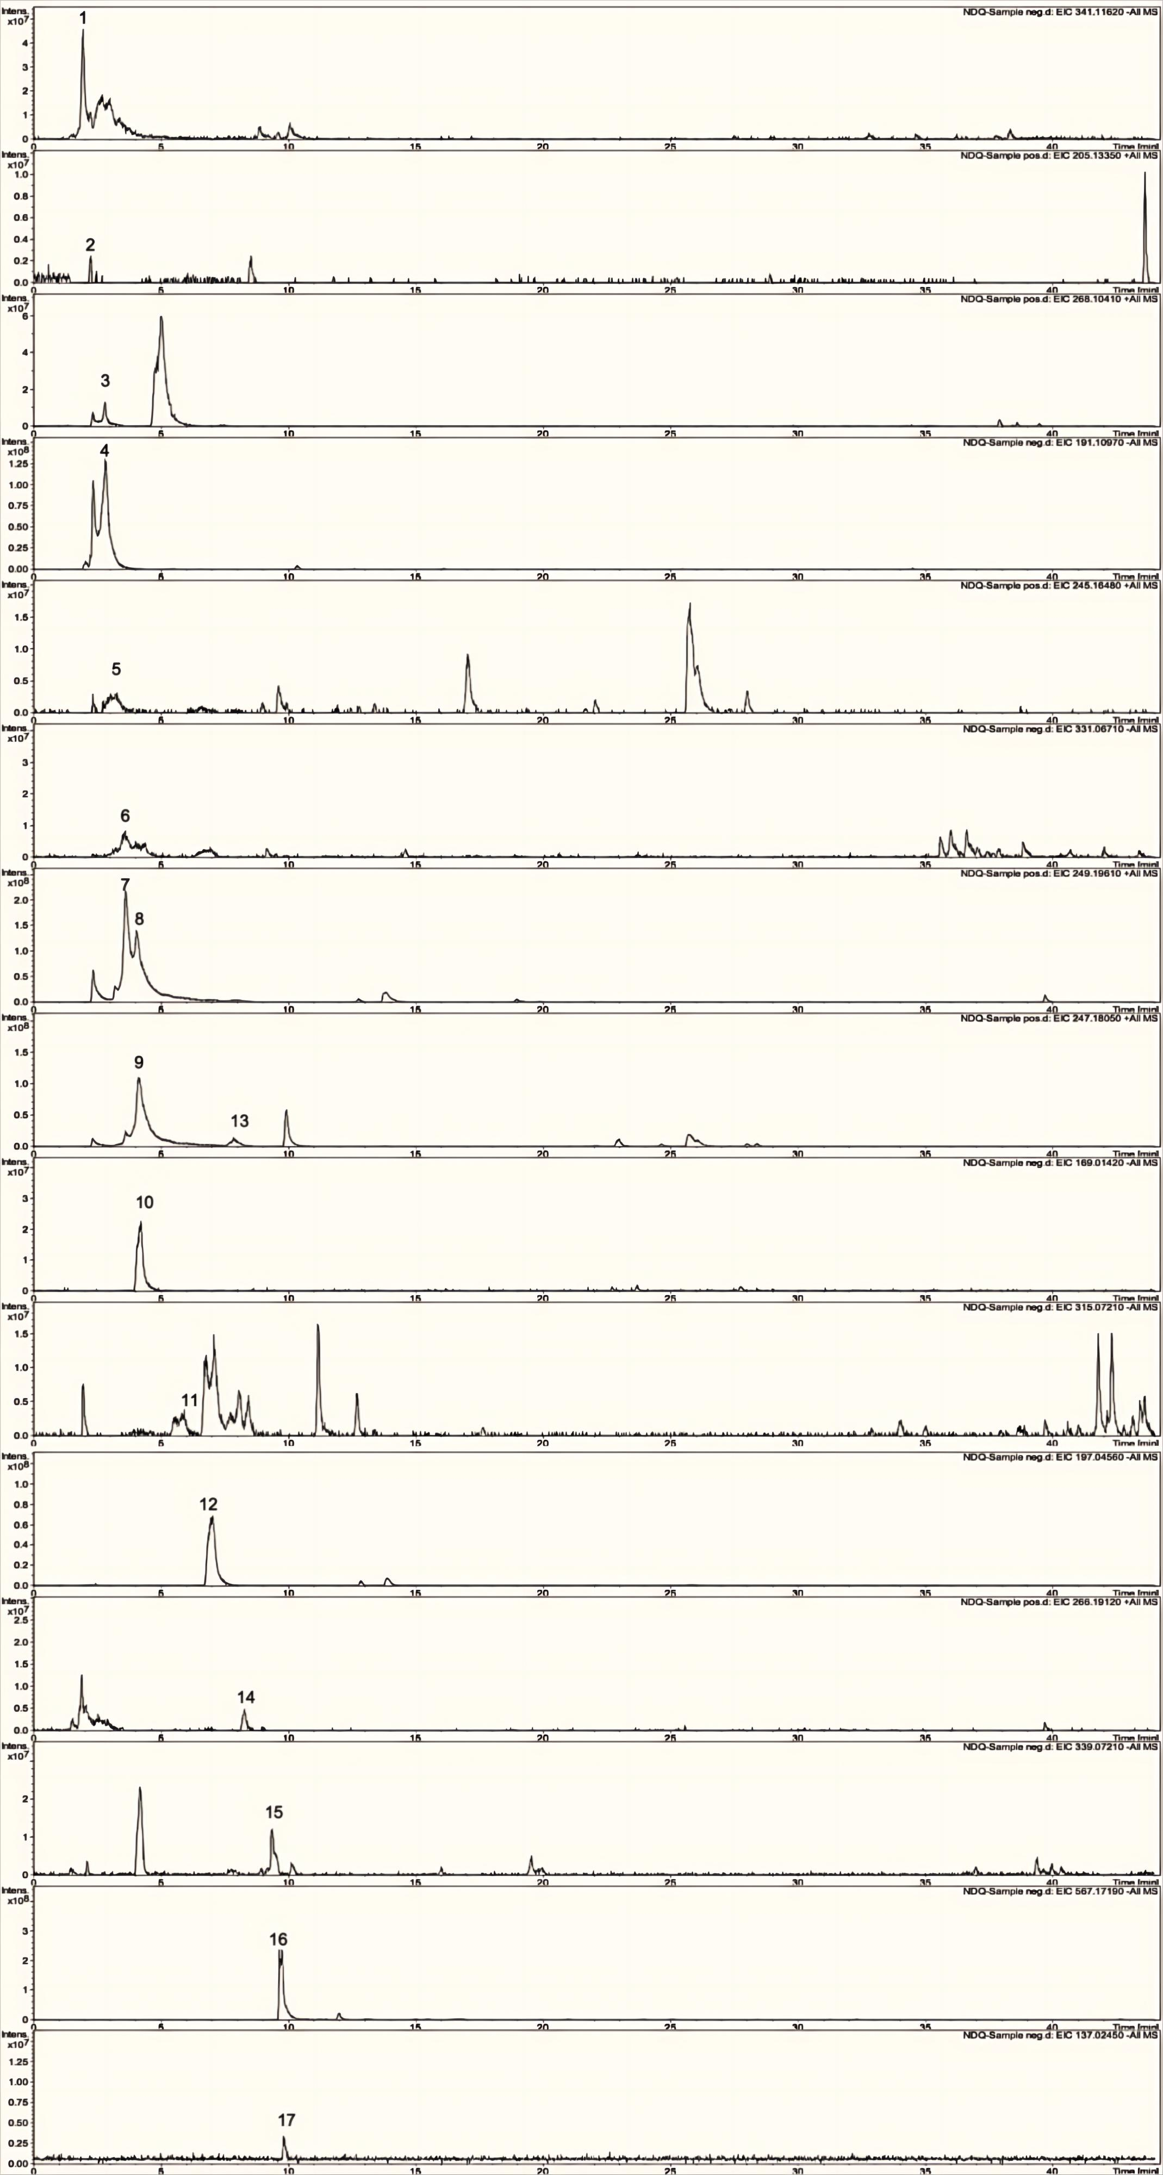

Fig. S1 Extracted ion chromatograms (EICs) for chemical compounds of UCG both in positive and negative ion mode.

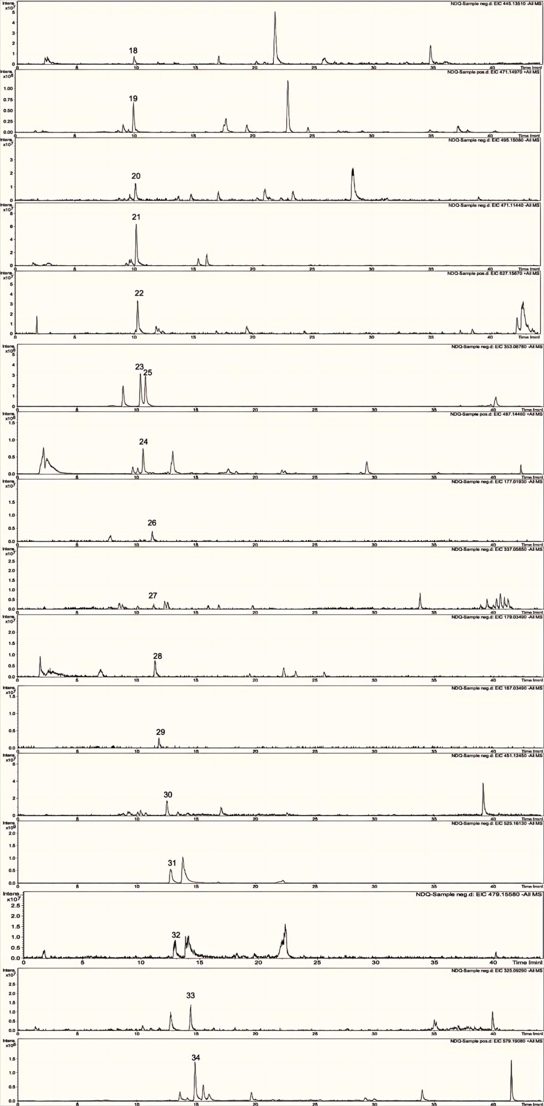

**Fig. S1** (continued)

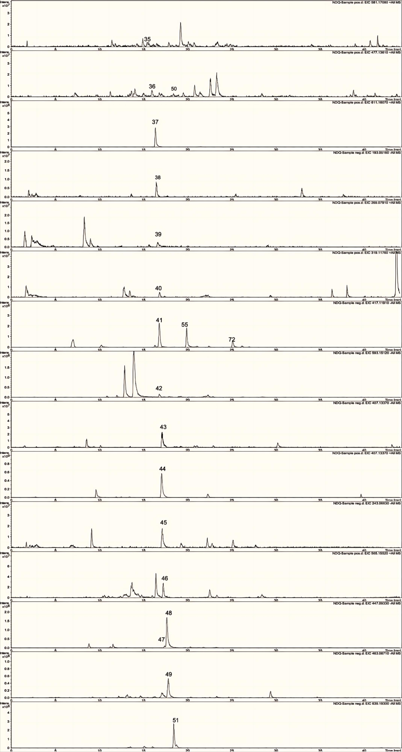

**Fig. S1** (continued)

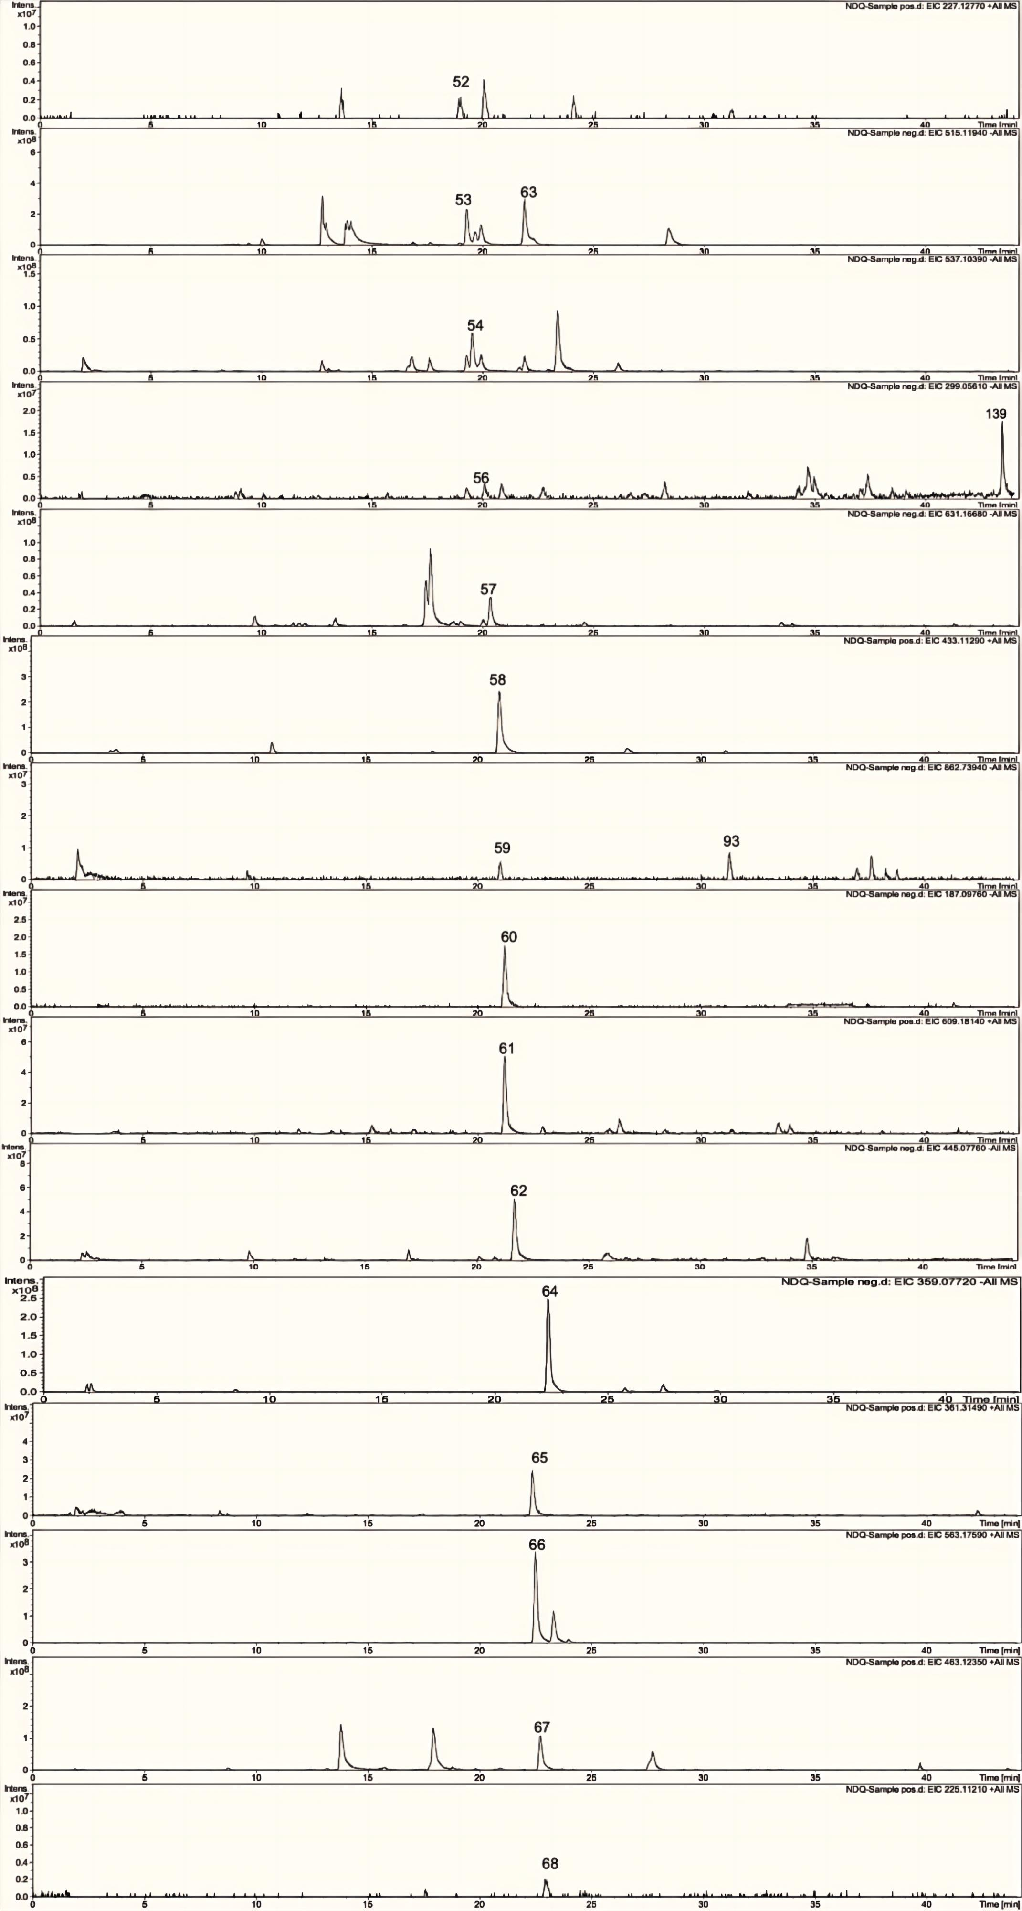

**Fig. S1** (continued)

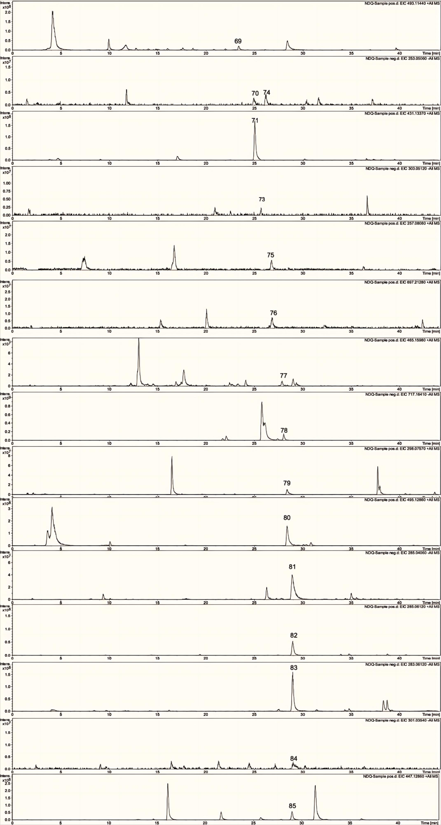

**Fig. S1** (continued)

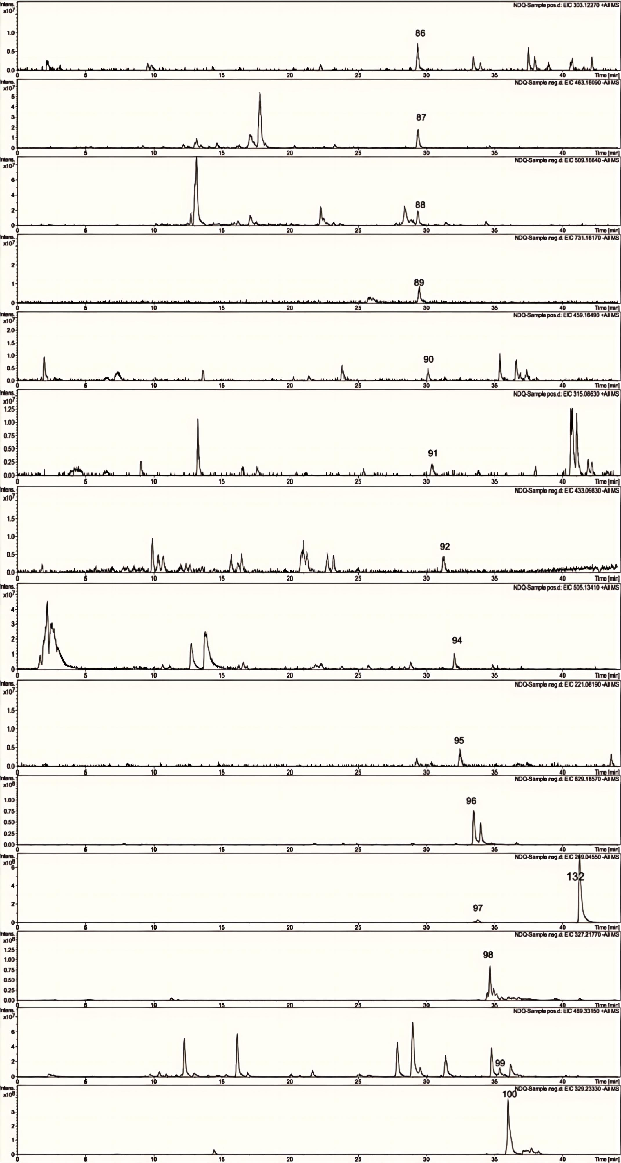

**Fig. S1** (continued)

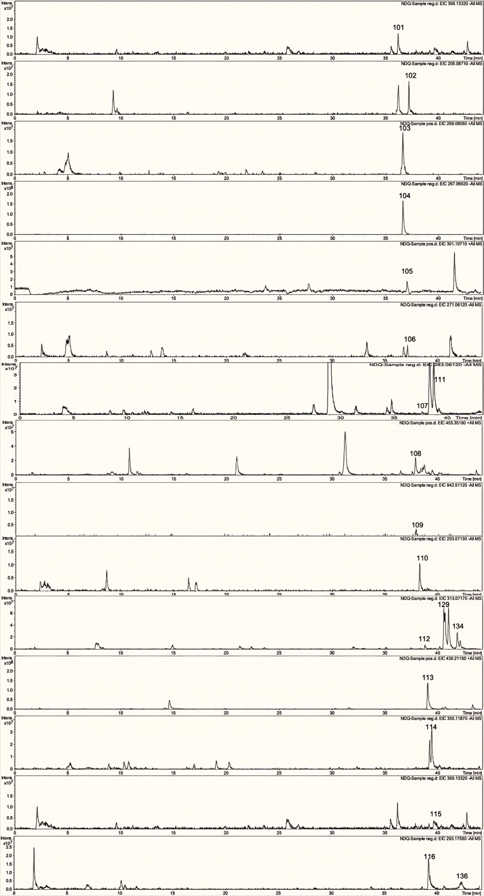

**Fig. S1** (continued)

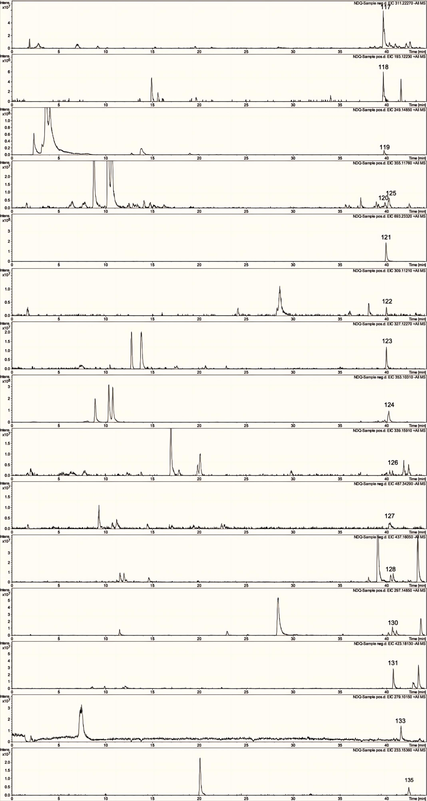

**Fig. S1** (continued)

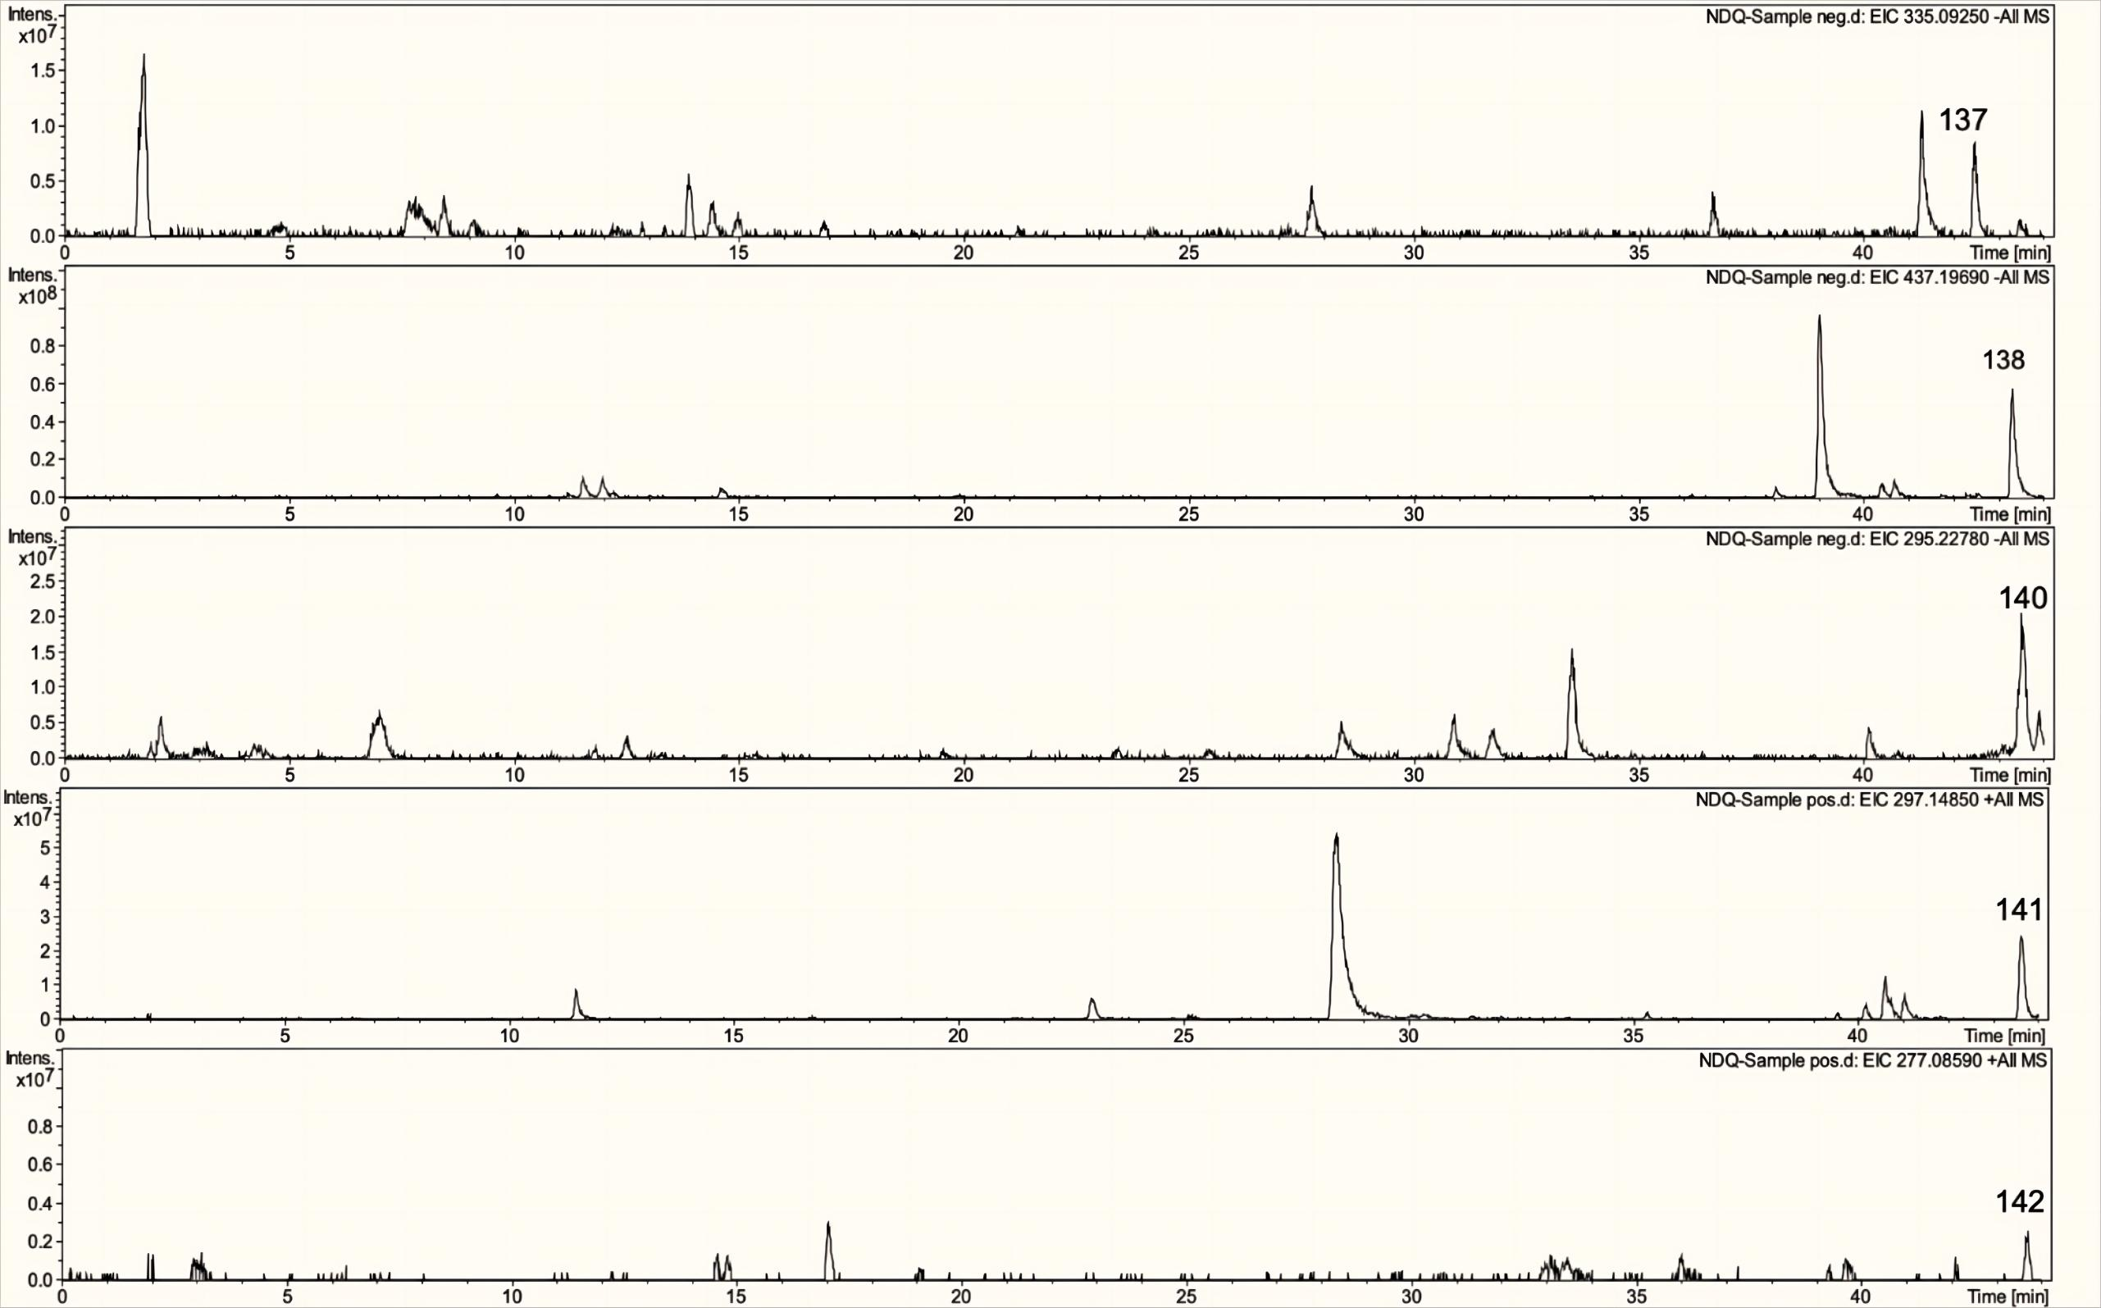

**Fig. S1** (continued)

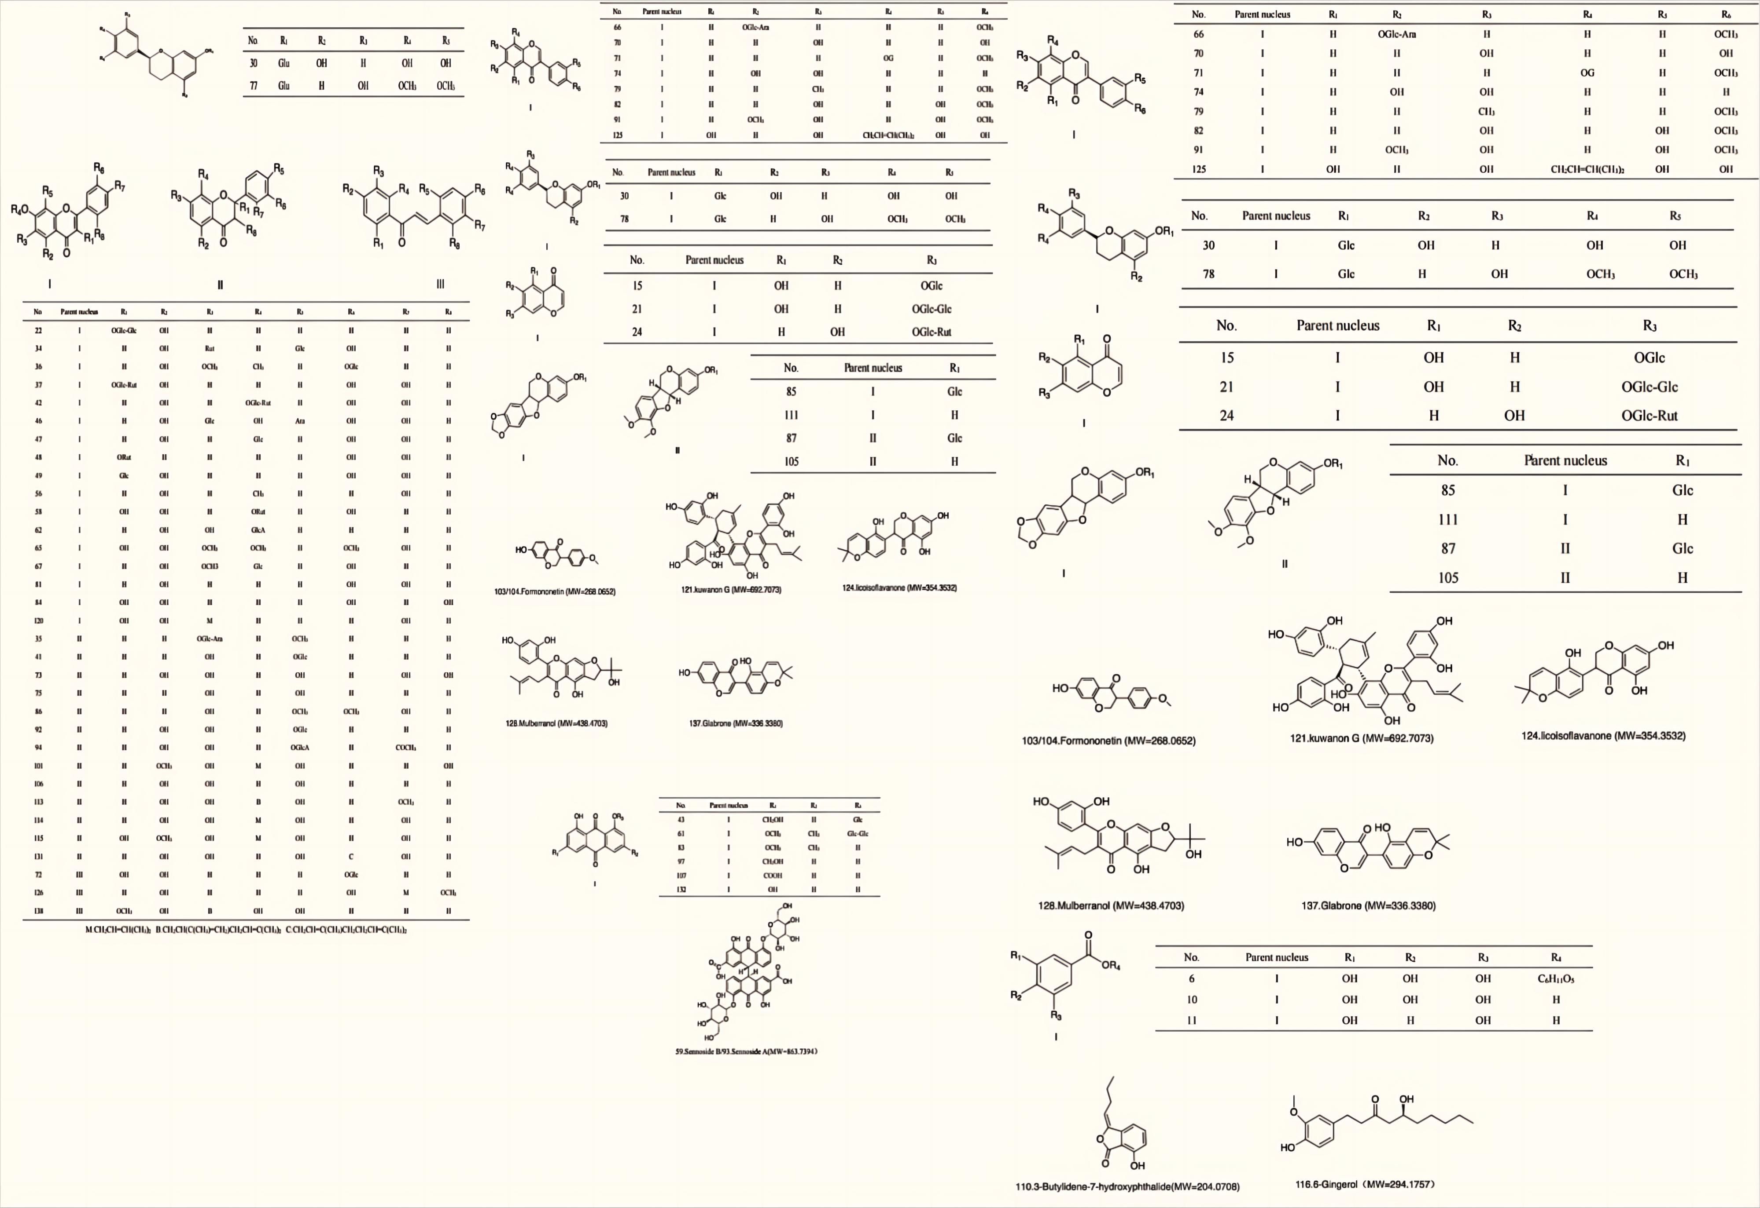

**Fig. S2** The chemical structures of compounds detected in UCG.

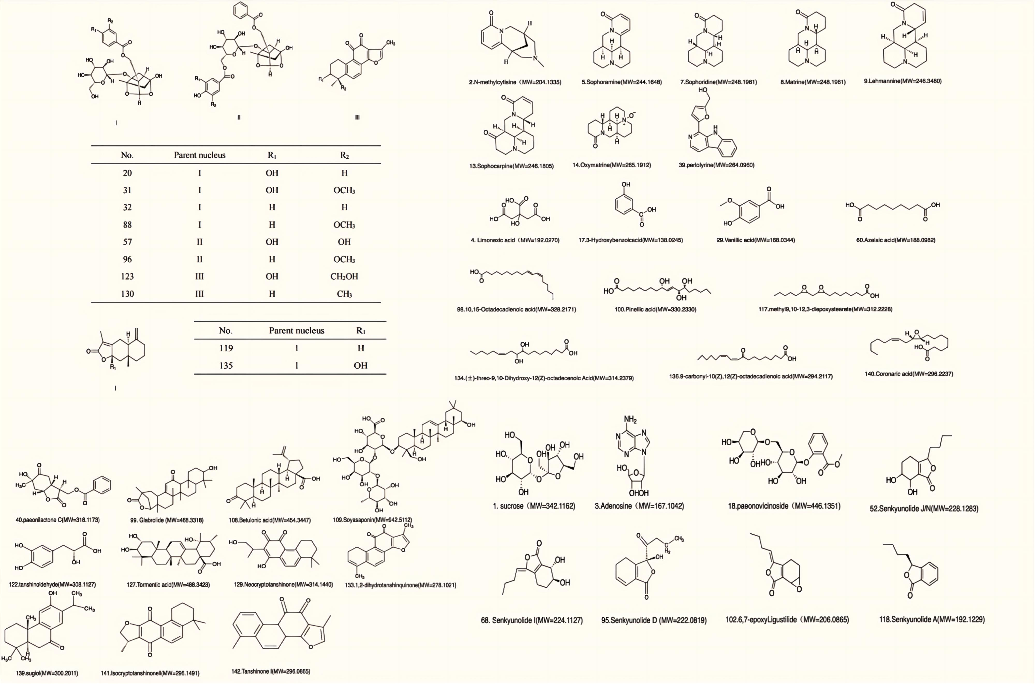

**Fig. S2** The chemical structures of compounds detected in UCG.(continued)

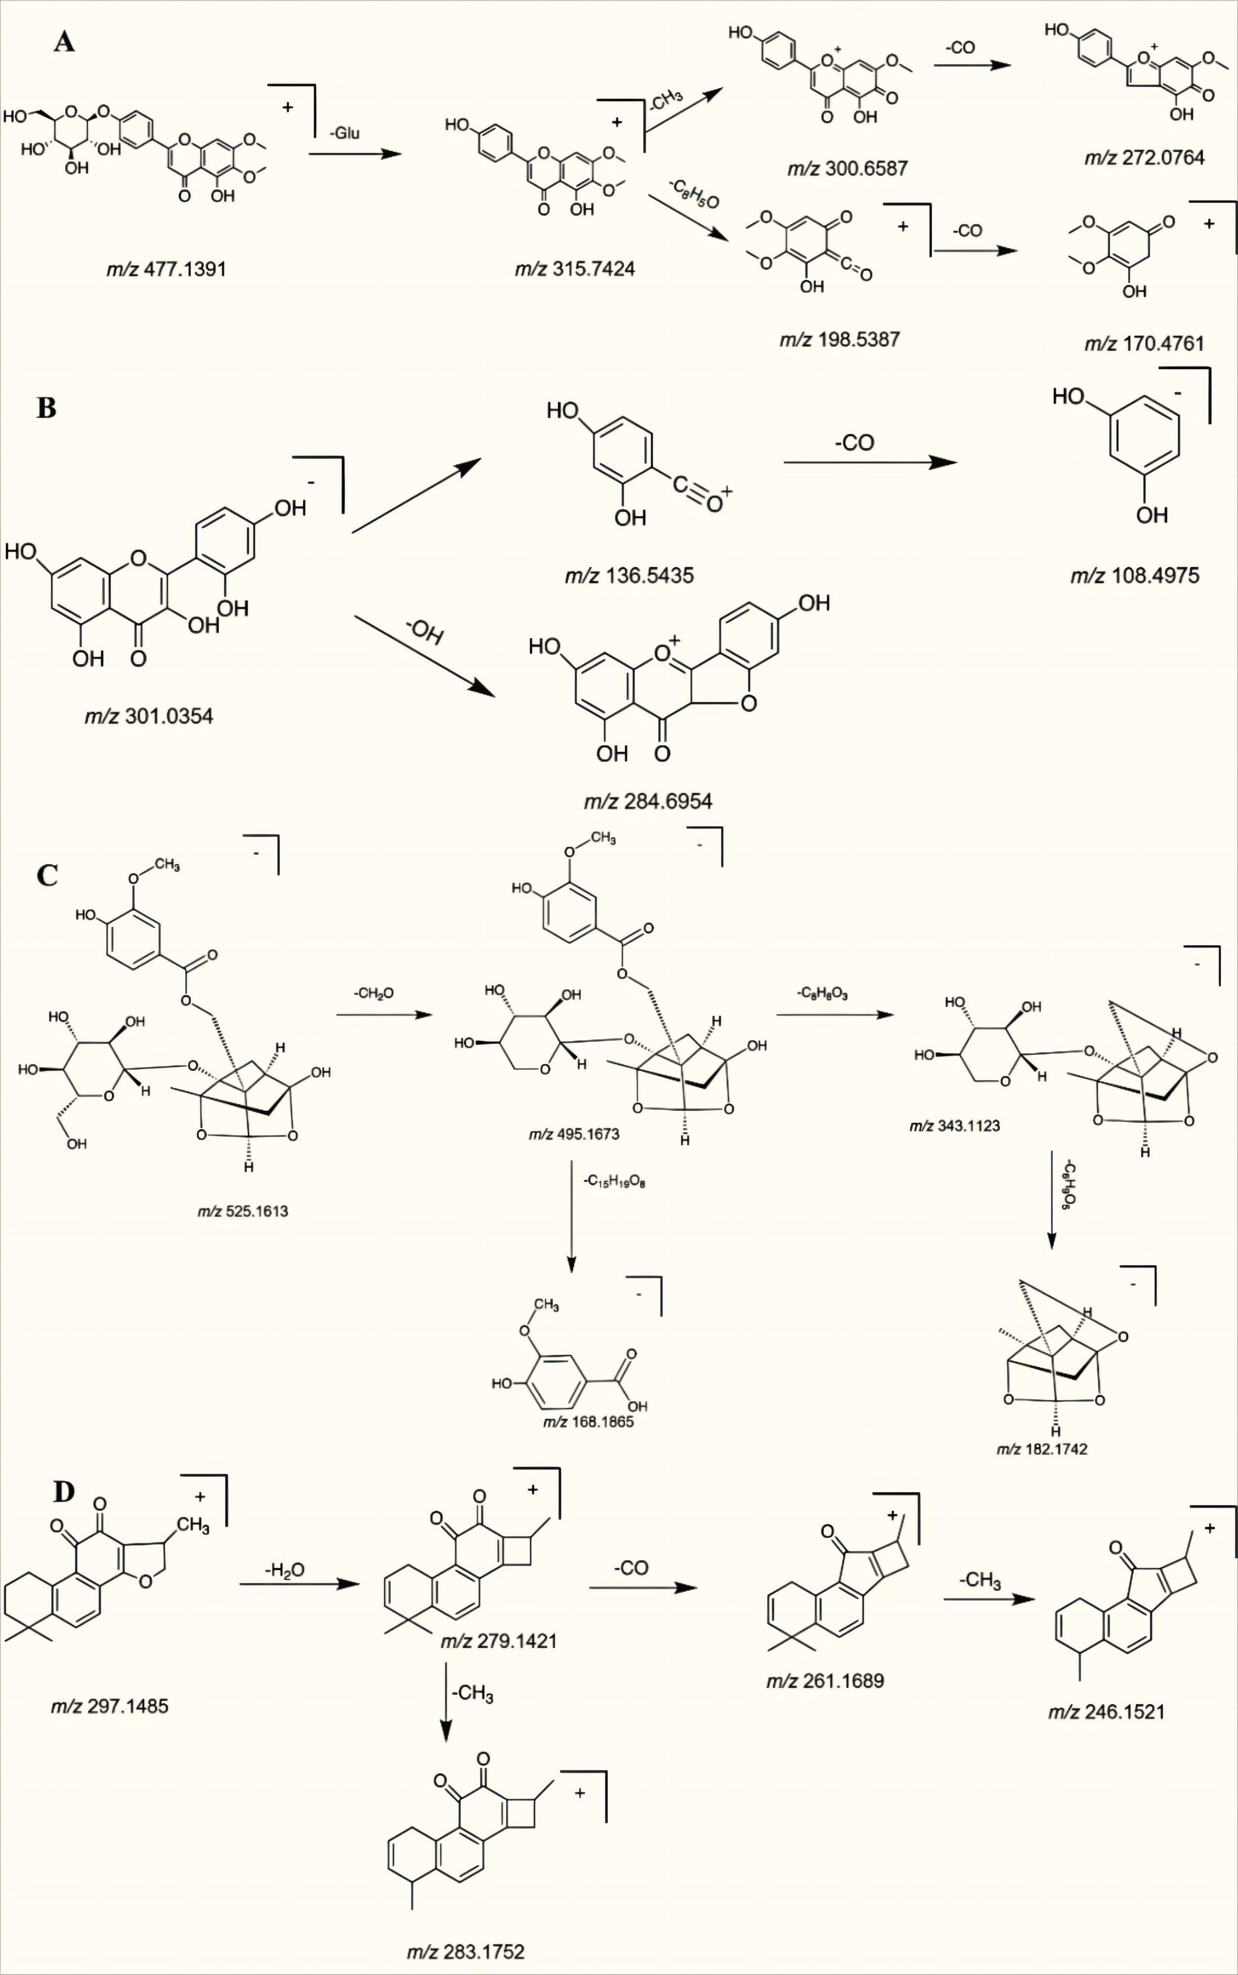

**Fig. S3** The possible fragmentation pathways of the typical compounds. A -Cirsimarin, B − Morin, C -Mudanpioside E, D -Cryptotanshinone.

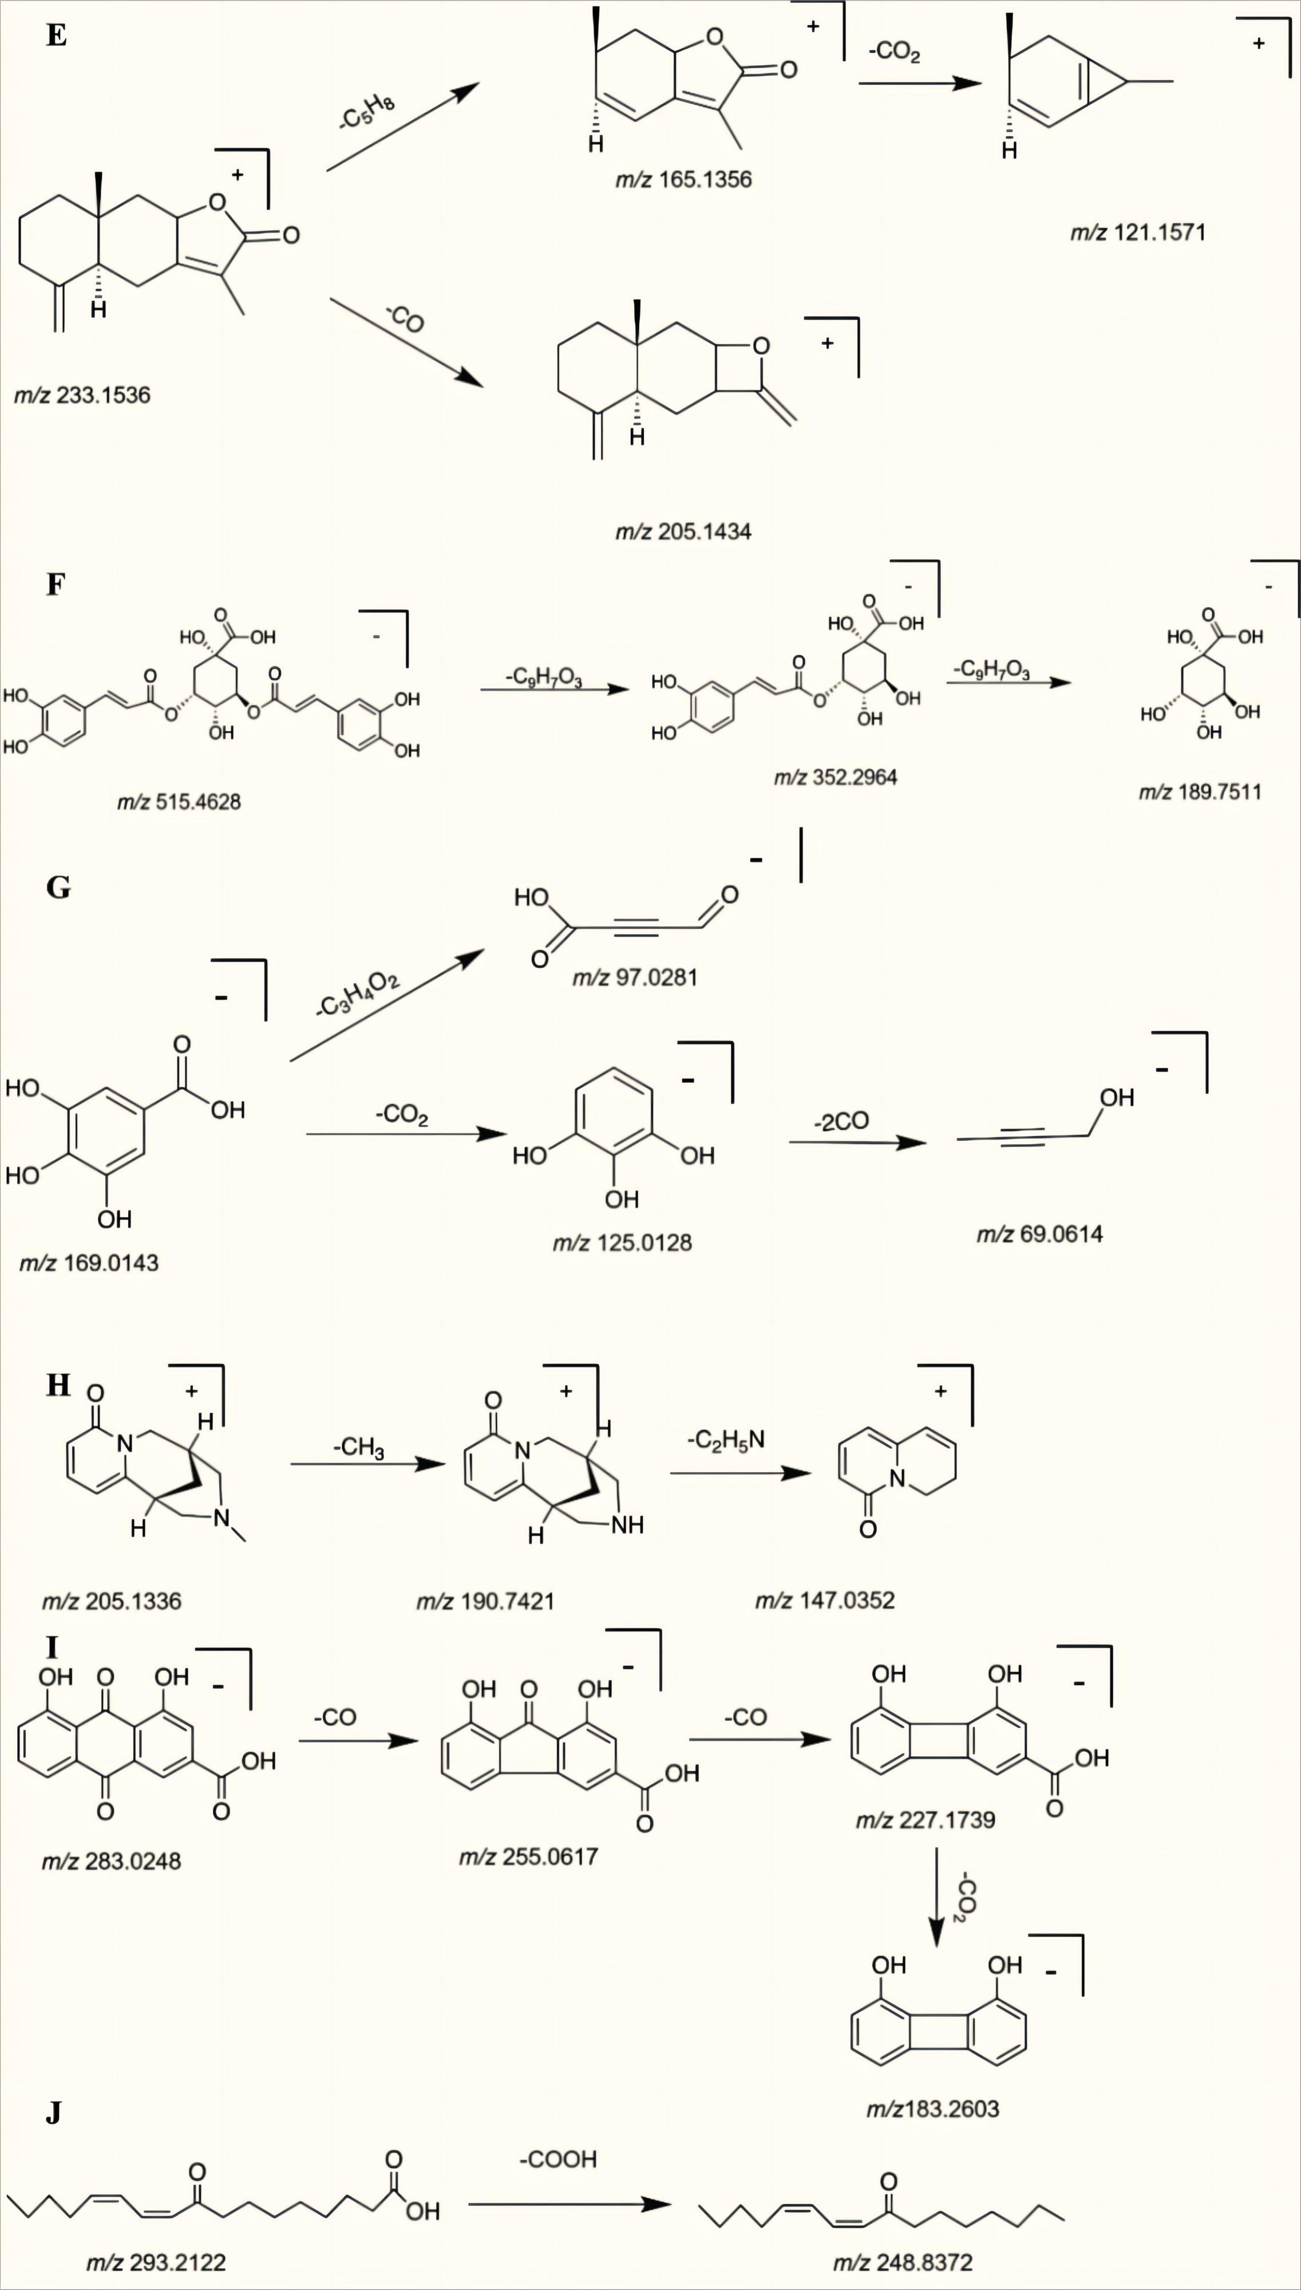

**Fig. S3** The possible fragmentation pathways of the typical compounds. E-Atractylenolide II, F-3,5-O-Dicaffeoylquinic acid, G-gallic acid, H- N-methylcytisine, I-Rhein, J-9-carbonyl-10(Z),12(Z)-octadecadienoic acid.

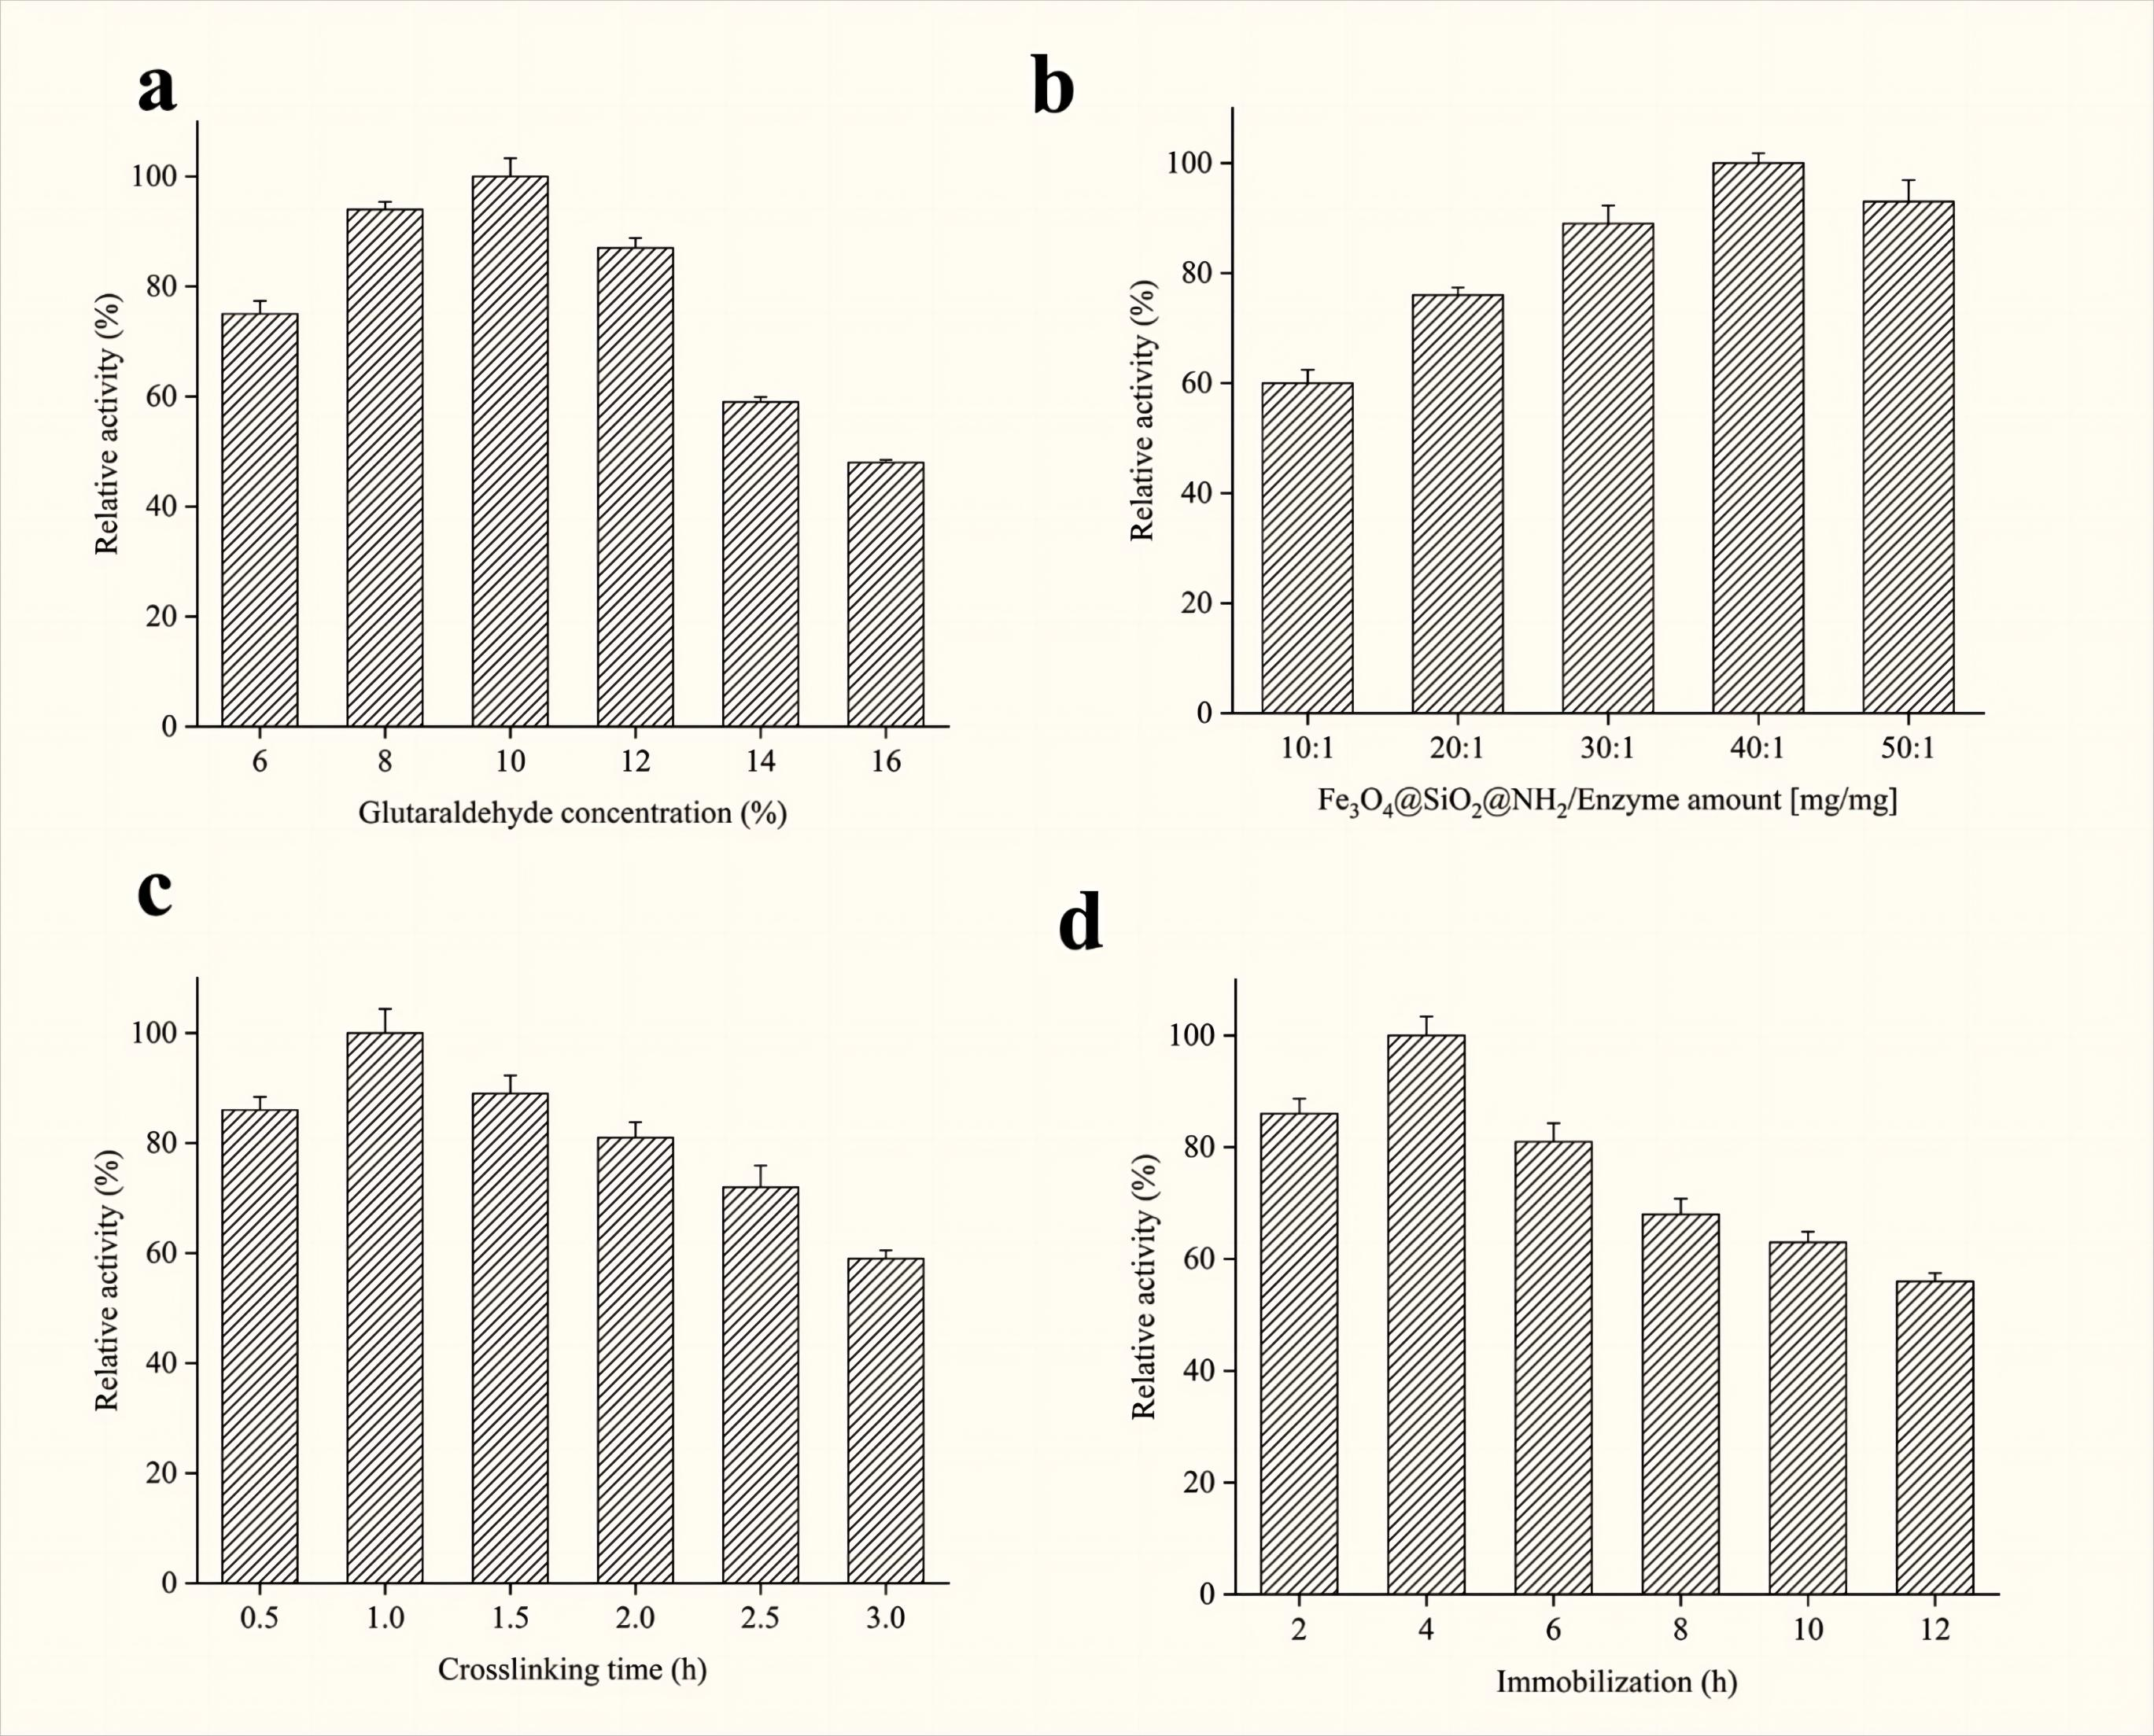

**Fig. S4** Effects of glutaraldehyde concentration (a), Fe3O4@SiO2@NH2/Enzyme amount (b), crosslinking time (c), immobilization time (d) on the relative activity of immobilized α-Glucosidase.

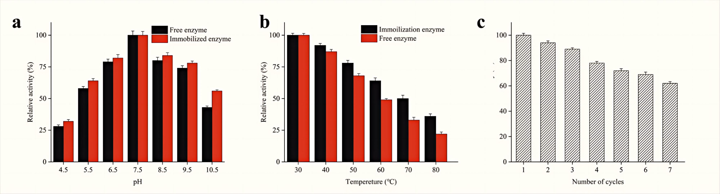

**Fig. S5** Enzyme activity assays with pH (a), thermo stabilities (b), reusability of the free and immobilized α-Glucosidase (c).

**Table S1** HPLC-FT-ICR-MS analysis of UCG.

|  |  |  |  |  |  |  |  |  |
| --- | --- | --- | --- | --- | --- | --- | --- | --- |
| No. | TR(min) | Identification | Formula | Theoretical mass(*m/z*) | Measured mass(*m/z*) | Error(ppm) | Ion mode | MS/MS(*m/z*） |
| 1 | 1.97 | Sucrose | C12H22O11 | 342.1162 | 341.1089 | -1.12 | [M-H]- | 119.03, 89.05, 71.01, 59.01 |
| 2 | 2.27 | N-methylcytisine | C12H16N2O | 204.1335 | 205.1336 | -2.69 | [M+H]+ | 190.74, 147.03 |
| 3 | 2.85 | Adenosine | C10H13N5O4 | 267.1042 | 268.1043 | -1.06 | [M+H]+ | 134.05 |
| 4 | 2.89 | Limonexic acid | C6H8O7 | 192.027 | 191.0197 | -0.11 | [M-H]- | 173.00, 129.01, 111.00, 87.01, 85.03 |
| 5 | 3.25 | Sophoramine | C15H20N2O | 244.1648 | 245.1648 | 0.11 | [M+H]+ | 98.09, 122.05, 174.09, 227.15 |
| 6 | 3.63 | 6-O-galloylglucose | C13H16O10 | 332.0672 | 331.0671 | -0.47 | [M-H]- | 169.01, 211.02, 151.00 |
| 7 | 3.64 | Sophoridin | C15H24N2O | 248.3661 | 249.1961 | 0.36 | [M+H]+ | 231.08, 178.34 |
| 8 | 4.10 | Matrine | C15H24N2O | 248.3661 | 249.1961 | 0.33 | [M+H]+ | 247.18, 230.15, 150.12, 148.11, 112.07 |
| 9 | 4.21 | Lehmannine | C15H22N2O | 246.3429 | 247.1805 | 0.29 | [M+H]+ | 229.16, 204.13, 176.10, 148.11, 136.11, 98.06 |
| 10 | 4.23 | Gallic acid | C7H6O5 | 170.1201 | 169.0142 | 0.15 | [M-H]- | 125.01, 97.02, 69.06 |
| 11 | 6.84 | Protocatechuic acid | C7H6O4 | 154.1246 | 153.5431 | -0.06 | [M-H]- | 109.02 |
| 12 | 7.06 | Danshensu* | C9H10O5 | 198.045 | 197.0456 | 0.05 | [M-H]- | 179.03 |
| 13 | 7.92 | Sophocarpine | C15H22N2O | 246.3575 | 247.1805 | 0.17 | [M+H]+ | 179.15, 136.11 |
| 14 | 8.31 | Oxymatrine | C15H24N2O2 | 265.1912 | 266.1912 | -0.31 | [M+H]+ | 247.18, 176.10, 148.11, 136.11, 98.09 |
| 15 | 9.41 | 5-methylumbelliferyl -7-o-β-D-glucopyranoside | C15H16O9 | 340.0324 | 339.0721 | -0.49 | [M-H]- | 281.91, 176.86 |
| 16 | 9.78 | Mulberroside A | C26H32O14 | 568.5243 | 567.1719 | -0.03 | [M-H]- | 405.11, 243.06 |
| 17 | 9.83 | 3-hydroxybenzoicacid | C7H6O3 | 138.1217 | 137.0245 | -0.2 | [M-H]- | 93.94, 75.23, 65.12 |
| 18 | 9.86 | paeonovicinoside | C19H26O12 | 446.4032 | 445.1351 | -0.74 | [M-H]- | / |
| 19 | 9.98 | Tangshenoside V | C21H26O12 | 470.2063 | 471.1497 | -1.12 | [M+H]+ | 325.09, 265.07, 235.06, 205.05 |
| 20 | 10.16 | Oxypaeoniflorin | C23H28O12 | 496.4613 | 495.1508 | -0.46 | [M-H]- | 477.13, 465.14, 333.09 |
| 21 | 10.23 | 5-methylumbelliferyl - 7-O-[β-D-apiofuranosyl-(1→6)]-β-D-glucopyranoside | C20H24O13 | 472.17 | 471.1144 | -0.43 | [M-H]- | 176. 89 |
| 22 | 10.32 | Quercetin 3-gentiobioside | C27H30O17 | 626.5174 | 627.1567 | -0.3 | [M+H]+ | 625.14, 301.04, 179.01 |
| 23 | 10.38 | Chlorogenic acid | C16H18O9 | 354.0867 | 353.0878 | -0.11 | [M-H]- | 309.09, 295.08, 191.05, 179.03, 143.04, 127.03 |
| 24 | 10.59 | 7-Methylumbelliferyl - 6-O-[α-L-mannopyranosyl-(1→6)]-β-D-glucopyranoside | C21H26O13 | 486.01 | 487.1446 | -1.09 | [M+H]+ | 179.03, 341.06, 451.17 |
| 25 | 10.78 | Isochlorogenic acid | C16H18O9 | 354.0867 | 353.0878 | 0.03 | [M-H]- | 275.02, 273.00, 261.00, 258.99 |
| 26 | 11.38 | Esculetin | C9H6O4 | 178.0192 | 177.0193 | 0.05 | [M-H]- | 196.92, 148.94, 133.04, 121.25, 104.95 |
| 27 | 11.48 | 7-hydroxycoumarin glucuronide | C15H14O9 | 338.11 | 337.0565 | -0.26 | [M-H]- | 289.05, 245.04, 198.91, 137.02, 125.02, 96.96 |
| 28 | 11.58 | Caffeic acid* | C9H8O4 | 180.1573 | 179.0349 | -0.08 | [M-H]- | 135.04, 134.03, 132.02, 79.05 |

*Compared with reference compounds.

**Table S1** (continued)

|  |  |  |  |  |  |  |  |  |
| --- | --- | --- | --- | --- | --- | --- | --- | --- |
| No. | TR(min) | Identification | Formula | Theoretical mass(*m/z*) | Measured mass(*m/z*) | Error(ppm) | Ion mode | MS/MS(*m/z*） |
| 29 | 11.88 | Vanillic acid | C8H8O4 | 168.0344 | 167.0349 | -0.11 | [M-H]- | 135.65 |
| 30 | 12.58 | Catechin--O-glucoside | C21H24O11 | 452.1235 | 451.1245 | -0.67 | [M-H]- | 289.07, 245.08, 203.07, 179.03 |
| 31 | 12.87 | Mudanpioside E | C24H30O13 | 526.1614 | 525.1613 | -1.5 | [M-H]- | 495.16, 343.11, 182.17, 168.18 |
| 32 | 13.92 | Paeoniflorin* | C23H28O11 | 480.4624 | 479.1558 | -0.58 | [M-H]- | 479.15, 449.14, 357.11 |
| 33 | 14.57 | Unknow | C15H18O8 | 326.1033 | 325.0929 | -0.52 | [M-H]- | 325.09 |
| 34 | 14.94 | Isoviolanthin | C27H30O14 | 578.1714 | 579.1708 | -0.87 | [M+H]+ | 457.33 |
| 35 | 15.59 | Kushenol J | C27H32O14 | 580.1782 | 581.1708 | -0.76 | [M+H]+ | / |
| 36 | 15.97 | Cirsimarin | C23H24O11 | 476.4302 | 477.1391 | -0.75 | [M+H]+ | 313.74, 299.65, 281.07, 197.53, 169.47 |
| 37 | 16.36 | Rutin | C27H30O16 | 610.5175 | 611.1607 | -1.06 | [M+H]+ | 465.10, 303.04, 285.03, 257.04, 229.05, 165.01, 153.01, 137.02 |
| 38 | 16.45 | (E)-Ferulic acid | C10H10O4 | 194.1845 | 193.0516 | -0.1 | [M-H]- | 177.05, 149.06 |
| 39 | 16.62 | Perlolyrine | C16H12N2O2 | 264.2791 | 265.0971 | -0.28 | [M+H]+ | 247.13, 235.25, 219.76, 206.24, 205.65, 167.21, 140.56 |
| 40 | 16.63 | Paeonilactone C | C17H18O6 | 318.3217 | 319.1176 | -0.79 | [M+H]+ | 301.27, 291.43, 273.12, 197.45, 151.35 |
| 41 | 16.81 | Liquiritin* | C21H20O9 | 418.3942 | 417.1191 | 0.09 | [M-H]- | 255.07, 135.01, 119.05 |
| 42 | 16.82 | Luteolin 7-O-rutinoside | C27H30O15 | 594.5183 | 593.1512 | -0.48 | [M-H]- | / |
| 43 | 17.04 | Torachrysone-8-O-beta-D-(6'-oxayl)-glucoside | C20H24O9 | 408.3992 | 407.1337 | -0.6 | [M-H]- | / |
| 44 | 17.05 | 2,3,5,4'-tetrahydroxy stilbene 2-Ο-β-D-glucoside | C20H22O9 | 406.1323 | 407.1337 | -0.6 | [M+H]+ | 243.06, 225.05, 215.07, 173.05 149.02, 137.02 |
| 45 | 17.15 | Oxyresveratrol | C14H12O4 | 244.2433 | 243.0663 | -1.12 | [M-H]- | 227.07 |
| 46 | 17.25 | Schaftoside | C26H28O14 | 564.4925 | 565.1552 | -0.65 | [M+H]+ | 473.11, 443.09, 383.08, 353.07 |
| 47 | 17.64 | Cynaroside | C21H20O11 | 448.3774 | 447.0933 | -0.35 | [M-H]- | 449.02, 287.17, 286.93 |
| 48 | 17.72 | Quercetin-3-rhamnoside | C21H20O11 | 448.3774 | 447.0933 | -0.35 | [M-H]- | 447.06, 405.00 |
| 49 | 17.95 | Isoquercetin | C21H20O12 | 464.3763 | 463.0871 | -0.84 | [M-H]- | 463.12, 449.43, 352.14 |
| 50 | 18.19 | Isolindleyin | C23H26O11 | 478.4462 | 477.1402 | -0.51 | [M-H]- | 313.05, 169.01, 125.02 |
| 51 | 18.44 | Plantamajoside | C29H36O16 | 640.5863 | 639.193 | 0.48 | [M-H]- | 178.95, 160.92, 133.39 |
| 52 | 19.03 | Senkyunolide J/N | C12H18O4 | 226.1283 | 227.1277 | -0.49 | [M+H]+ | 209.12, 158.96 |
| 53 | 19.32 | Isochlorogenic acid A | C25H24O12 | 516.12 | 515.1194 | -0.06 | [M-H]- | 353.08, 191.05, 179.03, 173.04, 161.02, 135.04, 111.04 |
| 54 | 19.58 | Salvianolic acid H | C27H22O12 | 538.4564 | 537.1039 | -0.39 | [M-H]- | 339.03, 295.06 |

*Compared with reference compounds.

**Table S1** (continued)

|  |  |  |  |  |  |  |  |  |
| --- | --- | --- | --- | --- | --- | --- | --- | --- |
| No. | TR(min) | Identification | Formula | Theoretical mass(*m/z*) | Measured mass(*m/z*) | Error(ppm) | Ion mode | MS/MS(*m/z*） |
| 55 | 19.90 | Salvianolic acid D | C20H18O10 | 418.3509 | 417.0827 | -0.15 | [M-H]- | 197.04, 193.05, 179.03, 175.04, 135.04, 72.99 |
| 56 | 20.12 | Hydroxygenkwanin | C16H12O6 | 300.2637 | 299.0561 | -0.15 | [M-H]- | 299.10, 284.04, 256.23 |
| 57 | 20.36 | Galloylpaeoniflorin | C30H32O15 | 632.5661 | 631.1668 | -0.68 | [M-H]- | 631.16, 491.12, 271.04, 169.01 |
| 58 | 20.99 | Kaempferol-7-O-α-L-rhamnoside | C21H20O10 | 432.3841 | 433.1129 | -0.78 | [M+H]+ | 473.43, 447.32, 429.45, 284.78 |
| 59 | 21.03 | Sennoside B | C42H38O20 | 863.7394 | 862.2041 | 0.12 | [M-H]- | 699.13, 537.08, 389.08, 265.04 |
| 60 | 21.22 | Azelaic acid | C9H16O4 | 188.2213 | 187.0976 | 0.05 | [M-H]- | 171.10, 153.09, 125.09 |
| 61 | 21.25 | Physciondiglucoside | C28H32O15 | 608.5453 | 609.1814 | -0.87 | [M+H]+ | / |
| 62 | 21.72 | Baicalin | C21H18O11 | 446.3613 | 445.0776 | -0.57 | [M-H]- | 271.05 |
| 63 | 21.94 | 3,5-O-Dicaffeoylquinic acid | C25H24O12 | 516.4628 | 515.1195 | 0.07 | [M-H]- | 353.29, 191.15, 179.21, 135.41 |
| 64 | 22.40 | Rosmarinic acid | C18H16O8 | 360.3148 | 359.0772 | -0.15 | [M-H]- | 197.04, 179.03, 161.02, 135.04, 133.02, 72.99 |
| 65 | 22.42 | Eupatin | C18H16O8 | 360.3148 | 361.0772 | -0.14 | [M+H]+ | 208.03 |
| 66 | 22.51 | Kushenol O | C27H30O13 | 562.5193 | 563.1759 | -1.27 | [M+H]+ | 269.13 |
| 67 | 22.74 | Homoplantaginin | C22H22O11 | 462.4042 | 463.1235 | -0.88 | [M+H]+ | 446.06, 299.05, 284.03 |
| 68 | 23.00 | Senkyunolide I | C12H16O4 | 224.2532 | 225.1121 | 0.15 | [M+H]+ | / |
| 69 | 23.40 | Salvianolic acid C | C26H20O10 | 492.4312 | 493.1144 | -0.01 | [M+H]+ | 295.05, 197.04, 185.02, 179.03, 135.04, 102.02 |
| 70 | 25.02 | 4，7-dihydroxy-2-phenylchromen-4-one | C15H10O4 | 254.0495 | 253.0506 | -0.2 | [M-H]- | 225.0548，209.0603 |
| 71 | 25.06 | Ononin | C22H22O9 | 430.4047 | 431.1337 | -0.78 | [M+H]+ | 269.08 |
| 72 | 25.12 | Isoliquiritin | C21H22O9 | 418.3942 | 417.1191 | -0.33 | [M-H]- | 255.06, 135.00, 119.08 |
| 73 | 25.70 | Dihydromorin | C15H12O7 | 304.2516 | 303.0512 | -0.6 | [M-H]- | 275.06, 176.79, 124.82 |
| 74 | 26.21 | 6,7-Dihydroxyflavone | C15H10O4 | 254.2385 | 253.0506 | -0.46 | [M-H]- | 225.05, 209.06 |
| 75 | 26.81 | Liquiritigenin* | C15H12O4 | 256.2634 | 257.0808 | -0.25 | [M+H]+ | 135.01, 119.05 |
| 76 | 26.90 | Liquiritin B | C35H36O15 | 696.2112 | 697.2128 | -0.38 | [M+H]+ | 279.08, 261.07 |
| 77 | 27.77 | Isomucronulatol 7-O-glucoside | C23H28O10 | 464.1596 | 465.1598 | -0.88 | [M+H]+ | 447.16, 303.12, 275.09 |
| 78 | 28.07 | Salvianolic acid B | C36H30O16 | 718.6138 | 717.1461 | 0.71 | [M-H]- | 561.10, 543.08 |
| 79 | 28.34 | 7-Methyl-calycosin | C17H14O5 | 297.0894 | 298.0757 | -0.66 | [M+H]+ | 297.04, 281.02, 251.16, 160.91 |
| 80 | 28.40 | Salvianolic acid A | C26H22O10 | 494.4469 | 495.1286 | -1.27 | [M+H]+ | 303.17, 295.16 |

*Compared with reference compounds.

**Table S1** (continued)

|  |  |  |  |  |  |  |  |  |
| --- | --- | --- | --- | --- | --- | --- | --- | --- |
| No. | TR(min) | Identification | Formula | Theoretical mass (*m/z*) | Measured mass (*m/z*) | Error (ppm) | Ion mode | MS/MS (*m/z*） |
| 81 | 28.91 | Luteolin* | C15H10O6 | 286.2363 | 285.0406 | -0.37 | [M-H]- | 269.04, 241.04, 213.05 |
| 82 | 28.99 | Calycosin | C16H12O5 | 284.2635 | 285.0612 | -0.36 | [M+H]+ | / |
| 83 | 29.01 | Physcion | C16H12O5 | 284.2635 | 283.0612 | -0.36 | [M-H]- | 269.04, 240.04, 225.05 |
| 84 | 29.03 | Morin | C15H10O7 | 302.2362 | 301.0354 | -0.53 | [M-H]- | 284.69, 136.54, 118.49 |
| 85 | 29.08 | Trifolrhizin | C22H22O10 | 446.4041 | 447.1286 | -0.87 | [M+H]+ | 283.21 |
| 86 | 29.38 | Isomucronulatol | C17H18O5 | 302.3221 | 303.1227 | -0.54 | [M+H]+ | 447.16, 303.12, 275.09 |
| 87 | 29.40 | Isomucronulatol-7-O-β-D-glc | C23H28O10 | 464.4605 | 463.1609 | -0.34 | [M-H]- | 447.16, 303.12, 275.09 |
| 88 | 29.41 | Mudanpioside D | C24H30O12 | 510.174 | 509.1664 | -0.5 | [M-H]- | 463.21, 331.17, 121.03 |
| 89 | 29.52 | 4'-O-methyl Aalvianolic Acid B | C37H32O16 | 732.1612 | 731.1617 | 0.12 | [M-H]- | 353.06, 335.05, 309.07, 135.04 |
| 90 | 30.15 | Mulberroside C | C24H29O9 | 458.4582 | 459.1649 | -0.65 | [M+H]+ | 327.19, 255.15 |
| 91 | 30.45 | Odor-atin | C17H14O6 | 314.0843 | 315.0863 | -0.17 | [M+H]+ | / |
| 92 | 31.24 | Choerospondin | C21H22O10 | 434.3932 | 433.0983 | -0.08 | [M-H]- | 255.06, 151.00, 135.00 |
| 93 | 31.30 | Sennoside A | C42H38O20 | 863.7394 | 862.2041 | 0.3 | [M-H]- | 699.13, 537.08, 389.08, 265.04 |
| 94 | 32.06 | 5-dihydroxy flavanone-6'-acetylglucoside | C24H24O12 | 504.1346 | 505.1341 | -0.93 | [M+H]+ | / |
| 95 | 32.49 | Senkyunolide D | C12H14O4 | 222.0819 | 221.0819 | -0.1 | [M-H]- | 221.11, 177.43 |
| 96 | 33.49 | Mudanpioside J | C31H34O14 | 630.5933 | 629.1875 | -0.11 | [M-H]- | 599.16, 507.14, 477.13, 433.10 |
| 97 | 33.73 | Aloe-emodin* | C15H10O5 | 270.2371 | 269.0455 | -0.23 | [M-H]- | 240.28 |
| 98 | 34.69 | 10,15-octadecadienoic acid* | C18H32O5 | 328.2171 | 327.2177 | -0.27 | [M-H]- | 291.19, 229.14, 211.13, 171.10 |
| 99 | 35.45 | Glabrolide | C30H44O4 | 468.6682 | 469.3312 | -1.37 | [M+H]+ | 203.06, 187.11 |
| 100 | 36.01 | Pinellic acid | C18H34O5 | 330.233 | 329.2333 | -0.16 | [M-H]- | 229.14, 211.13, 183.43, 171.10 |
| 101 | 36.20 | (2R,3R)-7,4ʹ-dihydroxy-5-methoxy-8-isopentenylflavonol | C21H22O6 | 370.1333 | 369.1332 | -0.98 | [M-H]- | 323.11, 161.04 |
| 102 | 36.25 | 6,7-epoxyligustilide | C12H14O3 | 206.0865 | 205.0871 | -0.15 | [M-H]- | 161.09 |
| 103 | 36.67 | Formononetin | C16H12O4 | 268.2643 | 269.0808 | -0.83 | [M+H]+ | 252.04, 223.03, 132.02 |
| 104 | 36.68 | Formononetin | C16H12O4 | 268.2643 | 267.0662 | -0.22 | [M-H]- | 254.05, 237.05, 213.09, 107.04 |
| 105 | 37.06 | Methylnissolin | C17H16O5 | 300.3135 | 301.1071 | -0.72 | [M+H]+ | 301.96, 167.45, 152.56 |
| 106 | 37.19 | Naringenin | C15H12O5 | 272.2628 | 271.0612 | -0.34 | [M-H]- | 151.00, 119.04 |
| 107 | 37.57 | Rhein* | C15H8O6 | 284.2204 | 283.0248 | -0.45 | [M-H]- | 255.06, 227.17, 183.26 |
| 108 | 37.92 | Betulonicacid | C30H46O3 | 454.6842 | 455.3519 | -1.38 | [M+H]+ | 407.41 |
| 109 | 38.00 | Soyasaponin | C48H78O18 | 943.5112 | 942.5115 | 0.11 | [M-H]- | 491.24 |
| 110 | 38.35 | 3-butylidene-7-hydroxyphthalide | C12H12O3 | 204.2221 | 203.0713 | -0.17 | [M-H]- | / |

*Compared with reference compounds.

**Table S1** (continued)

|  |  |  |  |  |  |  |  |  |
| --- | --- | --- | --- | --- | --- | --- | --- | --- |
| No. | TR(min) | Identification | Formula | Theoretical mass(*m/z*) | Measured mass(*m/z*) | Error(ppm) | Ion mode | MS/MS(*m/z*） |
| 111 | 38.75 | Maackiain | C16H12O5 | 284.0601 | 283.0612 | -0.47 | [M-H]- | 283.06, 255.06, 117. 05, 211.07, 137.02, 145.02, 240.04, 227.06 |
| 112 | 38.80 | Salvianolic acid F | C17H14O6 | 314.2895 | 313.0717 | -0.62 | [M-H]- | 375.06, 313.13, 269.93, 179.25, 135.02 |
| 113 | 39.06 | Leachianone A | C26H30O6 | 438.5132 | 439.2115 | -0.78 | [M+H]+ | 439.34, 301.13, 279.65, 219.69 |
| 114 | 39.21 | Leachianone G | C20H20O6 | 356.3693 | 355.1187 | -1.07 | [M-H]- | 193.08, 161.02, 124.01, 219.04, 149.09, 337.10, 355.11 |
| 115 | 39.23 | 2-hydroxyIsoxanthohumol | C21H22O6 | 370.1333 | 369.1332 | -0.7 | [M-H]- | 161.02, 133.03, 207.07 |
| 116 | 39.23 | 6-Gingerol | C17H26O4 | 294.3859 | 293.1758 | -0.45 | [M-H]- | 317.17, 159.04 |
| 117 | 39.64 | methyl 9,10-12,3-diepoxystearate | C18H32O4 | 312.4443 | 311.2227 | -0.74 | [M-H]- | 183.01, 293.21, 311.17 |
| 118 | 39.66 | Senkyunolide A | C12H16O2 | 192.1229 | 193.1223 | 2.27 | [M+H]+ | 175.11, 147.12, 137.06 |
| 119 | 39.73 | Atractylenolide III | C15H20O3 | 248.3184 | 249.1485 | -0.46 | [M+H]+ | 231.13, 203.14, 189.09, 175.07, 163.07 |
| 120 | 39.82 | Licoflavonol | C20H18O6 | 354.3532 | 355.1176 | -0.89 | [M+H]+ | 533.16, 429.14, 291.08, 177.05, 167.03 |
| 121 | 39.93 | Kuwanon G | C40H36O11 | 692.7073 | 693.2332 | -1.27 | [M+H]+ | 581.18, 419.14, 353.10 |
| 122 | 39.97 | Tanshinoldehyde | C19H16O4 | 308.1127 | 309.1121 | -0.67 | [M+H]+ | 289.27, 277.27, 265.11, 248.25, 224.22 |
| 123 | 39.98 | 3-hydroTanshinone IIB | C19H18O5 | 326.1283 | 327.1227 | -0.71 | [M+H]+ | 293.12, 283.13, 267.14 |
| 124 | 40.23 | Licoisoflavanone | C20H18O6 | 354.3532 | 353.1031 | -0.54 | [M-H]- | 297.01, 269.17 |
| 125 | 40.31 | Gancaonin L | C20H18O6 | 354.3532 | 355.1176 | -0.93 | [M+H]+ | 313.14, 299.09, 193.04 |
| 126 | 40.32 | Licochalcone C | C21H22O4 | 338.3974 | 339.1591 | -1.22 | [M+H]+ | 279.07, 243.10, 159.04 |
| 127 | 40.39 | Tormentic acid | C30H48O5 | 488.6992 | 487.3429 | -0.29 | [M-H]- | 471.34, 250.17 |
| 128 | 40.40 | Mulberranol | C25H26O7 | 438.4703 | 437.1605 | -0.68 | [M-H]- | 405.17, 356.19 |
| 129 | 40.60 | Neocryptotanshinone | C19H22O3 | 314.3756 | 313.1445 | -0.53 | [M-H]- | 299.12, 271.13, 253.12 |
| 130 | 40.63 | Cryptotanshinone | C19H20O3 | 296.3603 | 297.1485 | -0.55 | [M+H]+ | 283.17, 279.14, 261.16, 247.15 |
| 131 | 40.71 | Sanggenol A | C25H28O6 | 424.4862 | 423.1813 | -0.66 | [M-H]- | 298.13, 245,12, 151.55, 126.87 |
| 132 | 41.25 | Emodin | C15H10O5 | 270.2374 | 269.0455 | 0.21 | [M-H]- | 241.05, 225.05, 197.06 |
| 133 | 41.55 | 1,2-dihydrotanshinquinone | C18H14O3 | 278.3023 | 279.1015 | -0.51 | [M+H]+ | 261.09, 233.09 |
| 134 | 41.89 | (±)-threo-9,10-Dihydroxy-12(Z)-octadecenoic Acid | C18H34O4 | 314.2379 | 313.2384 | -0.56 | [M-H]- | / |
| 135 | 42.37 | Atractylenolide II | C15H20O2 | 232.3184 | 233.1536 | 0.02 | [M+H]+ | 205.14, 165.13, 121.15 |
| 136 | 42.38 | 9-carbonyl-10(Z),12(Z)-octadecadienoic acid | C18H30O3 | 294.2117 | 293.2122 | -0.67 | [M-H]- | 248.84 |

*Compared with reference compounds.

|  |  |  |  |  |  |  |  |  |
| --- | --- | --- | --- | --- | --- | --- | --- | --- |
| No. | TR(min) | Identification | Formula | Theoretical mass(*m/z*) | Measured mass(*m/z*) | Error(ppm) | Ion mode | MS/MS(*m/z*） |
| 137 | 42.49 | Glabrone | C20H16O5 | 336.3382 | 335.0925 | -0.58 | [M-H]- | 335.09, 291.10, 231.08 |
| 138 | 43.33 | Kuraridin | C26H30O6 | 438.5135 | 437.1969 | -0.95 | [M-H]- | 109.07 |
| 139 | 43.49 | Sugiol | C20H28O2 | 300.4352 | 299.2016 | -0.72 | [M-H]- | 281.14, 265.14 |
| 140 | 43.54 | Coronaric acid | C18H32O3 | 296.2273 | 295.2278 | -0.73 | [M-H]- | / |
| 141 | 43.65 | Isocryptotanshinonell | C19H20O3 | 296.1491 | 297.1485 | -0.93 | [M+H]+ | 282.12, 251.14 |
| 142 | 43.73 | Tanshinone I | C18H12O3 | 276.2864 | 277.0859 | -0.97 | [M+H]+ | 249.09，231.08 |

*Compared with reference compounds.

**Reference**

Liu, J., Zhao, M., Zhang, S. et al., 2022. Rapid characterization of the chemical constituents of Wangbi Capsule by UPLC coupled with Fourier transform ion cyclotron resonance mass spectrometry. Microchem. J. 180, 107603.

https://doi.org/10.1016/j.microc.2022.107603.

Zhang, Y.M., Zhao, M., Liu, T.T. et al., 2021. Rapid characterization of the chemical constituents of Yinchen Wuling Powder by UPLC coupled with Fourier transform ion cyclotron resonance mass spectrometry. J. Pharm. Biomed. Anal. 198, 114022. https://doi.org/10.1016 /j.jpba.2021.114022.

Ma, Y., Gao, H., Liu, J. et al., 2014. Identification and determination of the chemical constituents in a herbal preparation, Compound Kushen injection, by HPLC and LC-DAD-MS/MS. J. Liq. Chromatogr. Relat. Technol. 37 (2), 207-220.

https://doi.org/10.1080/10826076.2012.73863.

Wang, H., Xia, C., Chen, L. et al., 2019. Phytochemical information and biological activities of quinolizidine alkaloids in Sophora: a comprehensive review. Curr. Drug. Targets. 20 (15), 1572-1586.

https://doi.org/10.2174/1389450120666190618125816.

Li, P., Chai, W.C., Wang, Z.Y. et al., 2022. Bioactivity-guided isolation of compounds from Sophora flavescens with antibacterial activity against Acinetobacter baumannii. Nat. Prod. Res. 36 (17), 4334-4342. https://doi.org/10.1080/1478641 9.2021.1983570.

Wang, S.S., Xu, H.Y., Ma, Yan. et al., 2015. Characterization and rapid identification of chemical constituents of NaoXinTong capsules by UHPLC-linear ion trap/Orbitrap mass spectrometry. J. Pharm. Biomed. Anal. 111, 104-118.

https://doi.org/10.1016/j.jpba.2015.01.020.

Gong, K., Yang, Y., Li, K. et al., 2020. Identification of the metabolites of isochlorogenic acid A in rats by UHPLC-Q-Exactive Orbitrap MS. Pharm. Biol. 58 (1), 992-998. https://doi.org/10.1080/13880209.2020.1822421.

Yan, Y., Zhang, Q., Feng, F., 2016. HPLC-TOF‐MS and HPLC-MS/MS combined with multivariate analysis for the characterization and discrimination of phenolic profiles in nonfumigated and sulfur‐fumigated rhubarb. J. Sep. Sci. 39 (14), 2667-2677.

https://doi.org/10.1002/jssc.201501382.

Li, Y., Gan, L., Li, G.Q., Deng, L. et al., 2014. Pharmacokinetics of plantamajoside and acteoside from Plantago asiatica in rats by liquid chromatography–mass spectrometry. J. Pharm. Biomed. Anal. 89, 251-256.

https://doi.org/10.1016/j.jpba.2013.11.014.

Jiang, H., Yang, L., Xing, X. et al., 2019. Chemometrics coupled with UPLC-MS/MS for simultaneous analysis of markers in the raw and processed Fructus Xanthii, and application to optimization of processing method by BBD design. Phytomedicine. 57, 191-202. https://doi. org/10.1016/j.phymed.2018.12.020.

Zhang, E., Wang, Y., Xie, F. et al., 2021. Development and validation of a UPLC-MS/MS method for the quantitative determination and pharmacokinetic analysis of cirsimarin in rat plasma. Biomed. Res. Int. 2021, 1-7.

https://doi.org/10.1155/2021/9953664.

Sheng, Z., Jiang, Y., Liu, J. et al., 2021. UHPLC–MS/MS analysis on flavonoids composition in Astragalus membranaceus and their antioxidant activity. Antioxidants. 10 (11), 1852. https://doi.org/10.3390/antiox10111852.

Zhong, R.F., Xu, G.B., Wang, Z. et al. 2015. Identification of anti-inflammatory constituents from Kalimeris indica with UHPLC-ESI-Q-TOF-MS/MS and GC-MS. J. Ethnopharmacol. 165, 39-45.

http://doi.org/10.1016 /j.jep.2015.02.034

Cheng, G., Xing, J., Pi, Z. et al., 2019. α-Glucosidase immobilization on functionalized Fe3O4 magnetic nanoparticles for screening of enzyme inhibitors. Chin. Chem. Lett. 30 (3), 656-659. https://doi.org/10.1016/j.cclet.2018.12.003.

Feng, J., Yu, S., Li, J. et al., 2016. Enhancement of the catalytic activity and stability of immobilized aminoacylase using modified magnetic Fe3O4 nanoparticles. Chem. Eng. J. 286, 216-222. https://doi.org/10.1016/j.cej.2015.10.083.

Pan, C., Hu, B., Li, W. et al., 2009. Novel and efficient method for immobilization and stabilization of β-d-galactosidase by covalent attachment onto magnetic Fe3O4-chitosan nanoparticles. J. Mol. Catal. B. Enzym. 61 (3-4), 208-215. https://doi.org /10. 1016/j. molcatb.2009.07.003.

Liu, D.M., Chen, J., Shi, Y.P., 2017. α-Glucosidase immobilization on chitosan-enriched magnetic composites for enzyme inhibitors screening. Int. J. Biol. Macromol. 105, 308-316. https://doi.org/10.1016/j.ijbiomac.2017.07.045.

Li, T., Li, S., Wang, N., Tain, L., 2008. Immobilization and stabilization of pectinase by multipoint attachment onto an activated agar-gel support. Food. Chem. 109 (4), 703-708. https://doi.org/10.1016 /j.foodchem.2008.01.012.

Meng, X., Zong, H., Zheng, Z. et al., 2023. Ligand-targeted fishing of α-glucosidase inhibitors from Tribulus terrestris L. based on chitosan-functionalized multi-walled carbon nanotubes with immobilized α-glucosidase. Anal. Bioanal. Chem. 1-16.

Yi, Y., Hu, J., Ding, S. et al., 2022. A preparation strategy for protein-oriented immobilized silica magnetic beads with Spy chemistry for ligand fishing. J. Pharm. Anal. 12 (3), 415-423. https://doi.org/10.1016/j.jpha.2021.07.008.

Miao, J., Li, X., Zhao, C. et al., 2018. Active compounds, antioxidant activity and α-glucosidase inhibitory activity of different varieties of Chaenomeles fruits. Food. Chem. 248, 330-339. https://doi.org/10.1016/j.foodchem.2017.12.018.