Microwave Assisted Synthesis, Photoisomerization Study and Antioxidant Activity of a Series of N-acylhydrazones
Yahya Boubekri ª,Siham Slassi ^{a,b}, Mohammed Aarjane ^{a,c}, Bouchra Tazi ^{d} , Amina Amine ^{a,∗}
ª Laboratory of Chemistry-Biology Applied to the Environment, URL-CNRST N°13, University Moulay Ismail, Faculty of Science, BP 11201 Zitoune, Meknes, Morocco.
^{b} Laboratory of Analytical and Molecular Chemistry, Hassan II University of Casablanca, FS Ben M'sik, B.P. 7955 Casablanca, Morocco.
c Laboratory of Organic Synthesis, Extraction and Valorization, Hassan II University of Casablanca, FS Ain Chock, Route El Jadida Km2, BP:5366, Casablanca, Morocco.
^{d} Département des Sciences de Base, Ecole Nationale d’Agriculture, Meknes, Morocco.
*e-mail: a.amine@umi.ac.ma

Supplementary material

Figure S1 : 1H NMR spectrum of compound 4a

Figure S2 : 1H NMR spectrum of compound 4b

Figure S3 : 1H NMR spectrum of compound 4c

Figure S4 : 1H NMR spectrum of compound 4d

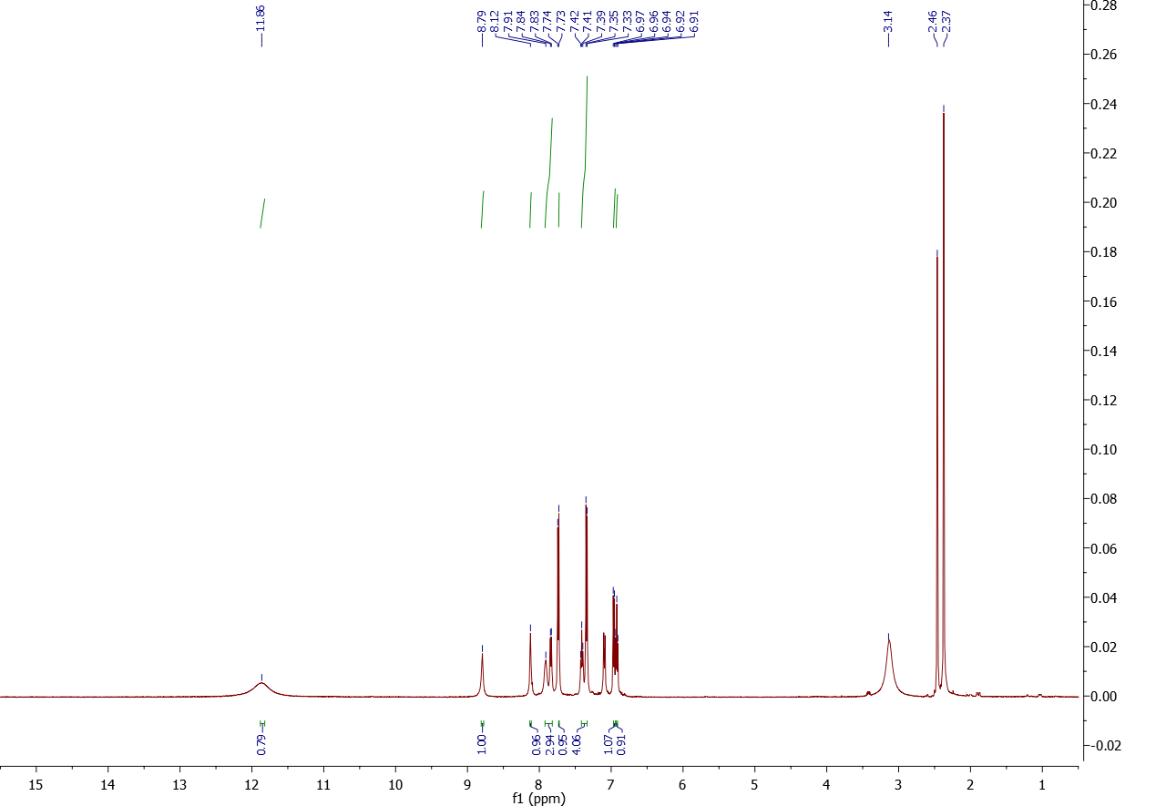
Figure S5 : 1H NMR spectrum of compound 4e

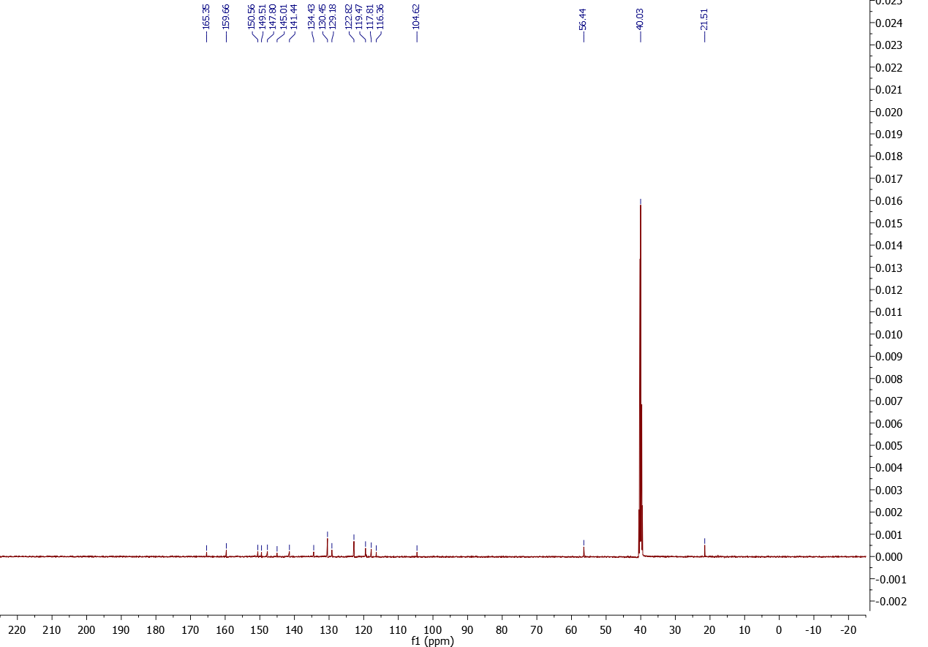
Figure S6 : 1H NMR spectrum of compound 4f

Figure S7 :13C NMR spectrum of compound 4a
Figure S8 :13C NMR spectrum of compound 4b
Figure S9 :13C NMR spectrum of compound 4c

Figure S10 :13C NMR spectrum of compound 4d
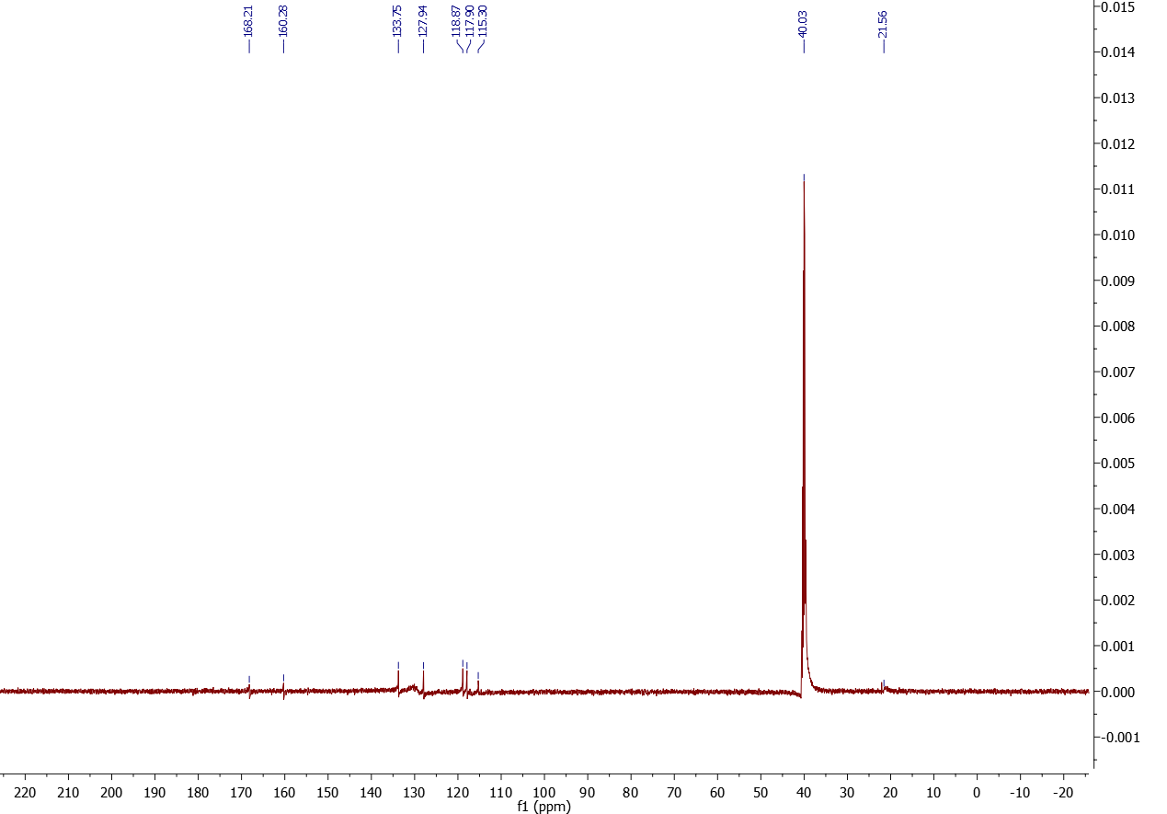
Figure S11 :13C NMR spectrum of compound 4e
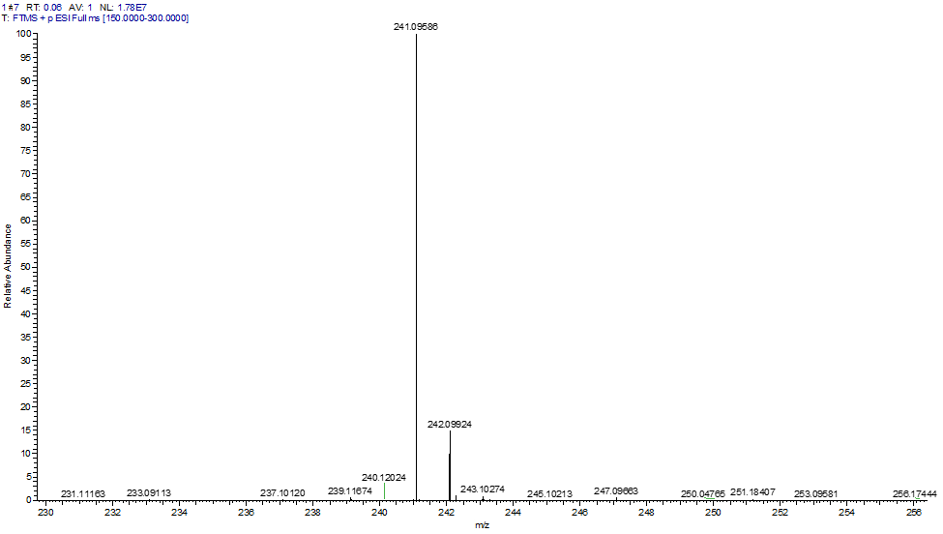
Figure S12 : HRMS spectrum of compound 4a

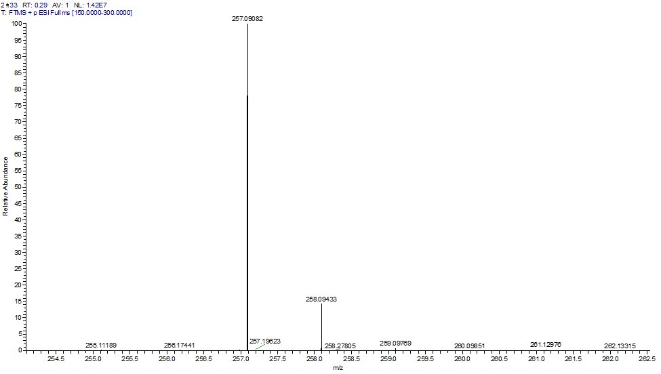
Figure S13. HRMS spectrum of compound 4b

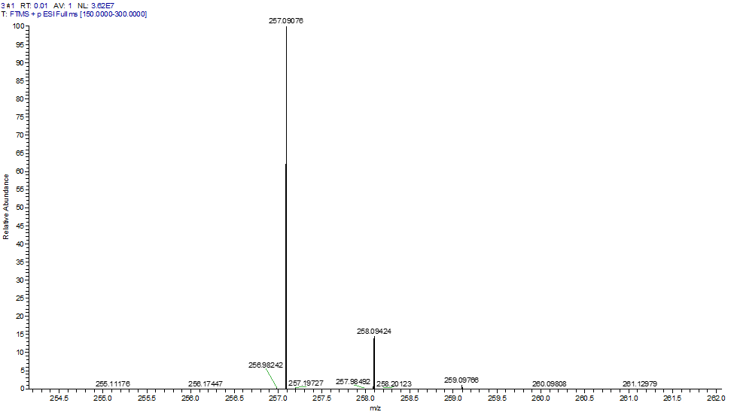
Figure S14 : HRMS spectrum of compound 4c

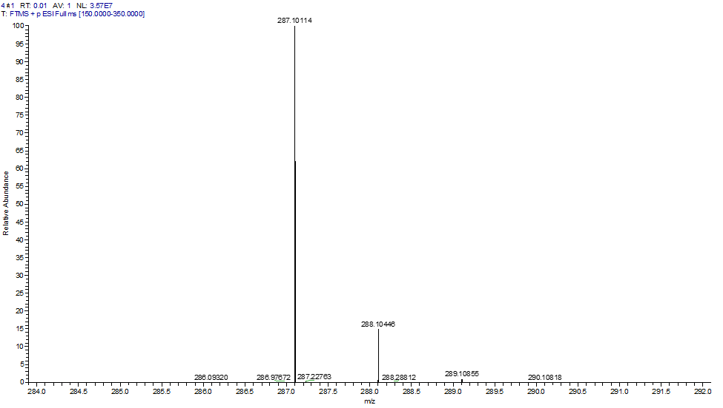
Figure S15. HRMS spectrum of compound 4d

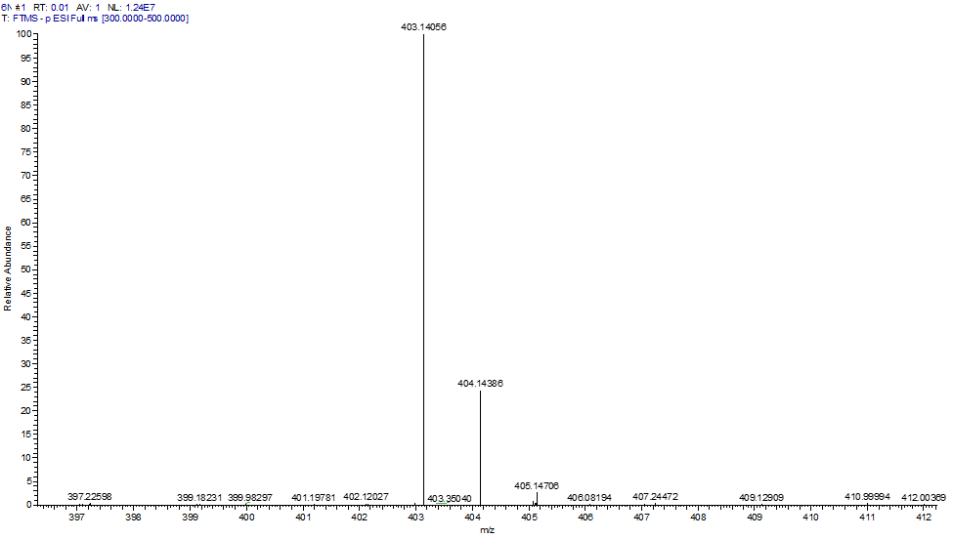
Figure S16. HRMS spectrum of compound 4e

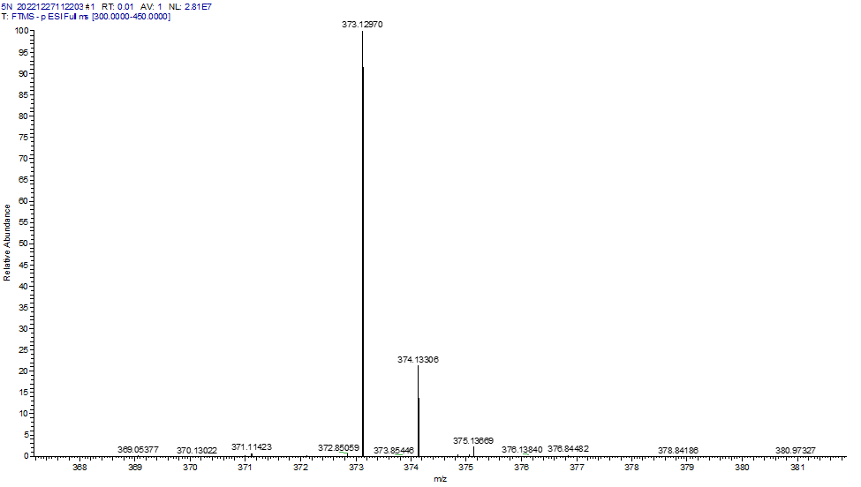
Figure S17. HRMS spectrum of compound 4f

