Supplementary table 1 Regression equations, determination coefficients, ranges of linearity and detection limits of heavy metals among six KT original plants.

|  |  |  |  |  |
| --- | --- | --- | --- | --- |
| Metal element | Regression equations | Determination coefficient (r2) | Ranges of linearity (μg/mL) | Detection limits (μg/mL) |
| 65Cu | y=358.61x+1490.9 | 0.9998 | 0.1~100 | 0.012 |
| 75As | y=145.61x+136.18 | 0.9997 | 0.1~100 | 0.003 |
| 111Cd | y=445x+80.962 | 0.9998 | 0.1~100 | 0.001 |
| 202Hg | y=1313.5x-319.77 | 0.9995 | 0.1~100 | 0.001 |
| 208Pb | y=6624x+1705.6 | 0.9998 | 0.1~100 | 0.001 |

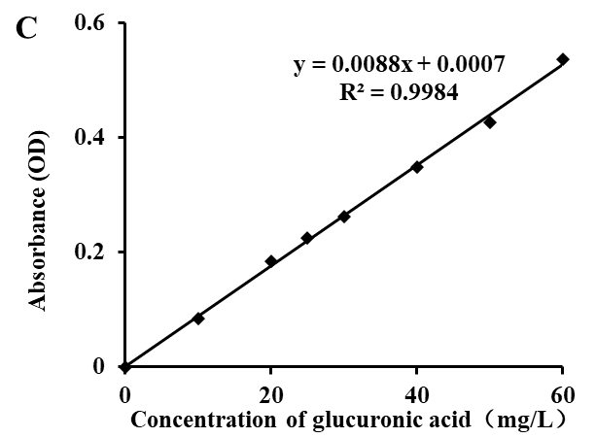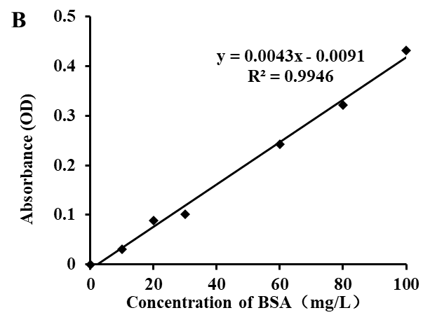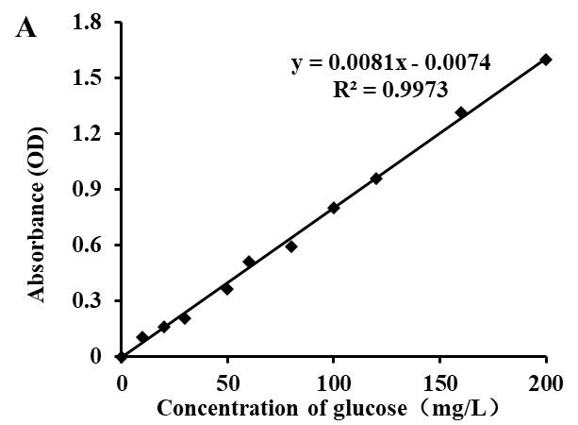

Supplementary Figure 1 The standard curves of carbohydrate, protein and uronic acid using glucose (A), bovine serum albumin (B) and glucuronic acid (C) as standards, respectively.

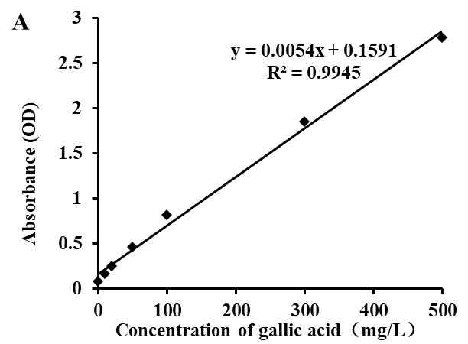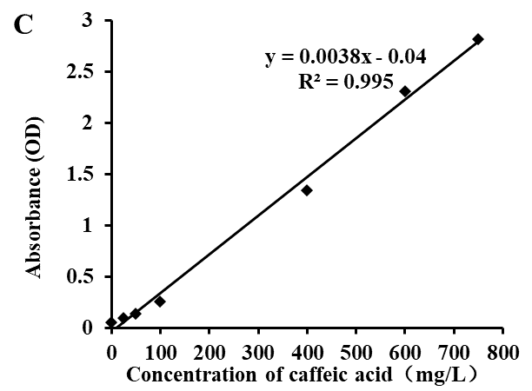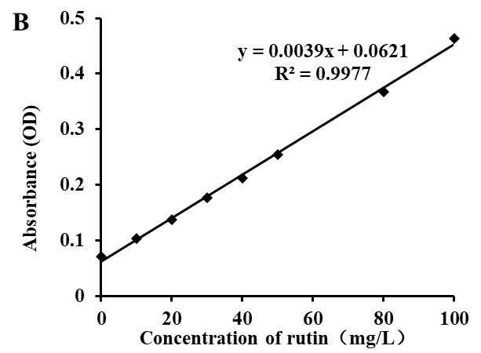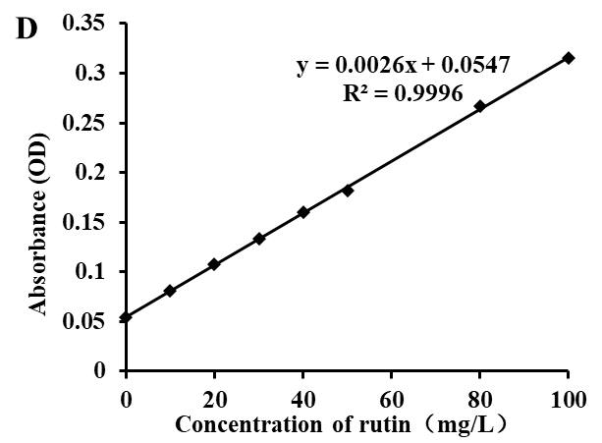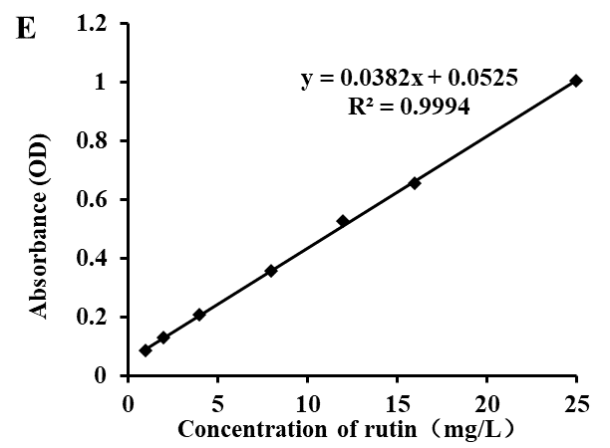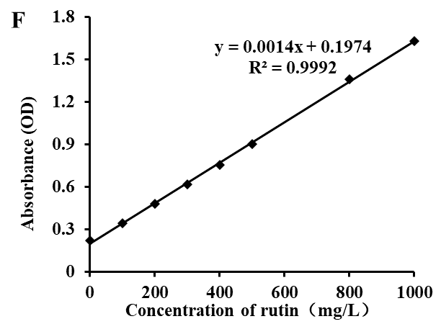

Supplementary Figure 2 The standard curves of total phenolics, flavonoids, phenolic acid, flavonol, flavanol and saponin using gallic acid (A), rutin (B), caffeic acid (C), rutin (D), catechin (E) and ginsenoside (F) as standards, respectively.

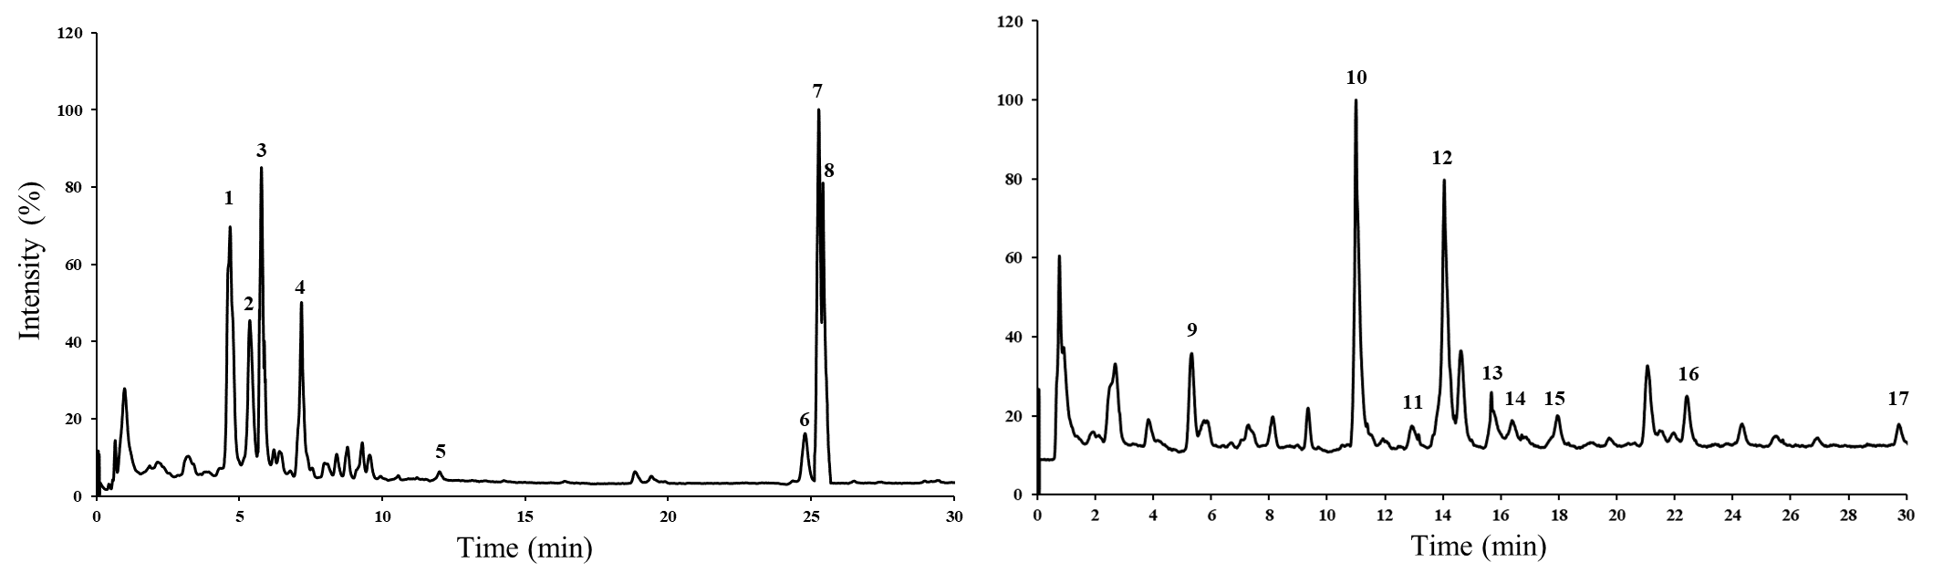

Supplementary Figure 3 The total ion current chromatogram of IP (A) and LJ (B) in negative mode