**Supplementary Materials to:**

**Exploration on the mechanism of “black as lacquer and sweetness as candy” based on the reactions of “crosslinking coloring and Maillard” and “oligosaccharide hydrolysis” during the processing of Radix Rehmanniae**

Jingjing Yanga, [1], Cheng Xuea, c, 1, Lihua Zhanga, Ning Menga, Jing Yanga, Ying Cuia, Yuefei Wanga, b, *, Xin Chaia, b,[2]*

# *a National Key Laboratory of Chinese Medicine Modernization,* *State Key Laboratory of Component-based Chinese Medicine, Tianjin Key Laboratory of TCM Chemistry and Analysis,* *Tianjin University of Traditional Chinese Medicine, Tianjin, 301617, China*

*b Haihe Laboratory of Modern Chinese Medicine, Tianjin, 301617, China*

*c Baoji Food and Drug Inspection and Testing Center, Shannxi, 721000, China*

**Table of Contents**

**Fig. S1.** The dynamic variations on the colors of different processed RR products.

**Fig. S2.** The dynamic variations on the contents of the saccharides in different processed RR products.

**Fig. S3.** The dynamic variations on the contents of the neutral, acidic, and alkaline amino acids in different processed RR products and RW.

**Fig. S4.** UV-vis spectra of CCRPs from reactions between Cat and (A1) Ala, (A2) Arg, or (A3) Glu in the presence of *β*-glucosidase at 0 and 12 h, respectively. Dynamic variations on the contents of Cat and the absorbance of CCRPs from reactions between Cat and (B1) Ala, (B2) Arg, or (B3) Glu in the presence of *β*-glucosidase in 12 h.

**Fig. S5.** UV-vis spectra of CCRPs from reactions between Leo and (A1) Ala, (A2) Arg, or (A3) Glu in the presence of *β*-glucosidase at 0 and 12 h, respectively. Dynamic variations on the contents of Leo, and the absorbance of CCRPs from reactions between Leo and (B1) Ala, (B2) Arg, or (B3) Glu in the presence of *β*-glucosidase in 12 h.

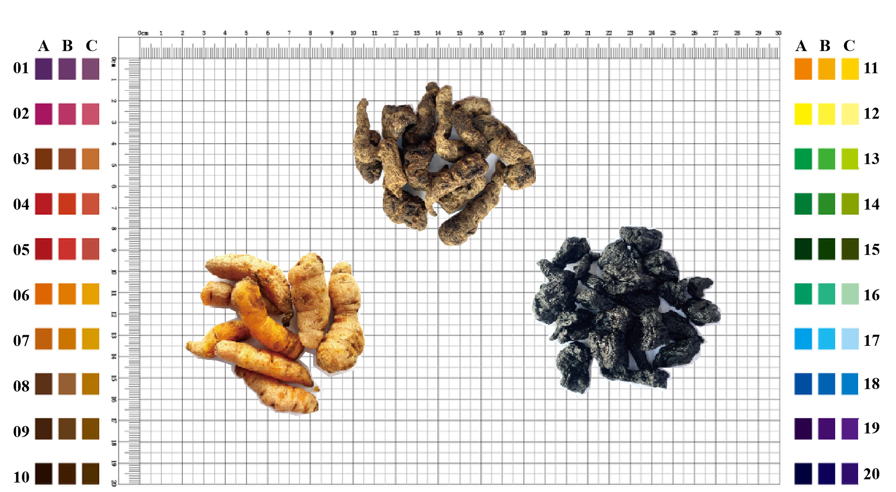

**Fig. S1.** The dynamic variations on the colors of different processed RR products.

Notes: The color of FRR ranges from 06A−07C; The color of RRR ranges from 03A−03C; The color of PRR ranges from 10A−10C.

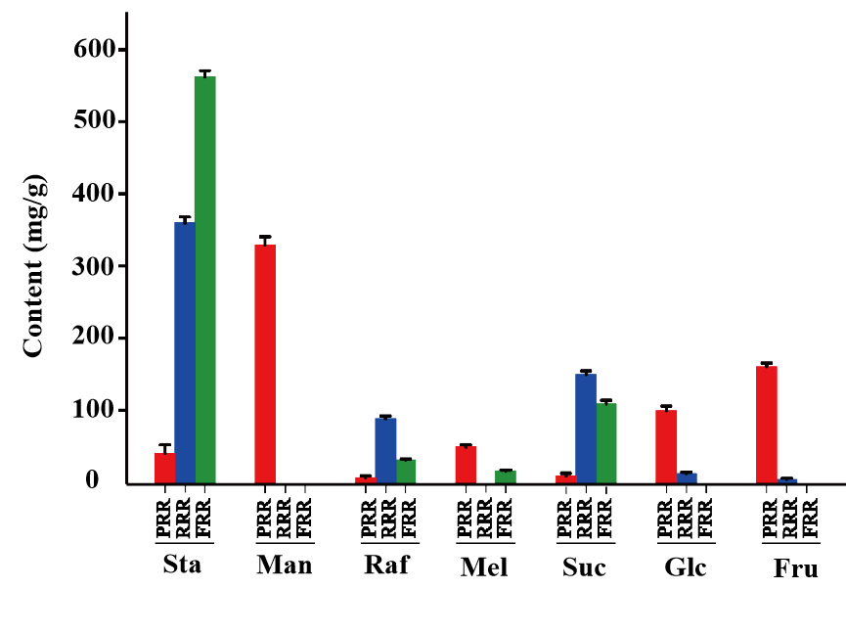

**Fig. S2.** The dynamic variations on the contents of the saccharides in different processed RR products.

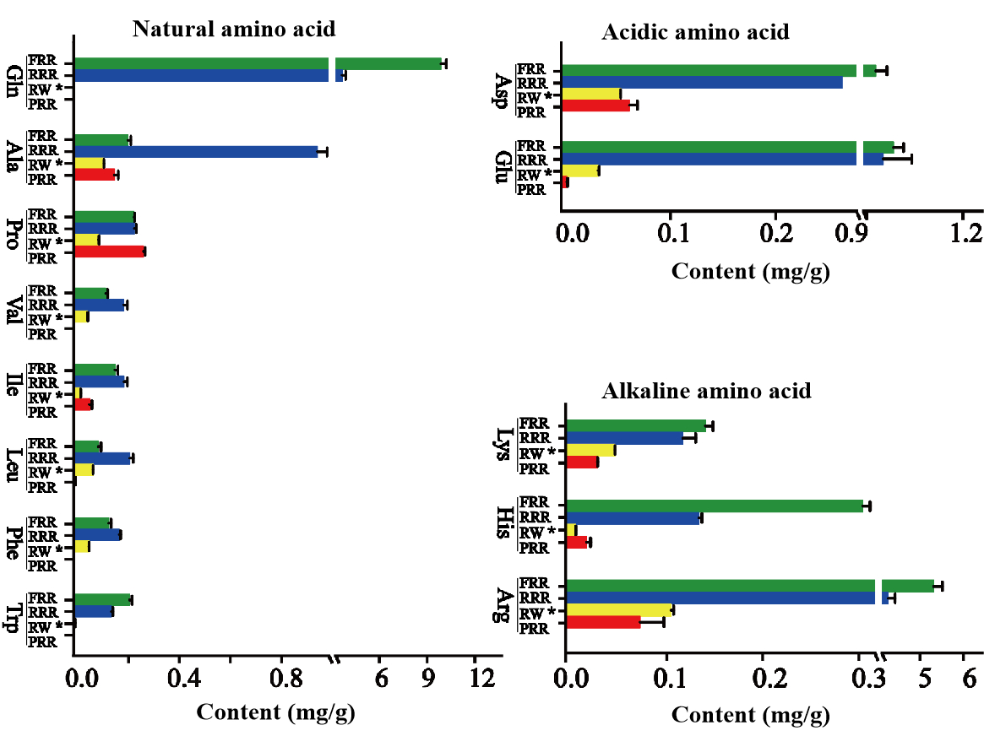

**Fig. S3.** The dynamic variations on the contents of the neutral, acidic, and alkaline amino acids in different processed RR products and RW.

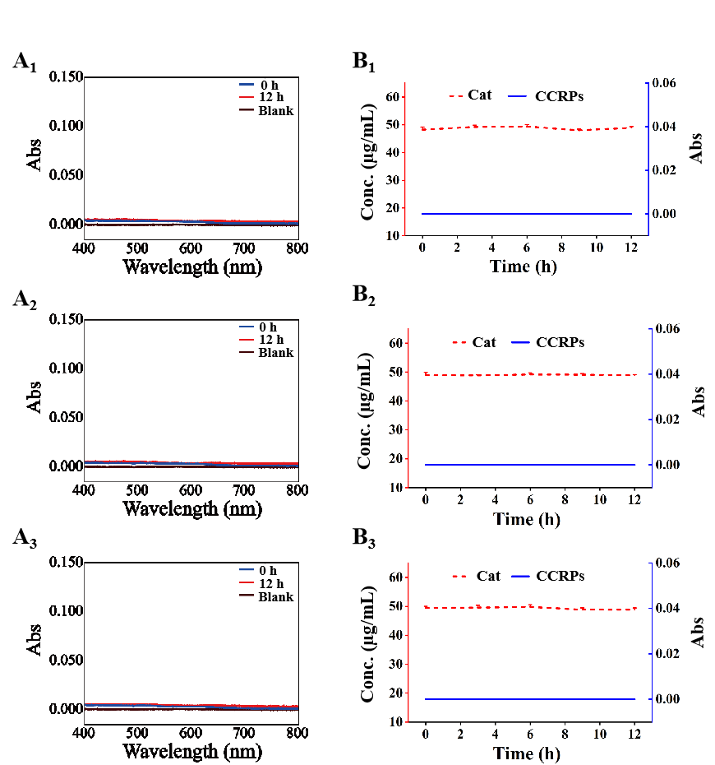

**Fig. S4.** UV-vis spectra of CCRPs from reactions between Cat and (A1) Ala, (A2) Arg, or (A3) Glu in the presence of *β*-glucosidase at 0 and 12 h, respectively. Dynamic variations on the contents of Cat and the absorbance of CCRPs from reactions between Cat and (B1) Ala, (B2) Arg, or (B3) Glu in the presence of *β*-glucosidase in 12 h.

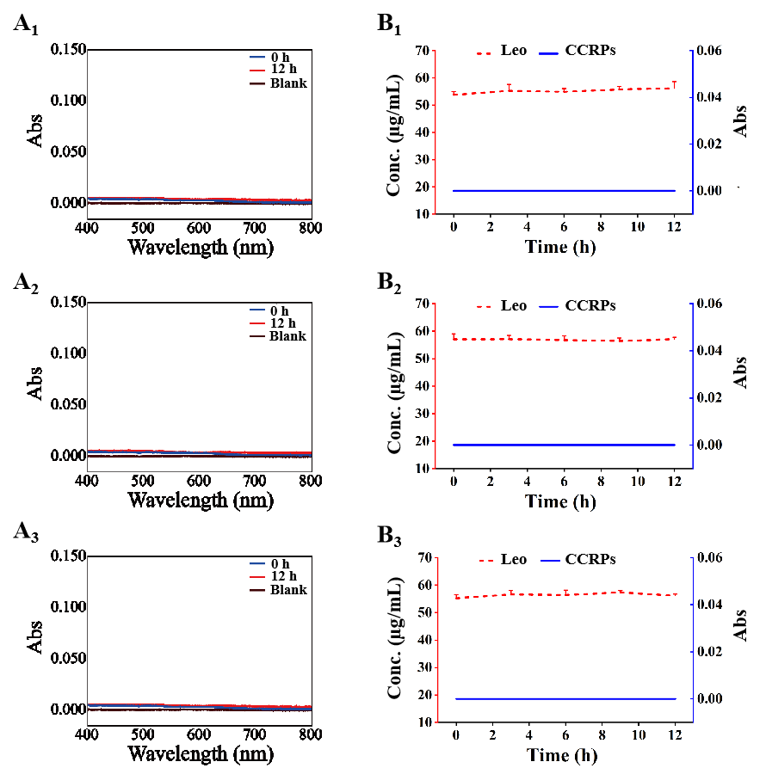

**Fig. S5.** UV-vis spectra of CCRPs from reactions between Leo and (A1) Ala, (A2) Arg, or (A3) Glu in the presence of *β*-glucosidase at 0 and 12 h, respectively. Dynamic variations on the contents of Leo, and the absorbance of CCRPs from reactions between Leo and (B1) Ala, (B2) Arg, or (B3) Glu in the presence of *β*-glucosidase in 12 h.

1. * Corresponding authors

   E-mail addresses: wangyf0622@tjutcm.edu.cn (Y. Wang),chaix0622@tjutcm.edu.cn (X. Chai).

   1 The two authors contributed equally to this article and share co-first authorship.
2.