Development of *in vitro* and *in vivo* c-Met Targeted Dual-modal Nanoprobes for NIR II Fluorescent Bioimaging and Magnetic Resonance Imaging of Breast Carcinoma Metastasis

1. **Experimental Section**
   1. **Materials and Characterization.**

*1.1.1 Materials.*

Ferric chloride (FeCl3•6H2O), cetyltrimethyl ammonium bromide (CTAB), ammonia, ethanol, tetraethyl orthosilicate (TEOS) were purchased from Aladdin (Shanghai, China). DAPI, FITC and CCK-8 kit assay were obtained from Sigma–Aldrich Chemicals (Madison, USA). Nhydroxysuccinimide (NHS) and 1-ethyl-3-(3-dimethylaminopropyl) carbodiimidehydrochloride (EDC•HCl) were purchased from Aladdin (Shanghai, China). Sodium acetate and HCl were of analytical grade and were purchased from Sinopharm Chemical Reagent Co. Ltd. (Shanghai, China).Gd-DTPA was purchased from German Bayer Shering Pharma AG (Berlin, Germany). ICG, PEG2000-NH2, were purchased from Beyotime Biotechnology. cMBP with the sequence of KSLSRHDHIHHHK(C) was fabricated by China Peptide Co. Ltd. (Shanghai, China). Recombinant human HGF were obtained from Novoprotein (Shanghai, China) All chemicals were used without further purification. Distilled and deionized water were used throughout the experiments.

* + 1. *Characterization.*

Transmission electron microscopy (TEM) images were acquired on FEI Tecnai G2 F30. TEM samples were obtained by dropping dilute nanomaterials onto carbon-coated copper grids. X-ray diffraction (XRD) was measured by a Rigaku Ultima IV X-ray diffractometer instrument. Fourier transform infrared (FTIR) spectra were recorded on a TENSOR II FTIR spectrophotometer (Bruker Corporation). Ultraviolet visible (UV/vis) spectra were performed on an UV-3600 Plus spectrophotometer. Dynamic laser scattering (DLS) and zeta potential were measured on PSS Nicomp Z3000 SOP. A N2 absorption-desorption instrument was used to measure the surface area pore size of Fe3O4@mSiO2 (Quantachrome Corporation, Quantachrome Autosorb Automated Gas Sorption System, USA). Fe3O4@mSiO2-ICG/cMBP and the clinical contrast gadopentetic acid (Gd-DOTA) at different Gd concentrations were imaged by a 3.0 T MRI [Magnetom Verio total imaging matrix (TIM). *In vivo* NIR fluorescent images were obtained under a NIR-OPTICS Series III 900/1700 system (808 nm excitation, beyond 1000 nm emission).

The home-made NIR-II fluorescence stereo system with cuboid appearance features epiillumination geometry and fiber-based configurations with a fluorescence signal excited by a 808 nm continuous-wave fiber laser. Then, light emitted from fiber (MHP550L02, Thorlabs, Newton, NJ, USA) was transmitted *via* a ground glass diffuser (Thorlabs, DG10-600-MD) providing uniform illumination in the irradiation area (0.1–1 W/cm2). For whole-body imaging of the mouse, long-pass (LP) filters (FELH1000, FELH1300, and FELH1500, Thorlabs) were employed, while *in vivo* images were acquired using a cooled InGaAs camera (NIRvana 640, Princeton Instruments; 640 × 512 pixels, response 900–1700 nm) with a short-wave infrared C-mount zoom lens (LM35HC-SW, Kowa, Tokyo, Japan). The working temperature of the InGaAs camera was −80 °C, the gain was set in high mode, and the analog-to-digital conversion rate was set at 2 or 10 MHz.

**1.2 *In vitro* TNBC and SCC tumor cell toxicity assay and cell targeting of Fe3O4@mSiO2-ICG/cMBP**

*1.2.1 Cell viability.*

All experiments were carried out in 96-well plates. Cytotoxicity of mSiO2-cMBP, e3O4-cMBP and Fe3O4@mSiO2-ICG/cMBP were tested by CCK-8 kit assay. Briefly, the primary MDA-MB 321 cells isolated through enzymatic digestion were seeded into a plate at 7×103/well in 100 μL of DMEM (10% FBS, 100 U/mL of penicillin and 100 μg/mL of streptomycin), and co-cultured in the 37℃ incubator for 24 h. Then, mSiO2-cMBP, e3O4-cMBP and Fe3O4@mSiO2-ICG/cMBP with various concentrations were added followed by 12 h incubation. Lately, 10 μL CCK-8 in 1mL fresh culture medium was added to the cells, and after 2 h incubation, the absorbance of each well at the wavelength of 450 nm was measured using a microplate reader. Data were presented as mean ± SD (n = 3). In parallel, cytotoxicity of various nanocomposites against SCC7 cells was also performed by the same procedure.

*1.2.2 CLSM images of cellular uptake*

The cellular uptake of Fe3O4@mSiO2, Fe3O4@mSiO2-cMBP and Fe3O4@mSiO2-cMBP+cMBP was investigated and imaged by confocal laser scanning microscopy (CLSM). Briefly, MDA-MB 231/SCC7 tumor cells were firstly seeded into 6-well plates at a concentration of 1×105 per well with 1 mL DMEM fresh medium (10% FBS, 100 units/mL of penicillin, 100 μg/mL of streptomycin) with high glucose for 24 h incubation. After the treatment with Fe3O4@mSiO2, Fe3O4@mSiO2-cMBP and Fe3O4@mSiO2-cMBP+cMBP (pre-treated tumor cells with cMBP) labeled with the same concentration of FITC (5 μg/mL), the MDA-MB 231/SCC7 cancer cells were incubated for another 6 hr. Then, all cell samples were washed by PBS 1X (3 times) and 1 μg /mL DAPI was applied for staining cellular nuclei for 0.5 h before CLSM observation.

**1.3 In biocompatibility evaluation of Fe3O4@mSiO2-ICG/cMBP**

*1.3.1 Bio-chemistry assays*

Normal Balb/c nude mice (Female, 6 weeks old) were divided into three groups (N = 6). After tail-vein injection of Fe3O4@mSiO2-ICG/cMBP (15 mg/kg), blood samples were collected at 7 days and 30 days. Blood samples from mice with PBS injection at 7 days were applied as control group. The serum biochemistry assays (ALT, AST, ALP, TBIL, BUN, CRE, and CK) were carried on.

*1.3.2 H&E-stained studies*

Normal Balb/c nude mice (Female, 6 weeks old) were divided into three groups (N = 6). After tail-vein injection of Fe3O4@mSiO2-ICG/cMBP (15 mg/kg), major organs (heart, liver, spleen, lung, kidney) tissues were collected at 7 days and 30 days. Normal organ tissues from mice with PBS injection at 7 days were applied as control group. Then all samples were fixed and the tissue sections were subjected to H&E.

1. **Supplementary Figures**

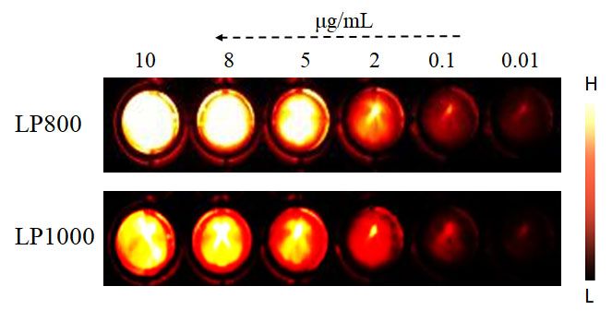

**Fig. S1.** NIR II fluorescence images of ICG with 800 nm (LP800) or 1000 nm long-pass filter (LP1000) at various concentrations.

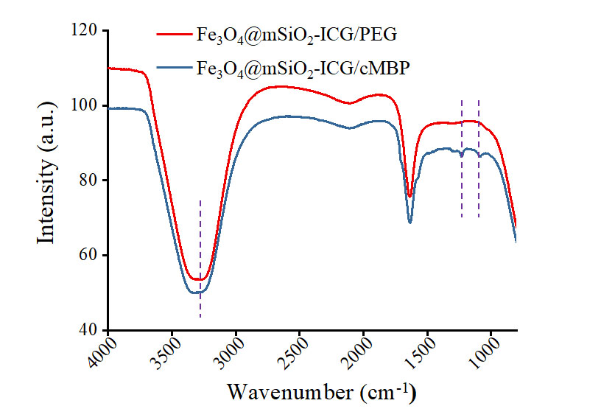

**Fig. S2.** FTIR data of Fe3O4@mSiO2-ICG/PEG and Fe3O4@mSiO2-ICG/cMBP.

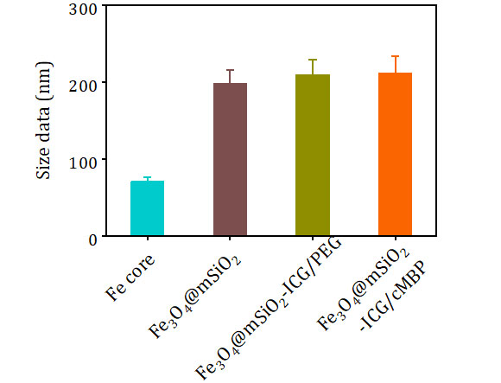

**Fig. S3.** Particle sizes of Fe core, Fe3O4@mSiO2, Fe3O4@mSiO2-ICG/PEG and Fe3O4@mSiO2-ICG/cMBP.

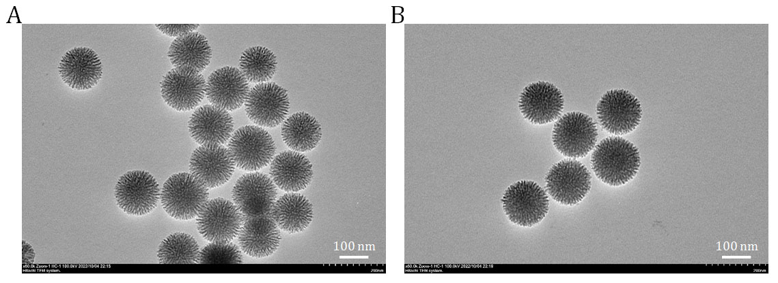

**Fig. S4.** TEM images of mSiO2 (A) and mSiO2-ICG/cMBP (B).

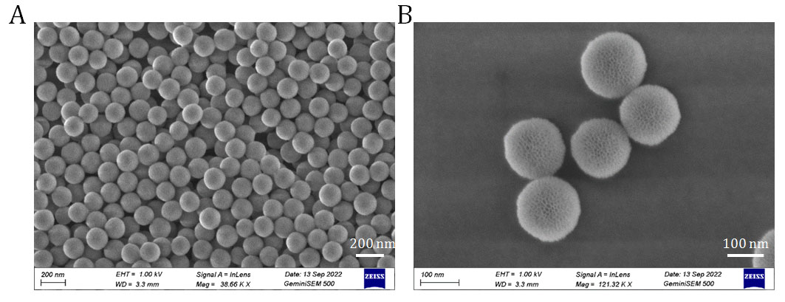

**Fig. S5.** SEM images of mSiO2 (A) and mSiO2-ICG/cMBP (B).

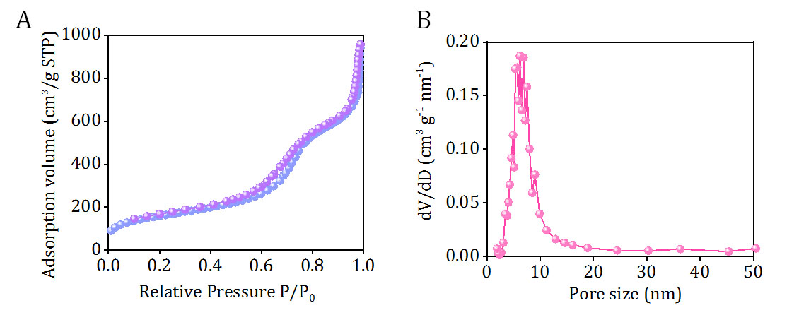

**Fig. S6.** The N2 absorption/desorption plot of mSiO2 (A). Pore size distribution of mSiO2 (B).

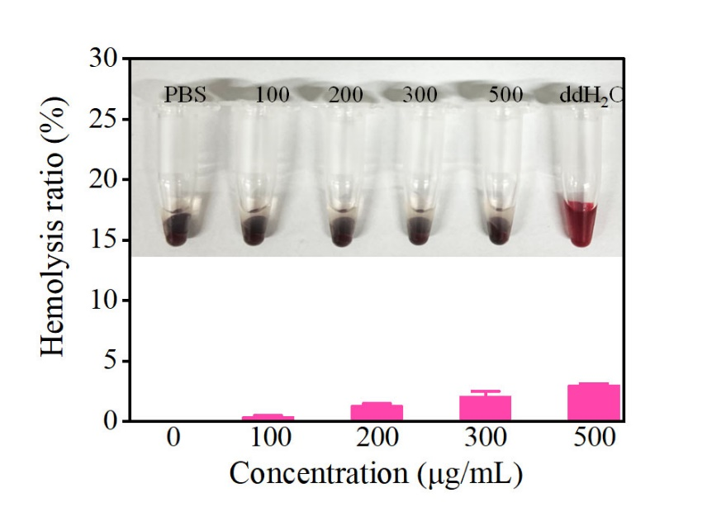

**Fig. S7.** Hemolytic effect evolution of Fe3O4@mSiO2-ICG/cMBP at various concentrations.

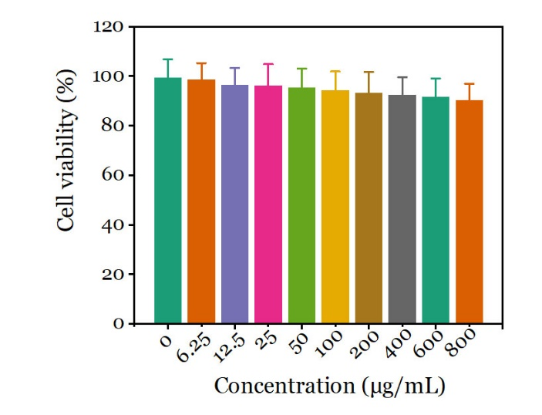

**Fig. S8.** Cell viability of Raw264.7 cell after treated with Fe3O4@mSiO2-ICG/cMBP at different concentrations.

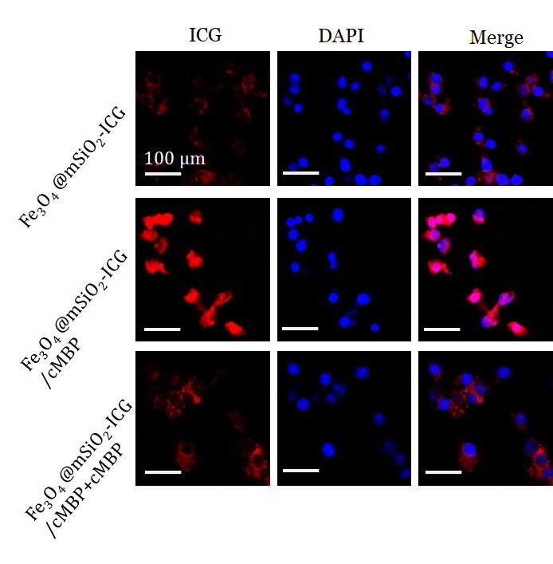

**Fig. S9.** CLSM images of MDA-MB 231 after incubated with Fe3O4@mSiO2-ICG, Fe3O4@mSiO2-ICG/cMBP and Fe3O4@mSiO2-ICG/cMBP + cMBP.

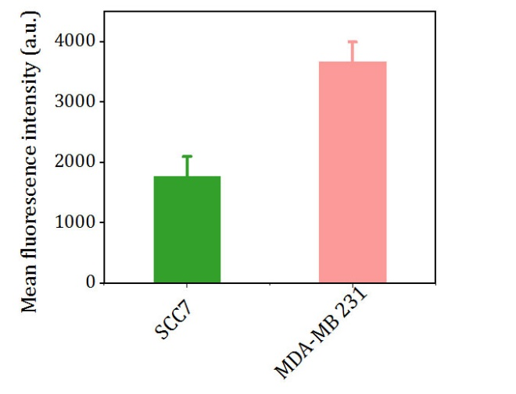

**Fig. S10.** Mean fluorescence intensity of Fe3O4@mSiO2-/cMBP (labelled FITC) treated with SCC7 and MDA-MB 231 tumor cells.

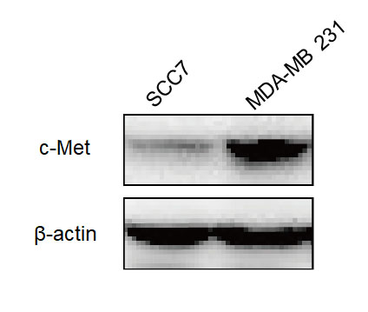

**Fig. S11.** C-MET expression in 4T1 and SCC7 cell lines *via* wester-blot.

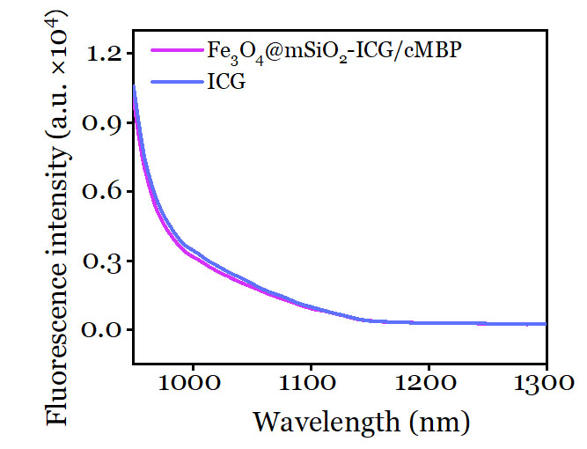

**Fig. S12.** NIR II emission spectra of ICG and Fe3O4@mSiO2-ICG/cMBP under 808 nm laser irradiation.

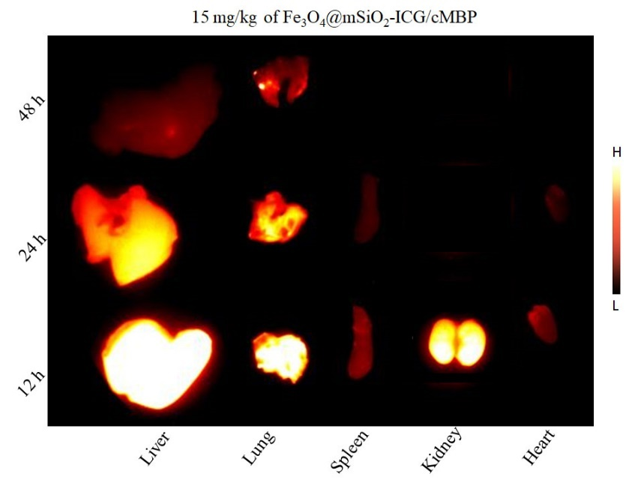

**Fig. S13.** *Ex vivo* NIR II fluorescence images of vital organs after injection of 15 mg/kg Fe3O4@mSiO2-ICG/cMBP for 12 h, 24 h and 48 h.

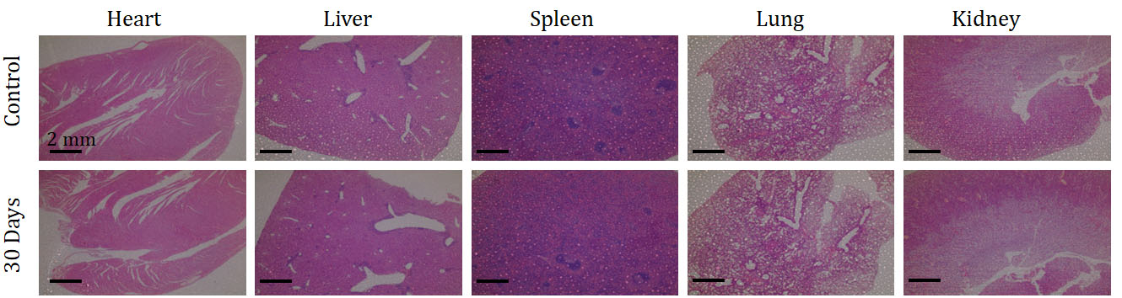

**Fig. S14.** Full-size H&E-stained-images of the main organ’s tissues (including heart, liver, spleen, lungs, kidney) resected from mice after 30 days treatment of Fe3O4@mSiO2-ICG/cMBP. PBS treated mice were set as control.