**Supplementary materials**

**For**

**Deciphering the Healing Power of *Swertia Chirayita*: A Potential Treatment for Acute Liver Injury**

Sa Guo1, Cen Wu1, Xinwei Liu2, Xianli Meng3, Yi Zhang2, *, Shaohui Wang 2,4, *

1. *State Key Laboratory of Southwestern Chinese Medicine Resources, School of Pharmacy, Chengdu University of Traditional Chinese Medicine, Chengdu 611137, China*
2. *State Key Laboratory of Southwestern Chinese Medicine Resources, School of Ethnic Medicine, Chengdu University of Traditional Chinese Medicine, Chengdu 611137, China*
3. *State Key Laboratory of Southwestern Chinese Medicine Resources, Innovative Institute of Chinese Medicine and Pharmacy, Chengdu University of Traditional Chinese Medicine, Chengdu 611137, China*
4. *Meishan Traditional Chinese Medicine Hospital, Meishan, 620010, China*

**Corresponding authors:** Chengdu University of Traditional Chinese Medicine 1166 Liutai Avenue, Wenjiang District, Chengdu 611137, China. Shaohui Wang (winter9091@163.com); Yi Zhang (zhangyi@cdutcm.edu.cn).

Tel: +86-028-61932600; Fax: +86-028-619326

**Figure Legend for Supplementary Data**

**Supplementary Figure 1** The structure of chemical components in 80% ethanolic extract of *Swertia chirayita*.

**Supplementary Figure 2** The secondary fragmentation information of standard substances. (A) Loganic acid, (B) Chlorogenic acid, (C) Swertiamarin, (D) Sweroside, (E) Isoorientin, (F) Ursolic Acid. And the standard substances as well as the extract compounds are shown in this figure.

**Supplementary Figure 3** Network analysis ofswertiamarine and acute liver injury.

(A) Venn diagram and candidate targets of swertiamarine and acute liver injury, (B) Protein-protein interaction (PPI) network.

**Supplementary Figure 1** The structure of chemical components in 80% ethanolic extract of *Swertia chirayita*.









**Supplementary Figure 2** The secondary fragmentation information of standard substances. (A) Loganic acid. And the standard substance as well as the extract compounds are shown in this figure.

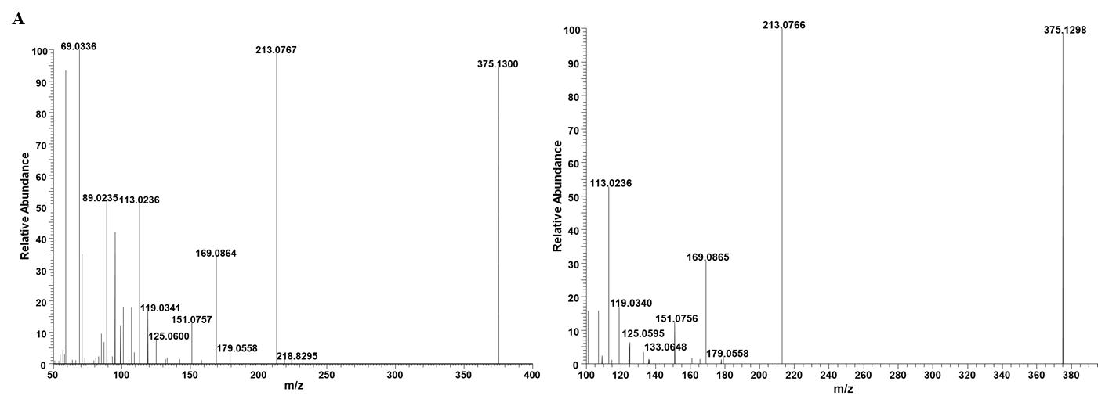

**Supplementary Figure 2** The secondary fragmentation information of standard substances. (B) Chlorogenic acid. And the standard substance as well as the extract compounds are shown in this figure.

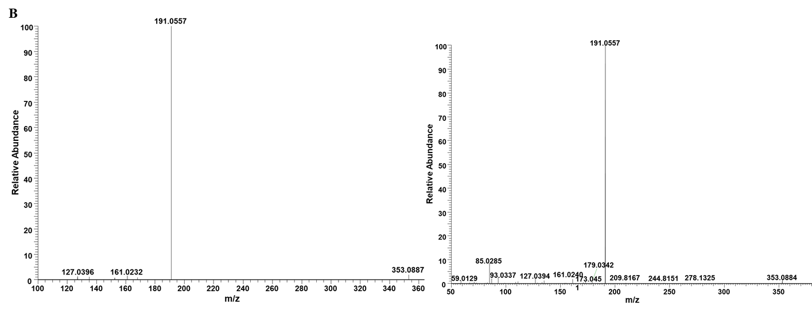

**Supplementary Figure 2** The secondary fragmentation information of standard substances. (C) Swertiamarin. And the standard substance as well as the extract compounds are shown in this figure.

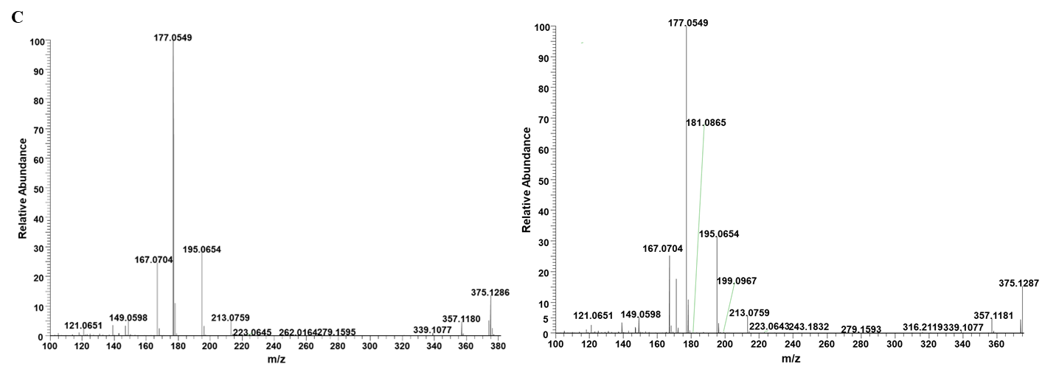

**Supplementary Figure 2** The secondary fragmentation information of standard substances. (D) Sweroside. And the standard substance as well as the extract compounds are shown in this figure.

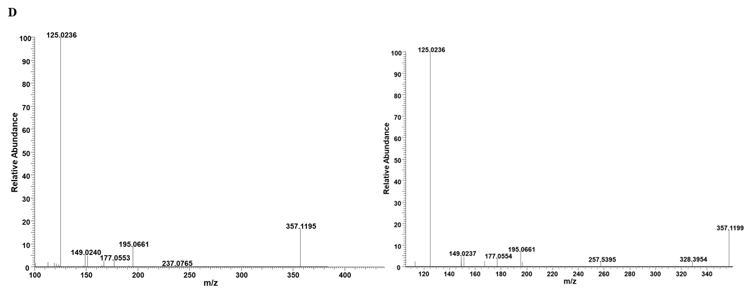

**Supplementary Figure 2** The secondary fragmentation information of standard substances. (E) Isoorientin. And the standard substance as well as the extract compounds are shown in this figure.

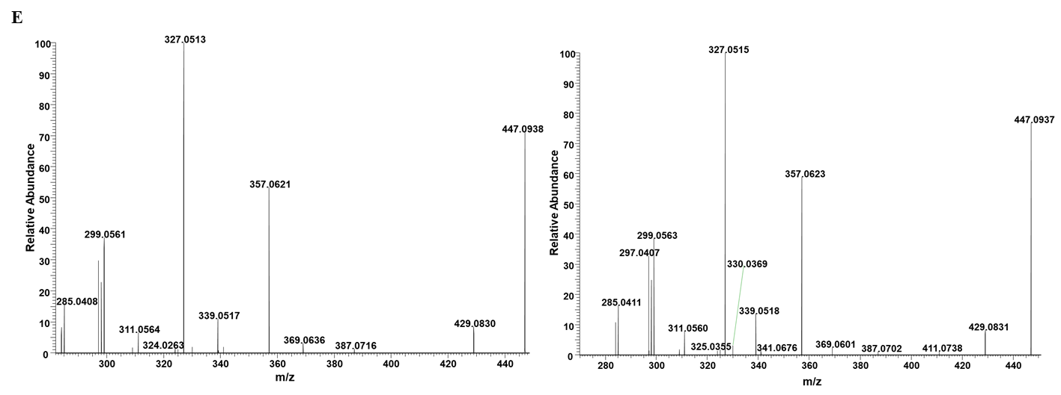

**Supplementary Figure 2** The secondary fragmentation information of standard substances. (F) Ursolic Acid. And the standard substance as well as the extract compounds are shown in this figure.

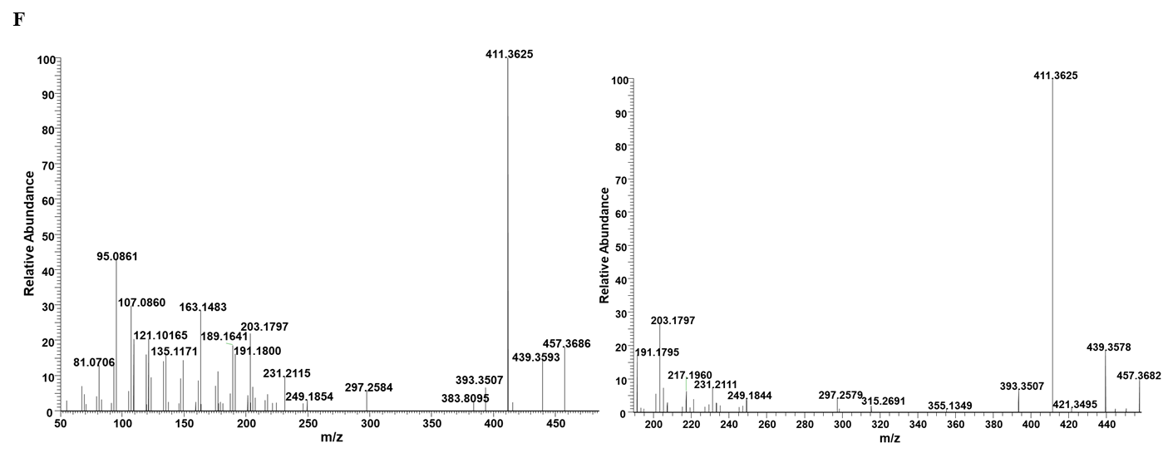

**Supplementary Figure 3** Network analysis ofswertiamarine and acute liver injury.

(A) Venn diagram and candidate targets of swertiamarine and acute liver injury, (B) Protein-protein interaction (PPI) network.

