Novel Hydroxy-Tagged Bis-Dihydrazothiazole Derivatives: Synthesis, Antimicrobial Capacity and Formation of Some Metal Chelates with Iron, Cobalt and Zinc

Refaie M. Kassab^{1*}, Sami A. Al-Hussain³, Magdi E.A. Zaki³, Gehad G. Mohamed^{1,2}, Zeinab A. Muhammad^{4*}

¹ Chemistry Department, Faculty of Science, Cairo University, Giza 12613, Egypt.
³ Nanoscience Department, Basic and Applied Sciences Institute, Egypt-Japan University of Science and Technology, New Borg El Arab, 21934, Alexandria, Egypt.
² Department of Chemistry, Faculty of Science, Imam Mohammad Ibn Saud Islamic University (IMSIU), Riyadh 11623, Saudi Arabia.
⁴ Department of Pharmaceutical Chemistry, National Organization for Drug Control and Research (NODCAR), Giza 12311, Egypt.

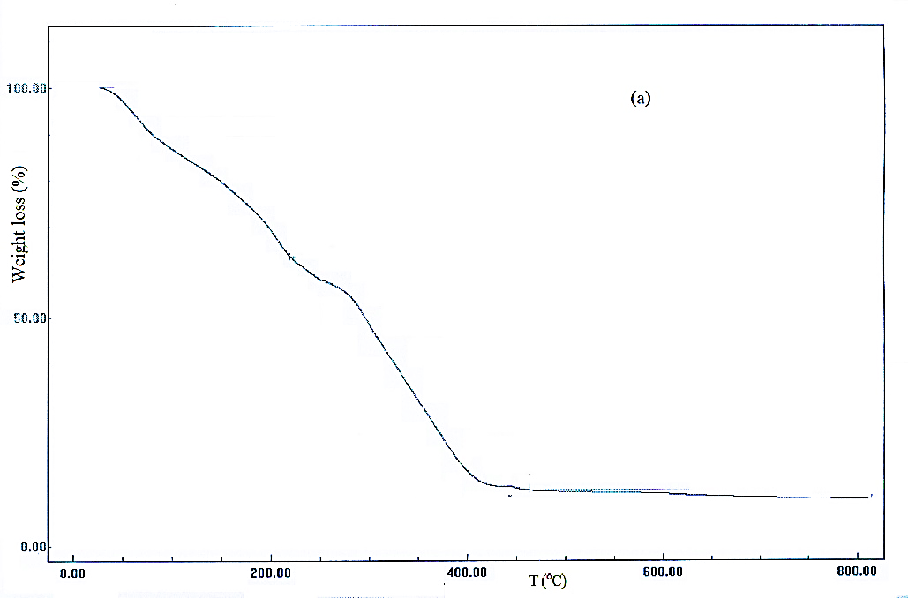
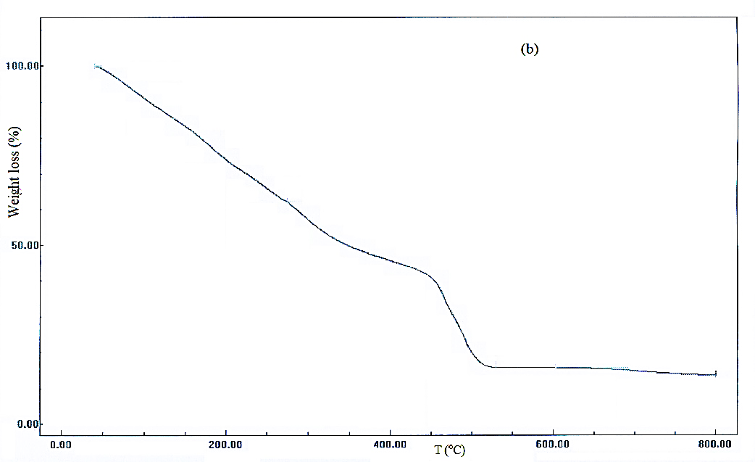
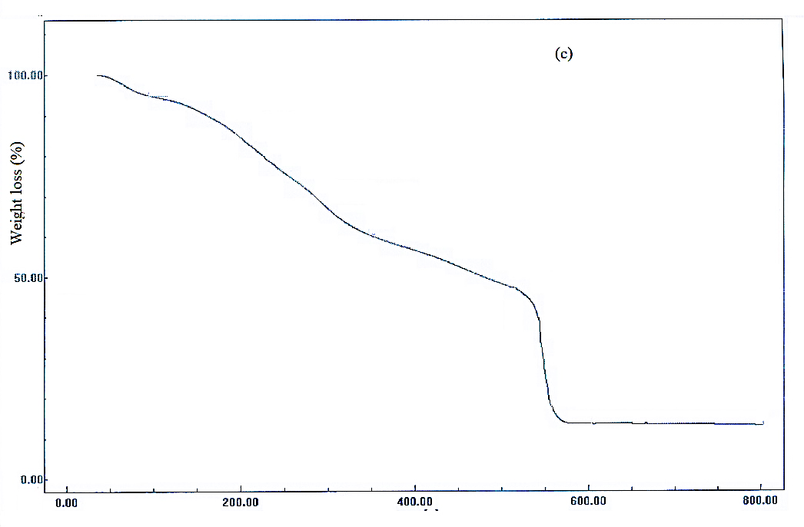

Supplementary Figure 1. Thermogravimetirc curves of (a) Fe(III)-, (b) Co(II)- and (c) Zn(II)-complexes.

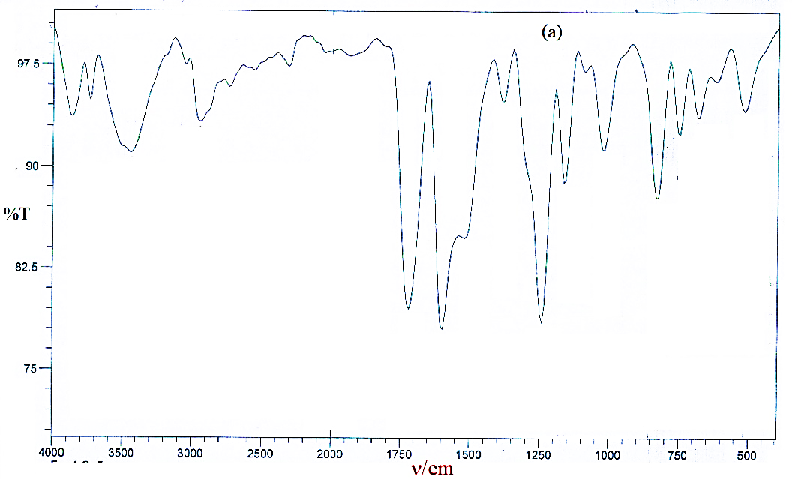
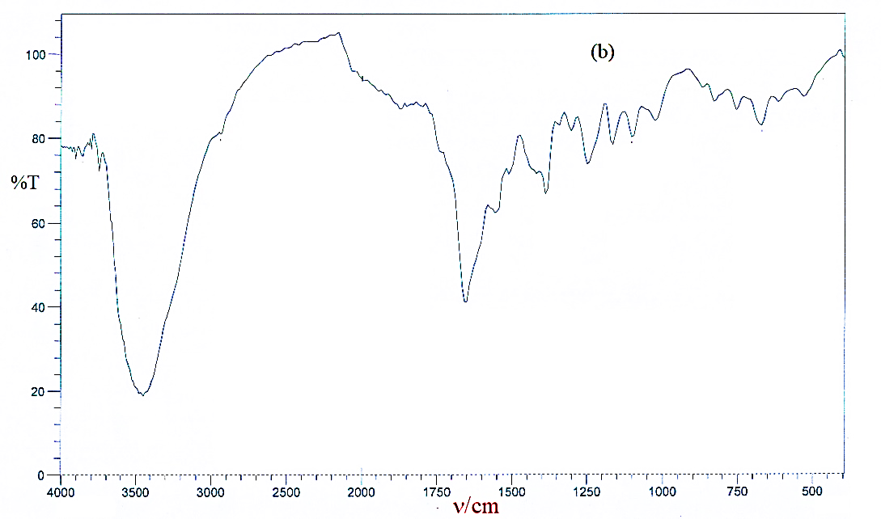
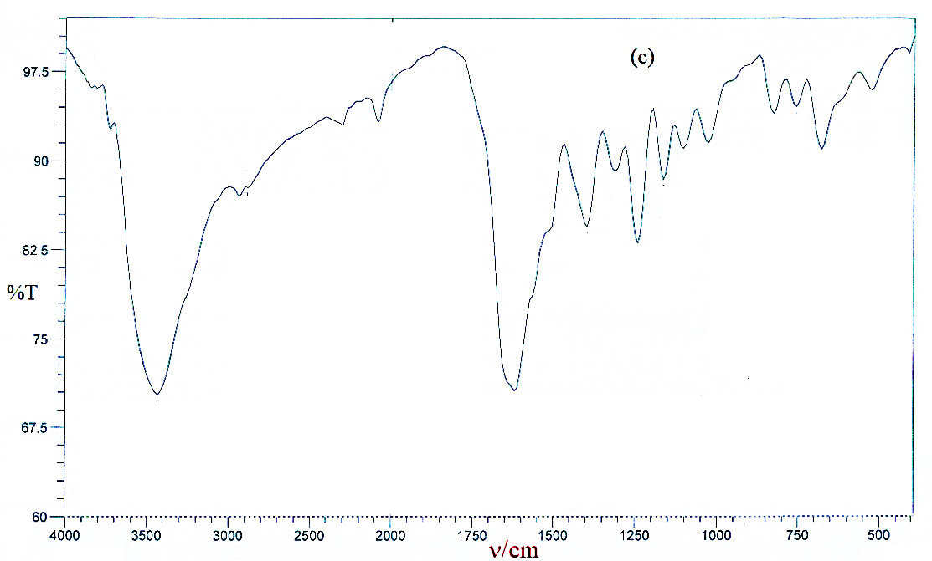
Supplementary Figure 2. IR spectra of (a) Fe(III)-, (b) Co(II)- and (c) Zn(II)-complexes.

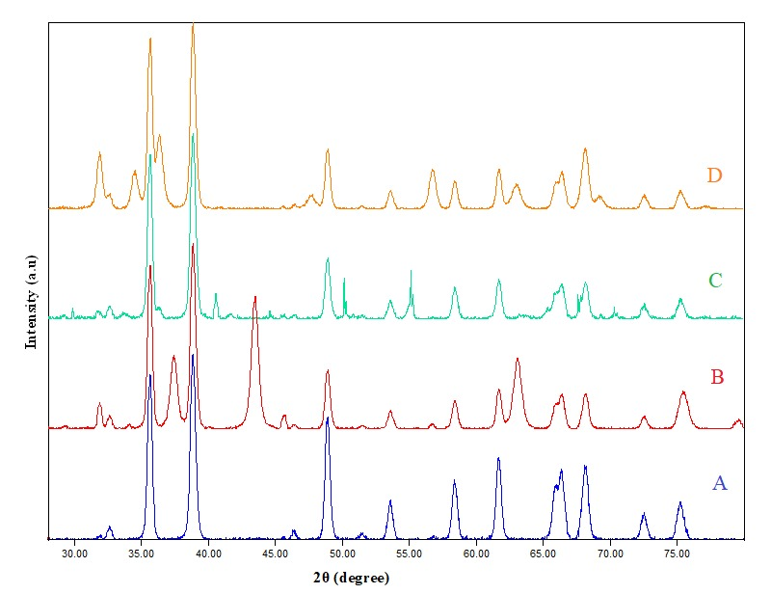

Supplementary Figure 3. XRD images of (a) ligand, (b) Fe(III)-, (c) Co(II)- and (d) Zn(II)-complexes.

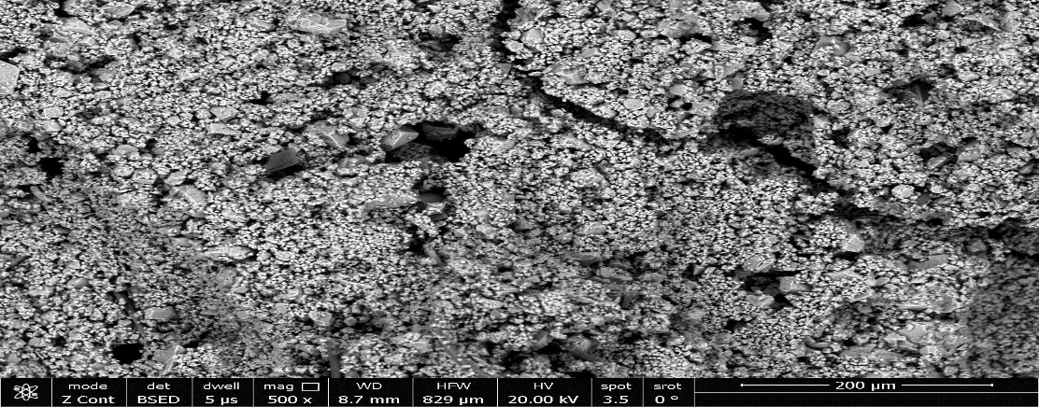
(a)

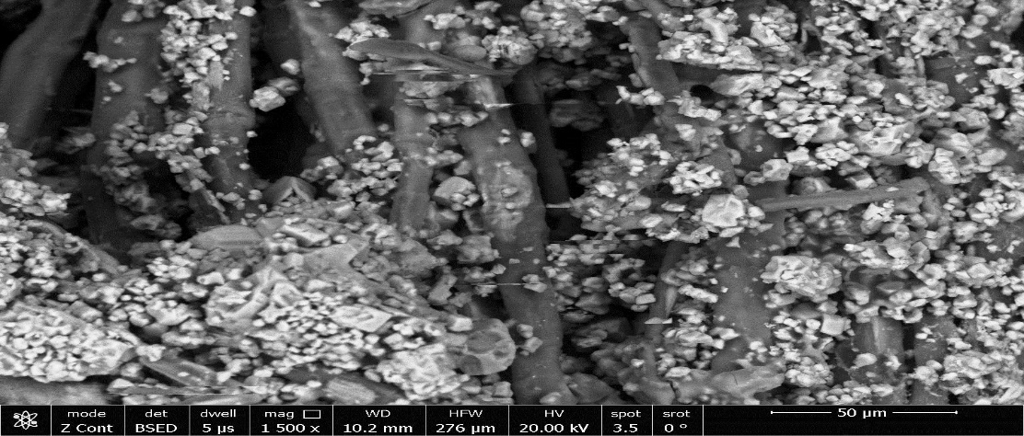

(b)

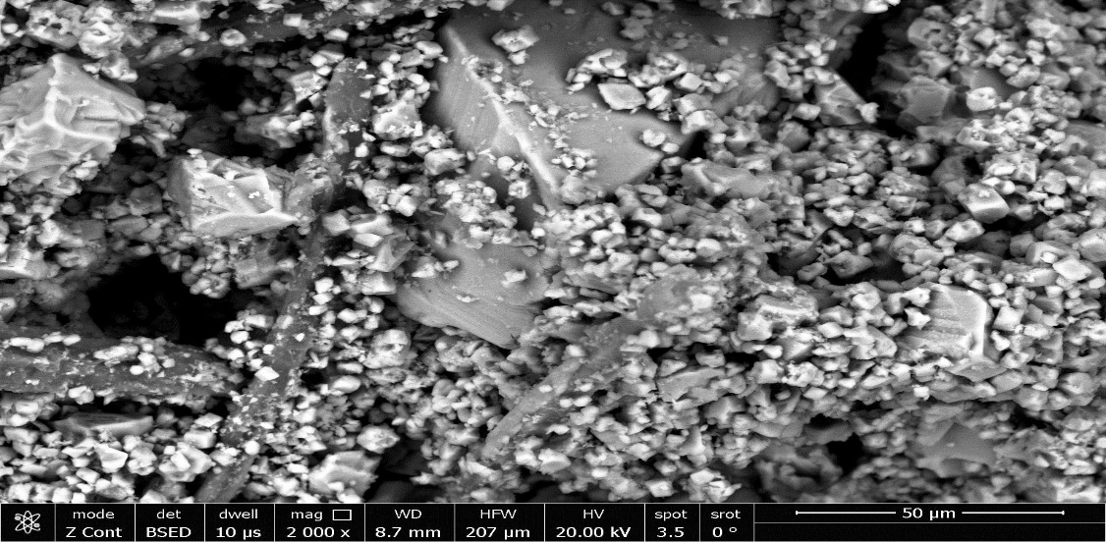

(c)

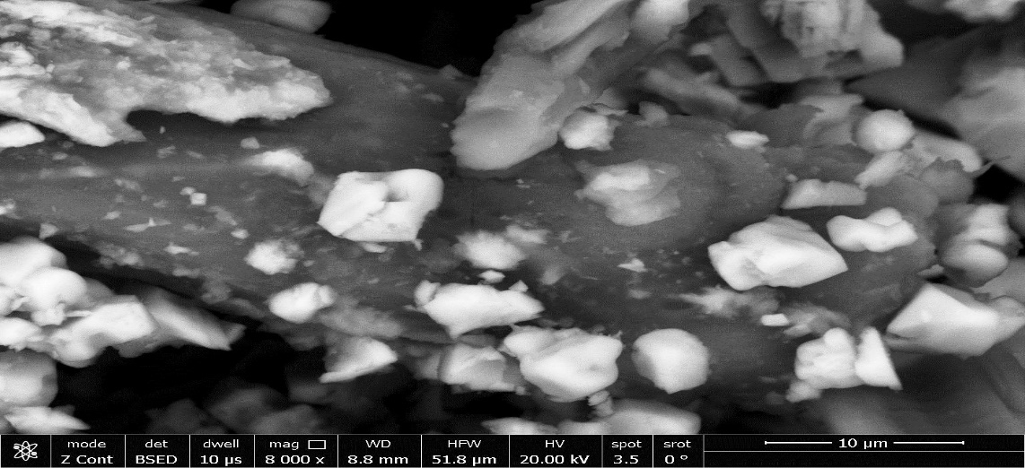

(d)

Supplementary Figure 4. SEM images of (a) ligand, (b) Fe(III)-, (c) Co(II)- and (d) Zn(II)-complexes.

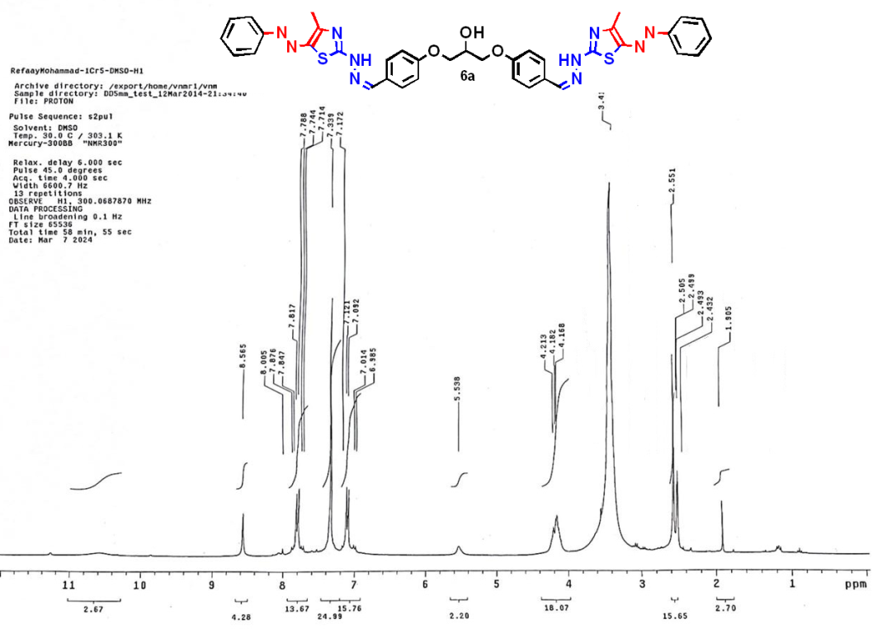
¹H NMR spectrum compound 6a
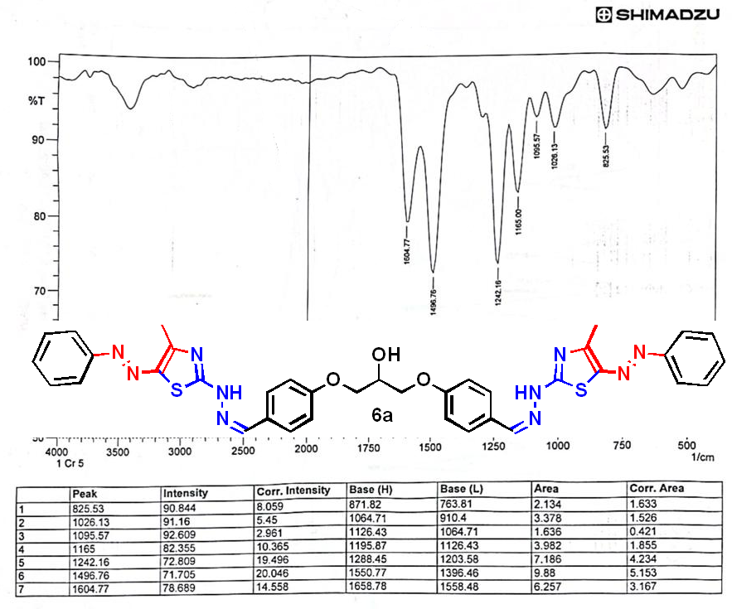
IR spectrum compound 6a
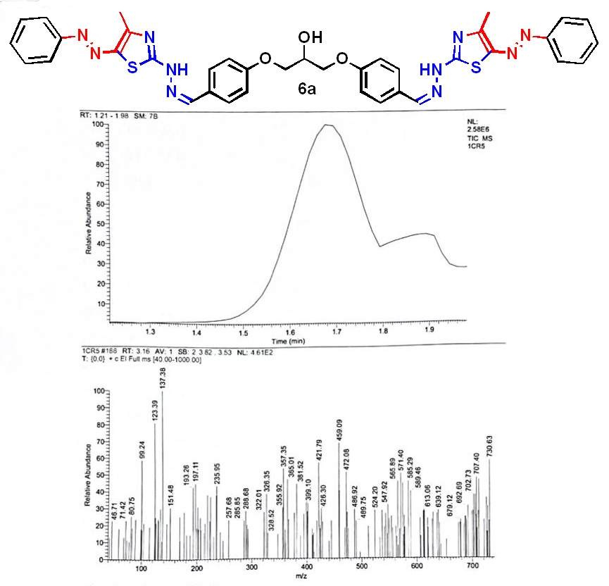
Mass spectrum compound 6a

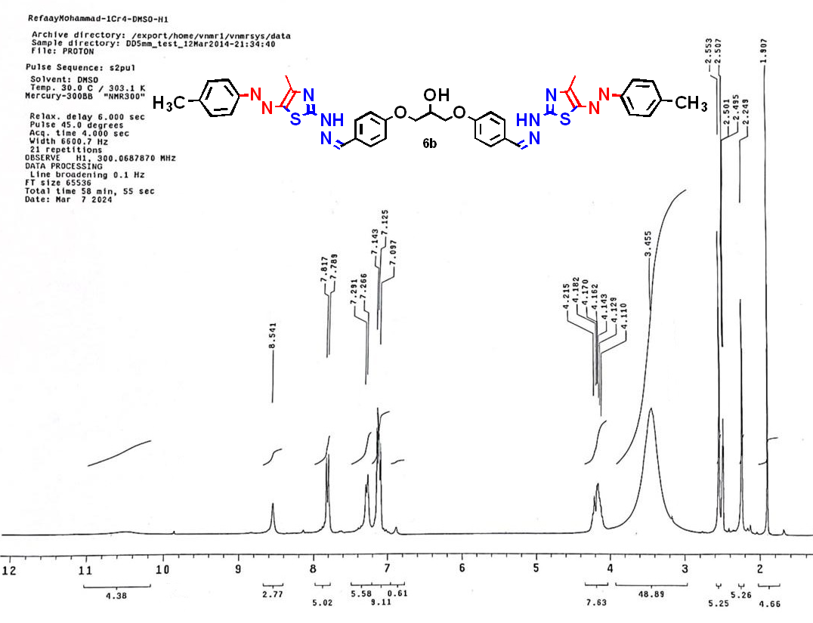
¹H NMR spectrum compound 6b
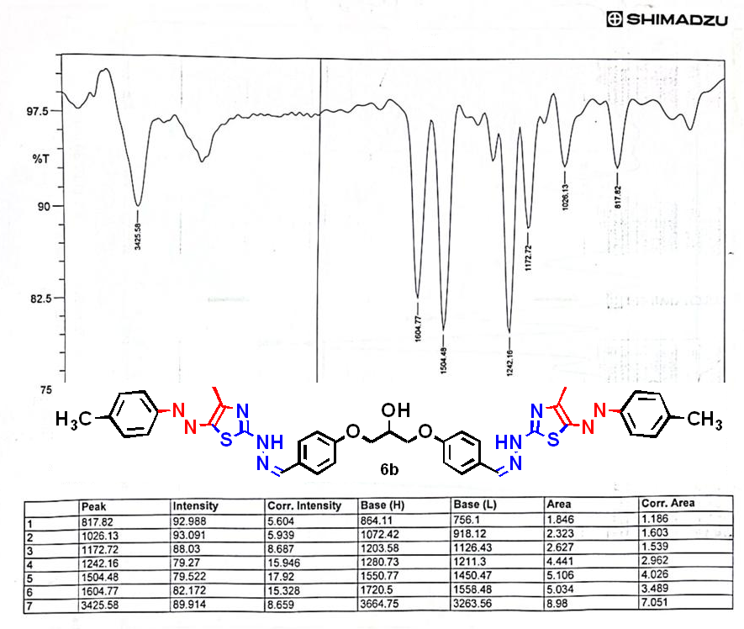
IR spectrum compound 6b

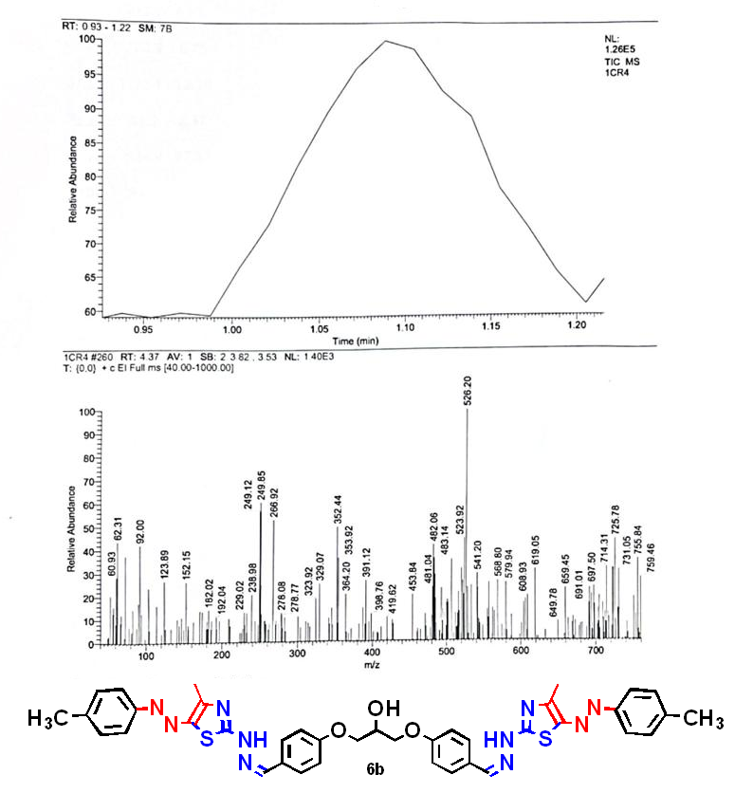
Mass spectrum compound 6b

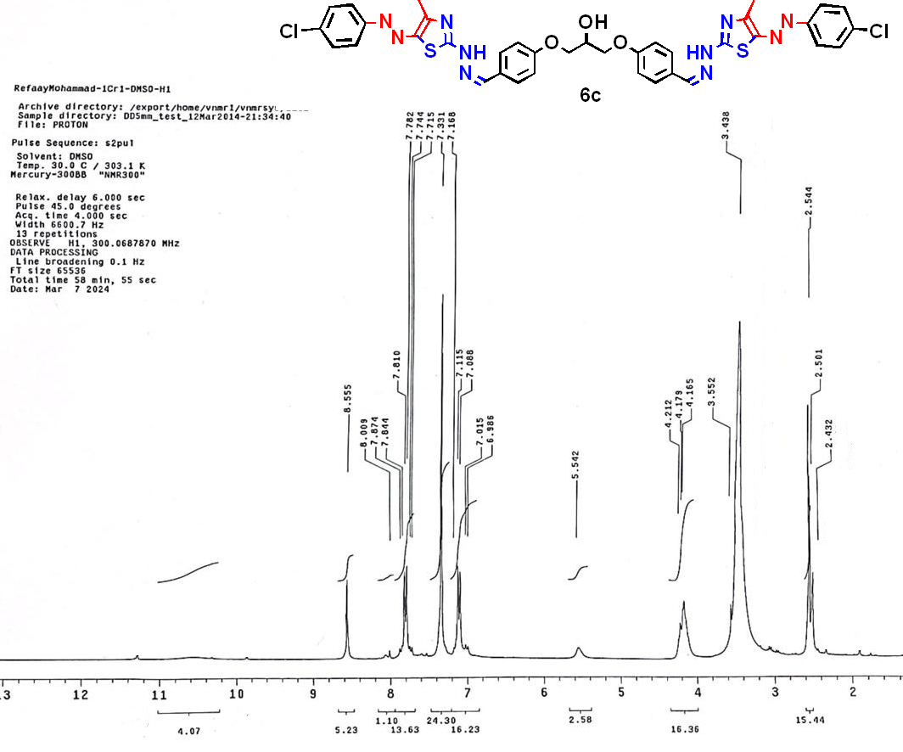
¹H NMR spectrum compound 6c
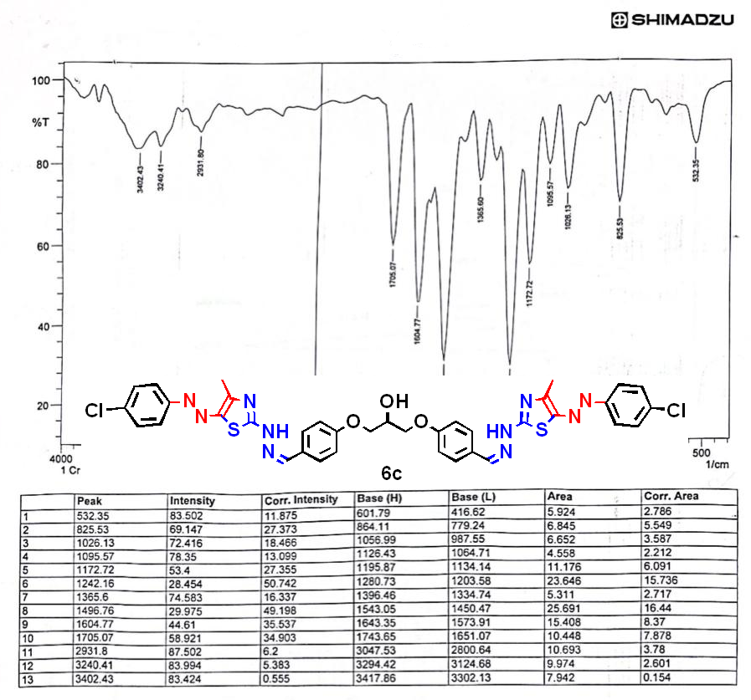
IR spectrum compound 6c

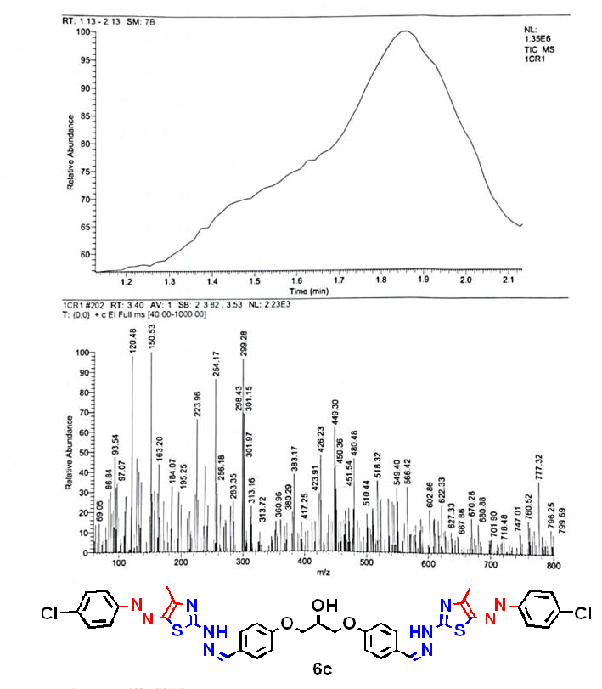
Mass spectrum compound 6c

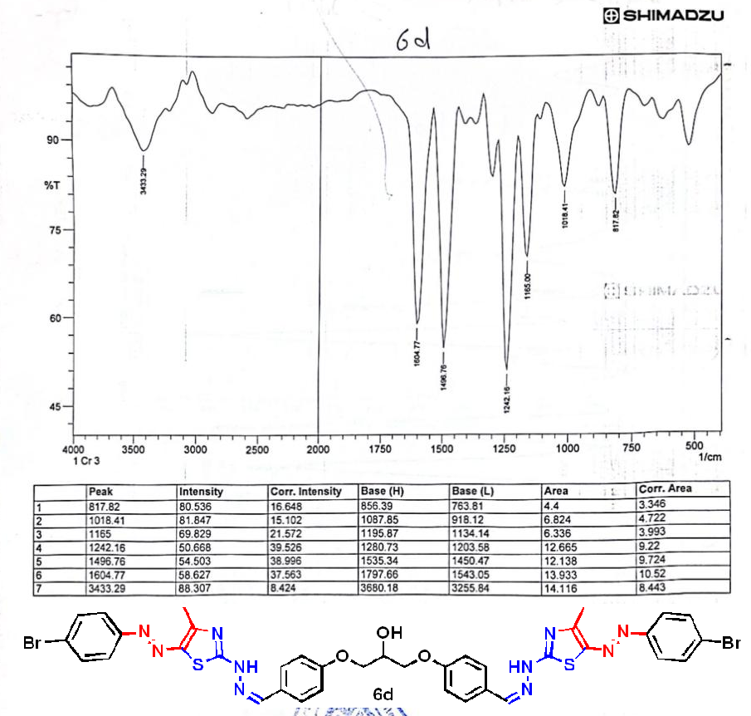
IR spectrum compound 6d

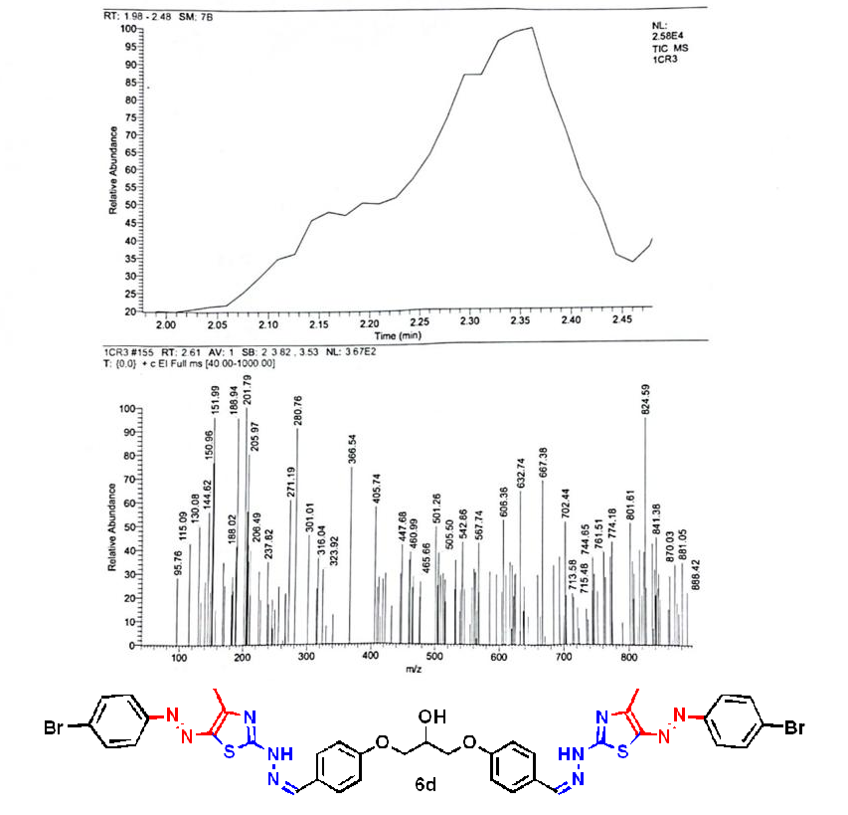
Mass spectrum compound 6d

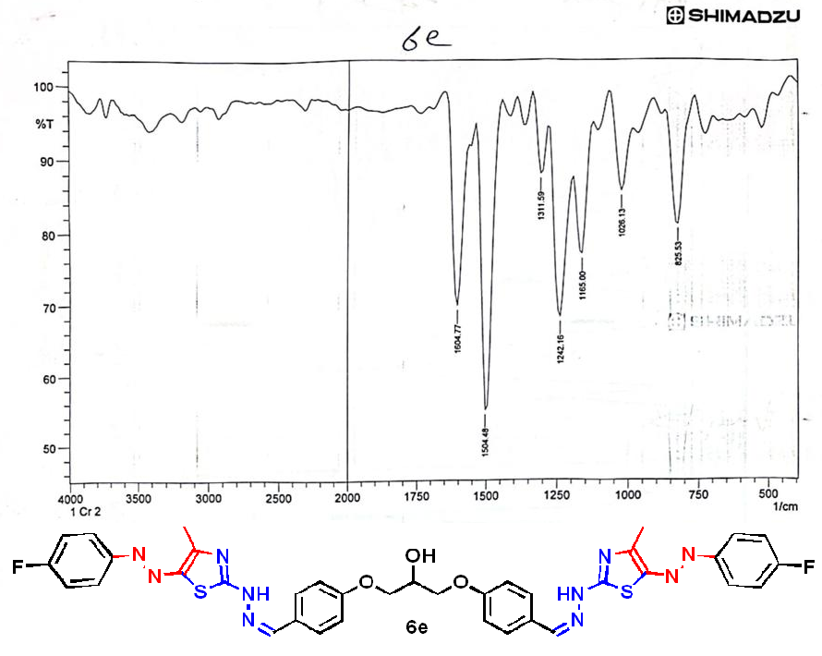
IR spectrum compound 6e

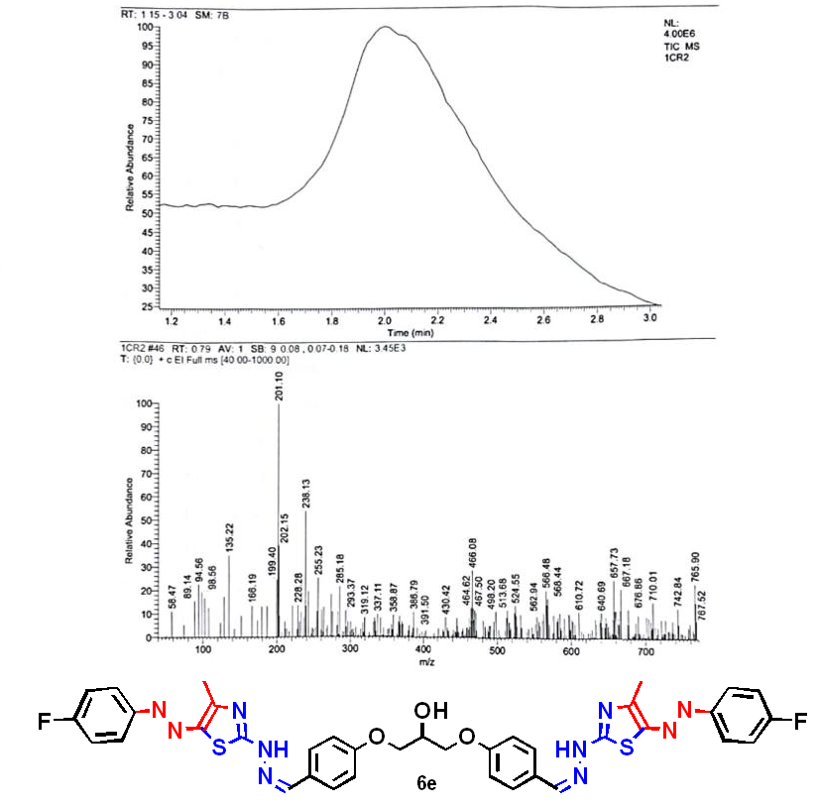
Mass spectrum compound 6e

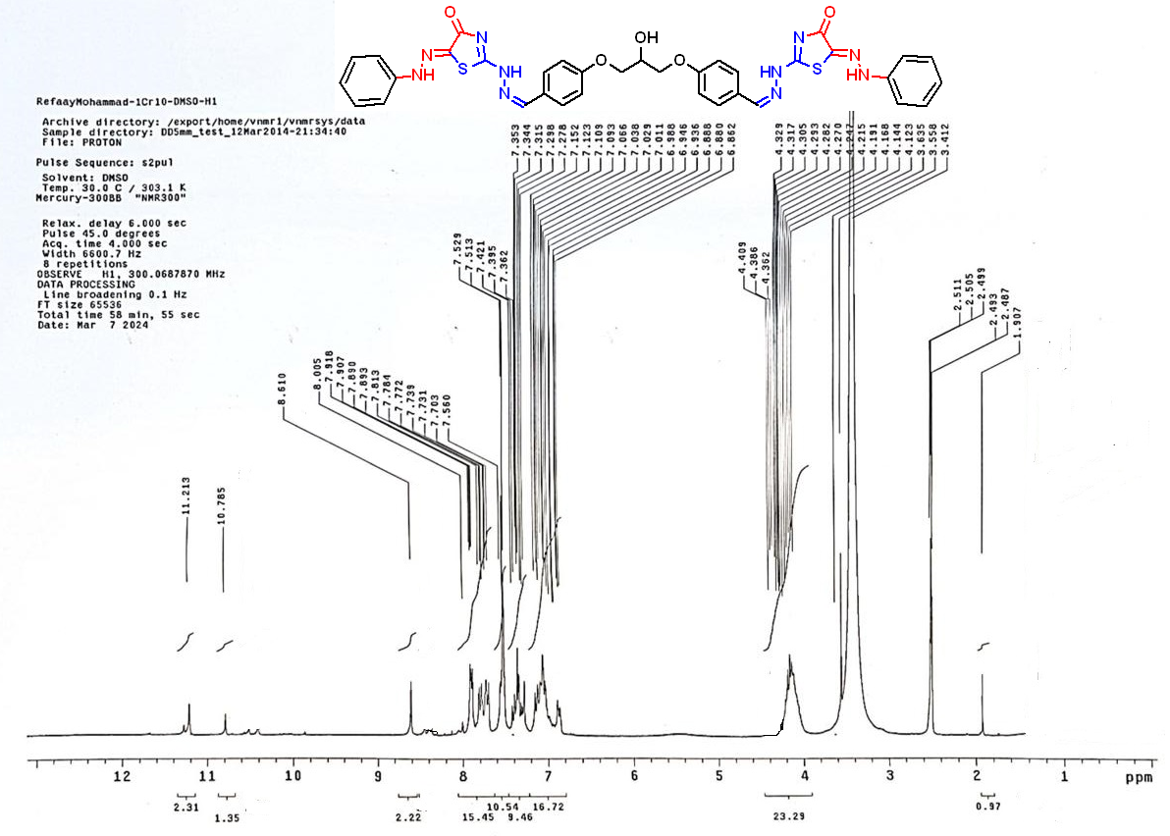
¹H NMR spectrum compound 9a
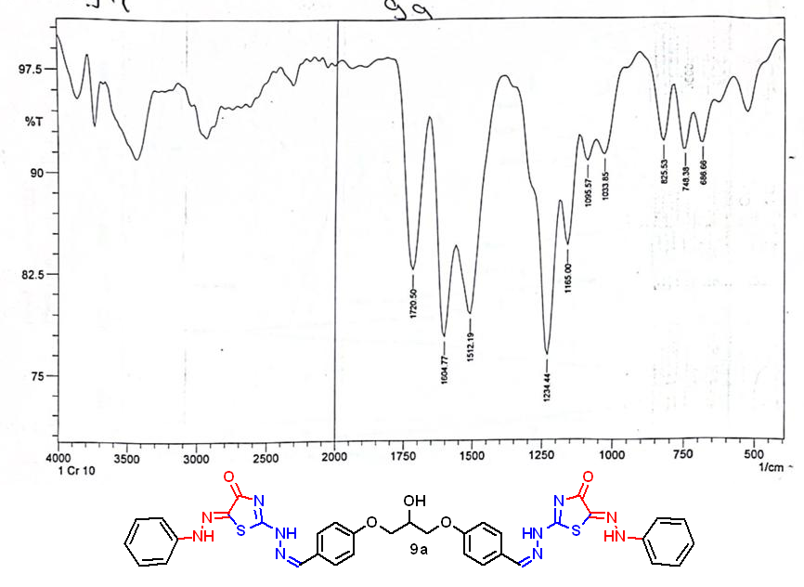
IR spectrum compound 9a

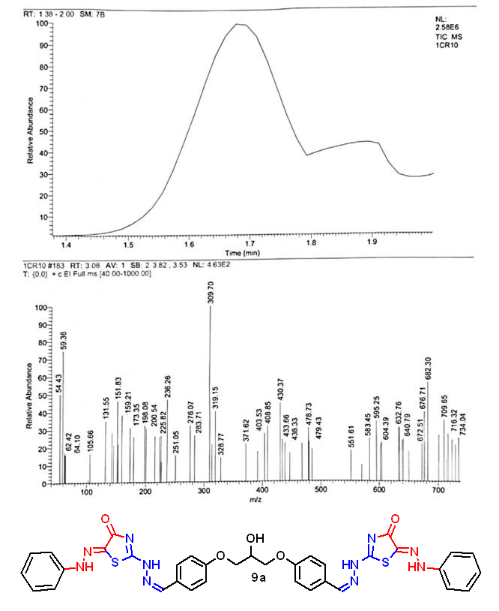
Mass spectrum compound 9a

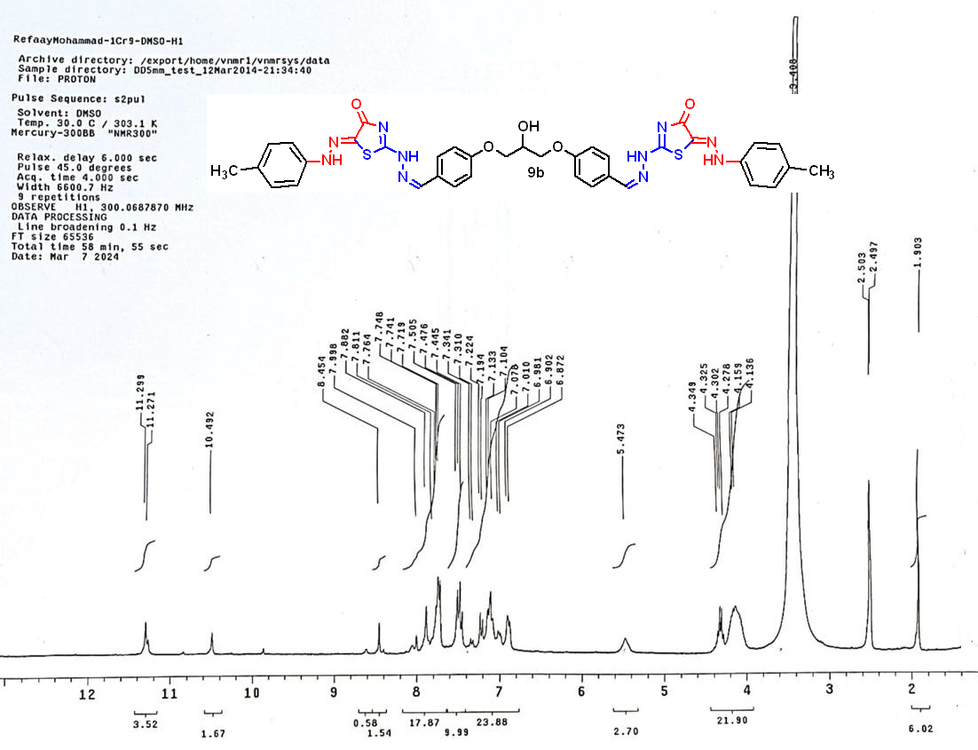
¹H NMR spectrum compound 9b

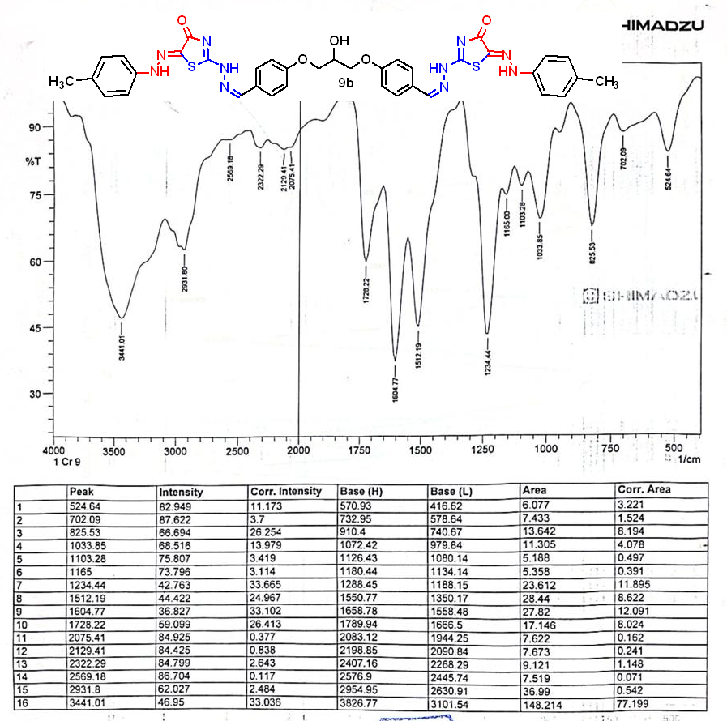
IR spectrum compound 9b

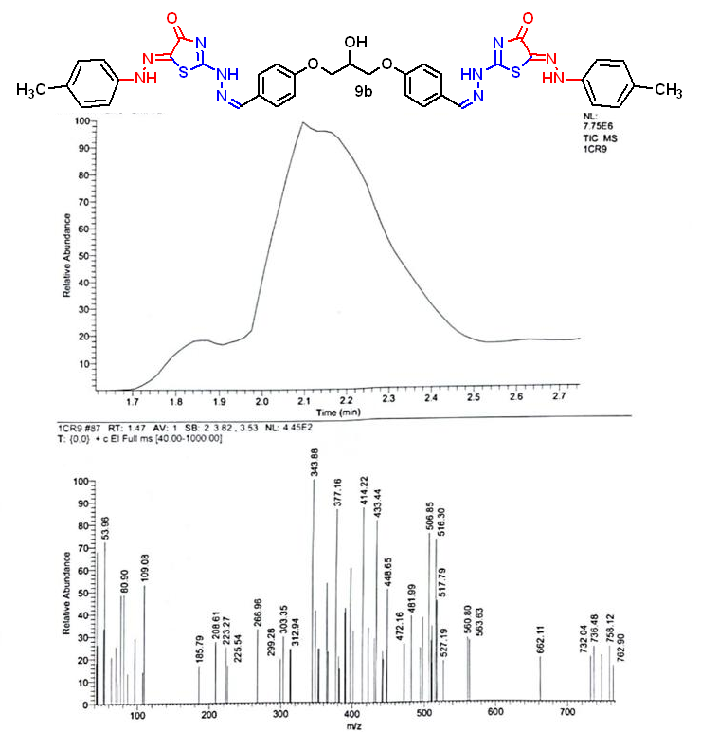
Mass spectrum compound 9b

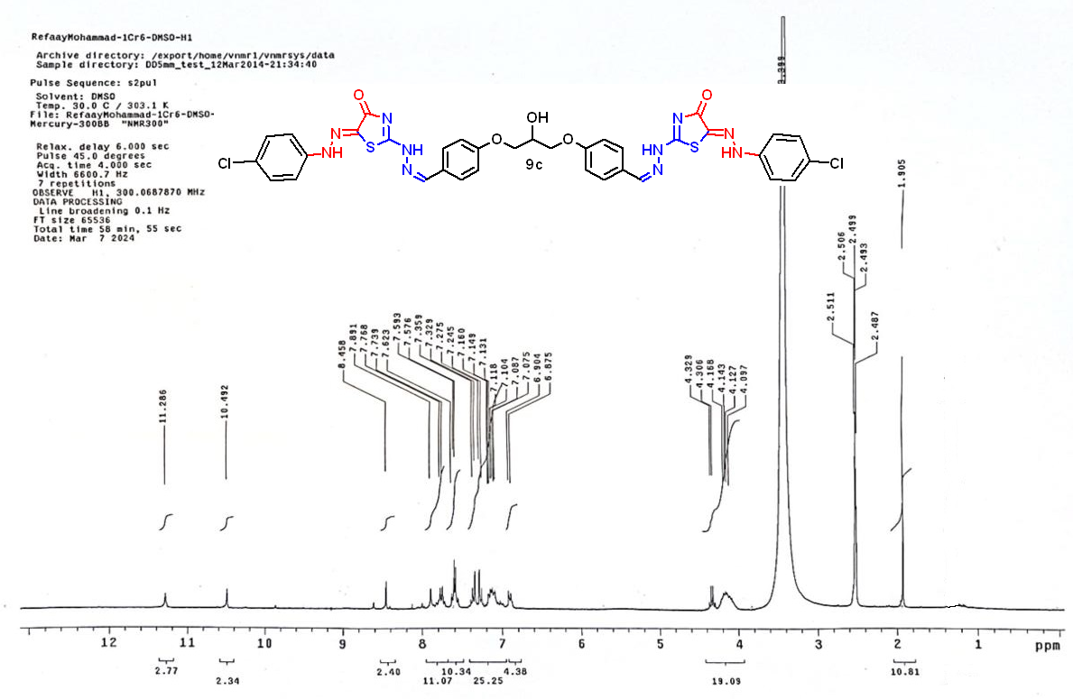
¹H NMR spectrum compound 9c
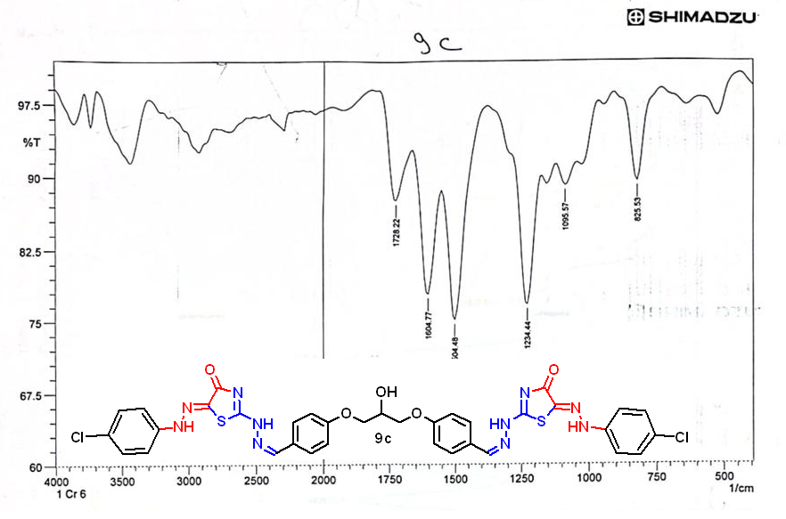
IR spectrum compound 9c

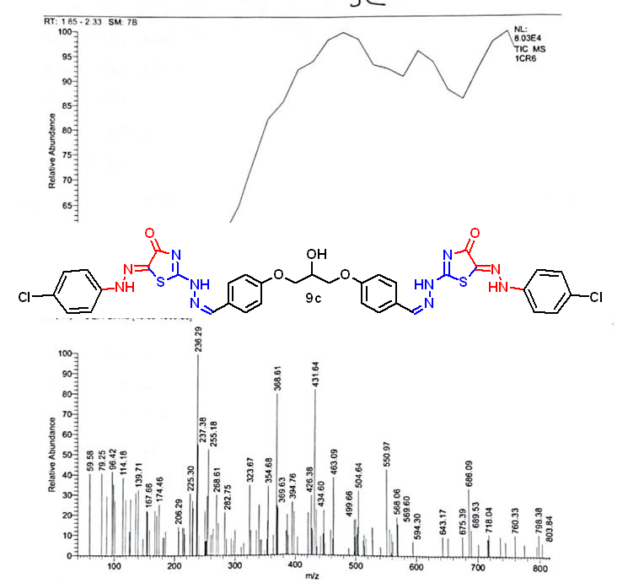
Mass spectrum compound 9c

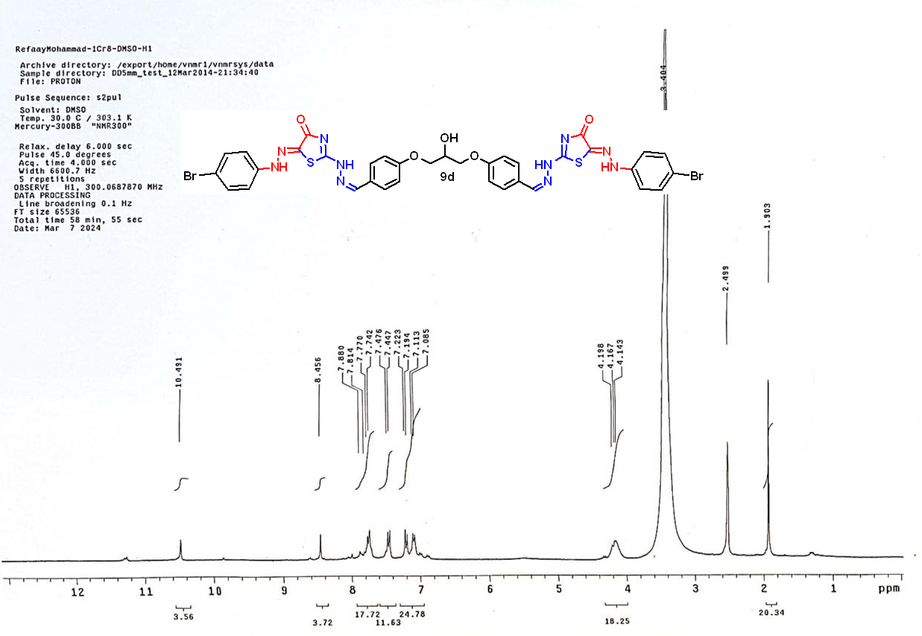
¹H NMR spectrum compound 9d

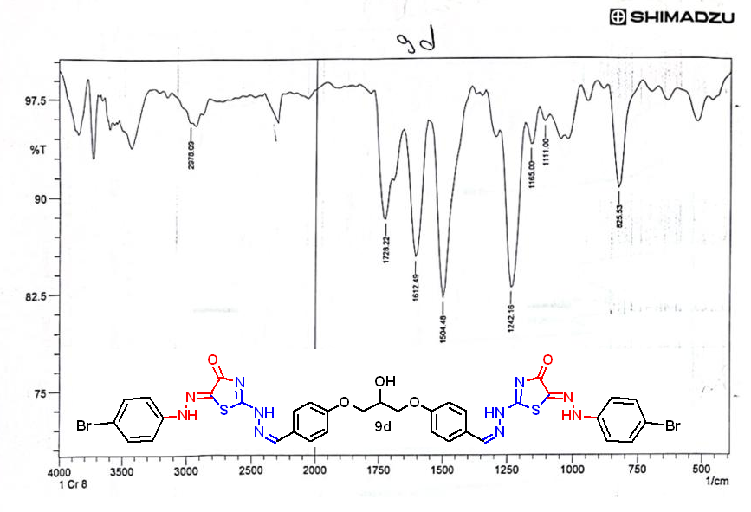
IR spectrum compound 9d

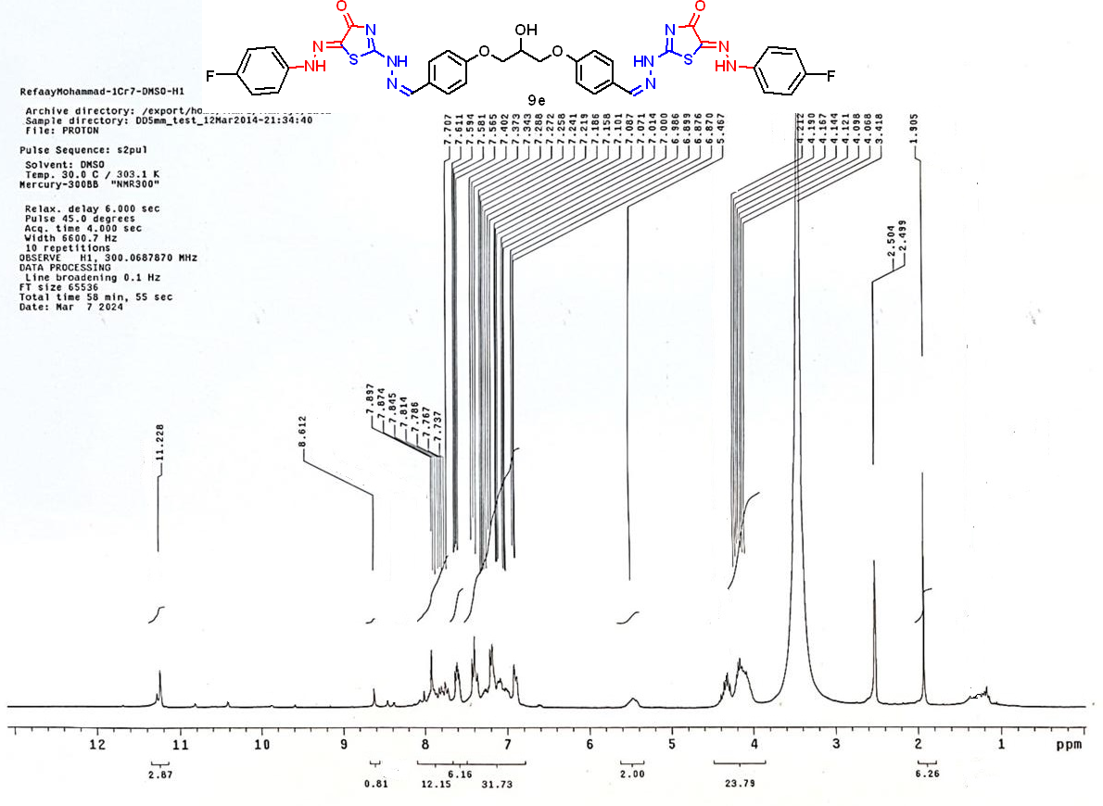
¹H NMR spectrum compound 9e

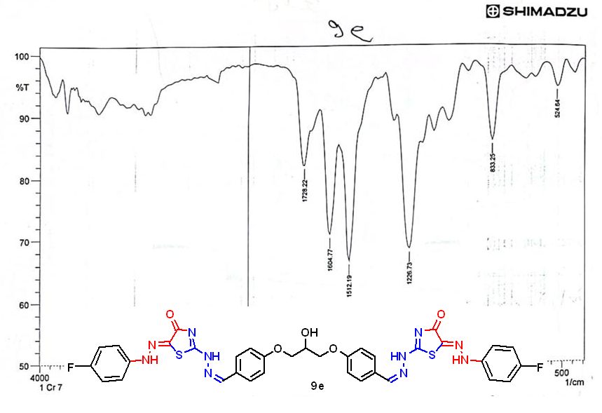
IR spectrum compound 9e

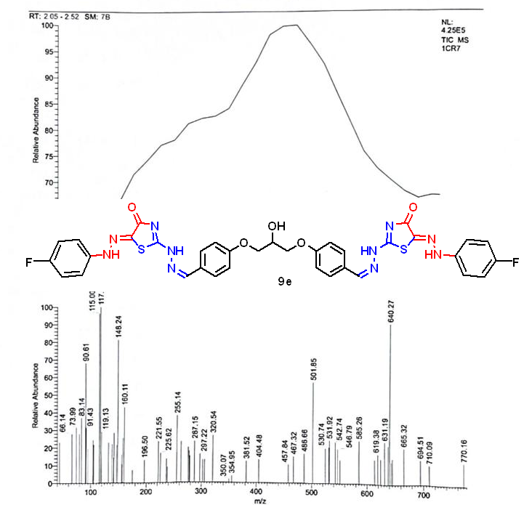
Mass spectrum compound 9e

