**Supporting supplementary data**

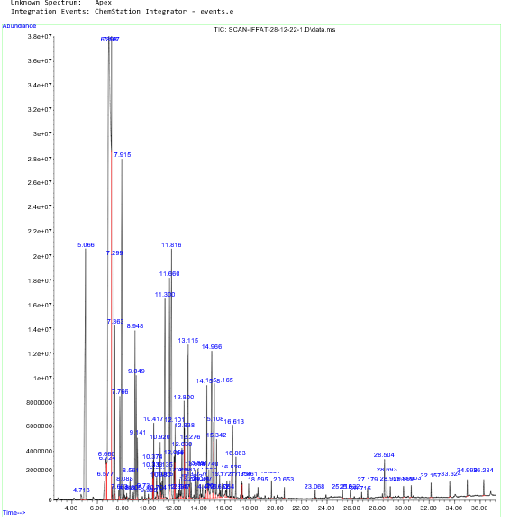

**Supplementary figure S1, GC-MS analysis of *Catharanthus roseus***

**Supplementary Table T1; Chemical composition and percentage of phytochemicals identified by GC-MS analysis of *C. roseus* essential oil**

|  |  |  |  |  |  |
| --- | --- | --- | --- | --- | --- |
| SR. No | Area % | RT  (minutes) | Compound Name | Mol. wt.  (g/mol) | Mol. formula |
| 1 | 0.14 | 4.178 | 1,2,4,4-Tetramethylcyclopentene | 124.22 | C9H16 |
| 2 | 0.40 | 6.577 | beta-Pinene | 136.23 | C10H16 |
| 3 | 1.19 | 6.660 | Gamma terpinene | 136 | C10H18O |
| 4 | 36.03 | 6.898 | alpha-Pinene | 136.23 | C10H16 |
| 5 | 2.16 | 7.299 | Camphene | 136.23 | C10H16 |
| 6 | 1.53 | 7.363 | Terpinolene | 136.23 | C10H16 |
| 7 | 0.09 | 7.683 | Cyclopropane | 42.08 | C3H6 |
| 8 | 0.09 | 7.691 | 2-Aminoresorcinol | 125.13 | [C6H7NO2](https://pubchem.ncbi.nlm.nih.gov/#query=C6H7NO2) |
| 9 | 0.13 | 8.08 | beta-Myrcene | 136.23 | C10H16 |
| 10 | 0.04 | 8.293 | 3,5-Octadiene | 110.2 | C8H14 |
| 11 | 0.28 | 8.561 | o-Isopropenyltoluene | 132.2 | C10H12 |
| 12 | 0.09 | 8.805 | p-Cymene | 134.22 | C10H14 |
| 13 | 1.85 | 8.948 | o-Cymene | 134.22 | C10H14 |
| 14 | 1.47 | 9.049 | D-Limonene | 136.23 | C10H16 |
| 15 | 1.47 | 9.051 | Limonene | 136.24 | C10H16 |
| 16 | 0.81 | 9.141 | Eucalyptol | 154.25 | C10H16O |
| 17 | 0.11 | 9.730 | Pinocarvone | 150.22 | C10H14O |
| 18 | 0.04 | 9.995 | Cyclohexanol | 100.15 | C6H12O |
| 19 | 0.26 | 10.333 | Methoxy(methyl)chlorosilane | 324.9 | [C19H17ClOSi](https://pubchem.ncbi.nlm.nih.gov/#query=C19H17ClOSi) |
| 20 | 0.33 | 10.371 | Cyclopentanol | 86.13 | C5H10O |
| 21 | 0.39 | 10.374 | Artemiseole | 152.23 | C10H16O |
| 22 | 0.17 | 10.980 | 1-Phenylpropanol | 136.19 | C9H12O |
| 23 | 0.19 | 11.065 | Thujone | 152.23 | C10H16O |
| 24 | 0.36 | 11.135 | Camphene | 136.23 | C12H16 |
| 25 | 2.93 | 11.300 | alpha- Campholenal | 152.23 | C10H16O |
| 26 | 2.93 | 11.311 | Fumaric acid | 116.07 | C4H4O4 |
| 27 | 3.37 | 11.660 | 1,4,9-Decatriene | 136.23 | C10H16 |
| 28 | 5.66 | 11.816 | Trans-verbenol | 152.237 | C10H16O |
| 29 | 0.24 | 12.455 | Terpinen-4-ol | 154.25 | C10H16O |
| 30 | 0.09 | 12.547 | Ethanone | 43.04 | C2H3O |
| 31 | 0.65 | 12.630 | m-Cymen-8-ol | 192.25 | C12H16O2 |
| 32 | 0.17 | 12.981 | Acetic acid | 60.052 | CH3COOH |
| 33 | 0.63 | 13.276 | trans-Carveol | 152.23 | C10H16O |
| 34 | 0.21 | 13.777 | Carvone | 150.22 | C10H14O |
| 35 | 0.38 | 13.891 | Isobutyric acid | 136.23 | C10H16 |
| 36 | 2.96 | 14.966 | Camphenone | 150.22 | C10H14O |
| 37 | 0.22 | 15.579 | alpha-Campholenal | 152.23 | C10H16O |
| 38 | 1.18 | 15.772 | 2-Carene | 136.23 | C10H16 |
| 39 | 0.17 | 16.364 | Copaene | 204.35 | C15H24 |
| 40 | 0.49 | 16.863 | Octanoic acid | 144.21 | [C8H16O2](https://pubchem.ncbi.nlm.nih.gov/#query=C8H16O2) |
| 41 | 0.12 | 17.354 | alpha-Campholenal | 152.23 | [C10H16O](https://pubchem.ncbi.nlm.nih.gov/#query=C10H16O) |
| 42 | 0.20 | 19.651 | Nerolidol | 222 | C15H26O |
| 43 | 0.11 | 25.832 | n-Hexadecanoic acid | 256.42 | C16H32O |
| 44 | 1.12 | 28.693 | Incensole, acetate | 334.49 | C21H34O |
| 45 | 0.19 | 36.284 | Hexasiloxane | 248.51 | O5Si6 |

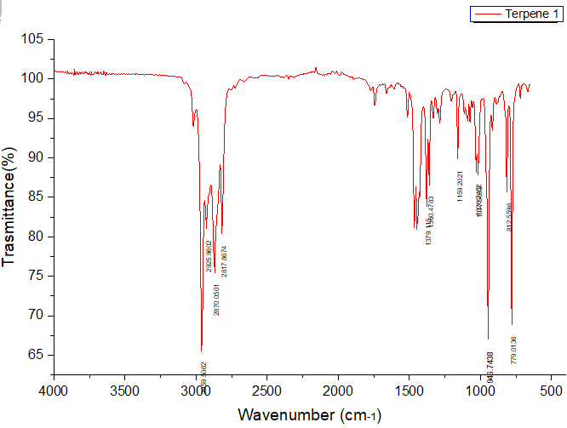

**Supplementary figure S2; IR spectrum of 2-carene**

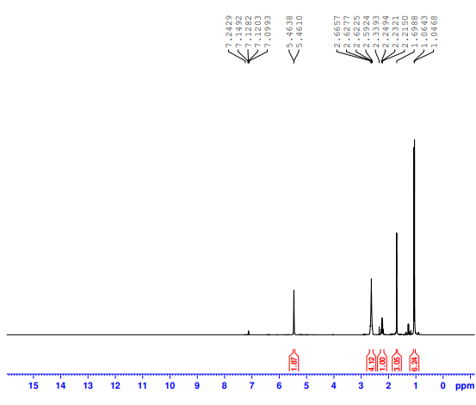

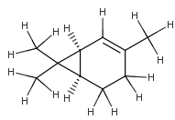

**Supplementary figure S3; IH-NMR of 2-carene**

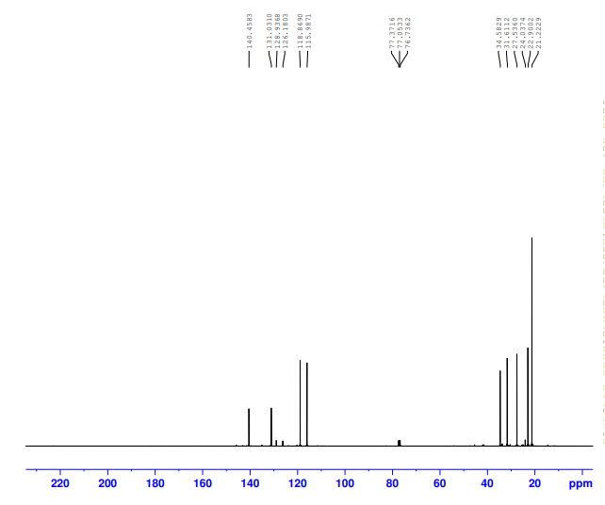

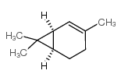

**Supplementary figure S4; 13 C-NMR of 2-carene**

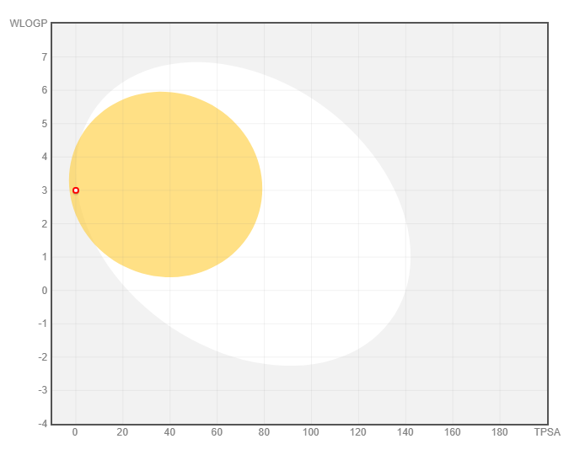

**Supplementary figure S5; BOILED-EGG MODEL of 2-carene for Brain Penetration and Absorption in the Gastrointestinal Tract.**

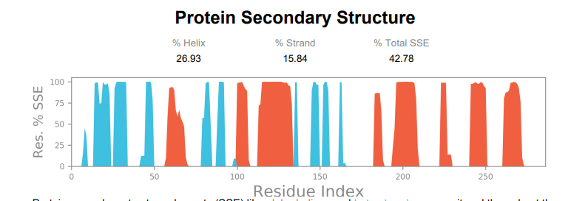

**Supplementary figure S6; MD simulation supporting figure**

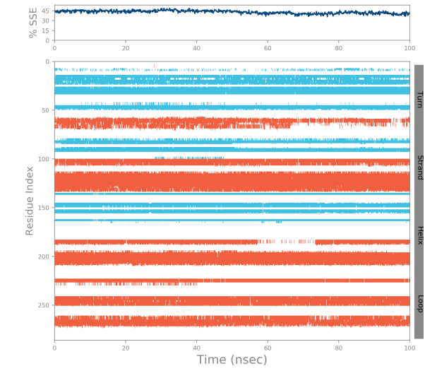

**Supplementary figure S7; Protein secondary structure elements (SSE) such as alpha-helices marked by orange and the beta-strands were labeled by cyan.**

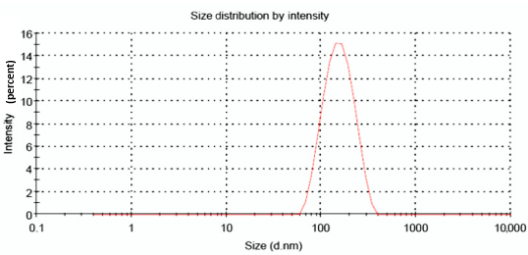

**Supplementary figure S8; Size-distribution analysis of 2-carene nanoemulsion**

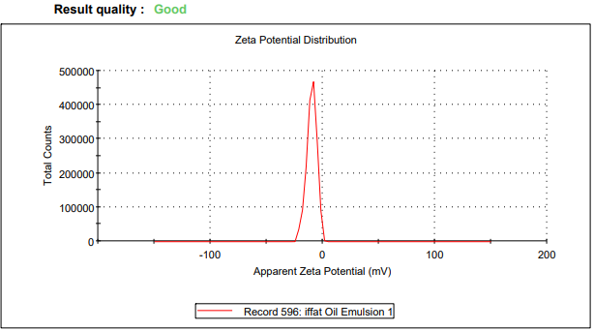

**Supplementary figure S9; Zeta potential analysis of 2-carene nanoemulsion**

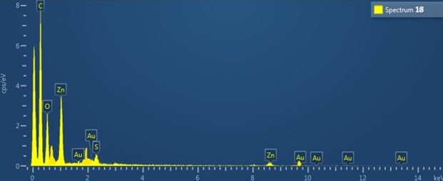

**Supplementary figure S10; EDX of 2-carene nanoemulsion**

**Supplementary Table T2; Effect of 2-carene and nanoemulsion on tumor volume and tumor ratio in control and experimental groups.**

|  |  |  |  |  |  |  |
| --- | --- | --- | --- | --- | --- | --- |
| Parameters | Vehicle control | Nanoemulsion control | DMBA | DMBA+ 2-carene | DMBA+ 2-careneNE | DMBA+EO |
| Tumor volume  mm3 (pre-treatment) | 0 | 0 | 8.32 | 10.12 | 7.54 | 9.108 |
| Tumor volume mm3(post- treatment) | 0 | 0 | |  | | --- | | 10.36 | | 8.56 | 6.198 | 7.712 |
| Tumor ratio | 0 | 0 | |  | | --- | | 1.251 | | 0.85 | 0.82 | 0.84 |

**MATERIALS AND CHEMICALS USED**

Tween-80 from Daejung, Methanol (MeOH), Ethanol (EtOH), Diethyl Ether,

Phosphate Buffer Saline (NaCl, KCl, Na2HPO4, K2HPO4), Di-Sodium Hydrogen

Phosphate, Phosphoric Acid (H3PO4) were purchased.

Trypsin and Fetal Bovine Serum (FBS) was purchased from Gibco

Switzerland (Life Technologies, AG). Hydro-Distillation apparatus was Ultrapure Millipore (Milford, USA).

Medium for cell‎ culture,‎ Dulbecco’s‎ Modified‎ Eagle’s‎ (DMEM)‎ was‎ purchased‎ from‎ Sigma‎ -

Aldrich,

MTT [5-diphenyltetrazolium bromide, 3-(4, 5-dimethylthiazol-2-yl) -2] assay kit from Merck Millipore Germany.

**INSTRUMENTS USED**

Instruments used for the preparation, In-vitro and In-vivo analysis of Syringe‎filter ‎(MFMillipore 13mm, Millex ®-GS, Germany), Vortex Mixer (Fisher Scientific ®, USA), PVF‎ Membrane‎ Filter‎ (Polyvinylidine‎ Fluoride‎ porosity‎ 0.45μm,‎ Sartorius®,‎Germany).

Analytical balance (Shimadzu ® 200, Japan), Laboratory Water Bath

System with 25Lcapacity (BS-11 Lab, Companion®, Korea),

Temperature Controlled Centrifuge (Thermo-Scientific, Centurion ®UK), Magnetic Stirrer (Benchmark ®,

USA), Viscometer (Brookfield AMETEK, USA), Flask Capacity 250mL,Sigma-Aldrich, Germany)

Fourier Transform Infra-Red Spectroscopy (Perkin Elmer, Waltham, MA, USA), X-Ray Diffractometer (XRD JDX-3532 Jeol, Japan), Zeta Sizer (Malvern instrument ltd. ZS-90, UK), Perkin Elmer UV-Visible

Spectrometer (UV Probe having Lamda-25, Series 200, Software Version-2.21), Scanning Electron Microscope (Jeol, JSM-5910, Japan), detector with variable wavelength.

Cell culture flasks (Sigma – Aldrich) and 96-well cell culture plates purchased from Thermo-Fisher Scientific Lab USA.