**Supplementary Information**

**Molecular Analysis of Recombinant Collagenase from *Bacillus siamensis* strain Z1: Gene Cloning, Expression and *In-silico* Characterization**

Archana G. Revankar1, Zabin K. Bagewadi1*, Ibrahim Ahmed Shaikh2, G Dhananjaya3, Nilkamal Mahanta3, Aejaz Abdullatif Khan4, Neha P. Bochageri1, Basheerahmed Abdulaziz Mannasaheb5

1Department of Biotechnology, KLE Technological University, Hubballi, Karnataka 580031, India, [archanagr96@gmail.com](mailto:archanagr96@gmail.com) (A. G. Revankar), [zabin@kletech.ac.in](mailto:zabin@kletech.ac.in) (Z. K. Bagewadi)

2Department of Pharmacology, College of Pharmacy, Najran University, Najran 66462, Saudi Arabia, [iashikh@nu.edu.sa](mailto:iashikh@nu.edu.sa) (I. A. Shaikh)

3Department of Chemistry, Indian Institute of Technology, Dharwad, Karnataka 580011, India, [212053002@iitdh.ac.in](mailto:212053002@iitdh.ac.in)(G Dhananjaya), [neel@iitdh.ac.in](mailto:neel@iitdh.ac.in) (N. Mahanta)

4Department of General Science, Ibn Sina National College for Medical Studies, Jeddah 21418, Saudi Arabia, [aejaz@ibnsina.edu.sa](mailto:aejaz@ibnsina.edu.sa) (A. A. Khan)

5Department of Pharmacy Practice, College of Pharmacy, AlMaarefa University, Ad Diriyah, 13713, Saudi Arabia, [bmannasaheb@um.edu.sa](mailto:bmannasaheb@um.edu.sa) (B. A. Mannasaheb)

**Running title**

**Gene Cloning, Expression and Characterization**

*Correspondence to: Dr.Zabin K. Bagewadi

Associate Professor,

Department of Biotechnology,

KLE Technological University,

Vidyanagar, Hubballi – 580 031, India

Tel.: +91-0836-2378231; Fax: +91-0836-2374985.

Email: [zabin@kletech.ac.in](mailto:zabin@kletech.ac.in)

S1: Collagenase gene showing sequence coverage of 63.8 %

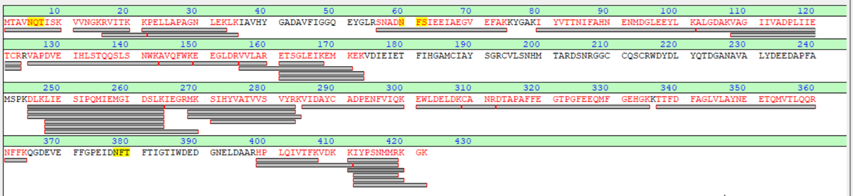

S2:Structural and functional characterization of Collagenase

S2A: Amino acid sequences obtained from EXPASY translate tool

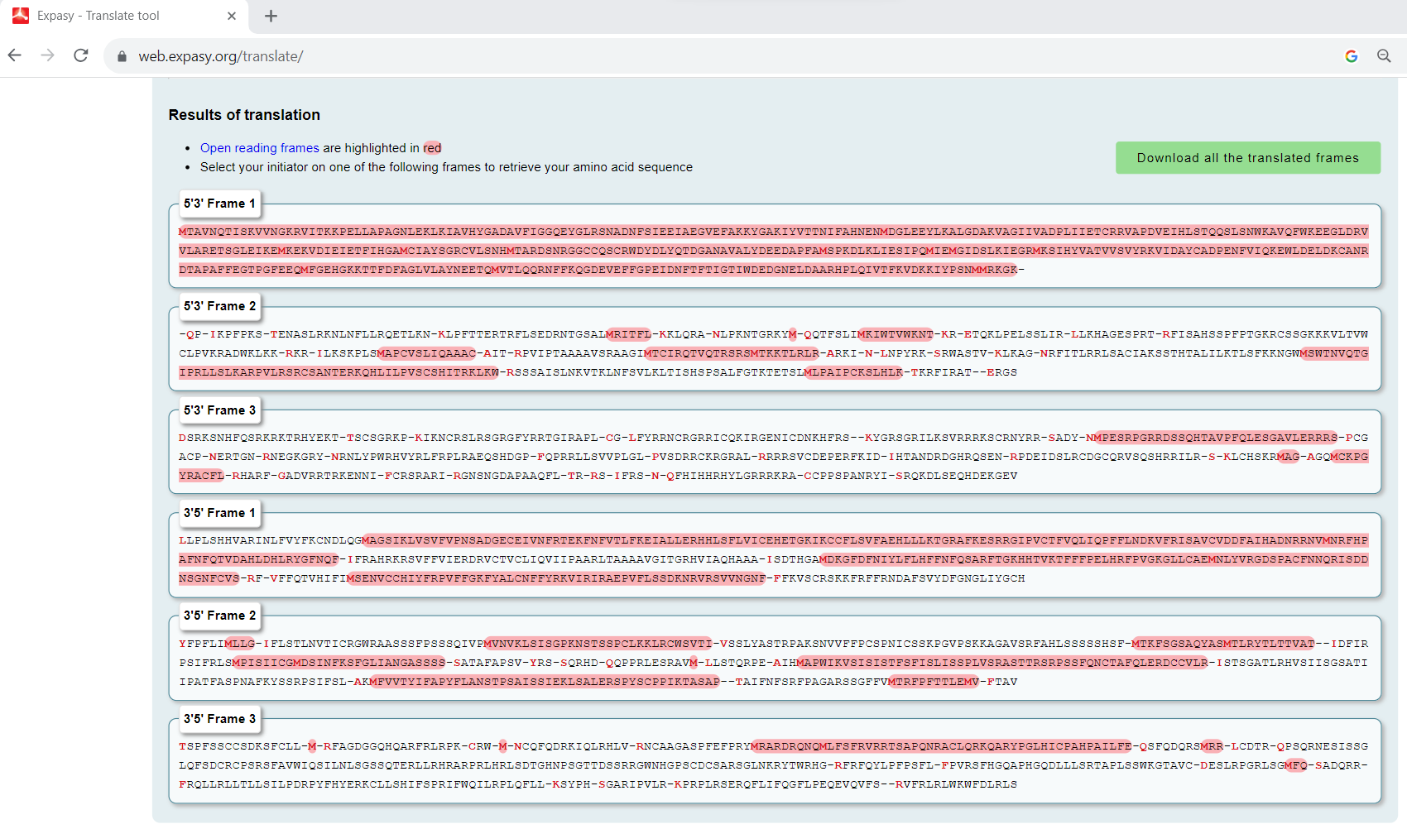

S2B:Collagenase nucleotide sequence phylogenetic tree constructed using MEGA software by neighbor joining method.

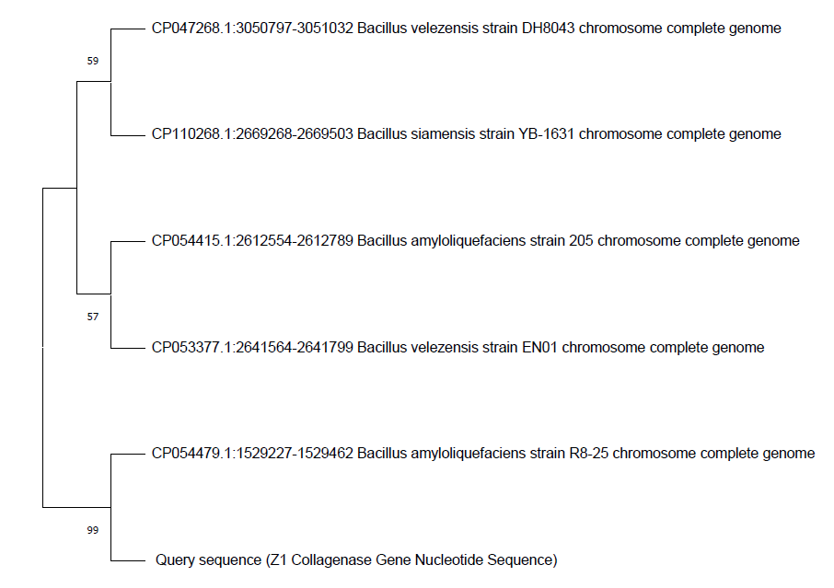

S2C:Collagenase gene protein sequence phylogenetic tree constructed using MEGA software by neighbor joining method

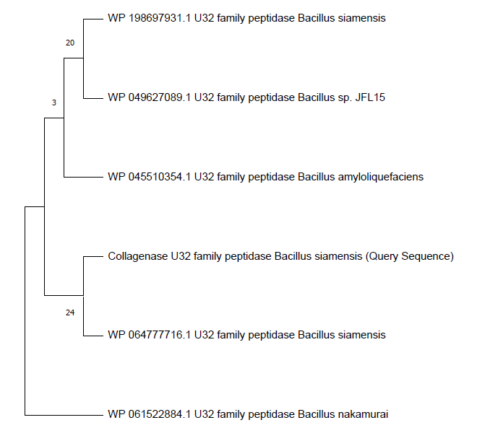

S2D: Gene sequence similarity of collagenase gene obtained by *Bacillus siamensis* strain Z1 with top result of BLAST NCBI of*Bacillus* strain.

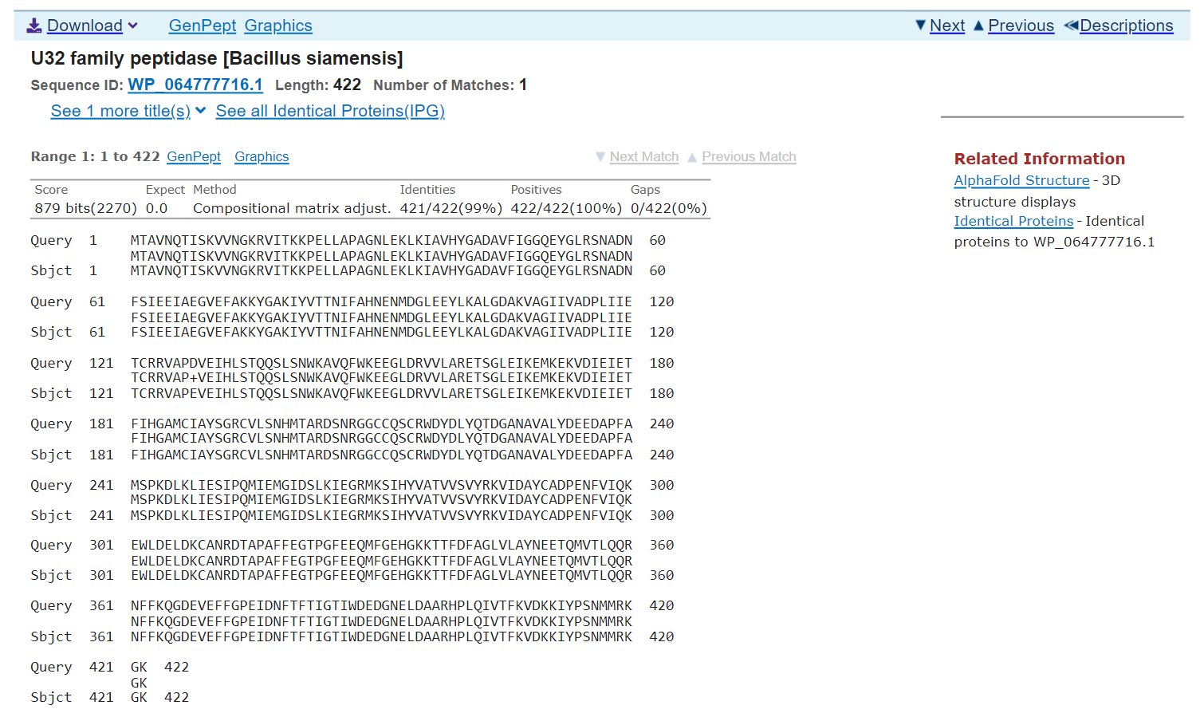

S2E: Collagenase gene analyzed by InterProScan tool.

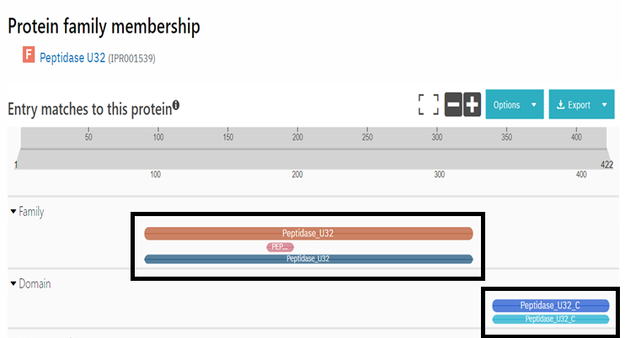

S2F: Predicted model structure for *Bacillus siamensis* Z1 collagenase.

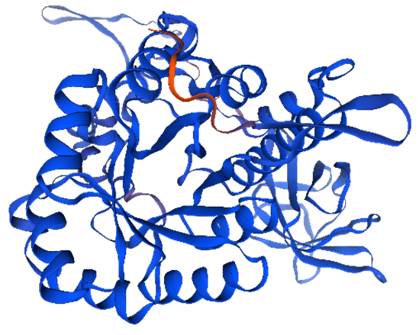

S2G: Raman Model structure obtained from Swiss-MODEL server.

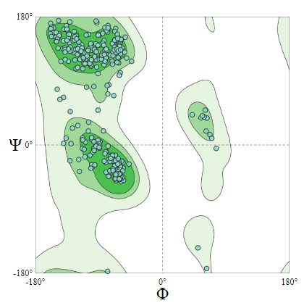

S2H: ERRAT analysis of modelled collagenase gene protein sequence from *Bacillus siamensis* Z1

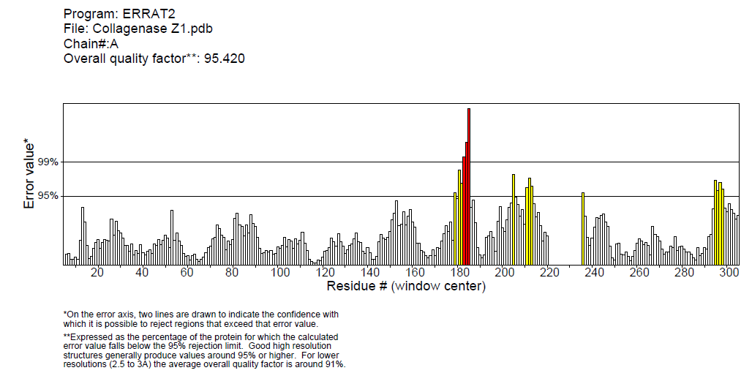

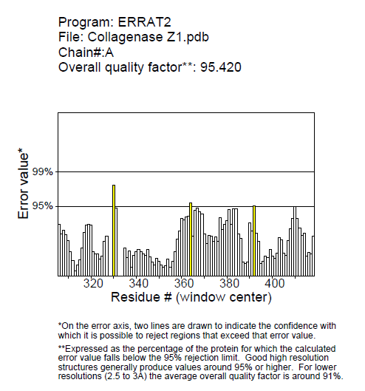

S2I: Profile value of predicted structure denoting the highly flexible loop regions of Collagenase.

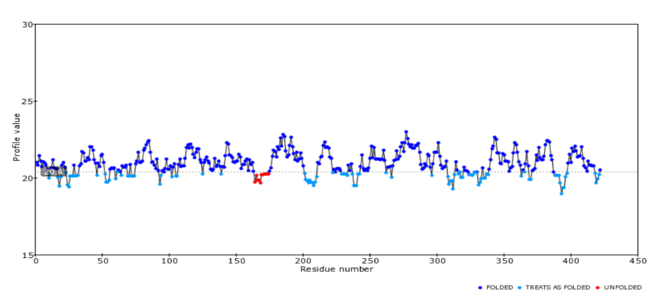

S3:2D and 3D structures of different substrates used in study with its Pubchem ID

|  |  |  |  |  |
| --- | --- | --- | --- | --- |
| Substrate | Pubchem ID | 2D structure | | 3D structure |
| APHACP (Alaska pollock hydroxyproline containing marine collagen peptide)  Collagen type 4 alpha (531-543)  PZ – peptide  FALGPA | 129908191  16132108  161208  6439513 |  |  | |

S4:Hydrogen Bond interactions of four substrates with amino acids of modelled collagenase docked using PyRx and Autodock software

|  |  |  |
| --- | --- | --- |
| Substrates | PyRx software | Autodock software |
| APHACP (Alaska pollock hydroxyproline containing marine collagen peptide)  Collagen type 4 alpha (531-543)  PZ – peptide  FALGPA | PHE 341(3.1Å), ASN 361(3.0 Å), LYS 270(3.3 Å), MET 269(2.6 Å), ASN 311(2.9 Å, 3.1 Å, 3.2 Å)  LYS 79(2.8 Å), TYR 81(3.0 Å), ARG 155(3.2 Å, 3.0 Å), GLU 177(3.2 Å), GLU 23(4.1 Å), ASP 287(2.8 Å, 2.4 Å), ARG 283(2.7 Å), PRO 374(2.7 Å), ILE 376(2.5 Å), ASN 378(3.2 Å), GLU 305(2.7 Å)  ARG 360(2.6 Å), PHE 341(2.9 Å), ASP 340(2.7 Å), PHE 339(2.0 Å), THR 337(2.8 Å), SER 271(2.6 Å)  ASN 311(3.0 Å), THR 337(3.0 Å), PHE 341(3.0 Å), ASN 361(2.9 Å), ASP 340(3.1 Å) | ARG 360(2.7 Å, 2.1 Å), CYS 309(2.3 Å), ASN 311(2.1 Å, 2.2 Å, 2.4 Å), ARG 312(2.2 Å), HIS 333(2.7 Å), ARG 215(2.8 Å), GLN 212(1.9 Å)  GLU 266(2.7 Å), SER 271(1.8 Å), HIS 273(2.8 Å), ARG 55(2.1 Å), THR 337(2.5 Å, 2.7 Å), LYS 335(3.0 Å), ASN 311(2.7 Å)  SER 271(2.3 Å), HIS 273(2.7 Å), ASN 311(2.7 Å, 2.6 Å), HIS 333(2.6 Å, 2.6 Å)  PHE 341(2.0 Å), SER 271(2.3 Å), ASN 311(2.0 Å, 2.3 Å) |