**Supplementary material**

**Efficient removal of** **Cr6+ by magnetically modified biochar from aqueous solution**

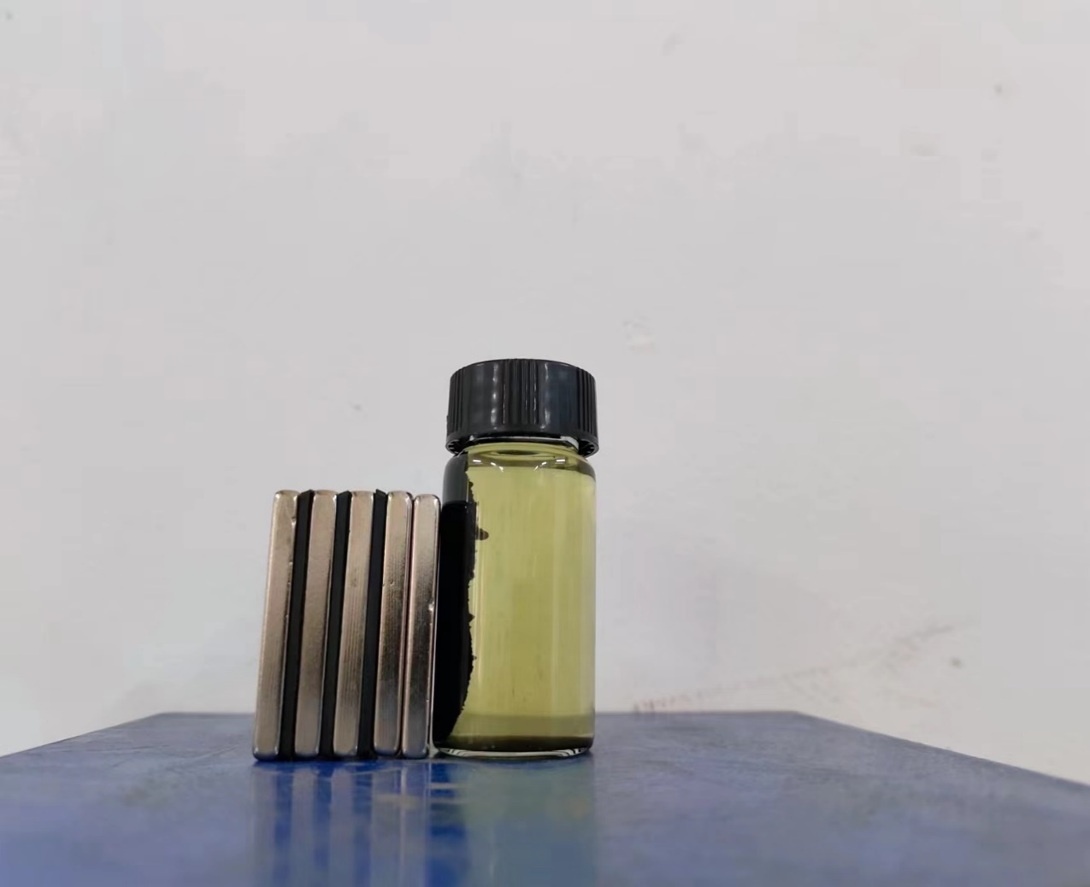

**Fig. S1** The images of the magnetic separation of the MB-600 after use.



**Fig.S2** The zeta potential value of the MB-600℃.

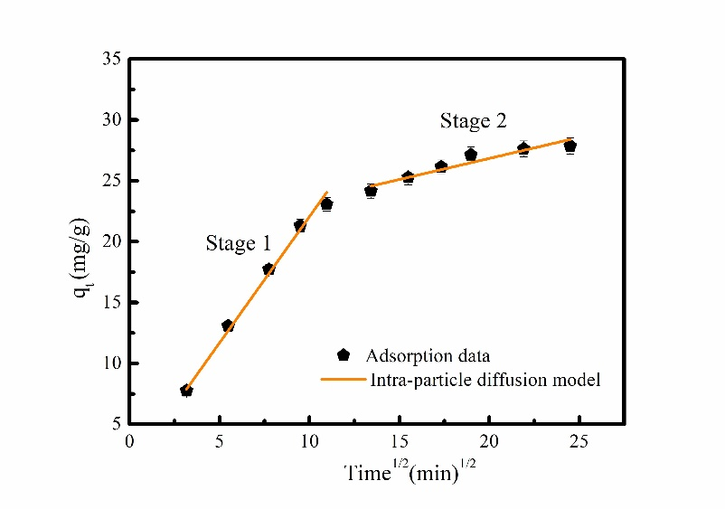

**Fig.S3** The Cr6+ adsorption data fitting intraparticle diffusion model.



**Fig.S4** The reusability results of MB-600℃ after three cycle.

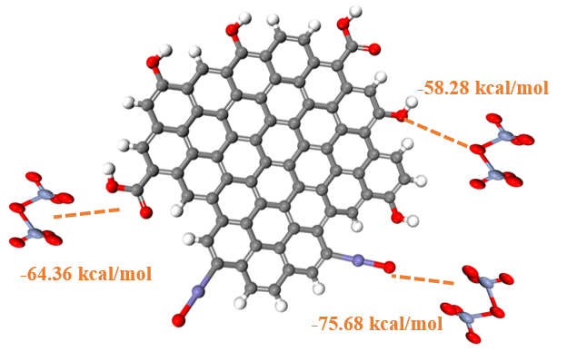

**Fig.S5** The calculated result of -COOH, -OH, and Fe-O groups interactions with Cr6+.



**Fig.S6** Breakthrough curve for Cr6+ adsorption.

**Table S3** The maximum adsorption capacity of similar adsorbents forCr6+ **r**emoval from wastewater.

|  |  |  |
| --- | --- | --- |
| Adsorbents | Maximum adsorption  capacity (mg/g) | References |
|  | Cr6+ |  |
| Cassava root biochar/ZnO | 28.37 | [1] |
| nZVI/sewage sludge co-pyrolyzed magnetic biochar | 13.27 | [2] |
| Carbon nano-onions | 27.86 | [3] |
| ZnO/ZnS/corn stover biochar | 24.5 | [4] |
| CTAB-Peanut shell biochar | 22.93 | [5] |
| Ball milled Fe0-biochar | 14.59 | [6] |
| Magnetic biochar | 42.7 | [7] |
| Zn/iron-based sludge/biochar | 27.04 | [8] |
| MC/nano-Fe3O4@PPy | 35.68 | [9] |
| biochar-based iron oxide composites | 24.37 | [10] |
| N-doped Fe3O4/carbon | 30.14 | [11] |
| FeOOH-coated ϒ-Fe2O3 | 16.0 | [12] |
| Fe3O4/C | 15.24 | [13] |
| MB-600℃ | 30.41 | This work |

**Table S4** Fixed bed models and corresponding parameters.

|  |  |  |
| --- | --- | --- |
| Model | Equations | Parameters |
| Thomas |  | *KTh* (mL min-1 mg-1) is the Thomas constant, *qth* (mg g-1)is the maximum adsorption capacity, *M* (mg) is the weight of PFMC, *V* (mL min-1) is the inlet flow. |
| Yoon-Nelson |  | KYN (min-1) is the Yoon-Nelson constant and t0.5 (min) is the time required for 50% breakthrough. |

**Table S5** Parameters and coefficients of determination obtained for Thomas and Yoon-Nelson models.

|  |  |  |
| --- | --- | --- |
| Models | Parameters | Pb(II) |
|  | qth (mg g-1) | 56.64 |
| Thomas | KTh (mL min-1 mg-1) | 0.00064 |
|  | R2 | 0.9505 |
| Yoon-Nelson | T0.5% (min) | 97.23 |
|  | KYN (min-1) | 0.0013 |
|  | R2 | 0.9560 |

**Table S6** The total production cost of the MB-600℃

|  |  |
| --- | --- |
| Item | Cost |
| Feedstock | $50,000/year |
| Processing Labor | $8,000/year |
| Electricity purchased | $10,000/year |
| Maintenance | $15,000/year |
| Consumables | $9,500/year |
| Pyrolysis machinery depreciation | $30,000/year |
| FeCl3 cost | $621, 546/year |
| Production cost of MB-600℃ | $2.48/1kg |

**Reference**

1. P.T. Tho, H.T. Van, L.H. Nguyen, T.K. Hoang, T.N. Ha Tran, T.T. Nguyen, T.B. Hanh Nguyen, V.Q. Nguyen, H. Le Sy, V.N. Thai, Q.B. Tran, S.M. Sadeghzadeh, R. Asadpour, P.Q. Thang, Enhanced simultaneous adsorption of As(iii), Cd(ii), Pb(ii) and Cr(vi) ions from aqueous solution using cassava root husk-derived biochar loaded with ZnO nanoparticles, RSC Advances, 11 (2021) 18881-18897.
2. L. Liu, X. Liu, D. Wang, H. Lin, L. Huang, Removal and reduction of Cr(Ⅵ) in simulated wastewater using magnetic biochar prepared by co-pyrolysis of nano-zero-valent iron and sewage sludge, Journal of Cleaner Production, 257 (2020) 120562.
3. C. Sakulthaew, C. Chokejaroenrat, A. Poapolathep, T. Satapanajaru, S. Poapolathep, Hexavalent chromium adsorption from aqueous solution using carbon nano-onions (CNOs), Chemosphere, 184 (2017) 1168-1174.
4. C. Li, L. Zhang, Y. Gao, A. Li, Facile synthesis of nano ZnO/ZnS modified biochar by directly pyrolyzing of zinc contaminated corn stover for Pb(II), Cu(II) and Cr(VI) removals, Waste Management, 79 (2018) 625-637.
5. H.A. Murad, M. Ahmad, J. Bundschuh, Y. Hashimoto, M. Zhang, B. Sarkar, Y.S. Ok, A remediation approach to chromium-contaminated water and soil using engineered biochar derived from peanut shell, Environmental Research, 204 (2022) 112125.
6. K. Wang, Y. Sun, J. Tang, J. He, H. Sun, Aqueous Cr(VI) removal by a novel ball milled Fe0-biochar composite: Role of biochar electron transfer capacity under high pyrolysis temperature, Chemosphere, 241 (2020) 125044.
7. L. Yan, F.X. Dong, X. Lin, X.H. Zhou, L.J. Kong, W. Chu, Z.H. Diao, Insights into the removal of Cr(VI) by a biochar–iron composite from aqueous solution: Reactivity, kinetics and mechanism, Environmental Technology & Innovation, 24 (2021) 102057.
8. Z. Zheng, X. Duan, J. Tie, One-pot synthesis of a magnetic Zn/iron-based sludge/biochar composite for aqueous Cr(VI) adsorption, Environmental Technology & Innovation, 28 (2022) 102661.
9. N.S. Marghaki, Z.A. Jonoush, A. Rezaee, Chromium (VI) removal using microbial cellulose/ nano-Fe3O4 @polypyrrole: Isotherm, kinetic and thermodynamic studies, Materials Chemistry and Physics, 278 (2022) 125696.
10. F.X. Dong, L. Yan, X.H. Zhou, S.T. Huang, J.Y. Liang, W.X. Zhang, Z.W. Guo, P.R. Guo, W. Qian, L.J. Kong, W. Chu, Z.H. Diao, Simultaneous adsorption of Cr(VI) and phenol by biochar-based iron oxide composites in water: Performance, kinetics and mechanism, Journal of Hazardous Materials, 416 (2021) 125930.
11. F. Xiao, J. Cheng, W. Cao, C. Yang, J. Chen, Z. Luo, Removal of heavy metals from aqueous solution using chitosan-combined magnetic biochars, Journal of Colloid and Interface Science, 540 (2019) 579-584.
12. Y. Li, S. Zhu, Q. Liu, Z. Chen, J. Gu, C. Zhu, T. Lu, D. Zhang, J. Ma, N-doped porous carbon with magnetic particles formed in situ for enhanced Cr(VI) removal, Water Research, 47 (2013) 4188-4197.
13. S. Afshin, Y. Rashtbari, M. Vosough, A. Dargahi, M. Fazlzadeh, A. Behzad, M. Yousefi, Application of Box–Behnken design for optimizing parameters of hexavalent chromium removal from aqueous solutions using Fe3O4 loaded on activated carbon prepared from alga: Kinetics and equilibrium study, Journal of Water Process Engineering, 42 (2021) 102113.