**Supporting Information**

**Elucidating the formation mechanism of gardenia blue pigment from amino acid and genipin**

Xiaoyu Zhang a, c, †, Ruihu Zhang a, †, Rui Li a, Jiaxing Zhang d, Yuefei Wang d, e, *, Xin Chai a, b, *, Yuefei Wang a, b, *

a *State Key Laboratory of Chinese Medicine Modernization, State Key Laboratory of Component-based Chinese Medicine, Tianjin University of Traditional Chinese Medicine, Tianjin 301617, China.*

b *Haihe Laboratory of Modern Chinese Medicine, Tianjin 301617, China.*

c *Sichuan-Chongqing Joint Key Laboratory of Innovation of New Drugs of Traditional Chinese Medicine, Chongqing Academy of Chinese Materia Medica, Chongqing 400065, China*

d *School of Chemical Engineering and Technology, State Key Laboratory of Chemical Engineering, Tianjin University, Tianjin 300072, P. R. China.*

e *Tianjin Key Laboratory of Membrane Science and Desalination Technology, Tianjin University, Tianjin 300072, P. R. China.*

† These authors contributed equally to this work.

*Correspondence: wangyf0622@tjutcm.edu.cn (Y. Wang)

chaix0622@tjutcm.edu.cn (X. Chai)

wangyuefei@tju.edu.cn (Y. Wang)

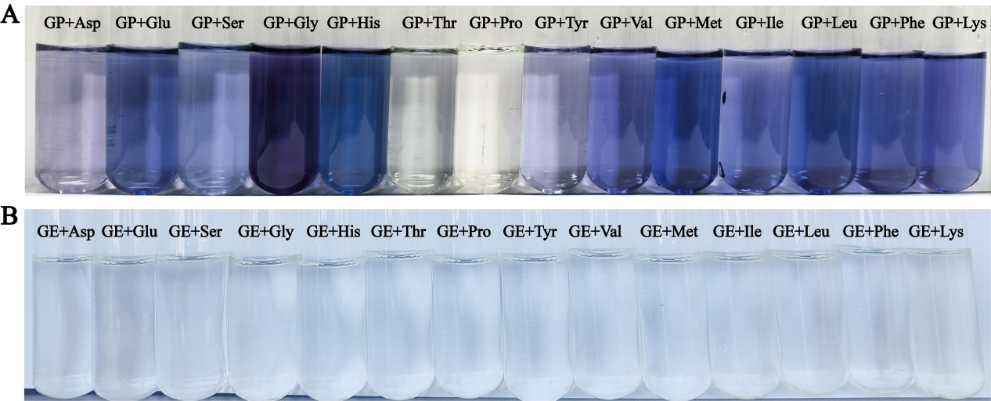

**Fig. S1.** Photographs of the reacted solution between the tested AAs and GP or GE incubated in buffer solution for 12 h. (A) Photographs of the reacted solution between the tested AAs and GP incubated in buffer solution for 12 h. (B) Photographs of the reacted solution between the tested AAs and GE incubated in buffer solution for 12 h.

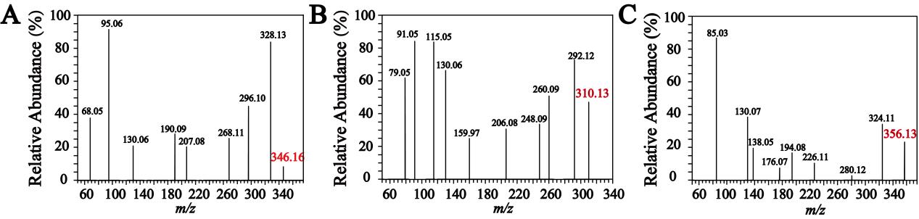

**Fig. S2.** MS/MS spectra of basic units in positive ion mode. (A) MS/MS spectrum of GH-B. (B) MS/MS spectrum of GT. (C) MS/MS spectrum of GG.

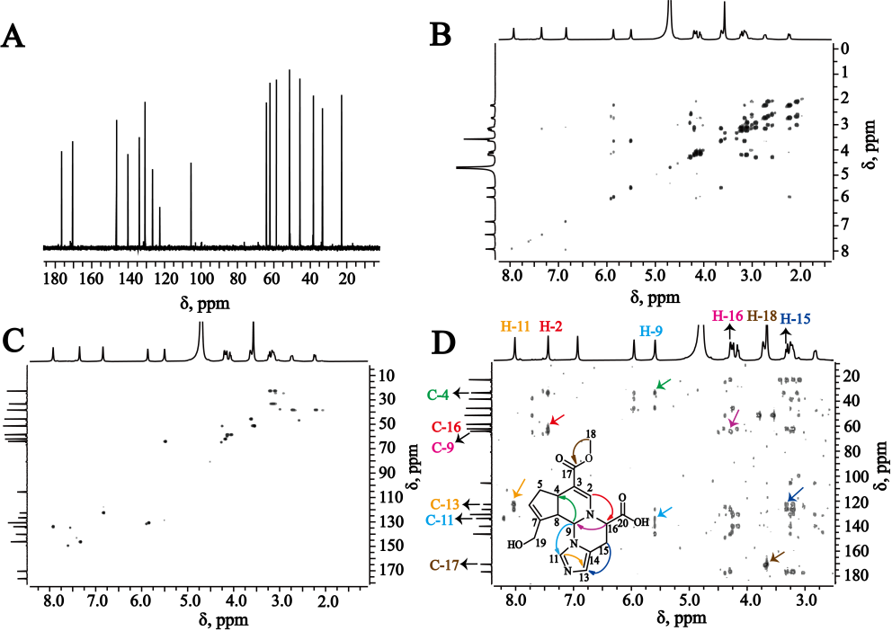

**Fig. S3.** NMR spectra of GH-A. (A) 13C NMR. (B) 1H−1H COSY. (C) HSQC. (D) HMBC.

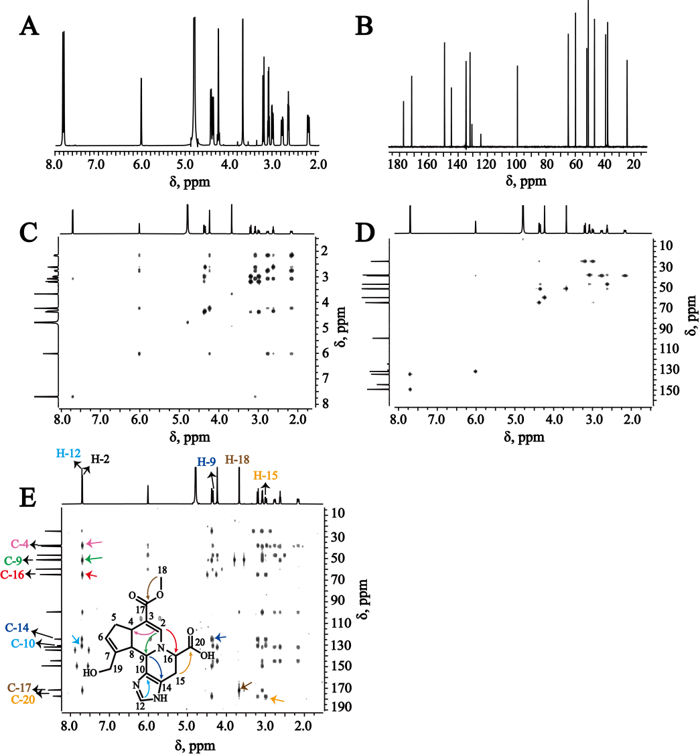

**Fig. S4.** NMR spectra of GH-B. (A) 1H NMR. (B) 13C NMR. (C) 1H−1H COSY. (D) HSQC. (E) HMBC. The 1H NMR spectrum showed 13 proton resonance signals, including three olefin proton signals at *δ*H 7.69 (1H, s), 6.01 (1H, s), and 7.71 (1H, s). Seventeen carbon signals are shown in the 13C NMR spectrum, from which the ester carbonyl at *δ*C 171.7, carboxyl at *δ*C 177.3, and seven olefinic carbons at *δ*C 149.3, 144.6, 134.6, 131.8, 130.6, 124.5, and 99.5 were observed. 1H−1H COSY confirmed the presence of '-CH(9)-CH(8)-CH(4)-CH2(5)-CH(6)-'. HSQC revealed eleven carbons, including three olefinic and eight aliphatic carbons. The *δ*C/*δ*H at 51.1/3.67 (3H, s) and 59.8/4.24 (2H, s) confirmed the presence of -OCH3 and -CH2OH moieties, respectively. In HMBC, the coupling between H-9 (*δ*H 4.35) with C-14 (*δ*C 124.5), H-12 (*δ*H 7.71) with C-10 (*δ*C 130.6), and H-2 (*δ*H 7.69) with C-9 (*δ*C 51.5) and C-16 (*δ*C 64.8) demonstrated that the connected position of GP and His was C-9 and C-10. Furthermore, the ester group was proved by the correlation between methoxyl protons (*δ*H 3.67) and carbonyl (*δ*C 171.7). The connected position of carboxyl group was demonstrated through HMBC correlations of H-15 (*δ*H 3.19 and 2.99) and C-20 (*δ*C 177.3). The detailed NMR data of GH-B were shown in **Table 1**, which was identified as a new compound, named as genihistidine B.

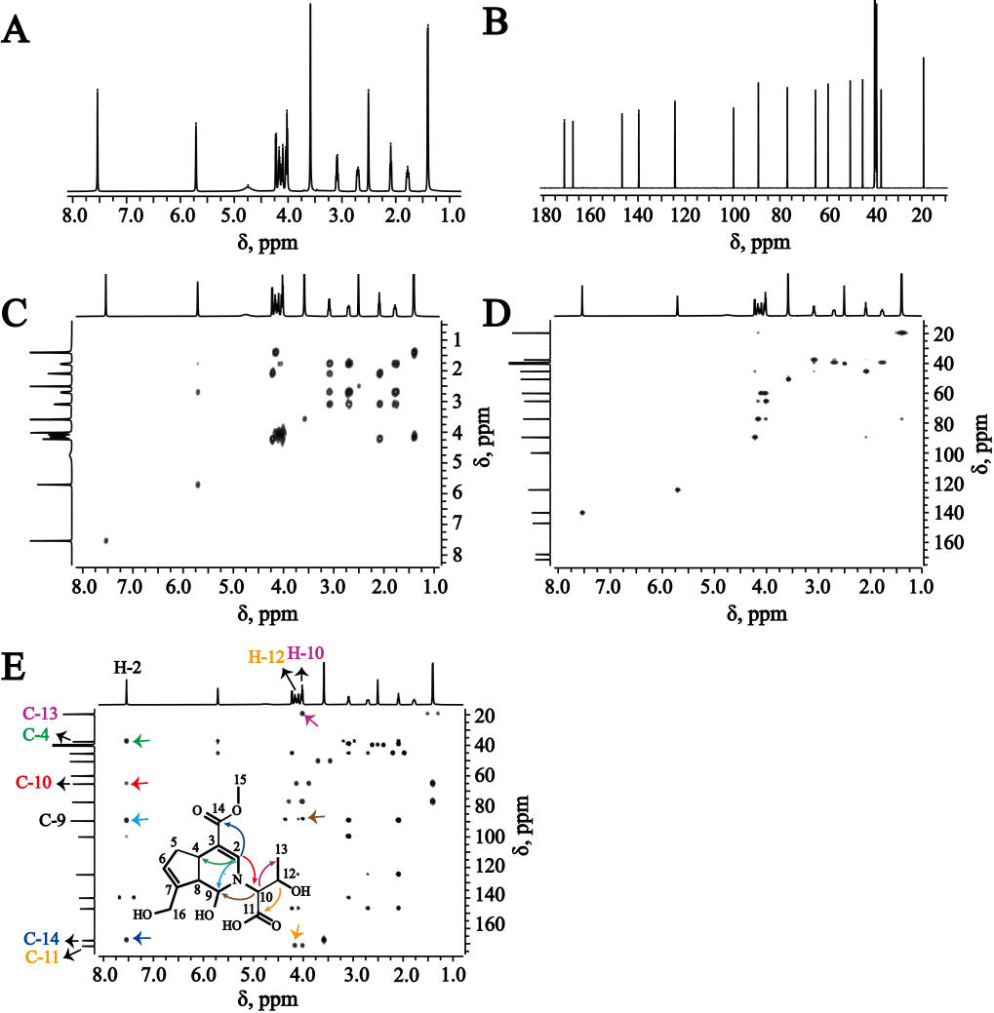

**Fig. S5.** NMR spectra of GT. (A) 1H NMR. (B) 13C NMR. (C) 1H−1H COSY. (D) HSQC. (E) HMBC. The 1H NMR spectrum showed 13 proton resonance signals, containing two olefin proton signals at *δ*H 7.54 (1H, s) and 5.71 (1H, s). 13C NMR spectrum displayed 15 carbons signals, including ester carbonyl at *δ*C 167.5, carboxyl at *δ*C 171.2, and olefinic carbons at *δ*C 139.7, 99.6, 124.4, and 146.7. In 1H−1H COSY spectrum, the existence of '-CH(9)-CH(8)-CH(4)-CH2(5)-CH(6)-' was demonstrated. Two olefinic and nine aliphatic carbons were discovered in HSQC spectrum, from which the -OCH3 moiety was revealed by *δ*C/*δ*H at 50.3/3.59 (3H, s), the -CH2OH moiety by *δ*C/*δ*H at 59.6/4.04, 4.10 (each 1H, d, *J* = 15.0 Hz), and the -CHOH moieties by *δ*C/*δ*H at 76.9/4.17 (1H, m) and 89.1/4.22 (1H, d, *J* = 8.4 Hz). In HMBC, the connected positions of N-1 and C-10 between GP and Thr could be confirmed by the correlations of H-10 (*δ*H 4.02) with C-9 (*δ*C 89.1) and C-13 (*δ*C 19.2), H-2 (*δ*H 7.54) with C-9 (*δ*C 89.1) and C-10 (*δ*C 64.9), and H-12 (*δ*H 4.17) with C-11 (*δ*C 171.2). In addition, the correlations of H-2 (*δ*H 7.54) with C-14 (*δ*C 167.5) and C-4 (*δ*C 37.2) were also found in the spectrum. The detailed NMR data of GT were shown in **Table 1**, which was identified as a new compound, named as genithreonine.

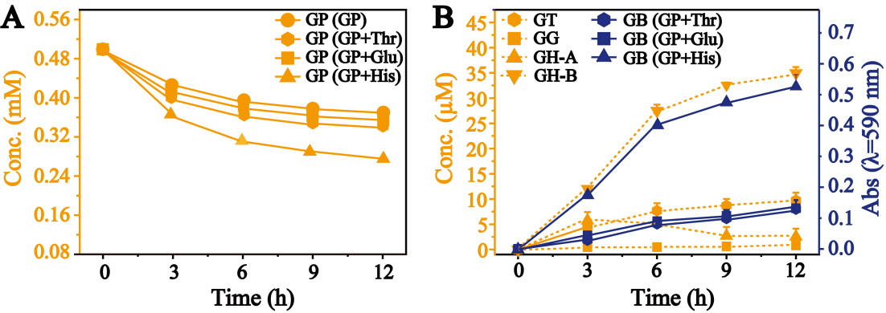

**Fig. S6.** Reaction kinetic curves of GP, basic units, and GB along with time in the reacted solution at pH 6.0. (A) Reaction kinetic curves of GP along with time in the reacted solution. (B) Reaction kinetic curves of basic units and GB formed along with time in the reacted solution.

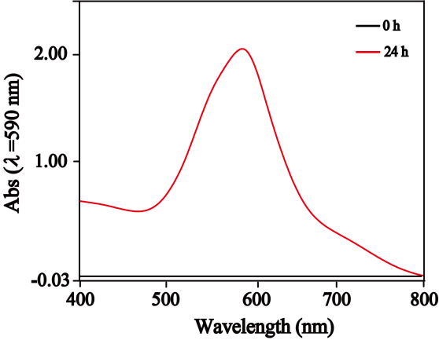

**Fig. S7.** UV–vis spectra of GH-A in buffer solution at pH 7.35.

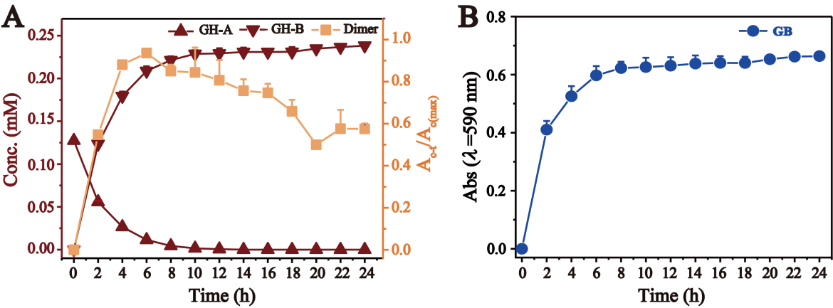

**Fig. S8.** Reaction kinetic curves of GH-A, GH-B, dimer, and GB in the reacted solution of GH-A at pH 6.0 along with time for 24 h. (A) Reaction kinetic curves of GH-A, GH-B, and dimer in the reacted solution along with time (Ac-t/Ac(max), the peak area of dimer divided by the maximum peak area at different reaction time; Ac-t, the peak area of dimer (c) at the different reaction time (t)). (B) Reaction kinetic curves of GB produced from GH-A in the reacted solution along with time.

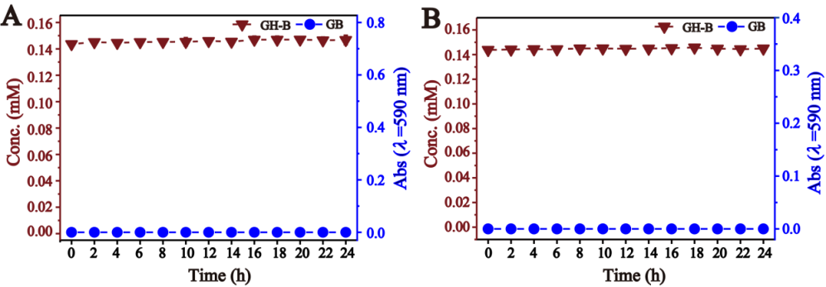

**Fig. S9.** Reaction kinetic curves of GH-B and GB along with time in different buffer solution. (A) Reaction kinetic curves of GH-B and GB along with time in buffer solution at pH 7.35. (B) Reaction kinetic curves of GH-B and GB along with time in buffer solution at pH 6.0.

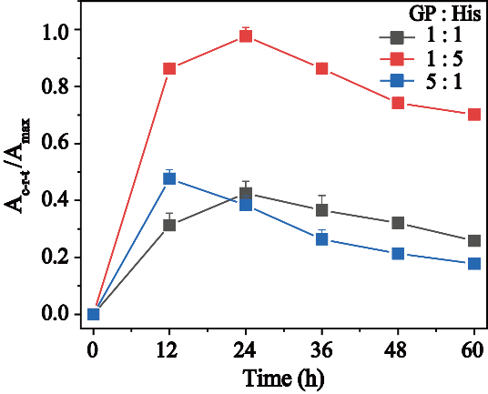

**Fig. S10.** Reaction kinetic curves of dimer produced by the different reacted ratios of GP and His along with time (Ac-r-t/Amax, the peak area of dimer divided by the maximum peak area; Ac-r-t, the peak area of dimer (c) at the fixed reacted ratio of GP and His (r) at different reaction time (t)).

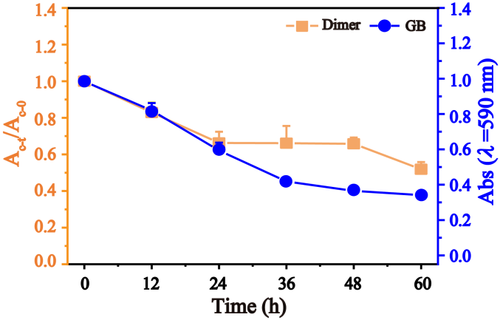

**Fig. S11.** Reaction kinetic curves of dimer and the absorbance of the reacted solution at 590 nm along with time at pH 6.0 (Ac-t/Ac-0, the peak area of dimer at different reaction time divided by that at 0 h; Ac-t, the peak area of the dimer (c) at the different time (t)).

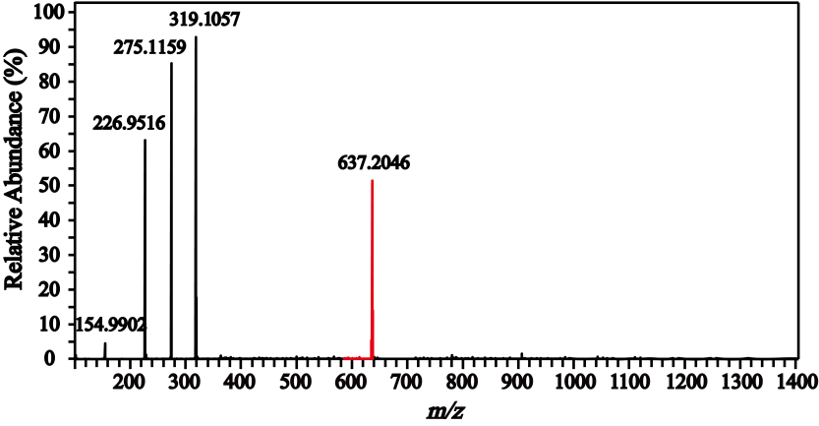

**Fig. S12.** MS spectrum of the dimer in positive ion mode.

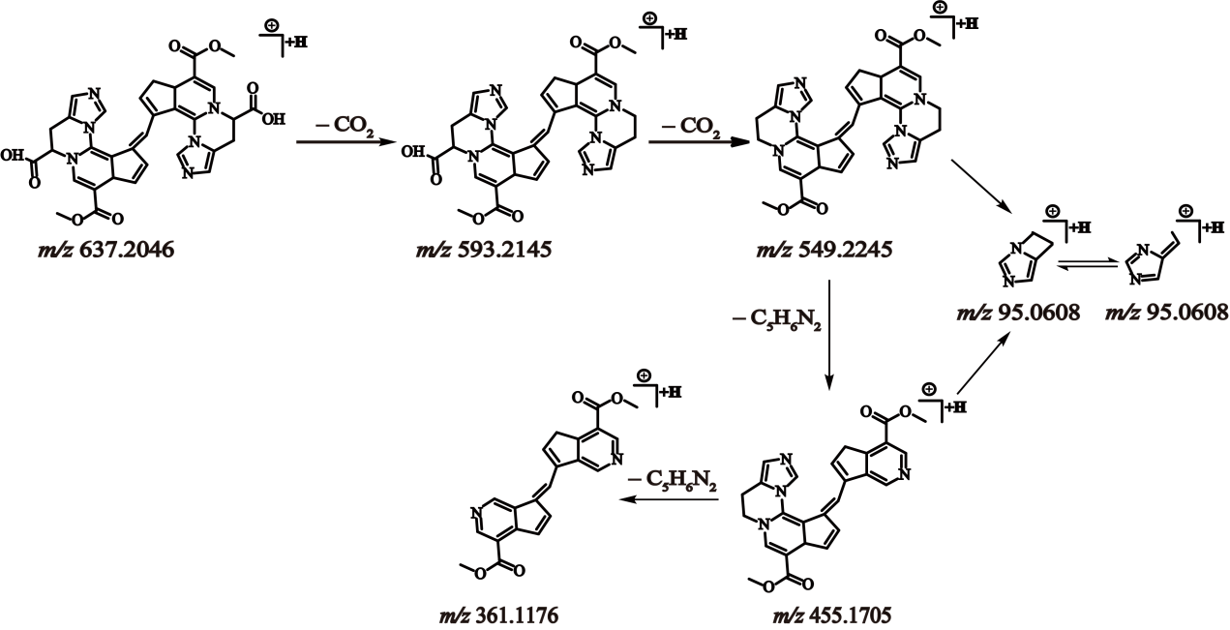

**Fig. S13.** The proposed mass fragmentation pathways of dimer.

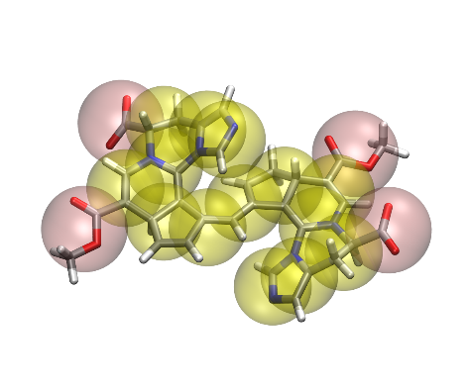

**Fig. S14.** Coarse-grained molecular diagram of dimer.