**Supporting information**

**Three new spirocyclic** **terpenoids from *Euphorbia amygdaloides* exhibit cytotoxicity against cancerous cell lines through early and late apoptosis**

**Ardalan Pasdaran a, b, e, Negar Azarpira c, Mahdokht Hossein Aghdaie c, Maryam Zare d, e,** **Negin Sheidaie d, e,** **Fatemeh Hajeb Fard d, e, Azadeh Hamedi a, e\***

a Medicinal Plants Processing Research Center, Shiraz University of Medical Sciences, Shiraz, Iran.

b Phytopharmaceutical Technology and Traditional Medicine Incubator, Shiraz University of Medical Sciences, Shiraz, Iran.

c Transplant Research Center, Shiraz University of Medical Sciences, Shiraz, Iran.

d Student research committee, School of Pharmacy, Shiraz University of Medical Sciences, Shiraz, Iran.

e Department of Pharmacognosy, School of Pharmacy, Shiraz University of Medical Sciences, Shiraz, Iran.

Corresponding Authors

*Tel: +987132424127-ext.246. E-mail: [Hamediaz@sums.ac.ir](mailto:Hamediaz@sums.ac.ir).

**Table of contents**

**Figure S1.** A diagram of the procedure for purifying Zagrosin I-III

**Figure S2.** LC chromatogram ‎of Zagrosin 1 (up) and its fragmentation pattern (down).

**Figure S3.** 1H NMR (300 MHz, chloroform-d) spectrum of Zagrosin ***1***.

**Figure S4.** 13C NMR(‎75 ‎MHz, chloroform-d) spectrum of Zagrosin ***1.***

**Figure S5.** DEPT 135 spectrum of Zagrosin ***1.***

**Figure S6.** HMBC spectrum of Zagrosin ***1.***

**Figure S7**. ExpandedHMBC spectrum of Zagrosin ***1***

**Figure S8**. ExpandedHMBC spectrum of Zagrosin ***1***

**Figure S9**. ExpandedHMBC spectrum of Zagrosin ***1***

**Figure S10.** ‎ HSQC-TCOSY spectrum of Zagrosin ***1.***

**Figure S11**. ExpandedHSQC-TCOSY spectrum of Zagrosin ***1.***

**Figure S12**. ExpandedHSQC-TCOSY spectrum of Zagrosin ***1.***

**Figure S13.** ‎ UV spectra ‎of Zagrosin ***1***.

**Figure S14.** LC chromatogram ‎of Zagrosin 2 (up) and its fragmentation pattern (down).

**Figure S15.** 1H NMR (300 MHz, chloroform-d) spectrum of Zagrosin ***2***.

**Figure S16.** 13C NMR(‎75 ‎MHz, chloroform-d) spectrum of Zagrosin ***2.***

**Figure S17.** DEPT 135 spectrum of Zagrosin ***2.***

**Figure S18.** HMBC spectrum of Zagrosin ***2.***

**Figure S19.** Expanded HMBC spectrum of Zagrosin ***2.***

**Figure S20.** Expanded HMBC spectrum of Zagrosin ***2.***

**Figure S21.** Expanded HMBC spectrum of Zagrosin ***2.***

**Figure S22.** ‎ HSQC-TCOSY spectrum of Zagrosin ***2.***

**Figure S23.** Expanded HSQC-TCOSY spectrum of Zagrosin ***2.***

**Figure S24.** Expanded HSQC-TCOSY spectrum of Zagrosin ***2.***

**Figure S25.** ‎ UV spectra ‎of Zagrosin ***2***.

**Figure S26.** LC chromatogram of Zagrosin 3 and its fragmentation pattern.

**Figure S27.** 1H NMR (300 MHz, chloroform-d) spectrum of Zagrosin ***3***.

**Figure S28.** 13C NMR(‎75 ‎MHz, chloroform-d) spectrum of Zagrosin ***3.***

**Figure S29.** DEPT 135 spectrum of Zagrosin ***3.***

**Figure S30.** HMBC spectrum of Zagrosin ***3.***

**Figure S31.** Expanded HMBC spectrum of Zagrosin ***3.***

**Figure S32.** ‎ HSQC-TCOSY spectrum of Zagrosin ***3.***

**Figure S33.** ExpandedHSQC-TCOSY spectrum of Zagrosin ***3.***

**Figure S34.** ExpandedHSQC-TCOSY spectrum of Zagrosin ***3.***

**Figure S35.** UV spectra ‎of Zagrosin ***3***.

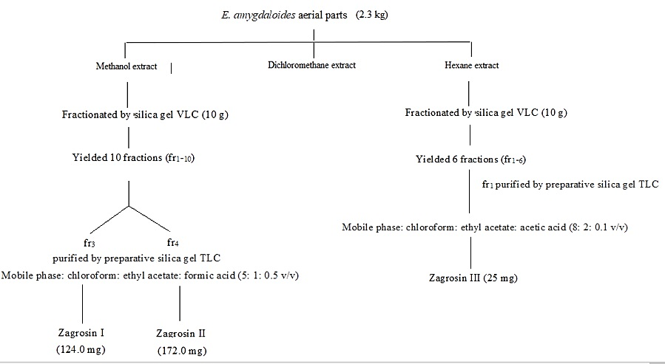

**Figure S1.** A diagram of the procedure for purifying Zagrosin I-III



**Figure S2.** LC chromatogram ‎of Zagrosin 1 (up) and its fragmentation pattern (down).

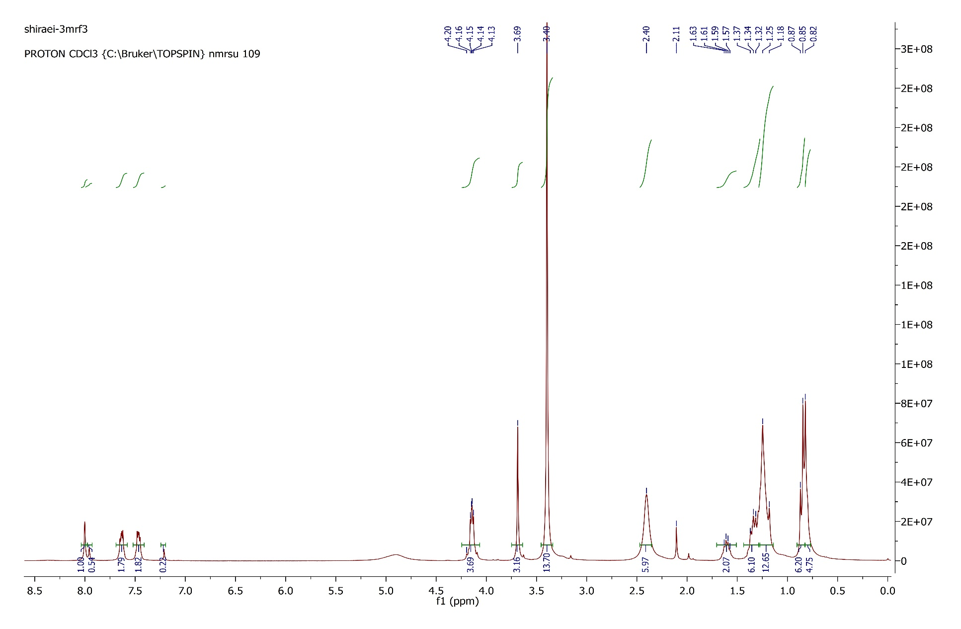

**Figure S3.** 1H NMR (300 MHz, chloroform-d) spectrum of Zagrosin ***1***.

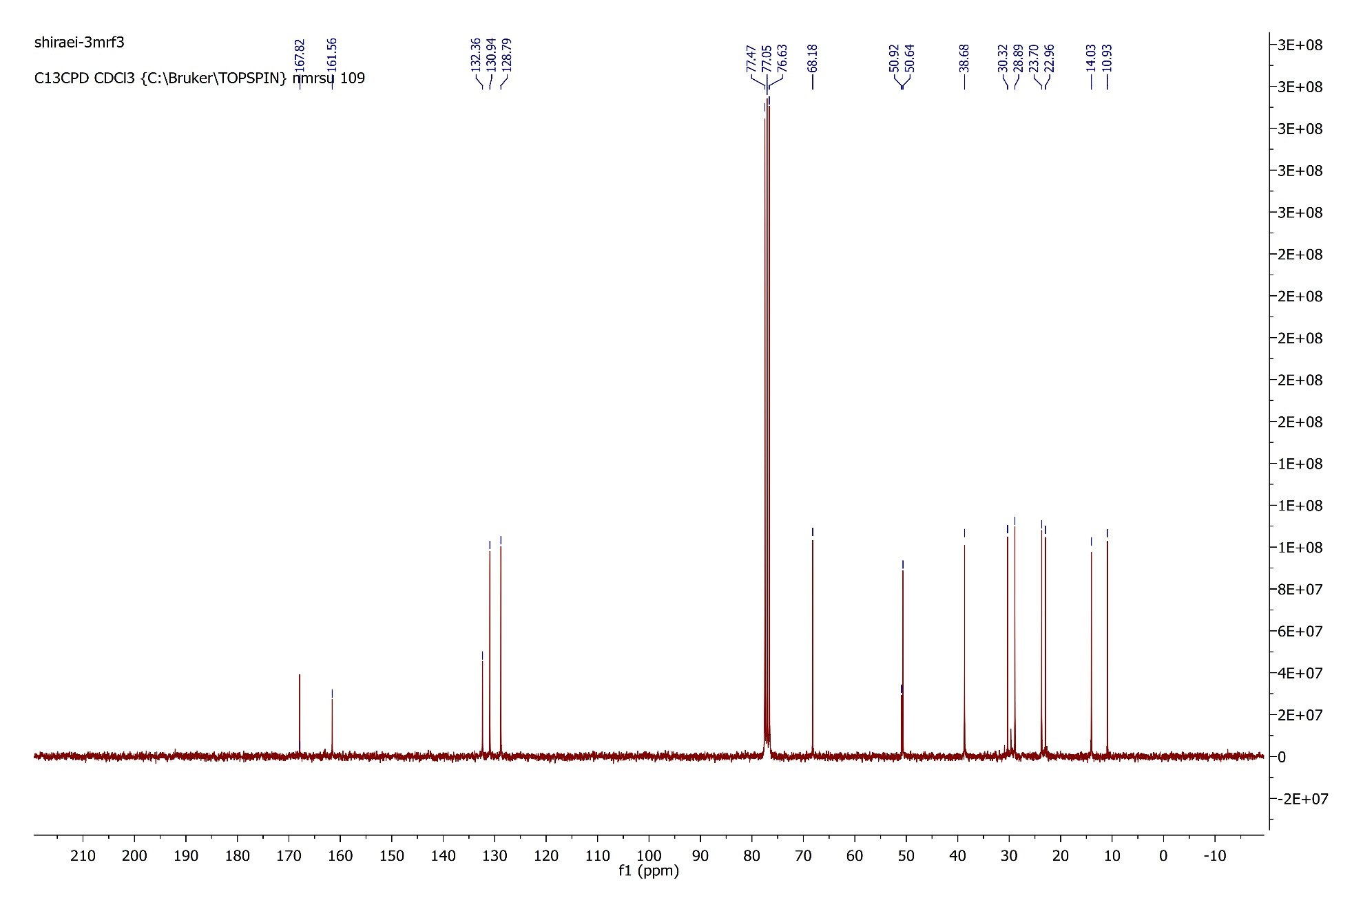

**Figure S4.** 13C NMR(‎75 ‎MHz, chloroform-d) spectrum of Zagrosin ***1.***

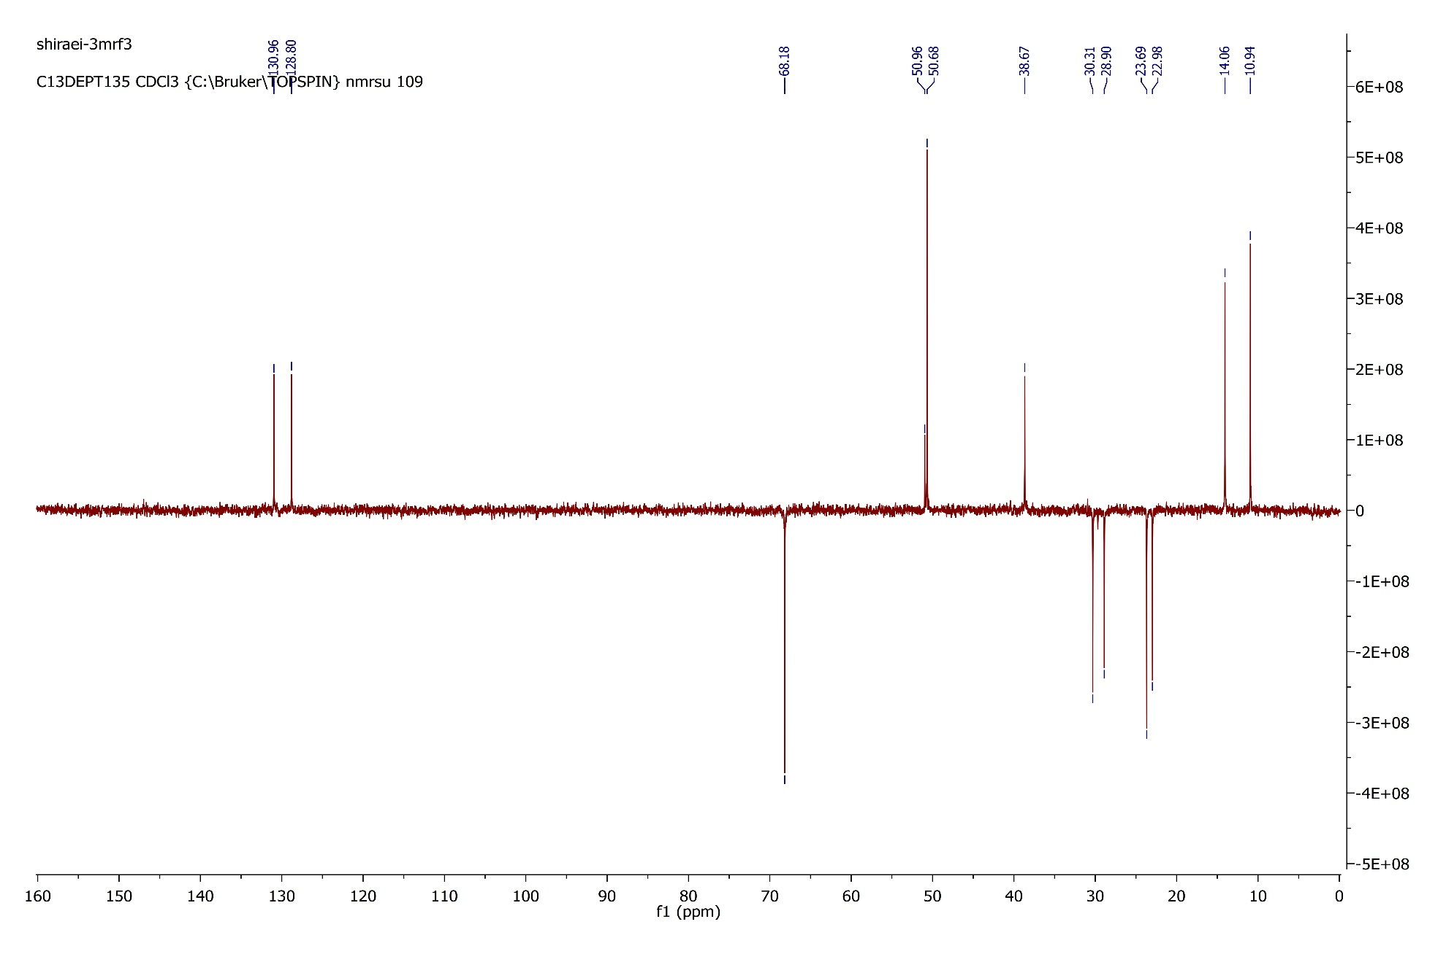

**Figure S5.** DEPT 135 spectrum of Zagrosin ***1.***

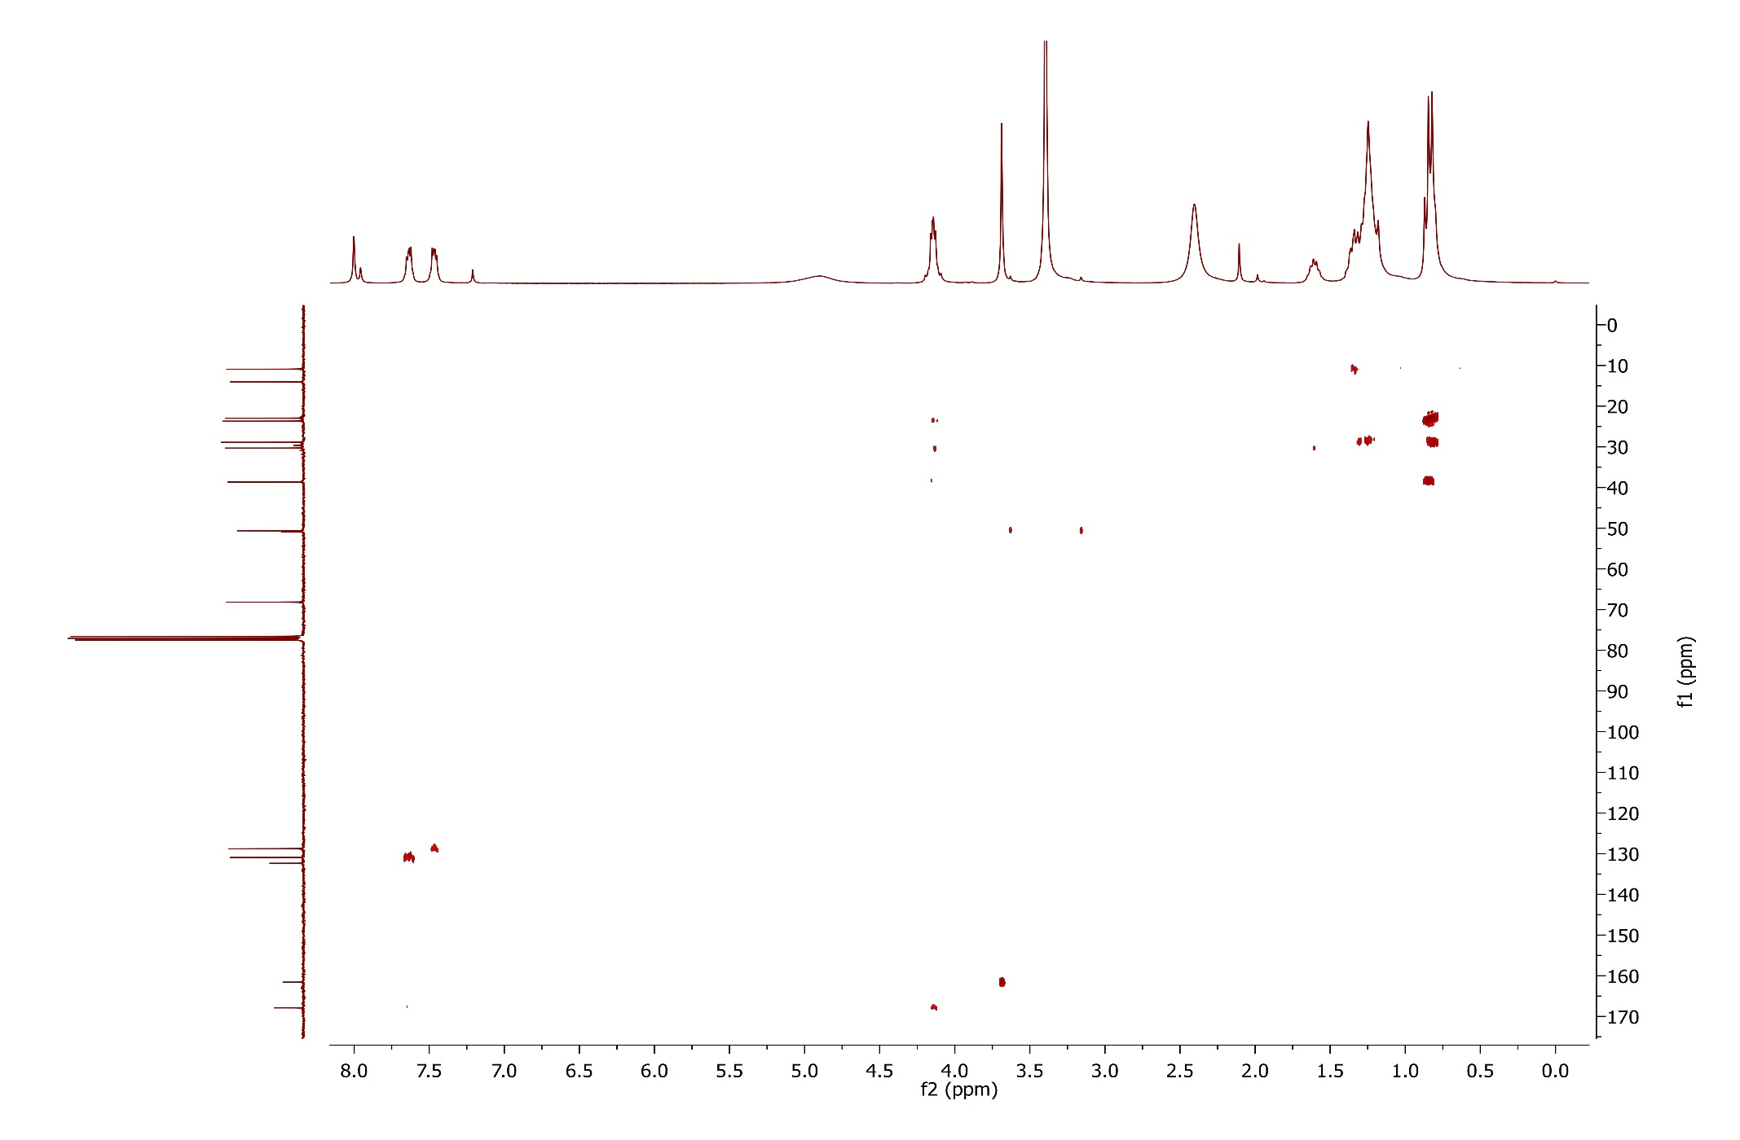

**Figure S6.** HMBC spectrum of Zagrosin ***1.***

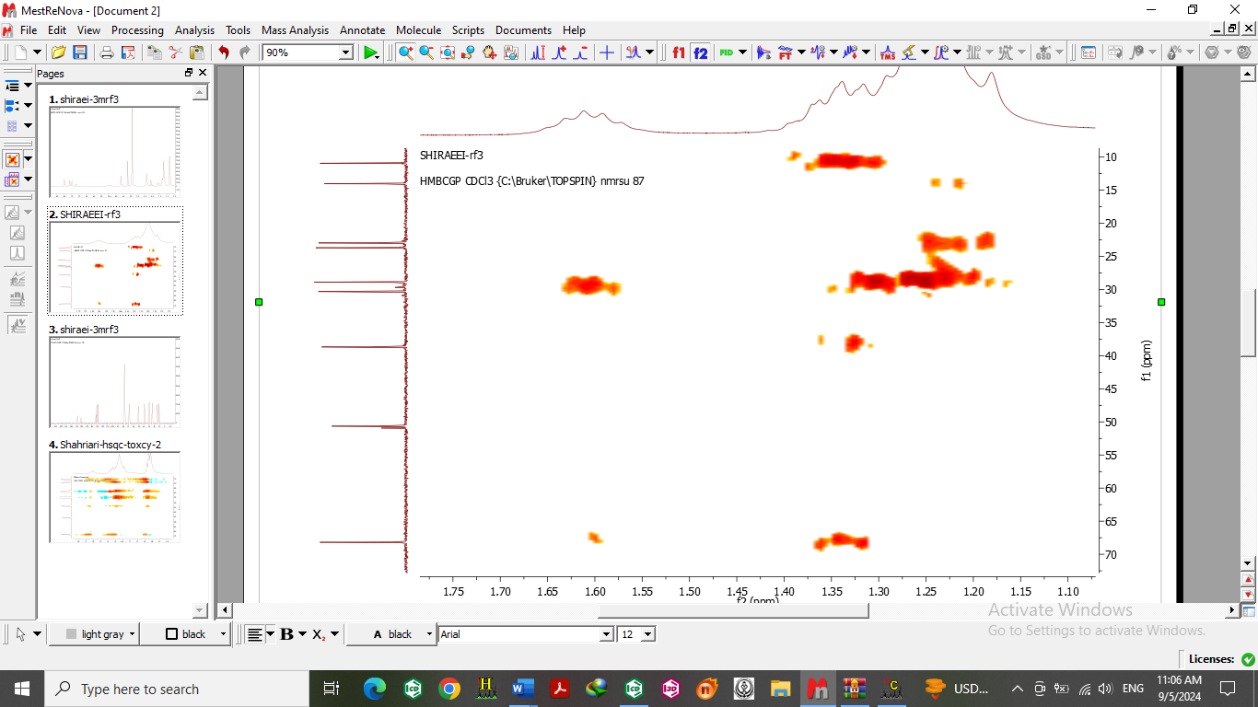

**Figure S7**. ExpandedHMBC spectrum of Zagrosin ***1.***

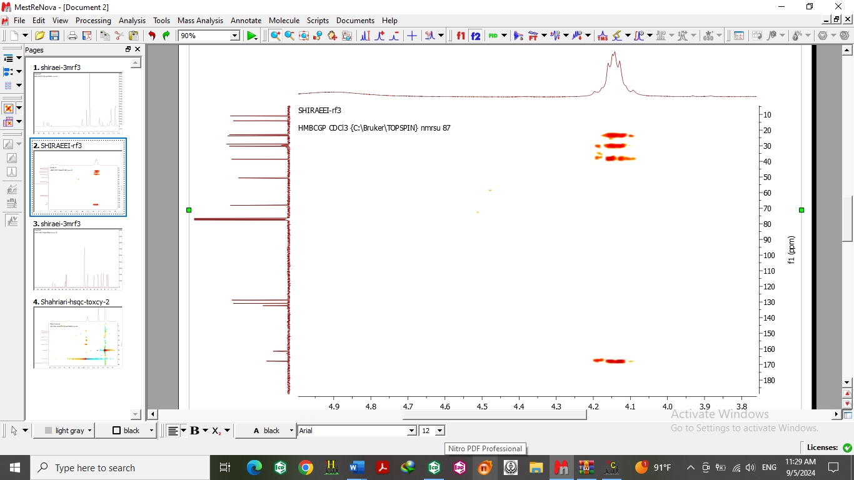

**Figure S8**. ExpandedHMBC spectrum of Zagrosin ***1.***

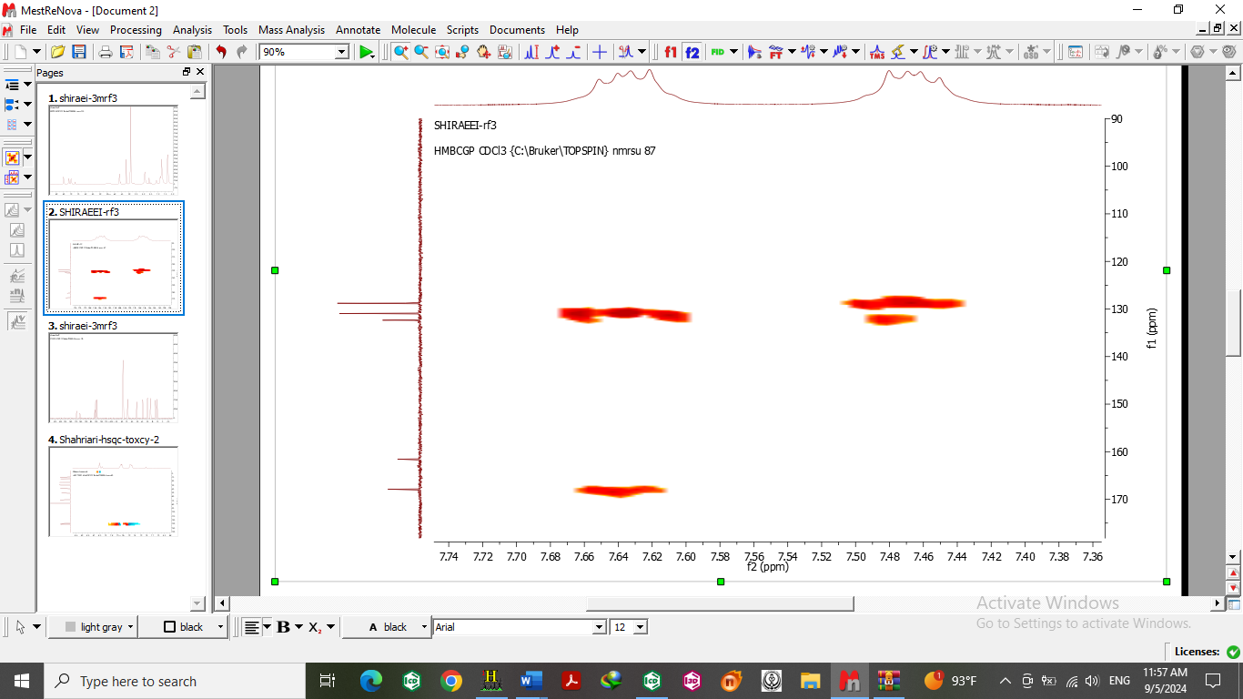

**Figure S9**. ExpandedHMBC spectrum of Zagrosin ***1.***

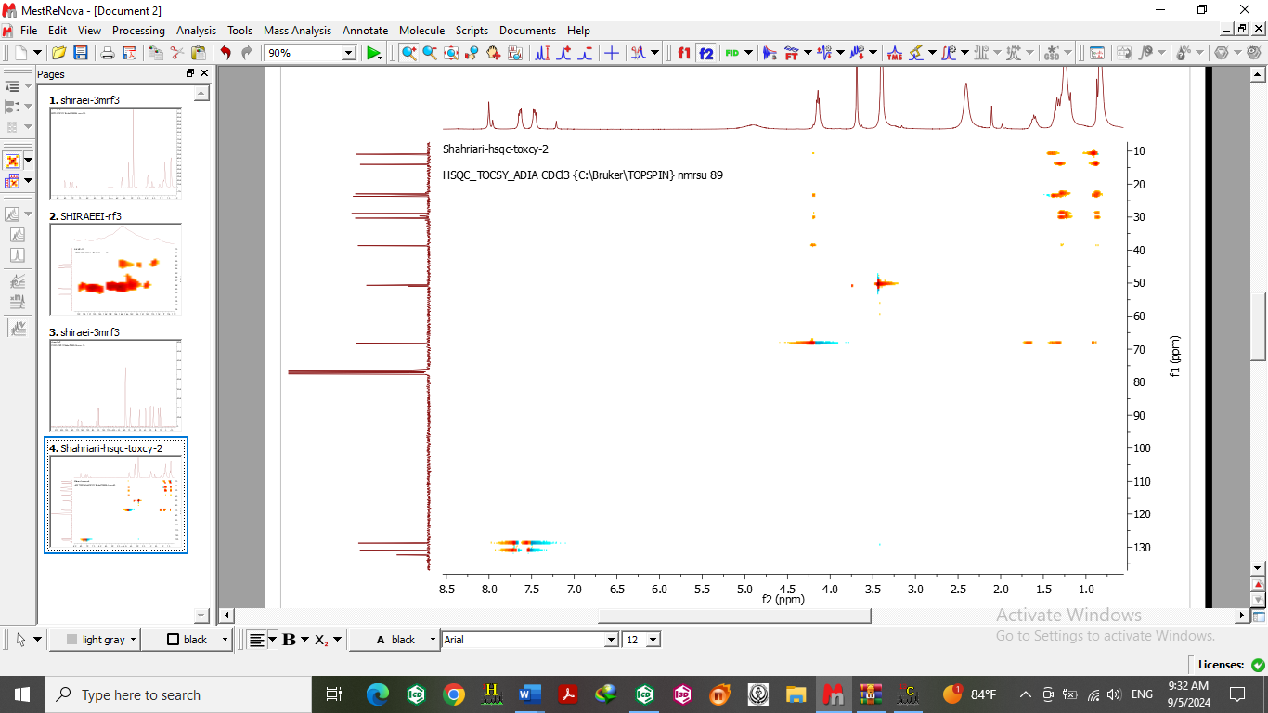

**Figure S10.** HSQC-TCOSY spectrum of Zagrosin ***1.***

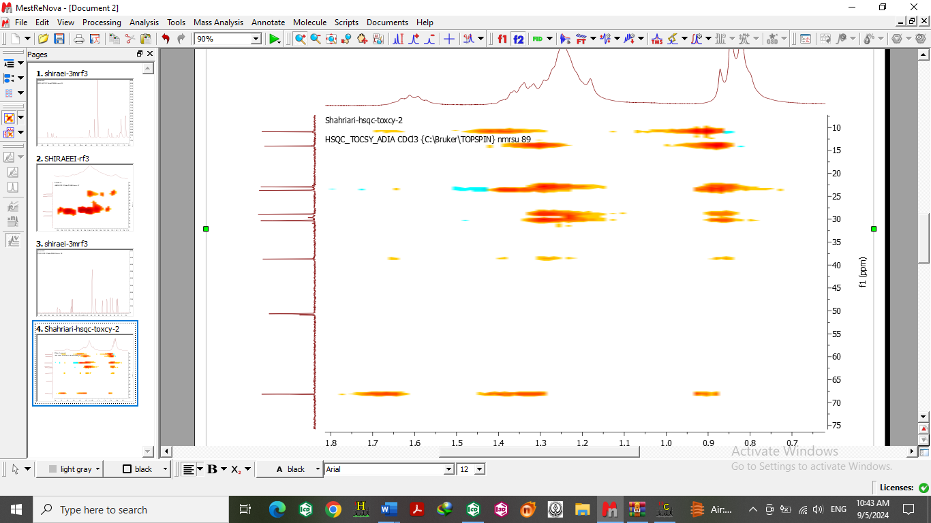

**Figure S11**. ExpandedHSQC-TCOSY spectrum of Zagrosin ***1.***

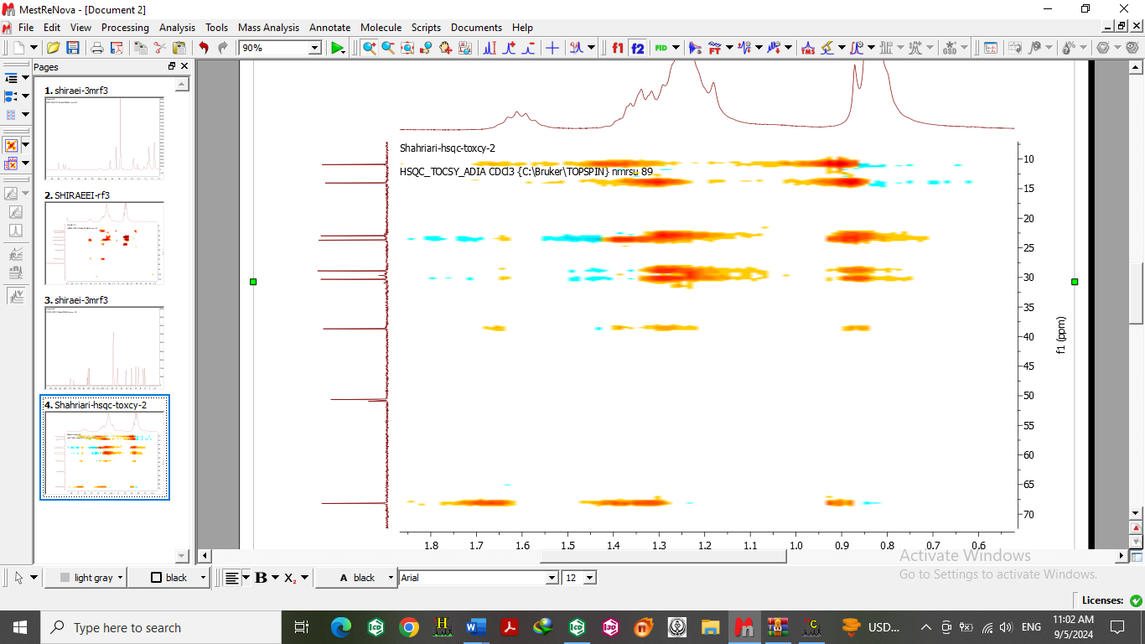

**Figure S12**. ExpandedHSQC-TCOSY spectrum of Zagrosin ***1.***

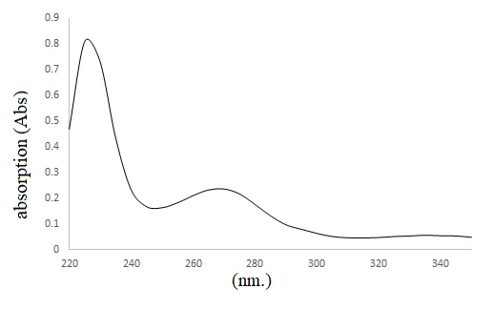

**Figure S13.** ‎ UV spectra ‎of Zagrosin ***1***.

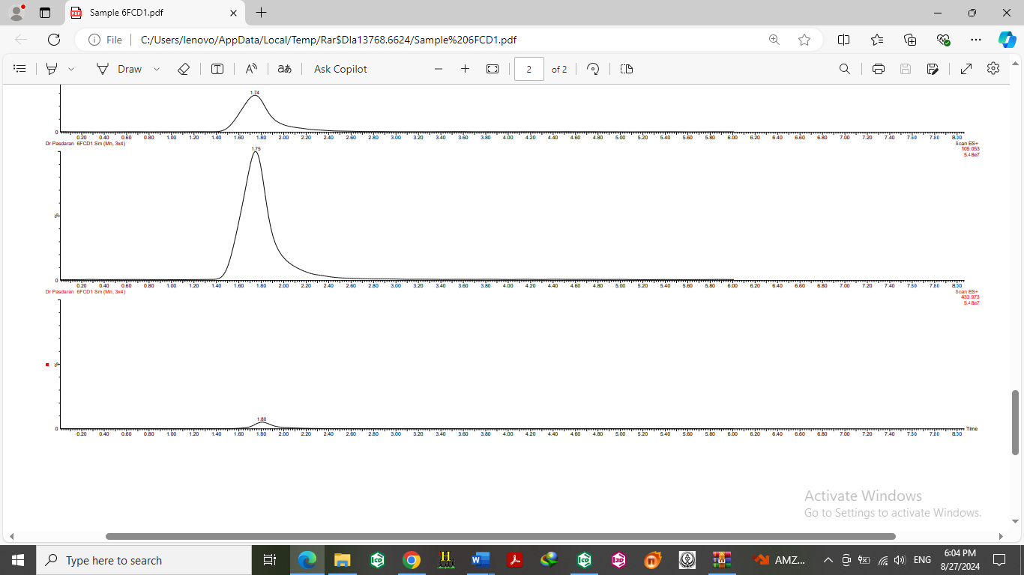

**Figure S14.** ‎ LC chromatogram ‎of Zagrosin 2 (up) and its fragmentation pattern (down).

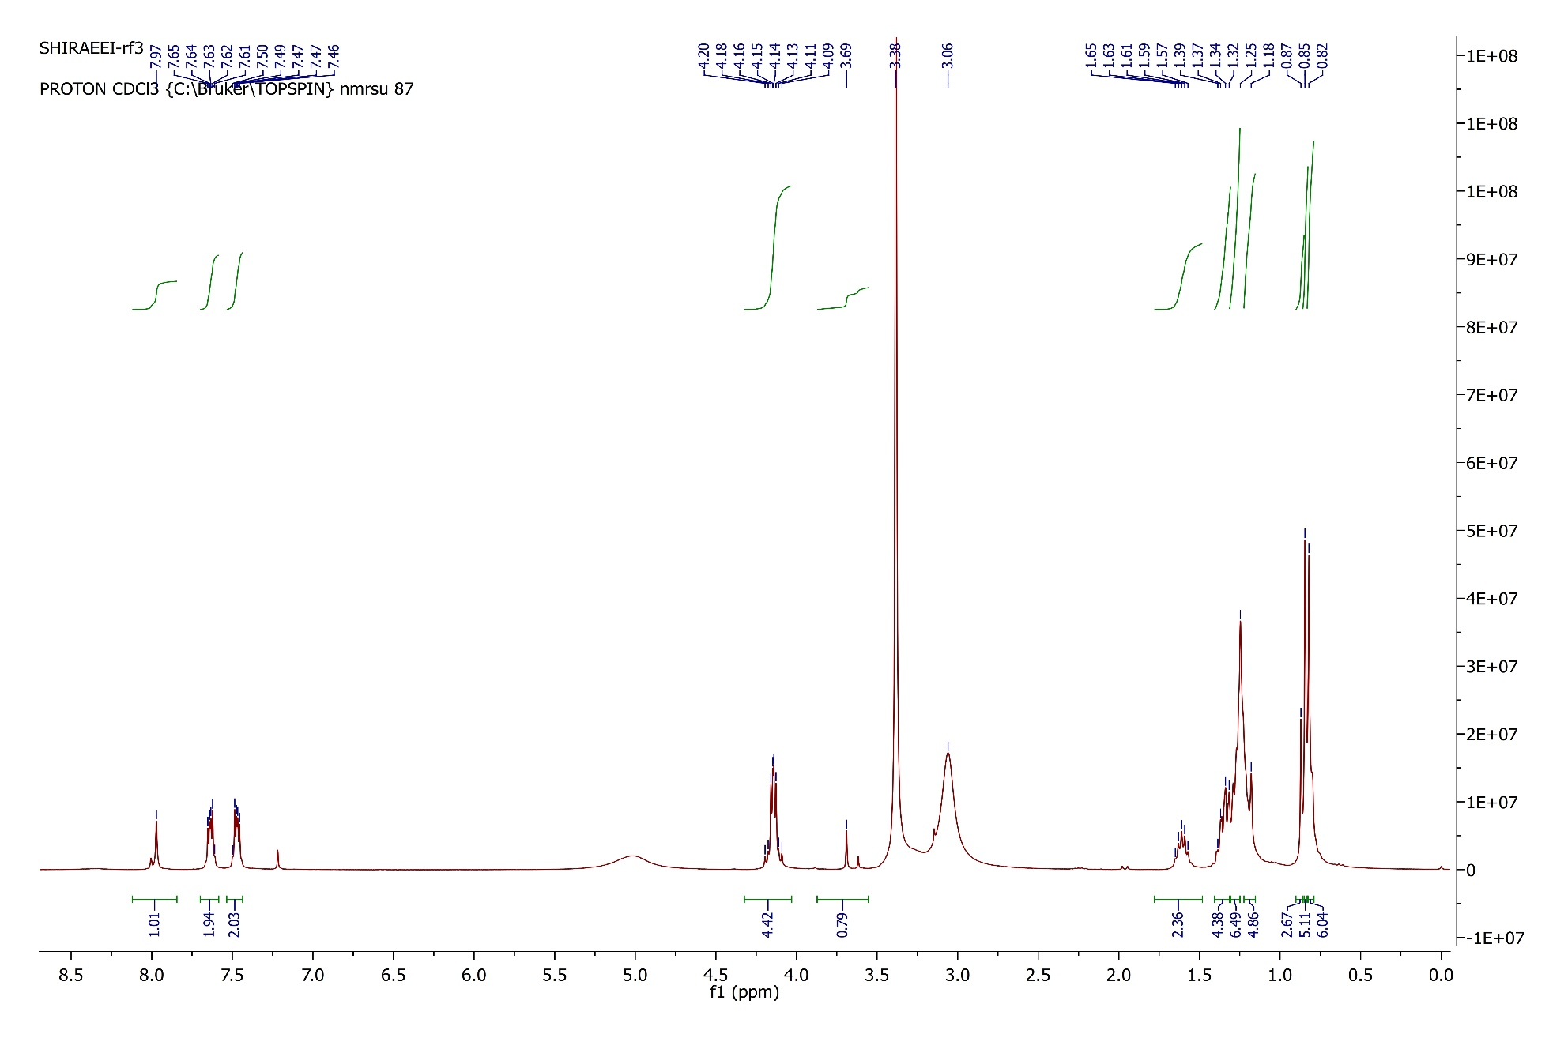

**Figure S15.** 1H NMR (300 MHz, chloroform-d) spectrum of Zagrosin ***2***.

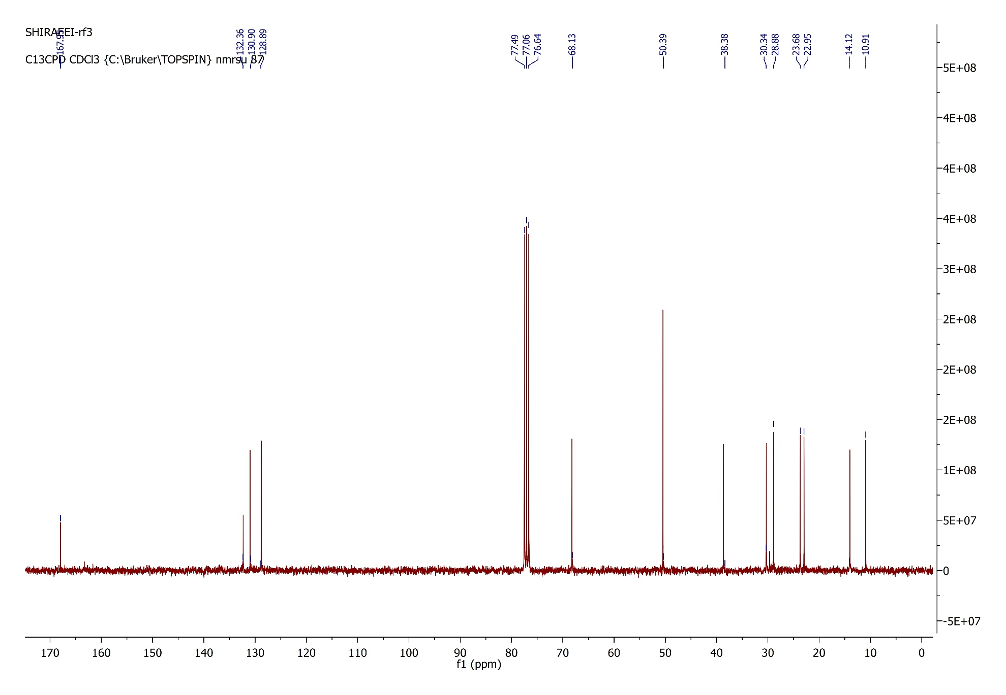

**Figure S16.** 13C NMR(‎75 ‎MHz, chloroform-d) spectrum of Zagrosin ***2.***

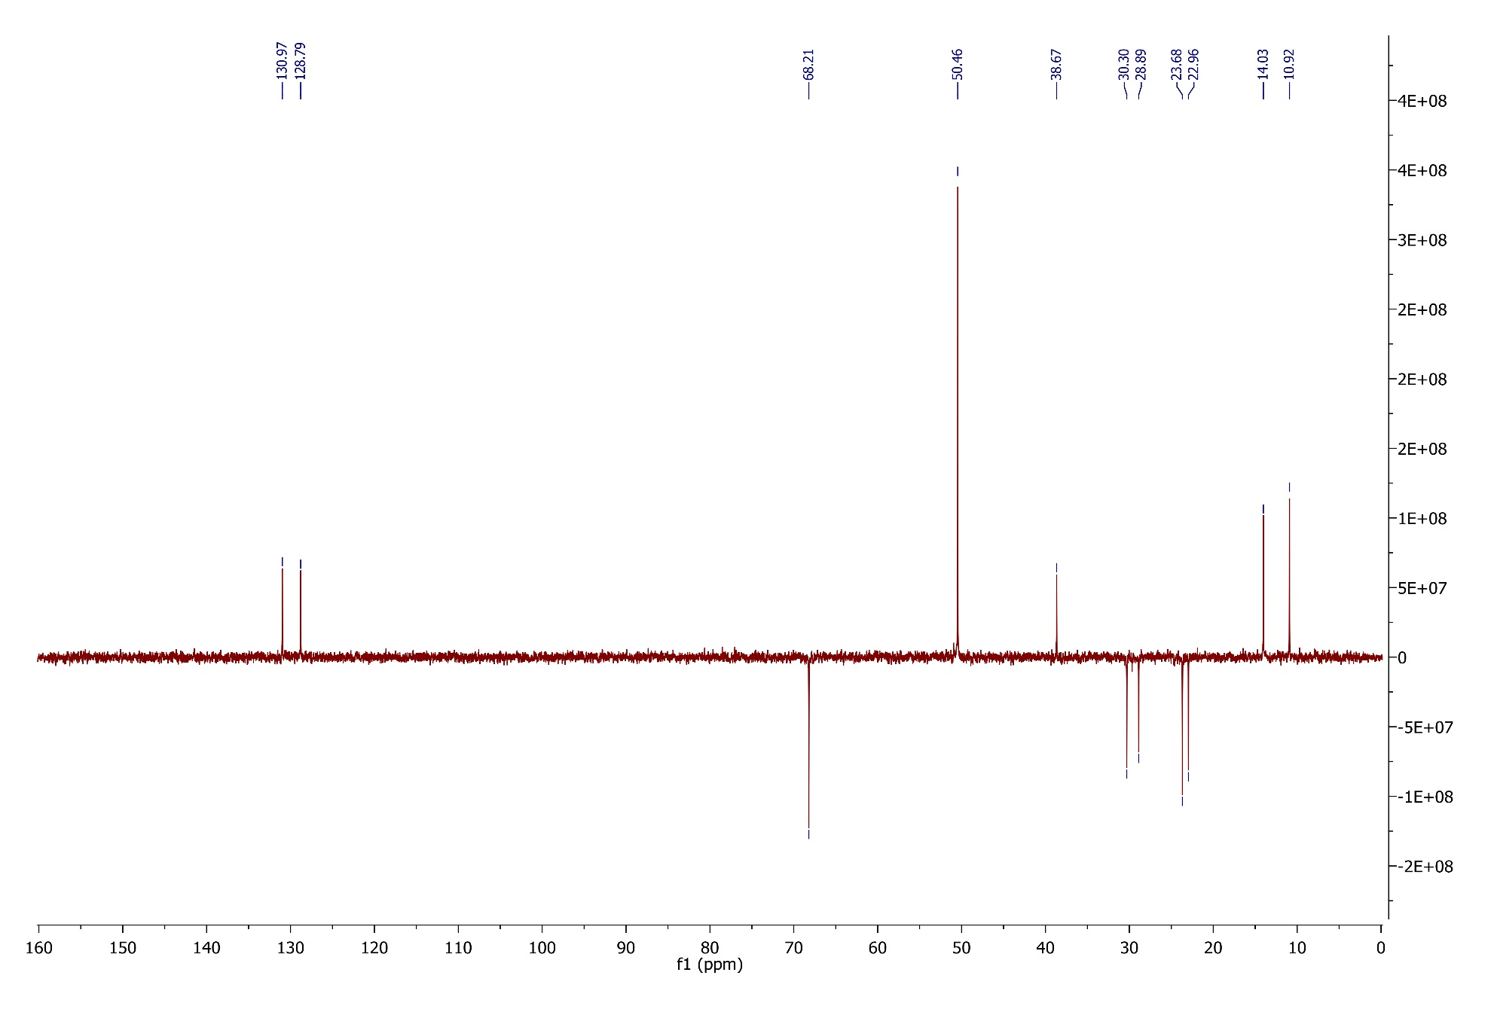

**Figure S17.** DEPT 135 spectrum of Zagrosin ***2.***

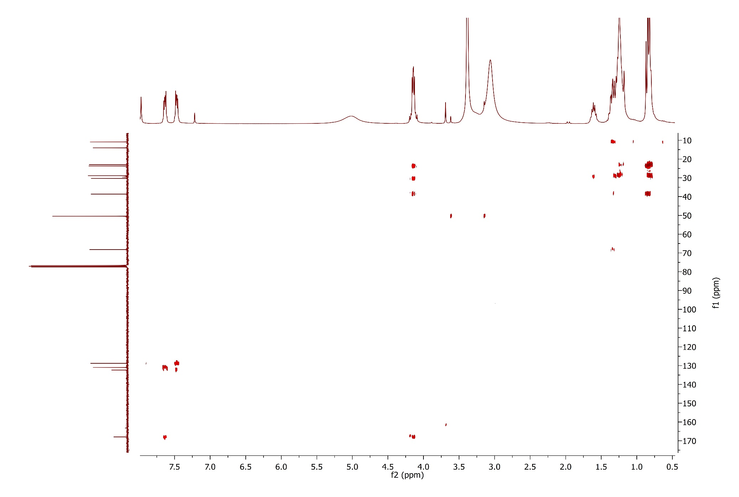

**Figure S18.** HMBC spectrum of Zagrosin ***2.***

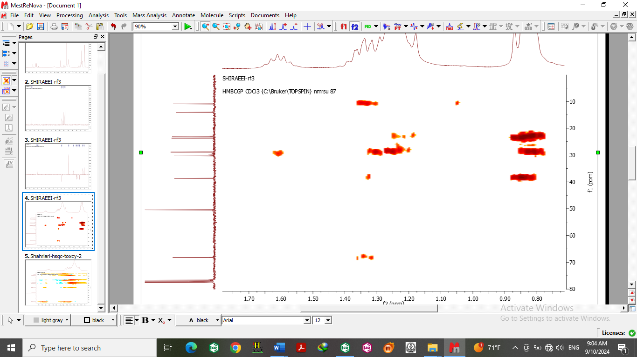

**Figure S19.** Expanded HMBC spectrum of Zagrosin ***2.***

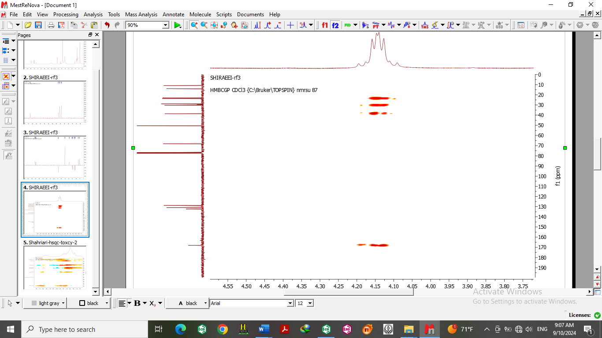

**Figure S20.** Expanded HMBC spectrum of Zagrosin ***2.***

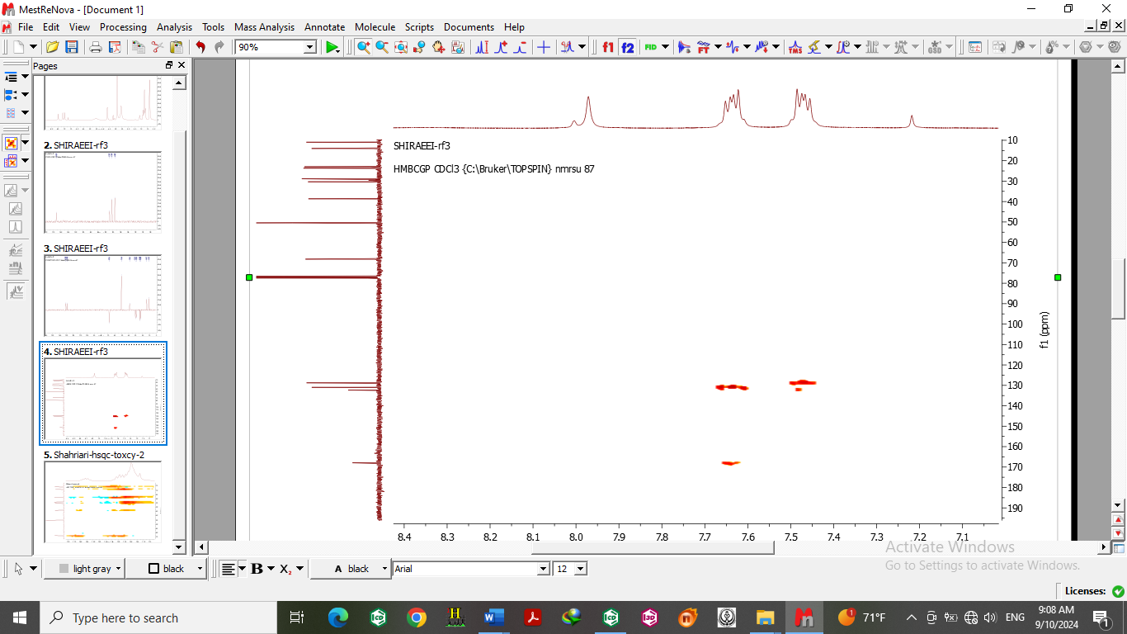

**Figure S21.** Expanded HMBC spectrum of Zagrosin ***2.***

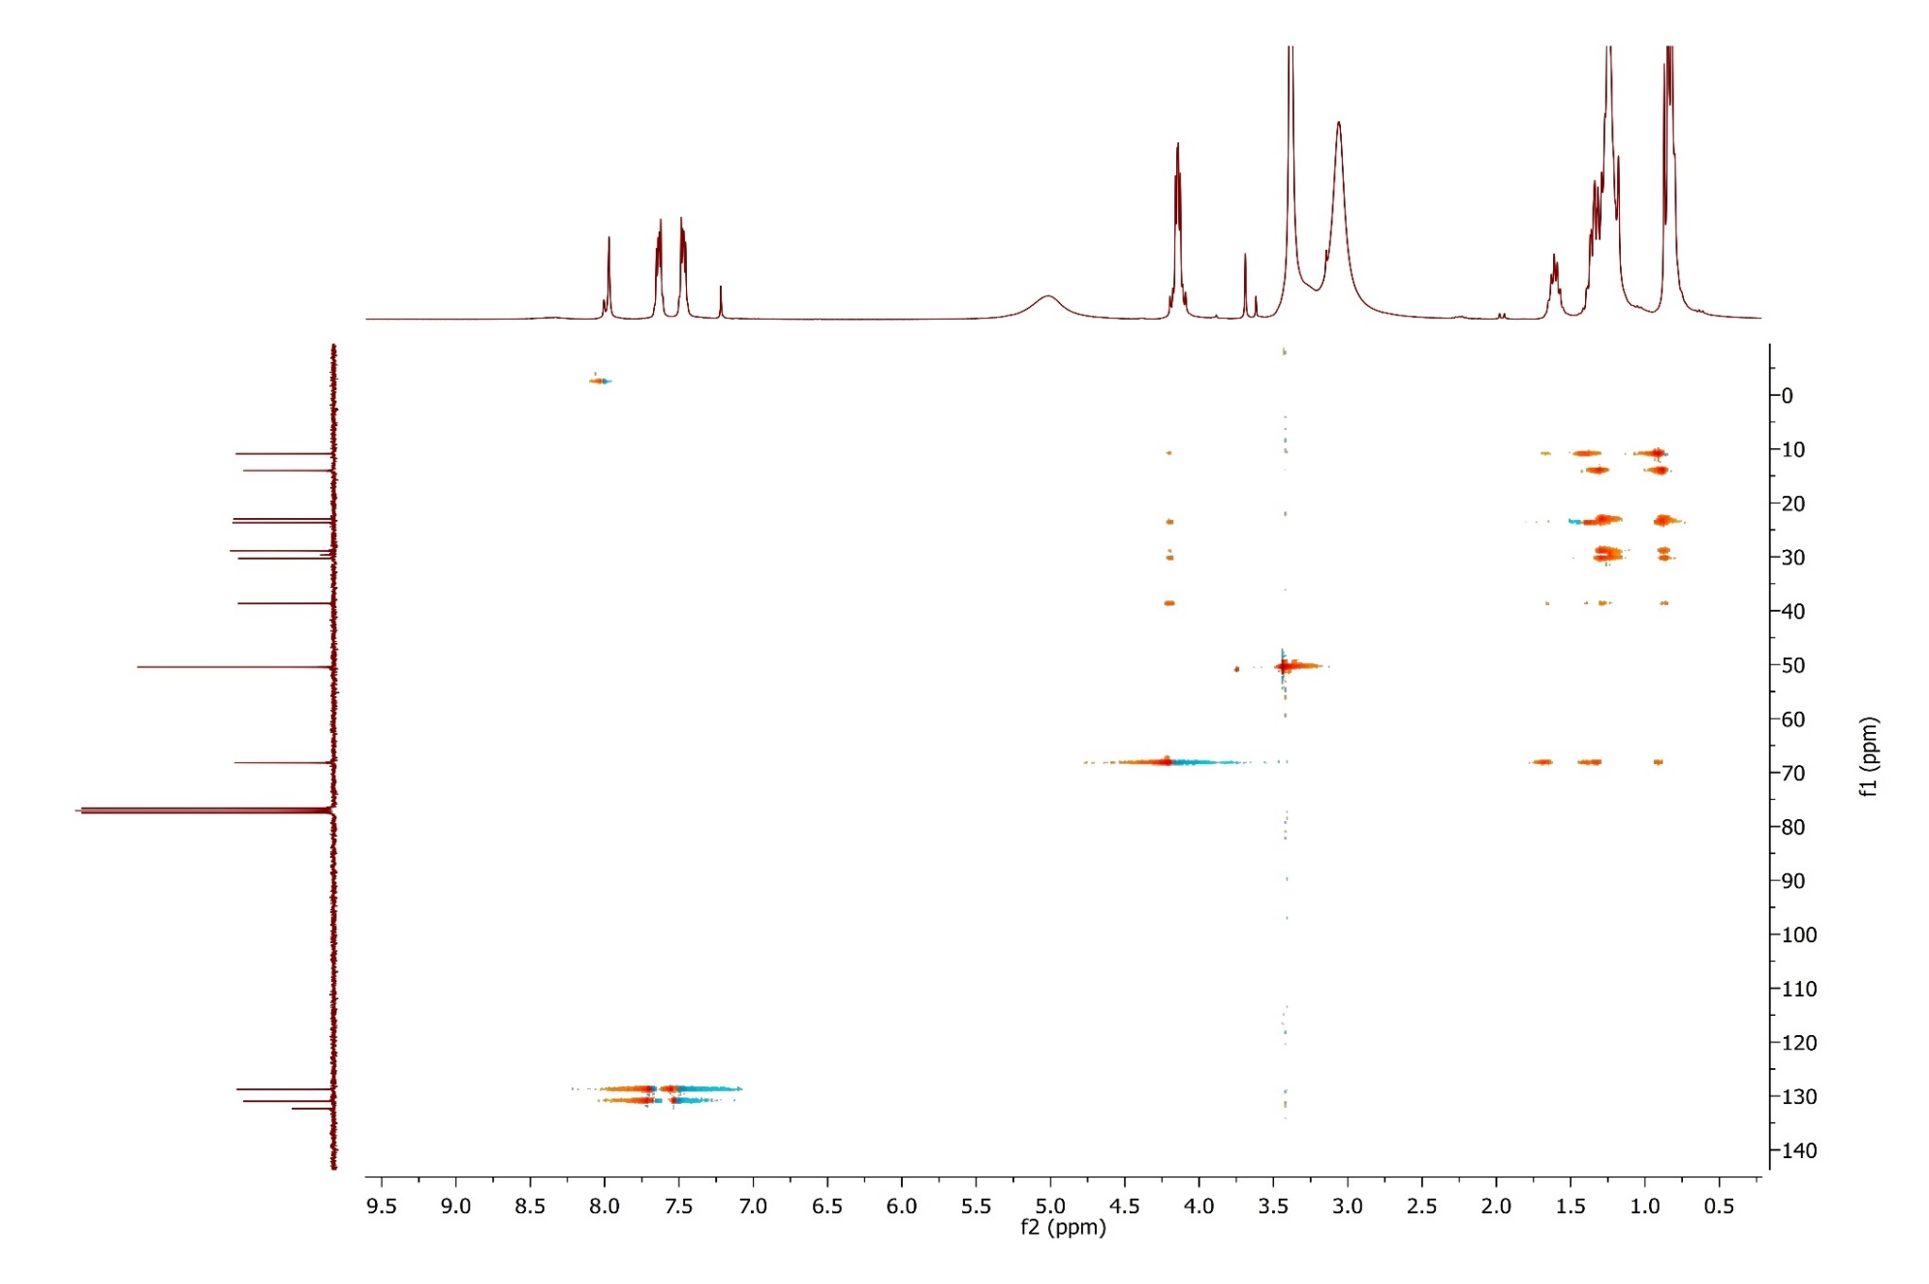

**Figure S22.** HSQC-TCOSY spectrum of Zagrosin ***2.***

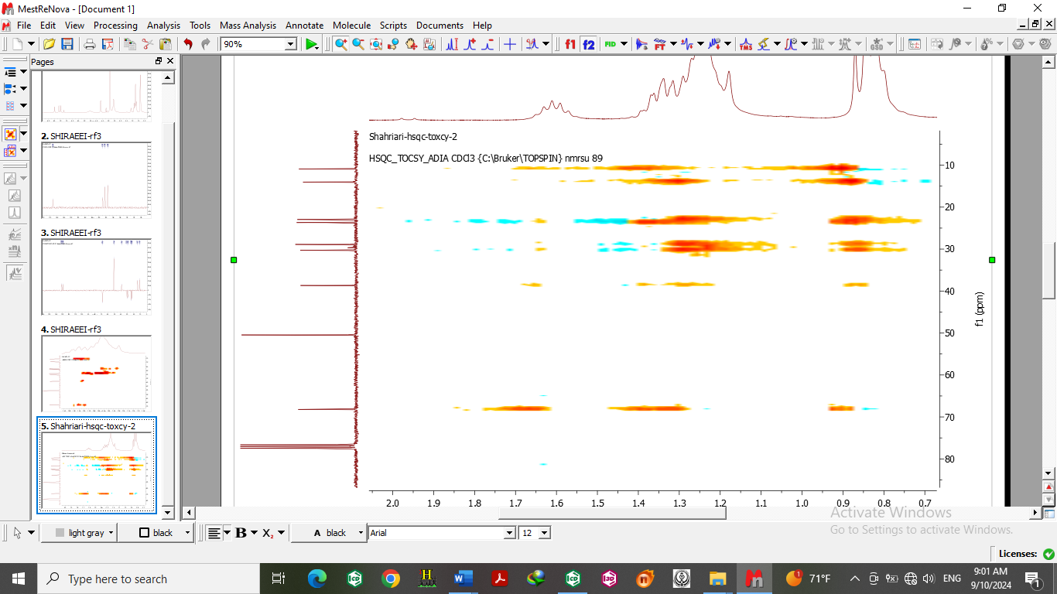

**Figure S23.** ExpandedHSQC-TCOSY spectrum of Zagrosin ***2.***

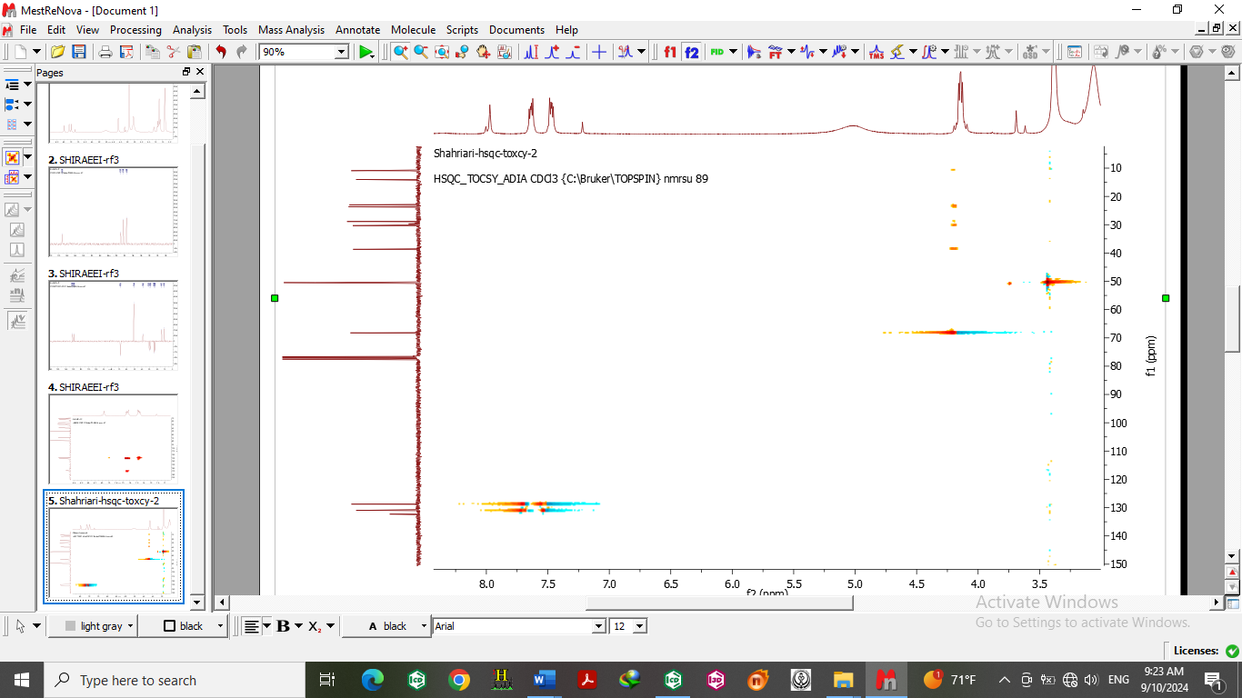

**Figure S24.** ExpandedHSQC-TCOSY spectrum of Zagrosin ***2.***

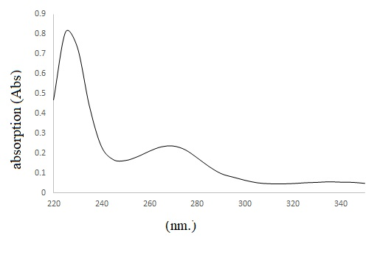

**Figure S25.** ‎ UV spectra ‎of Zagrosin ***2***.

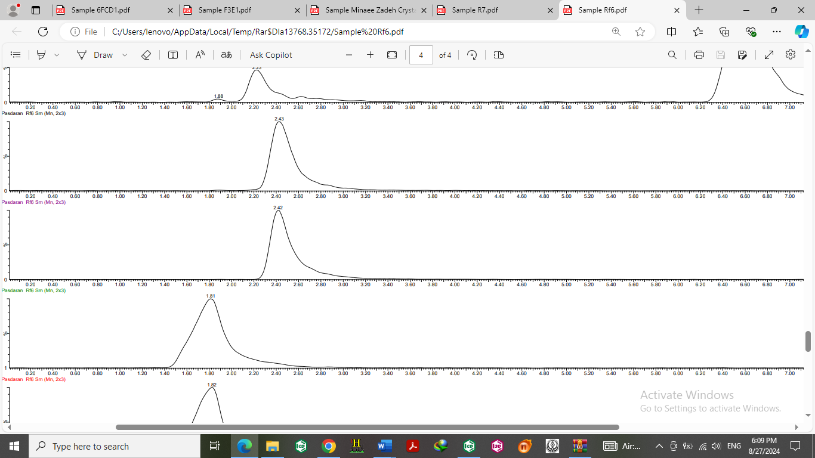

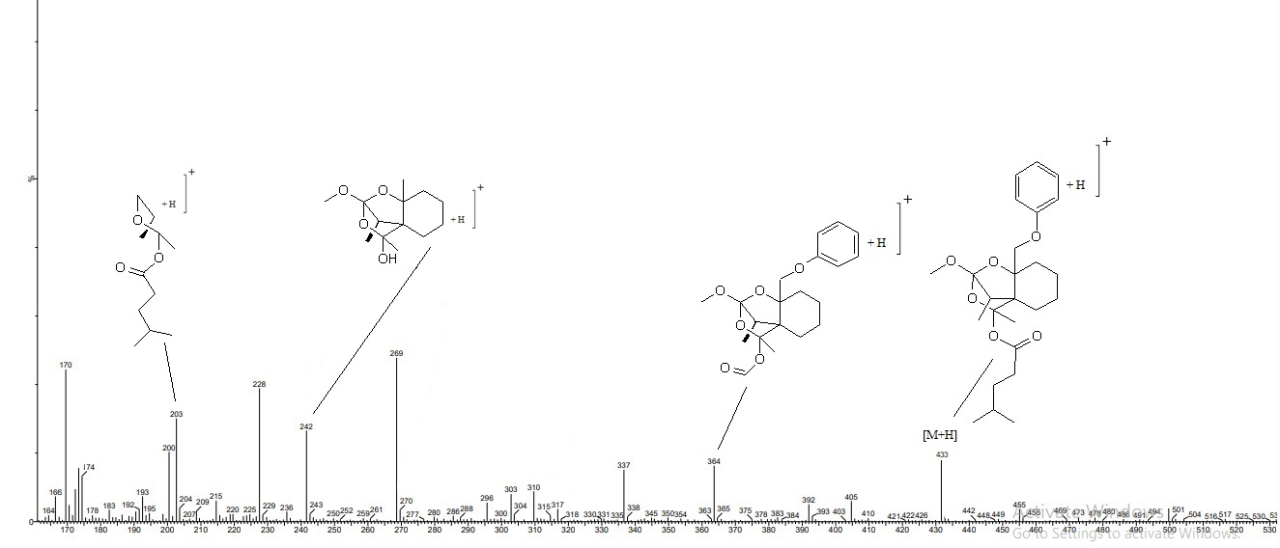

**Figure S 26.** LC chromatogram of Zagrosin 3 (up)and Its fragmentation pattern (down).

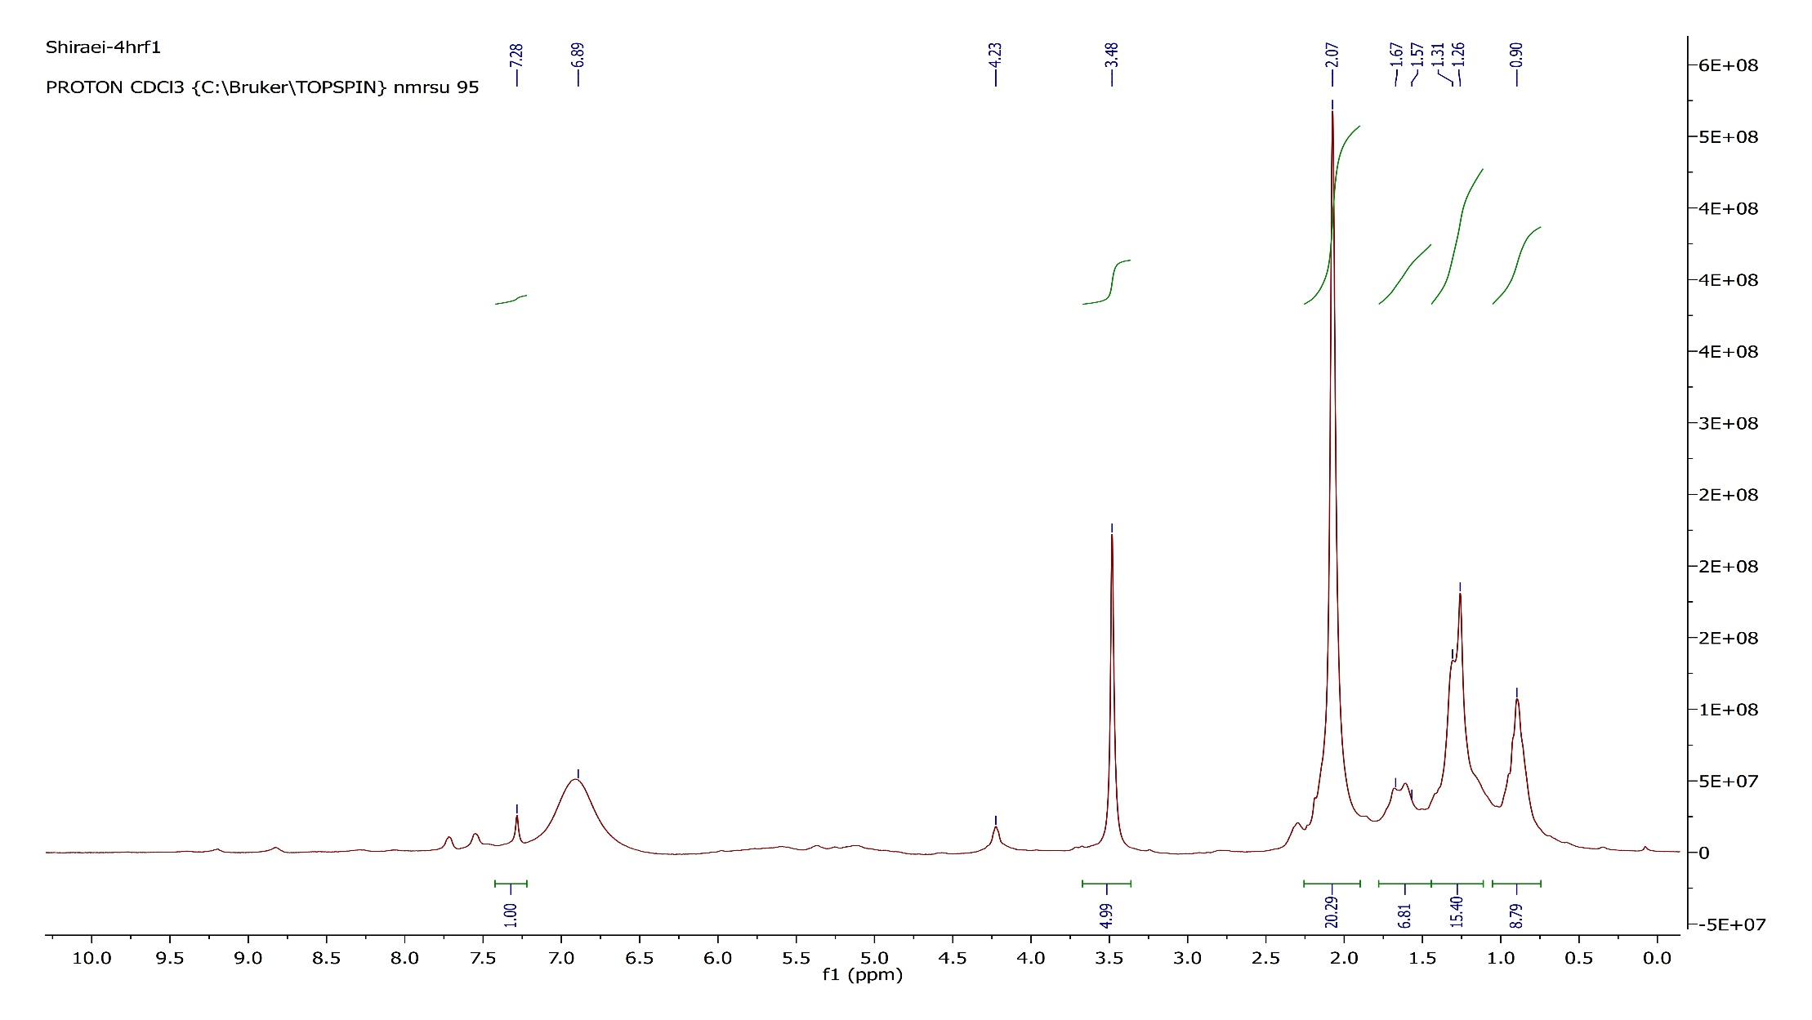

**Figure S27.** 1H NMR (300 MHz, chloroform-d) spectrum of Zagrosin ***3***.

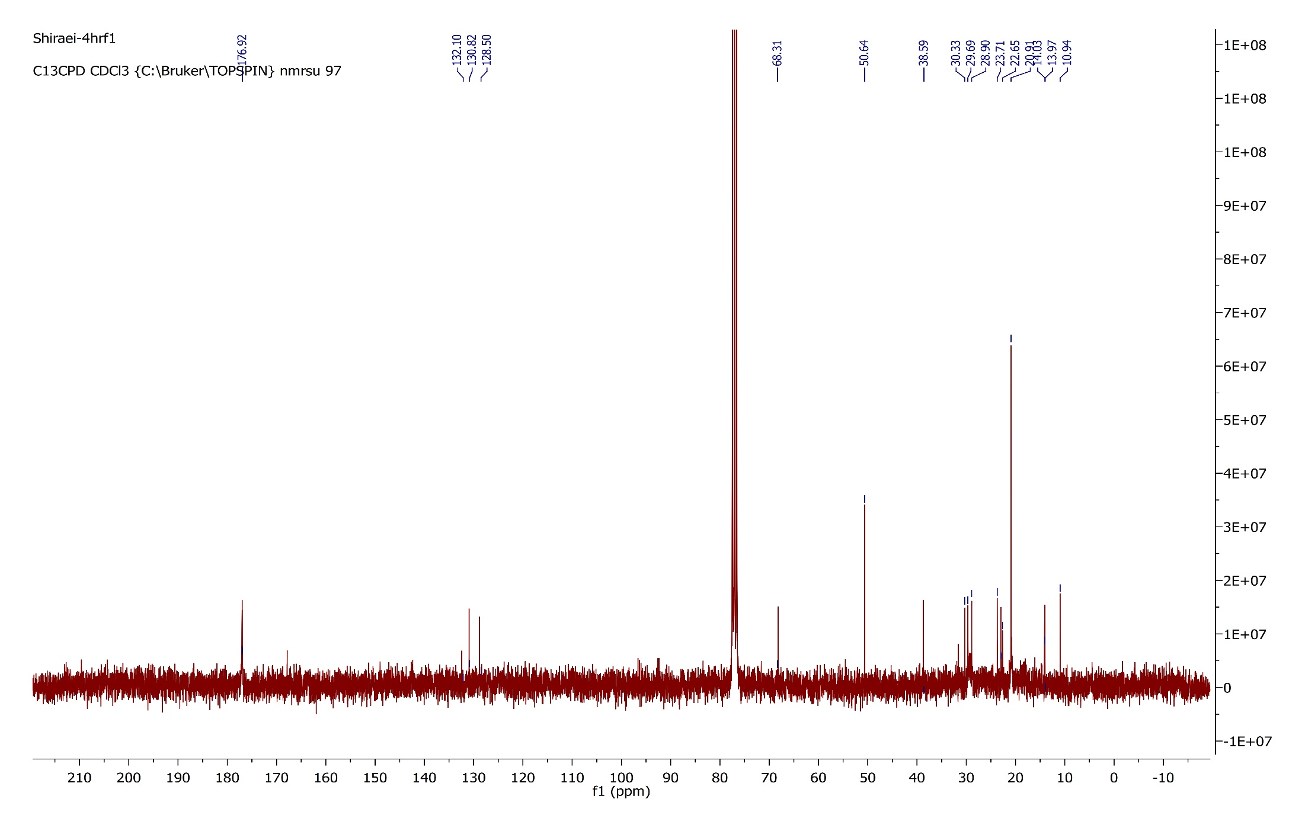

**Figure S28.** 13C NMR(‎75 ‎MHz, chloroform-d) spectrum of Zagrosin ***3.***

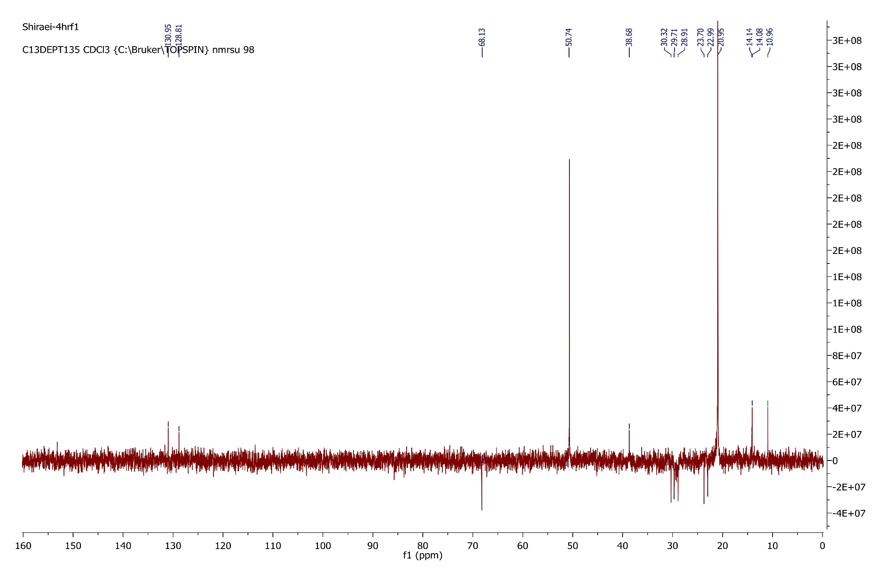

**Figure S29.** DEPT 135 spectrum of Zagrosin ***3.***

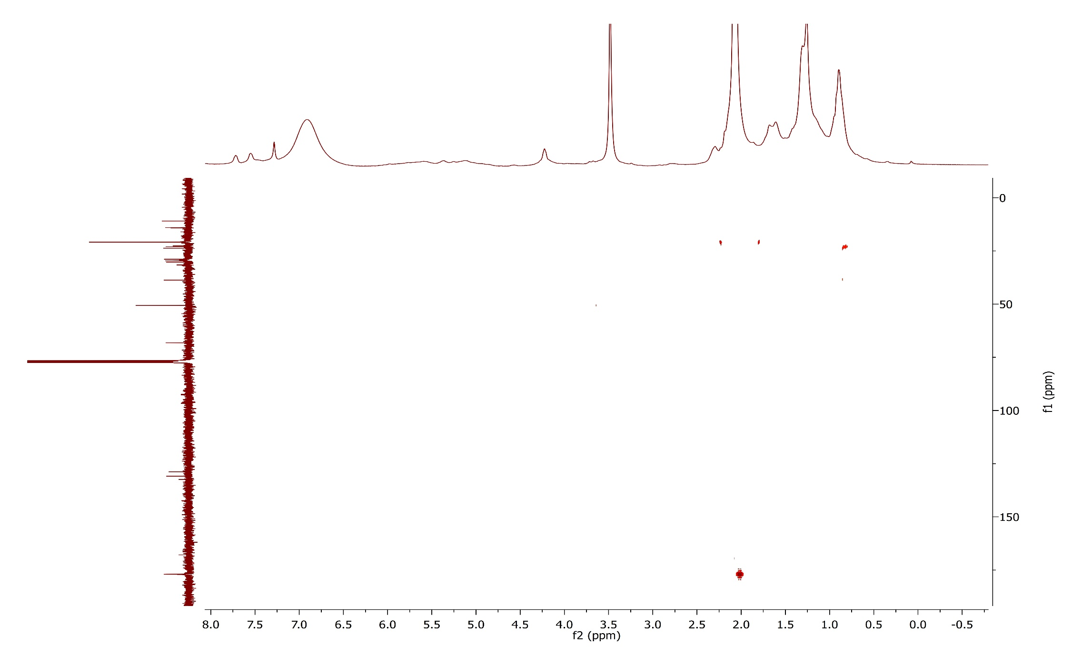

**Figure S30.** HMBC spectrum of Zagrosin ***3.***

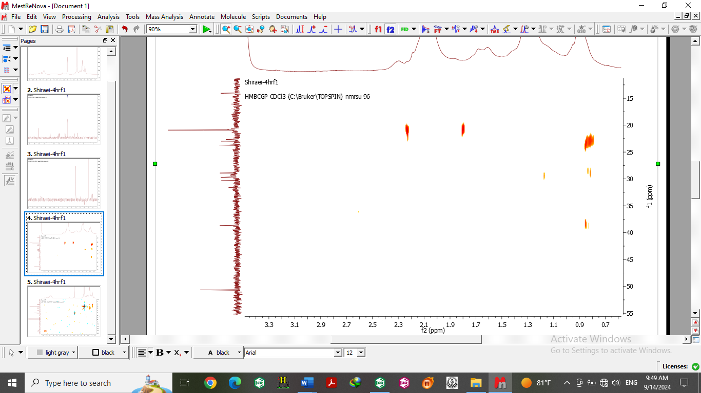

**Figure S31.** Expanded HMBC spectrum of Zagrosin ***3.***

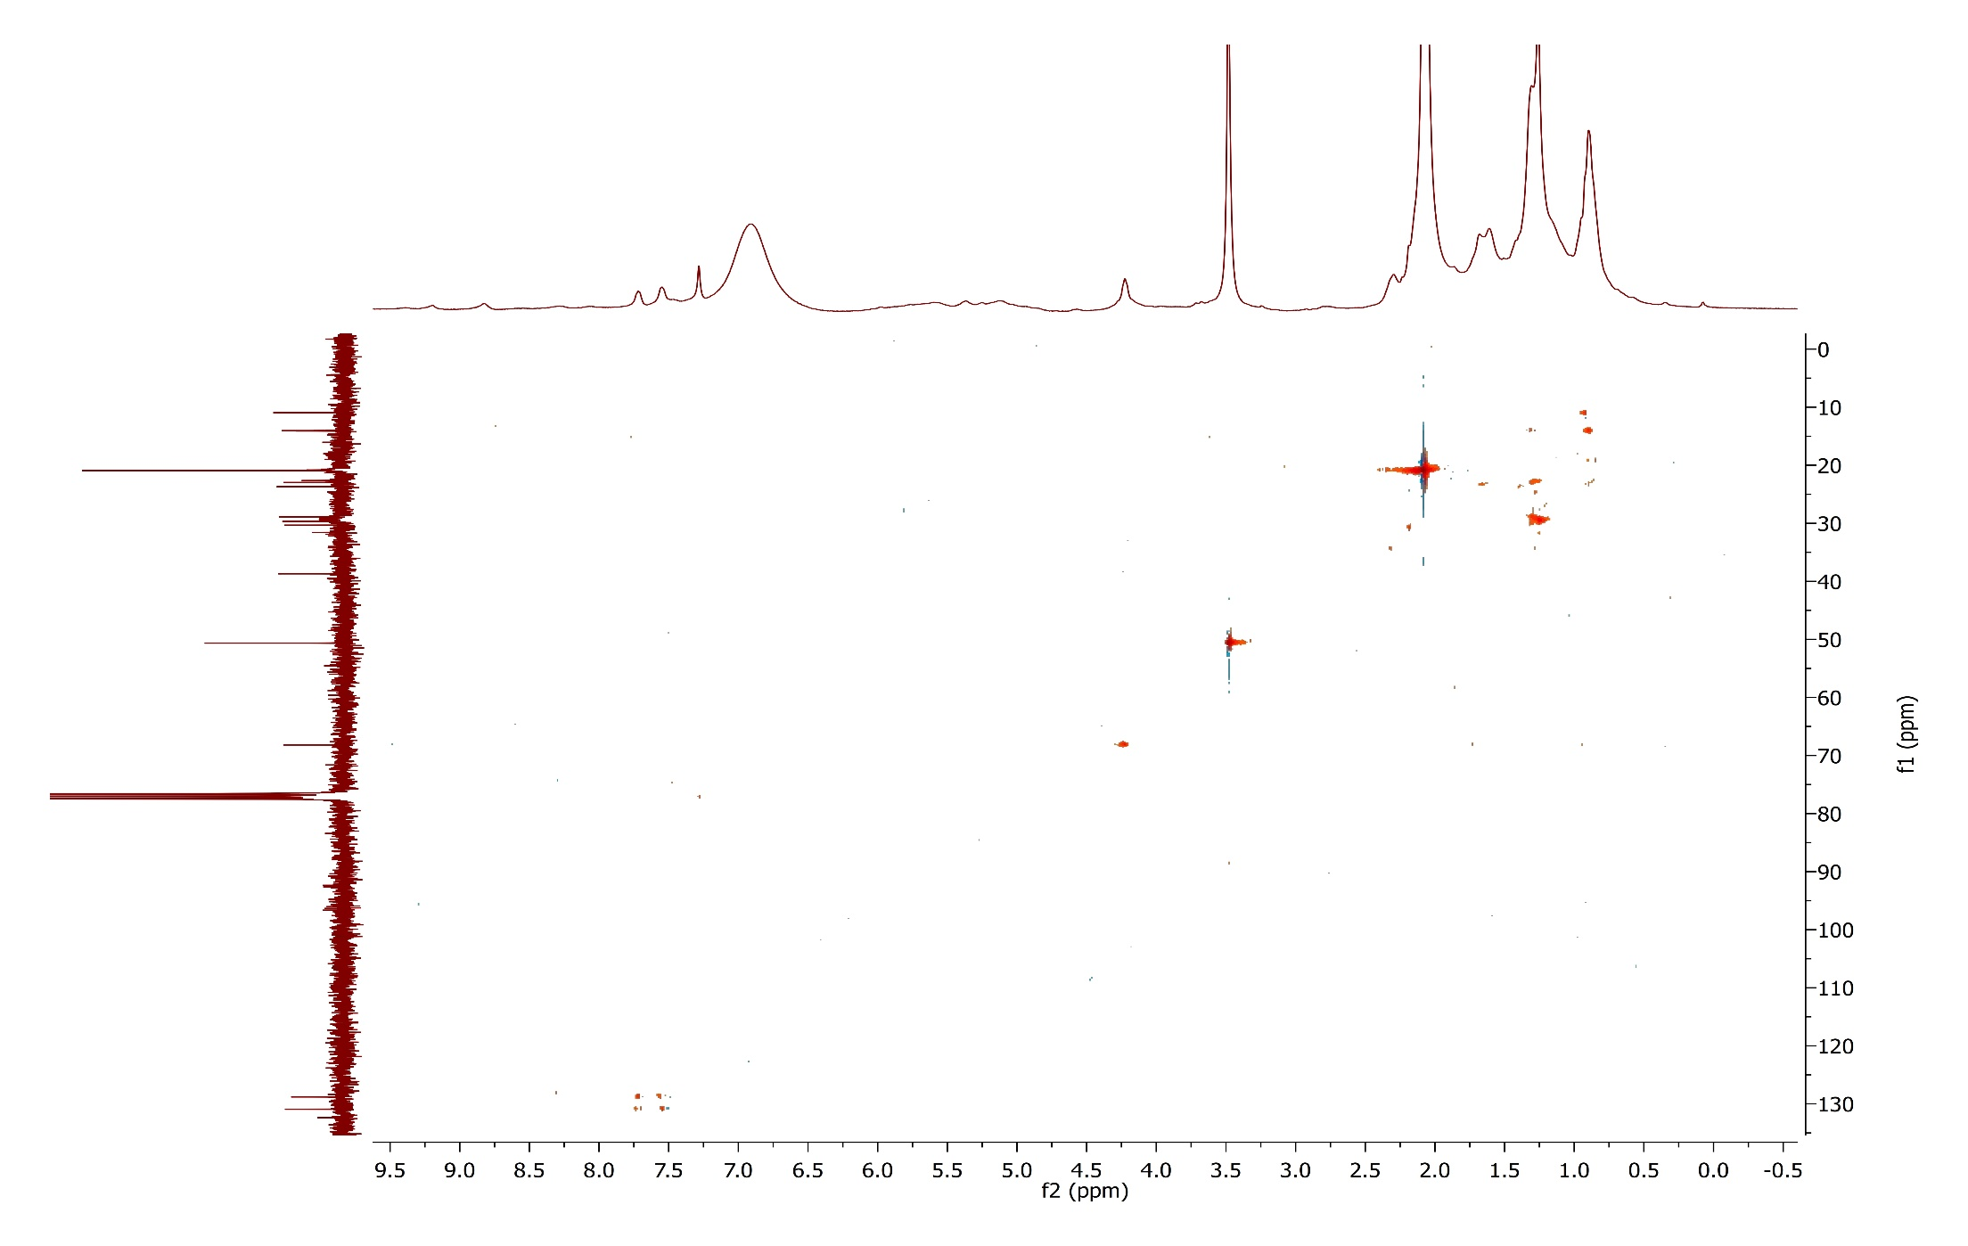

**Figure S32.** HSQC-TCOSY spectrum of Zagrosin ***3.***

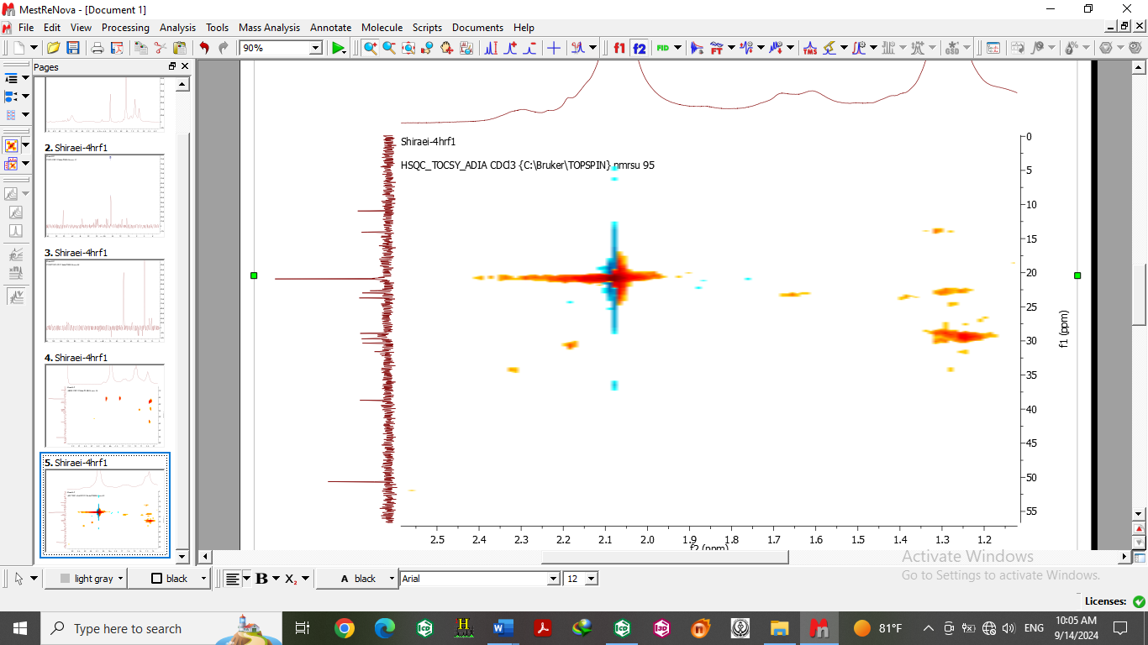

**Figure S33.** ExpandedHSQC-TCOSY spectrum of Zagrosin ***3.***

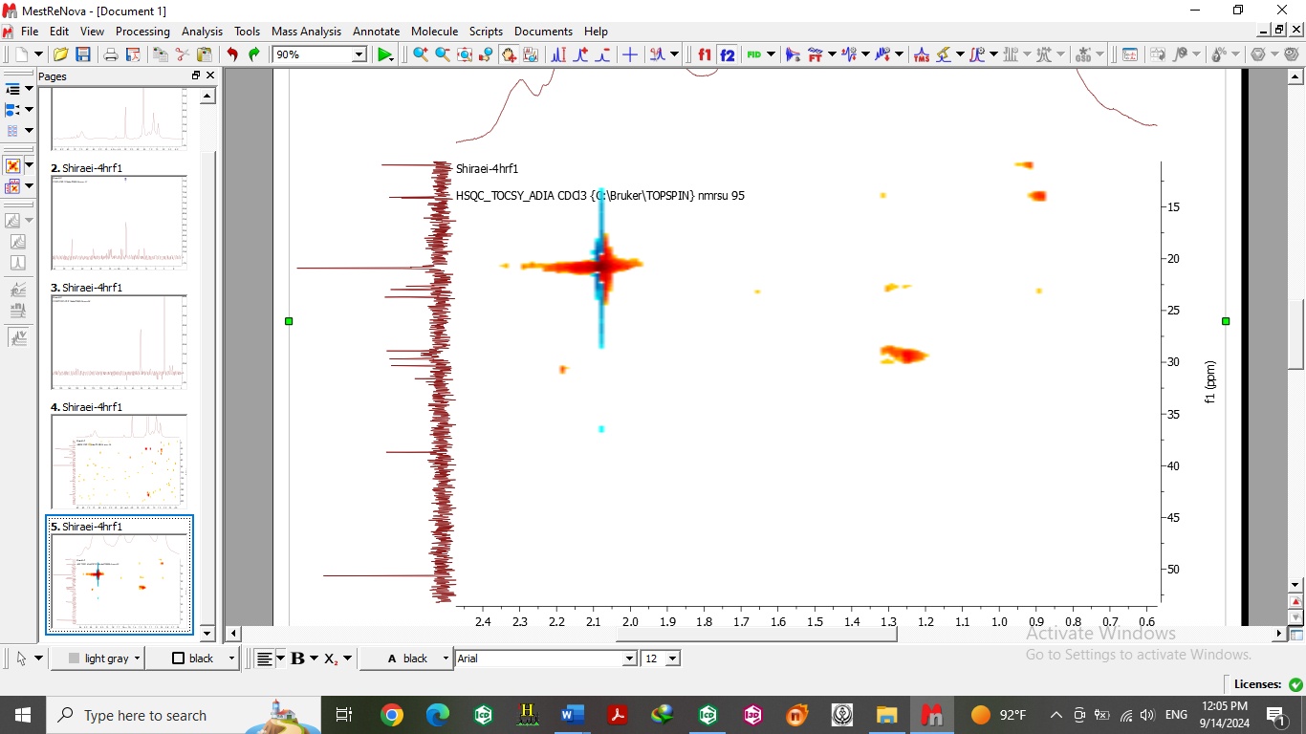

**Figure S34.** ExpandedHSQC-TCOSY spectrum of Zagrosin ***3.***

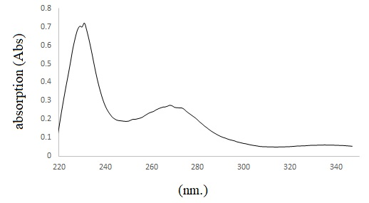

**Figure S35.** UV spectra of Zagrosin ***3***.