**Supplementary Material**

**1.** **Preparation of biological samples and a schematic with the study design**

BALF was obtained via gentle intratracheal lavage of 3 mL cold PBS into the left lung injection three times after ligating the right lung hilum. On the one hand, part of BALF was transferred and filtered with a 0.22 µm filter, and the filter membrane was used for 16S rRNA sequencing analysis. On the other hand, the remaining BALF was centrifuged (3,000 rpm, 10 min, 4 °C) to collect supernatants and pelleted cells.

Part of lung tissue was homogenized in a ten-fold volume of saline, and centrifuged at 4,000 rpm for 10 min at 4 °C to obtain supernatants for subsequent kit testing and metabolomic research. Part of intestinal contents was lyophilized for 48 h to facilitate homogenization. Another part of intestinal contents was used for 16S rRNA sequencing analysis.

A schematic with the study design was as follows:

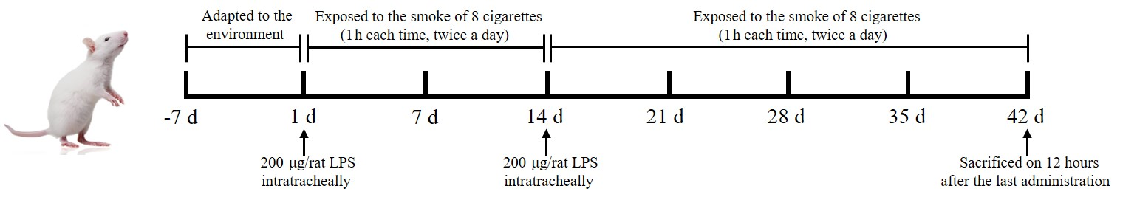

**2. Transcriptomic research**

**Table S1** List of representative DEGs.

|  |  |  |
| --- | --- | --- |
| Name | log2FoldChange | *p* adj |
| MMP8 | 8.83 | 4.88E-101 |
| IL-6 | 8.51 | 3.57E-04 |
| IL-1β | 5.65 | 1.99E-02 |
| PTGS2 | 3.64 | 2.58E-02 |
| NLRP3 | 2.65 | 1.52E-11 |

The relevant primer sequences were as follows:

|  |  |  |
| --- | --- | --- |
| **Name** | **Primer sequence (5′–3′)** | |
| **Forward** | **Reverse** |
| IL1β | ATGCCTCGTGCTGTCTGACC | TTTGTCGTTGCTTGTCTCTCCTTG |
| MMP8 | AACCAATGCTGGAGATACGACA | CCTGGGAACACGCTTGCTAT |
| PTGS2 | GTGGGATGACGAGCGACTGTTC | AGAGGCAATGCGGTTCTGATACTG |
| NLRP3 | ACGGCAAGTTCGAAAAAGGC | TCACTTCGATCCACTTCAGCAG |

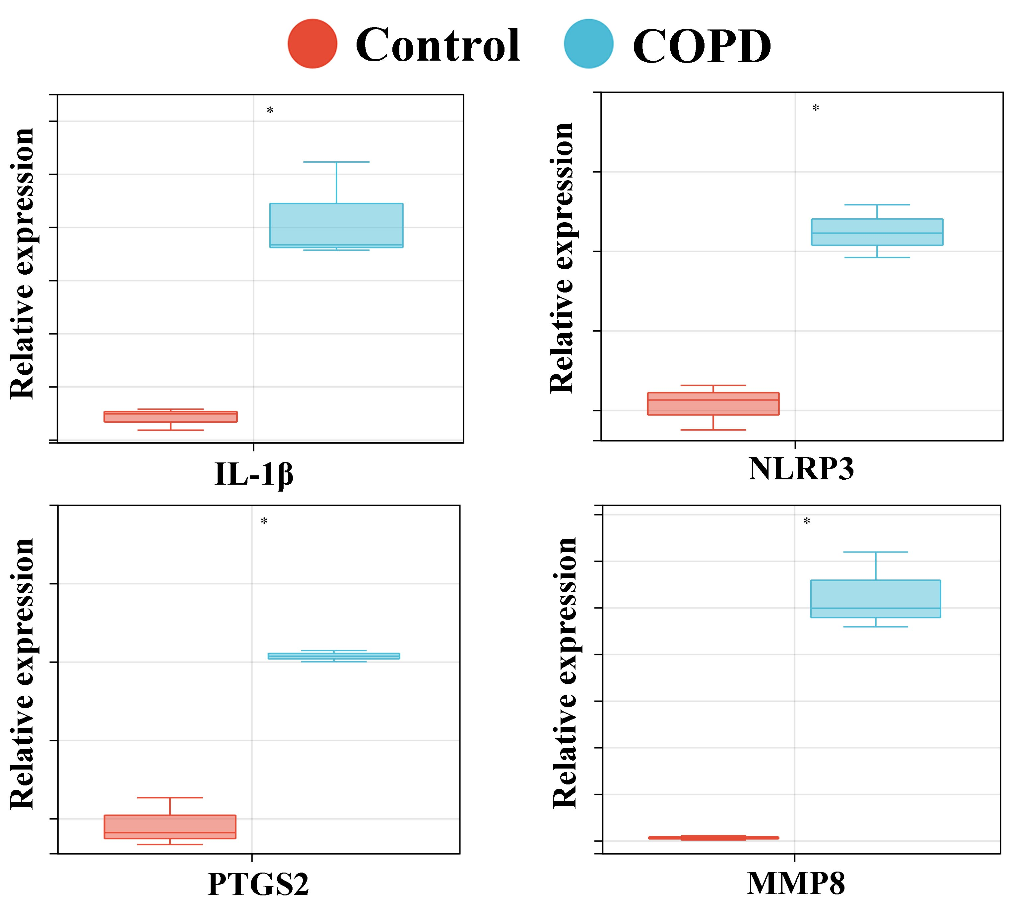

**Fig. S1.** RT-qPCR results of IL-1β, NLRP3, PTGS2 and MMP8 (n = 3). **\***, *p* < 0.05.

**3. Metabolomic research**

**3.1.** **Metabolomics based on HPLC-ESI-QTOF-MS**

**Sample preparation**

100 μL lung tissue homogenates or 300 μL BALF supernatant was diluted with three-fold volume of methanol, then vortexed for 60 s and centrifuged at 12,000 rpm and 4 °C for 10 min. The supernatant was blown to dryness by 30 °C Nitrogen and reconstituted by 100 μL of acetonitrile-deionized water (50:50, *v/v*), then centrifuged at 12,000 rpm and 4 °C for 10 min.

100 mg freeze-dried powder of intestinal contents was diluted with 1 mL deionized water, followed by vortexing for 3 min and sonication for 3 min. The mixture was extracted with 2.5 mL ethyl acetate, with subsequent vortexing (3 min) and centrifugation (12,000 rpm, 4 °C, 10 min). The upper layer was collected, and the lower precipitate was extracted with 2.5 mL methanol-deionized water (80:20, *v*/*v*), followed by vortexing for 3 min and centrifugation at 12,000 rpm, 4 °C for 10 min. Twice supernatants were combined, filtered with 0.45 μm membrane and dried under 30 °C Nitrogen. Then 100 μL acetonitrile-deionized water (50:50, *v*/*v*) was added as reconstitution reagent. The sample was subjected to vortexing for 3 min, sonication for

3 min and centrifugation at 12,000 rpm, 4 °C for 10 min.

A 2 µL of the supernatant was then used for the HPLC-ESI-QTOF-MS analysis. Quality control (QC) samples were prepared by mixing equal volumes of different samples.

**Chromatography and mass spectrometry conditions**

ACQUITY UPLC BEH C18 column (2.1 × 100 mm, 1.7 μm, Waters, Milford, MA, USA) and a LC-20 A Prominence™ UFLC XR system (Shimadzu, Kyoto, Japan) were applied for chromatography analysis. The column temperature was maintained at 30 °C and the flow rate was 0.4 ml·min-1. Mobile phase A was water containing 0.1% formic acid and mobile phase B was acetonitrile containing 0.1% formic acid. The elute gradient was set as follow: 50–75% B from 0 to 2 min, 75–98% B from 2 to 5 min, kept 4 min then returned to 50% B and maintained to 12 min.

A typical information dependent acquisition (IDA) was used to carry out the MS/MS experiment. The TOF MS scan involved a mass range of m/z 50–1000. Nitrogen was used as a nebulizer and auxiliary gas. Continuous recalibration was carried out every 2 h using an Auto Calibration Delivery System (CDS). Analyst software (version 1.7, Sciex) was used for operations.The optimized MS parameters were as follows:

Ionspray voltage floating (ISVF), The turbo spray temperature (TEM), Declustering potential (DP), Collision gas (CE), Nebulizer gas (Gas 1), Heater gas (Gas 2) and Curtain gas for positive and negative ionization mode.

|  |  |  |
| --- | --- | --- |
| **Parameters** | **positive mode** | **negative mode** |
| ISVF | 5500 V | -4500 V |
| TEM | 550 °C | 550 °C |
| DP | 100 V | -80 V |
| CE | 30 eV | -10 eV |
| Gas 1 | 50 psi | 50 psi |
| Gas 2 | 50 psi | 50 psi |
| Curtain gas | 30 psi | 30 psi |

Preparation of Quality control (QC) samples: QC samples obtained by mixing equal volumes of different individual sample, were inserted in the sequence to validate the precision of injection, repeatability and stability of the method.

**Method validation and metabolites identification**

The method was validated for the precision of injection, repeatability and stability. At the beginning of the analytical batch, 6 QC samples were injected to balance the system. The precision of the injection was evaluated by 6 replicated analyses of the same QC sample. 6 QC samples prepared in parallel were used to appraised the repeatability. After the analysis of every ten samples, the QC sample was injected to assess the stability of analytical workflow. Then selected ion chromatographic peaks, six ions from lung and feces samples respectively, were selected for method validation in positive and negative mode, and their retention times and peak areas were calculated to evaluate the system. The selected ions were distributed over the analysis mass range and time. The result indicated all RSD values were below 15%, implying the reliability of method (**Table S2**-**S5**).

Based on VIP > 1, *p* < 0.05 and Fold change > 2, differential metabolites were filtered. The differential metabolites were identified through comparing the accurate mass and MS/MS spectrum with reference literatures or public databases, such as mzCloud (<https://www.mzcloud.org/>), Massbank (<http://www.massbank.jp>) and HMDB (<http://www.hmdb.ca/>).

**Table S2** The analytical performance of Lung samples in positive mode.

|  |  |  |  |  |  |  |
| --- | --- | --- | --- | --- | --- | --- |
| m/z_RT | Precision (RSD %) | | Repeatability (RSD %) | | Stability (RSD %) | |
| RT | Intensity | RT | Intensity | RT | Intensity |
| 115.2564_1.11 | 0.68 | 11.72 | 0.87 | 11.45 | 0.74 | 10.43 |
| 234.5896_2.05 | 1.30 | 9.89 | 1.36 | 14.68 | 1.36 | 7.34 |
| 324.1287_3.22 | 0.21 | 14.14 | 0.23 | 8.73 | 0.30 | 6.34 |
| 423.2349_4.86 | 0.14 | 13.69 | 0.15 | 11.87 | 0.17 | 7.68 |
| 545.1548_5.34 | 0.09 | 6.68 | 0.09 | 4.39 | 0.14 | 4.78 |
| 676.4126_7.84 | 0.13 | 10.77 | 0.14 | 6.49 | 0.16 | 7.47 |

**Table S3** The analytical performance of Lung samples in negative mode.

|  |  |  |  |  |  |  |
| --- | --- | --- | --- | --- | --- | --- |
| m/z_RT | Precision (RSD %) | | Repeatability (RSD %) | | Stability (RSD %) | |
| RT | Intensity | RT | Intensity | RT | Intensity |
| 105.4297_1.68 | 0.41 | 9.50 | 0.44 | 13.82 | 0.56 | 13.26 |
| 225.5812_2.57 | 0.27 | 6.08 | 0.18 | 12.46 | 0.29 | 7.38 |
| 334.2741_3.76 | 0.20 | 7.26 | 0.18 | 9.96 | 0.18 | 7.66 |
| 458.8417_4.27 | 0.17 | 7.95 | 0.16 | 5.99 | 0.17 | 6.98 |
| 567.5178_5.25 | 0.11 | 12.88 | 0.13 | 13.37 | 0.11 | 12.64 |
| 736.3447_6.58 | 0.14 | 10.19 | 0.16 | 8.49 | 0.18 | 9.11 |

**Table S4** The analytical performance of intestinal contents samples in positive mode.

|  |  |  |  |  |  |  |
| --- | --- | --- | --- | --- | --- | --- |
| m/z_RT | Precision (RSD %) | | Repeatability (RSD %) | | Stability (RSD %) | |
| RT | Intensity | RT | Intensity | RT | Intensity |
| 121.2894_1.02 | 0.67 | 12.11 | 0.80 | 13.47 | 0.57 | 10.50 |
| 256.6521_2.46 | 0.28 | 9.92 | 0.38 | 11.63 | 0.30 | 6.76 |
| 365.2587_3.11 | 0.24 | 13.82 | 0.25 | 9.91 | 0.31 | 5.63 |
| 438.5478_4.74 | 0.10 | 13.33 | 0.15 | 11.82 | 0.15 | 8.54 |
| 567.3487_5.96 | 0.12 | 7.28 | 0.14 | 8.05 | 0.10 | 10.60 |
| 639.9824_7.16 | 0.08 | 10.14 | 0.10 | 9.09 | 0.13 | 9.91 |

**Table S5** The analytical performance of intestinal contents samples in negative mode.

|  |  |  |  |  |  |  |
| --- | --- | --- | --- | --- | --- | --- |
| m/z_RT | Precision (RSD %) | | Repeatability (RSD %) | | Stability (RSD %) | |
| RT | Intensity | RT | Intensity | RT | Intensity |
| 125.6578_1.43 | 0.40 | 11.33 | 0.48 | 14.87 | 0.33 | 12.10 |
| 212.4578_2.42 | 0.28 | 4.92 | 0.34 | 11.99 | 0.31 | 13.17 |
| 336.9671_3.43 | 0.20 | 8.24 | 0.24 | 9.33 | 0.27 | 10.45 |
| 476.2614_4.68 | 0.10 | 8.11 | 0.11 | 8.37 | 0.08 | 7.85 |
| 546.3489_5.49 | 0.13 | 13.83 | 0.14 | 14.68 | 0.18 | 13.93 |
| 710.1794_6.83 | 0.10 | 12.54 | 0.12 | 11.65 | 0.14 | 9.61 |

**3.2. Metabolomics based on 1H-NMR**

**Sample preparation**

300 μL BALF was mixed with 300 μL phosphate buffer in D2O (pH 7.0), then vortexed and centrifuged at 12,000 rpm and 4 °C for 15 min. In addition, for lung and intestinal contents samples, basically consistent with the LS-MS metabolomics preparation method until the reconstitution step, that 600 μL H2O-D2O (50:50, *v*/*v*) phosphate buffer (pH 7.0) was added. The mixture was vortexed and centrifuged (12,000 rpm, 4 °C and 10 min) to collect supernatant. Above supernatants were transferred to the 5 mm NMR tube for 1H-NMR analysis.

**1H-NMR spectrum acquisition**

To suppress the protein signals, a transverse relaxation-edit Call-Purcell-Meiboom-Gill (CPMG) sequence was adopted. 1H-NMR spectra were recorded with 128 scans into 32 K data points within a spectral width of 7500 Hz. Before the Fourier transformation, the resultant free induction decays (FIDs) were zero-filled and multiplied by an exponential line broadening function with a line broadening factor of 0.5 Hz.

**Data processing and metabolites identification**

ASICS package of R platform was employed for dealing with 1H-NMR metabolomic data by baseline correction, peak alignment normalization, metabolites identification, etc., and the part corresponding to water (4.5-5.1 ppm) was cut off. The PLS-DA analysis of metabolites matrix was completed by SIMCA-P. Based on VIP > 1 and *p* < 0.05, differential metabolites were filtered.

**Table S6** COPD related differential metabolites in BALF, lung and feces.

|  |  |  |  |  |  |  |  |
| --- | --- | --- | --- | --- | --- | --- | --- |
| **No.** | **Putative identification** | **Formula** | **Ion adduction** | **HMDB ID** | **KEGG ID** | **Source** | **NMR or LCMS** |
| 1 | Norlinolenic acid | C17H28O2 | [M-H2O-H]- | - | C16344 | Feces | LCMS_NEG |
| 2 | (9Z,11E,13E,15Z)-4-Oxo-9,11,13,15-octadecatetraenoic acid | C18H26O3 | [M-H]- | HMDB0031098 | - | Feces | LCMS_NEG |
| 3 | Cibaric acid | C18H28O5 | [M-H2O-H]- | HMDB0038580 | - | Feces | LCMS_NEG |
| 4 | 5α-Dihydrotestosterone sulfate | C19H30O5S | [M+C2H4O2-H]- | HMDB0006278 | - | Feces | LCMS_NEG |
| 5 | LPE(14:0) | C19H40NO7P | [M-H]- | HMDB0011500 | - | Feces | LCMS_NEG |
| 6 | Lacto-N-triaose | C20H35NO16 | [M+C2H3N-H]- | HMDB0006592 | - | Feces | LCMS_NEG |
| 7 | 2(R)-hydroxyicosanoic acid | C20H40O3 | [M-H]- | HMDB0061659 | - | Feces | LCMS_NEG |
| 8 | H-Leu-Glu-Ala-Val-Val-OH | C24H43N5O8 | [M-H2O-H]- | - | - | Feces | LCMS_NEG |
| 9 | 17Z-hexacosenoic acid | C26H50O2 | [M+C2H4O2-H]- | HMDB0062452 | - | Feces | LCMS_NEG |
| 10 | Urobilin | C33H42N4O6 | [M-H]- | HMDB0004160 | C05794 | Feces | LCMS_NEG |
| 11 | Stercobilinogen | C33H48N4O6 | [M-H]- | HMDB0004157 | C05789 | Feces | LCMS_NEG |
| 12 | Cer(t18:0/16:0) | C34H69NO4 | [M+FA-H]- | HMDB0010697 | - | Feces | LCMS_NEG |
| 13 | Cer(d18:1/24:1) | C42H81NO3 | [M+FA-H]- | HMDB0004953 | C00195 | Feces | LCMS_NEG |
| 14 | TG(14:1/14:1/16:1) | C47H84O6 | [M-H]- | HMDB0047886 | - | Feces | LCMS_NEG |
| 15 | Erythritol | C4H10O4 | [M-H2O-H]- | HMDB0002994 | C00503 | Feces | LCMS_NEG |
| 16 | Undecylenic acid | C11H20O2 | [M+C2H3N+H]+ | HMDB0033724 | C13910 | Feces | LCMS_POS |
| 17 | Undecanoic acid | C11H22O2 | [M+C2H3N+H]+ | HMDB0000947 | C17715 | Feces | LCMS_POS |
| 18 | Cellobiose | C12H22O11 | [M+Na]+ | HMDB0000055 | C06422 | Feces | LCMS_POS |
| 19 | 11-Hydroxy-9-tridecenoic acid | C13H24O3 | [M-H2O+H]+ | HMDB0035881 | - | Feces | LCMS_POS |
| 20 | Lysyltyrosine | C15H23N3O4 | [M+Na]+ | HMDB0028963 | - | Feces | LCMS_POS |
| 21 | Stearic acid | C18H36O2 | [M+H]+ | HMDB0000827 | C01530 | Feces | LCMS_POS |
| 22 | MG(16:0/0:0/0:0) | C19H38O4 | [M+Na]+ | HMDB0011564 | - | Feces | LCMS_POS |
| 23 | Stearoylethanolamide | C20H41NO2 | [M-H2O+H]+ | HMDB0013078 | - | Feces | LCMS_POS |
| 24 | MG(18:0/0:0/0:0) | C21H42O4 | [M+Na]+ | HMDB0011131 | - | Feces | LCMS_POS |
| 25 | Docosatrienoic acid | C22H38O2 | [M+NH4]+ | HMDB0002823 | - | Feces | LCMS_POS |
| 26 | 2,4,12-Octadecatrienoic acid isobutylamide | C22H39NO | [M+H]+ | HMDB0032033 | - | Feces | LCMS_POS |
| 27 | PGF2α ethanolamide | C22H39NO5 | [M+C2H3N+H]+ | HMDB0013628 | C13828 | Feces | LCMS_POS |
| 28 | Docosadienoic acid | C22H40O2 | [M+NH4]+ | HMDB0061714 | C16533 | Feces | LCMS_POS |
| 29 | Nutriacholic acid | C24H38O4 | [M+NH4]+ | HMDB0000467 | - | Feces | LCMS_POS |
| 30 | Cholic acid | C24H40O5 | [M-H2O+H]+ | HMDB0000619 | C00695 | Feces | LCMS_POS |
| 31 | Varanic acid | C26H44O5 | [M+H2O+H]+ | HMDB0002195 | - | Feces | LCMS_POS |
| 32 | Ergosterol | C28H44O | [M+H]+ | HMDB0000878 | C01694 | Feces | LCMS_POS |
| 33 | Cer(d18:0/12:0) | C30H61NO3 | [M+H]+ | HMDB0011758 | - | Feces | LCMS_POS |
| 34 | 5-Oxo-delta-bilirubin | C33H34N4O7 | [M+H]+ | - | C20666 | Feces | LCMS_POS |
| 35 | DG(16:0/18:0/0:0) | C37H72O5 | [M-H2O+H]+ | HMDB0007100 | C00165 | Feces | LCMS_POS |
| 36 | DG(18:0/16:0/0:0) | C37H72O5 | [M+Na]+ | HMDB0007156 | C00165 | Feces | LCMS_POS |
| 37 | Cer(d18:0/22:0) | C40H81NO3 | [M+H]+ | HMDB0011765 | - | Feces | LCMS_POS |
| 38 | PC(16:0/18:1) | C42H82NO8P | [M+Na]+ | HMDB0007972 | C13875 | Feces | LCMS_POS |
| 39 | PC(O-18:1/16:0) | C42H84NO7P | [M+Na]+ | HMDB0013426 | - | Feces | LCMS_POS |
| 40 | DG(11D5/11M3/0:0) | C44H74O7 | [M+H2O+H]+ | HMDB0116380 | - | Feces | LCMS_POS |
| 41 | PC(20:0/18:3(9Z,12Z,15Z)) | C46H86NO8P | [M-H2O+H]+ | HMDB0008272 | - | Feces | LCMS_POS |
| 42 | PC(20:0/18:0) | C46H92NO8P | [M+H2O+H]+ | HMDB0008267 | - | Feces | LCMS_POS |
| 43 | 3-Methyl-1-butylamine | C5H13N | [M+C2H3N+H]+ | HMDB0031659 | C02640 | Feces | LCMS_POS |
| 44 | 1-Aminooctane-2,3,4,5,6-pentol | C8H19NO5 | [M+C2H3N+H]+ | - | - | Feces | LCMS_POS |
| 45 | Phthalic acid | C8H6O4 | [M+H]+ | HMDB0002107 | C01606 | Feces | LCMS_POS |
| 46 | N-Acetylisoputreanine | C9H18N2O3 | [M+H2O+H]+ | HMDB0094713 | - | Feces | LCMS_POS |
| 47 | dTMP | C10H15N2O8P | - | HMDB0001227 | C00364 | Feces | NMR |
| 48 | L-Anserine | C10H16N4O3 | - | HMDB0000194 | C01262 | Feces | NMR |
| 49 | Argininosuccinic acid | C10H18N4O6 | - | HMDB0000052 | C03406 | Feces | NMR |
| 50 | 1,4-D-xylobiose | C10H18O9 | - | HMDB0029894 | C01630 | Feces | NMR |
| 51 | N-Acetylneuraminic acid | C11H19NO9 | - | HMDB0000230 | C19910 | Feces | NMR |
| 52 | Lactulose | C12H22O11 | - | HMDB0000740 | C07064 | Feces | NMR |
| 53 | Androsterone | C19H30O2 | - | HMDB0000031 | C00523 | Feces | NMR |
| 54 | Glycocholic acid | C26H43NO6 | - | HMDB0000138 | C01921 | Feces | NMR |
| 55 | Acetic acid | C2H4O2 | - | HMDB0000042 | C00033 | Feces | NMR |
| 56 | Glycolic acid | C2H4O3 | - | HMDB0000115 | C03547 | Feces | NMR |
| 57 | L-Glycine | C2H5NO2 | - | HMDB0000123 | C00037 | Feces | NMR |
| 58 | Taurine | C2H7NO3S | - | HMDB0000251 | C00245 | Feces | NMR |
| 59 | Malonic acid | C3H4O4 | - | HMDB0000691 | C04025 | Feces | NMR |
| 60 | Guanidinoacetic acid | C3H7N3O2 | - | HMDB0000128 | C00581 | Feces | NMR |
| 61 | L-Serine | C3H7NO3 | - | HMDB0000187 | C00065 | Feces | NMR |
| 62 | D-(-)-3-Phosphoglyceric acid | C3H7O7P | - | HMDB0000807 | C00597 | Feces | NMR |
| 63 | 2-Propanol | C3H8O | - | HMDB0000863 | C01845 | Feces | NMR |
| 64 | PropyleneGlycol | C3H8O2 | - | HMDB0001881 | C00583 | Feces | NMR |
| 65 | Trimethylamine | C3H9N | - | HMDB0000906 | C00565 | Feces | NMR |
| 66 | TMAO | C3H9NO | - | HMDB0000925 | C01104 | Feces | NMR |
| 67 | 1-Methylhydantoin | C4H6N2O2 | - | HMDB0003646 | C02565 | Feces | NMR |
| 68 | TartaricAcid | C4H6O6 | - | HMDB0000956 | C00898 | Feces | NMR |
| 69 | Creatinine | C4H7N3O | - | HMDB0000562 | C00791 | Feces | NMR |
| 70 | N-Acetylglycine | C4H7NO3 | - | HMDB0000532 | - | Feces | NMR |
| 71 | L-Asparagine | C4H8N2O3 | - | HMDB0000168 | C00152 | Feces | NMR |
| 72 | Butyric acid | C4H8O2 | - | HMDB0000039 | C00246 | Feces | NMR |
| 73 | 2-Hydroxybutyric acid | C4H8O3 | - | HMDB0000008 | C05984 | Feces | NMR |
| 74 | 2-Aminobutyric acid | C4H9NO2 | - | HMDB0000650 | C02261 | Feces | NMR |
| 75 | GABA | C4H9NO2 | - | HMDB0000112 | C00334 | Feces | NMR |
| 76 | L-Threonine | C4H9NO3 | - | HMDB0000167 | C00188 | Feces | NMR |
| 77 | D-Xylulose | C5H10O5 | - | HMDB0001644 | C00310 | Feces | NMR |
| 78 | D-(+)-Xylose | C5H10O5 | - | HMDB0000098 | C00181 | Feces | NMR |
| 79 | Betaine | C5H11NO2 | - | HMDB0000043 | C00719 | Feces | NMR |
| 80 | Xylitol | C5H12O5 | - | HMDB0242149 | C00379 | Feces | NMR |
| 81 | 2-Oxoglutarate | C5H6O5 | - | HMDB0000208 | C00026 | Feces | NMR |
| 82 | Dihydrothymine | C5H8N2O2 | - | HMDB0000079 | C00906 | Feces | NMR |
| 83 | Ethylmalonic acid | C5H8O4 | - | HMDB0000622 | - | Feces | NMR |
| 84 | Trans 4 Hydroxy-L-proline | C5H9NO3 | - | HMDB0000725 | C01157 | Feces | NMR |
| 85 | 2-AminoAdipic acid | C6H11NO4 | - | HMDB0302754 | - | Feces | NMR |
| 86 | Ala-Ala | C6H12N2O3 | - | HMDB0028680 | - | Feces | NMR |
| 87 | L-Isoleucine | C6H13NO2 | - | HMDB0000172 | C00407 | Feces | NMR |
| 88 | 3-Methylxanthine | C6H6N4O2 | - | HMDB0001886 | C16357 | Feces | NMR |
| 89 | D-(+)-Threo-isocitric acid | C6H8O7 | - | HMDB0001874 | C00451 | Feces | NMR |
| 90 | 3-Methyl-L-Histidine | C7H11N3O2 | - | HMDB0000479 | C01152 | Feces | NMR |
| 91 | Homoarginine | C7H16N4O2 | - | HMDB0000670 | C01924 | Feces | NMR |
| 92 | L-Carnitine | C7H16NO3 | - | HMDB0000062 | C00318 | Feces | NMR |
| 93 | Spermidine | C7H19N3 | - | HMDB0001257 | C00315 | Feces | NMR |
| 94 | 4-EthylPhenol | C8H10O | - | HMDB0029306 | C13637 | Feces | NMR |
| 95 | N-acetyl-histidine | C8H11N3O3 | - | HMDB0032055 | C02997 | Feces | NMR |
| 96 | Dopamine | C8H11NO2 | - | HMDB0000073 | C03758 | Feces | NMR |
| 97 | N-Acetyl-D-mannosamine | C8H15NO6 | - | HMDB0001129 | C00645 | Feces | NMR |
| 98 | Alpha-Lipoamide | C8H15NOS2 | - | HMDB0000962 | C00248 | Feces | NMR |
| 99 | N-Acetyl-D-glucosamine 6-phosphate | C8H16NO9P | - | HMDB0001062 | C00357 | Feces | NMR |
| 100 | DL-2-Aminocaprylic acid | C8H17NO2 | - | HMDB0000991 | - | Feces | NMR |
| 101 | 3-HydroxyphenylAcetic acid | C8H8O3 | - | HMDB0000440 | C05593 | Feces | NMR |
| 102 | 4-HydroxyphenylAcetic acid | C8H8O3 | - | HMDB0000020 | C00642 | Feces | NMR |
| 103 | 3-PhenylPropionic acid | C9H10O2 | - | HMDB0000764 | C05629 | Feces | NMR |
| 104 | Pantothenic acid | C9H17NO5 | - | HMDB0000210 | C00864 | Feces | NMR |
| 105 | Methanol | CH4O | - | HMDB0001875 | C00132 | Feces | NMR |
| 106 | 8-Oxo-dGMP | C10H14N5O8P | [M-H]- | HMDB0011670 | C19968 | Lung | LCMS_NEG |
| 107 | 10-Oxodecanoate | C10H18O3 | [M+C2H4O2-H]- | - | C02217 | Lung | LCMS_NEG |
| 108 | Sebacic acid | C10H18O4 | [M-H]- | HMDB0000792 | C08277 | Lung | LCMS_NEG |
| 109 | Propionylcarnitine | C10H19NO4 | [M+FA-H]- | HMDB0000824 | C03017 | Lung | LCMS_NEG |
| 110 | N-Lactoylphenylalanine | C12H15NO4 | [M-H]- | HMDB0062175 | - | Lung | LCMS_NEG |
| 111 | Dodecenoic acid | C12H22O2 | [M+C2H4O2-H]- | HMDB0010729 | C21202 | Lung | LCMS_NEG |
| 112 | 3-Oxododecanoic acid | C12H22O3 | [M+FA-H]- | HMDB0010727 | C02367 | Lung | LCMS_NEG |
| 113 | Dodecanedioic acid | C12H22O4 | [M-H]- | HMDB0000623 | C02678 | Lung | LCMS_NEG |
| 114 | N-(1-Deoxy-1-fructosyl)phenylalanine | C15H21NO7 | [M-H]- | HMDB0037846 | - | Lung | LCMS_NEG |
| 115 | Farnesoic acid | C15H24O2 | [M+C2H4O2-H]- | - | C16502 | Lung | LCMS_NEG |
| 116 | Farnesol | C15H26O | [M+C2H4O2-H]- | HMDB0004305 | C06081 | Lung | LCMS_NEG |
| 117 | Butyrin | C15H26O6 | [M-H]- | HMDB0031094 | C13870 | Lung | LCMS_NEG |
| 118 | Tridecanoylglycine | C15H29NO3 | [M-H]- | HMDB0013317 | - | Lung | LCMS_NEG |
| 119 | Pentadecanal | C15H30O | [M-H]- | HMDB0031078 | C01948 | Lung | LCMS_NEG |
| 120 | Myristoylglycine | C16H31NO3 | [M-H]- | HMDB0013250 | - | Lung | LCMS_NEG |
| 121 | 16-Hydroxyhexadecanoic acid | C16H32O3 | [M-H]- | HMDB0006294 | C18218 | Lung | LCMS_NEG |
| 122 | 12-hydroxyheptadecanoic acid | C17H34O3 | [M-H]- | HMDB0061663 | - | Lung | LCMS_NEG |
| 123 | Estrone sulfate | C18H22O5S | [M-H]- | HMDB0001425 | C02538 | Lung | LCMS_NEG |
| 124 | N-Cyclopentyl-8-propylaminoadenosine | C18H28N6O4 | [M+FA-H]- | - | - | Lung | LCMS_NEG |
| 125 | Linolenelaidic acid | C18H30O2 | [M-H]- | HMDB0030964 | C06427 | Lung | LCMS_NEG |
| 126 | 9,12,13-Trihydroxy-10(e),15(Z)-octadecadienoic acid | C18H32O5 | [M-H]- | HMDB0035919 | - | Lung | LCMS_NEG |
| 127 | 2-Oxooctadecanoic acid | C18H34O3 | [M-H]- | - | C00869 | Lung | LCMS_NEG |
| 128 | 9-Oxooctadecanoic acid | C18H34O3 | [M+FA-H]- | HMDB0030979 | - | Lung | LCMS_NEG |
| 129 | 9,10,13-TriHOME | C18H34O5 | [M-H]- | HMDB0004710 | C14835 | Lung | LCMS_NEG |
| 130 | Palmitoylglycine | C18H35NO3 | [M-H]- | HMDB0013034 | - | Lung | LCMS_NEG |
| 131 | 2-Hydroxystearic acid | C18H36O3 | [M-H]- | HMDB0062549 | C03045 | Lung | LCMS_NEG |
| 132 | Arachidonic acid | C20H32O2 | [M-H]- | HMDB0001043 | C00219 | Lung | LCMS_NEG |
| 133 | Prostaglandin F2 | C20H34O5 | [M-H]- | HMDB0001139 | C00639 | Lung | LCMS_NEG |
| 134 | 6-Keto-PGF1α | C20H34O6 | [M-H]- | HMDB0002886 | C05961 | Lung | LCMS_NEG |
| 135 | 15-Oxo-11-eicosenoic acid | C20H36O3 | [M-H]- | HMDB0029797 | - | Lung | LCMS_NEG |
| 136 | Docosahexaenoic acid | C22H32O2 | [M-H]- | HMDB0002183 | C06429 | Lung | LCMS_NEG |
| 137 | Adrenic acid | C22H36O2 | [M-H]- | HMDB0002226 | C16527 | Lung | LCMS_NEG |
| 138 | N-Stearoyl GABA | C22H43NO3 | [M-H]- | HMDB0062341 | - | Lung | LCMS_NEG |
| 139 | LPE(17:0) | C22H46NO7P | [M-H]- | HMDB0061691 | - | Lung | LCMS_NEG |
| 140 | Hexadecanedioic acid | C23H43NO6 | [M-H]- | HMDB0000712 | - | Lung | LCMS_NEG |
| 141 | Tetracosapentaenate | C24H38O2 | [M-H]- | HMDB0006323 | - | Lung | LCMS_NEG |
| 142 | Chenodeoxycholic acid | C24H40O4 | [M+FA-H]- | HMDB0000518 | C02528 | Lung | LCMS_NEG |
| 143 | LPC(18:0) | C26H54NO7P | [M-H]- | HMDB0010384 | C04230 | Lung | LCMS_NEG |
| 144 | 7α-Hydroxy-3-oxo-4-cholestenoic acid | C27H42O4 | [M-H]- | HMDB0012458 | C17337 | Lung | LCMS_NEG |
| 145 | 3β,7α-Dihydroxy-5-cholestenoate | C27H44O4 | [M+FA-H]- | HMDB0012454 | C17335 | Lung | LCMS_NEG |
| 146 | PE(P-16:0/18:2) | C39H74NO7P | [M-H]- | HMDB0011343 | - | Lung | LCMS_NEG |
| 147 | PE(P-16:0/18:1) | C39H76NO7P | [M-H]- | HMDB0011342 | - | Lung | LCMS_NEG |
| 148 | PE(P-18:1/18:1) | C41H78NO7P | [M-H]- | HMDB0011441 | - | Lung | LCMS_NEG |
| 149 | PE(P-18:0/18:1) | C41H80NO7P | [M-H]- | HMDB0011375 | - | Lung | LCMS_NEG |
| 150 | PS(20:1/16:0) | C42H80NO10P | [M-H]- | HMDB0112543 | - | Lung | LCMS_NEG |
| 151 | PC(20:2/18:2) | C46H84NO8P | [M+FA-H]- | HMDB0008336 | - | Lung | LCMS_NEG |
| 152 | Pyroglutamic acid | C5H7NO3 | [M-H]- | HMDB0000267 | C01879 | Lung | LCMS_NEG |
| 153 | Glutaric acid | C5H8O4 | [M-H]- | HMDB0000661 | C00489 | Lung | LCMS_NEG |
| 154 | N-Acetyl-L-alanine | C5H9NO3 | [M-H]- | HMDB0000766 | - | Lung | LCMS_NEG |
| 155 | L-Glutamic acid | C5H9NO4 | [M-H]- | HMDB0000148 | C00025 | Lung | LCMS_NEG |
| 156 | 2-Methyl-4-pentenoic acid | C6H10O2 | [M+C2H4O2-H]- | HMDB0031158 | - | Lung | LCMS_NEG |
| 157 | 3-Hydroxymethylglutaric acid | C6H10O5 | [M-H]- | HMDB0000355 | C03761 | Lung | LCMS_NEG |
| 158 | L-Lysine | C6H14N2O2 | [M-H]- | HMDB0000182 | C00047 | Lung | LCMS_NEG |
| 159 | L-Arginine | C6H14N4O2 | [M-H]- | HMDB0000517 | C00062 | Lung | LCMS_NEG |
| 160 | 2-aminophenol sulphate | C6H7NO4S | [M+C2H4O2-H]- | HMDB0061116 | - | Lung | LCMS_NEG |
| 161 | L-Histidine | C6H9N3O2 | [M-H]- | HMDB0000177 | C00135 | Lung | LCMS_NEG |
| 162 | N-Acetylhistamine | C7H11N3O | [M+C2H4O2-H]- | HMDB0013253 | C05135 | Lung | LCMS_NEG |
| 163 | Heptanoic acid | C7H14O2 | [M+C2H4O2-H]- | HMDB0000666 | C17714 | Lung | LCMS_NEG |
| 164 | N-Acryloyl-L-glutamic acid | C8H11NO5 | [M-H]- | - | - | Lung | LCMS_NEG |
| 165 | 3-oxooctane | C8H16O | [M-H]- | HMDB0031295 | C17145 | Lung | LCMS_NEG |
| 166 | L-Tyrosine | C9H11NO3 | [M-H]- | HMDB0000158 | C00082 | Lung | LCMS_NEG |
| 167 | Azelaic acid | C9H16O4 | [M-H]- | HMDB0000784 | C08261 | Lung | LCMS_NEG |
| 168 | Indolelactic acid | C11H11NO3 | [M-H2O+H]+ | HMDB0000671 | C02043 | Lung | LCMS_POS |
| 169 | L-Tryptophan | C11H12N2O2 | [M+H]+ | HMDB0000929 | C00078 | Lung | LCMS_POS |
| 170 | Trideca-9,11-dienoic acid | C13H22O2 | [M+NH4]+ | - | - | Lung | LCMS_POS |
| 171 | Palmitoleic acid | C16H30O2 | [M+Na]+ | HMDB0003229 | C08362 | Lung | LCMS_POS |
| 172 | MG(16:0/0:0/0:0) | C19H38O4 | [M-H2O+H]+ | HMDB0011564 | - | Lung | LCMS_POS |
| 173 | Eicosapentaenoic acid | C20H30O2 | [M-H2O+H]+ | HMDB0001999 | C06428 | Lung | LCMS_POS |
| 174 | 8-HETE | C20H32O3 | [M-H2O+H]+ | HMDB0004679 | C14776 | Lung | LCMS_POS |
| 175 | 11,14,17-eicosatrienoic acid | C20H34O2 | [M+Na]+ | HMDB0060039 | C16522 | Lung | LCMS_POS |
| 176 | 8Z,11Z-eicosadienoic acid | C20H36O2 | [M+Na]+ | HMDB0062432 | C21936 | Lung | LCMS_POS |
| 177 | MG(18:0/0:0/0:0) | C21H42O4 | [M-H2O+H]+ | HMDB0011131 | - | Lung | LCMS_POS |
| 178 | 11-HDoHE | C22H32O3 | [M-H2O+H]+ | HMDB0060040 | - | Lung | LCMS_POS |
| 179 | Neuroprotectin D1 | C22H32O4 | [M-H2O+H]+ | HMDB0003689 | - | Lung | LCMS_POS |
| 180 | Docosanic acid | C22H44O2 | [M+NH4]+ | HMDB0000944 | C08281 | Lung | LCMS_POS |
| 181 | Leukotriene E3 | C23H39NO5S | [M+H2O+H]+ | HMDB0002355 | - | Lung | LCMS_POS |
| 182 | LPE(18:0/0:0) | C23H48NO7P | [M+H]+ | HMDB0011130 | C21484 | Lung | LCMS_POS |
| 183 | LPC(18:0) | C26H54NO7P | [M+Na]+ | HMDB0010384 | C04230 | Lung | LCMS_POS |
| 184 | LPC(18:0) | C26H54NO7P | [M+H]+ | HMDB0010384 | C04230 | Lung | LCMS_POS |
| 185 | N-tetradecanoyl-15-methylhexadecasphinganine | C31H63NO3 | [M+C2H3N+H]+ | - | - | Lung | LCMS_POS |
| 186 | Cer(d18:0/14:0) | C32H65NO3 | [M+H]+ | HMDB0011759 | - | Lung | LCMS_POS |
| 187 | Biliverdin | C33H34N4O6 | [M+H]+ | HMDB0001008 | C00500 | Lung | LCMS_POS |
| 188 | Cer(d18:1/16:0) | C34H67NO3 | [M+H]+ | HMDB0004949 | C00195 | Lung | LCMS_POS |
| 189 | Cer(d18:1/16:0) | C34H67NO3 | [M-H2O+H]+ | HMDB0004949 | C00195 | Lung | LCMS_POS |
| 190 | Cer(d18:1/16:0) | C34H67NO3 | [M+Na]+ | HMDB0004949 | C00195 | Lung | LCMS_POS |
| 191 | DG(18:0/14:0/0:0) | C35H68O5 | [M-H2O+H]+ | HMDB0007153 | - | Lung | LCMS_POS |
| 192 | PC(16:0/14:0) | C38H76NO8P | [M+H]+ | HMDB0007965 | - | Lung | LCMS_POS |
| 193 | PE(18:0/15:0) | C38H76NO8P | [M+C2H3N+H]+ | HMDB0008988 | - | Lung | LCMS_POS |
| 194 | PE(16:0/18:1) | C39H76NO8P | [M+Na]+ | HMDB0008927 | C13877 | Lung | LCMS_POS |
| 195 | DG(22:0/14:0/0:0) | C39H76O5 | [M-H2O+H]+ | HMDB0007588 | - | Lung | LCMS_POS |
| 196 | SM(d18:1/16:0) | C39H79N2O6P | [M+H]+ | HMDB0010169 | - | Lung | LCMS_POS |
| 197 | PC(14:0/18:1) | C40H78NO8P | [M+H]+ | HMDB0007872 | - | Lung | LCMS_POS |
| 198 | PC(P-16:0/16:0) | C40H80NO7P | [M+H]+ | HMDB0011206 | - | Lung | LCMS_POS |
| 199 | PC(14:0/18:0) | C40H80NO8P | [M+H]+ | HMDB0007871 | - | Lung | LCMS_POS |
| 200 | PE(P-16:0/20:4) | C41H74NO7P | [M+H]+ | HMDB0011352 | - | Lung | LCMS_POS |
| 201 | PE(16:0/20:2) | C41H78NO8P | [M+H]+ | HMDB0008934 | - | Lung | LCMS_POS |
| 202 | PE(18:1/18:0) | C41H80NO8P | [M+H]+ | HMDB0009057 | - | Lung | LCMS_POS |
| 203 | SM(d18:1/18:1) | C41H81N2O6P | [M+H]+ | HMDB0012101 | - | Lung | LCMS_POS |
| 204 | PC(20:5/14:0) | C42H74NO8P | [M+H]+ | HMDB0008492 | - | Lung | LCMS_POS |
| 205 | PC(14:0/20:4) | C42H76NO8P | [M+H]+ | HMDB0007883 | - | Lung | LCMS_POS |
| 206 | PC(16:0/18:1) | C42H82NO8P | [M+H]+ | HMDB0007972 | C13875 | Lung | LCMS_POS |
| 207 | DAG(43:8) | C46H74O5 | [M-H2O+H]+ | - | - | Lung | LCMS_POS |
| 208 | 2,3-bis[[(3Z,6Z,9Z)-dodeca-3,6,9-trienoyl]oxy]propyl (Z)-nonadec-9-enoate | C46H74O6 | [M+C2H3N+H]+ | - | - | Lung | LCMS_POS |
| 209 | PC(16:0/22:6) | C46H80NO8P | [M+H]+ | HMDB0007991 | - | Lung | LCMS_POS |
| 210 | PC(20:3/18:1) | C46H84NO8P | [M+Na]+ | HMDB0008367 | - | Lung | LCMS_POS |
| 211 | PC(20:4/20:1) | C48H86NO8P | [M+H]+ | HMDB0008472 | - | Lung | LCMS_POS |
| 212 | PC(22:0/18:4) | C48H88NO8P | [M+H]+ | HMDB0008536 | - | Lung | LCMS_POS |
| 213 | Coenzyme Q9 | C54H82O4 | [M+K]+ | HMDB0006707 | C01967 | Lung | LCMS_POS |
| 214 | Hypoxanthine | C5H4N4O | [M+H]+ | HMDB0000157 | C00262 | Lung | LCMS_POS |
| 215 | L-Arginine | C6H14N4O2 | [M+H]+ | HMDB0000517 | C00062 | Lung | LCMS_POS |
| 216 | Niacinamide | C6H6N2O | [M+H]+ | HMDB0001406 | C00153 | Lung | LCMS_POS |
| 217 | 3-carboxy-6-(methylthio)-2-oxohexanoate | C8H10O5S | [M+C2H3N+H]+ | - | - | Lung | LCMS_POS |
| 218 | Tyramine | C8H11NO | [M-H2O+H]+ | HMDB0000306 | C00483 | Lung | LCMS_POS |
| 219 | dTMP | C10H15N2O8P | - | HMDB0001227 | C00364 | Lung | NMR |
| 220 | Acetic acid | C2H4O2 | - | HMDB0000042 | C00033 | Lung | NMR |
| 221 | Glycolic acid | C2H4O3 | - | HMDB0000115 | C03547 | Lung | NMR |
| 222 | Acetamide | C2H5NO | - | HMDB0031645 | C06244 | Lung | NMR |
| 223 | Dimethylsulfone | C2H6O2S | - | HMDB0004983 | C11142 | Lung | NMR |
| 224 | Malonic acid | C3H4O4 | - | HMDB0000691 | C04025 | Lung | NMR |
| 225 | Acetone | C3H6O | - | HMDB0001659 | C00207 | Lung | NMR |
| 226 | Lactate | C3H6O3 | - | HMDB0001311 | C00256 | Lung | NMR |
| 227 | 2-Propanol | C3H8O | - | HMDB0000863 | C01845 | Lung | NMR |
| 228 | Propanol | C3H8O | - | HMDB0000820 | C05979 | Lung | NMR |
| 229 | Glycerol | C3H8O3 | - | HMDB0000131 | C00116 | Lung | NMR |
| 230 | Trimethylamine | C3H9N | - | HMDB0000906 | C00565 | Lung | NMR |
| 231 | TMAO | C3H9NO | - | HMDB0000925 | C01104 | Lung | NMR |
| 232 | DL-alpha-Glycerol Phosphate | C3H9O6P | - | HMDB0000126 | C00093 | Lung | NMR |
| 233 | Creatinine | C4H7N3O | - | HMDB0000562 | C00791 | Lung | NMR |
| 234 | Phosphocholine | C5H15NO4P | - | - | C00588 | Lung | NMR |
| 235 | Dihydrothymine | C5H8N2O2 | - | HMDB0000079 | C00906 | Lung | NMR |
| 236 | L-Cystine | C6H12N2O4S2 | - | HMDB0000192 | C00491 | Lung | NMR |
| 237 | D-Glucose-6-Phosphate | C6H14NO8P | - | HMDB0001254 | C00352 | Lung | NMR |
| 238 | Isocitric acid | C6H8O7 | - | HMDB0000193 | C00311 | Lung | NMR |
| 239 | Pimelic acid | C7H12O4 | - | HMDB0000857 | C02656 | Lung | NMR |
| 240 | Alpha-Lipoamide | C8H15NOS2 | - | HMDB0000962 | C00248 | Lung | NMR |

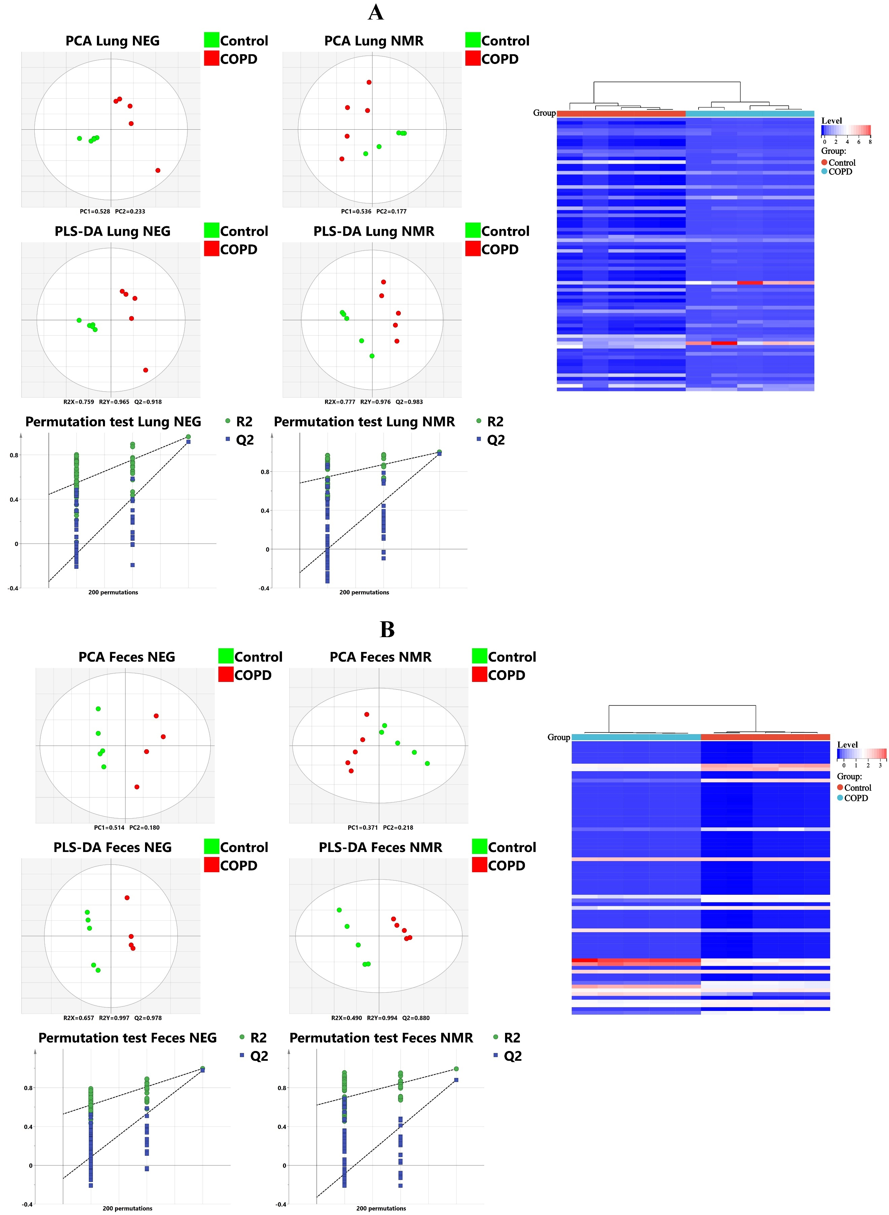

**Fig. S2.** A, Metabolomic analysis of lung in LC-MS (negative mode) and 1H-NMR: PCA, PLS-DA and permutation test; Heatmap and hierarchical cluster analysis of pulmonary metabolomic biomarkers. B, Metabolomic analysis of intestinal contents in LC-MS (negative mode) and 1H-NMR: PCA, PLS-DA and permutation test; Heatmap and hierarchical cluster analysis of fecal metabolomic biomarkers.

**Table S7-1** Pulmonary microbial information involved in correlation analysis.

|  |  |
| --- | --- |
| **Abbreviation** | **Taxa** |
| Microbiota1 | Bacteria.Proteobacteria.Gammaproteobacteria.Pasteurellales |
| Microbiota2 | Bacteria.Proteobacteria.Gammaproteobacteria.Pasteurellales.Pasteurellaceae |
| Microbiota3 | Bacteria.Proteobacteria.Gammaproteobacteria.Pasteurellales.Pasteurellaceae.Rodentibacter |
| Microbiota4 | Bacteria.Bacteroidetes |
| Microbiota5 | Bacteria.Bacteroidetes.Bacteroidia |
| Microbiota6 | Bacteria.Proteobacteria.Alphaproteobacteria.Rhodobacterales |
| Microbiota7 | Bacteria.Proteobacteria.Alphaproteobacteria.Rhodobacterales.Rhodobacteraceae |
| Microbiota8 | Bacteria.Proteobacteria.Gammaproteobacteria.Pseudomonadales.Moraxellaceae.Psychrobacter |
| Microbiota9 | Bacteria.Proteobacteria.Gammaproteobacteria.Enterobacteriales.Enterobacteriaceae.Enterobacter |

**Table S7-2** Fecal microbial information involved in correlation analysis.

|  |  |
| --- | --- |
| **Abbreviation** | **Taxa** |
| Microbiota1 | Bacteria.Firmicutes.Clostridia.Clostridiales.Ruminococcaceae.Ruminococcus_2 |
| Microbiota2 | Bacteria.Actinobacteria |
| Microbiota3 | Bacteria.Actinobacteria.Actinobacteria |
| Microbiota4 | Bacteria.Actinobacteria.Actinobacteria.Bifidobacteriales.Bifidobacteriaceae |
| Microbiota5 | Bacteria.Actinobacteria.Actinobacteria.Bifidobacteriales.Bifidobacteriaceae.Bifidobacterium |
| Microbiota6 | Bacteria.Actinobacteria.Actinobacteria.Bifidobacteriales |
| Microbiota7 | Bacteria.Firmicutes.Clostridia.Clostridiales.Ruminococcaceae.Ruminococcaceae_UCG_014 |
| Microbiota8 | Bacteria.Proteobacteria |
| Microbiota9 | Bacteria.Proteobacteria.Gammaproteobacteria |
| Microbiota10 | Bacteria.Bacteroidetes.Bacteroidia.Bacteroidales.Prevotellaceae.Prevotellaceae_UCG_001 |

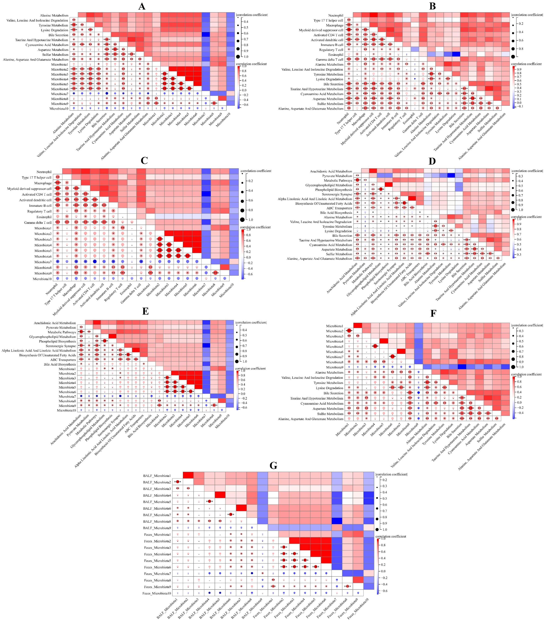

**Fig. S3.** A, correlation heatmap of fecal metabolic pathways and microfloras. B, correlation heatmap of pulmonary immune cells and fecal metabolic pathways. C, correlation heatmap of pulmonary immune cells and fecal microfloras. D, correlation heatmap of pulmonary metabolic pathways and fecal metabolic pathways. E, correlation heatmap of pulmonary metabolic pathways and fecal microfloras. F, correlation heatmap of pulmonary microfloras and fecal metabolic pathways. G, correlation heatmap of pulmonary microfloras and fecal microfloras.