Supplementary Material

Mineralogical and geochemical characteristics of barium slag and ecological risks associated with heavy metals
Chengbing Fu ^{a, b, c}, Yu Zhang ^{b, c}, Juan Tian ^{d}, Wenxing Chen ^{d}, Hongyan Pan ^{b, c}, Jianxin Cao ^{a, b, c,} *
ª College of Resources and Environmental Engineering, Guizhou University, Guiyang, Guizhou 550025, China
^{b} School of Chemistry and Chemical Engineering, Guizhou University, Guiyang, Guizhou 550025, China
^{c} Guizhou Key Laboratory for Green Chemical and Clean Energy Technology, Guizhou University, Guiyang, Guizhou 550025, China
^{d} Guizhou Chemical Research Institute, Guiyang, Guizhou 550003, China

* Corresponding Author:
E-mail: jxcao@gzu.edu.cn

Table S1. Statistics of BS screening results.
Number | wt (%)
BS1 | 52.55
BS2 | 13.52
BS3 | 13.10
BS4 | 9.330
BS5 | 11.50
Total | 100.0

Table S2. Chemical composition distribution (wt%) in BS with different particle size.
Chemical compositions | ≥850 μm  (BS1) | 425-850 μm  (BS2) | 150-425 μm  (BS3) | 75-150 μm  (BS4) | ＜75 μm  (BS5) | Total
SiO₂  BaO  SO₃  CaO  Al₂O₃  Fe₂O₃  MgO  Na₂O  K₂O  TiO₂  P₂O₅  SrO  V₂O₅  ZnO  MnO | 50.84  48.69  45.75  54.93  52.77  50.74  52.08  40.97  56.16  51.36  61.63  51.30  56.29  50.41  51.07 | 14.62  12.73  12.29  13.69  14.30  11.02  13.28  14.74  14.70  14.25  13.84  12.72  14.11  10.68  14.55 | 13.34  12.90  12.75  11.65  15.04  11.20  13.93  17.45  12.55  15.43  11.05  12.79  9.120  12.00  13.19 | 7.020  11.09  12.87  7.730  9.140  9.490  10.42  12.21  7.340  8.990  5.680  9.500  7.260  10.27  8.420 | 6.620  14.60  16.36  12.00  8.750  17.54  10.29  14.63  9.250  9.980  7.800  13.69  13.22  16.64  12.77 | 100.0  100.0  100.0  100.0  100.0  100.0  100.0  100.0  100.0  100.0  100.0  100.0  100.0  100.0  100.0

Table S3. Heavy metal distribution (%) in BS with different particle size.
Heavy  metal | ≥850 μm  (BS1) | 425-850 μm  (BS2) | 150-425 μm  (BS3) | 75-150 μm  (BS4) | ＜75 μm  (BS5) | Total
Cu  Zn  Pb  Cr  Cd  Ni  Fe  Mn  As  Ba | 50.44  49.85  59.68  51.52  52.08  56.64  51.04  52.24  51.61  45.39 | 10.97  11.71  14.06  12.11  12.15  13.10  10.99  12.98  11.25  11.48 | 11.39  12.55  8.270  12.16  11.77  13.67  11.07  12.31  10.62  15.44 | 10.15  10.20  6.830  9.010  9.520  11.17  9.650  9.110  9.840  12.30 | 17.05  15.69  11.16  15.20  14.49  5.430  17.25  13.35  16.69  15.40 | 100.0  100.0  100.0  100.0  100.0  100.0  100.0  100.0  100.0  100.0

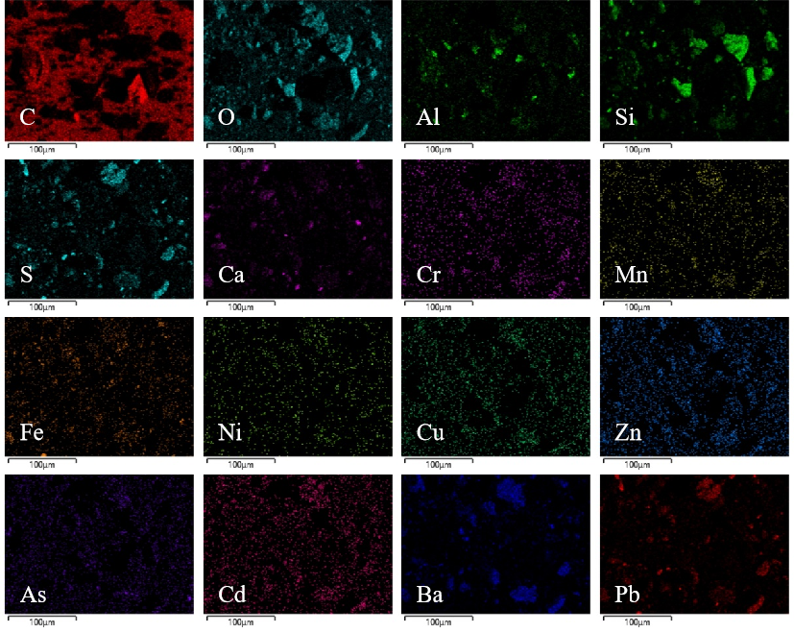
Fig.S1. Representative elemental mappings (C, O, Al, Si, S, Ca, Cr, Mn, Fe, Ni, Cu, Zn, As, Cd, Ba and Pb) of the BS1.
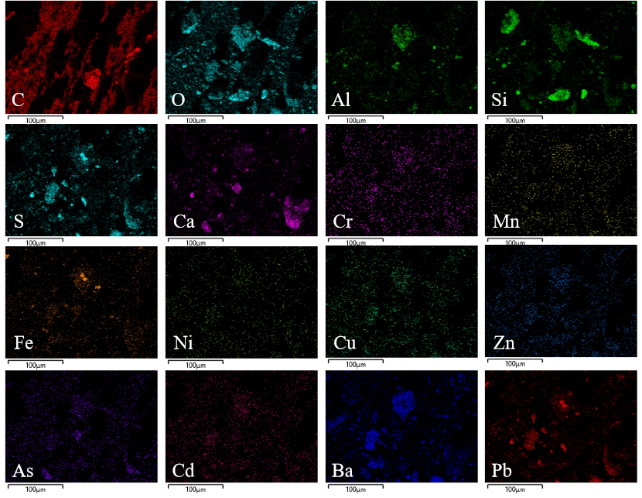
Fig.S2. Representative elemental mappings (C, O, Al, Si, S, Ca, Cr, Mn, Fe, Ni, Cu, Zn, As, Cd, Ba and Pb) of the BS2.
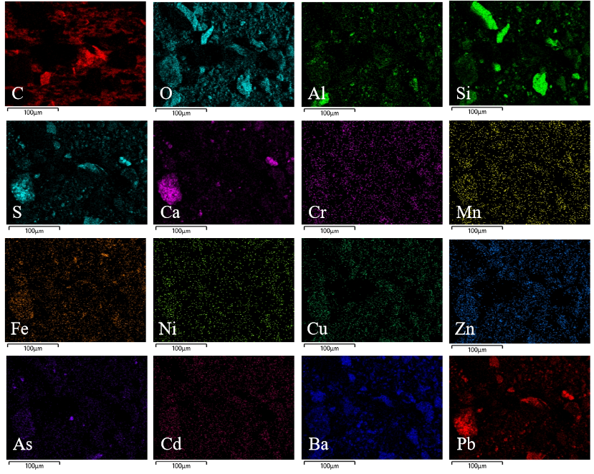
Fig.S3. Representative elemental mappings (C, O, Al, Si, S, Ca, Cr, Mn, Fe, Ni, Cu, Zn, As, Cd, Ba and Pb) of the BS3.
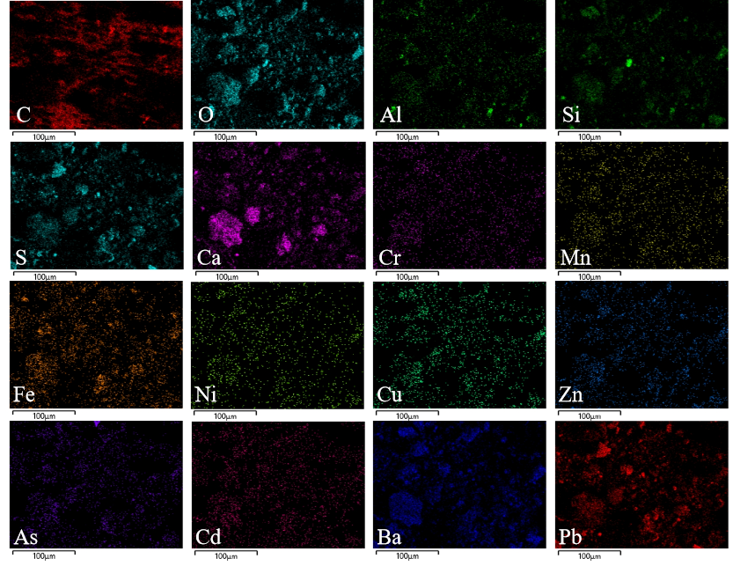
Fig.S4. Representative elemental mappings (C, O, Al, Si, S, Ca, Cr, Mn, Fe, Ni, Cu, Zn, As, Cd, Ba and Pb) of the BS4.
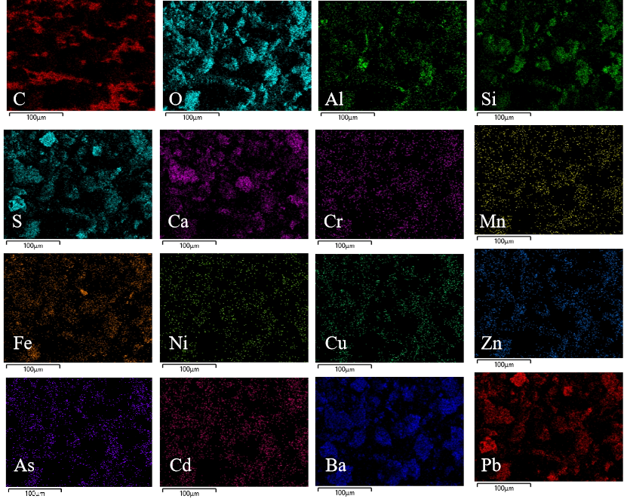
Fig.S5. Representative elemental mappings (C, O, Al, Si, S, Ca, Cr, Mn, Fe, Ni, Cu, Zn, As, Cd, Ba and Pb) of the BS5.

