# Oxidative desulfurization catalyzed by magnetically recoverable CoFe2O4 Nano-particles

Fengmin Wu1, Qinlin Yuan1, Jinlong Wang1, Xiaowei Wang1, Jie Luo1, Yafei Guo1, Hang Xu1,2,*, Xuefeng Wei1

1. School of Chemistry and Chemical Engineering, Henan University of Science and Technology, Luoyang 471023, People’s Republic of China
2. School of Chemical Sciences, The University of Auckland, Auckland 1010, New Zealand

**Optimization of desulfurization conditions**

Acetonitrile has low surface tension and facilitates easy mass transfer at the biphasic solvent interface. What is more, acetonitrile, with a better extraction effect on dibenzothiophene, is selected as an extractor as a typical solvent, leading to a higher desulfurization rate. The produced DBTO2 can be extracted from model oil by acetonitrile solvent, which significantly enhanced the ODS efficiency of CoFe2O4 in this work[1]. Therefore, by using Acetonitrile as an extractant, it is significant to investigate the catalytic performance of the CoFe2O4 in the Extractive Catalytic Oxidative Desulfurization (ECODS) experiments.

From -30 min to 0 min, there was only a simple extraction desulfurization process, while no oxidation desulfurization process. From -30 min to 0 min was a process of extraction gradually reaching equilibrium. The oxidant was applied at 0 min (extraction equilibrium), and only then did it start the real extraction oxidation desulfurization reaction.

Catalyst dose has a remarkable effect on the oxidation of DBT. The effect of CoFe2O4 powder dosage on sulfur removal was evaluated (Fig. 6(a)). The desulfurization efficiencies of CoFe2O4 dosages increased with CoFe2O4 powder dosages varied from 50 mg to 125 mg within 20 min. The result indicated that more active sites were generated for the activation of PMS. The sulfur removal efficiency reached up to 95% within only 60 min with a catalyst loading of 125 mg. But the desulfurization rate decreased when the catalyst amount exceeded 125 mg. The mesoporous nature of CoFe2O4 assisted the diffusion of the substrate. The relatively large channel was more suitable for the adsorption and desorption of large sulfur-containing substances compared to the narrow channeled materials. Moreover, it also indicated that the CoFe2O4 and PMS combined system possessed excellent desulfurization rates.

Fig. 6(b) demonstrated the desulfurization rates at different desulfurization temperatures. In the extraction stage, DBT was diffused from the oil phase to the extraction phase. After the addition of PMS into the system, the desulfurization rate was improved with the increase in temperatures. The sulfur removal efficiencies significantly increased in the range from 30 oC to 40 oC within 80 min. However, the desulfurization rate decreased when the temperature increased to 50 oC or 60 oC. The exorbitant high temperature is not favorable for catalytic oxidation[2]. In addition, PMS is not stable and decomposes easily at 65 oC[3]. From heat source utilization efficiency and catalytic efficiency, catalytic ODS is better at 40 ℃.

A suitable oxygen to sulfur ratio (O/S), using the correct amount of PMS (20 wt. %), is crucial to obtaining an efficient ODS process. If the O/S ratio is too low, the ability of the system to oxidize DBT in the model oil will be compromised[4]. However, excess PMS is not favorable for the catalytic oxidation ability of cobalt ions. Therefore, a suitable PMS dosage is important. Fig. 7(c) demonstrated the desulfurization rate increased from 71.49% to 95.10%, with the O/S ratio increasing from 1: 1 to 3: 1. Furthermore, when the O/S ratios further increased from 3: 1 to 7: 1, the desulfurization rate decreased obviously. The experimental results may be attributed to the content of PMS exceeding the optimum value because the strong acidity from hydrogen persulfate is not favorable for the catalytic oxidation of cobalt ions. Moreover, hydrogen persulfate also serves as the scavenger of sulfate radical[5], which is not favorable for the reaction. Therefore, the optimal O/S ratio for the desulfurization system is found to be 3: 1.

Fig. 6(d) showed the effect of the initial DBT concentration on the desulfurization process. The increase in the initial sulfur contents from 300 to 1200 ppm led to a decrease in the removal efficiencies from 20.05 to 16.60% in the first extraction region. In the second extraction–oxidation catalytic desulfurization (EOCDS) region, the sulfur removal efficiencies significantly increased within the first 20 min for all the initial sulfur content concentrations. CoFe2O4 can catalyze PMS to produce a large number of HSO5− due to its excellent catalytic activity, so its desulfurization efficiency is significantly and rapidly improved. At constant initial CoFe2O4 dosage and PMS dosage, the sulfur removal efficiency decreased with the rise of initial sulfur content (Fig. 6(e)).

Desulfurization tests on BT, DBT, and 4,6-DMDBT were performed under identical conditions to investigate the effects of CoFe2O4 nanoparticles on various sulfur-containing compounds. The results showed that the catalytic oxidation reaction of sulfur-containing compounds had a better removal effect on DBT than 4,6-DMDBT and BT, as shown in Fig. 6(f). The BT sulfur atom had the lowest reactivity because its electron density (5.696) was lower than those of DBT (5.758) and 4,6-DMDBT (5.760)[6] . Therefore, BT showed low reactivity. Since the electron concentrations of the sulfur atoms in DBT and 4, 6-DMDBT are comparable, these substances would have responded in a similar manner. However, the two methyl groups in 4,6-DMDBT may cause steric hindrance, which reduces the interaction between the CoFe2O4 nanoparticle catalyst and the oxide. Therefore, it is more difficult to remove 4,6-DMDBT than DBT.

As shown in Table 1, compared with other cobalt-containing or iron-containing catalysts, the CoFe2O4 catalyst has the shortest reaction time, the lowest required temperature and the lowest amount of oxidant under the same efficiency.

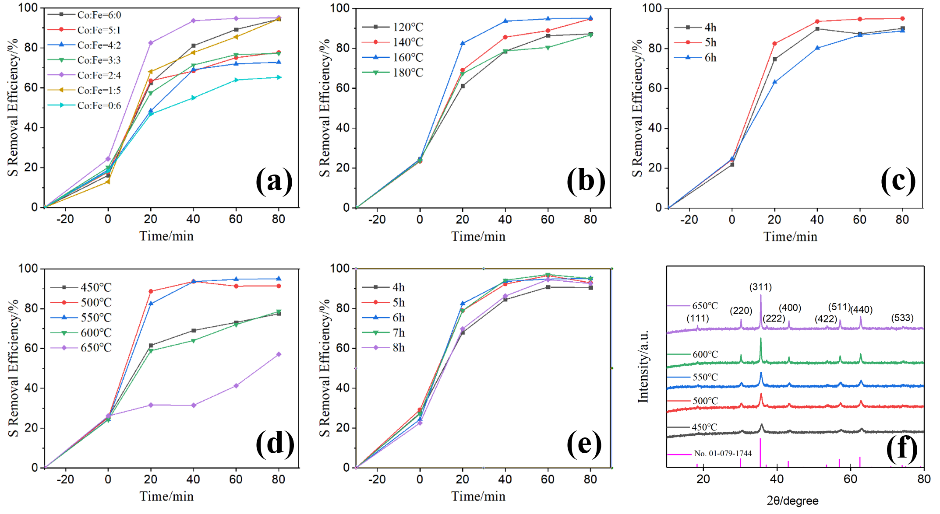

Fig. S1 The S removal efficiency in different factors on CoFe2O4 preparation: the effect of Co: Fe (a), the effect of hydrothermal reaction temperature (b), the effect of hydrothermal reaction time (c), the effect of calcination temperature (d), the effect of calcination time (e); XRD of CoFe2O4 at different calcination temperatures (f).



Fig. S2 Blank experiment without catalyst and without extraction

XRF test before and after desulfurization for check the amount of extraction of catalyst. The XRF test results showed that the catalyst after desulfurization testing contained K and S elements, and the content of K element was consistent with that of S element in K2SO4. The K2SO4 came from the reduction product of the oxidant compound salt PMS. Therefore, the results basically indicate that the catalyst does not adsorb the target analyte. We speculate that the loss of catalyst is the main reason of activity reduction.

Table.S1 XRF test before and after desulfurization

|  |  |  |
| --- | --- | --- |
| element | Result % | characteristic spectral line |
| Co | 20.727 | Co Ka |
| Fe | 2.914 | Fe Ka |

Table.S1 XRF test before and after desulfurization

|  |  |  |
| --- | --- | --- |
| element | Result % | characteristic spectral line |
| K | 54.454 | K Ka |
| S | 21.860 | S Ka |
| Co | 20.727 | Co Ka |
| Fe | 2.914 | Fe Ka |

[1] Y. Muhammad, A. Shoukat, A. U. Rahman, H. U. Rashid and W. Ahmad, Oxidative desulfurization of dibenzothiophene over Fe promoted Co-Mo/Al2O3 and Ni-Mo/Al2O3 catalysts using hydrogen peroxide and formic acid as oxidants. Chinese Journal of Chemical Engineering. 26(2018)593-600, 10.1016/j.cjche.2017.05.015.

[2] H. Li, W. Zhu, Y. Wang, J. Zhang, J. Lu and Y. Yan, Deep oxidative desulfurization of fuels in redox ionic liquids based on iron chloride. Green Chemistry. 11(2009)810-815, 10.1039/b901127g.

[3] A. M. Kermani, A. Ahmadpour, T. R. Bastami and M. Ghahramaninezhad, Deep oxidative desulfurization of dibenzothiophene with {Mo-132} nanoballs supported on activated carbon as an efficient catalyst at room temperature. New Journal of Chemistry. 42(2018)12188-12197, 10.1039/c8nj01735b.

[4] C. Zhang, X. Pan, F. Wang and X. Liu, Extraction-oxidation desulfurization by pyridinium-based task-specific ionic liquids. Fuel. 102(2012)580-584, 10.1016/j.fuel.2012.07.040.

[5] J. Madhavan, P. Maruthamuthu, S. Murugesan and S. Anandan, Kinetic studies on visible light-assisted degradation of acid red 88 in presence of metal-ion coupled oxone reagent. Applied Catalysis B: Environmental. 83(2008)8-14, 10.1016/j.apcatb.2008.01.021.

[6] T. N. Shujiro Otsuki, Noriko Takashima, Weihua Qian, and T. I. Atsushi Ishihara, and Toshiaki Kabe, Oxidative Desulfurization of Light Gas Oil and Vacuum Gas Oil by Oxidation and Solvent Extraction. Energy & Fuels. 14(2000)1232-1239, 10.1021/ef000096i.