**Supplementary material**

Phosphate removal performance and mechanism of Zirconium-doped magnetic gasification slag

Baoguo Yang a,b, Fengcheng Jiang *c, Yinxin Zhao *d, Hongbin Li a, Shengguang Zhang a, Kanghui Liu a

a School of Resources and Environment, Yili Normal University, Yining 835000, China

b Xinjiang Key Laboratory of Clean Conversion and High Value Utilization of Biomass Resources, Yili Normal University, Yining 835000, China

c Institute of Resource and Environment, Henan Polytechnic University, Jiaozuo, Henan 454003, China

d Geological Survey of Ningxia Province, Yinchuan, 750000, PR China

*Corresponding author

E-mail address: fc.jiang@hpu.edu.cn (F. Jiang), zhaoYX04@163.com (Y. Zhao)

**Text S1: The adsorption capacity *q***

The adsorption amount *q*(mg/g) is computed according to the following equation (Abdellaoui et al., 2021):

$q={\left(C_{o}-C_{t}\right)×V}/m$ (1)

where *Co, Ct* are respective phosphate concentrations (mg/L) of the initial and time *t* (h), *m*, *V* are the mass of sorbent (g) and the solution volume (mL), respectively. *q* (mg/g) indicates the amount of phosphate adsorbed per unit weight of adsorbent.

**Text S2: Phosphate species at different pH solution**

H3PO4, H2PO4-, HPO42- and PO43- are the main forms of the phosphate at different pH solution, which can be illustrated as follows (Abdellaoui et al., 2021; Xiong et al., 2017):

H3PO4 H++ H2PO4-  H++ HPO42-  PO43- + H+ (2)

where dissociation constant *pKa1, pK a2 and pK a3* are 2.15, 7.20 and 12.33, respectively.

**Text S3: Langmuir, Freundlich and Temkin isotherm equations**

The Langmuir and Freundlich non-linear equations can be expressed as follows (Arni et al., 2023; Sewu et al., 2017):

Langmuir isotherm equation:

$q_{e}=K_{L}q_{m}C_{e}/(1+K_{L}C_{e})$ (3)

Freundlich isotherm equation:

$q_{e}=K_{F}{C_{e}}^{1/n}$ (4)

Temkin isotherm equation:

$q_{e}=Aln(K_{T}C_{e})$　 (5)

$A={RT}/b$　 (6)

Where *Ce* (mg/L)represents the phosphate concentration at the equilibrium stage of sorption, *qe* and *qm* represents the sorption amounts of phosphate at equilibrium and the theoretical maximum monolayer sorption capacity, respectively, *KL* refers to the Langmuir constant, and measures the sorbent affinity to the solute. *KF* is the adsorption coefficient, *KT* represents Temkin constant, b represents heat of adsorption (J/mol).

**Text S4: kinetic model**

The non-linear equations of the three commonkinetic models can be displayed below (Akram et al., 2017; Liang et al., 2018)：

The pseudo first order equation:

$q_{t}$ = $q_{e}(1-e^{{-k}_{1}t})$ (5)

The pseudo second order equation:

$q_{t}=k_{2}q_{e}^{2}t/(1+k_{2}q_{e}t)$ (6)

The intraparticle diffusion model:

$q_{t}=K_{id}t^{1/2}+C$ (7)

where *qe* and *qt* represent the respective adsorbed amount of phosphate at equilibrium and any time t (min). *k1, k2*and *kid* are the rate constants of the Eq. (5), Eq. (6) and Eq. (7), respectively. *C* represents the thickness of the boundary layer.



Fig.S1. The preparation process of samples.

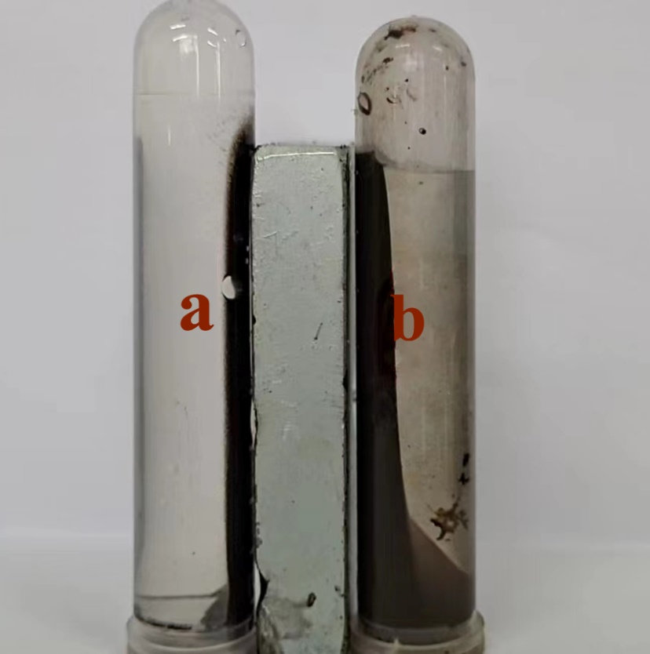

**Fig. S2.** The magnetic properties of co-precipitation of Zr and Fe (a) are stronger than loading Zr onto magnetic CGCS (after Fe) (b)

**Table S1**

Adsorption isotherm parameters. Adsorption conditions: reaction time, 24 h; sorbent dose, 1 g/L; initial phosphate concentration, 20-65 mg/L.

|  |  |  |
| --- | --- | --- |
| Isothermal model | Parameter | Value |
| Langmuir | *kL*(L/mg) | 0.384 |
| *qm*(mg/g) | 26.02 |
| R2 | 0.992 |
| Freundlich | *KF ((mg/g)/(mg/L)1/n)* | 14.07 |
| 1/n | 0.154 |
| R2 | 0.965 |
| Temkin | *KT*(L/mg) | 99.393 |
| A | 2.981 |
| R2 | 0.958 |

**Table S2**

Comparison of the adsorption capacity of GS-Z2M and adsorbents given in literatures for phosphate.

|  |  |  |  |  |  |
| --- | --- | --- | --- | --- | --- |
| Adsorbent | Initial concentration  (mg P/L) | pH | Temperature  (°C) | Sorption capacity  (mg/g) | Ref. |
| Zr/Al-Mt | 20–50 | 5.0 | 25 | 17.2 | (Huang et al., 2015) |
| BFSs | 50-500 | 7.0 | 20 | 18.9 | (Kostura et al., 2005) |
| La-Ves | 1.02-5.03 | 7.1 | 25 | 6.7 | (Li et al., 2009) |
| Magnetic Fe–Zr binary oxide | 0-100 | 4.0 | 25 | 13.65 | (Long et al., 2011) |
| Iron oxide tailings | 5-150 | 6.6-6.8 | 20-21 | 8.2 | (Zeng et al., 2004) |
| Zr-CNTs | 5-50 | 3 | 30 | 10.9 | (Gu et al., 2019) |
| Lepidocrocite | 2–100 | 7.2 | 25 | 3.2 | (Sleiman et al., 2016) |
| ACF-LaFe | 5-60 | / | 25 | 29.44 | (Liu et al., 2013) |
| ACF-LaOH | 10-70 | / | 25 | 15.3 | (Zhang et al., 2012) |
| La-Z | 5-60 | 6.0 | 40 | 17.2 | (He et al., 2017) |
| La-FACC | 10-200 | / | 25 | 24.9 | (Asaoka et al., 2021) |
| MKC | 0-160 | 7.5 | 25 | 11.92 | (Deng and Shi, 2015) |
| GS-Z2M | 20-65 | 6 | 25 | 26.02 | This study |

**Table S3**

Adsorption kinetic parameters of GS-Z2M to phosphate.

|  |  |  |  |
| --- | --- | --- | --- |
| Kinetic models and Experimental results | Plot parameters | | Values |
| Experimental adsorption capacity | qe,exp (mg/g) | | 9.985 |
| Pseudo-first-order | *qe,cal*(mg/g) | | 9.889 |
|  | *K1*(min-1) | | 9.496 |
|  | *R2* | | 0.786 |
| Pseudo-second-order | *qe,cal*(mg/g) | | 10.021 |
|  | *K2*(min-1) | | 3.547 |
|  | *R2* | | 0.993 |
| Intraparticle diffusion | *Kid1*(mg/g min1/2) | | 1.403 |
|  | *C* | | 8.372 |
|  | *R2* | 0.977 | |
|  | *Kid2* (mg/g min1/2) | 0.107 | |
|  | *C* | 9.742 | |
|  | *R2* | 0.999 | |
|  | *Kid3*(mg/g min1/2) | 0.005 | |
|  | *C* | 9.968 | |
|  | *R2* | 0.999 | |

**Table S4**

Comparison of the toxic leaching results of GS-Z2M with the concentration limit of Class I surface water in China's surface water environmental quality standards. Units: mg/L.

|  |  |  |
| --- | --- | --- |
| Element | Concentration leached from GS-Z2M | Concentration limit for Class I surface water |
| As | < 0.0004 | 0.05 |
| Hg | < 0.00002 | 0.00005 |
| Cr | 0.0043 | 0.01 |
| Ni | 0.00096 | 0.02 |
| Cu | < 0.00053 | 0.01 |
| Zn | < 0.00031 | 0.05 |
| Cd | < 0.00006 | 0.01 |
| Pb | < 0.00008 | 0.001 |

**Table S5**

Comparison of leaching results of iron and zirconium from GS-Z2M.

|  |  |  |  |  |
| --- | --- | --- | --- | --- |
| Element | Water type | Units | Concentration at pH 3 | Concentration at pH 3 |
| Fe | DI water | mg/L | 1.02 | < 0.03 |
| Zr | Phosphate solution | μg/L | 0.14 | < 0.02 |

**Table S6** Main components of actual wastewater.

|  |  |  |
| --- | --- | --- |
| Main components | Units | Content |
| Ca2+ | mg/L | 60.3 |
| K+ | mg/L | 10.1 |
| Mg2+ | mg/L | 24.5 |
| Na+ | mg/L | 74.7 |
| NH4+ | mg/L | 5.4 |
| Cl- | mg/L | 120.3 |
| NO3- | mg/L | 10.6 |
| SO42- | mg/L | 80.2 |
| DOC | mg/L | 6.3 |
| PO43- | mg/L | 1.5 |
| pH | / | 7.4 |

**Table S7**

BET specific surface area and BJH pore parameters of CGCS and GS-Z2M.

|  |  |  |  |
| --- | --- | --- | --- |
| Sample | BET specific surface area (m2/g) | BJH average pore diameter (nm） | BJH cumulative volume of pores (cm3/g) |
| CGCS | 10 | 6.73 | 0.0129 |
| GS-Z2M | 188 | 5.22 | 0.2097 |

**References**

Abdellaoui, Y., Abou Oualid, H., Hsini, A., El Ibrahimi, B., Laabd, M., El Ouardi, M., Giácoman-Vallejos, G., Gamero-Melo, P., 2021. Synthesis of zirconium-modified merlinoite from fly ash for enhanced removal of phosphate in aqueous medium: experimental studies supported by monte carlo/sa simulations. Chem. Eng. J. 404, 126600. https://10.1016/j.cej.2020.126600.

Akram, M., Bhatti, H.N., Iqbal, M., Noreen, S., Sadaf, S., 2017. Biocomposite efficiency for Cr(Ⅵ) adsorption: kinetic, equilibrium and thermodynamics studies. Journal of Environmental Chemical Engineering 5, 400-411. https://10.1016/j.jece.2016.12.002.

Arni, L.A., Hapiz, A., Abdulhameed, A.S., Khadiran, T., Alothman, Z.A., Wilson, L.D., Jawad, A.H., 2023. Design of separable magnetic chitosan grafted-benzaldehyde for azo dye removal via a response surface methodology: characterization and adsorption mechanism. Int. J. Biol. Macromol. 242, 125086. https://10.1016/j.ijbiomac.2023.125086.

Asaoka, S., Kawakami, K., Saito, H., Ichinari, T., Nohara, H., Oikawa, T., 2021. Adsorption of phosphate onto lanthanum-doped coal fly ash—blast furnace cement composite. J. Hazard. Mater. 406, 124780. https://10.1016/j.jhazmat.2020.124780.

Deng, L., Shi, Z., 2015. Synthesis and characterization of a novel Mg–Al hydrotalcite-loaded kaolin clay and its adsorption properties for phosphate in aqueous solution. J. Alloy. Compd. 637, 188-196. https://10.1016/j.jallcom.2015.03.022.

Gu, Y., Yang, M., Wang, W., Han, R., 2019. Phosphate adsorption from solution by zirconium-loaded carbon nanotubes in batch mode. Journal of Chemical & Engineering Data 64, 2849-2858. https://10.1021/acs.jced.9b00214.

He, Y., Lin, H., Dong, Y., Wang, L., 2017. Preferable adsorption of phosphate using lanthanum-incorporated porous zeolite: characteristics and mechanism. Appl. Surf. Sci. 426, 995-1004. https://10.1016/j.apsusc.2017.07.272.

Huang, W., Chen, J., He, F., Tang, J., Li, D., Zhu, Y., Zhang, Y., 2015. Effective phosphate adsorption by zr/al-pillared montmorillonite: insight into equilibrium, kinetics and thermodynamics. Appl. Clay Sci. 104, 252-260. https://10.1016/j.clay.2014.12.002.

Kostura, B., Kulveitová, H., Leško, J., 2005. Blast furnace slags as sorbents of phosphate from water solutions. Water Res. 39, 1795-1802. https://10.1016/j.watres.2005.03.010.

Li, H., Ru, J., Yin, W., Liu, X., Wang, J., Zhang, W., 2009. Removal of phosphate from polluted water by lanthanum doped vesuvianite. J. Hazard. Mater. 168, 326-330. https://10.1016/j.jhazmat.2009.02.025.

Liang, Q., Luo, H., Geng, J., Chen, J., 2018. Facile one-pot preparation of nitrogen-doped ultra-light graphene oxide aerogel and its prominent adsorption performance of Cr(Ⅵ). Chem. Eng. J. 338, 62-71. https://10.1016/j.cej.2017.12.145.

Liu, J., Zhou, Q., Chen, J., Zhang, L., Chang, N., 2013. Phosphate adsorption on hydroxyl–iron–lanthanum doped activated carbon fiber. Chem. Eng. J. 215-216, 859-867. https://10.1016/j.cej.2012.11.067.

Long, F., Gong, J., Zeng, G., Chen, L., Wang, X., Deng, J., Niu, Q., Zhang, H., Zhang, X., 2011. Removal of phosphate from aqueous solution by magnetic Fe–Zr binary oxide. Chem. Eng. J. 171, 448-455. https://10.1016/j.cej.2011.03.102.

Sewu, D.D., Boakye, P., Jung, H., Woo, S.H., 2017. Synergistic dye adsorption by biochar from co-pyrolysis of spent mushroom substrate and saccharina japonica. Bioresour. Technol. 244, 1142-1149. https://10.1016/j.biortech.2017.08.103.

Sleiman, N., Deluchat, V., Wazne, M., Courtin, A., Saad, Z., Kazpard, V., Baudu, M., 2016. Role of iron oxidation byproducts in the removal of phosphate from aqueous solution. Rsc Adv. 6, 1627-1636. https://10.1039/C5RA22444F.

Xiong, W., Tong, J., Yang, Z., Zeng, G., Zhou, Y., Wang, D., Song, P., Xu, R., Zhang, C., Cheng, M., 2017. Adsorption of phosphate from aqueous solution using iron-zirconium modified activated carbon nanofiber: performance and mechanism. J. Colloid Interface Sci. 493, 17-23. https://10.1016/j.jcis.2017.01.024.

Zeng, L., Li, X., Liu, J., 2004. Adsorptive removal of phosphate from aqueous solutions using iron oxide tailings. Water Res. 38, 1318-1326. https://10.1016/j.watres.2003.12.009.

Zhang, L., Zhou, Q., Liu, J., Chang, N., Wan, L., Chen, J., 2012. Phosphate adsorption on lanthanum hydroxide-doped activated carbon fiber. Chem. Eng. J. 185-186, 160-167. https://10.1016/j.cej.2012.01.066.