**Quantitative profiling and mechanisms exploration of Epimedium Total Flavonoid Capsules in neuroinflammation: An integrated study of pharmacokinetics, network pharmacology, and molecular pathways**

Xiaochun Zeng a, 1, Junran Shao a, 1, Dabo Pan d, Siying Zeng a, Zhenzhong Wang b, c, Xinsheng Yao a, Haibo Li b, c, *, Wei Xiao b, c, *, Yang Yu a, *

*a State Key Laboratory of Bioactive Molecules and Druggability Assessment; Guangdong Province Key Laboratory of Pharmacodynamic Constituents of TCM and New Drugs Research;International Cooperative Laboratory of Traditional Chinese Medicine Modernization and Innovative Drug Development of Ministry of Education (MOE) of China; Institute of Traditional Chinese Medicine & Natural Products, College of Pharmacy, Jinan University, Guangzhou, 510632, China*

*b State Key Laboratory on Technologies for Chinese Medicine Pharmaceutical Process Control and Intelligent Manufacture, Jiangsu Kanion Pharmaceutical Co. Ltd., Jiangsu, Lianyungang, 222001, China*

*c School of Pharmacy, Nanjing University of Chinese Medicine, Nanjing, 210023, China*

*d Department of Medical Technology, Qiandongnan Vocational and Technical College for Nationalities, Kaili, 556000, China*

*Correspondence to:* *Dr. Haibo Li, E-mail: lihaibo1985124@sina.com*

*Dr. Wei Xiao, E-mail:* [*xwv8521@kanion.com*](mailto:xwv8521@kanion.com)

*Dr. Yang Yu, E-mail: 1018yuyang@163.com*

***1*** *The first two authors contributed equally to this work*

# S1. Experiment and Methods

*S1.1 Sample preparation of ETFCs*

2.0 g ETFCs were weighed and dissolved in 20 mL 70% methanol. The solution was diluted 10 times and centrifuged at 13300 rpm for 10 min, and a 2 μL supernatant aliquot was injected for UPLC analysis. All reference standards were dissolved in methanol to obtain standard solutions.

*S1.2 UPLC-QqQ-MS analysis*

The UPLC system, chromatographic column, and mobile phase were the same as described in “UPLC-Q/TOF-MS”, except that the flow rate was 0.3 mL/min and the column temperature was 35 °C. In the plasma pharmacokinetic study, the elution gradient program was operated as follows: 0-1 min, 2-10% B; 1-3 min, 10-20% B; 3-6.5 min, 20-35% B; 6.5-8.5 min, 35-60% B; 8.5-9.5 min, 60-80% B; 9.5-11.5 min, 80-100% B; 11.5-12 min, 100-100% B; 12-13 min, 100-2% B; 13-14 min, 2-2% B. In the brain tissue distribution study, the gradient program was run as follows: 0-2 min, 2-15% B; 2-5.5 min, 15-35% B; 5.5-7.5 min, 35-48% B; 7.5-9.5 min, 48-80% B; 9.5-10.5 min, 80-100% B; 10.5-11 min, 100-100% B; 11-12 min, 100-2% B; 12-13 min, 2-2% B.

The UPLC system was coupled with an Xevo TQ-XS mass spectrometer (Waters Corp., Milford, MA, USA), equipped with an electrospray ionization (ESI) source. The Multiple Reaction Monitoring (MRM) parameters of quantitative components in the pharmacokinetics and brain tissue study were optimized and displayed in Table S2 and Table S3 respectively.

*S1.3 Method validation of pharmacokinetic research*

The specificity was evaluated by comparing the chromatograms of blank plasma, blank plasma spiked with LLOQ and internal standard (IS) standards solutions, and plasma samples obtained after oral administration of ETFCs.

The calibration curves were established by fitting the peak area ratios (y) of analytes to IS and the calibration standards concentration (x) by weighted (1/x2) least square linear regression. The lower limit of quantification (LLOQ) was defined as the lowest concentration on the calibration curve with a signal-to-noise ratio (S/N) of 10.

The intra-day and inter-day precision and accuracy were assessed by analyzing six replicates of QC samples at low, medium, and high levels on one day and three consecutive days, respectively. Relative standard deviation (RSD) and relative error (RE) were defined for precision and accuracy, respectively.

The extraction recoveries and matrix effects were assessed with six replicates of QC samples at three concentration levels. The extraction recovery was measured by comparing the IS-normalized peak area of blank samples spiked with analytes before extraction with post-extraction samples. The matrix effects were evaluated by comparing the IS-normalized peak areas of the analytes dissolved in blank biological matrixes with those dissolved in MeOH solutions.

The stabilities of analytes were determined by six replicates of QC samples at low, medium, and high levels under four different conditions (three freeze-thaw cycles, room temperature (25 °C) for 4 h, -80 °C for 30 days, auto-sampler (15 °C) for 24 h.

# S2. Chemical profile of ETFCs by UPLC-Q/TOF-MS analysis

A total of 65 compounds were detected in ETFCs, including 54 flavonoids, 8 organic acids, 1 alkaloid, and 2 other-type components. Among them, 16 compounds were accurately identified by comparing the retention time and mass spectrum fragments with the reference standards. The detailed information of compounds including chemical formulas, retention times, and mass spectral information were summarized in Table S4. The base peak intensity (BPI) chromatograms are shown in Figure S1.

*Identification of* *Prenylfavonols*

Prenylfavonols with isopentenyl substitution at the C-8 position are the major active compounds of Epimedium. Their aglycone skeleton was divided into three sub-types: icaritin, demethylicaritin, and 3'-hydroxyicariine. Most ﬂavonoid glycosides were 3-*O*-, 7-*O*-, or 3,7-di-*O*-glycosides containing glucose, rhamnose, xylose, and dideoxyfuranose (Wang et al., 2010).

Type 1. A total of 18 prenylated flavonoid glycosides with aglycone of icaritin were detected in ETFCs (compounds **37, 39, 40, 41, 42, 43, 44, 48, 49, 50, 51, 52, 60, 61, 62, 63, 64 and 65**). According to literature (Zhao et al., 2008), their characteristic fragmentation pathway is the neutral loss of sugar residues to produce radical aglycone ionat *m/z* 366.1106 [icaritin-H].- or aglycone ionat *m/z* 367.1182 [icaritin-H]- and 3-*O*-sugar substitutions of these flavonoids are more likely to generate radical aglycone ion than those with 7-*O*-sugar substitutions. Among them, *m/z* 367.1182 first generated a [icaritin-H-CH3]- ion at *m/z* 352.0938 by the elimination of the C-4' methoxyl residue, then yieled fragment ions at *m/z* 297.0399 [icaritin-H-CH3-C4H7]- and *m/z* 309.0434 [icaritin-H-CH3-C3H7]- via the cleavage of the isopentenyl at the C-8 position. While *m/z* 366.1106 produced a series characterized ions at *m/z* 351.0876 [icaritin-H-CH3]-, *m/z* 323.0919 [icaritin-H-C3H7]- and *m/z* 311.0556 [icaritin-H-C4H7]- through loss of 4’-methoxyl, C3H7 and C4H7 of isopentenyl residues, respectively. Taking structural identification of **44** and **64** as examples. Compound **44** was unambiguously identified as icariin (Fig. S2A) by comparing it with the reference substance. In negative mode, it exhibited quasi-molecular ion [M-H+HCOOH]- at *m/z* 721.2361, and the obvious fragment ion [M-H-Glu]- at *m/z* 513.1762 was observed by the neutral loss of a glucose (162 Da). In the MSE spectrum, the aglycone ion at *m/z* 367.1186 [icaritin-H]-, as well as its production *m/z* 352.0941, *m/z* 297.0408 and *m/z* 309.0424 were also abundant. Compound **64** was assigned as icariside II (Fig. S2B) based on the standard substance. Its quasi-molecular ion [M-H]- at *m/z* 513.1764 (C27H30O10) revealed a radical aglycone ion at *m/z* 366.1706 as the base peak resulting from the loss of rhamnose (146 Da) and the distinct daughter ions at *m/z* 351.0876, *m/z* 323.0925 and *m/z* 311.0556 were originated from 366.1706.

In addition, **39, 40, 41, 42, 60, 61, 62, and 63** showed similar mass characteristics with reference standards, which were precisely identified as epimedin A1, epimedin A, epimedin B, epimedin B, sagittatoside A, icariside I, sagittatoside B, and respectively. Similarly, compounds **37, 43, 48, 51, 52 and 65** showed the similar fragmentation pattern, which were successfully identified as acuminatoside, 4''-*O*-rhamnosylicariin, anhydroicaritin-3-*O*-rhamnopyranosyl-glucopyranoside-7-*O*-glucuronic acid, icaritin-3-O-(2-hydroxy-2-carboxyl-5-methyltetrahydrofuran-1-yl), sempervirenoside B, 3'''-carbonyl-2''-β-L-quinovosyl icariside II, respectively.

Type 2. 12 compounds of demethylicaritin aglycone were identiﬁed from ETFCs (compounds **23, 25, 26, 30, 31, 36, 46, 53, 55, 57, 58** and **59**). These compounds all displayed aglycone ion peaks of *m/z* 353 or 352 in the high energy MSE spectrum which has a C-4′ hydroxyl substitution. Component **30** gave mother [M-H]- ion at *m/z* 661.2139 and displayed the molecular formula of C32H38O15. The characteristic ions at *m/z* 514.1476 [M-H-Rha].- and 352.0912 [M-H-Rha-Glu]- were exhibited by the elimination of rhamnose and glucose. Consequently, it was identified as epimedoside A (Fig. S2C) by comparison with a reference standard. Based on the similar fragmentation pathways, other flavonols of this type were tentatively characterized.

Type 3. There were 5 prenylfavonols with 3′-hydroxyicariine aglycone in ETFCs. The structural characteristics of 3′-hydroxyicariine aglycone are that C-3′ and C-4′ of icaritin have been substituted with hydroxyls and methoxyls, respectively. The diagnostic fragment ions of these compounds were the same as previously reported (Zhao et al., 2008). Briefly, the primary MS behavior was to generate aglycone ion at *m/z* 383.1131 [aglycone-H]- after completely losing the sugar substituents. Compounds **54** and **56** were isomers which exhibited the same formula (C27H30O11) and the same precursor ion [M+H]+ at *m/z* 529.1718. They both afford the aglycone ion at *m/z* 383.1120 [M-H-Rha]- as the base peak. In addition, a series of daughter ions produced by aglycone ion at *m/z* 312.0654 [M-H-Rha-C3H7-CO]-, *m/z* 297.0411 [M-H-Rha-C3H7-CO-CH3]– and *m/z* 269.0458 [M-H-Rha-C3H7-2CO-CH3]- could be detected. Therefore, **54** and **56** were preliminarily identified as caohuoside C or its isomers. Compound **33** exhibited the mother ion [M-H]- at *m/z* 691.2225 and the abundant fragment ions at *m/z* 529.1713 [M-H-Glu]-, *m/z* 383.1143 [M-H-Glu-Rha]-. The aglycone ion sequentially lost CH3 and C3H7 resulting in the fragment ions at *m/z* 368.0912 [M-H-Glu-Rha-CH3]- and 325.0377 [M-H-Glu-Rha-CH3-C3H7]-. Therefore, this compound was preliminarily identified as sagittasine C (Fig. S2D) by showing the same fragmentation ions with authentic reference.

In addition to the three main types mentioned above, another 5 obvious peaks of ETFCs were identified as prenylfavonols. Compound **29** gave the mother ion [M+H]+at *m/z* 695.2551 in positive ion mode, with a molecular formula of C33H42O16. The fragment ions *m/z* 549.1954 [M+H-Glu]+ and 387.1420 [M+H-Glu-Rha]+ were observed via neutral loss of glucose and rhamnose. Its aglycon ion *m/z* 387.1420 further neutrally lost H2O to produce *m/z* 369.1336 [M+H-Glu-Rha-H2O]+, which was speculated that its aglycon structure might be hydration of the C8-position isopentenyl group to form 3"-OH. Based on the fragment information, compound **29** was preliminarily identified as icarisid B. Similarly, compounds **28, 45, and 47** were preliminarily identified as icarisid D, wanepimedoside A, and 4'-methoxynoricaritin-3-*O*-rhamnoside, respectively.

*Identification of other favonols*

In addition to prenylfavonols, 12 flavonols with kaempferol and quercetin as aglycones were detected in ETFCs. Compounds **10, 15, 17, 19, 24,** and **27** gave mother [M-H]- ions at *m/z* 739.2101, *m/z* 577.1562, *m/z* 447.0935, *m/z* 447.0916, *m/z* 417.0819 and *m/z* 431.0993, respectively. The fragment ion of kaempferol aglycone at *m/z* 285.0399 [aglycone-H]-.were observed in their high energy MSE spectrum Moreover, product ions at *m/z* 255.0293 [aglycone-H-HCHO]- and *m/z* 227.0379 [aglycone-H-HCHO-CO]- were exhibited by the neutral loss of HCOH and CO. Combined with the self-built database, they were preliminarily identified as kaempferol-3-*O*-rhamnopyranosyl-glucopyranoside-7-*O*-rhamnoside, kaempferol-3,7-di-*O*-rhamnoside, trifolin/astragalin, kaempferol-3-*O*-xylopyranoside and kaempferol-3-*O*-rhamnoside, respectively.

Component **14** exhibited a [M-H]- ion at *m/z* 463.0878 (C21H20O12) with the aglycone fragment ions at *m/z* 301.0340 [aglycone-H]- and *m/z* 300.0277 [aglycone-H]·- via the lossing of Glu (162 Da). And the characteristic fragment ions at *m/z* 271.0252 [aglycone-H-HCOH]- and *m/z* 255.0288 [aglycone-H-(CO+H2O)]- were generated from the aglycone fragment ions. Thus, it was identified as hyperoside (Fig. S2E) by comparing with the reference substance. Similarly, compounds **11, 18** and **20** were tentatively characterized as quercetin-3,7-di-*O*-rhamnoside、quercetin-3-*O*-α-L-arabinopyranoside and quercetin-3-O-rhamnoside, respectively.

*Identification of Organic acids and alkaloid*

In this work, a total of 8 organic acids (compounds **1, 3, 4, 5, 7, 8, 11,** and **13**) and 1 alkaloid (compound **9**) were characterized in ETFCs. Compound **13** gave the [M-H]- ion at *m/z* 163.0399 (C9H8O3), and fragmentation of this molecule generated ions at *m/z* 119.0506[M-H-CO2]- by losing CO2 (44 Da) and its structure was speculated to be *p*-hydroxycinnamic acid. The [M-H]- ions of Compounds **3, 7, 8,** and **11** were observed at *m/z* 337.0923, indicating they have the same elemental composition of C16H18O8. The fragment *m/z* 163.0395 [coumalic acid-H]- and the characteristic fragment ion of quinic acid *m/z* 191.0556 [quinic acid-H]- were exhibited in the high energy MSE spectrum. Due to the lack of reference substances, they were temporarily identified as 5-*O*-p-coumaroylquinic acid or its isomers. Compounds **1**, **4,** and **5** exhibited the same deprotonated ion at *m/z* 353.0873 [M-H]- and a series of fragment ions at *m/z* 191.0556 [M-H-C9H6O3]-, 179.0344[M-H-C7H10O5]- and 135.0441[M-H-C7H10O5-CO2]-, which were unambiguously identified as neochlorogenic acid, cryptochlorogenic acid and chlorogenic acid respectively with reference standards. Compound **9** eluted at 3.25 min with a [M+H]+ ion at *m/z* 342.1702 indicating an elemental composition of C20H23NO4. It was unambiguously identified as magnoflorine by reference standard.

# S3. Identification of EFTCs-related metabolites in rat bio-sample

*Quercetin-related metabolites*

A total of 10 quercetin-related metabolites were detected in rat biological samples after administration of ETFCs. The metabolic reactions mainly included methylation, acetylation, sulfonation, and glucuronidation. **M4, M8, M11, M16, M20, M24, M25, M46, M52, and M61** all displayed the radical aglycone ion [M-H] - at *m/z* 300.0277 or the aglycone ion [M-H]- at *m/z* 301.0399 in the MSE spectrum. **M4** showed [M+H]+ ions at *m/z* 479.0826 (C21H18O13), whose molecular weight was 176.0321 Da heavier than quercetin, inferred to be produced by the glucuronidation of quercetin. **M20** and **M61** were deduced as the sulfated and acetylated product of quercetin respectively, because their protonated ion [M-H]- at *m/z* 380.9918 and 343.0461 were 80 Da and 42 Da heavier than quercetin, respectively. Similarly, **M46** and **M52** were characterized as deoxygenated and methylated products of quercetin. **M8, M11 and M16** showed [M-H]- ions at *m/z* 491.0826 (C22H19O13), and further yielded [aglycone-H]- ions at *m/z* 315.0500 by a neutral loss of 176 Da in MS/MS spectra. Therefore, they were tentatively identified as isomers of glucuronidated and methylated products of quercetin. Similarly, **M24** and **M25** whose molecular weights were 15 Da than **M20** were identified as sulfated and methylated quercetin.

*kaempferol-related metabolites*

After oral administration of ETFCs, about 9 kaempferol-related metabolites were characterized in rat biological samples (**M5, M6, M9**, **M18, M21, M22,** **M47, M48** and **M43)**. **M5, M6,** and **M9**, 176 Da heavier than kaempferol, were isomers with protonated ions at *m/z* 463.0877 [M+H]+, which displayed the same diagnostic ions *m/z* 285.0556 [M+H-GluA]+. Therefore, they were characterized as glucuronidated metabolites of kaempferol. Similarly, **M47** and **M48** were believed to be the methylated products of quercetin. **M18**, **M21,** and **M22** were deduced as sulfated conjugates of kaempferol. **M43** was characterized as a deoxidation product of kaempferol.

*Prenylfavonols-related metabolites*

Icaritin is an important intermediate in the metabolism of prenylated flavonoid glycosides(Zhao et al., 2010), therefore, icariin (**M86**) was chosen as the core structure for screening potential metabolites ofprenylfavonols. A total of 64 prenylated flavonoid metabolites were detected in rat biological samples. Their phase I metabolic pathways included hydroxylation, dehydrogenation, hydration and demethylation and phase II metabolic pathways included acetylation and glucuronidation.

Demethylation and dehydrogenation metabolites. **M79** had a quasi-molecular ion [M+H]+ at *m/z* 355.1180 and the characteristic fragment ion [M+H-CH4]+ at *m/z* 299.0555 which were 14 Da (CH2) less than the corresponding ion of icaritin, so **M79** was inferred to be demethylated icaritin. Similarly, **M14, M67, and M69** were identified sequentially. **M84** showed a [M+H]+ quasi-molecular ion at *m/z* 367.1190, 2 Da less than icaritin, indicating that M84 was a dehydrogenated metabolite of icaritin.

Hydroxylation and hydration metabolites. **M81** and **M82,** 16 Da (O) heavier than icaritin, were a pair of isomers with protonated ion at *m/z* 385.1286 [M+H]+, which displayed the same diagnostic ions [M+H-H2O]+ (*m/z* 367.1181). Therefore, they were characterized as hydroxylation metabolites of icaritin. In addition, the aglycone ion *m/z* 385.1287 was also observed in MS/MS spectra of **M17, M50, M56, M58, M60, M68, M70, and M72**, which were preliminarily identified as hydroxylation products of prenylfavonols. **M77** showed an obvious loss of 18 Da (H2O) from the quasi-molecular ion at *m/z* 387.1443 to the ion at m/z 369.1188, which suggested that it was a hydration product of icaritin.

Glucuronidation metabolites. Glucuronidation was the prime metabolic pathway of the prenylﬂavonoid in rat bio-samples. **M75, M76** and **M78** were characterized as monoglucuronidated products of icaritin because the molecular weight of mother ions of these metabolites were all 176 Da higher than icaritin. The quasi-molecular ion of **M31, M34, M62, and M63** in positive ion mode was *m/z* 721.1965, and the fragmentation of this molecule produced product ions at *m/z* 545.1659 [M+H-GluA]+ and *m/z* 369.1334 [M+H-2GluA]+ corresponding to continuous loss of glucuronic acid moiety. Therefore, they were inferred as diglucuronidated products of icaritin. **M44, M45, and M57** were a pair of isomers, whose molecular weights were 176 Da heavier than **M79**, inferred to be a pair of isomers produced by the glucuronidation of demethylated icaritin. Similarly, **M13 and M49** were also tentatively identified as diglucuronidated products of demethylated icaritin. **M51, M54, M55 and M59** showed [M+H]+ at *m/z* 561.1608, which were 16 Da heavier than **M75, M76 and M78** and gave characteristic fragment ions at *m/z* 385.1293 [M+H-GluA]+ and *m/z* 367.1182 [M+H-GluA-H2O]+, indicating that they were hydroxylation of glucuronidated icaritin. **M38 and M64** were identiﬁed as hydration of glucuronidated icaritin. In addition, **M26** showed precursor ions [M+H]+ at *m/z* 549.1604 and characteristic fragment ion at *m/z* 373.1277 [M+H-GluA]+ which were 14 Da (CH2) less than the corresponding ions of **M38 and M64** indicating that they were hydration and glucuronidation and demethylation products of icaritin.

**Figure captions**

**Fig. S1.** Structural types and formulas of the determined chemical components in ETFCs by UPLC-Q/TOF-MS

**Fig. S2.** The detailed fragmentation and proposed fragment pathways of five compounds. (A) icariin, (B) icariside II, (C) epimedoside A, (D) sagittasine C, (E) hyperosid

**Fig. S3.** Specificity for 13 analytes and IS in plasma: (a)-blank plasma; (b)-blank plasma spiked with LLOQ; (c)-plasma sample at 0.25 h. (1) Epimedoside A, (2) Epimedin A1, (3) Epimedin A, (4) Epimedin B, (5) Epimedin C, (6) Icariin, (7) Ikarisoside A, (8) Icariside I, (9) Sagittatoside A, (10) Sagittatoside B, (11) 2″-*O*-rhamnosyl icariside , (12) Icariside II, (13) Icaritin, (14) IS (Isobavachin).

**Fig. S4.** Carryover for 13 quantitative components and IS in plasma: (a)- blank plasma spiked with LLOQ; (b)- blank plasma; (c)- blank plasma spiked with HLOQ (1) Epimedoside A, (2) Epimedin A1, (3) Epimedin A, (4) Epimedin B, (5) Epimedin C, (6) Icariin, (7) Ikarisoside A, (8) Icariside I, (9) Sagittatoside A, (10) Sagittatoside B, (11) 2″-*O*-rhamnosyl icariside , (12) Icariside II, (13) Icaritin, (14) IS (Isobavachin).

**Fig. S5.** Specificity for 11 analytes and IS in brain tissue: (a)-blank plasma; (b)-blank plasma spiked with LLOQ; (c)-plasma sample at 0.25 h. (1) Epimedoside A, (2) Epimedin A1, (3) Epimedin A, (4) Epimedin B, (5) Epimedin C, (6) Icariin, (7) Ikarisoside A, (8) Icariside I, (9) Sagittatoside B, (10) 2″-O-rhamnosyl icariside, (11) Icariside II, (12) IS (Isobavachin).

**Fig. S6.** Carryover for 11 quantitative components and IS in brain tissue: (a)- blank plasma spiked with LLOQ; (b)- blank plasma; (c)- blank plasma spiked with HLOQ. (1) Epimedoside A, (2) Epimedin A1, (3) Epimedin A, (4) Epimedin B, (5) Epimedin C, (6) Icariin, (7) Ikarisoside A, (8) Icariside I, (9) Sagittatoside B, (10) 2″-*O*-rhamnosyl icariside, (11) Icariside II, (12) IS (Isobavachin).

**Fig. S7.** Relative peak area-time curves of 8 semi-quantitative components after oral administration of ETFCs (mean ± SD, n = 6)

**Fig. S8.** Heat map of molecular docking scoring (kcal/mol)

**Fig. S9.** Effects of different concentrations of 11compounds on the survival rate of BV-2 cells (mean ± SD, n = 3)

**Table captions**

**Table S1** Reference standards used in this study

**Table S2** The optimized MRM parameters of quantitative and semi-quantitative analytes in the pharmacokinetics study

**Table S3** The optimized MRM parameters of 11 analytes in the brain tissue study

**Table S4** Characterization of compounds identified from ETFCs by UPLC-Q-TOF/MS

**Table S5** The linear ranges and regression equations of 13 analytes in plasma (n=3)

**Table S6** The LLOQs of 13 analytes in plasma (n=6)

**Table S7** Precision and accuracy data of 13 analytes in plasma (n=6)

**Table S8** Extraction recoveries and matrix effects of 13 analytes and IS in plasma (n=6)

**Table S9** Short-term stability, long-term stability, auto-sampler stability and three freeze-thaw stability of 13 analytes in plasma (n=6)

**Table S10** The linear ranges and regression equations of 11 analytes in brain tissue (n=3)

**Table S11** The LLOQs of 11 analytes in brain tissue (n=6)

**Table S12** Precision and accuracy data of 11 analytes in brain tissue (n=6)

**Table S13** Extraction recoveries and matrix effects of 11 analytes and IS in brain tissue (n=6)

**Table S14** Short-term stability, long-term stability, auto-sampler stability and three freeze-thaw stability of 11 analytes in brain tissue (n=6)

**Table S15** The sequences of PCR primers

**Table S16** Compounds and targets with degree values greater than or equal to the mediator value

**Table S17** five key targets using molecular docking

**WB raw data**



**Fig. S1.** Structural types and formulas of the determined chemical components in ETFCs by UPLC-Q/TOF-MS.

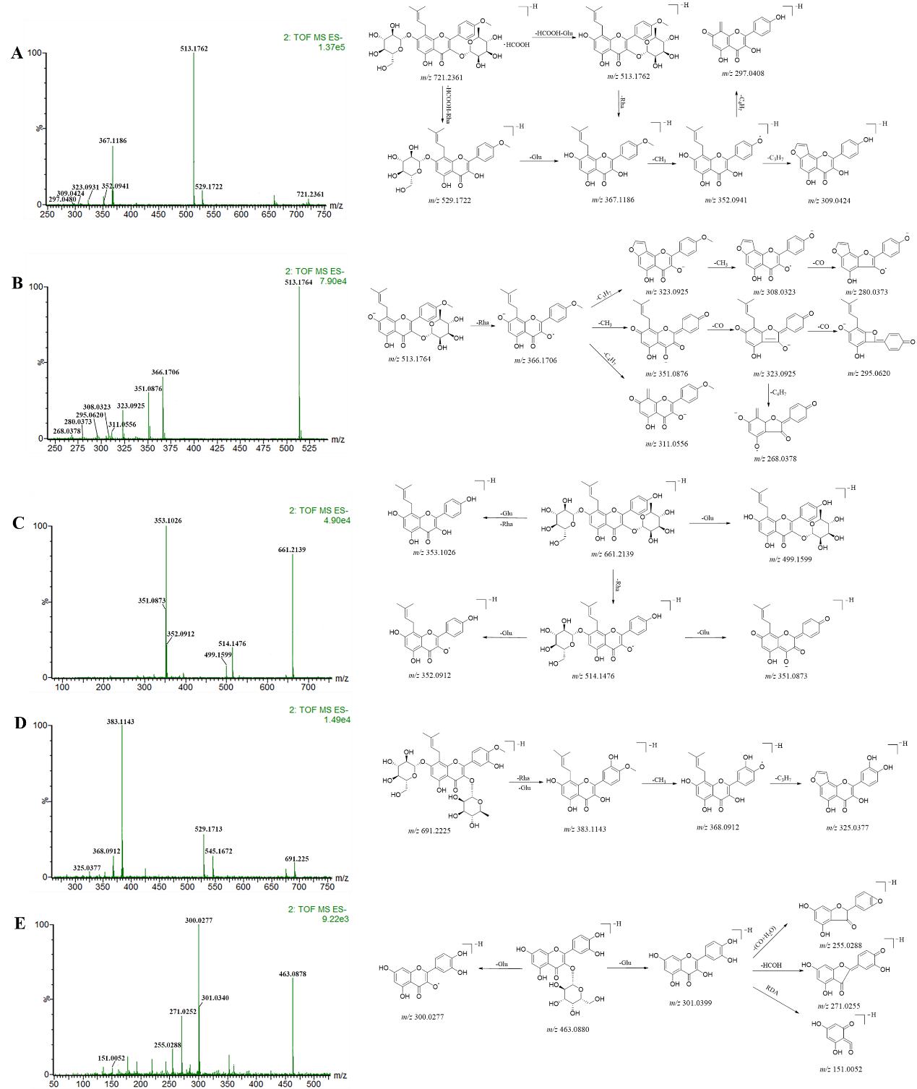

**Fig. S2.** The detailed fragmentation and proposed fragment pathways of five compounds. (A) icariin, (B) icariside II, (C) epimedoside A, (D) sagittasine C, (E) hyperosid

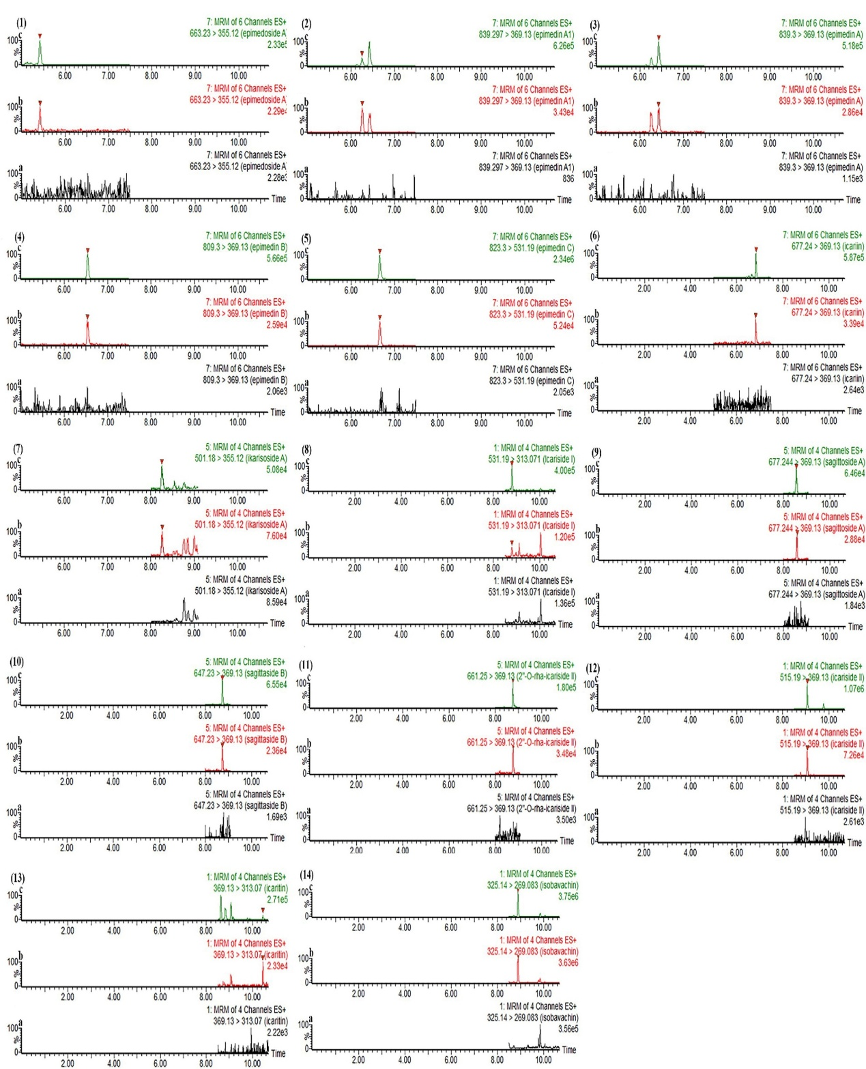

**Fig. S3.** Specificity for 13 analytes and IS in plasma:(a)-blank plasma; (b)-blank plasma spiked with LLOQ; (c)-plasma sample at 0.25 h. (1) Epimedoside A, (2) Epimedin A1, (3) Epimedin A, (4) Epimedin B, (5) Epimedin C, (6) Icariin, (7) Ikarisoside A, (8) Icariside I, (9) Sagittatoside A, (10) Sagittatoside B, (11) 2″-*O*-rhamnosyl icariside , (12) Icariside II, (13) Icaritin, (14) IS (Isobavachin).

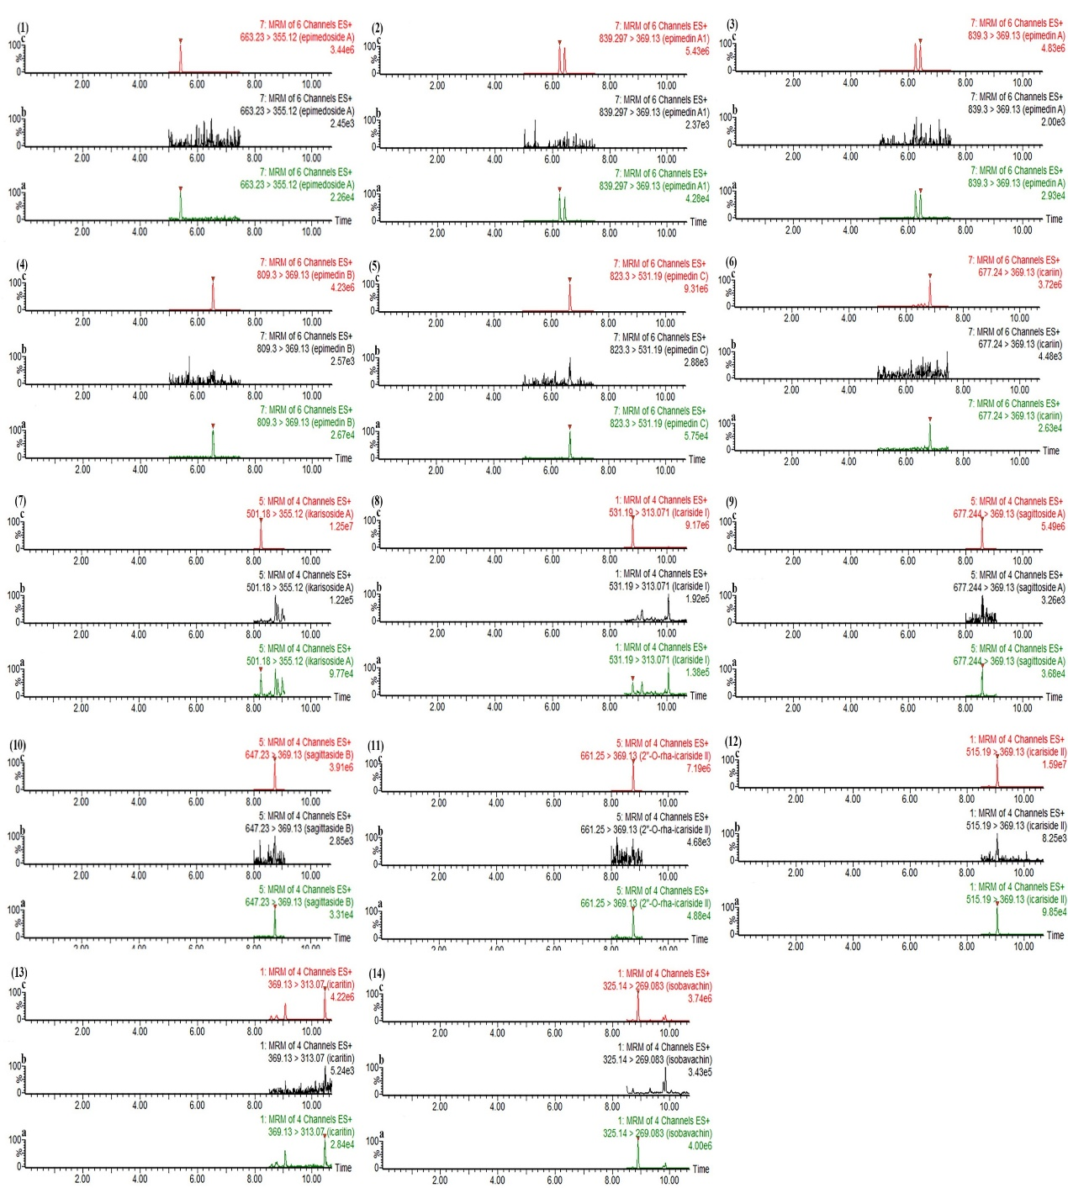

**Fig. S4.** Carryover for 13 quantitative components and IS in plasma: (a)- blank plasma spiked with LLOQ; (b)- blank plasma; (c)- blank plasma spiked with HLOQ (1) Epimedoside A, (2) Epimedin A1, (3) Epimedin A, (4) Epimedin B, (5) Epimedin C, (6) Icariin, (7) Ikarisoside A, (8) Icariside I, (9) Sagittatoside A, (10) Sagittatoside B, (11) 2″-*O*-rhamnosyl icariside Ⅱ, (12) Icariside II, (13) Icaritin, (14) IS (Isobavachin).

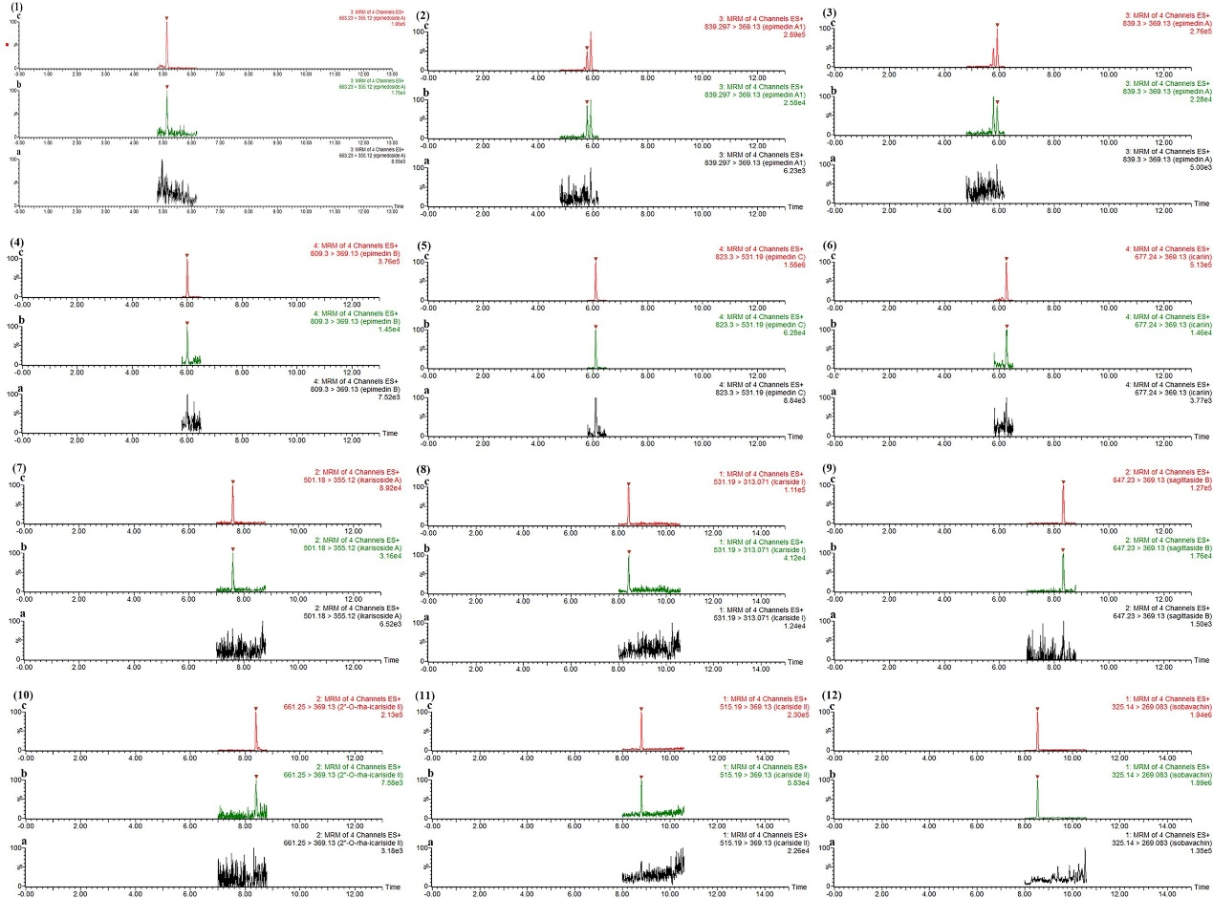**Fig. S5.** Specificity for 11 analytes and IS in brain tissue:(a)-blank plasma; (b)-blank plasma spiked with LLOQ; (c)-plasma sample at 0.25 h. (1) Epimedoside A, (2) Epimedin A1, (3) Epimedin A, (4) Epimedin B, (5) Epimedin C, (6) Icariin, (7) Ikarisoside A, (8) Icariside I, (9) Sagittatoside B, (10) 2″-*O*-rhamnosyl icariside, (11) Icariside II, (12) IS (Isobavachin).

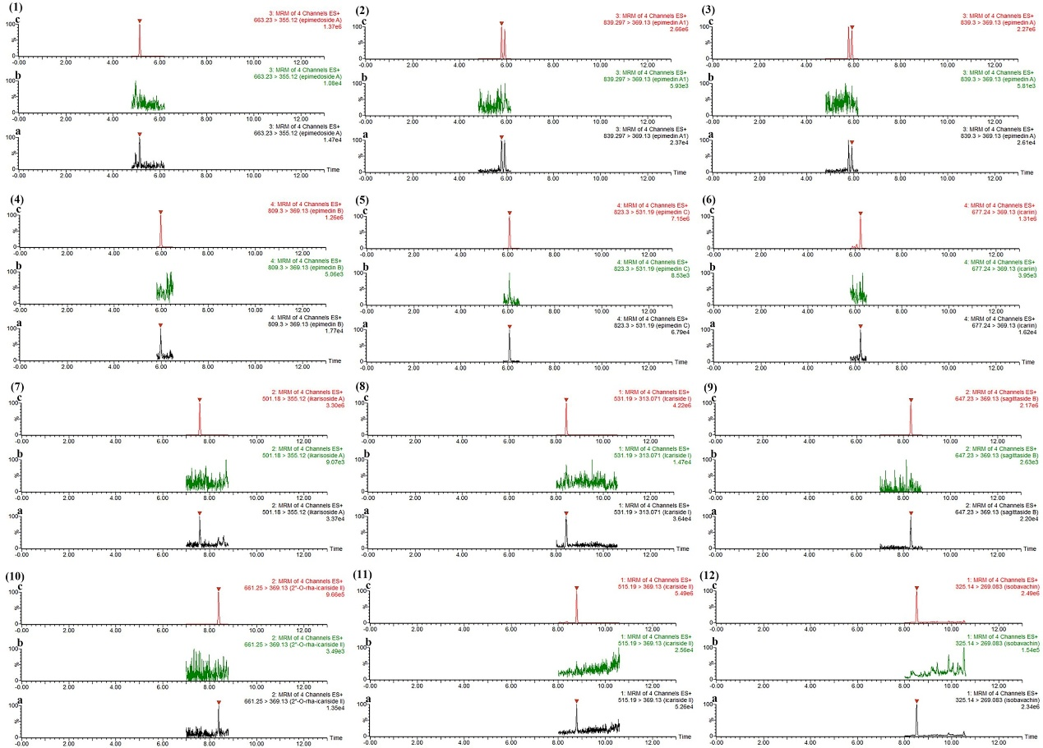**Fig. S6.** Carryover for 11 quantitative components and IS in brain tissue: (a)- blank plasma spiked with LLOQ; (b)- blank plasma; (c)- blank plasma spiked with HLOQ. (1) Epimedoside A, (2) Epimedin A1, (3) Epimedin A, (4) Epimedin B, (5) Epimedin C, (6) Icariin, (7) Ikarisoside A, (8) Icariside I, (9) Sagittatoside B, (10) 2″-*O*-rhamnosyl icariside, (11) Icariside II, (12) IS (Isobavachin).

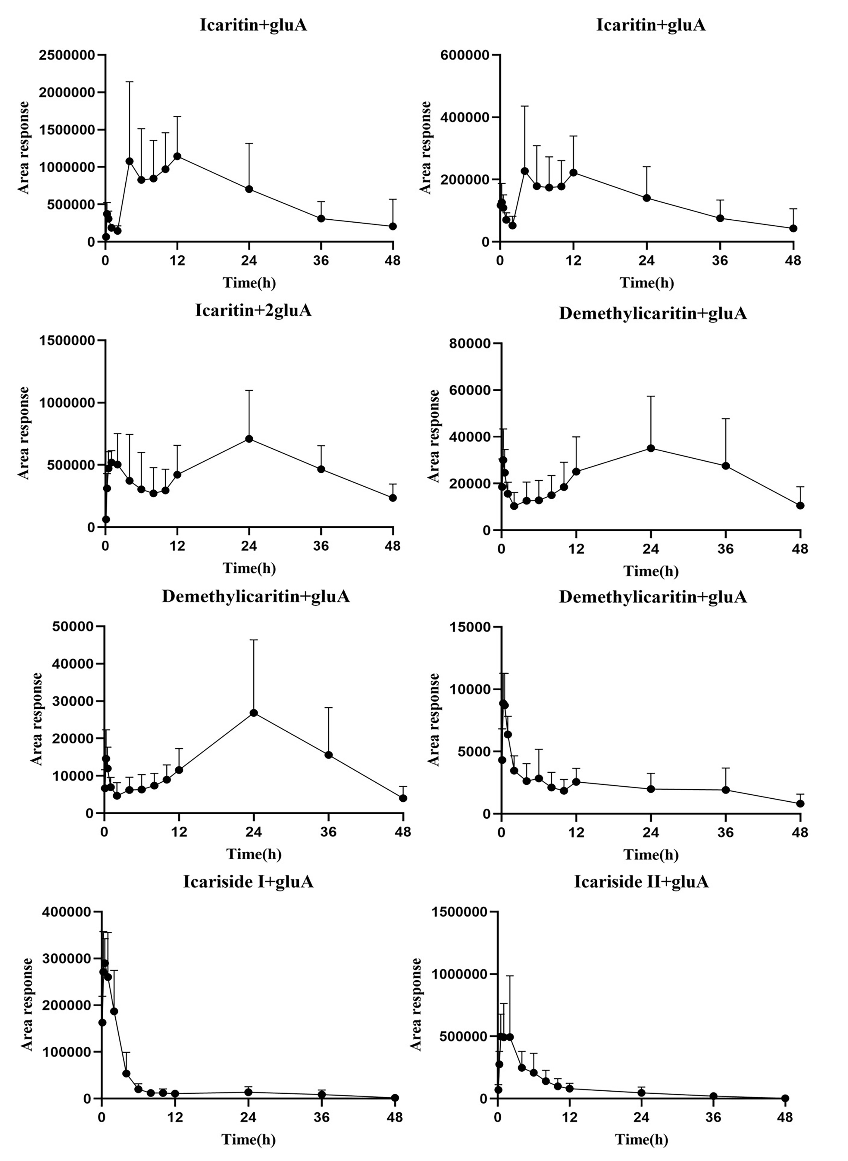

**Fig. S7.** Relative peak area-time curves of 8 semi-quantitative components after oral administration of ETFCs (mean ± SD, n = 6)

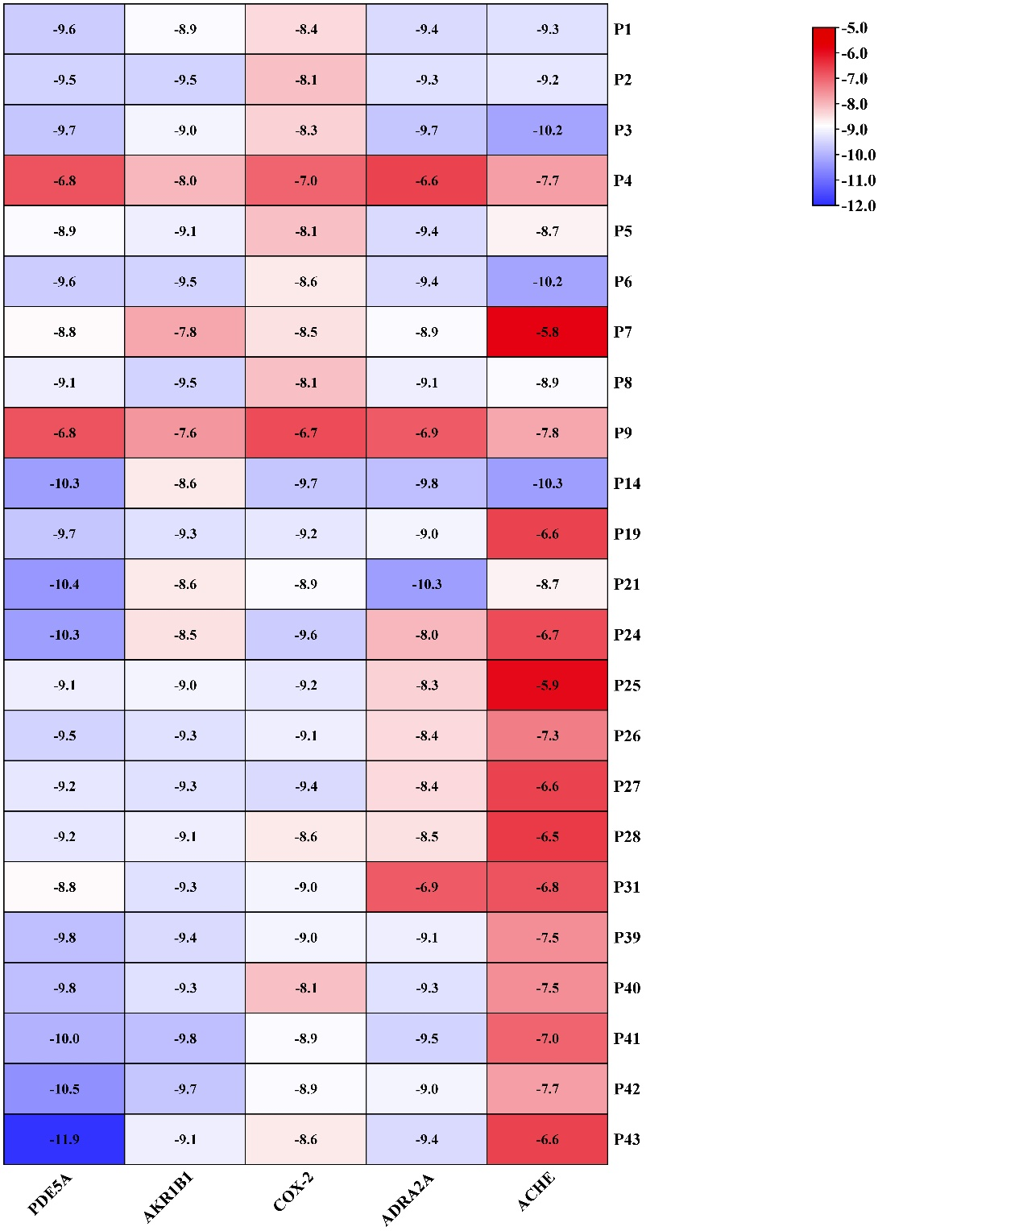

**Fig. S8.** Heat map of molecular docking scoring (kcal/mol)

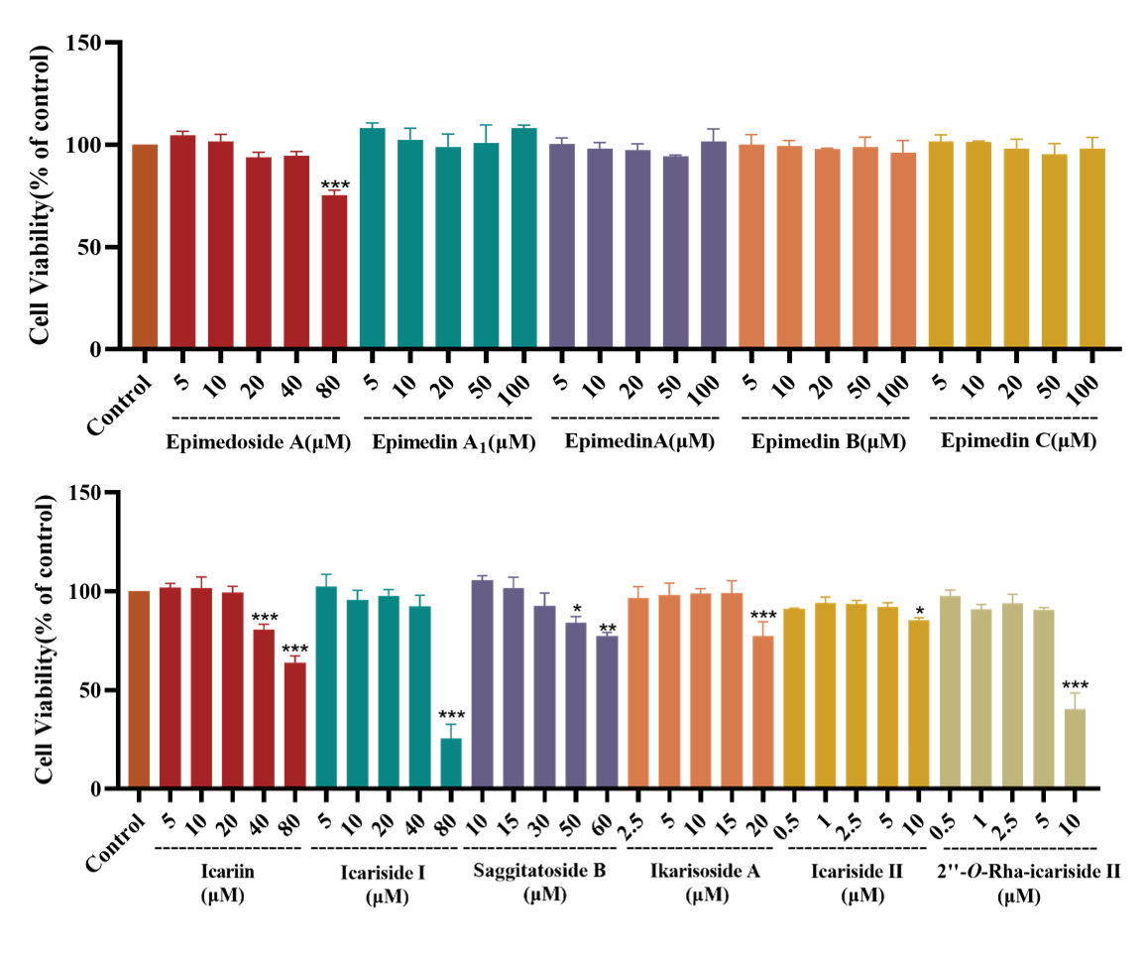

**Fig. S9.** Effects of different concentrations of 11compounds on the survival rate of BV-2 cells (mean ± SD, n = 3)

**Table S1** Reference standards used in this study

|  |  |  |  |  |
| --- | --- | --- | --- | --- |
| **No.** | **Name** | **Formula** | **CAS** | **Batch NO.** |
| 1 | Neochlorogenic acid | C16H18O9 | 906-33-2 | 210603 |
| 2 | Magnoflorine | C20H23NO4 | 2141-09-5 | 160627 |
| 3 | Epimedin B | C38H48O19 | 110623-73-9 | 180529 |
| 4 | Cryptochlorogenic acid | C16H18O9 | 905-99-7 | 160620 |
| 5 | Chlorogenic acid | C16H18O9 | 327-97-9 | PS0775-0005 |
| 6 | Hyperoside | C21H20O12 | 482-36-0 | PRF22051641 |
| 7 | Sagittatoside A | C33H40O15 | 118525-35-2 | PRF20080301 |
| 8 | Sagittatoside B | C32H38O14 | 118525-36-3 | PRF22051324 |
| 9 | 2″-*O*-rhamnosyl icariside | C33H40O14 | 135293-13-9 | PRF22051325 |
| 10 | Ikarisoside A | C26H28O10 | 55395-07-8 | PRF23091541 |
| 11 | Epimedoside A | C32H38O15 | 39012-04-9 | PRF20021946 |
| 12 | Icariin | C33H40O15 | 489-32-7 | PRF22051341 |
| 13 | Epimedin A1 | C39H50O20 | 140147-77-9 | RDD-Y00411803005 |
| 14 | Epimedin A | C39H50O20 | 110623-72-8 | RDD-C06811810018 |
| 15 | Epimedin C | C39H50O19 | 110642-44-9 | RDD-C01311804026 |
| 16 | Icariside I | C27H30O11 | 56725-99-6 | RDD-C01111812016 |
| 17 | Icariside II | C27H30O10 | 113558-15-9 | RDD-Y15001905013 |
| 18 | Icaritin | C21H20O6 | 118525-40-9 | RDD-B06301912024 |

**Table S2** The optimized MRM parameters of quantitative and semi-quantitative analytes in the pharmacokinetics study.

|  |  |  |  |  |  |  |
| --- | --- | --- | --- | --- | --- | --- |
| Analytes | | tR (min) | Ion mode | Ion pair (Precursor>product, *m/z*) | Cone voltge (V) | Collision voltage (eV） |
| Quantitative  analytes | Epimedoside A | 5.41 | [M+H]+ | 663.23>355.12 | 32 | 30 |
| Epimedin A1 | 6.25 | [M+H]+ | 839.30>369.13 | 28 | 34 |
| Epimedin A | 6.43 | [M+H]+ | 839.30>369.13 | 30 | 42 |
| Epimedin B | 6.53 | [M+H]+ | 809.30>369.13 | 30 | 50 |
| Epimedin C | 6.66 | [M+H]+ | 823.30>531.30 | 33 | 22 |
| Icariin | 6.84 | [M+H]+ | 677.24>369.13 | 20 | 50 |
| Ikarisoside A | 8.25 | [M+H]+ | 501.17>355.12 | 25 | 12 |
| Sagittatoside A | 8.58 | [M+H]+ | 677.24>369.13 | 27 | 12 |
| Icariside I | 8.80 | [M+H]+ | 515.19>313.07 | 35 | 38 |
| Sagittatoside B | 8.73 | [M+H]+ | 647.23>369.13 | 21 | 10 |
| 2″-*O*-rhamnosyl icariside | 8.77 | [M+H]+ | 661.25>369.13 | 28 | 20 |
| Icariside | 9.07 | [M+H]+ | 515.19>369.13 | 8 | 10 |
| Icaritin | 10.45 | [M+H]+ | 369.13>313.07 | 5 | 23 |
| Semi-quantitative  analytes | Icaritin-di-*O*-gluA | 6.33 | [M+H]+ | 721.20>369.13 | 30 | 35 |
| Icaritin-7-*O*-glu+gluA | 6.38 | [M+H]+ | 707.22>369.13 | 30 | 35 |
| Icaritin-3-*O*-rha+gluA | 6.83 | [M+H]+ | 691.22>369.13 | 30 | 35 |
| Demethylicaritin+gluA | 7.14 | [M+H]+ | 531.15>355.18 | 30 | 35 |
| Demethylicaritin+gluA | 7.60 | [M+H]+ | 531.15>355.18 | 30 | 35 |
| Demethylicaritin+gluA | 7.80 | [M+H]+ | 531.15>355.18 | 30 | 35 |
| Anhydroyicaritin+gluA | 8.63 | [M+H]+ | 545.17>369.13 | 30 | 35 |
| Anhydroyicaritin+gluA | 8.84 | [M+H]+ | 545.17>369.13 | 30 | 35 |
| (IS) | | 8.90 | [M+H]+ | 325.14>269.08 | 45 | 14 |

**Table S3** The optimized MRM parameters of 11 analytes in the brain tissue study.

|  |  |  |  |  |  |
| --- | --- | --- | --- | --- | --- |
| Analytes | tR (min) | Ion mode | Ion pair (Precursor>product, *m/z*) | Cone voltage (V) | Collision voltage (eV） |
| Epimedoside A | 5.14 | [M+H]+ | 663.23>355.12 | 32 | 30 |
| Epimedin A1 | 5.78 | [M+H]+ | 839.30>369.13 | 28 | 34 |
| Epimedin A | 5.92 | [M+H]+ | 839.30>369.13 | 30 | 42 |
| Epimedin B | 6.00 | [M+H]+ | 809.30>369.13 | 30 | 50 |
| Epimedin C | 6.10 | [M+H]+ | 823.30>531.19 | 33 | 22 |
| Icariin | 6.26 | [M+H]+ | 677.24>369.13 | 20 | 50 |
| Ikarisoside A | 7.60 | [M+H]+ | 501.18>355.12 | 25 | 12 |
| Icariside I | 8.43 | [M+H]+ | 515.19>313.07 | 35 | 38 |
| Sagittatoside B | 8.33 | [M+H]+ | 647.23>369.13 | 21 | 10 |
| 2″-*O*-rha-icariside | 8.40 | [M+H]+ | 661.25>369.13 | 28 | 20 |
| Icariside | 8.80 | [M+H]+ | 515.19>369.13 | 35 | 25 |
| IS | 8.51 | [M+H]+ | 325.14>269.08 | 45 | 14 |

**Table S4** Characterization of compounds identified from ETFCs by UPLC-Q-TOF/MS.

|  |  |  |  |  |  |  |  |  |  |
| --- | --- | --- | --- | --- | --- | --- | --- | --- | --- |
| **No** | **t*R*** | **Elemental composition** | **Selected**  **ion** | **Measured**  **mass** | **Calculated**  **mass** | **Mass**  **error** | **MS/MS or MSE fragmentation** | | **Identification** |
| **ESI+** | **ESI-** |
| 1**\*** | 2.18 | C16H18O9 | [M-H]- | 353.0869 | 353.0873 | -1.1 | N/A | 191.0569, 179.0344, 135.0441 | neochlorogenic acid |
| 2 | 2.37 | C15H16O9 | [M-H]- | 339.0711 | 339.0716 | -1.5 | N/A | 177.0190 | 5,7-dihydroxychromone-7-*β*-D-glucoside |
| 3 | 2.57 | C16H18O8 | [M-H]- | 337.0929 | 337.0923 | 1.8 | N/A | 191.0563, 163.0399 | *trans*-5-*O*-*p*-coumaroylquinic acid |
| 4**\*** | 2.62 | C16H18O9 | [M-H]- | 353.0874 | 353.0873 | 0.3 | 163.0395 | 191.0526, 179.0348 | cryptochlorogenic acid |
| 5**\*** | 2.73 | C16H18O9 | [M-H]- | 353.0876 | 353.0873 | 0.8 | 163.0395 | 191.0570, 179.0352 | chlorogenic acid |
| 6 | 2.89 | C9H6O4 | [M-H]- | 177.0191 | 177.0188 | 1.7 | 123.0446 | 133.0287 | 5,7-dihydroxychromone |
| 7 | 3.11 | C16H18O8 | [M-H]- | 377.0929 | 337.0923 | 1.8 | N/A | 191.0563, 173.0454, 163.0403 | 4-*O-p*-coumaroylquinic acid |
| 8 | 3.16 | C16H18O8 | [M-H]- | 377.0927 | 337.0923 | 1.2 | N/A | 191.0546, 163.0396 | 3-*O-p*-coumaroylquinic acid |
| 9**\*** | 3.25 | C20H23NO4 | [M+H]+ | 342.1702 | 342.1705 | -0.9 | 297.1112, 282.0891, 265.0862, 237.0906, 191.0857 | N/A | magnoflorine |
| 10 | 3.35 | C33H40O19 | [M-H]- | 739.2101 | 739.2086 | 2.0 | 565.1559, 287.0549 | 593.1486, 447.0896, 285.0402 | kaempferol-3-*O*-rhamnopyranosyl-glucopyranoside-7-*O*-rhamnoside |
| 11 | 3.52 | C16H18O8 | [M-H]- | 337.0923 | 337.0923 | 0.0 | N/A | 191.0558, 163.0390 | *cis*-5-*O*-*p*-coumaroylquinic acid |
| 12 | 3.54 | C27H30O15 | [M-H]- | 593.1516 | 593.1506 | 1.7 | N/A | 447.0927, 301.0352, 271.0244, 255.0264 | quercetin-3,7-di-*O*-rhamnoside |
| 13 | 3.58 | C9H8O3 | [M-H]- | 163.0399 | 163.0395 | 2.5 | N/A | 119.0506 | *p*-hydroxycinnamic acid |
| 14**\*** | 3.9 | C21H20O12 | [M-H]- | 463.0878 | 463.0877 | 0.6 | 303.0500, 287.0526, 229.0506, 177.0907 | 301.0340, 300.0277, 271.0252, 255.0288 | hyperoside |
| 15 | 3.97 | C27H30O14 | [M-H]- | 577.1562 | 577.1557 | 0.9 | 433.1131, 287.0565 | 431.0980, 285.0409, 255.0295 | kaempferol-3,7-di-*O*-rhamnoside |
| 16 | 4.01 | C18H24O10 | [M-H]- | 399.1305 | 399.1291 | 3.5 | N/A | 237.0764, 219.0662, 193.0867 | unknow |
| 17 | 4.31 | C21H20O11 | [M-H]- | 447.0935 | 447.0927 | -2.0 | 287.0555, 257.0434 | 284.0321, 255.0296, 227.0353 | trifolin/astragalin |
| 18 | 4.46 | C20H18O11 | [M-H]- | 433.0767 | 433.0771 | -0.9 | 303.0503, 283.0813, 265.0698, 247.0607 | 301.0348, 271.0245, 255.0302 | quercetin-3-*O*-α-L-arabinopyranoside |
| 19 | 4.54 | C21H20O11 | [M-H]- | 447.0916 | 447.0927 | -2.5 | 287.0552 | 285.0385, 255.0299, 227.0344 | trifolin/astragalin |
| 20 | 4.61 | C21H20O11 | [M-H]- | 447.0910 | 447.0927 | -3.8 | N/A | 301.0340, 300.0260, 271.0240, 255.0294 | quercetin-3-*O*-rhamnoside |
| 21 | 4.86 | C32H38O16 | [M-H]- | 677.2094 | 677.2082 | 1.8 | 533.1656, 371.1129, 315.0504, 287.0548 | 531.1495, 530.1443, 515.1561, 369.0982 | dihydroanhydroicaritin-3-*O*-rhamnopyranosyl-7-*O*-glucopyranoside |
| 22 | 4.95 | C33H42O17 | [M+H]+ | 711.2485 | 711.25 | -2.1 | 565.1898, 403.1384, 385.1264, 313.0706 | N/A | C33H42O17 |
| 23 | 5.06 | C32H38O16 | [M-H]- | 677.2076 | 677.2082 | -0.9 | 517.1708, 355.1177, 299.0553 | 515.1209, 353.0966, 323.0919 | hexandraside E |
| 24 | 5.19 | C20H18O10 | [M-H]- | 417.0819 | 417.0822 | -0.7 | N/A | 285.0400, 284.032, 255.0298, 227.034 | kaempferol-3-*O*-xylopyranoside |
| 25 | 5.26 | C38H48O20 | [M-H]- | 823.2659 | 823.2661 | -0.2 | 663.2294, 517.1709, 355.1186 | 661.2126, 515.1556, 353.1032 | diphylloside A |
| 26 | 5.42 | C37H46O19 | [M-H]- | 793.2549 | 793.2555 | -0.8 | 663.2292, 517.1714, 355.1793 | 631.2026, 514.1473, 353.0998, 352.0952, 351.0882 | epimedoside E |
| 27 | 5.47 | C21H20O10 | [M-H]- | 431.0993 | 431.0978 | 3.5 | N/A | 285.0398, 284.0329, 255.0298, 227.0354 | kaempferol-3-*O*-rhamnoside |
| 28 | 5.60 | C39H52O20 | [M+H]+ | 841.3111 | 841.3130 | -2.3 | 823.2977, 695.2546, 549.1960, 531.1899, 387.1469, 369.1379, 313.0727 | N/A | icarisid D |
| 29 | 5.63 | C33H42O16 | [M+H]+ | 695.2536 | 695.2551 | -2.2 | 549.1954, 387.1420, 369.1336, 313.0714 | N/A | icarisid B |
| 30**\*** | 5.68 | C32H38O15 | [M-H]- | 661.2139 | 661.2132 | -0.5 | 517.1719, 355.1181 | 514.1476, 499.1599, 353.1026, 352.0912, 351.0873 | epimedoside A |
| 31 | 5.77 | C38H48O19 | [M-H]- | 807.2708 | 807.2712 | -0.5 | N/A | 661.2140, 645.2175, 353.1018 | diphylloside B |
| 32 | 5.99 | C39H50O20 | [M-H]- | 837.2802 | 837.2817 | -1.8 | 693.2396, 547.1824, 385.1291, 329.0671, 299.0580 | 675.2288, 383.1136, 312.0676 | sagittasine B |
| 33 | 6.06 | C33H40O16 | [M-H]- | 691.2236 | 691.2238 | -0.3 | 547.1828, 385.1287, 329.0665, 314.0413 | 545.1672, 529.1713, 383.1143, 368.0912, 325.0377 | sagittasine C |
| 34 | 6.29 | C24H34O9 | [M-H]- | 465.2131 | 465.2125 | 1.3 | N/A | 303.1598, 285.1486 | taxifolin-7-*O*-glucoside |
| 35 | 6.78 | C33H40O16 | [M+H]+ | 693.2394 | 693.2395 | -0.1 | 547.1813, 531.1858, 385.1273, 367.1186 | N/A | sagittasine C of isomer |
| 36 | 6.82 | C39H48O20 | [M-H]- | 835.2639 | 835.2661 | -2.6 | 705.2368, 517.1704, 367.1176, 355.1172 | 673.2182, 515.1557, 353.1028 | 4''-*O*-acetyl-3-*O*-xylopyranosylepimedoside A |
| 37 | 7.03 | C45H60O24 | [M+H]+ | 985.3547 | 985.3553 | -0.6 | 839.2961, 677.2425, 531.1865, 369.1340 | N/A | acuminatoside |
| 38 | 7.09 | C28H32O14 | [M+H]+ | 593.1817 | 593.187 | 0.2 | 447.1290, 285.0761 | 283.0599 | acacetin-7-*O*-rutinoside |
| 39**\*** | 7.32 | C39H50O20 | [M-H]- | 837.2802 | 837.2817 | -1.8 | 677.2436, 531.1868, 369.1327, 313.0710 | 675.2303, 367.1189, 352.0956, 309.0402 | epimedin A1 |
| 40**\*** | 7.58 | C39H50O20 | [M-H]- | 837.2823 | 837.2817 | 0.7 | 677.2347, 531.1874, 369.1336, 313.0714 | 675.2295, 366.1107, 351.0878, 323.0938, 311.0561, 295.0636 | epimedin A |
| 41**\*** | 7.79 | C38H48O19 | [M-H]- | 807.2014 | 807.2712 | 0.2 | 677.2441, 531.1866, 369.1336, 313.0712 | 645.2192, 366.1118, 351.0865, 323.0928, 295.0615 | epimedin B |
| 42**\*** | 8.02 | C39H50O19 | [M-H]- | 821.2862 | 821.2868 | -0.7 | 677.2447, 531.1866, 369.1340, 313.0713 | 659.2322, 366.1091, 351.0871, 323.0905, 311.0567 | epimedin C |
| 43 | 8.13 | C39H50O19 | [M-H]- | 821.2877 | 821.2868 | 1.1 | 677.2432, 531.1863, 369.1335, 287.2023 | 659.2350, 367.1171, 366.1111, 351.0874, 323.0916 | 4''-*O*-rhamnosylicariin |
| 44**\*** | 8.21 | C33H40O15 | [M+HCOOH-H]- | 721.2346 | 721.2344 | 0.3 | 531.1874, 369.1340, 313.0721 | 529.1722, 513.1762, 367.1186, 352.0941, 309.0424, 297.0408 | icariin |
| 45 | 8.35 | C33H42O15 | [M-H]- | 677.2451 | 677.2445 | 0.9 | N/A | 384.1188, 367.1194, 341.1040 | wanepimedoside A |
| 46 | 8.39 | C26H28O11 | [M-H]- | 515.1564 | 515.1553 | 2.1 | 355.1170 | 353.1013, 309.0340, 297.0396 | epimedoside C |
| 47 | 8.6 | C27H32O11 | [M-H]- | 531.1858 | 531.1866 | -1.5 | 387.1449, 369.1329, 313.0713 | 385.1283, 367.1194, 311.0544 | 4'-methoxynoricaritin-3-*O*-rhamnoside |
| 48 | 8.89 | C39H48O21 | [M-H]- | 851.2595 | 851.2610 | -1.8 | 677.2437, 531.1871, 369.1333 | 689.2107, 513.1763, 367.1197 | anhydroicaritin-3-*O*-rhamnopyranosyl-glucopyranoside-7-*O*-glucuronic acid |
| 49 | 8.92 | C38H46O20 | [M+H]+ | 823.2649 | 823.2661 | -1.5 | 677.2397, 531.1860, 369.1331 | N/A | C38H46O20 |
| 50 | 9.0 | C38H46O20 | [M-H]- | 821.2488 | 821.2504 | -1.9 | N/A | 645.2191, 513.1772, 367.1181, | C38H46O20 |
| 51 | 9.3 | C39H48O19 | [M-H]- | 819.2714 | 819.2712 | 0.2 | 677.2431, 531.1866, 369.1337 | 657.2214, 529.1716, 367.1190 | anhydroicaritin-3-*O*-rhamnopyranosyl-furan acid-7-*O*-glucopyranoside |
| 52 | 9.43 | C40H50O20 | [M+H]+ | 851.2967 | 851.2974 | -0.8 | 719.2551, 531.1866, 369.1338 | N/A | sempervirenoside B |
| 53 | 10.07 | C32H38O15 | [M-H]- | 661.2156 | 661.2132 | 3.6 | N/A | 352.0956 | ikarisoside B or its isomer |
| 54 | 10.27 | C27H30O11 | [M-H]- | 529.1718 | 529.1718 | 1.5 | 385.1284, 369.1313 | 383.1120, 312.0654, 297.0411, 269.0458 | caohuoside C or its isomer |
| 55 | 10.32 | C32H38O15 | [M-H]- | 661.2135 | 661.2132 | 0.5 | N/A | 353.1034, 297.0393 | ikarisoside B or its isomer |
| 56 | 10.66 | C27H30O11 | [M-H]- | 529.1719 | 529.1718 | 1.7 | N/A | 383.1129, 297.0394 | caohuoside C or its isomer |
| 57 | 10.78 | C31H36O14 | [M-H]- | 631.2023 | 631.2027 | -0.6 | N/A | 352.0952 | ikarisoside F |
| 58 | 10.92 | C32H38O14 | [M-H]- | 645.217 | 645.2183 | -2.0 | N/A | 352.094 | 2''-*O*-rhamnosylikarsoside A |
| 59**\*** | 11.56 | C26H28O10 | [M-H]- | 499.161 | 499.1604 | 1.2 | 355.1179, 299.0553 | 353.1028, 352.0943, 324.0978 | ikarisoside A |
| 60**\*** | 12.78 | C33H40O15 | [M-H]- | 675.23 | 675.2289 | 1.6 | 515.1919, 369.1341 | 513.1742, 367.1183, 366.1101, 352.0926, 351.0877, 323.0913 | sagittatoside A |
| 61**\*** | 12.88 | C27H30O11 | [M-H]- | 529.1715 | 529.171 | 0.9 | N/A | 367.1179, 309.0397, 297.0380 | icariside I |
| 62**\*** | 12.9 | C32H38O14 | [M-H]- | 645.219 | 645.2183 | -0.5 | N/A | 513.1735, 366.1150, 351.0874, 323.0547 | sagittatoside B |
| 63**\*** | 12.93 | C33H40O14 | [M-H]- | 659.2344 | 659.234 | 0.6 | 515.1909, 369.1340 | 366.1105, 351.0866, 323.0901, 311.0542 | 2″-*O*-rhamnosyl icariside II |
| 64**\*** | 13.17 | C27H30O10 | [M-H]- | 513.1764 | 513.1761 | 0.8 | 369.1338 | 366.1706, 351.0876, 323.0925, 311.0556, 308.0323, 295.0620, 268.0378, 280.0373 | icariside II |
| 65 | 13.47 | C33H38O17 | [M-H]- | 657.2164 | 657.2183 | 2.9 | 515.1899, 369.1331 | 513.1736, 367.1173, 352.0938 | 3'''-carbonyl-2''-*β*-L-quinovosyl icariside II |

Note: *the compound was unambiguously identified with reference standard; N/A: not detected.

**Table S5** The linear ranges and regression equations of 13 analytes in plasma (n=3)

|  |  |  |  |  |
| --- | --- | --- | --- | --- |
| **Analytes** | **tR (min)** | **Range (ng/mL)** | **Linear regression equation**  **(n=3)** | **Correlation coefficient (r)** |
| Epimedoside A | 5.41 | 0.05-9.99 | Y=0.108561X+0.00124682 | 0.9941 |
| Epimedin A1 | 6.25 | 0.10-20.00 | Y=0.0830463X+0.00127197 | 0.9951 |
| Epimedin A | 6.43 | 0.10-20.02 | Y=0.0776935X+0.00149102 | 0.9964 |
| Epimedin B | 6.53 | 0.25-50.01 | Y=0.0275616X+0.00162119 | 0.9963 |
| Epimedin C | 6.66 | 0.25-50.00 | Y=0.0564747X+0.00372058 | 0.9972 |
| Icariin | 6.84 | 0.25-49.98 | Y=0.0227324X+0.00179507 | 0.9951 |
| Ikarisoside A | 8.25 | 0.05-9.99 | Y=0.316341X+0.00260466 | 0.9953 |
| Sagittatoside A | 8.58 | 0.05-10.00 | Y=0.128651X+00115357 | 0.9956 |
| Icariside I | 8.80 | 0.03-5.98 | Y=0.389044X+0.000841445 | 0.9949 |
| Sagittatoside B | 8.73 | 0.05-9.98 | Y=0.117184X+0.00128102 | 0.9966 |
| 2″-*O*-rhamnosyl icariside | 8.77 | 0.10-20.02 | Y=0.0901505X+0.00219791 | 0.9927 |
| Icariside | 9.07 | 0.25-49.98 | Y=0.0795832X+0.0023139 | 0.9945 |
| Icaritin | 10.45 | 0.20-40.00 | Y=0.0213335X+0.000955446 | 0.9939 |

**Table S6** The LLOQs of 13 analytes in plasma (n=6)

|  |  |  |  |  |
| --- | --- | --- | --- | --- |
| **Analytes** | **Spiked conc.**  **(ng/mL)** | **Mean** | **RE%** | **RSD%** |
| Epimedoside A | 0.05 | 0.05 | 0.43 | 3.87 |
| Epimedin A1 | 0.10 | 0.10 | 0.84 | 7.94 |
| Epimedin A | 0.10 | 0.10 | 1.25 | 4.08 |
| Epimedin B | 0.25 | 0.25 | -1.81 | 5.25 |
| Epimedin C | 0.25 | 0.25 | -0.46 | 3.18 |
| Icariin | 0.25 | 0.25 | -1.23 | 4.92 |
| Ikarisoside A | 0.05 | 0.05 | 0.42 | 4.95 |
| Sagittatoside A | 0.05 | 0.05 | 0.71 | 7.61 |
| Icariside I | 0.03 | 0.03 | -3.01 | 6.90 |
| Sagittatoside B | 0.05 | 0.05 | -2.84 | 5.94 |
| 2″-*O*-rhamnosyl icariside | 0.10 | 0.10 | -3.58 | 5.55 |
| Icariside | 0.25 | 0.24 | -2.09 | 3.42 |
| Icaritin | 0.20 | 0.20 | -1.10 | 13.94 |

**Table S7** Precision and accuracy data of 13 analytes in plasma (n=6)

|  |  |  |  |  |  |  |  |
| --- | --- | --- | --- | --- | --- | --- | --- |
| **Analytes** | **Spiked conc.**  **(ng/mL)** | **Inter-day (n=6)** | | | **Intra-day (n=18)** | | |
| **Observed conc.** | **Accuracy** | **Precision** | **Observed conc.** | **Accuracy** | **Precision** |
| **(ng/mL)** | **RE%** | **RSD%** | **(ng/mL)** | **RE%** | **RSD%** |
| Epimedoside A | 0.10 | 0.11 | 4.27 | 4.76 | 0.10 | 3.49 | 9.45 |
| 0.50 | 0.50 | 0.23 | 5.06 | 0.52 | 3.60 | 5.97 |
| 5.00 | 4.95 | -0.83 | 6.10 | 5.02 | 0.49 | 5.70 |
| Epimedin A1 | 0.20 | 0.19 | -2.90 | 3.67 | 0.20 | 0.52 | 6.75 |
| 1.00 | 0.98 | -2.09 | 6.12 | 1.02 | 1.79 | 5.63 |
| 10.00 | 9.92 | -0.66 | 3.71 | 10.09 | 0.90 | 4.38 |
| Epimedin A | 0.20 | 0.20 | -1.41 | 9.45 | 0.20 | 1.78 | 7.94 |
| 1.00 | 1.03 | 2.50 | 5.06 | 1.04 | 3.91 | 5.40 |
| 10.01 | 9.58 | -4.25 | 5.94 | 9.96 | -0.48 | 5.53 |
| Epimedin B | 0.50 | 0.50 | -0.63 | 8.58 | 0.51 | 1.14 | 6.00 |
| 2.50 | 2.59 | 3.50 | 4.32 | 2.55 | 1.85 | 5.70 |
| 25.00 | 25.11 | 0.41 | 6.64 | 25.37 | 1.46 | 4.77 |
| Epimedin C | 0.50 | 0.50 | 0.21 | 4.29 | 0.51 | 2.92 | 7.13 |
| 2.50 | 2.52 | 0.71 | 5.33 | 2.57 | 2.68 | 5.28 |
| 25.00 | 24.67 | -1.31 | 5.67 | 25.10 | 0.42 | 5.00 |
| Icariin | 0.50 | 0.50 | -0.79 | 6.95 | 0.51 | 3.59 | 9.76 |
| 2.50 | 2.44 | -2.39 | 5.65 | 2.54 | 1.74 | 6.37 |
| 24.99 | 24.41 | -2.32 | 5.48 | 24.92 | -0.27 | 4.68 |
| Ikarisoside A | 0.10 | 0.10 | -1.74 | 1.75 | 0.10 | 0.92 | 4.28 |
| 0.50 | 0.50 | -0.14 | 1.95 | 0.51 | 2.15 | 3.78 |
| 5.00 | 4.97 | -0.56 | 3.28 | 5.01 | 0.21 | 4.36 |
| Sagittatoside A | 0.10 | 0.10 | 1.21 | 7.60 | 0.10 | 2.82 | 4.88 |
| 0.50 | 0.52 | 3.67 | 2.05 | 0.52 | 4.54 | 3.48 |
| 5.00 | 5.03 | 0.57 | 5.86 | 5.10 | 2.01 | 5.30 |
| Icariside I | 0.06 | 0.06 | -2.45 | 6.00 | 0.06 | -1.34 | 7.17 |
| 0.30 | 0.30 | 1.11 | 1.71 | 0.31 | 3.16 | 2.88 |
| 2.99 | 2.92 | -2.49 | 3.19 | 3.00 | 0.32 | 5.29 |
| Sagittatoside B | 0.10 | 0.10 | 2.00 | 9.92 | 0.10 | -0.95 | 9.01 |
| 0.50 | 0.50 | 0.69 | 4.32 | 0.52 | 4.03 | 5.35 |
| 4.99 | 4.97 | -0.42 | 2.36 | 5.03 | 0.84 | 7.55 |
| 2″-*O*-rhamnosyl icariside | 0.20 | 0.20 | 1.34 | 5.67 | 0.20 | 1.86 | 4.67 |
| 1.00 | 1.00 | -0.41 | 3.19 | 1.02 | 1.59 | 4.68 |
| 10.02 | 9.93 | -0.77 | 4.82 | 10.04 | 0.34 | 5.93 |
| Icariside Ⅱ | 0.50 | 0.49 | -1.59 | 2.17 | 0.51 | 2.97 | 5.28 |
| 2.50 | 2.49 | -0.23 | 6.52 | 2.62 | 5.02 | 6.09 |
| 24.99 | 24.26 | -2.91 | 2.71 | 26.05 | 4.26 | 7.40 |
| Icaritin | 0.40 | 0.40 | -0.26 | 8.40 | 0.40 | 0.67 | 9.93 |
| 2.00 | 1.97 | -1.72 | 4.45 | 2.07 | 3.35 | 8.42 |
| 20.00 | 19.71 | -1.45 | 9.83 | 20.61 | 3.04 | 8.84 |

**Table S8** Extraction recoveries and matrix effects of 13 analytes and IS in plasma (n=6)

|  |  |  |  |  |  |  |
| --- | --- | --- | --- | --- | --- | --- |
| **Analytes** | **Spiked conc.**  **(ng/mL)** | **Matrix effect**  **(n=6)** | | **Recovery**  **(n=6)** | | |
| **Mean%** | **RSD%** | | **Mean%** | **RSD%** |
| Epimedoside A | 0.10 | 99.90 | 6.03 | | 100.44 | 5.21 |
| 0.50 | 99.15 | 0.64 | | 95.39 | 4.03 |
| 5.00 | 96.26 | 6.50 | | 91.73 | 4.40 |
| Epimedin A1 | 0.20 | 105.31 | 3.56 | | 91.94 | 0.96 |
| 1.00 | 98.98 | 1.08 | | 87.37 | 0.87 |
| 10.00 | 101.56 | 3.15 | | 88.23 | 0.91 |
| Epimedin A | 0.20 | 101.36 | 1.39 | | 94.65 | 3.97 |
| 1.00 | 101.14 | 2.21 | | 88.74 | 2.73 |
| 10.01 | 106.07 | 3.70 | | 82.39 | 3.33 |
| Epimedin B | 0.50 | 105.82 | 2.62 | | 96.80 | 2.45 |
| 2.50 | 101.71 | 0.84 | | 87.79 | 1.30 |
| 25.00 | 98.55 | 2.55 | | 89.91 | 3.70 |
| Epimedin C | 0.50 | 106.94 | 5.70 | | 93.12 | 6.65 |
| 2.50 | 98.23 | 2.16 | | 95.67 | 2.69 |
| 25.00 | 99.52 | 2.78 | | 87.39 | 3.70 |
| Icariin | 0.50 | 101.34 | 3.49 | | 98.73 | 7.49 |
| 2.50 | 101.01 | 3.19 | | 96.49 | 2.20 |
| 24.99 | 96.94 | 3.50 | | 92.88 | 3.12 |
| Ikarisoside A | 0.10 | 100.74 | 5.41 | | 88.37 | 1.19 |
| 0.50 | 102.16 | 0.70 | | 97.17 | 5.89 |
| 5.00 | 103.07 | 0.73 | | 88.07 | 2.03 |
| Sagittatoside A | 0.10 | 97.28 | 5.22 | | 94.91 | 2.65 |
| 0.50 | 99.16 | 2.31 | | 88.19 | 1.71 |
| 5.00 | 103.71 | 1.90 | | 88.46 | 3.45 |
| Icariside I | 0.06 | 100.36 | 1.36 | | 83.62 | 2.51 |
| 0.30 | 100.11 | 0.87 | | 94.05 | 2.64 |
| 2.99 | 104.14 | 1.56 | | 80.66 | 5.11 |
| Sagittatoside B | 0.10 | 100.59 | 3.09 | | 89.42 | 3.66 |
| 0.50 | 101.22 | 1.73 | | 85.99 | 2.15 |
| 4.99 | 105.93 | 2.70 | | 88.16 | 0.89 |
| 2″-*O-*rhamnosyl icariside II | 0.20 | 100.17 | 2.21 | | 90.73 | 3.05 |
| 1.00 | 94.16 | 2.59 | | 91.02 | 3.17 |
| 10.02 | 105.75 | 1.41 | | 89.72 | 2.65 |
| Icariside Ⅱ | 0.50 | 99.09 | 1.14 | | 86.93 | 1.69 |
| 2.50 | 94.05 | 1.72 | | 94.42 | 3.39 |
| 24.99 | 94.40 | 1.73 | | 86.79 | 1.47 |
| Icaritin | 0.40 | 85.49 | 5.94 | | 69.80 | 6.72 |
| 2.00 | 104.35 | 8.09 | | 65.86 | 6.98 |
| 20.00 | 102.36 | 8.79 | | 62.79 | 11.74 |
| IS | 5.00 | 100.65 | 0.27 | | 91.67 | 2.64 |
| 5.00 | 97.48 | 2.81 | | 95.71 | 2.27 |
| 5.00 | 98.60 | 1.90 | | 93.02 | 1.99 |

**Table S9** Short-term stability, long-term stability, auto-sampler stability and three freeze-thaw stability of 13 analytes in plasma (n=6)

|  |  |  |  |  |  |  |  |  |  |  |  |  |  |  |
| --- | --- | --- | --- | --- | --- | --- | --- | --- | --- | --- | --- | --- | --- | --- |
| **Analytes** | **Spiked**  **conc.**  **(ng/mL)** | **Short-term stability 25 ℃ for 4 h** | | | **long-term stability -80 ℃ for 30 days** | | | **Three freeze-thaw cycles** | | | **Auto-sampler stability 15 ℃ for 24 h** | | | |
| **Observed**  **conc.**  **(ng/mL)** | **Precision**  **RE(%)** | **Accuracy**  **RSD(%)** | **Observed**  **conc.**  **(ng/mL)** | **Precision**  **RE(%)** | **Accuracy**  **RSD(%)** | **Observed**  **conc.**  **(ng/mL)** | **Precision**  **RE(%)** | **Accuracy**  **RSD(%)** | **Observed**  **conc.**  **(ng/mL)** | **Precision**  **RE(%)** | **Accuracy**  **RSD(%)** |
| Epimedoside A | 0.10 | 0.10 | 4.44 | 1.27 | 0.10 | 9.17 | -1.74 | 0.10 | 5.84 | -0.23 | 0.10 | 7.28 | 0.60 |
| 0.50 | 0.50 | 3.16 | 0.43 | 0.54 | 5.44 | 8.07 | 0.51 | 2.67 | 2.47 | 0.49 | 2.82 | -1.40 |
| 5.00 | 4.96 | 3.38 | -0.64 | 4.75 | 1.49 | -4.98 | 4.87 | 2.11 | -2.41 | 4.87 | 5.15 | -2.42 |
| Epimedin A1 | 0.20 | 0.20 | 5.14 | 0.27 | 0.19 | 14.60 | -2.57 | 0.20 | 5.40 | -0.98 | 0.20 | 5.44 | -0.73 |
| 1.00 | 1.01 | 2.64 | 1.01 | 1.14 | 8.09 | 14.08 | 1.02 | 1.94 | 2.24 | 1.00 | 2.02 | -0.34 |
| 10.00 | 9.88 | 2.76 | 9.88 | 9.06 | 1.90 | -9.43 | 9.65 | 2.13 | -1.50 | 10.19 | 4.59 | 1.90 |
| Epimedin A | 0.20 | 0.20 | 6.26 | -0.16 | 0.20 | 8.25 | -1.16 | 0.20 | 6.77 | 0.50 | 0.20 | 7.53 | 0.34 |
| 1.00 | 1.00 | 2.05 | -0.10 | 1.04 | 3.14 | 3.72 | 1.01 | 2.18 | 1.40 | 0.99 | 3.83 | -0.66 |
| 10.01 | 9.96 | 2.26 | -0.49 | 9.62 | 1.19 | -3.92 | 9.93 | 2.75 | -0.75 | 9.91 | 4.62 | -0.97 |
| Epimedin B | 0.50 | 0.51 | 5.04 | 1.93 | 0.50 | 1.73 | 0.33 | 0.49 | 4.03 | -1.40 | 0.50 | 6.33 | 0.93 |
| 2.50 | 2.53 | 2.99 | 1.00 | 2.53 | 2.95 | 1.07 | 2.57 | 1.66 | 2.63 | 2.51 | 4.05 | 0.23 |
| 25.00 | 24.70 | 2.69 | -1.21 | 24.36 | 1.65 | -2.59 | 24.54 | 1.07 | -1.85 | 25.36 | 5.34 | 1.41 |
| Epimedin C | 0.50 | 0.50 | 3.43 | -0.56 | 0.50 | 13.33 | -0.62 | 0.49 | 7.47 | -2.29 | 0.50 | 11.35 | -0.09 |
| 2.50 | 2.54 | 2.75 | 1.74 | 2.64 | 4.26 | 5.44 | 2.56 | 3.25 | 2.31 | 2.47 | 3.68 | -1.38 |
| 25.00 | 24.60 | 3.37 | -1.59 | 24.59 | 3.43 | -1.61 | 24.76 | 2.78 | -0.95 | 24.86 | 5.53 | -0.55 |
| Icariin | 0.50 | 0.51 | 5.95 | 1.67 | 0.48 | 6.13 | -3.36 | 0.51 | 6.97 | 1.24 | 0.50 | 6.14 | 0.87 |
| 2.50 | 2.48 | 2.55 | -0.96 | 2.56 | 2.99 | 2.49 | 2.53 | 3.95 | 1.30 | 2.49 | 3.89 | -0.49 |
| 24.99 | 25.01 | 2.81 | 0.08 | 24.26 | 2.09 | -2.93 | 24.61 | 1.02 | -1.51 | 24.98 | 4.94 | -0.03 |
| Ikarisoside A | 0.10 | 0.10 | 7.19 | 1.76 | 0.10 | 13.79 | -0.41 | 0.10 | 6.18 | -1.08 | 0.10 | 7.47 | 0.59 |
| 0.50 | 0.51 | 4.03 | 1.19 | 0.51 | 7.10 | 1.72 | 0.51 | 3.43 | 2.13 | 0.50 | 2.35 | 0.99 |
| 5.00 | 4.98 | 2.07 | -0.37 | 4.93 | 1.39 | -1.39 | 4.91 | 1.69 | -1.62 | 5.02 | 2.49 | 0.53 |
| Sagittatoside A | 0.10 | 0.10 | 5.85 | 1.21 | 0.10 | 4.42 | -1.96 | 0.10 | 3.95 | -2.13 | 0.10 | 5.58 | 0.54 |
| 0.50 | 0.51 | 2.58 | 2.04 | 0.51 | 3.48 | 1.37 | 0.51 | 3.14 | 2.84 | 0.51 | 2.22 | 1.37 |
| 5.00 | 4.92 | 2.27 | -1.59 | 4.88 | 1.89 | -2.29 | 4.87 | 0.58 | -2.64 | 5.02 | 3.33 | 0.35 |
| Icariside I | 0.06 | 0.06 | 9.01 | 0.61 | 0.06 | 9.07 | -0.50 | 0.06 | 4.80 | 2.56 | 0.06 | 5.07 | -0.50 |
| 0.30 | 0.30 | 3.78 | 0.89 | 0.30 | 3.60 | 1.06 | 0.31 | 1.66 | 2.56 | 0.31 | 3.38 | 2.40 |
| 2.99 | 2.96 | 2.83 | -0.94 | 2.96 | 2.54 | -0.96 | 2.93 | 0.84 | -1.94 | 2.98 | 2.82 | -0.46 |
| Sagittatoside B | 0.10 | 0.10 | 8.61 | -0.51 | 0.10 | 5.50 | 1.50 | 0.10 | 3.43 | 0.49 | 0.10 | 2.85 | -1.34 |
| 0.50 | 0.51 | 3.13 | 2.46 | 0.51 | 2.30 | 3.03 | 0.51 | 3.08 | 1.66 | 0.50 | 3.61 | -0.01 |
| 4.99 | 4.89 | 2.33 | -2.10 | 4.94 | 2.27 | -1.05 | 4.89 | 1.21 | -2.13 | 5.02 | 3.01 | 0.56 |
| 2″-*O*-rhamnosyl icariside | 0.20 | 0.20 | 4.89 | -0.58 | 0.20 | 11.98 | 0.20 | 3.10 | 0.09 | 3.10 | 0.20 | 4.77 | -0.41 |
| 1.00 | 1.02 | 2.65 | 2.13 | 1.06 | 6.20 | 1.02 | 2.32 | 2.15 | 2.32 | 1.01 | 1.60 | 0.97 |
| 10.02 | 9.83 | 2.20 | -1.77 | 9.51 | 3.56 | 9.89 | 2.36 | -1.13 | 2.36 | 10.04 | 3.33 | 0.37 |
| Icariside Ⅱ | 0.50 | 0.50 | 5.30 | -0.79 | 0.49 | 13.87 | -1.19 | 0.50 | 4.57 | 0.64 | 0.50 | 7.59 | 0.17 |
| 2.50 | 2.57 | 4.00 | 2.85 | 2.61 | 3.23 | 4.46 | 2.58 | 6.38 | 3.12 | 2.51 | 2.37 | 0.46 |
| 24.99 | 24.35 | 2.07 | -2.55 | 24.14 | 3.36 | -3.40 | 24.68 | 2.24 | -1.22 | 24.89 | 2.38 | -0.40 |
| Icaritin | 0.40 | 0.40 | 9.41 | 0.32 | 0.40 | 14.22 | -0.80 | 0.38 | 7.17 | -4.01 | 0.40 | 8.82 | -0.43 |
| 2.00 | 1.97 | 13.85 | -1.62 | 2.06 | 2.78 | 2.90 | 2.05 | 3.28 | 2.28 | 2.06 | 3.67 | 3.04 |
| 20.00 | 20.27 | 10.74 | 1.32 | 19.52 | 3.78 | -2.42 | 19.50 | 2.50 | -2.53 | 19.85 | 3.45 | -0.74 |

**Table S10** The linear ranges and regression equations of 11 analytes in brain tissue (n=3)

|  |  |  |  |  |
| --- | --- | --- | --- | --- |
| **Analytes** | **tR (min)** | **Range (ng/mL)** | **Linear regression equation**  **(n=3)** | **Correlation coefficient (r)** |
| Epimedoside A | 5.14 | 0.05-6.43 | Y=0.102564X+0.00097894 | 0.9973 |
| Epimedin A1 | 5.78 | 0.10-12.82 | Y=0.0927372X-0.00004814 | 0.9983 |
| Epimedin A | 5.92 | 0.10-12.82 | Y=0.0854523X+0.00100681 | 0.9980 |
| Epimedin B | 6.00 | 0.10-12.82 | Y=0.0441489X+0.00124885 | 0.9962 |
| Epimedin C | 6.10 | 0.20-25.60 | Y=0.125096X+0.00480887 | 0.9983 |
| Icariin | 6.26 | 0.20-25.62 | Y=0.0252647X+0.00190136 | 0.9973 |
| Ikarisoside A | 7.60 | 0.05-6.40 | Y=0.271375X-0.00001109 | 0.9986 |
| Icariside I | 8.43 | 0.025-3.22 | Y=0.57332X+0.00469747 | 0.9920 |
| Sagittatoside B | 8.33 | 0.05-6.38 | Y=0.160818X+0.00109986 | 0.9980 |
| 2″-*O*-rhamnosyl icariside Ⅱ | 8.40 | 0.05-6.38 | Y=0.0743943X+0.00087320 | 0.9938 |
| Icariside | 8.80 | 0.10-12.81 | Y=0.175457X+0.0082257 | 0.9959 |

**Table S11** The LLOQs of 11 analytes in brain tissue (n=6)

|  |  |  |  |  |
| --- | --- | --- | --- | --- |
| **Analytes** | **Spiked conc.**  **(ng/mL)** | **Mean** | **RE %** | **RSD%** |
| Epimedoside A | 0.05 | 0.05 | 0.26 | 9.87 |
| Epimedin A1 | 0.10 | 0.10 | -0.16 | 4.82 |
| Epimedin A | 0.10 | 0.10 | 2.54 | 3.52 |
| Epimedin B | 0.10 | 0.1 | 1.48 | 11.78 |
| Epimedin C | 0.20 | 0.20 | 0.45 | 4.22 |
| Icariin | 0.20 | 0.20 | 2.42 | 5.29 |
| Ikarisoside A | 0.05 | 0.05 | 0.30 | 7.18 |
| Icariside I | 0.025 | 0.025 | -0.08 | 10.49 |
| Sagittatoside B | 0.05 | 0.05 | 1.25 | 8.74 |
| 2″-*O*-rhamnosyl icariside Ⅱ | 0.05 | 0.05 | -0.42 | 11.99 |
| Icariside | 0.10 | 0.1 | 1.87 | 10.45 |

**Table S12** Precision and accuracy data of 11 analytes in brain tissue (n=6)

|  |  |  |  |  |  |  |  |  |
| --- | --- | --- | --- | --- | --- | --- | --- | --- |
| **Analytes** | **Spiked conc. (ng/mL)** | **Inter-day (n = 6)** | | | **Intra-day (n = 18)** | | | |
| **Observed conc.** | **Accuracy** | **Precision** | | **Observed conc.** | **Accuracy** | **Precision** |
| **(ng/mL)** | **RE%** | **RSD%** | | **(ng/mL)** | **RE%** | **RSD%** |
| Epimedoside A | 0.10 | 0.10 | -0.73 | 7.17 | | 0.10 | -0.12 | 9.84 |
| 0.40 | 0.40 | 0.09 | 3.09 | | 0.40 | -0.28 | 6.81 |
| 3.21 | 3.23 | 0.67 | 1.58 | | 3.18 | -1.12 | 3.40 |
| Epimedin A1 | 0.20 | 0.20 | 0.92 | 2.96 | | 0.20 | 0.26 | 3.43 |
| 0.80 | 0.79 | -1.01 | 3.35 | | 0.80 | 0.16 | 6.57 |
| 6.41 | 6.48 | 1.05 | 1.36 | | 6.40 | -0.16 | 4.15 |
| Epimedin A | 0.20 | 0.20 | 0.54 | 3.69 | | 0.20 | 0.29 | 4.82 |
| 0.80 | 0.82 | 1.87 | 2.36 | | 0.80 | 0.01 | 7.27 |
| 6.41 | 6.45 | 0.66 | 2.96 | | 6.43 | 0.27 | 4.11 |
| Epimedin B | 0.20 | 0.20 | -0.10 | 12.94 | | 0.19 | -4.40 | 14.10 |
| 0.80 | 0.81 | 0.57 | 5.70 | | 0.80 | -0.56 | 7.39 |
| 6.41 | 6.41 | -0.04 | 2.09 | | 6.41 | 0.00 | 2.98 |
| Epimedin C | 0.40 | 0.40 | 0.70 | 4.44 | | 0.40 | 0.81 | 5.01 |
| 1.60 | 1.60 | -0.13 | 4.06 | | 1.55 | -3.02 | 6.50 |
| 12.80 | 13.01 | 1.71 | 2.01 | | 12.94 | 1.16 | 3.74 |
| Icariin | 0.40 | 0.39 | -2.24 | 4.67 | | 0.39 | -3.20 | 7.47 |
| 1.60 | 1.58 | -1.62 | 4.48 | | 1.61 | 0.40 | 5.83 |
| 12.81 | 12.84 | 0.26 | 1.79 | | 12.73 | -0.60 | 2.63 |
| Ikarisoside A | 0.10 | 0.10 | -1.20 | 3.29 | | 0.10 | 0.19 | 4.55 |
| 0.40 | 0.41 | 1.30 | 1.53 | | 0.41 | 1.36 | 4.74 |
| 3.20 | 3.20 | -0.01 | 2.18 | | 3.20 | 0.01 | 2.65 |
| Icariside I | 0.05 | 0.05 | -0.08 | 3.48 | | 0.05 | 1.24 | 5.38 |
| 0.20 | 0.20 | 1.08 | 3.35 | | 0.20 | 1.63 | 4.53 |
| 1.61 | 1.59 | -1.08 | 3.52 | | 0.59 | -1.16 | 4.29 |
| Sagittatoside B | 0.1 | 0.10 | 1.25 | 2.54 | | 0.10 | 0.53 | 4.10 |
| 0.4 | 0.40 | 0.13 | 3.09 | | 0.40 | 0.45 | 3.62 |
| 3.2 | 3.22 | 0.93 | 2.38 | | 3.20 | 0.16 | 3.18 |
| 2″-*O*-rhamnosyl icariside Ⅱ | 0.10 | 0.10 | -2.26 | 5.26 | | 0.10 | -0.47 | 7.39 |
| 0.40 | 0.40 | 1.29 | 5.51 | | 0.40 | -0.22 | 4.83 |
| 3.19 | 3.18 | -0.30 | 1.51 | | 3.22 | 0.73 | 2.16 |
| Icariside Ⅱ | 0.20 | 0.20 | 0.84 | 4.22 | | 0.20 | 1.17 | 9.76 |
| 0.80 | 0.79 | -1.89 | 4.55 | | 0.76 | -4.59 | 6.00 |
| 6.40 | 6.45 | 0.70 | 5.63 | | 6.59 | 2.94 | 4.37 |

**Table S13** Extraction recoveries and matrix effects of 11 analytes and IS in brain tissue (n=6)

|  |  |  |  |  |  |
| --- | --- | --- | --- | --- | --- |
| **Analytes** | **Spiked conc.**  **(ng/mL)** | **Matrix effect**  **(n=6)** | | **Recovery**  **(n=6)** | |
| **Mean%** | **RSD%** | **Mean%** | **RSD%** |
| Epimedoside A | 0.10 | 102.08 | 2.09 | 107.11 | 1.62 |
| 0.40 | 101.32 | 1.79 | 87.20 | 1.77 |
| 3.21 | 93.89 | 0.77 | 90.48 | 1.50 |
| Epimedin A1 | 0.20 | 102.79 | 2.01 | 97.74 | 8.28 |
| 0.80 | 107.13 | 1.10 | 87.49 | 1.02 |
| 6.41 | 96.91 | 1.30 | 91.00 | 1.37 |
| Epimedin A | 0.20 | 101.76 | 2.23 | 103.68 | 2.21 |
| 0.80 | 103.93 | 1.34 | 89.98 | 1.26 |
| 6.41 | 96.33 | 0.88 | 92.63 | 1.95 |
| Epimedin B | 0.20 | 111.24 | 9.38 | 96.63 | 9.59 |
| 0.80 | 107.66 | 0.89 | 88.02 | 1.40 |
| 6.41 | 93.30 | 1.83 | 91.23 | 2.06 |
| Epimedin C | 0.40 | 102.69 | 0.84 | 100.40 | 7.33 |
| 1.60 | 107.67 | 1.60 | 85.46 | 1.71 |
| 12.80 | 95.55 | 1.51 | 89.61 | 1.22 |
| Icariin | 0.40 | 107.00 | 2.88 | 102.16 | 10.98 |
| 1.60 | 107.94 | 2.36 | 81.27 | 3.80 |
| 12.81 | 94.57 | 0.85 | 87.68 | 1.95 |
| Ikarisoside A | 0.10 | 100.54 | 2.03 | 106.95 | 2.63 |
| 0.40 | 101.28 | 0.12 | 91.47 | 0.84 |
| 3.20 | 99.11 | .0.51 | 91.32 | 0.40 |
| Icariside I | 0.05 | 103.26 | 0.95 | 98.62 | 2.18 |
| 0.20 | 104.01 | 0.86 | 89.12 | 1.70 |
| 1.61 | 97.80 | 1.58 | 89.10 | 2.60 |
| Sagittatoside B | 0.1 | 98.73 | 1.57 | 107.43 | 3.76 |
| 0.4 | 101.91 | 1.43 | 87.19 | 2.00 |
| 3.2 | 98.68 | 1.86 | 88.68 | 2.45 |
| 2″-*O*-rhamnosyl icariside Ⅱ | 0.10 | 99.81 | 1.98 | 104.12 | 4.35 |
| 0.40 | 105.18 | 2.05 | 88.74 | 5.29 |
| 3.19 | 99.35 | 0.77 | 84.92 | 1.28 |
| Icariside Ⅱ | 0.20 | 101.50 | 2.21 | 103.53 | 11.74 |
| 0.80 | 102.38 | 6.05 | 88.59 | 5.58 |
| 6.40 | 97.28 | 5.17 | 103.18 | 7.14 |
| IS | 5.00 | 104.79 | 1.04 | 95.96 | 1.98 |
| 5.00 | 100.54 | 2.03 | 106.95 | 2.63 |
| 5.00 | 101.28 | 0.12 | 91.47 | 0.84 |

**Table S14** Short-term stability, long-term stability, auto-sampler stability and three freeze-thaw stability of 11 analytes in brain tissue (n=6)

|  |  |  |  |  |  |  |  |  |  |  |  |  |  |  |
| --- | --- | --- | --- | --- | --- | --- | --- | --- | --- | --- | --- | --- | --- | --- |
| **Analytes** | **Spiked**  **conc.**  **(ng/mL)** | **Short-term stability 25 ℃ for 4 h** | | | **long-term stability -80 ℃ for 30 days** | | | **Three freeze-thaw cycles** | | | **auto-sampler stability 15 ℃ for 24 h** | | | |
| **Observed**  **conc.**  **(ng/mL)** | **Precision**  **RE(%)** | **Accuracy**  **RSD(%)** | **Observed**  **conc.**  **(ng/mL)** | **Precision**  **RE(%)** | **Accuracy**  **RSD(%)** | **Observed**  **conc.**  **(ng/mL)** | **Precision**  **RE(%)** | **Accuracy**  **RSD(%)** | **Observed**  **conc.**  **(ng/mL)** | **Precision**  **RE(%)** | **Accuracy**  **RSD(%)** |
| Epimedoside A | 0.10 | 0.10 | -0.07 | 6.23 | 0.10 | 2.59 | 2.21 | 0.10 | -0.56 | 11.36 | 0.10 | -0.90 | 10.78 |
|  | 0.40 | 0.40 | 0.76 | 7.96 | 0.41 | 2.87 | 7.77 | 0.41 | 2.54 | 4.22 | 0.42 | 3.41 | 8.58 |
|  | 3.21 | 3.22 | 0.32 | 4.69 | 3.21 | -0.04 | 4.42 | 3.24 | 0.85 | 3.82 | 3.17 | -1.30 | 7.58 |
| Epimedin A1 | 0.20 | 0.20 | 0.76 | 5.00 | 0.20 | 0.26 | 5.01 | 0.21 | 2.50 | 3.86 | 0.20 | -1.07 | 9.61 |
|  | 0.80 | 0.82 | 2.38 | 3.77 | 0.82 | 1.94 | 3.85 | 0.80 | 0.03 | 2.73 | 0.82 | 2.25 | 4.76 |
|  | 6.41 | 6.37 | -0.66 | 4.56 | 6.18 | -3.54 | 3.97 | 6.52 | 1.65 | 3.52 | 6.33 | -1.30 | 4.13 |
| Epimedin A | 0.20 | 0.20 | -0.46 | 7.09 | 0.19 | -3.29 | 3.23 | 0.20 | 1.21 | 4.11 | 0.20 | -2.29 | 8.95 |
|  | 0.80 | 0.83 | 3.85 | 4.91 | 0.82 | 2.27 | 3.32 | 0.80 | 0.27 | 4.85 | 0.82 | 2.48 | 6.65 |
|  | 6.41 | 6.41 | -0.03 | 5.10 | 6.32 | -1.31 | 2.76 | 6.45 | 0.63 | 3.55 | 6.35 | -0.98 | 4.98 |
| Epimedin B | 0.20 | 0.20 | 0.07 | 3.92 | 0.19 | -4.09 | 3.38 | 0.20 | -2.26 | 6.22 | 0.20 | -0.27 | 7.18 |
|  | 0.80 | 0.82 | 2.50 | 9.12 | 0.82 | 2.56 | 2.94 | 0.80 | -0.41 | 6.12 | 0.80 | -0.02 | 4.49 |
|  | 6.41 | 6.39 | -0.28 | 5.46 | 6.30 | -1.72 | 3.49 | 6.40 | -0.19 | 4.05 | 6.25 | -2.51 | 3.76 |
| Epimedin C | 0.40 | 0.39 | -2.97 | 4.81 | 0.40 | -0.34 | 4.39 | 0.40 | 0.66 | 4.49 | 0.41 | 2.62 | 8.62 |
|  | 1.60 | 1.66 | 3.68 | 4.44 | 1.64 | 2.28 | 4.77 | 1.62 | 1.26 | 4.04 | 1.60 | 0.28 | 9.23 |
|  | 12.80 | 12.74 | -0.40 | 5.06 | 12.91 | 0.92 | 4.13 | 12.69 | -0.79 | 4.05 | 12.67 | -1.00 | 6.95 |
| Icariin | 0.40 | 0.40 | -0.78 | 11.85 | 0.41 | 2.17 | 4.42 | 0.39 | -2.78 | 7.28 | 0.40 | -0.70 | 7.30 |
|  | 1.60 | 1.66 | 3.48 | 4.89 | 1.67 | 4.41 | 3.02 | 1.63 | 1.79 | 7.00 | 1.66 | 3.51 | 5.03 |
|  | 12.81 | 12.71 | -0.80 | 3.83 | 12.38 | -3.37 | 2.92 | 12.89 | 0.62 | 3.93 | 12.56 | -1.95 | 6.82 |
| Ikarisoside A | 0.10 | 0.10 | -0.03 | 4.52 | 0.10 | 3.47 | 3.80 | 0.10 | 1.30 | 6.51 | 0.10 | -3.20 | 8.06 |
|  | 0.40 | 0.40 | 1.14 | 3.86 | 0.40 | -0.11 | 3.34 | 0.40 | 0.01 | 2.68 | 0.41 | 1.97 | 5.57 |
|  | 3.20 | 3.19 | -0.31 | 3.18 | 3.21 | 0.38 | 2.21 | 3.18 | -0.76 | 5.61 | 3.16 | -1.41 | 6.70 |
| Icariside I | 0.05 | 0.05 | -0.08 | 7.18 | 0.05 | -0.41 | 5.56 | 0.05 | -1.41 | 5.79 | 0.05 | 1.24 | 8.86 |
|  | 0.20 | 0.20 | 0.74 | 8.05 | 0.21 | 3.14 | 3.35 | 0.20 | 0.33 | 2.99 | 0.19 | -3.89 | 6.96 |
|  | 1.61 | 1.62 | 0.61 | 3.53 | 1.62 | 0.38 | 3.18 | 1.65 | 2.47 | 2.36 | 1.64 | 1.59 | 6.04 |
| Sagittatoside B | 0.1 | 0.10 | 0.25 | 3.03 | 0.10 | -0.75 | 6.85 | 0.10 | -1.92 | 3.06 | 0.10 | 0.42 | 6.33 |
|  | 0.4 | 0.41 | 3.17 | 4.40 | 0.41 | 2.34 | 2.46 | 0.41 | 1.59 | 3.19 | 0.41 | 2.01 | 6.63 |
|  | 3.2 | 3.18 | -0.51 | 4.20 | 3.10 | -2.89 | 3.17 | 3.13 | -1.79 | 2.88 | 3.11 | -2.70 | 6.30 |
| 2″-*O*-rhamnosyl icariside Ⅱ | 0.10 | 0.10 | 0.42 | 5.34 | 0.10 | -2.09 | 3.76 | 0.10 | -0.25 | 5.08 | 0.10 | -1.92 | 5.87 |
|  | 0.40 | 0.41 | 2.80 | 4.32 | 0.41 | 3.63 | 2.57 | 0.39 | -1.25 | 5.44 | 0.39 | -1.96 | 7.41 |
|  | 3.19 | 3.18 | -0.27 | 3.30 | 3.20 | 0.23 | 2.27 | 3.17 | -0.63 | 5.19 | 3.17 | -0.60 | 4.21 |
| Icariside | 0.20 | 0.20 | 1.34 | 6.06 | 0.20 | 1.84 | 6.37 | 0.20 | 1.17 | 4.87 | 0.20 | -0.49 | 10.80 |
|  | 0.80 | 0.82 | 2.13 | 1.48 | 0.82 | 2.98 | 3.12 | 0.81 | 1.42 | 4.41 | 0.79 | -0.89 | 9.20 |
|  | 6.40 | 6.48 | 1.14 | 3.05 | 6.30 | -1.69 | 1.99 | 6.46 | 0.86 | 3.90 | 6.54 | 2.04 | 10.12 |

**Table S15** The sequences of PCR primers

|  |  |  |
| --- | --- | --- |
| Gene | Forward | Reverse |
| TNF-α | CCCTCACACTCAGATCATCTTCT | GCTACGACGTGGGCTACAG |
| IL-6 | TAGTCCTTCCTACCCCAATTTCC | TTGGTCCTTAGCCACTCCTTC |
| β-actin | GTCGTACCACAGGCATTGTGATGG | GCAATGCCTGGGTACATGGTG |
| iNOS | CTGGCTGCCTTGTTCAGCTA | AGTGTAGCGTTTCGGGATCT |
| COX-2 | TGCTGTACAAGCAGTGGCAA | AGGTGCTCGGCTTCCAGTAT |
| NF-kb1 | AGAGGGGATTTCGATTCCGC | CCTGTGGGTAGGATTTCTTGTTC |
| Ikb-α | CCGTCCTGCAGGCCACCAACTACA | CAAGAGCGAAACCAGGTCAGGATT |
| P65 | TGCGATTCCGCTATAAATGCG | ACAAGTTCATGTGGATGAGGC |
| IkK-α | CTCGTTCATAAGGCTCACTACC | TACAGCGACAGCACAGAGAT |

**Table S16** Compounds and targets with degree values greater than or equal to the mediator value

|  |  |  |  |  |  |
| --- | --- | --- | --- | --- | --- |
| **No.** | **name** | **Betweenness** | **Closeness** | **Degree** | **note** |
| 1 | P28 | 0.1403 | 0.4710 | 46 | Compound |
| 2 | P39 | 0.1284 | 0.4710 | 46 | Compound |
| 3 | P42 | 0.1098 | 0.4643 | 44 | Compound |
| 4 | P27 | 0.1018 | 0.4610 | 43 | Compound |
| 5 | P43 | 0.3409 | 0.4452 | 38 | Compound |
| 6 | P7 | 0.3001 | 0.4305 | 36 | Compound |
| 7 | P8 | 0.0852 | 0.3693 | 12 | Compound |
| 8 | P14 | 0.0068 | 0.3736 | 12 | Compound |
| 9 | P24 | 0.0046 | 0.3693 | 10 | Compound |
| 10 | P5 | 0.0128 | 0.3631 | 9 | Compound |
| 11 | P19 | 0.0035 | 0.3672 | 9 | Compound |
| 12 | P25 | 0.0037 | 0.3672 | 9 | Compound |
| 13 | P3 | 0.0047 | 0.3611 | 8 | Compound |
| 14 | P6 | 0.0047 | 0.3611 | 8 | Compound |
| 15 | P9 | 0.0253 | 0.3552 | 8 | Compound |
| 16 | P1 | 0.0034 | 0.3571 | 7 | Compound |
| 17 | P2 | 0.0034 | 0.3571 | 7 | Compound |
| 18 | P31 | 0.0022 | 0.3631 | 7 | Compound |
| 19 | P40 | 0.0022 | 0.3631 | 7 | Compound |
| 20 | P41 | 0.0022 | 0.3631 | 7 | Compound |
| 21 | P4 | 0.0461 | 0.3333 | 6 | Compound |
| 22 | P21 | 0.0180 | 0.3066 | 5 | Compound |
| 23 | AKR1B1 | 0.0878 | 0.4437 | 19 | Target |
| 24 | PDE5A | 0.0784 | 0.4407 | 17 | Target |
| 25 | PTGS2(COX-2) | 0.0587 | 0.4207 | 13 | Target |
| 26 | ADRA2A | 0.0278 | 0.4000 | 12 | Target |
| 27 | ACHE | 0.0048 | 0.3430 | 11 | Target |
| 28 | NOX4 | 0.0048 | 0.3430 | 11 | Target |
| 29 | CD38 | 0.0048 | 0.3430 | 11 | Target |
| 30 | APP | 0.0163 | 0.3562 | 10 | Target |
| 31 | PRKCA | 0.0163 | 0.3562 | 10 | Target |
| 32 | ABCB1 | 0.0175 | 0.3504 | 10 | Target |
| 33 | MMP2 | 0.0470 | 0.3951 | 9 | Target |
| 34 | BACE1 | 0.0067 | 0.3448 | 9 | Target |
| 35 | MMP12 | 0.0242 | 0.3412 | 8 | Target |
| 36 | TNF | 0.0022 | 0.3377 | 8 | Target |
| 37 | XDH | 0.0125 | 0.3430 | 8 | Target |
| 38 | ADORA1 | 0.0205 | 0.4000 | 8 | Target |
| 39 | ALOX5 | 0.0227 | 0.4000 | 6 | Target |
| 40 | ADORA3 | 0.0165 | 0.3951 | 6 | Target |
| 41 | EGFR | 0.0321 | 0.3927 | 6 | Target |
| 42 | ADORA2A | 0.0325 | 0.4437 | 6 | Target |
| 43 | KCNA3 | 0.0005 | 0.3325 | 5 | Target |
| 44 | CYP1B1 | 0.0089 | 0.3377 | 5 | Target |
| 45 | DRD2 | 0.0114 | 0.3835 | 5 | Target |
| 46 | PPARG | 0.0114 | 0.3835 | 5 | Target |
| 47 | SIGMAR1 | 0.0114 | 0.3835 | 5 | Target |
| 48 | PRKCG | 0.0114 | 0.3835 | 5 | Target |
| 49 | PRKACA | 0.0148 | 0.3927 | 5 | Target |
| 50 | OPRM1 | 0.0086 | 0.3812 | 4 | Target |
| 51 | SRC | 0.0080 | 0.3768 | 4 | Target |
| 52 | PRKCB | 0.0001 | 0.3308 | 4 | Target |
| 53 | PRKCE | 0.0001 | 0.3308 | 4 | Target |
| 54 | BCL2 | 0.0001 | 0.3308 | 4 | Target |
| 55 | F10 | 0.0001 | 0.3308 | 4 | Target |
| 56 | TP53 | 0.0001 | 0.3308 | 4 | Target |
| 57 | SERPINE1 | 0.0001 | 0.3308 | 4 | Target |
| 58 | ABCG2 | 0.0001 | 0.3308 | 4 | Target |
| 59 | ALDH2 | 0.0001 | 0.3308 | 4 | Target |
| 60 | NOS2 | 0.0001 | 0.3308 | 4 | Target |
| 61 | AKT1 | 0.0001 | 0.3308 | 4 | Target |
| 62 | BCHE | 0.0001 | 0.3308 | 4 | Target |
| 63 | PLG | 0.0001 | 0.3308 | 4 | Target |
| 64 | NFKB1 | 0.0001 | 0.3308 | 4 | Target |
| 65 | CYP1A2 | 0.0001 | 0.3308 | 4 | Target |
| 66 | F2 | 0.0114 | 0.3904 | 4 | Target |

**References**

Wang, Y.Q., Guo, Z.M., Jin, Y., Zhang, X.L., Wang, L., Xue, X.Y., Liang, X.M., 2010. Identification of prenyl flavonoid glycosides and phenolic acids in Epimedium koreanum Nakai by Q-TOF-MS combined with selective enrichment on “click oligo (ethylene glycol)” column. Journal of Pharmaceutical and Biomedical Analysis 51(3), 606-616.

Zhao, H.Y., Fan, M.X., Fan, L., Sun, J.H., Guo, D., 2010. Liquid chromatography–tandem mass spectrometry analysis of metabolites in rats after administration of prenylflavonoids from Epimediums. Journal of Chromatography B 878(15-16), 1113-1124.

Zhao, H.Y., Sun, J.H., Fan, M.X., Fan, L., Zhou, L., Li, Z., Han, J., Wang, B.R., Guo, D.A., 2008. Analysis of phenolic compounds in Epimedium plants using liquid chromatography coupled with electrospray ionization mass spectrometry. Journal of Chromatography A 1190(1-2), 157-181.

**WB raw data (icariin)**

**Repeat:**

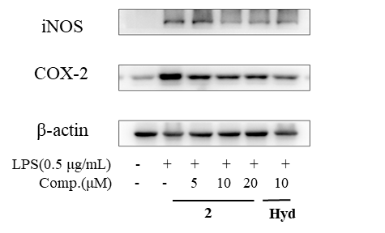

**β-actin-1: COX-2-1: iNOS-1:**

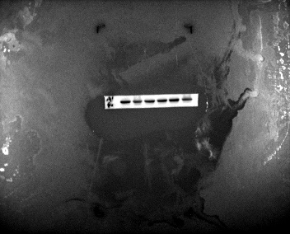 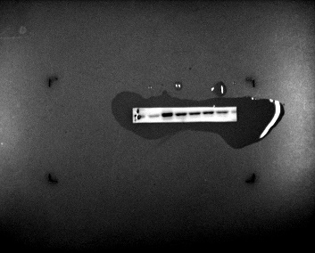 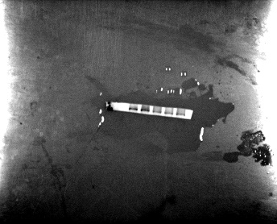

  

**Group 2:**

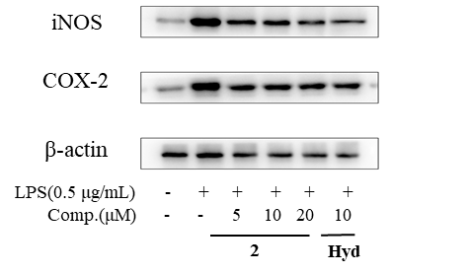

**β-actin-2: COX-2-2: iNOS-2:**

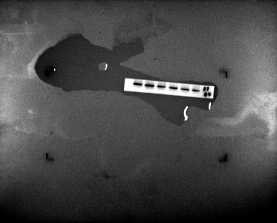 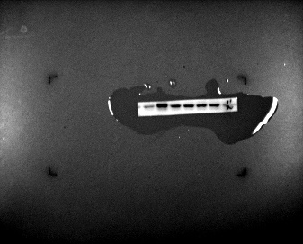 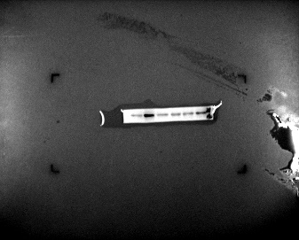

  

**Group 3:**

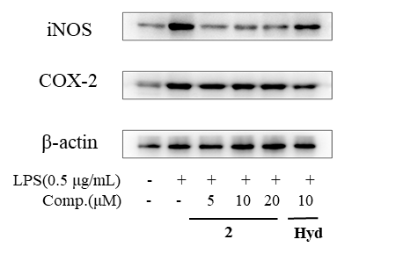

**β-actin-3: COX-2-3: iNOS-3:**

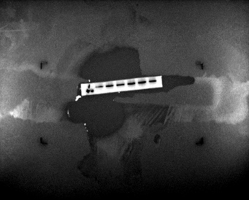 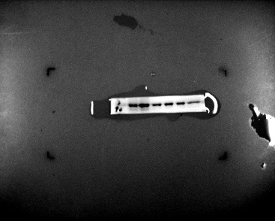 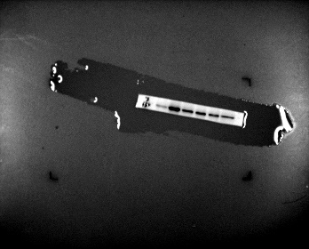

  

**iNOS:**

|  |  |  |  |  |  |
| --- | --- | --- | --- | --- | --- |
| **Control** | **Model** | **2** | | | **Hyd** |
| 5 | 10 | 20 | 10 |
| 0.3 | 1.26 | 1.04 | 1.11 | 1.04 | 0.97 |
| 0.33 | 1.42 | 1.07 | 0.93 | 0.81 | 0.89 |
| 0.3 | 1.12 | 1 | 1 | 0.84 | 0.81 |

**COX-2:**

|  |  |  |  |  |  |
| --- | --- | --- | --- | --- | --- |
| **Control** | **Model** | **2** | | | **Hyd** |
| 5 | 10 | 20 | 10 |
| 0.3 | 0.93 | 1.05 | 0.91 | 0.89 | 0.59 |
| 0.5 | 0.97 | 0.86 | 0.9 | 0.97 | 0.57 |
| 0.36 | 0.97 | 0.9 | 0.91 | 0.7 | 0.42 |

**WB raw data (icariside II)**

**Repeat:**

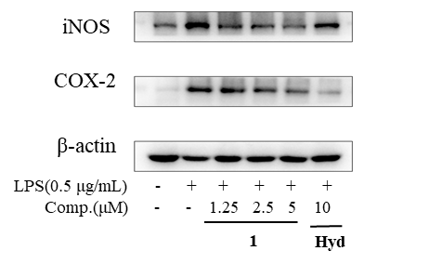

**β-actin-1: COX-2-1: iNOS-1:**

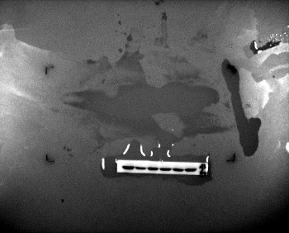 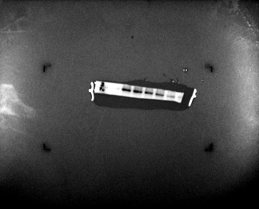 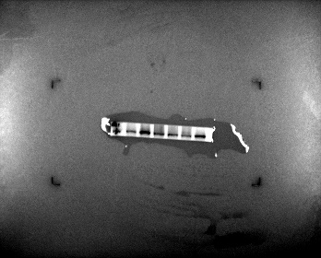

  

**Group 2:**

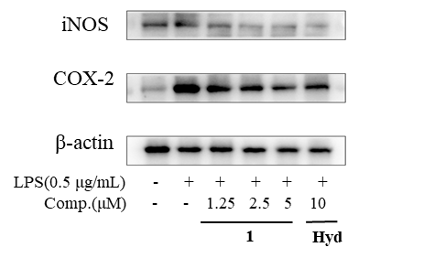

**β-actin-2: COX-2-2: iNOS-2:**

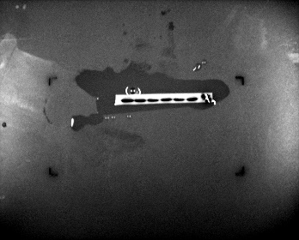 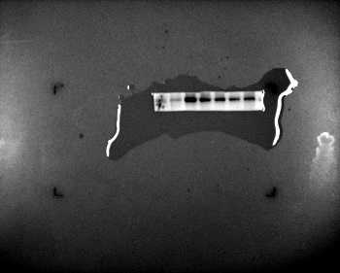 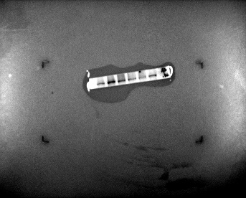

  

**Group 3:**

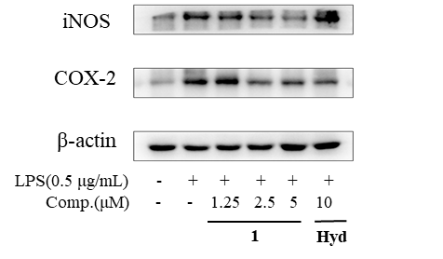

**β-actin-3: COX-2-3: iNOS-3:**

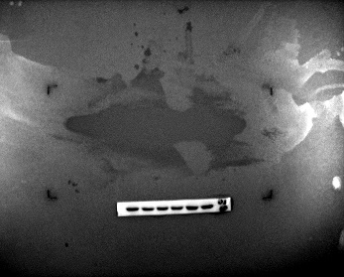 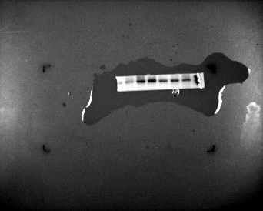 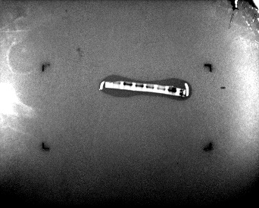

  

**iNOS:**

|  |  |  |  |  |  |
| --- | --- | --- | --- | --- | --- |
| **Control** | **Model** | **1** | | | **Hyd** |
| 1.25 | 2.5 | 5 | 10 |
| 0.38 | 0.81 | 0.82 | 0.75 | 0.62 | 0.92 |
| 0.50 | 1.06 | 0.90 | 0.61 | 0.70 | 0.57 |
| 0.33 | 0.98 | 1.06 | 0.68 | 0.64 | 0.89 |

**COX-2:**

|  |  |  |  |  |  |
| --- | --- | --- | --- | --- | --- |
| **Control** | **Model** | **5** | | | **Hyd** |
| 1.25 | 2.5 | 5 | 10 |
| 0.24 | 1.30 | 1.50 | 0.90 | 0.64 | 0.63 |
| 0.14 | 0.93 | 1.14 | 0.98 | 0.88 | 0.59 |
| 0.38 | 1.14 | 1.16 | 0.85 | 0.95 | 0.86 |